(College logo)



**Project synopsis on**

**GPS CLOCK**

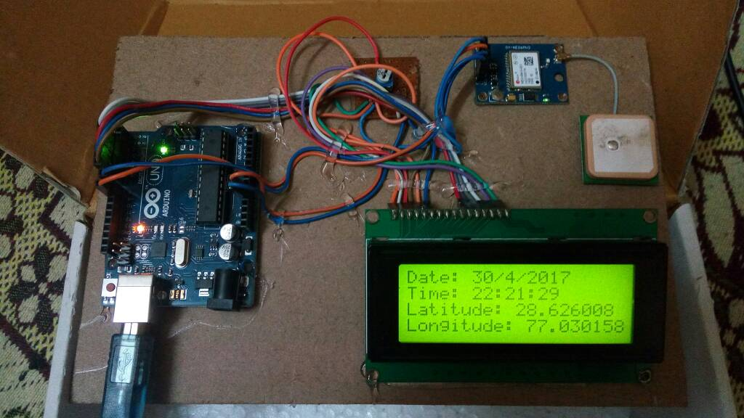

Under taken by:

Name 1 Roll no. 1 Name 2 Roll no. 2  
 Name 3 Roll no. 3 Name 4 Roll no. 4

**ABSTRACT:**

This is a project to build a clock with an Arduino that sets itself using time broadcast from GPS satellites.

There are many GPS satellites around the Earth which are used to provide the exact location of any place. Along with the location coordinates (Latitude and Longitude), it also provide other data like time, date, altitude, direction tracking angle etc. We have already learned to read this GPS data from Satellite using Arduino. So we are going to make a GPS clock using the ‘Time and Date’ data from the GPS satellite. GPS Updated Clock is very accurate and provides the real time data with precision of milliseconds.

**WORKING PRINCIPLE:**

The Global Positioning System (GPS), originally Navstar GPS, is a space-based radionavigation system owned by the United States government and operated by the United States Air Force. It is a global navigation satellite system that provides geolocation and time information to a GPS receiver anywhere on or near the Earth where there is an unobstructed line of sight to four or more GPS satellites.

The GPS system does not require the user to transmit any data, and it operates independently of any telephonic or internet reception, though these technologies can enhance the usefulness of the GPS positioning information. The GPS system provides critical positioning capabilities to military, civil, and commercial users around the world.

The GPS project was launched in the United States in 1973 to overcome the limitations of previous navigation systems, integrating ideas from several predecessors, including a number of classified engineering design studies from the 1960s.

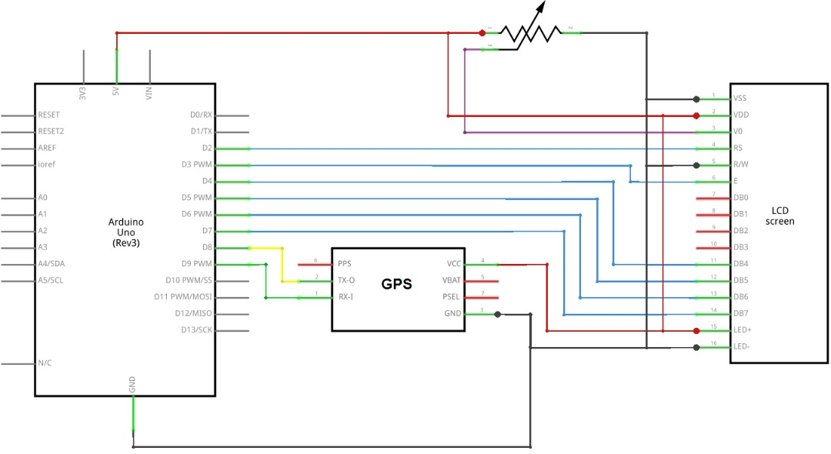**SCHEMATIC DIAGRAM:**

**COMPONENTS REQUIRED**

* Jumper wires
* Arduino uno
* GPS Module
* LCD 16*2

**REFERENCES:**

* <https://www.u-blox.com/en/product/neo-6-series>
* <https://developer.mbed.org/media/uploads/edodm85/board_gps.jpg>
* <https://learn.adafruit.com/arduino-clock/overview>
* <https://learn.adafruit.com/arduino-clock/hardware>
* <https://circuitdigest.com/microcontroller-projects/arduino-gps-clock>
* <https://circuitdigest.com/microcontroller-projects/arduino-gps-clock>