1. ARDUINO UNO R3

**Arduino Uno** is a microcontroller board based on the ATmega328P. It has 14 digital input/output pins, 6 analog inputs, a 16 MHz quartz crystal, a USB connection, a power jack, an ICSP header and a reset button. It contains everything needed to support the microcontroller; simply connect it to a computer with a USB cable or power it with a AC-to-DC adapter or battery to get started.

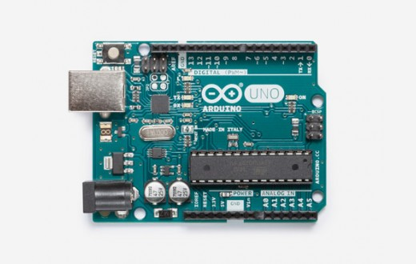

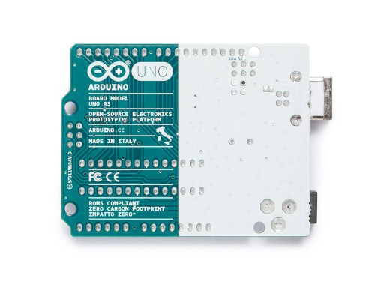

1. PUSH-BUTTON

A push-button (also spelled pushbutton) or simply button is a simple switch mechanism for controlling some aspect of a machine or a process.

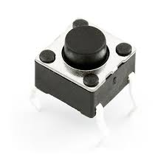

1. LEDS

A light-emitting diode (LED) is a semiconductor device that emits visible light when an electric current passes through it. The light is monochromatic, occurring at a single wavelength. The output from an LED can range from red (at a wavelength of approximately 700 nanometers) to blue-violet (about 400 nanometers). Some LEDs emit infrared (IR) energy (830 nanometers or longer); such a device is known as an infrared-emitting diode (IRED).

An LED or IRED consists of two elements of processed material called P-type semiconductors and N-type semiconductors. These two elements are placed in direct contact, forming a region called the P-N junction.

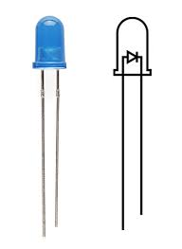

1. NPN TRANSISTORS

NPN Transistors are three-terminal, three-layer devices that can function as either amplifiers or electronic switches.

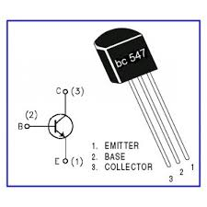

1. DIODE 1N4007

A diode is a device which allows current flow through only one direction. That is the current should always flow from the Anode to cathode. The cathode terminal can be identified by using a grey bar as shown in the picture above.

For 1N4007 Diode, the maximum current carrying capacity is 1A it withstand peaks up to 30A. Hence we can use this in circuits that are designed for less than 1A. The reverse current is 5uA which is negligible. The power dissipation of this diode is 3W.

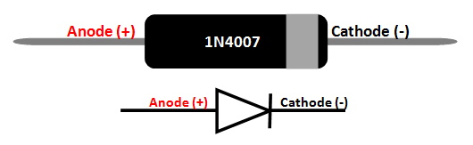

1. RESISTORS MULTIVALUE

The resistor is a passive electrical component to create resistance in the flow of electric current.

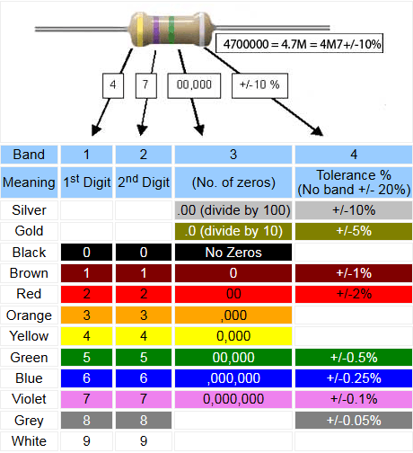

1. CERAMIC CAPACITORS

A ceramic capacitor is a fixed-value capacitor in which ceramic material acts as the dielectric. It is constructed of two or more alternating layers of ceramic and a metal layer acting as the electrodes. Ceramic capacitors are divided into two application classes:

Class 1 ceramic capacitors offer high stability and low losses for resonant circuit applications.

Class 2 ceramic capacitors offer high volumetric efficiency for buffer, by-pass, and coupling applications.

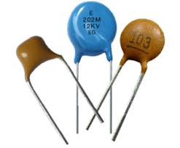

1. 9V BATTERY

The nine-volt battery, or 9-volt battery, is a common size of battery. It has a rectangular prism shape with rounded edges and a polarized snap connector at the top.

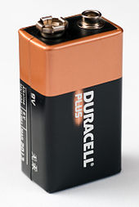

1. M TO M JUMPER WIRES

Male to male jumper wire, used in connecting female header pin of any developemnt board (like arduino) to other development board or breadboard.

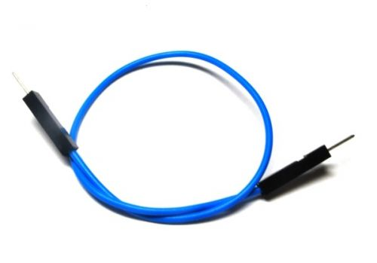

1. BUZZER

A buzzer or beeper is an audio signalling device,which may be mechanical, electromechanical, or piezoelectric.

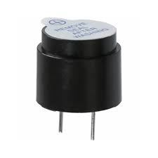

1. PHOTO TRANSISTOR

Phototransistor is a semiconductor light sensor formed from a basic transistor with a transparent cover that provides much better sensitivity than a photodiode .

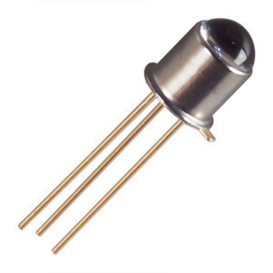

1. POTENTIOMETER

A potentiometer is a three terminal resistor in which the resistance is manually varied to control the flow of electric current.

The potentiometer consists of three terminals among which two are fixed and one is variable.

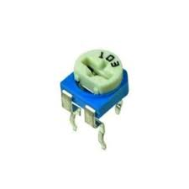

1. TEMPERATURE SENSOR

A temperature sensor is a device that provides temperature measurement through an electrical signal.

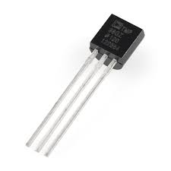

1. SEVEN SEGMENT DISPLAY

Seven segment displays are the output display devices that provide a way to display information in the form of image or text.

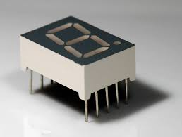

1. DC MOTOR

A motor is an electrical machine which converts electrical energy into mechanical energy. The principle of working of a DC motor is that "whenever a current carrying conductor is placed in a magnetic field, it experiences a mechanical force".

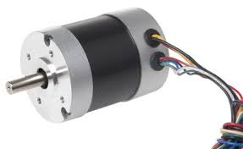

1. BREADBOARD

A breadboard is a reusable solderless device used to build a prototype of an electronic circuit and for experimenting with circuit designs.

