RS1…6
1.VCC
2.Signal to sample using ADC
3.GND
R11…16
Voltage dividers for pin2, so as to control input voltage to ADC

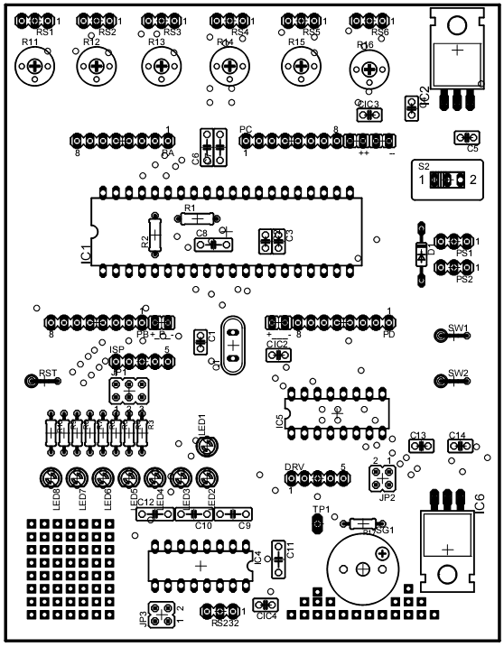

Supply for attachments
VCC|VCC|GND|GND

S2
ON-OFF switch
ISP
Insystem programmer insert connection. Pin5 > GND. Insert marked pin of programmer here.
JP1
Open : to disable LED3,2,1
PS1,PS2(parallel) Board supply
1. GND
2. VCC (7.5V -20V)

SW1,SW2
Micro switches connected to PC0 and PC1 respectively
RST
Reset switch

IC6
Motor driver supply regulator. You can put 7808,…,7812 here as per requirement
LED8...LED1
LEDs for debugging
LED8 >PB0
….
LED1 >PB7

JP2
1. GND connection
2. VCC connection of L293D
These jumpers can be opened to turn off supply of L293D drivers

speaker, JP1 pin of speaker can be connected to any pin of uC using external wire.
RS232
1. GND 2. TXD
3. RXD
JP3
Close : to connect MAX232 inputs to PD0, PD1
Output of L293D motor driver
L293D outputs and DRV :
1. 1Y 2. 4Y 3. GND
4. 3Y 5. 2Y
Pin1&2 > can control 1st motor
Pin 4&5> can control 2nd motor

L293D connections with uC :
1-2EN & 3-4 EN >PD3
#1A >PD6 #2A >PD7
#3A >PD5 #4A >PD4

