

Plugin Lite “Hello World” Linux Tutorial

1. SSH into your Linux box
2. Run **git clone** [**https://github.com/electric-cloud/PluginLite**](https://github.com/electric-cloud/PluginLite)
   * 1. This will clone the git repo to your server
3. Run **cd PluginLite**
4. Run **sudo apt-get install default-jdk** (skip this step if you have JDK installed already. Agree to any overrides.)
   * 1. This installs as jdk for you to create jar files
5. Run **jar cvf PluginLiteUPDATE.jar dsl/ META-INF/ pages**
   * 1. This will create your jar file
     2. PluginLiteUPDATE will be the name of your jar file. dsl/, META-INF and pages/ are the directories you are jarring. Note: when creating a jar file only jar the directories
6. Run **ls** to make sure the jar file is in your working directory
7. Login to ectool (ectool login admin changeme for EC users)
   * 1. If ectool is not working properly, make sure to export the path by running: **export PATH=$PATH:/opt/electriccloud/electriccommander/bin/**
     2. For a more permanent solution add the following to /etc/profile (**sudo vi etc/profile/)** to the end of the file
     3. **export PATH=$PATH:/opt/electriccloud/electriccommander/bin/**
     4. **export PATH**
        + 1. *You must log out and log back in for this to take effect*
8. Run **export TEMP=/tmp**
9. Run **ectool installPlugin PluginLiteUPDATE.jar**
10. Run **ectool promotePlugin PluginLite-1.0**

Testing Plugin Lite

1. Run **ectool runProcedure "PluginLite-1.0" --procedureName "Sample Procedure"**
   * 1. This ectool command will run the procedure within Flow, which will trigger PluginLite. See the [docs](http://docs.electric-cloud.com/eflow_doc/6_5/API/HTML/APIflowHTML.htm#apijobs.htm) for more info
        1. Matt's Hard Drive:Users:mpeters:Desktop:Screen Shot 2016-08-17 at 11.11.45 AM.pngYou can do the same thing within the flow GUI by navigating to <https://flow/commander> . Click on Projects. Click on PluginLite-1.0. Click
2. Navigate to <https://flow/commander>
3. Click on the last ran job

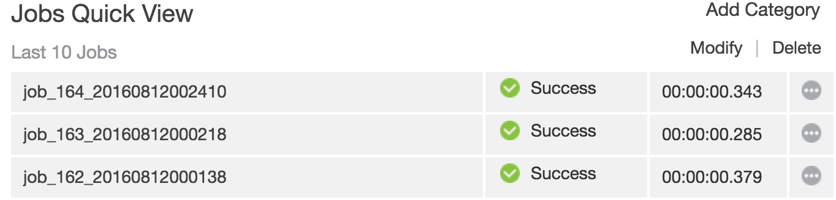

1. Click Matt's Hard Drive:Users:mpeters:Desktop:Screen Shot 2016-08-16 at 3.12.39 PM.png to view the log. This contains output from the plugin
2. Expected output

