

Plugin Lite “Hello World” Linux Tutorial

- SSH into your Linux box
- Run git clone https://github.com/electric-cloud/PluginLite
    - This will clone the git repo to your server
- Run cd PluginLite
- Run sudo apt-get install default-jdk (skip this step if you have JDK installed already. Agree to any overrides.)
    - This installs as jdk for you to create jar files
- Run jar cvf PluginLiteUPDATE.jar dsl/ META-INF/ pages
    - This will create your jar file
    - PluginLiteUPDATE will be the name of your jar file. dsl/, META-INF and pages/ are the directories you are jarring. Note: when creating a jar file only jar the directories
- Run ls to make sure the jar file is in your working directory
- Login to ectool (ectool login admin changeme for EC users)
    - If ectool is not working properly, make sure to export the path by running: export PATH=$PATH:/opt/electriccloud/electriccommander/bin/
    - For a more permanent solution add the following to /etc/profile (sudo vi etc/profile/) to the end of the file
    - export PATH=$PATH:/opt/electriccloud/electriccommander/bin/
    - export PATH
        - You must log out and log back in for this to take effect

- Run export TEMP=/tmp
- Run ectool installPlugin PluginLiteUPDATE.jar
- Run ectool promotePlugin PluginLite-1.0

Testing Plugin Lite

- Run ectool runProcedure "PluginLite-1.0" --procedureName "Sample Procedure"
    - This ectool command will run the procedure within Flow, which will trigger PluginLite. See the docs for more info

      - You can do the same thing within the flow GUI by navigating to https://flow/commander . Click on Projects. Click on PluginLite-1.0. Click
- Navigate to https://flow/commander

- Click on the last ran job
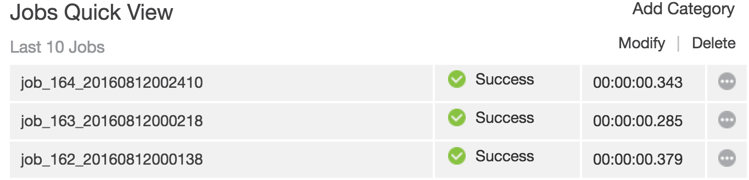
- Click  to view the log. This contains output from the plugin
- Expected output

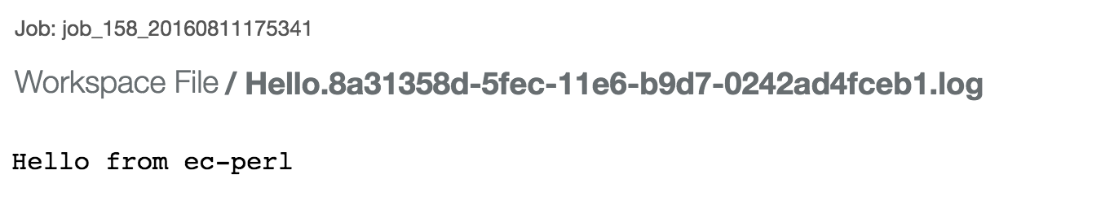

Diving Into the DSL/Groovy

In the steps above, we installed a pre-made plug-in from github. Below is the Groovy code, which can be found in PluginLite/dsl/promote.groovy. Promote.groovy is the heart of the Plugin and is a very simple example of how a plugin is made within Electric Flow.
To create your own plugin, understanding DSL/Groovy is essential. Also, if you’d like to create your own plugin, re-pull the repository from github to a new directory. Modify promote.groovy to perform the actions you’d like your plugin to do and follow on from step 5 in the “Hello World Linux Tutorial” above. Remember to create a unique name for your jar file and your plugin.

// Variables available for use in DSL code
def pluginName = args.pluginName
def pluginKey = getProject("/plugins/$pluginName/project").pluginKey
def pluginDir = getProperty("/server/settings/pluginsDirectory").value + "/" + pluginName
// END Variables

// Sample plugin project content. pluginName can be replaced by a name
// to create a non-plugin project
project pluginName,{

// Make this plugin visible in all contexts
property "ec_visibility", value: "all" // Legal values: pickListOnly, hidden, all

procedure "Sample Procedure",{

// Server level property that exposes this procedure for use in pipeline tasks,
// application processes and component processes (pick lists). Note that
// procedureName an intrinsic variable for the procedure closure
property "/server/ec_customEditors/pickerStep/$pluginKey - $procedureName",
value:
"""\
<step>
<project>/plugins/$pluginKey/project</project>
<procedure>$procedureName</procedure>
<category>Utility</category>
</step>
""".stripIndent(),
description: "A sample procedure"
// TIP: Remove this property in demote.groovy
// END property

step "Hello", shell: "ec-perl",
// Get step content from a file in this plugin directory
command: new File(pluginDir + "/dsl/steps/Hello.pl").text
}

}

