Entities, Attributes and Relationships
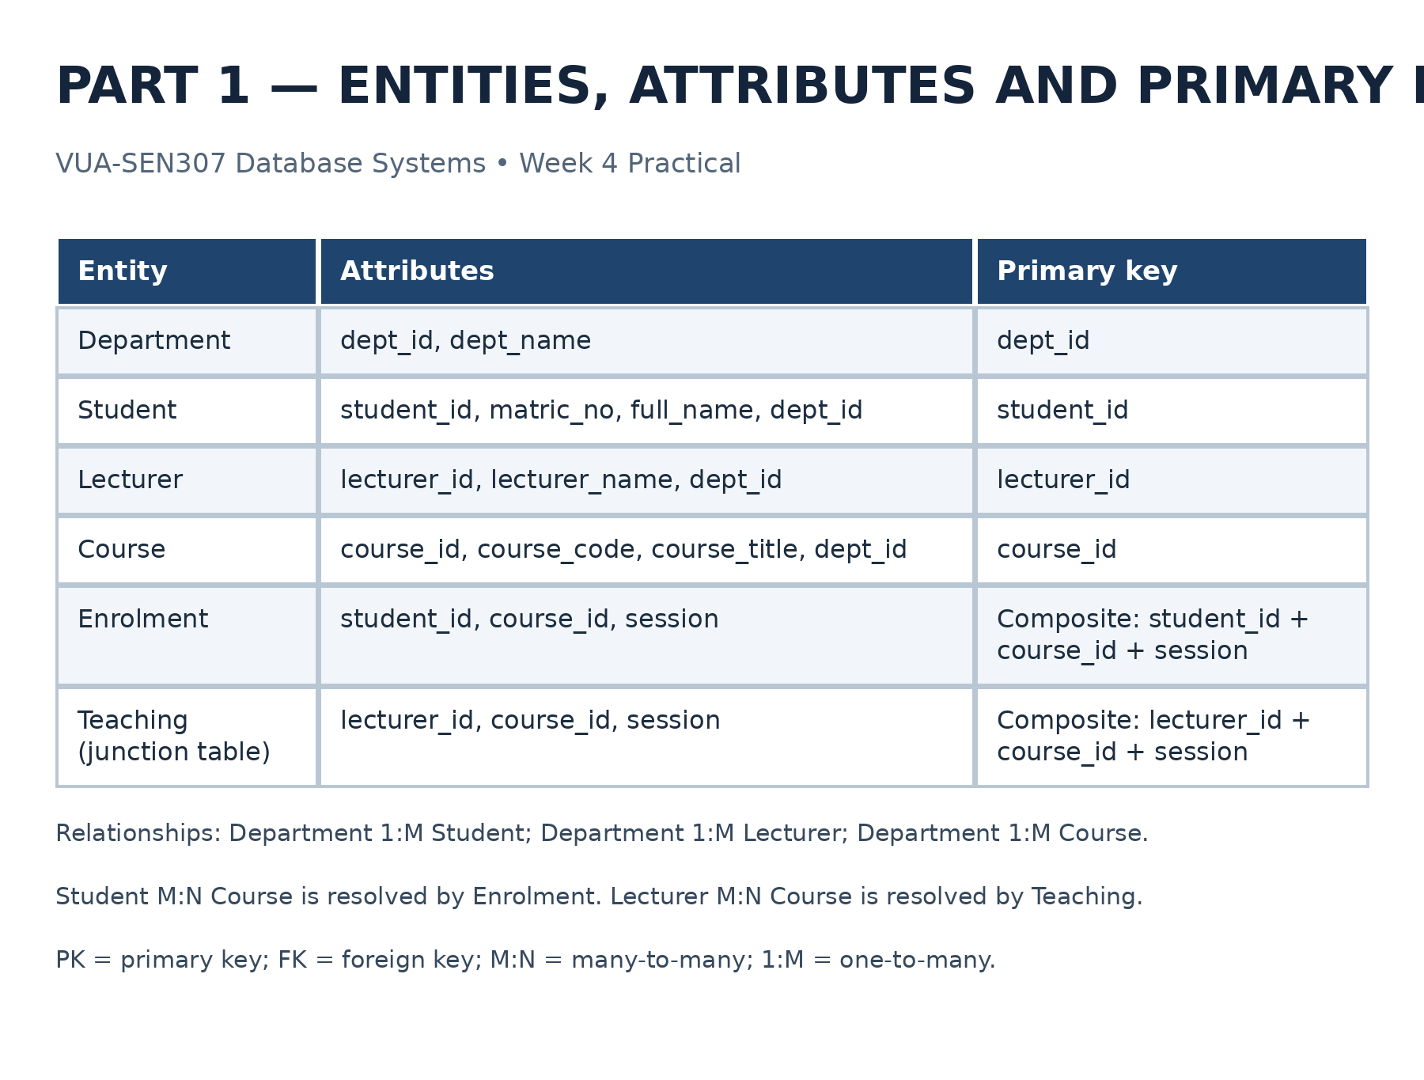
What do these terms mean?
- Entity: Something you want to store data about, such as a Student.
- Attribute: A piece of information about that entity, such as full_name.
- Primary key (PK): A column or combination of columns that uniquely identifies a record.
- Foreign key (FK): A column that connects one table to another.

Question | Answer
How many departments does one student belong to? | One department.
How many students can one department have? | Many students.
How many courses can one student register for? | Many courses.
How many students can one course have? | Many students.
How many lecturers can teach one course across sessions? | Many lecturers.
How many courses can one lecturer teach? | Many courses.
There are two many-to-many relationships to resolve:
- Students ↔ Courses, resolved by the Enrolment table.
- Lecturers ↔ Courses, resolved by the Teaching table.

Unnormalized table (UNF)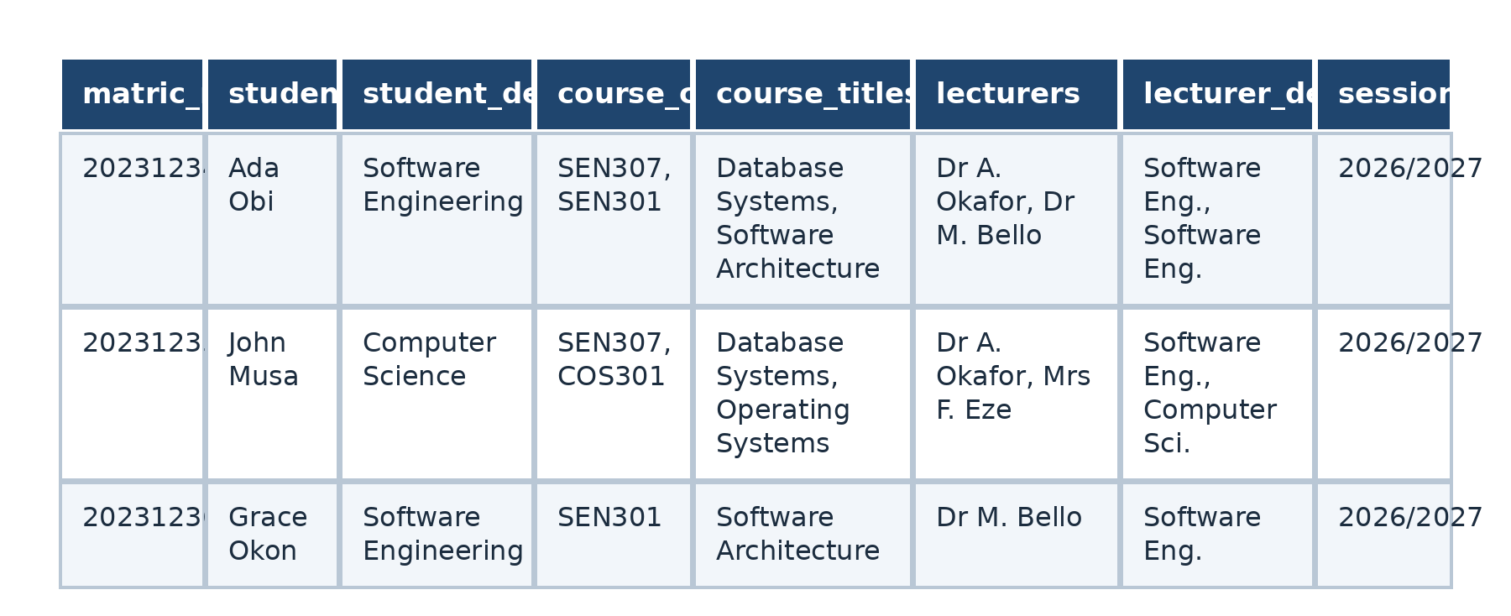
This table is unnormalized because several columns contain multiple values in a single cell.

First Normal Form (1NF)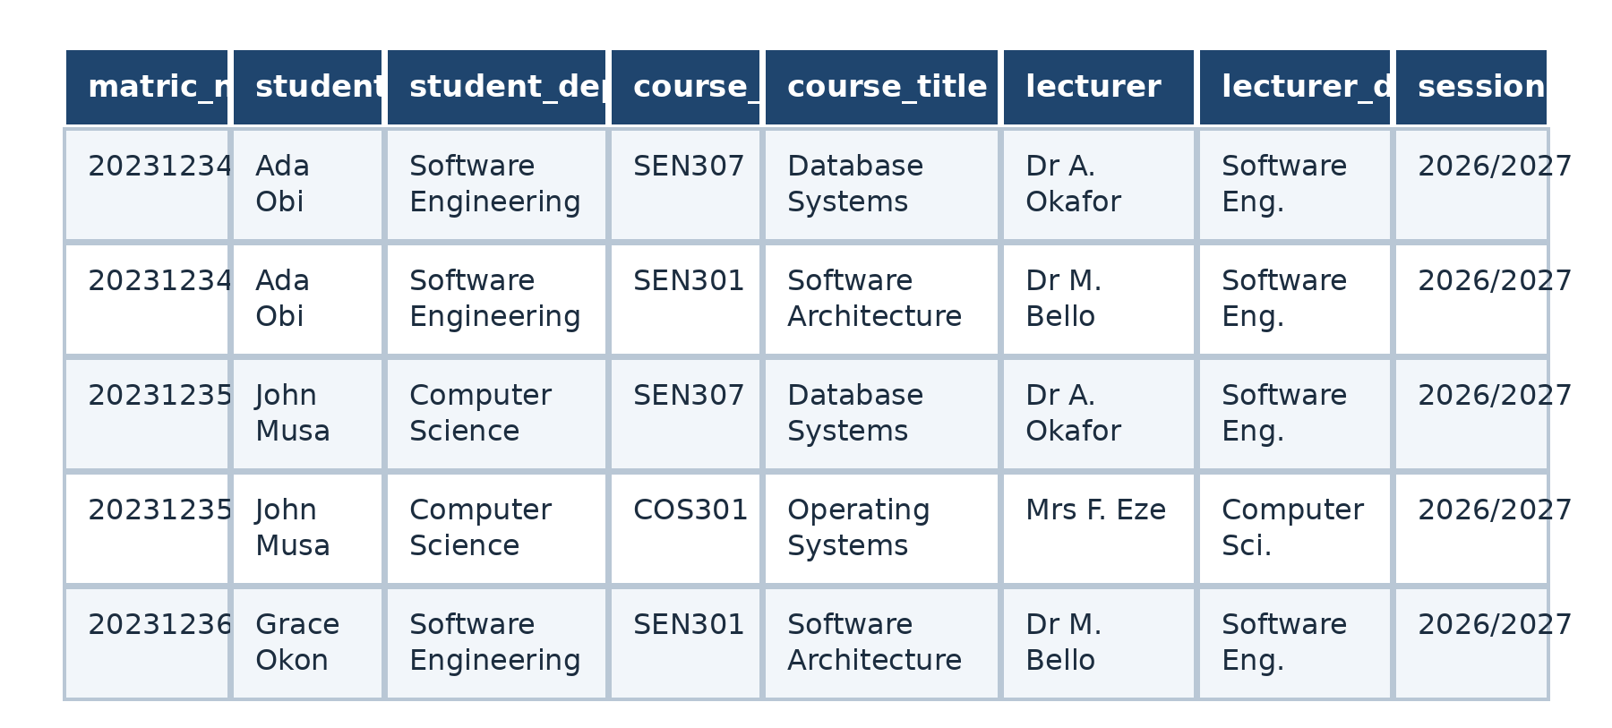
First Normal Form was achieved by removing multiple values from individual cells and storing each student-course registration as a separate row.

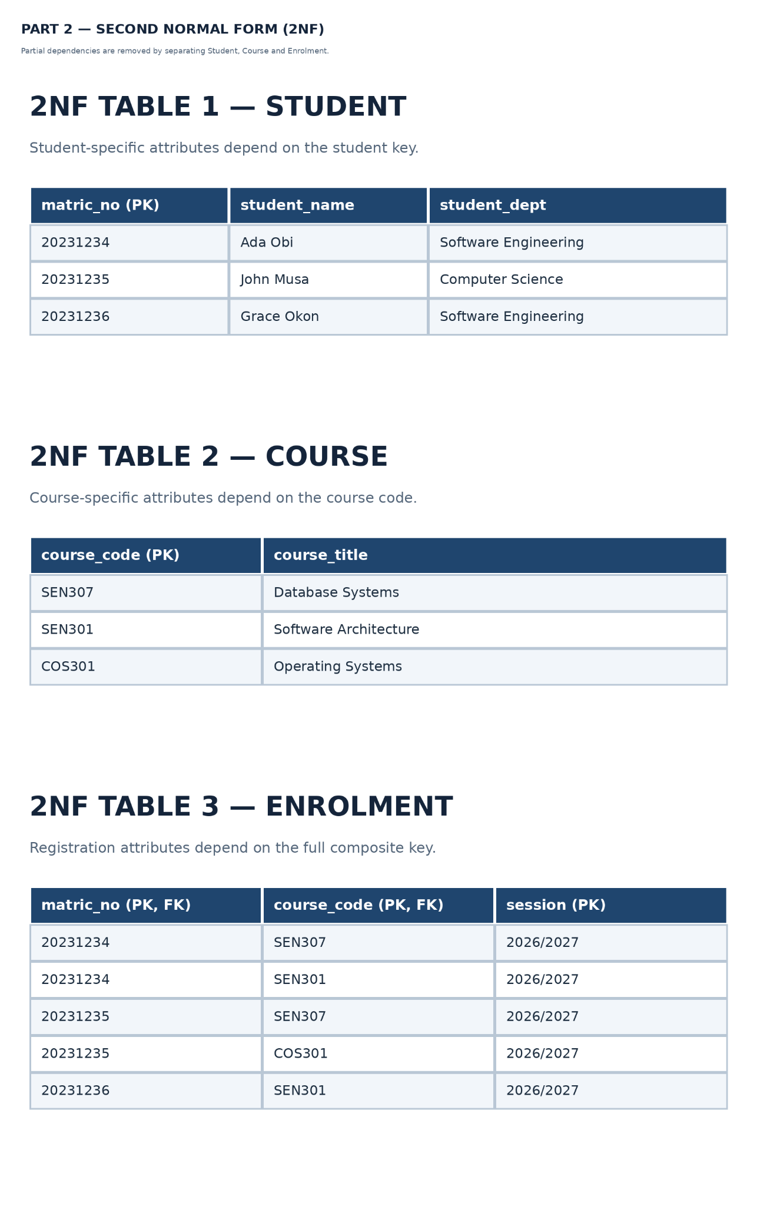
Second Normal Form was achieved by separating Student, Course and Enrolment so that student details depend on the student key, course details depend on the course key, and registration records depend on the full composite key.

Third Normal Form (3NF)
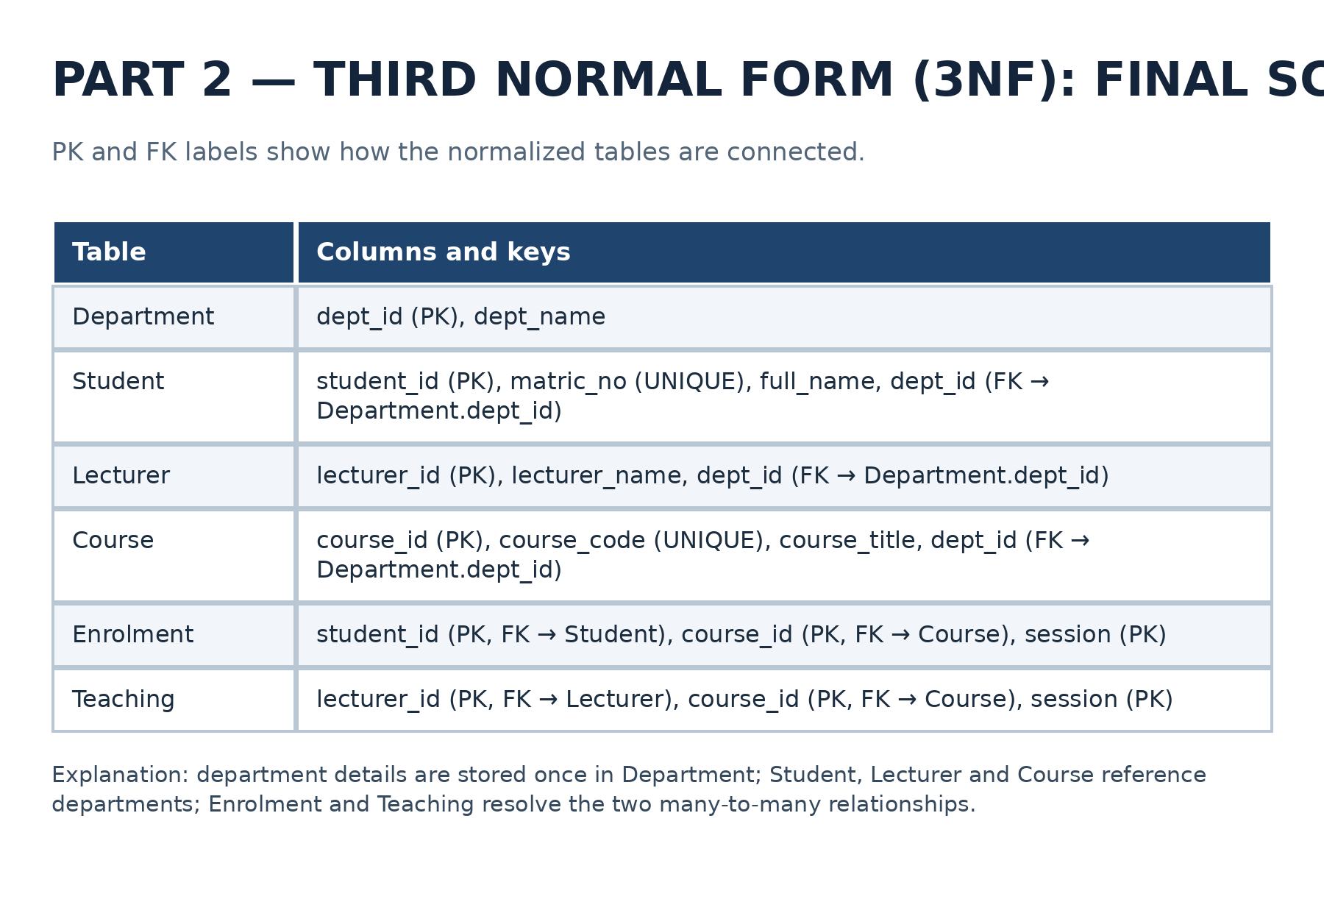

Third Normal Form was achieved by separating department information into its own table, referencing departments through foreign keys, and using a Teaching junction table to record lecturers, courses and sessions.

EER diagram in MySQL Workbench

