Post-Mortem Analysis: Google Gemini "Dear Sydney" Olympics Ad
AIML-510-01 | Assignment 6.2 | Arun Kumar Vallala | July 2026

Product Summary and Failure
In July 2024, Google aired a 60-second Olympics commercial titled "Dear Sydney" to promote its Gemini AI chatbot. The ad depicts a father who wants to help his young daughter—a devoted fan of Olympic hurdler Sydney McLaughlin-Levrone—write a fan letter. Rather than guiding her through the writing process, the father prompts Gemini: "Help my daughter write a letter telling Sydney how inspiring she is." The ad closes with the tagline "A little help from Gemini" and footage of the girl running on a track.
The product failed in the court of public opinion, not because Gemini malfunctioned technically, but because customers rejected what the ad represented. Within days, viewers across social media accused Google of encouraging families to outsource emotionally meaningful communication to a machine. Critics called the spot "tone-deaf," "anti-human," and "dystopian," arguing that writing a fan letter is precisely the kind of authentic, vulnerable, human activity that should not be automated—especially for a child. Google phased the ad out of its Olympics rotation in early August 2024, acknowledging feedback while maintaining that Gemini was intended only as a "starting point" for writing.
Root Cause Analysis (RAI Perspective)
From a Responsible AI perspective, the failure was rooted in a mismatch between Google's efficiency narrative and customers' expectations of authenticity and empowerment. The assignment's two guiding questions—Is this product empowering? Is this product authentic?—expose the problem clearly. Empowerment requires that technology expand human capability without creating dependence. The ad did the opposite: it portrayed AI as a substitute for a parent's patient coaching, reducing the daughter's agency to express her own admiration in her own words. Authenticity requires honest representation and genuine connection. Although Google claimed the output was merely a draft, the storytelling placed AI at the center of an intimate parent-child moment, implying that machine-generated prose could carry the same emotional weight as a handwritten letter from a child.
The deeper root cause was a Golden Rule failure (Matthew 7:12): Google marketed the product from the company's perspective—showcasing Gemini's versatility—without asking how customers would feel if AI replaced their own meaningful efforts. Philippians 2:3-4 calls leaders to consider others' interests above their own; here, the pursuit of maximum AI visibility during a high-profile event took priority over how families experience connection. James 3:17 describes wisdom as "pure, peaceable, considerate"; the backlash suggests customers experienced the ad as inconsiderate of what makes writing personal. Trust is fragile—"it arrives on foot but leaves on horseback"—and Google's brand trust suffered because the ad signaled that even heartfelt communication was a candidate for automation.
RAI Lessons Learned and Recommendations for SentinelOneX Security
SentinelOneX Security (Assignment 1.3) builds AI for malware detection, SOC alert triage, incident response recommendations, and vendor risk assessment—domains where customers already face high-stakes decisions. The Dear Sydney post-mortem yields four lessons directly applicable to our RAI framework.
First, never position AI as a replacement for human judgment in moments that define trust. Just as a fan letter should come from the child, a containment decision on a critical incident must remain with the customer's security team. Our incident response recommendation engine should present options and rationale, not execute autonomously without consent.
Second, marketing must match product reality. Google claimed Gemini was a "thought starter," but the ad showed full letter generation. SentinelOneX must avoid anthropomorphic or over-autonomous messaging—SOC triage AI should be marketed as decision support that analysts control, not as a replacement analyst.
Third, empowerment requires exit ramps and configurability. Customers should choose automation levels, override AI rankings without penalty, and export their data. Fourth, authenticity requires transparent labeling whenever AI influences customer outcomes—alert scores, risk ratings, and vendor assessments should include explainability coverage (our 90%+ target) so customers understand what the system is and is not doing on their behalf.
Updated RAI Framework — Customer Perspective
The chart below extends our Assignment 1.3 framework with four customer-centric dimensions: Empowerment, Authenticity, Customer Agency, and Trust Stewardship. These integrate with existing principles of fairness, accountability, transparency, privacy, reliability, and human oversight.
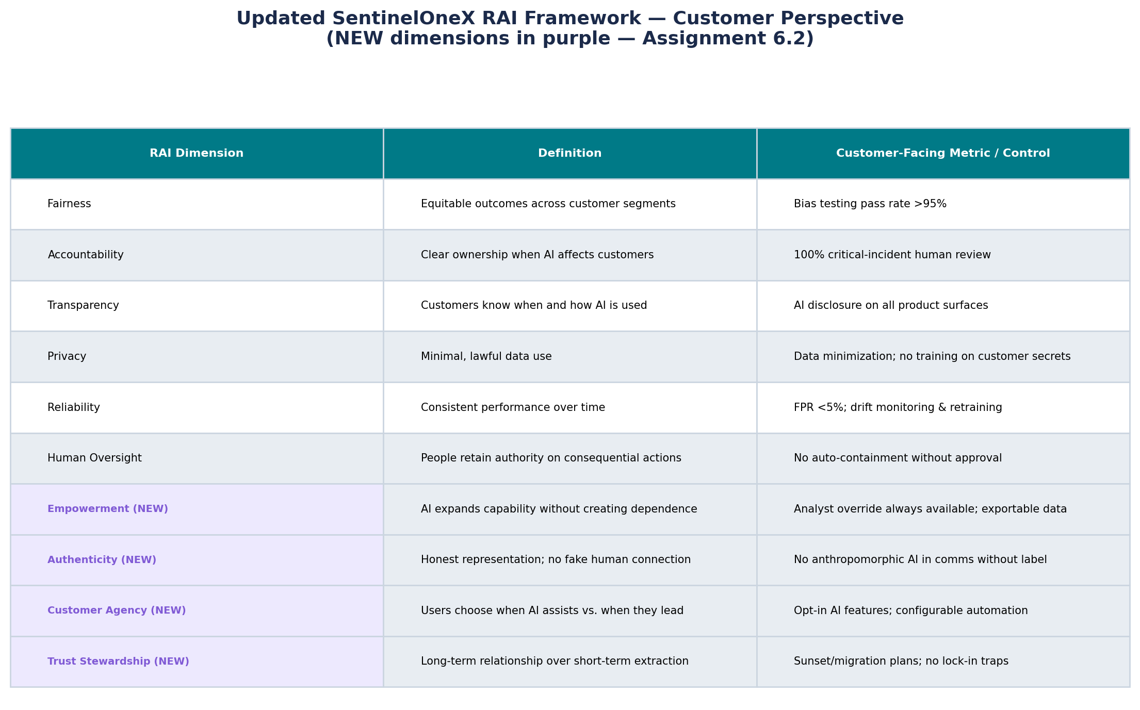
Figure 1. SentinelOneX RAI Framework — Customer Perspective Update

References
De Vynck, G. (2024, August 2). Google pulls Olympics ad for Gemini AI after backlash. The Washington Post. https://www.washingtonpost.com/technology/2024/08/02/google-gemini-ad-ai-sydney-mclaughlin/
Kelly, S. M. (2024, August 2). Google pulls AI ad for Olympics following backlash. CNBC. https://www.cnbc.com/2024/08/02/google-pulls-ai-ad-for-olympics-following-backlash.html
Peters, J. (2024, August 2). Google pulls Gemini AI ad from Olympics after backlash. The Verge. https://www.theverge.com/2024/8/2/24212078/google-gemini-olympics-ad-backlash

