Five Color Spotlight
SL5C3.1
AMG

Introduction
The SP5C projector is designed to reproduce as closely as possible the different natural lighting. Warm white is dominant but cold white, red, green and blue can also be mixed. We can thus obtain different atmospheres. For example the sweetness of a sunrise, the power of the noon, or the mystery of a moonlit night.
The intensity of the five different colors is adjusted thanks to an exponential function integrated in the projector, which allows you to adjust the intensity very finely and to go from one end to the other in a gradual way even in low intensities.

Warning
The light is emitted with an angle of 25 °, it could cause damage to the eyes if we look at the projector in front and near. It is recommended that you do not look directly at the projector unless you are at least 2 meters away.

Description
The projector is powered with a voltage of 24V / 3Amax, it is controlled by a DMX512 BUS.
It uses first quality Cree LED. The heart is based on the Arduino open source system. The firmware also open source can be updated by USB plug and Arduino IDE. The DMX address is easily programmable by the DMX bus and can be done simply, even while staying away from the projector. A magnetic sensor can easily trigger the programming of the address simply by approaching a small magnet projector.

The projector has a temperature sensor and disables the LEDs if the temperature rises above a limit value of 60 ° C. Always use the projector in a place where air can flow freely and never cover the projector. Low intensity blue lights indicate overheating.

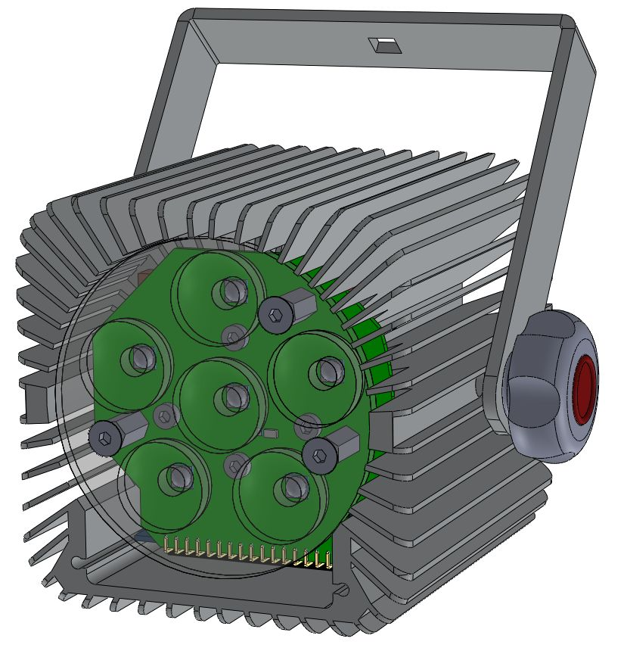
Buttons and connectors
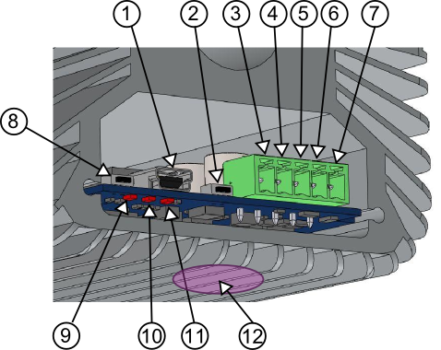
- USB socket for firmware update
- Button for changing the DMX address
- GND (0V)
- Power supply 24V
- DMX-
- DMX+
- GND
- Reset (optional)
- LED TX USB (optional)
- LED RX USB (optional)
- LED for power
- Magnetic area

DMX Addresses
By default the addresses of the projector are 1,2,3,4 and 5 which corresponds respectively to the warm white, cold white, red, green and blue. When reprogramming the address of the projector, it is only indicated the warm white address, the other colors are automatically following.
If there is no DMX signal on the projector, there is a low level redlight.

Programming DMX address
To program the DMX address the spotlight must be connected to the DMX network. The specific DMX addresses 511 and 512 serve as registers for containing the two parts of the address to be programmed.
The address to be programmed is calculated as follows:
Ap the new address to program
R511 the value of the register at address 511
R512 the value of the register at address 512
we have
Ap = R511 * 256 + R512
Example 1 :
given R511=0 et R512=10
we find Ap = 10
Example 2 :
given R511=1 et R512=10
we find Ap=256+10=266

The maximum value for Ap is 510, addresses 511 and 512 are reserved.
Once the registers have been configured, it is defined which projector must be reprogrammed by pressing the address button. You can also pass a magnet below the button and the magnetic sensor will act in the same way. If R511 and R512 are at 0 nothing happens, if at least one of them is different then the new address is memorized and a blinking of the color LEDs appears for a short time and confirms the change of address.

Firmware update
Firmware source code can be downloaded here:
https://github.com/electroZ-microsystems/SL5C

Once you have the source files you can open the SL5CS.ino file with the Arduino IDE and simply compile and load the firmware through the USB port. There is abundant documentation on this subject on internet. The USB port also allows you to view some information about the version, the DMX address and some status. This is done using the Arduino IDE terminal.

Features
Power 40W max
Size 90x90x100 mm
Voltage 24V/3A
Power LED color :
WarmWhite (3000K, 85CRI) 16W
Cold White (6850K) 6W
Red (625nm ) 6W
Green (528nm ) 6W
Blue (458nm) 6W
Lens angle : 25 deg.

