*Name :*

*Assignment Title :*

*Assignment Number :*

*Course Number :*

*Date:*

*[Document Title]*

*[Document Subtitle]*

# Introduction

Text should be clear and understandable in full sentences with no grammar errors. Equations should be edited with the equation editor and should include numbers where needed.

$$E=mc^{2}$$ ( 1 )

# Analytical Solution

More text follows…. And maybe you need to reference a paper about depletion [1].

# Results

All of the figures and such will need to be presented nicely as is Figure 1 below. Please note you should reference all figures in the text.

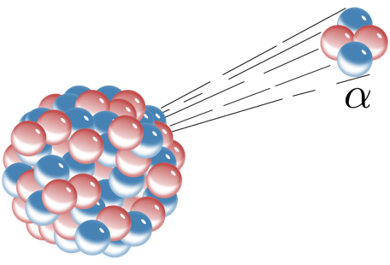

Figure : This image, of alpha emission, was created by Inductiveload from Wikimedia Commons and is in the public domain. Accordingly, I don't need to cite it, but I can attribute it anyway.

# References

[1] Gauld, Ian C., Georgeta Radulescu, Germina Ilas, Brian D. Murphy, Mark L. Williams, and Dorothea Wiarda. 2011. “Isotopic Depletion and Decay Methods and Analysis Capabilities in SCALE.” *Nuclear Technology* 174 (2): 169–95. <https://doi.org/dx.doi.org/10.13182/NT11-3>.