JDC
Military Time Alarm Clock
2022-12 v1.0.0

Table of Contents
Introduction 3
Purpose 3
Usage 4
Setup The Clock 4
First Time Power On 6
Setting The Time 8
Sync Time 9
Setting The Alarm 10
Activating The Alarm 11
Alarm Duration 11
Technical Data 12
Specifications 12
Schematic 13
CAD 17
Code 21

Introduction

Purpose
The military time alarm clock is a standard alarm clock that uses military time for the display. The clock includes one alarm that is set in military time. The clock is designed using the state-of-the-80’s hardware for user serviceability along with a full open source design under the MIT license.
Inside the clock is a 8051 micro-controller (ATMEL 89S51 variant) to power the device. This is a widely used part that is still being produced and used in multiple products as its core controller. The time base clock is a state-of-the-cmos 4060. The 4060 is a divider that has some of its unused clocks fed to a 4051 selection chip with an output to a LM386 amplifier. This gives the alarm its distinctive sound that cycles through all the tones being fed to it.

Usage

Setup The Clock
- Remove the clock from its packaging.
- Check that all the parts are included.
  - One clock
  - One 5 volt power adapter
- Set the clock near a wall outlet that the power adapter can reach.
  - WARNING DO NOT PUT STRESS ON THE CORD.
- Place the clock on a stable surface to prevent falling.
Figure 1.0

First Time Power On
- After setting up the clock, plug the power adapter into the wall.
- Plug the barrel jack of the power adapter into the rear connector of the clock.
  - This will insert about half an inch into the device, this is normal.
  - See figure 1.0 on the previous page.
- The clock will take approximately 2 seconds to power on.
- Once powered on it will flash 00:00 every other second.
- This will continue till TIME SET is pressed.
  - See figure 1.1 on the next page.
- The clock is now ready for operation.
Figure 1.1

Setting The Time
- Once the clock is powered on, time set can be performed.
- Press and hold the TIME SET button, while performing the following actions. See figure 1.1 on previous page.
  - Press the minute button to increment the minutes till the desired number is displayed.
    - Can be pressed and held for speed increment, tapped for single increments.
    - Minutes will roll over from 59 to 0 and will not increment hours.
  - Press the hour button to increment the hours till the desired number is displayed.
    - Can be pressed and held for speed increment, tapped for single increments.
    - Hours will roll over from 23 to 0.
- Let go of the TIME SET button to complete time set.

Sync Time
To sync the time with another clock follow this procedure.
    - Set the time to one minute ahead of the clock you would like to sync to.
    - Hold the TIME SET button till the clock to sync to changes to that minute, and let go.
      - The clock will start from 0 seconds (seconds are reset) whenever TIME SET is pressed.

Setting The Alarm
- With the time set, the alarm can be set in a similar manner.
- Press and hold the ALARM SET button, while performing the following actions. See figure 1.1 on page 7.
  - Press the minute button to increment the minutes till the desired number is displayed.
    - Can be pressed and held for speed increment, tapped for single increments.
    - Minutes will roll over from 59 to 0 and will not increment hours.
  - Press the hour button to increment the hours till the desired number is displayed.
    - Can be pressed and held for speed increment, tapped for single increments.
    - Hours will roll over from 23 to 0.
- Let go of the ALARM SET button to complete alarm set.

Activating The Alarm
The alarm is activated by pressing the ALARM ACT button.
  - See figure 1.1 on page 7.
  - Pressing and holding will only toggle the alarm once.
  - When the alarm LED is on, the alarm is on.
  - When the alarm LED is off, the alarm is off.

Alarm Duration
When the alarm is reached, it will stay active for one minute without intervention. Alarm can be shut off early by pressing the ALARM ACT button.

Technical Data

Specifications
- POWER: 5 volt DC at 500 mA max. Center Positive.
- Audio output: 325 mW Max
- Time Display: Green 7 segment LED, with 5 Binary seconds LED (0 to 59)
- Micro-controller: 89S51
- Case: ABS Plastic

Schematic
The following pages contain the schematic for the device.
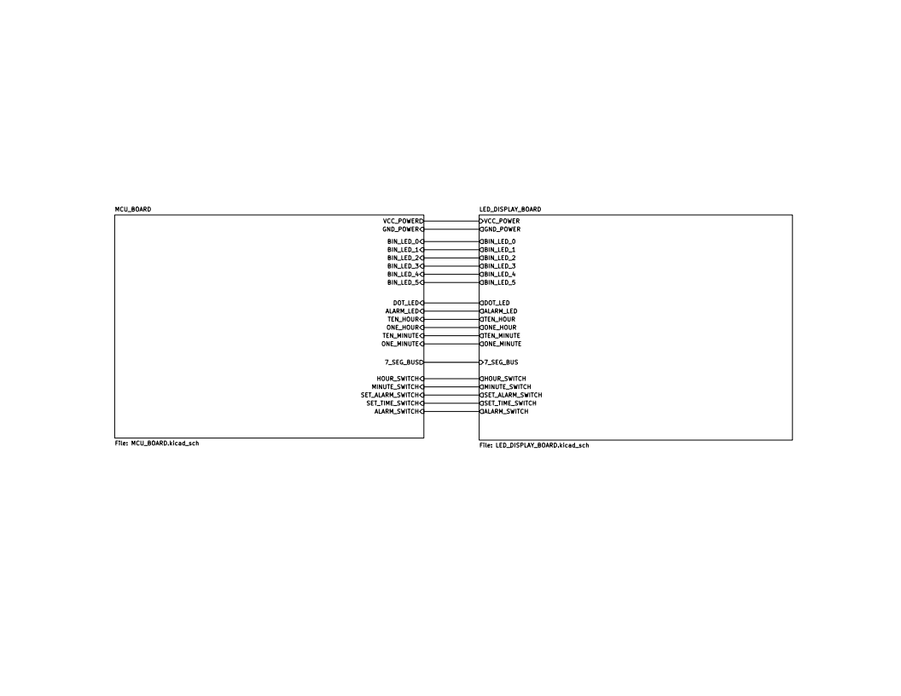
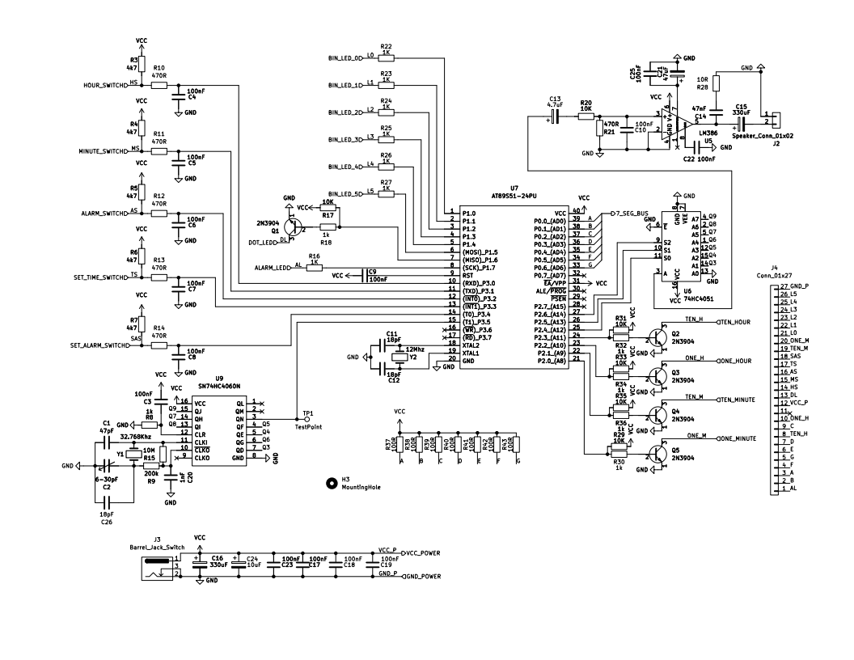
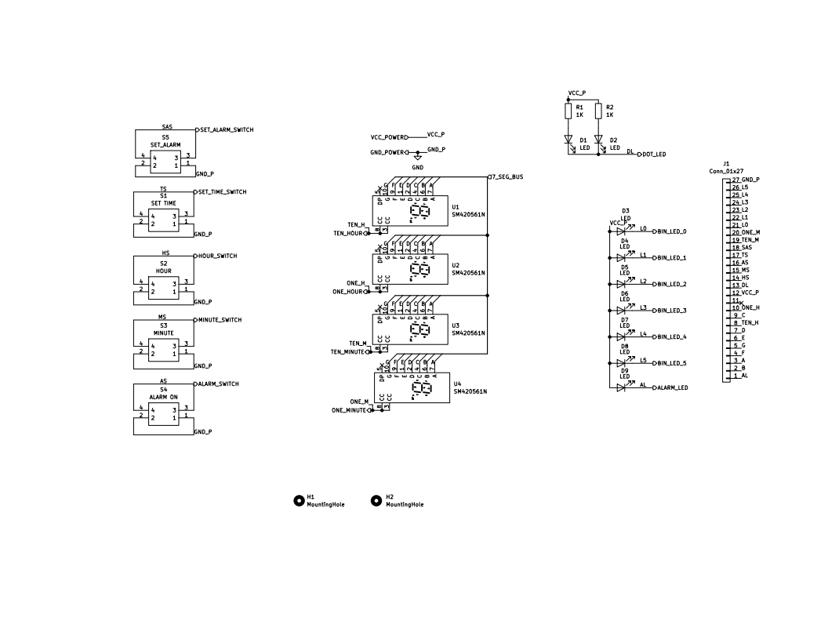

CAD
The following pages contain the CAD for the device. Dimensions are not complete, and all are in inches.

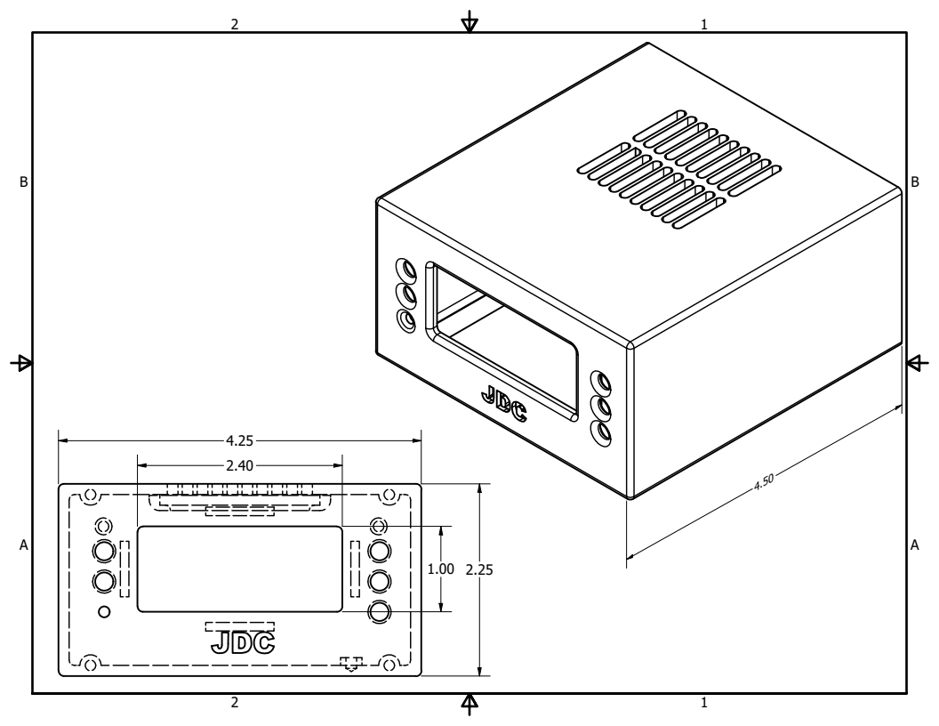
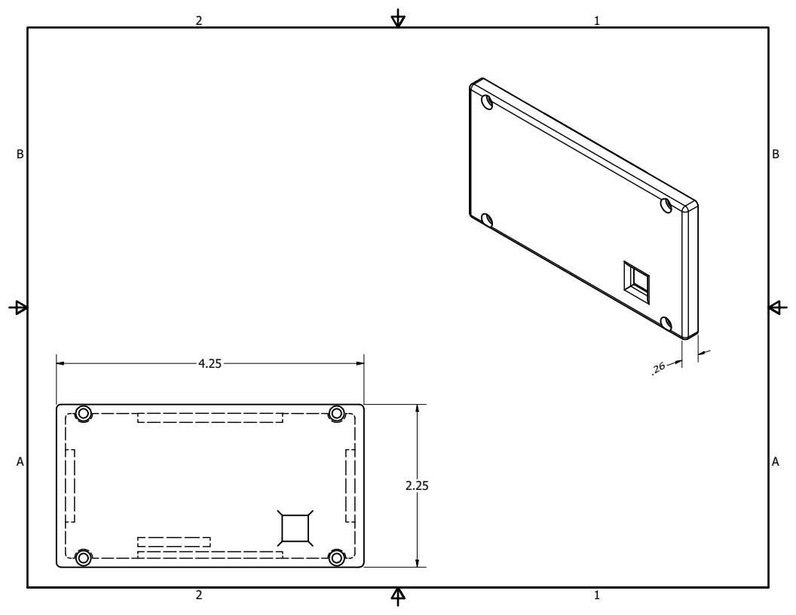
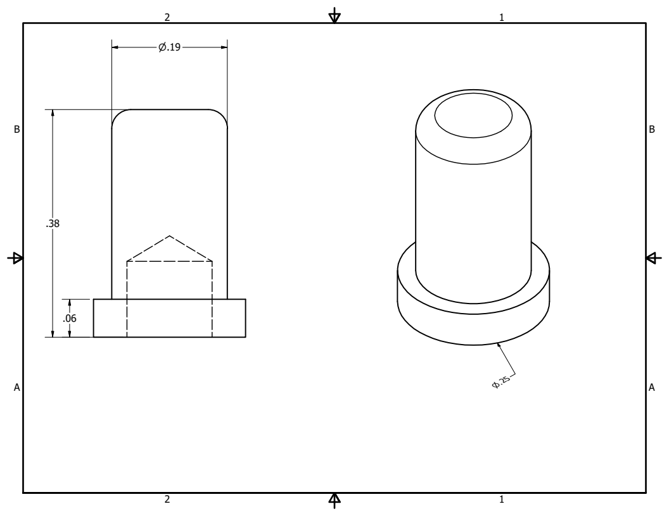

Code
The following pages contain the C code for the device. They are sideways for proper formatting.

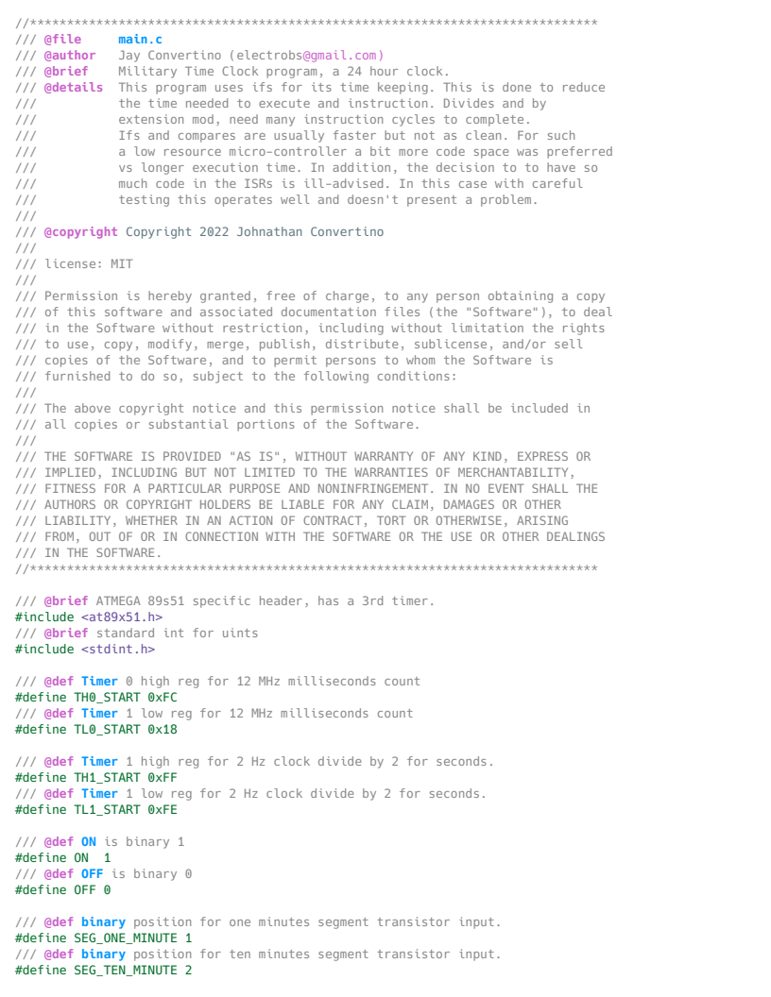
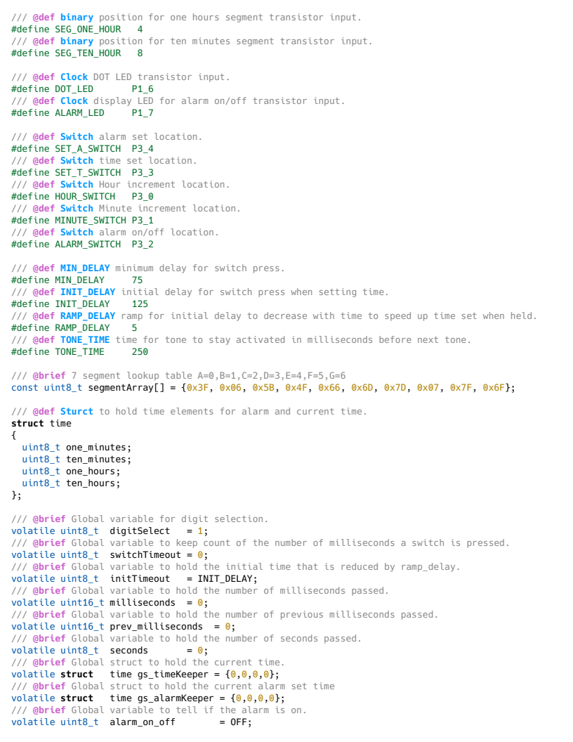
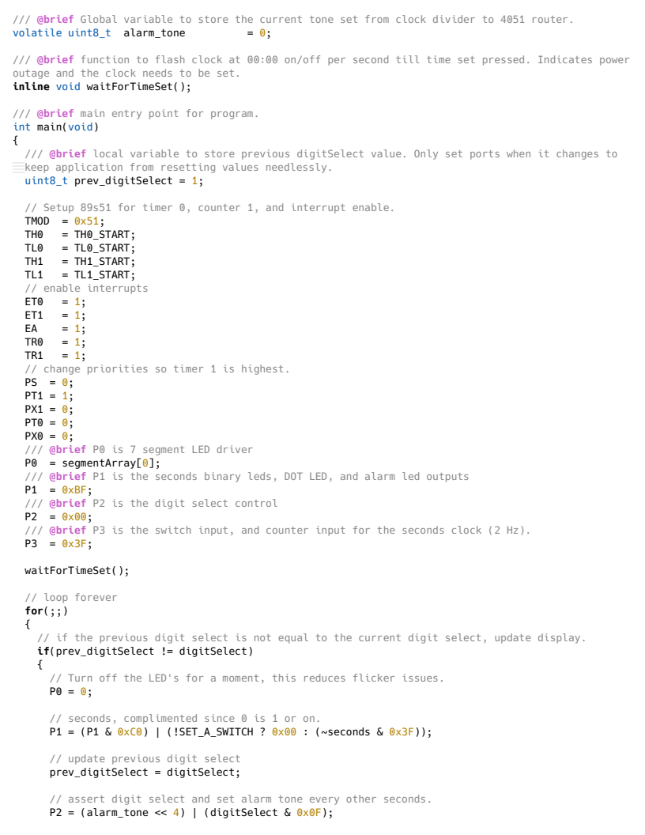
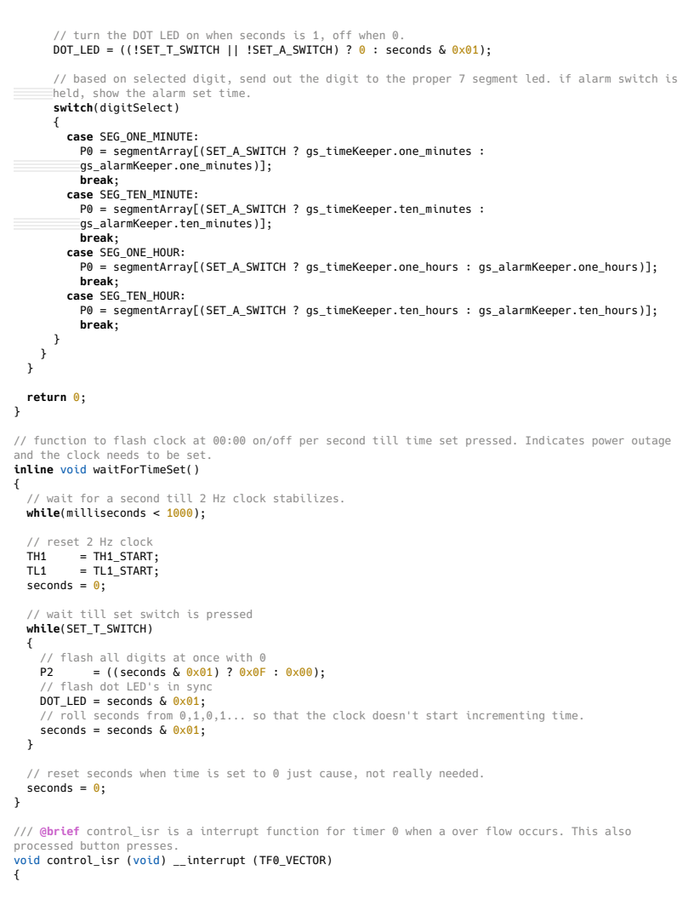
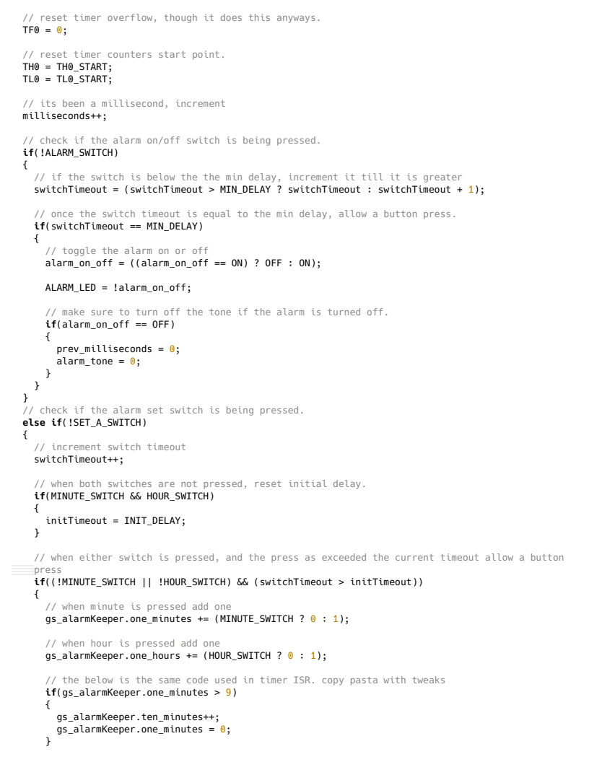
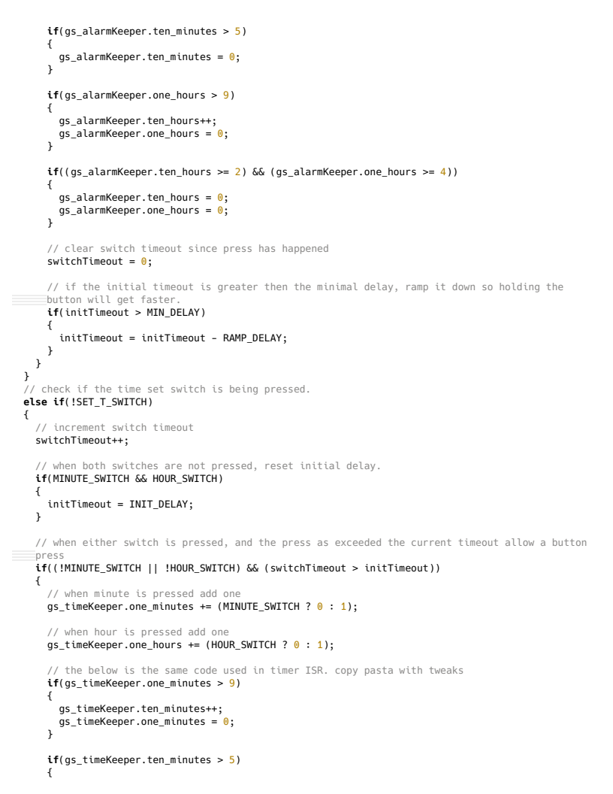
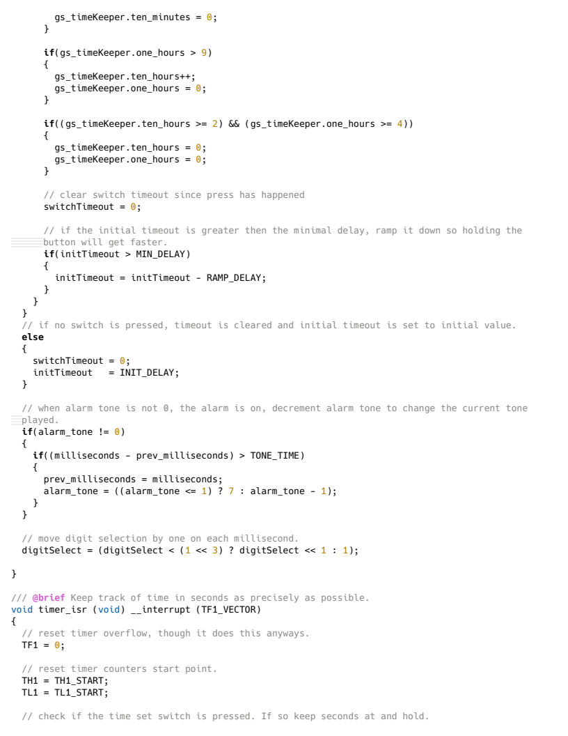
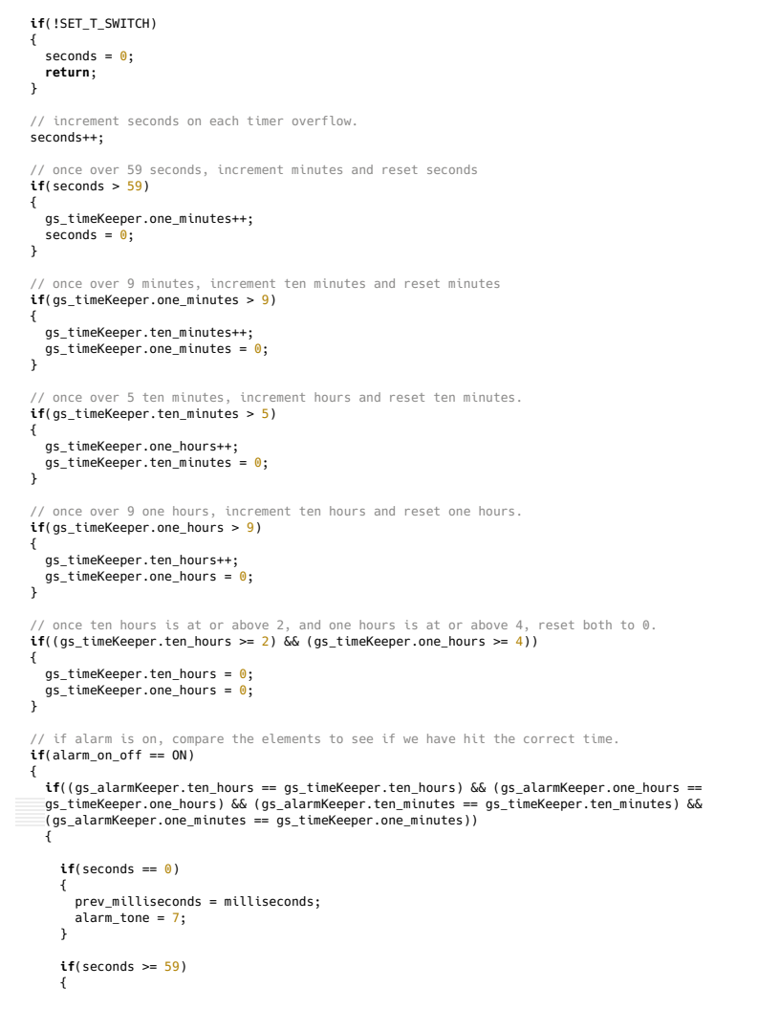

JDC
Military Time Alarm Clock
2022-12
v1.0.0

