**NAME : D.AJAY KUMAR**

**REGISTER NUMBER : 192211089**

**COURSE : CSA5752 FUNDAMENTALS OF COMPUTING**

**1)READING THE VALUE AND FIND IT’S SQUARE**

**SHELL PROGRAMMING :**

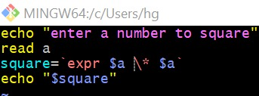

**OUTPUT:**

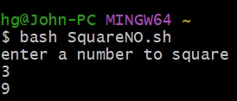

**2)FINDING BIGGEST AMONG THREE NUMBERS**

**SHELL PROGRAM :**

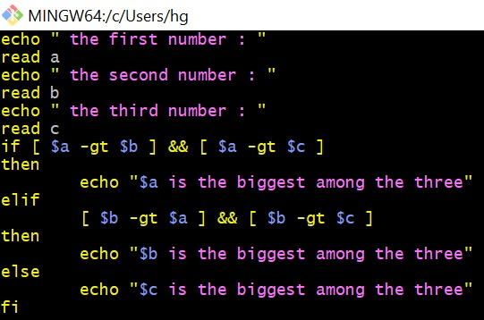

**OUTPUT :**

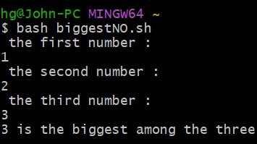

**3) FINDING LEAP YEAR**

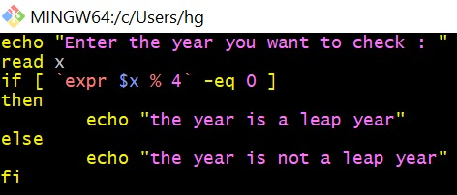

**OUTPUT :**

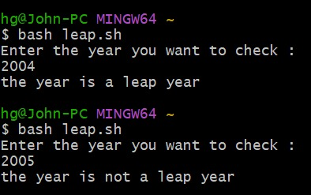

**4) CREATING A MARK LIST**

**SHELL PROGRAM :**

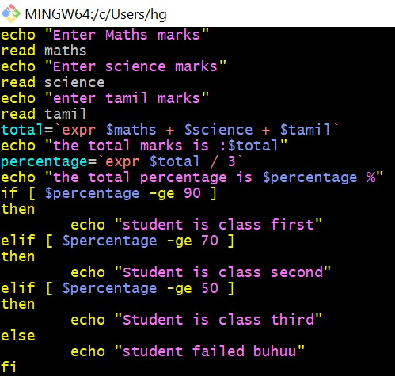

**OUTPUT:**

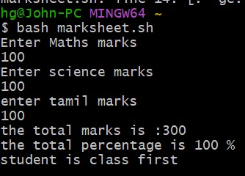

**5)ARITHMETIC OPERATIONS**

**SHELL PROGRAM :**

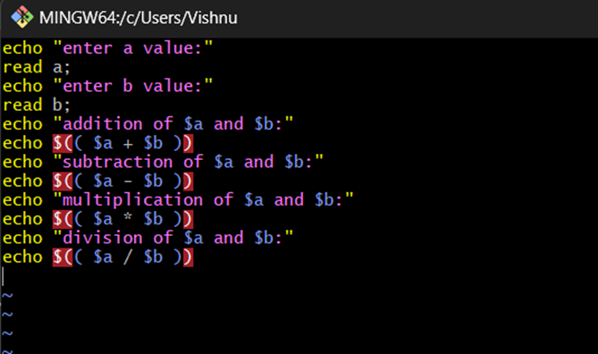

**OUTPUT:**

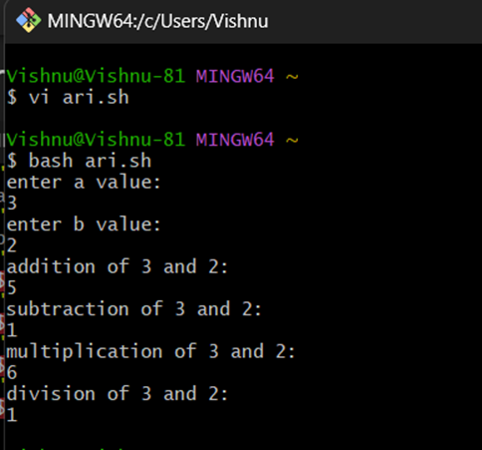

**6)PRINTING N NATURAL NUMBERS**

**SHELL PROGRAM :**

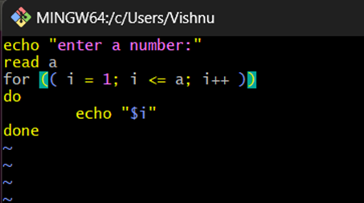

**OUTPUT :**

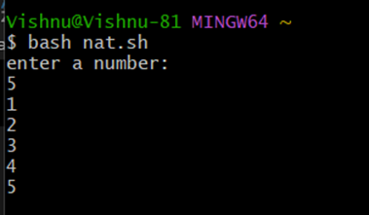

**7)PALINDROME OR NOT**

**SHELL PROGRAM :**

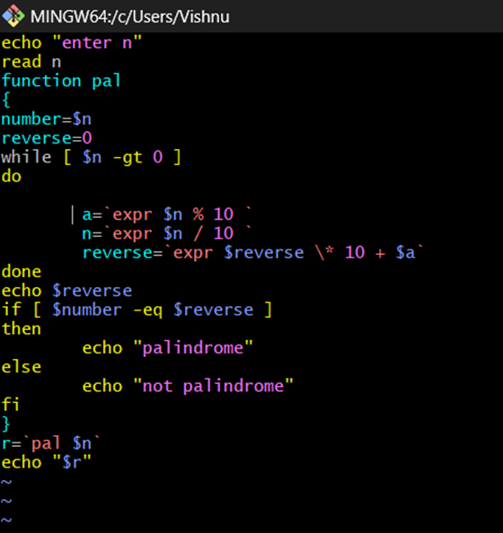

**OUTPUT :**

