**NAME:D.AJAY KUMAR**

**REGISTER NUMBER : 192211089**

**SLOT D : CCSA5752 FUNDAMENTALS OF COMPUTING**

1. **Generation of number series 1, 2, 3, 4,…..n**

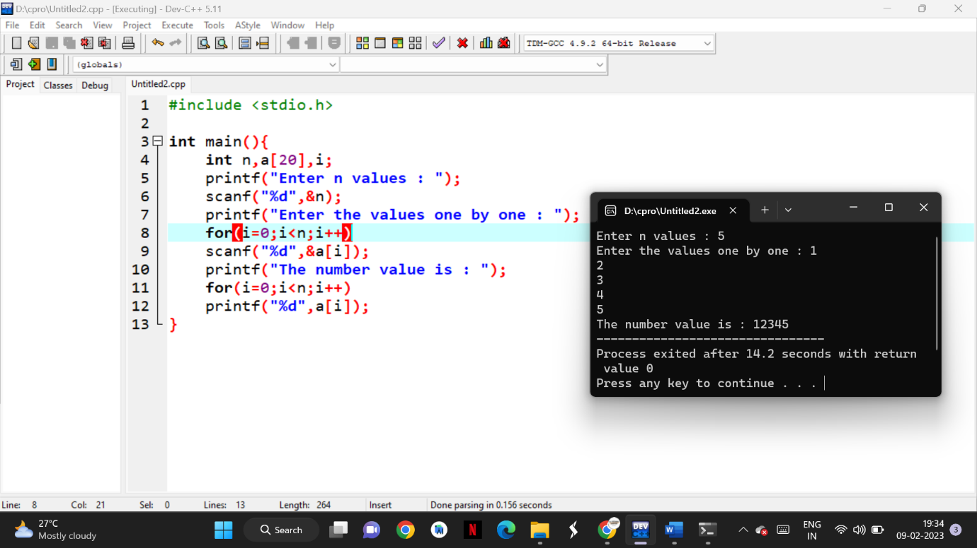

1. **Generation of even number series 2, 4, 6, …..n**

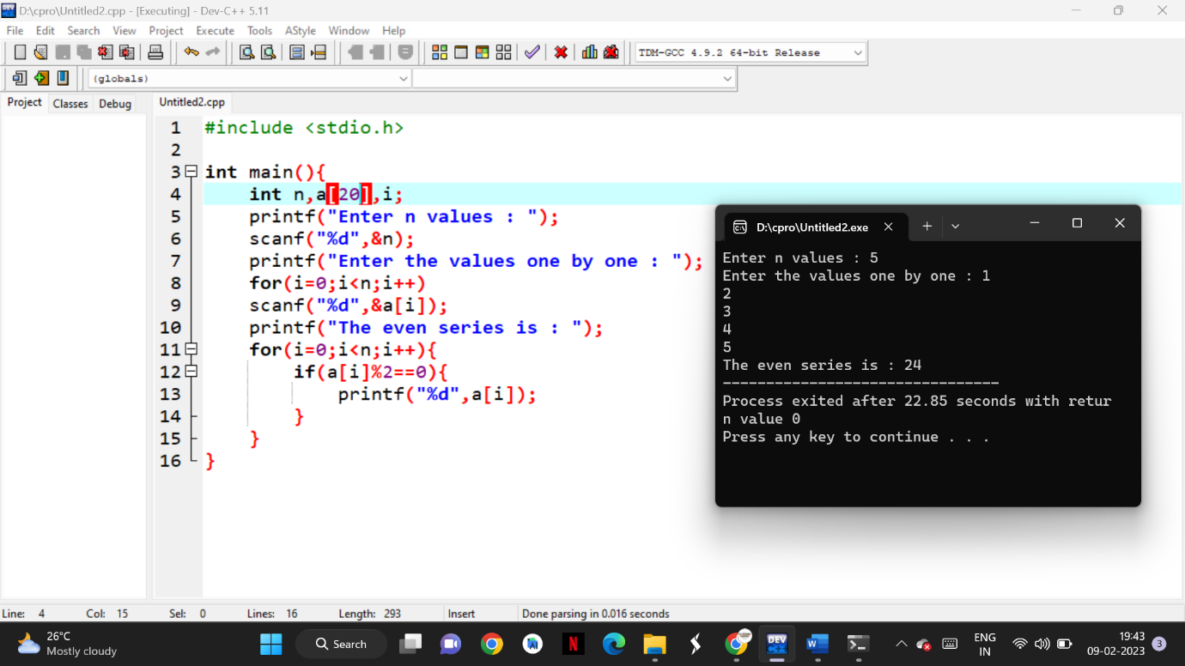

1. **Generation of ODD number series 1, 3, 5, …..n**

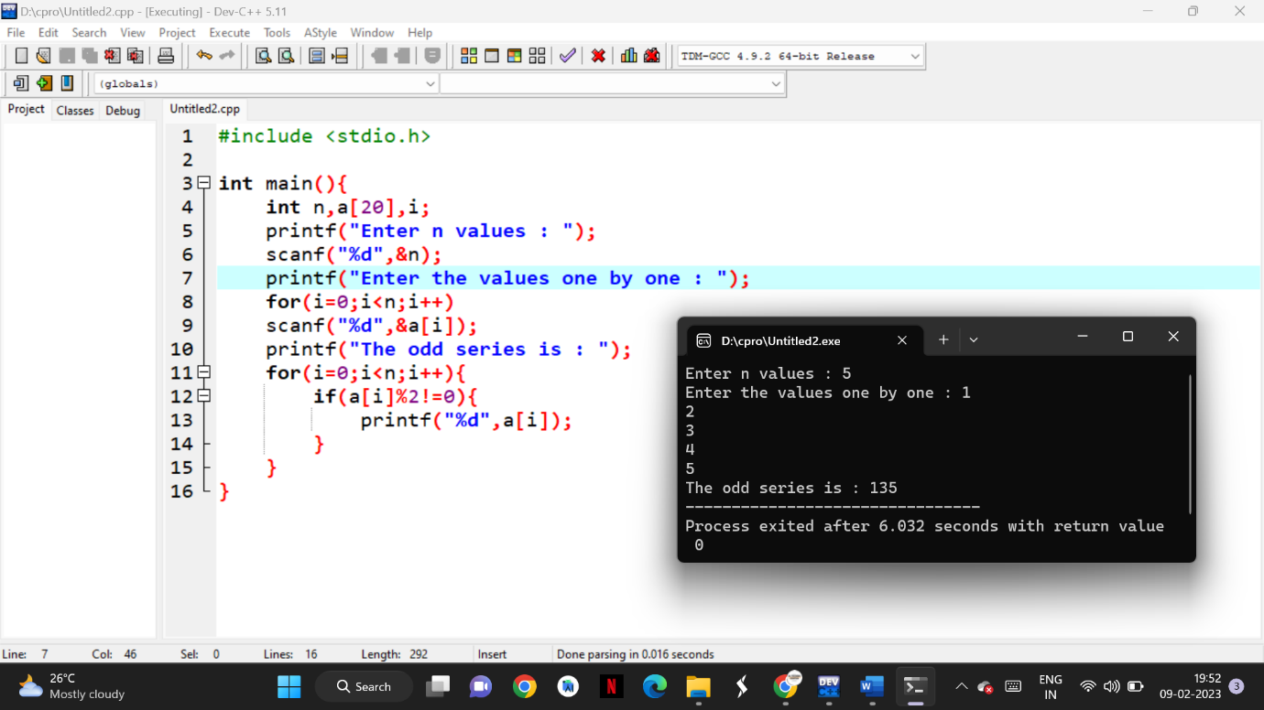

1. **Generation of Fibonacci series 0, 1, 1, 2, 3, 5, 8, …..n**

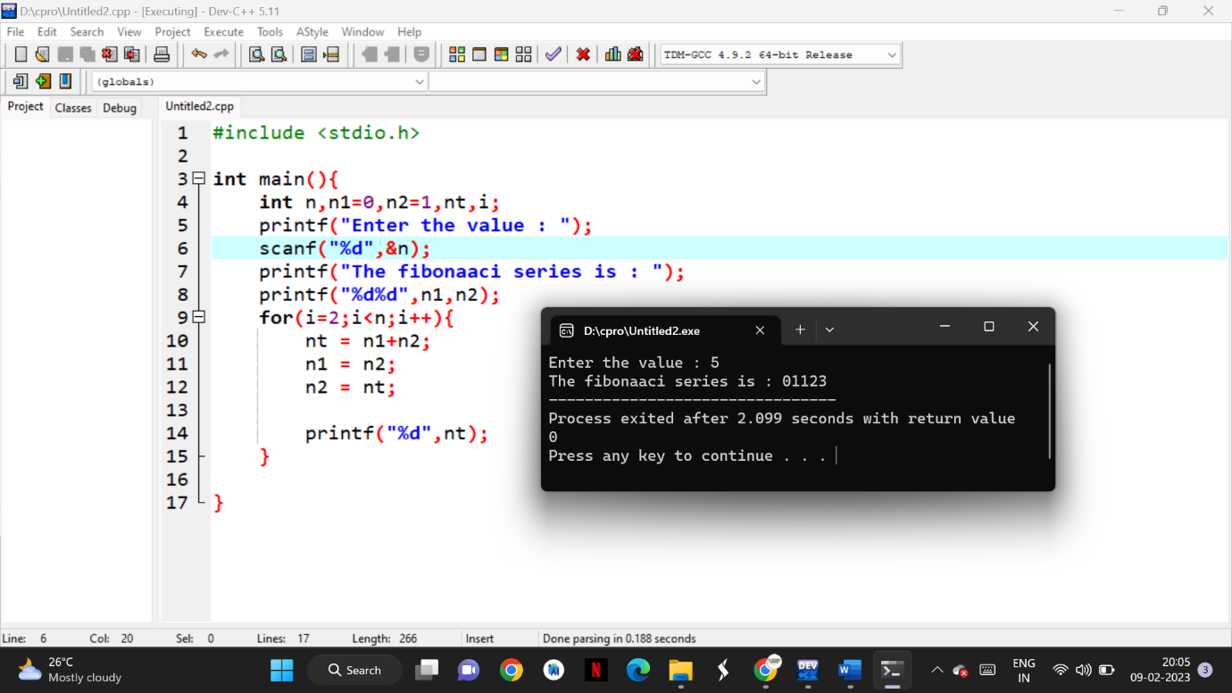

1. **Summing up series 1 + 2 + 3 + 4….. +n**

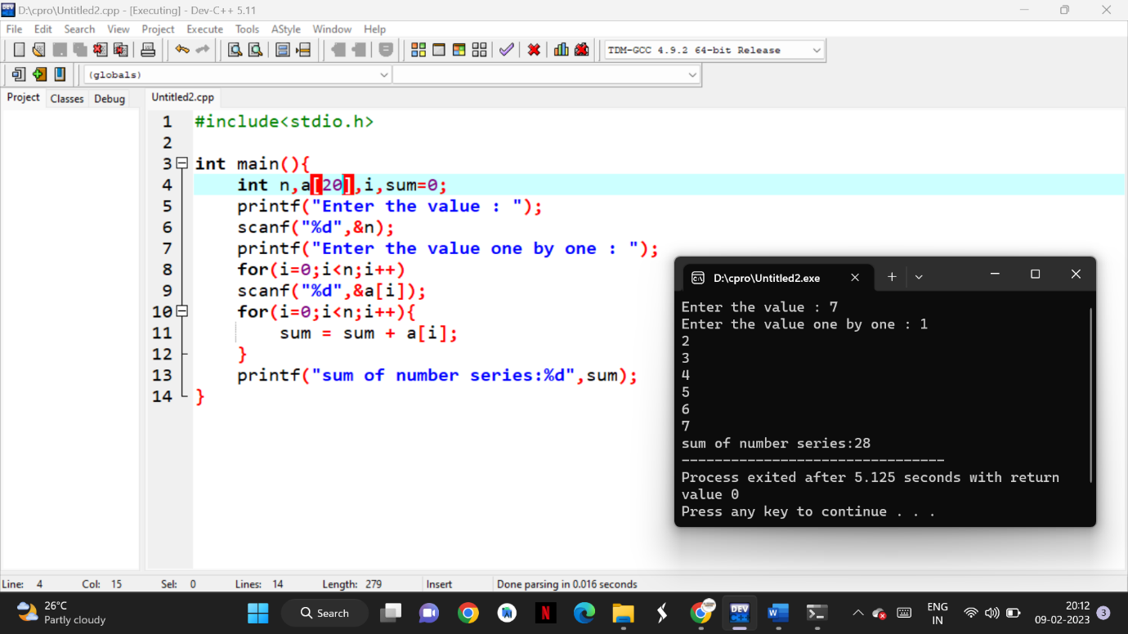

1. **Summing up Even Number series**

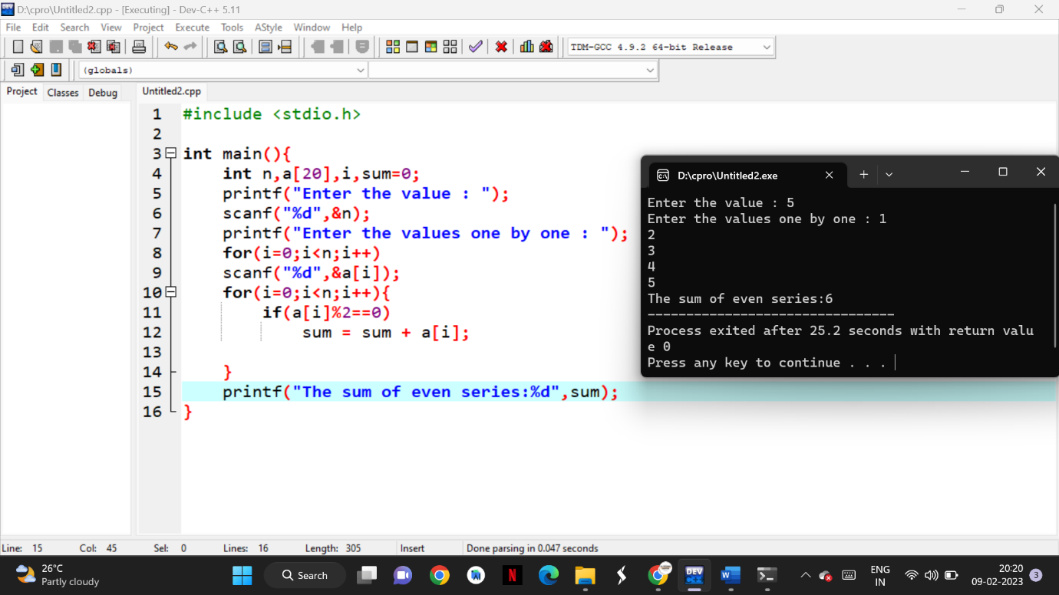

1. **Summing up cubes of n numbers**

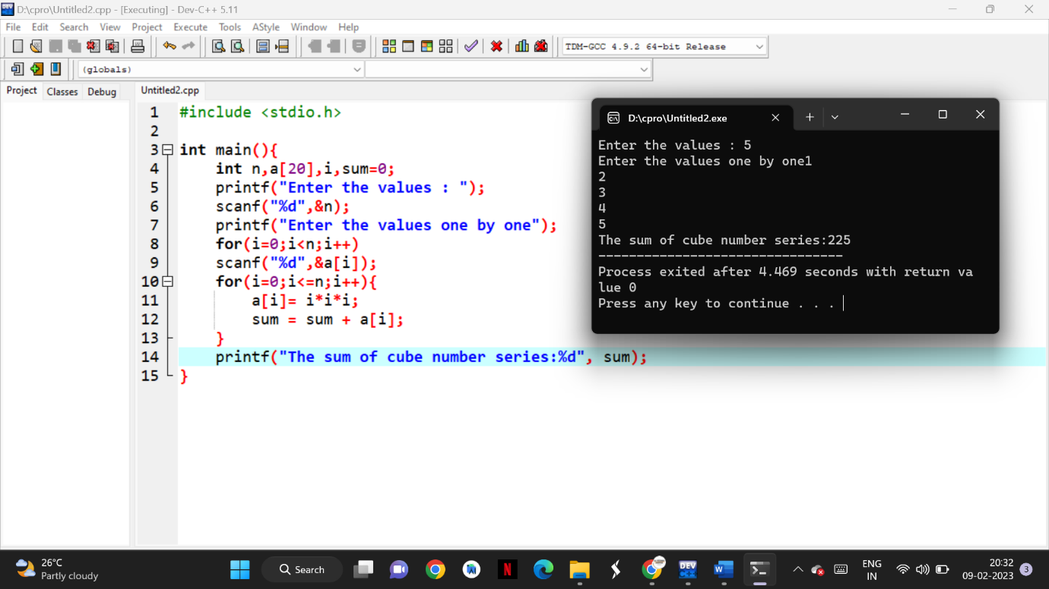

1. **Finding whether the given integer is odd or even**

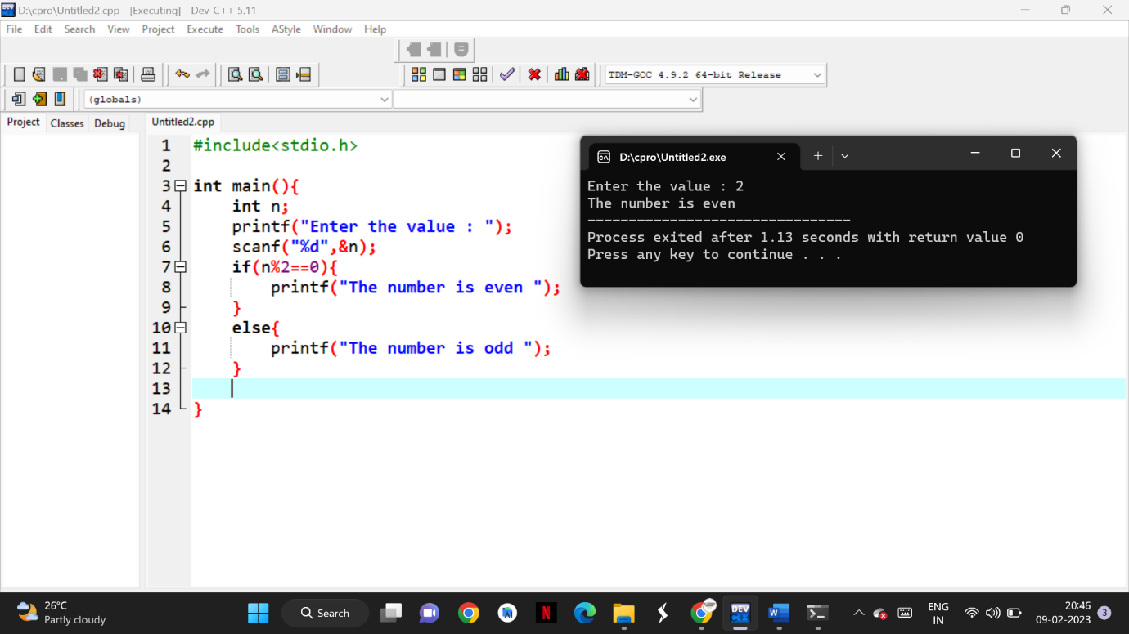

1. **Product series (Factorial of a given number)**

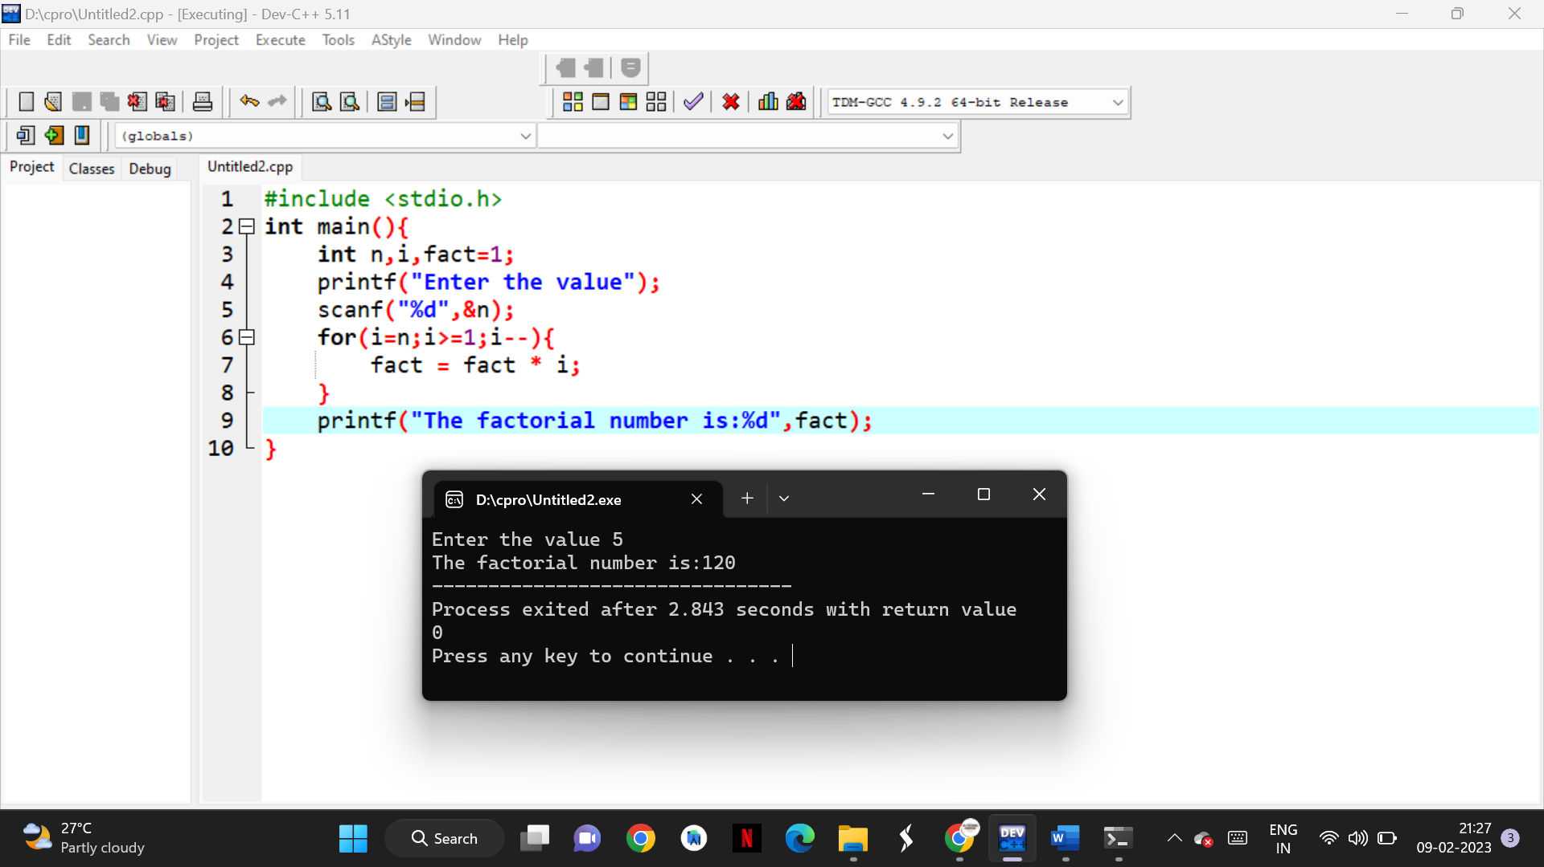

1. **Finding given number is Armstrong or not**

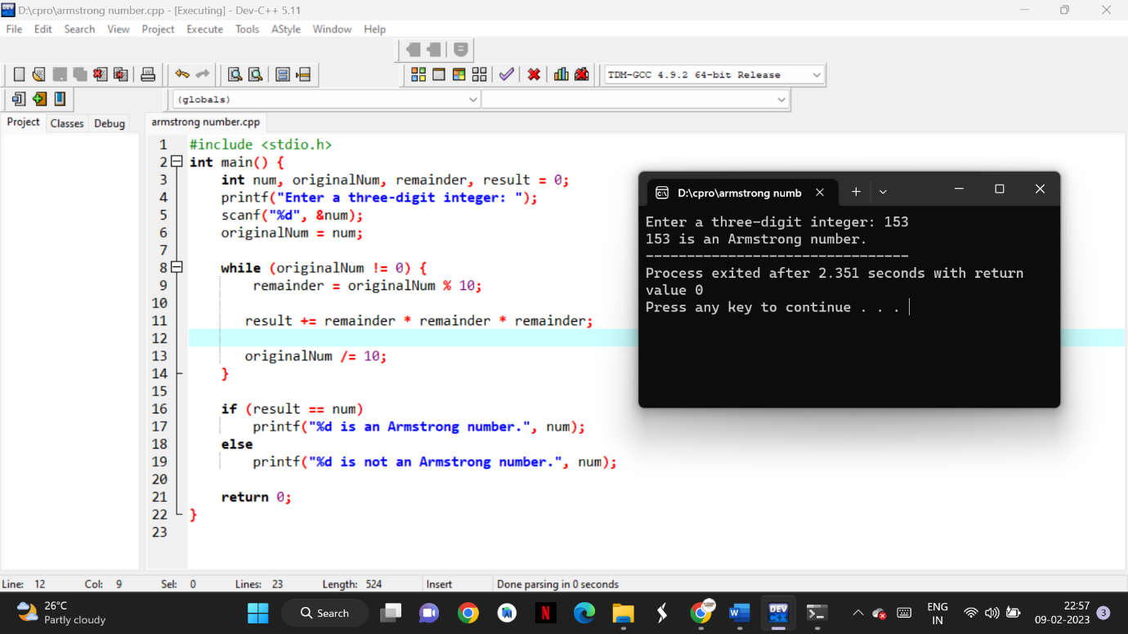

1. **Summing up any n numbers and finding average**

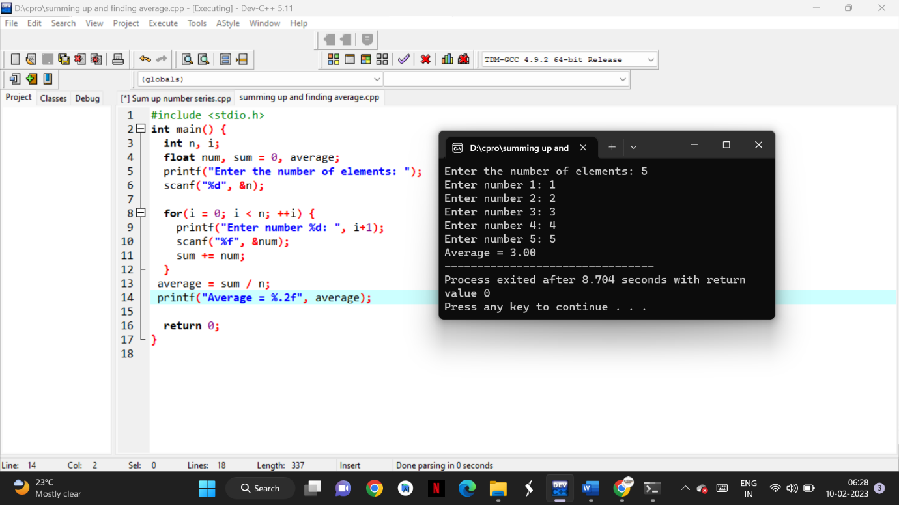

1. **Printing digits of an integer number**

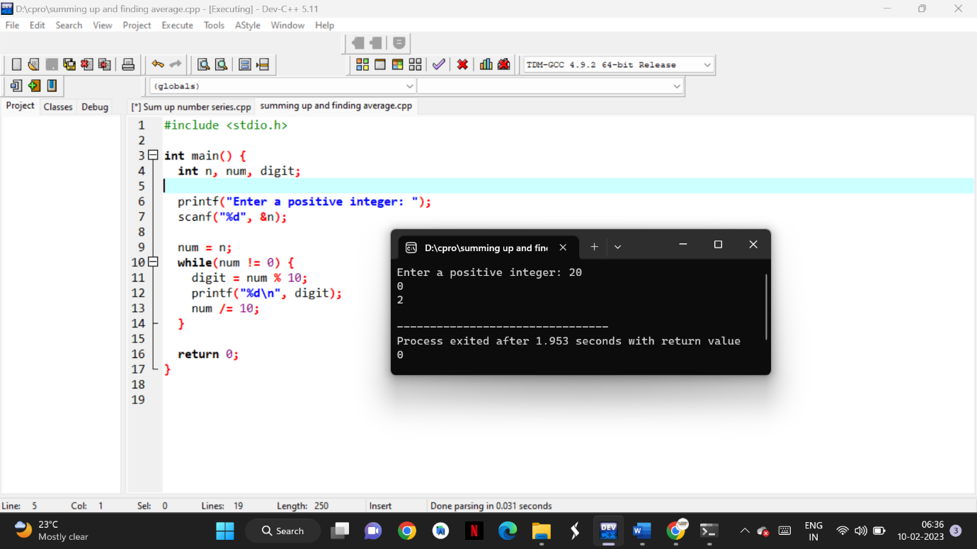

1. **Summing up the digits of an integer number**

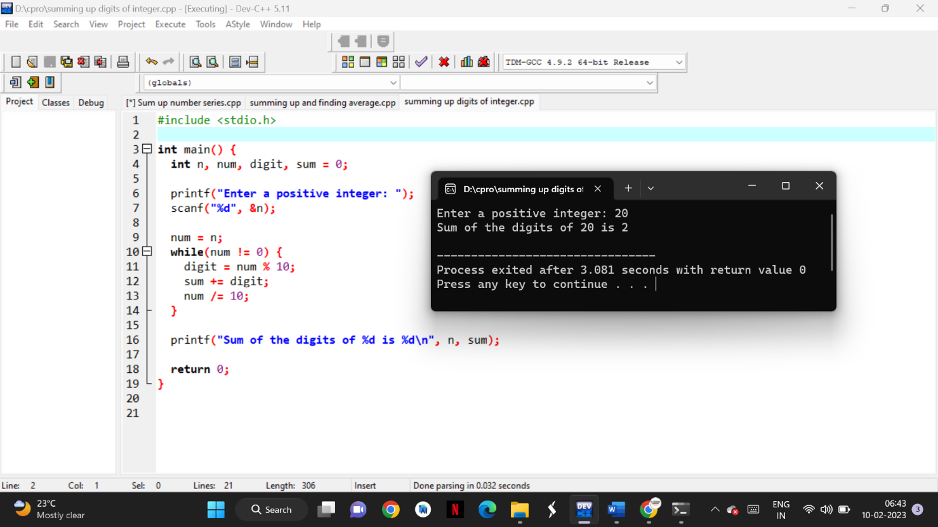

1. **Revering the digits of an integer number**

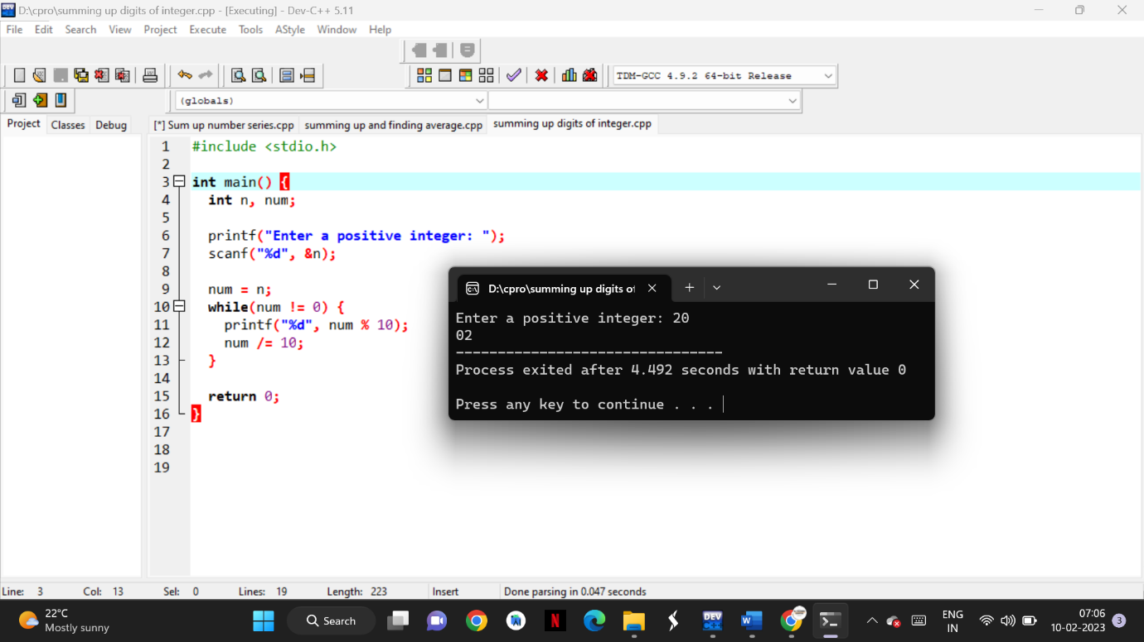

**15)** **Finding the given integer is positive or negative**

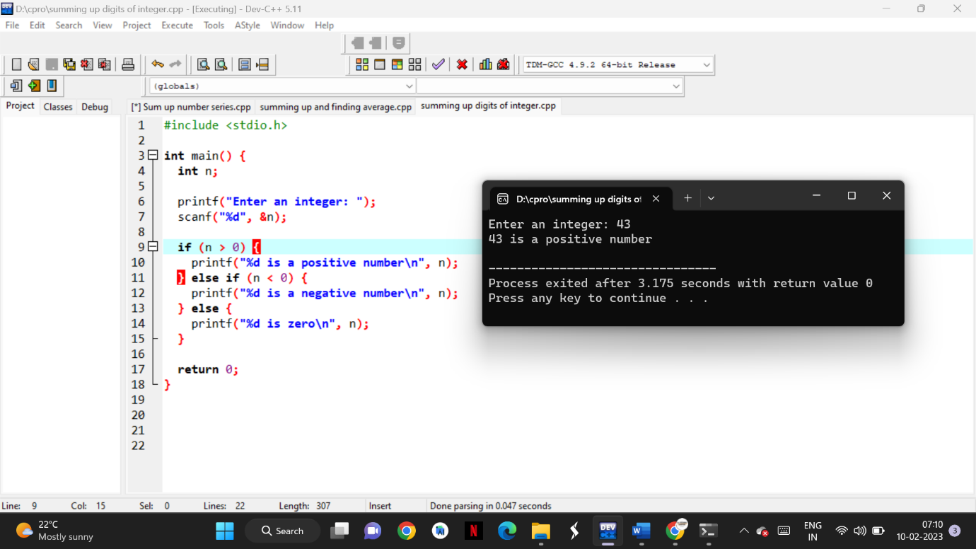

**16)Swapping two numbers with a temporary variable**

