eSearch Pro | TARILIO
User Guide
Contents
Welcome! 3
Installation & System Requirements 4
How to Install eSearch Pro or TARILIO 4
How to upgrade to a later version 4
Install eSearch Portable on a USB 3.x drive 5
New Install 5
Updating 5
Quick Start 6
Support Articles: 6
Index 7
File Explorer 7
Indexing Options 8
Filetype filter 8
Search Queries 9
Scrollable Word List 10
Search-as-you-type 10
Intelligent indexing 10
Use List option 11
Stemming & Synonym options 12
Soundex 13
Settings 14
Search Settings 14
Stemming 14
List Index Contents on empty query 14
Search as you type 14
Synonym Files 14
Results Settings 16
Viewer Settings 17
PDF Options 18
Geolocation in images 19
Audio & Video files 20
Data files 21
Source Code files 22
Index Settings 24
Stop words 24
Maximum word length 24
Maximum File Size 24
Case Sensitive 24
AI Mode 26
AI - Connecting to Custom API’s 27
Usage of AI Models 28
MCP Client 29
eSearch Portable – Forensics 30
eSearch Portable – Publishing 31
Plugins 32
Keyboard Shortcuts 35
User Translation 36
View menu 36
Language File Editor 36
Registration 37
eSearch Pro 37
Evaluation 37
TARILIO versions. 37
eSearch Lite 37
Support 38
Feedback 38
Error Log 38
Known Issues 39
Accessibility 40
Command Line options 40
Issue 38 41
Beta status July 2025: eSearch Pro is now open sourced and is free of charge for private, non-commercial use. TARILIO includes additional closed source code and is the brand for commercial use. 41

Welcome!
We hope you enjoy using eSearch Pro | TARILIO.

eSearch Pro combines advanced information retrieval with an integrated AI Mode that offers multiple connections to online Large Language Model (LLM) Provider APIs and/or locally installed LLMs and MCP Servers for enhanced productivity.

- Scrollable word list: Quickly discover vocabulary or spot typos in a document collection. Gain rapid insights into a case, project, or prior research. In AI Mode the word list displays question stems for AI-powered web search or assistance.
- Efficient search: Double-click on a word in the word list or select it and press Enter to insert it in the search bar to minimize typos.
Forward slash (/) shortcut puts the cursor in the search bar.

Voice input option:
AI Mode

- AND, OR, NOT buttons: For quick and foolproof entry of Boolean operators. Operators which you type are automatically uppercased!

- For Legal professionals: Use List of keyword search queries to share with others. For Early Case Assessment (ECA), case reviews, etc.
- Sort search results by filetype, title, size, chronologically, or automatically extracted meta data.
- Expand search with multilingual stemming and synonyms with pre-defined and user defined thesaurus files.

- Export timestamped search results & reports in XML, comma or tab separated formats, with selected metadata included.
- Viewer supports plain text with keyword highlighting, built-in PDF viewer, colour syntax highlighting and line numbers in source code. Tables for csv files. Images with geolocation on map. Player for web format audio & videos files.
- User Interface (UI) is User translatable. French and German supplied. Free Language File Editor.

- Dark mode/high contrast theme options for eye comfort. Horizontal or Vertical Viewer layout options.
- Portable version can be run from a USB drive with nothing installed on the host machine. Index and search files on the host machine for IT/investigative use, or create a portable library of projects, research, newsletters or more for your own use, or publish search-only copies with no expiry.

Installation & System Requirements
NOTICE
eSearch Pro and eSearch Portable are open-sourced and free of charge for private, non-commercial use. TARILIO versions include closed source code and are for commercial use.

They are self-contained x64-bit .NET 8.0 applications. Install on any Windows 10 or 11 machine without worrying about the .NET runtime version installed on that machine. The .NET runtimes and all necessary libraries within the application itself to ensure it runs smoothly with the exact version it was tested with.

How to Install eSearch Pro or TARILIO
- Download the esearch_installer.zip file, this consists of a zipped Microsoft Software Installer (.msi) file.
- Extract the file, right-click and choose Extract All...
- Double-click on the .msi file and follow the instructions.
The default install path is under the Program Files folder. User settings are stored in the Users\Username\AppData\Roaming folder.
- TARILIO versions: Enter your serial number on the Help > About window.
IT departments can disable indexing if required by adding an -s command-line parameter to the Windows shortcut. (Note: this is not the same as the non-expiry Portable – Search-Only version).
Disk Space required: 2Gb minimum. Additional space is required for the indexes.
Unlike some search products that simply index everything on the installed drive, you can select specific folders and files to include in an index. You can also quickly select by file type or a category of file types using a tree view control – see Filetype Filter.

How to upgrade to a later version
1. In Windows go to Add or Remove programs, navigate to eSearch Pro and choose to uninstall. It will not remove your indexes in the Desktop version. If you are upgrading the Portable version, see Updating.
2. Install the latest version as above.
3. From the Index menu, select Manage Indexes... Press Rebuild for each index to ensure the latest file parsers are being used.

Install eSearch Portable on a USB 3.x drive
See also eSearch Portable - Forensics and eSearch Portable - Publishing
If an older eSearch Portable version is on the USB drive, see UPDATING below:

New Install
- Download the eSearchPortable.zip file.
- Right-click on the file and choose Extract All...
- Click on Browse... select the USB drive.
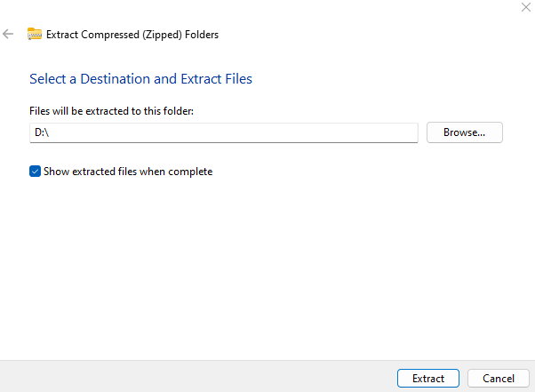
- Click Extract.

.

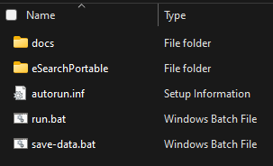
- Click on run.bat to start eSearch Portable.
- Enter your serial number in the Help > About window.
- To index and search files on the USB drive, create a “docs” folder (and sub-folders if needed) and keeps all the files under there.

Updating
The Portable version stores user settings in the ProgramData folder within the eSearchPortable directory.
- Before carrying out the instructions under NEW INSTALL, click on save-data.bat, this will rename the ProgramData folder on the USB to ProgramDataOLD.
- Next, carry out the NEW INSTALL steps, select overwrite existing files when prompted.
- Click on run.bat to start eSearch Portable as before. It will automatically rename the Program Data folder to ProgramDataNEW and rename ProgramDataOLD to ProgramData if it exists.

Quick Start
Go straight to the View menu, choose your language, theme and layout.

Need to translate the UI? See: Translation
eSearch uses indexes to locate information fast!

Go to the Index menu. choose New…
Enter a meaningful name for the index
Add Files  or Folders 
For more information see: Index
Support Articles:
https://searchcloudone.com/esearch-support-articles/
You’re now ready to search!
See: Search Queries

If you later edit, add or remove documents, go to Index menu > Manage Indexes… to Update, Rebuild, Rename, remove files from the index, or Delete the index.
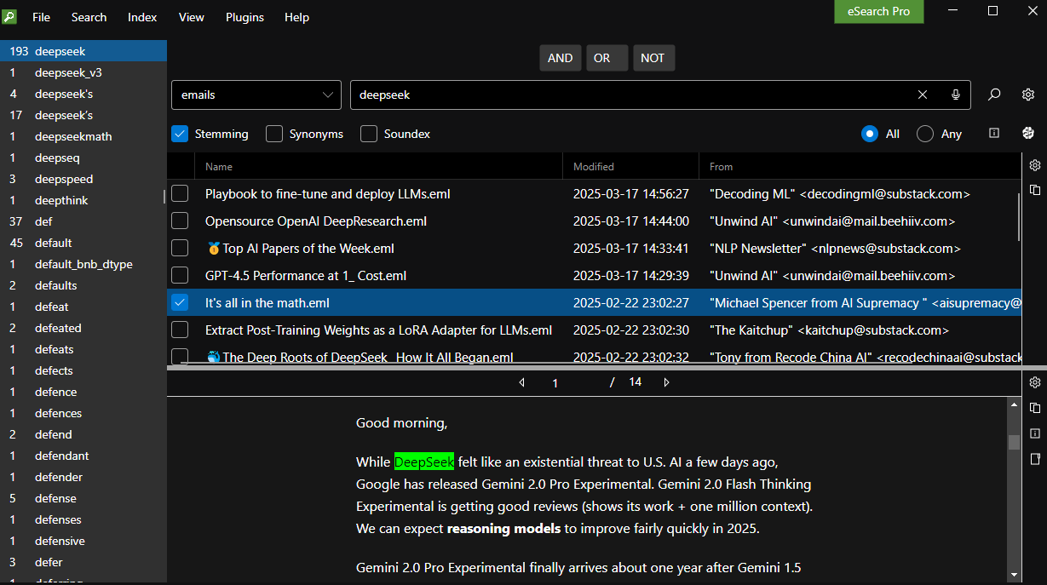

Index
Enter a name for the index, e.g. Closed-Cases, Recipes-Vegetarian, Projects-old.
We recommend maintaining indexes small and specific. Separate archived or infrequently changed material from files that are frequently edited. This approach simplifies updates and enhances overall manageability.

Choose Folder or File, you can add multiple files and multiple folders in the same index and apply filetype filters as needed. You should also check that Settings… are appropriate.

File Explorer

To select multiple files in a range, select the first file, hold down the Shift key, and then press the Down arrow key to select the rows. To select another range, hold down the Ctrl key and use the Down arrow key to skip unwanted rows. Then, press Shift + Ctrl + Down arrow key to select additional rows.

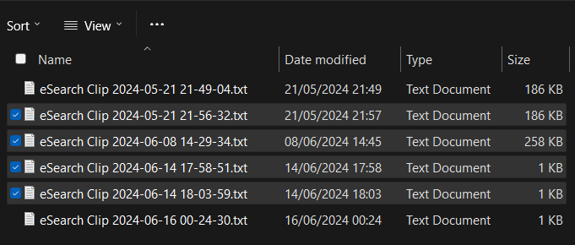

To select multiple files, hold down the Ctrl key and use the Down arrow key to skip unwanted rows. Select rows by clicking the checkbox with the mouse or by pressing the spacebar.
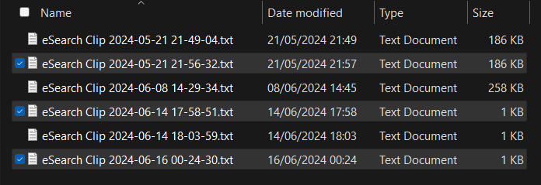

Indexing Options

Filetype filter
(Pro version. Lite version defaults to Include All)
When creating or updating an index you can select which file types to include. This is useful when indexing a Folder that may have nested folders containing filetypes that are not of interest and is quicker than having to select Files to index.
You can select all or parts of a category or individual filetypes from the tree view:
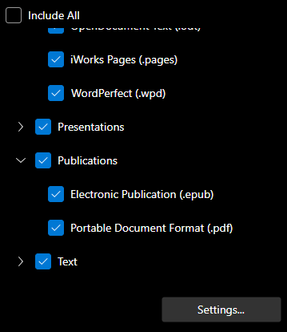

If Include All is selected it will only exclude a list of known executable extensions. It will attempt to parse every unrecognised filetype as well as all the filetypes in the tree view.
If you need to index a Folder with unknown filetypes, especially if the file(s) are large, we recommend a trial index of a single File to check it will be handled.

Click on Settings… for more options that may be needed.

Search Queries
By default, eSearch Pro will search-as-you-type and list all the documents in the selected index without having to enter a search query. (You can change the default behaviour from Search settings).
Enter a search query to limit the results list to just the files of interest. Search queries can just be a list of keywords like dog hound pooch (DON’T separate with commas or other characters).
Choose ALL if you want the words joined by AND, this will narrow your search the more words you add; remove words if you get no results. Word order does not matter.
Choosing ANY is a last resort for a broad search.
For more precise searching use Boolean AND OR NOT operators.
 | Example Query | Will find files containing:
Boolean | dog AND cat | both words dog and cat.
Boolean | dog OR cat | dog or cat or both words.
Boolean | dog NOT cat | dog and not cat.
Proximity | “cat mouse”~10 | mouse within 10 words of cat.
Phrase | "dog kennel" | the exact phrase 'dog kennel'.
Wildcards  (Do NOT use at the start of a word.) | dog* | dogma, doggy, dogfish, etc.  (* replaces several characters)
Wildcards  (Do NOT use at the start of a word.) | moderni?e, | modernize or modernise  (? replaces a single character)
Fuzzy | word~  500~ | similar words or numbers.
Fields | Some files may contain fields you can search like Fieldname:  e.g.  Content-Length:500~ | File size of approximately 500 bytes.
Regular Expressions | /[mh]otel/ | either motel or hotel
Note: Synonyms includes a Numeric Pattern file that has a regular expression for finding IPv4 addresses.

Scrollable Word List

Search-as-you-type
As you type a word in the search query bar, it will ‘search as you type’. At the same time, the word list will scroll to the matching word. An alternative to typing, especially if you are unfamiliar with the content of the index, is to scroll through the word list and double-click on a word of interest. It will then be entered as a search query.

Intelligent indexing
The word list keeps numbers and letters separated by punctuation together. For example, complete IP addresses and sums of money appear in the word list unbroken, as do possessive apostrophes and contractions.
Email addresses are split at the “@” symbol, so domains and email aliases appear separately in the word list. You can search for all users at contoso.com by entering that as the search query (do NOT use a wildcard). Alternatively, you can enter an alias like jon.doe to find all emails with that alias at any domain, such as jon.doe@gmail.com or jon.doe@contoso.com. To search for the exact email, use both the alias and domain in quotes with the “@” sign, e.g., “jon.doe@contoso.com”.
eSearch Pro includes a useful regular expression in the pre-defined synonyms list for searching for IPv4 addresses. To use it, go to Search Settings and select the Sample Numeric Patterns, select Synonyms and just enter “IPV4” as the search query.
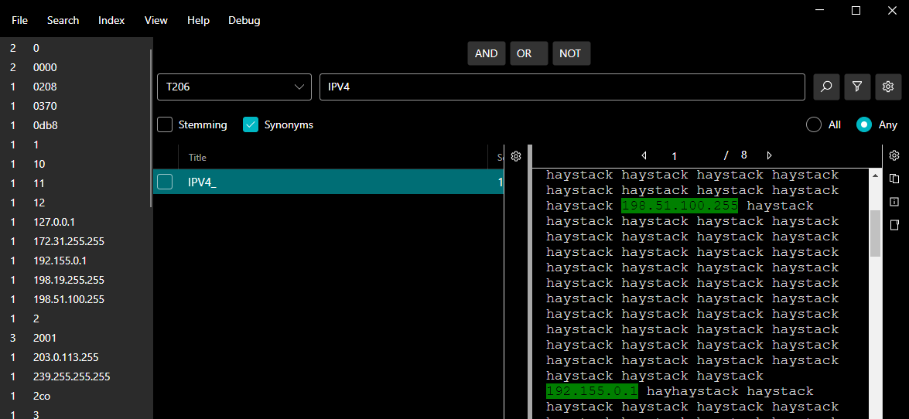
The image above shows IPV4 search query used to find and highlight all IPv4 addresses.

Use List option
Intended for using a ‘Keyword List’ during eDiscovery (eDisclosure) by case reviewers. To create a list the first step is to sample the dataset.
1) Create an index of a sample of the data and use the fully scrollable word list to quickly identify the vocabulary, jargon & abbreviations used.

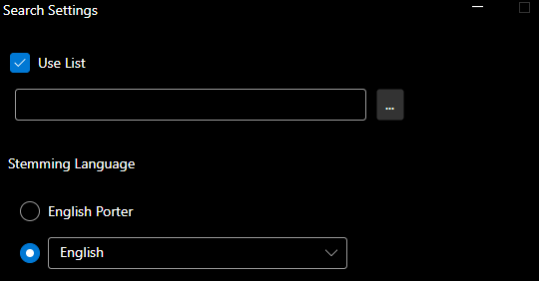
2) Create a file in NotePad or similar text editor and save it in Unicode format. The file should contain a list of keywords (words that you identified as important from the word list) or valid search queries, one per line. Leave no blank lines. Save it in your Documents folder or with your case files, we recommend the filename should have a timestamp and suitable file name e.g. Case479_2024-04-01.
3) Open the Search Settings window and check the Use List checkbox.


4) Click on the navigation button and open the file you created above. Click OK. The search query will appear in the search bar.
5) Select the index and press search:
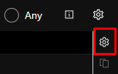
You can expand the search using stemming or synonyms to discover additional responsive documents.
6) Choose suitable columns from Results Settings:

7) Click on column headers in the results table to sort as needed.
8) Check the checkbox next to any row to select for export by pressing the space bar.
- Go to the File Menu and select Export Search Results. This allows you
to choose which results and columns to export in a timestamped file in .xml, comma, or tab-separated formats for import into Excel or other software for further review or sharing with others.

Stemming & Synonym options

Check either of these to expand a search.
Stemming
Stemming will expand a search term such as “apply” using different word endings such as applied, applies, applying.
You need to select the correct language from Search Settings.

There is a choice of English Porter Stemming or stemming in English or 30 other languages. A vocabulary file for evaluating the Porter Stemmer is available from here: https://tartarus.org/martin/PorterStemmer/

Note: when using the Case Sensitive index option, Stemming should be deselected. If Stemming in eSearch Pro is selected it will expand a search by making it case-insensitive as well by using different word endings.

Synonyms
Synonyms will expand a search with user-defined or the supplied pre-defined synonym files in several languages.
You need to select one or more of either type from Search Settings.

Soundex
If you are unsure of the spelling of a person’s name, use the Soundex option to expand the search to similar sounding names.
Soundex matches names that sound similar but have different spellings. It was used by the National Archives to index the U.S. censuses. https://www.archives.gov/research/census/soundex
A limitation of the Soundex algorithm is that words must start with the same letter to be considered a match. For instance, a search for “Smith” will also find “Smithe” and “Smythe”, and a search for “Philipp” will find “Phillipe” or “Philip”, but it will not find “Filip” because it begins with a different letter.
If you have also selected Stemming, it will find “Phillips”, “Philips”, etc. which may or not be desirable depending on the purpose of your search.
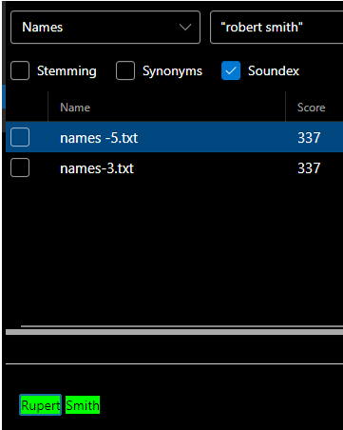
Example shows a search for “Robert Smith”, with Soundex option selected will also find “Rupert Smith”.

Names-3: Robert Smith

Soundex is based on English pronunciation, which can lead to inaccuracies with some European names. For instance, the French name ‘Roux’ has a silent ‘x’. Although ‘Roux’ and ‘Rue’ are pronounced the same, they receive different Soundex codes: R000 and R200, respectively.
https://en.wikipedia.org/wiki/Soundex

Settings

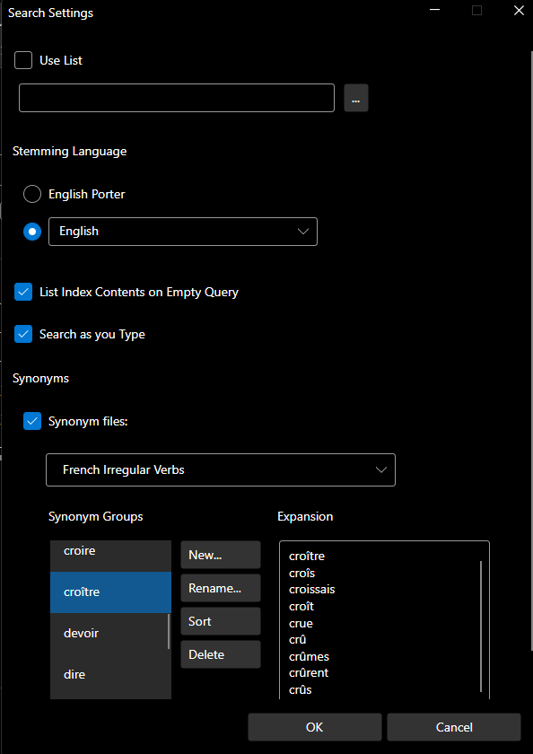
Search Settings

Use List
see separate section.
Stemming
Stemming Language should match the language of your search queries.

List Index Contents on empty query
The default setting is on. Turn it off if you have many large files in the index, as it can make searching sluggish.

Search as you type
The default setting in on.

Synonym Files
Pre-defined synonym files are available in multiple languages. You can also select 1, 2, or 3 from the Synonym Files list to add your own user-defined synonym groups.
In addition to synonyms, you can include related or equivalent words or phrases in other languages. Regular expressions are supported as well. For example, the sample numeric patterns file includes a regular expression to find IPv4 addresses.
You can select multiple synonym files. For instance, if you are searching through a mix of English and Spanish texts, you might want to select the English irregular verbs and nouns, as well as the Spanish irregular nouns and verbs. Additionally, you can add your own subject-specific synonym group.
Danish irregular nouns  Danish irregular verbs  Dutch irregular nouns  Dutch irregular verbs  English irregular nouns  English irregular verbs  French irregular verbs  Italian irregular verbs  Norwegian irregular nouns  Norwegian irregular verbs  Sample colours  Sample currencies  Sample days  Sample fashion  Sample geographic  Sample Jours de la semaine français  Sample legal  Sample medical | Sample months  Sample names cross lingual  Sample names genealogy  Sample names political  Sample names Russian female  Sample names Russian male  Sample numbers  Sample numeric patterns  Sample Prenoms Francais Masculins  Sample trade  Sample Unregelmäßige Deutsche Verben  Sample Verbe Irrégulier Français  Sample Wochentage Deutsch  Spanish irregular verbs  Swedish irregular nouns  Swedish irregular verbs

Note: the sample numeric patterns file contains regular expressions for IP addresses and credit-cards. The IPv6 example will not currently work with eSearch Pro indexes because the colon (:) character is treated as a space with no option to change it.
The Amex, Visa and Diners card regular expressions may work; however, they are not foolproof. They might detect patterns that are not credit card numbers or miss valid card numbers, as there is no checksum validation.

Results Settings
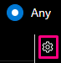

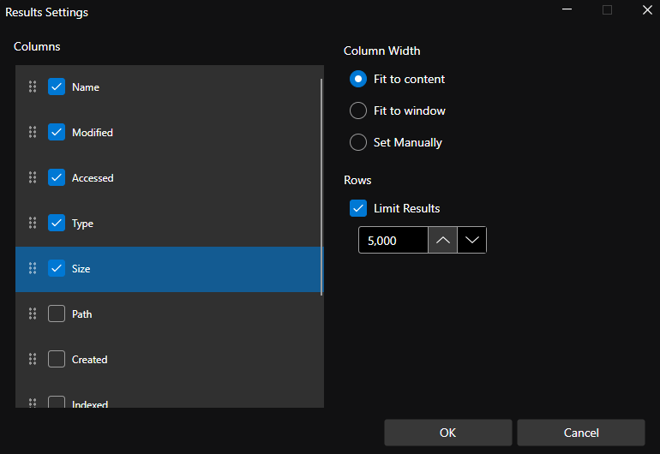
Columns
The list includes metadata automatically collected from the files in your current index. For example, if emails are included, it may show ‘To’, ‘From’, and ‘Subject’. If images are included, it may show geolocation, DateTime, and camera details of a photo.
Drag and drop columns to reorder them. Press OK to save the settings and close the window. Unselected columns will fall to the bottom after the window is closed.
Sort results by any column by clicking on the column header in the results list
Column Width
This is remembered if you choose ‘Set Manually’.

Rows
You can set the number of rows to display in the results table.
5000 is the maximum, but you may prefer to set to a lower number for a quicker response.

Viewer Settings
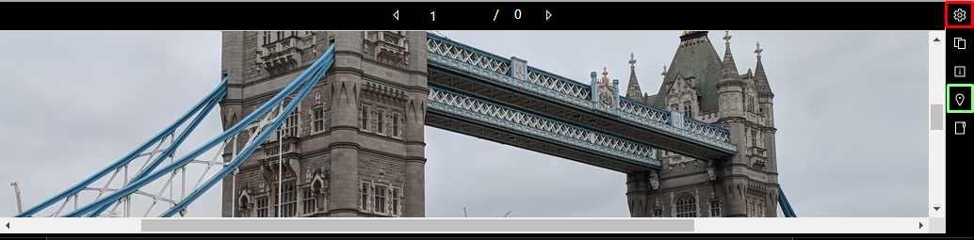
Viewer Settings
Map Pin

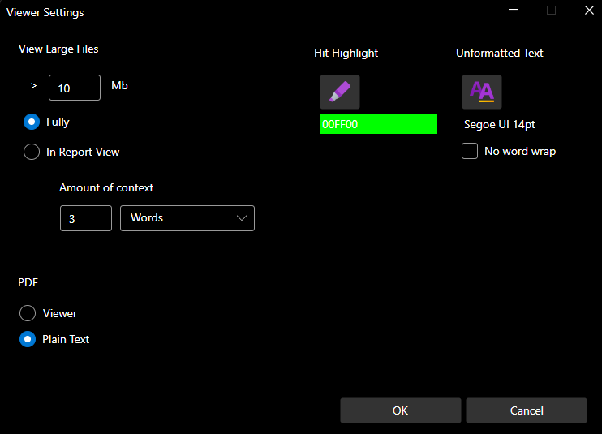
The Map Pin button is a Pro version feature, it is displayed when images with geolocation metadata are viewed.
View Large File: Large files may be very slow to open in the viewer, choose Report View to quickly show only keywords in context (KWIC).
You can select the colour of the highlighted words or set the size and font of the text in the Plain Text view.

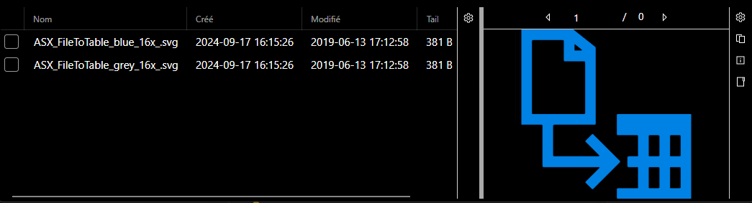
Small images may be better viewed in horizontal mode to increase size.
Change the layout in the View menu from Vertical to Horizontal.

PDF: See PDF Options.

PDF Options
You can view as text with hits highlighted in your choice of colour or use the built-in PDF viewer as shown below.
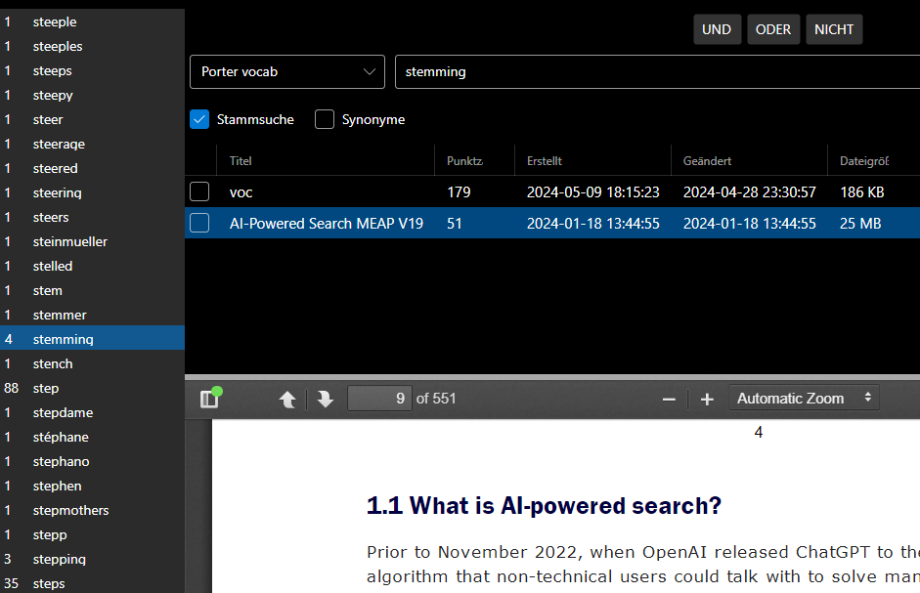
Built in PDF Viewer.
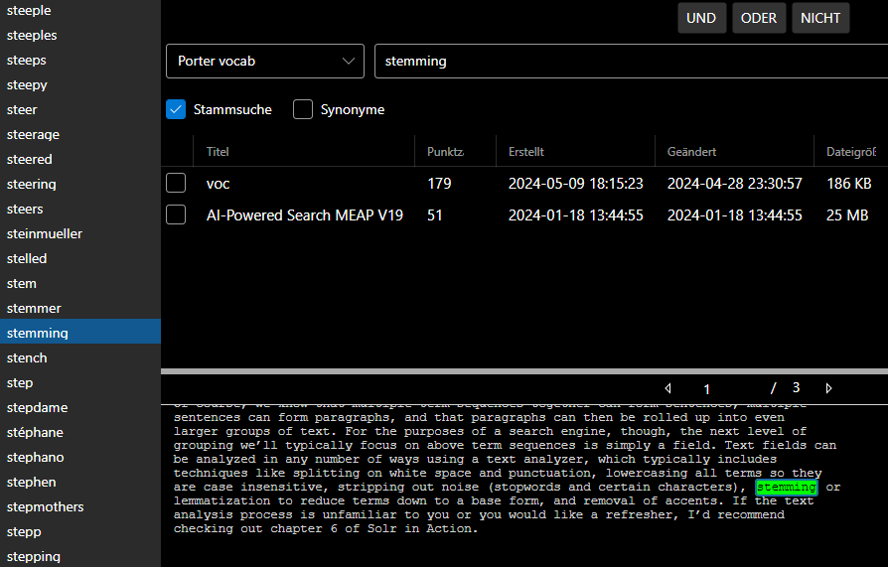

Illustration shows sample German UI translation. Viewing a 25Mb PDF as Plain Text with highlighted hits.

Geolocation in images
From Results Settings select the metadata you want to display. Images in many formats are displayed in the Viewer. Automatically extracted metadata includes full geolocation, camera details, etc. You can sort on any column.
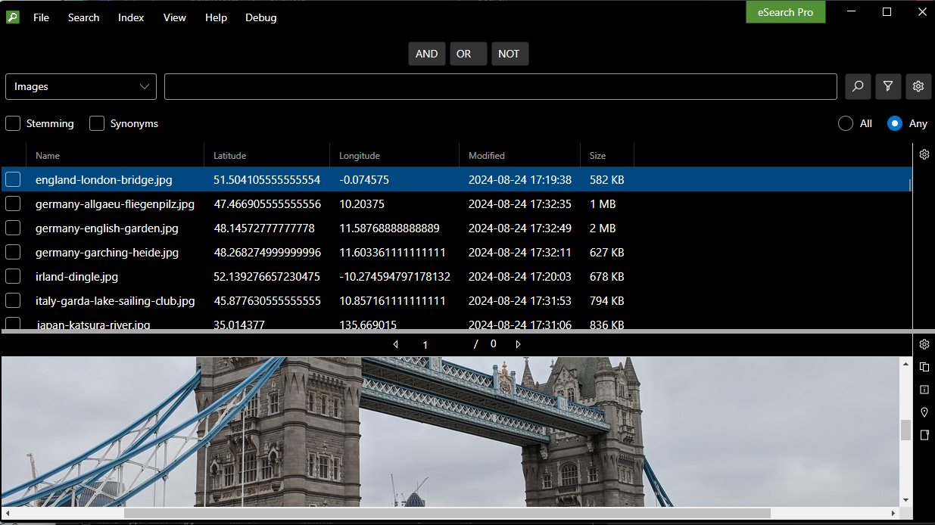
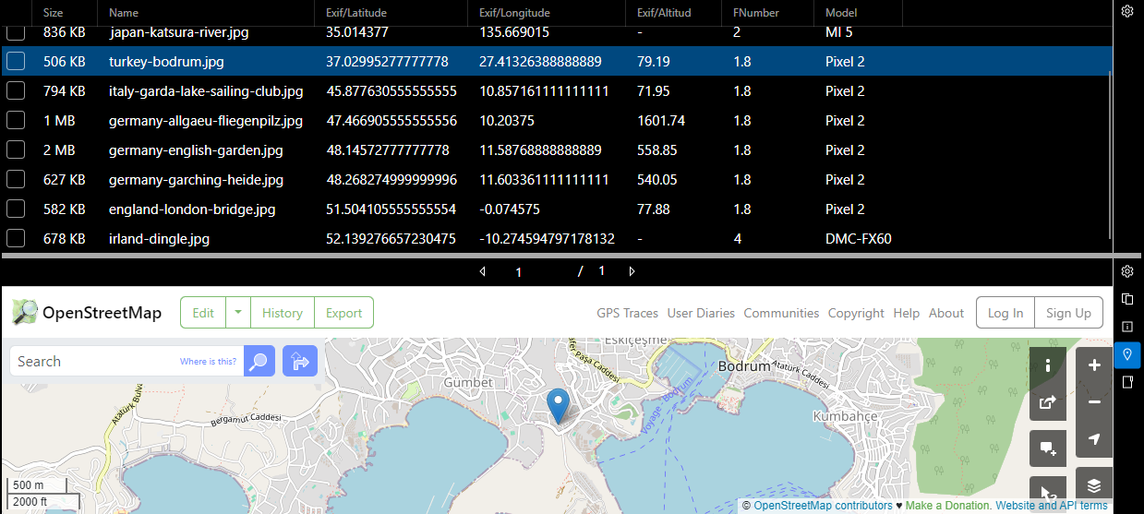
Click on the Map Pin button to view the location on a map. (Pro only)
From the File menu, choose Export Search Results. Select metadata, then choose .csv for output of a timestamped file to Excel.
Images above use geolocation test photos from https://www.geoimgr.com/sample-photos.html

Audio & Video files

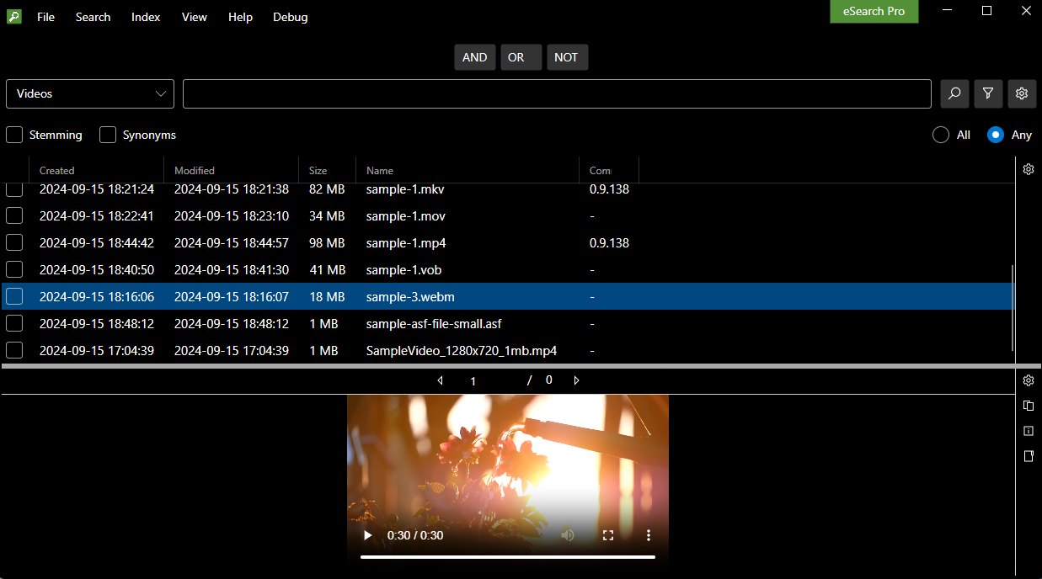

Web format audio and video container files, such as (.wav, .mp3, .mp4, .ogg, .webm), contain different audio and video codecs, not all of which may play in the viewer. For files that don’t play in the viewer, we recommend installing VLC Media Player and click on ‘View in folder’
Ensure that VLC Media Player is set as the default for opening the filetypes in your indexes.VLC is a free and open-source cross-platform multimedia player, it can be downloaded from https://www.videolan.org/vlc/
If your collection contains little meta data, use the default search setting to return all files in the index with an empty search query.
The results are limited to 5000. For larger collections split your files up so that different formats, subject areas, projects, dates, etc. are in different folders. Create a separate index for each folder.
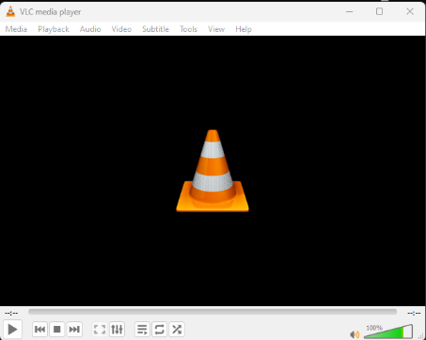

VLC Player can also be used for static image files.

Data files

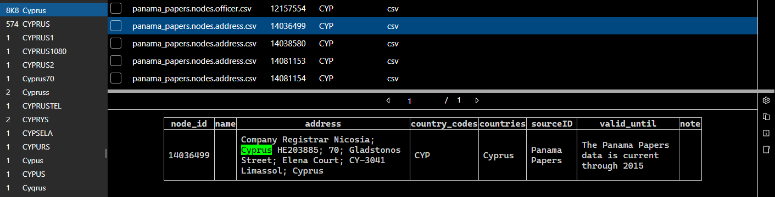
CSV and JSONL files are indexed as records, with table layout preserved and hits highlighted. Indexing is fast, over a million such records can be extracted from a zipped CSV and indexed in a minute on a modern PC.
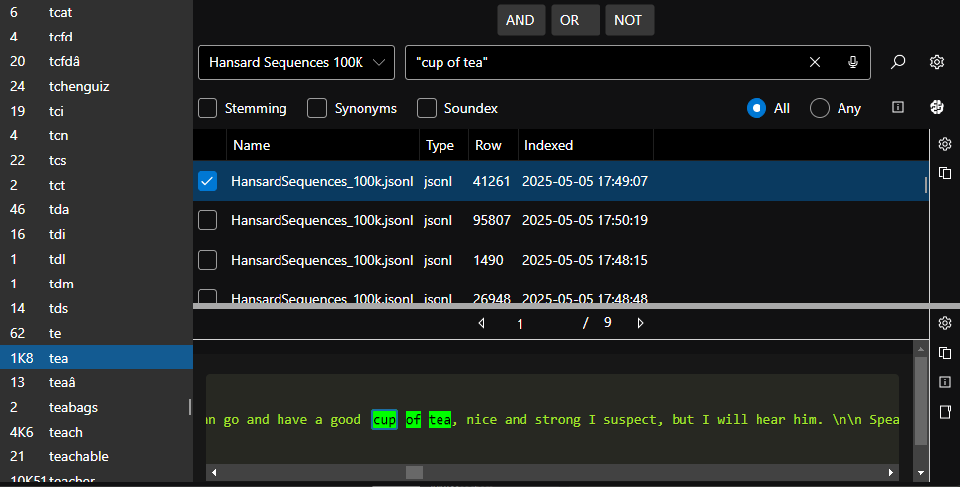
Showing 100,000 row JSONL file indexed with no stop words. Index time 2-3 minutes on a Windows 11 office PC with a single 12th gen Intel CPU with 32Gb RAM. Hansard Sequences file is available here: https://github.com/stewhsource/GovernmentGPT/blob/main/README.md

Source Code files
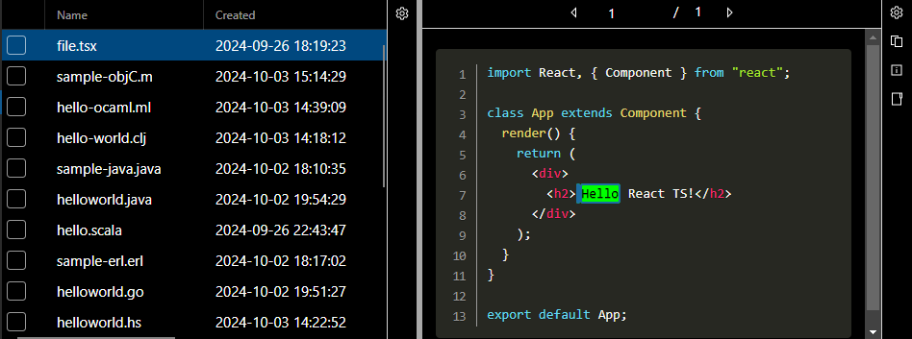

Hit highlighting in source code with syntax highlighting & line numbers.

Translation file support

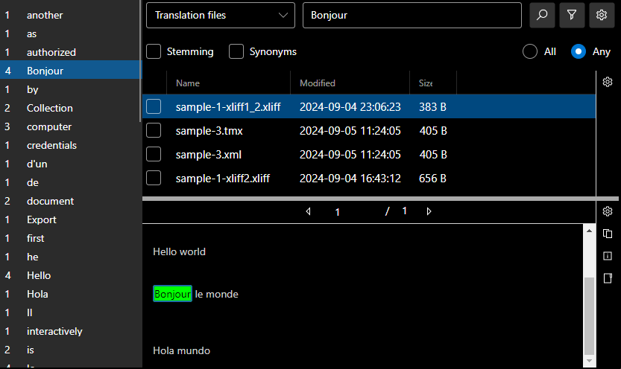
Translation industry file formats XLIFF 1.2, XLIFF 2.0, .tbx, and .tmx are supported for small files only. The image shows an index with the Case Sensitive option enabled, ensuring that acronyms and abbreviations are found. Additionally, contractions like d’un are preserved in the index and appear in the word list.

eSearch Pro 1.0 currently lacks file segmentation functionality, which splits large data files, such as translation industry XML formats, by rows or nodes, allowing them to be indexed as separate files. However, it will index CSV or JSONL formats with each record treated as a separate file.

The free GSplit 3.0 by G.D.G. Software SARL can be used for splitting translation industry XML formats.
https://www.gdgsoft.com/gsplit The UI is available in many languages.

Index Settings

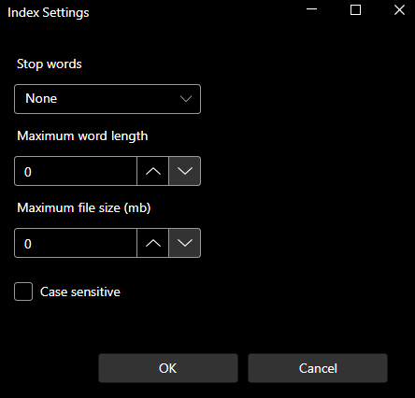
Settings will not take effect until you Rebuild an index.

Stop words
Stop words (also known as noise words) are frequently used words that are not included in an index to save indexing time and storage space.
Choose from a list of stop words in 30 languages or you can choose ‘None’ (at top of the list). If you change the stop words used by an index, you will need to rebuild the index for the change to take effect. You can edit the stop words from the ..AppData\Roaming\eSearch\Stop folder.

Maximum word length
The default setting is 0, which means no limit. (The actual limit is currently 125). You may prefer to lower this if your documents contain many long strings of letters or numbers.

Maximum File Size
The default setting is 0, which means no limit.

Case Sensitive
If Case sensitive is selected it will index language, LANGUAGE and Language as three separate words; it is useful for more precise searching, for example distinguishing wax polish from Polish (a person from Poland), chapter titles, brand names (Apple NOT apple) or acronyms and
cont…
cont…
abbreviations (PIN NOT pin). Indexes will be larger with this option.
Note: Stemming should be disabled for case-sensitive searches.
In eSearch, stemming will broaden the search by making it case-insensitive and expanding it to include words with different endings. (e.g. a search on ‘title’ will find TITLE, Title, title, titles).
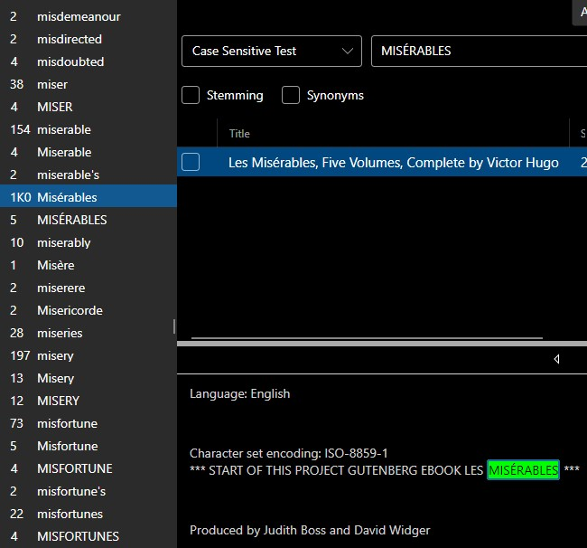

With the ‘Case sensitive’ option selected the word list shows alphabetically sorted uppercase words and letters as well as accented words. eSearch also correctly retains possessive apostrophes (‘s) and contractions like d’un in the word list.

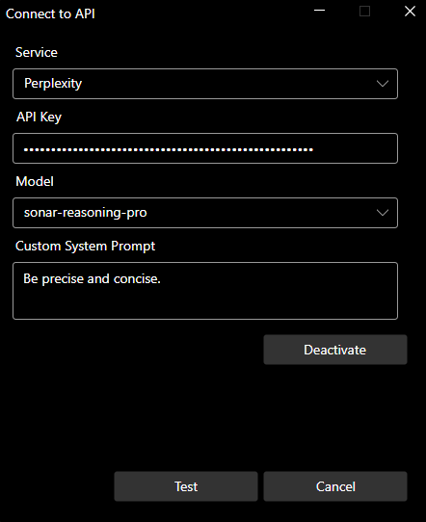
AI Mode
Connection to AI Services is setup from the AI > AI Connections menu.
The Perplexity service uses up-to-date web search combined with a choice of fast non-reasoning or slower reasoning models.
Usage requires a Perplexity.ai API key. This is a pre-pay pay-as-you-go service, no paid subscription is required. https://www.perplexity.ai/settings/api
Select the Perplexity Model, enter your API-key, Press Test to check the connection.
Click on the AI Mode button (blue button in the image below) to toggle between indexed and AI mode. In AI mode the Model will be displayed at the top of the viewer window.
The suggested question stems in the word list boost your productivity. Simply double-click on a word, or select it and press Enter, to insert it into the search bar.
Enter the remainder of the question. Optionally, add instructions to provide the answer in any language. Press Enter.
Verify the answer or get further information by clicking on any of the links to open them in your browser.
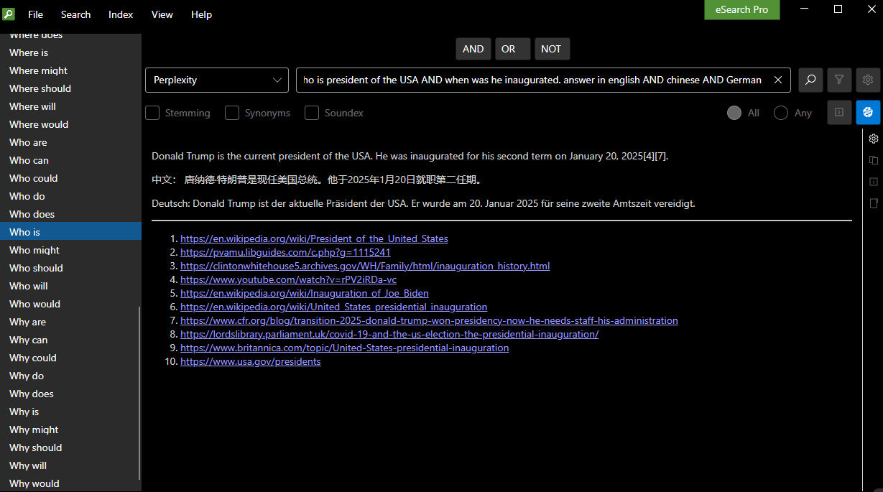
The image above shows AI Mode using Perplexity Sonar Pro. Apart from Perplexity models, OpenAI’s ChatGPT and Custom services are available.
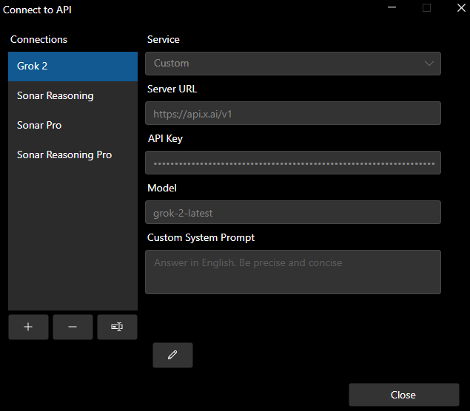
AI - Connecting to Custom API’s
From the Service drop-down list, select ‘Custom’ to connect to any OpenAI-Compatible service, such as a local LLM or another online LLM API provider, to access the latest models. You can also enter a system prompt to meet your organization’s exact search needs.
Setup allows you to add (+) or
Remove (-) connections.
Rename connections, to identify services and models or associate them with projects or cases to control costs.
A security best practice is to rotate API-keys, setup allows you to edit the API-key.
You can add other Perplexity models via the Custom form. Note the server URL is: https://api.perplexity.ai
(Do not add /v1)
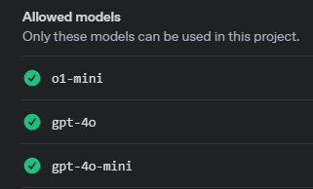
Online services usually require the organization’s owner, such as an IT department, to setup projects with different API keys. These projects can have limits set such as token usage or be restricted to specific models, allowing for controlled costs and allocation to specific cases, projects, or users.
Image above shows OpenAI project setup.
Locally run LLMs have the advantage that they are free, there is no need to pay subscriptions or usage charges. Security and privacy concerns such as keeping your queries and outputs within your organisation, as well as access to uncensored or fine-tuned domain specific models are other advantages of running local LLMs. It is possible to locally run quantized versions even on machines with a single CPU or modest GPU. For more information see the Support Articles
It's prudent to use online services initially. This approach allows you to test and compare models to determine the best fit for your organization’s needs while managing costs effectively. Unified services like Openrouter.ai allow access to hundreds of models – including free models - with a single API Key and with no subscription.

Usage of AI Models
When you click on the AI mode button it will toggle between indexing and AI mode, ready to start a new multi-turn conversation. The button will be highlighted - in blue on image below – to indicate AI mode.
Select the model/service from the drop-down as shown in the image below.
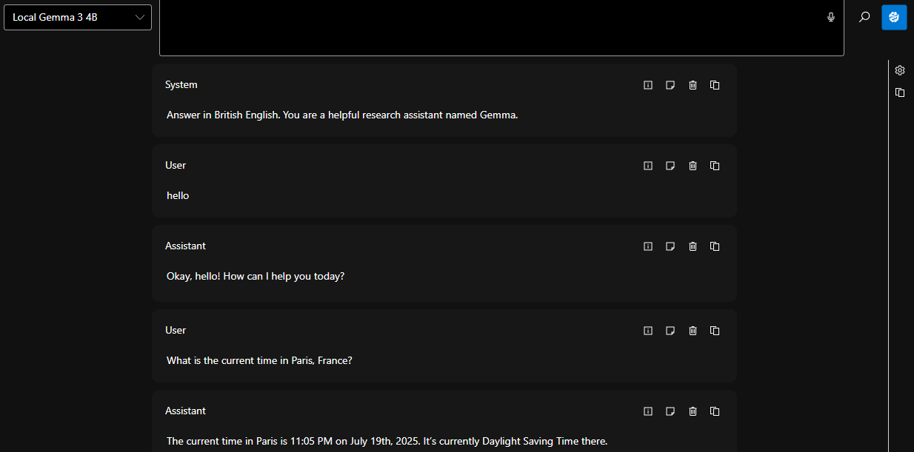
Above shows a multi-part conversation with a free locally hosted LLM.
Be aware that models without web search capabilities, or without access to an up-to-date document collection, will have a knowledge cutoff date and usually won’t include citations or links to sources on the web.
In the image above the small non-reasoning Gemma 3 4B quantized LLM is able to get the real time by using the Time MCP Server.
Non-reasoning models will usually give faster answers.

For more information on AI mode see the Support Articles.

MCP Client
eSearch Pro has a built-in Model Context Protocol (MCP) Client. From the AI menu select MCP Servers.
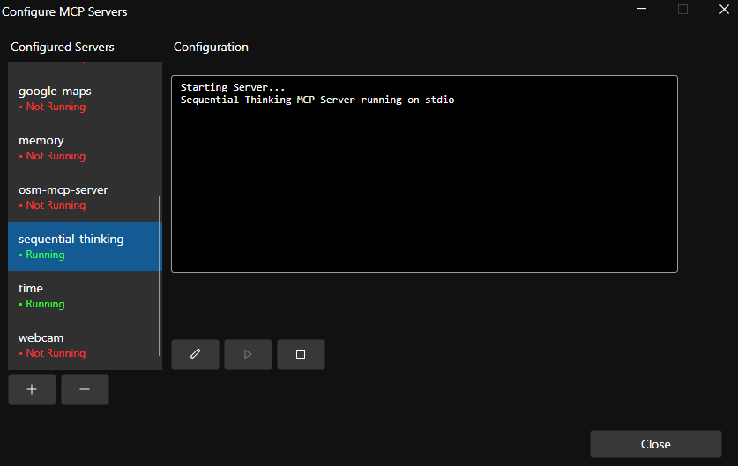

Select + to add a new server. Copy the MCP server configuration (usually published with an MCP server) and paste it in the Configuration window.

Select run
After a short while it will display that it is running.

It is best to have only one or two servers running at once. Stop any unwanted servers.


If an error occurs you may need to edit the configuration, some MCP servers need you to enter paths to folders, or API keys.


(Anthropic have now published a standard for a one-click install DSK file format, this will be added in future versions).

eSearch Portable – Forensics
eSearch Portable is designed to run from a USB 3.x flash drive. It requires read-only access to the host machine and does not install files on it. Indexes and user settings are saved on the USB flash drive.
However, if you intend to search for and retrieve files of interest from the host machine for forensic purposes, where evidence may be needed for legal proceedings, you must take precautions to ensure the files are not altered in any way. Additionally, ensure that no accidental changes are made to the host machine.
USB flash drives are usually supplied formatted as FAT32, which is generally the preferred format to ensure fast read/write operations. However, if you intend to copy files from the host machine to the USB flash drive, consider the following:
1. File System Choice: For forensic investigations, NTFS is generally preferred over FAT32 because it provides more precise timestamp information and better handles time zone and DST changes. NTFS timestamps include created, modified, accessed, and entry modified times, all with high precision.
2. Preservation of Timestamps: When copying files from NTFS to FAT32, there can be a loss of precision and potential discrepancies due to the 2-second granularity of FAT32 timestamps. This can be problematic in forensic contexts where exact times are critical.
3. Daylight Saving Time (DST): FAT32 does not account for time zone or DST changes, which can lead to inconsistencies if files are accessed or modified across different systems with varying DST settings. NTFS, on the other hand, handles these changes more robustly.
4. Forensic Tools: Use specialized forensic tools that can preserve and analyse timestamps accurately. Tools like EnCase, FTK, or X-Ways Forensics are designed to handle these tasks and can help ensure the integrity of timestamp data during investigations.
5. File Integrity: Use write-blockers when accessing storage devices to prevent any changes to the data, including timestamps. This helps maintain the integrity of the evidence.

eSearch Portable – Publishing
If you want to index and search files on a USB drive, create a “docs” folder (and sub-folders if needed) and place all the files there. Then, create one or more indexes of those folders. Do not copy indexes created by eSearch Pro from a machine to the USB drive, they are not suitable.
The standard license covers the installation of one copy on one USB flash drive. You can make a backup copy for your own archival purposes.
Publishing
If you want to make multiple copies for distribution to others (to search only the documents on the USB flash drive with no expiry) please contact us so that we can issue the required license and serial number to enable that functionality. (This requires a TARILIO version).

It is possible to distribute a searchable collection of documents and images within an organization or to clients (e.g., accounts, reports, project data, legal documents, ‘e-Bibles’) either freely or for sale. We offer one-time or annual licenses. Please contact us with your requirements.

Plugins
eSearch Pro supports plugins to extend its functionality. For example, it’s possible to index files outside of the local file system using a plugin.
A free plugin that can index files on an Amazon S3 store is available from here: https://searchcloudone.com/plugins-for-esearch-pro/
To install the plugin:
1 Download the plugin file to a folder on your local file system.
2 Right-click on the .zip file and choose Extract all…
2 Click on the Plugins menu, then press the Add… button. Navigate to the extracted plugin file and click Open
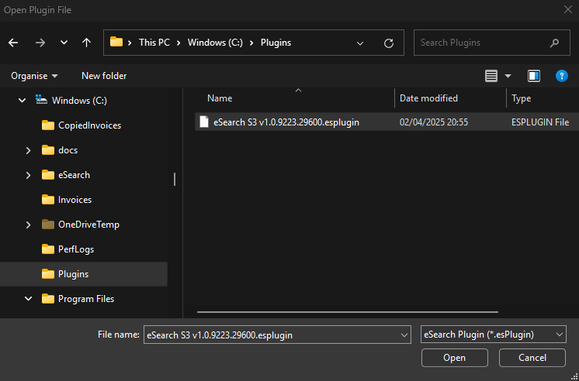
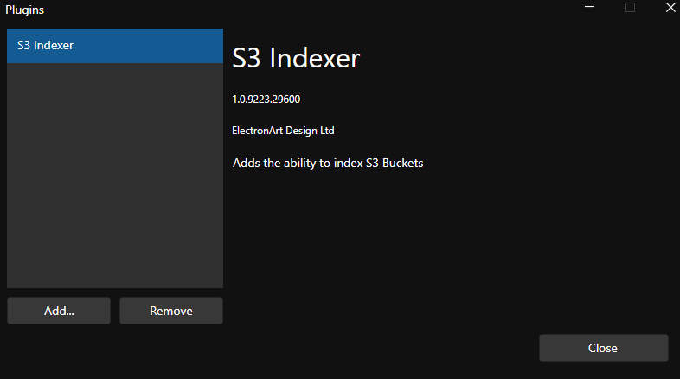
The plugin will now appear on the Plugins list:

Continue…
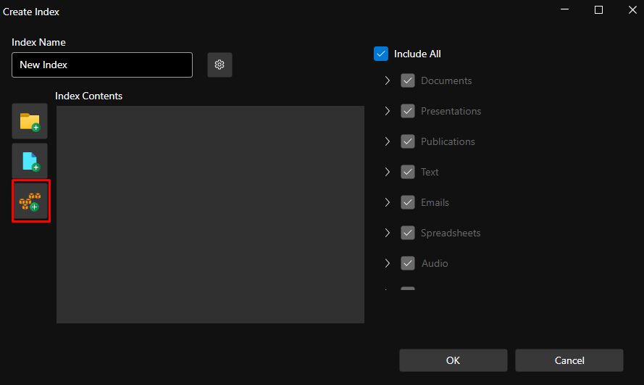
Now click on the Index > New… menu, the Create Index window will appear.
Click on the new button (outlined in red in the image below).

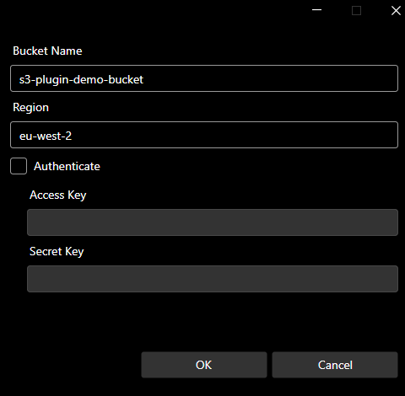

The Bucket Name and Region is a demonstration bucket. You do not need to enter any other details.
Press OK.
If you have files stored in an Amazon S3 Bucket that is not public, you will need to
enter the correct Bucket Name and Region, then check the Authenticate box and enter the Access key and Secret key before pressing OK.
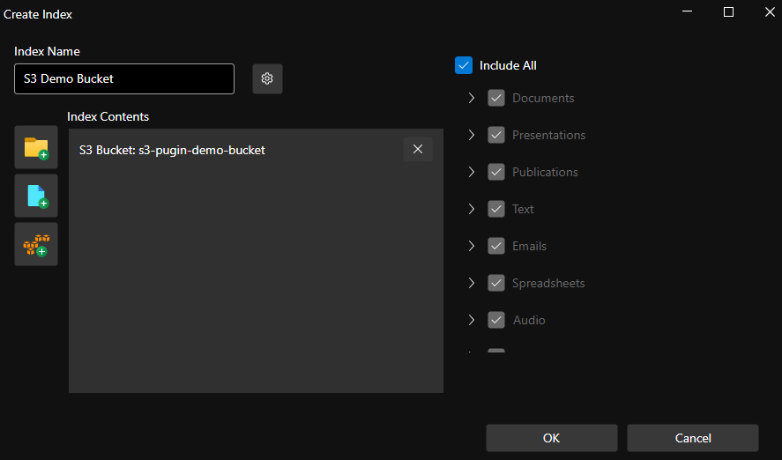

Edit the Index Name to ‘S3 Demo Bucket’ for example.
Press OK.

Continue…
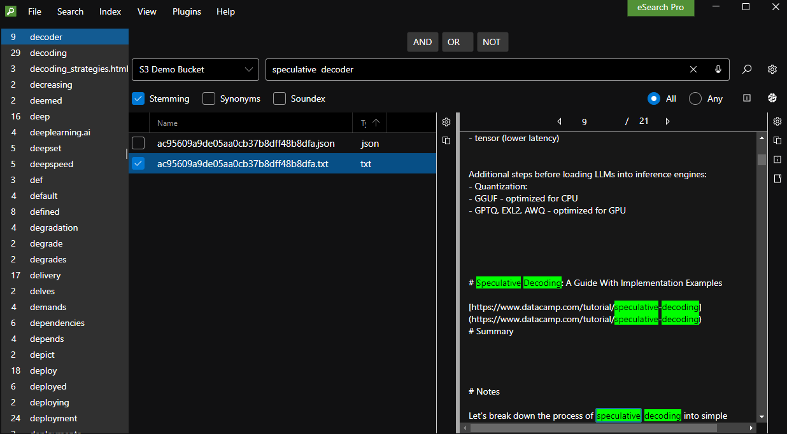
The new index will be created in a few seconds, close the dialog.
The new index will be automatically selected. Search the files as usual.
Example of an ‘All Words’ search for the words speculative, decoder.
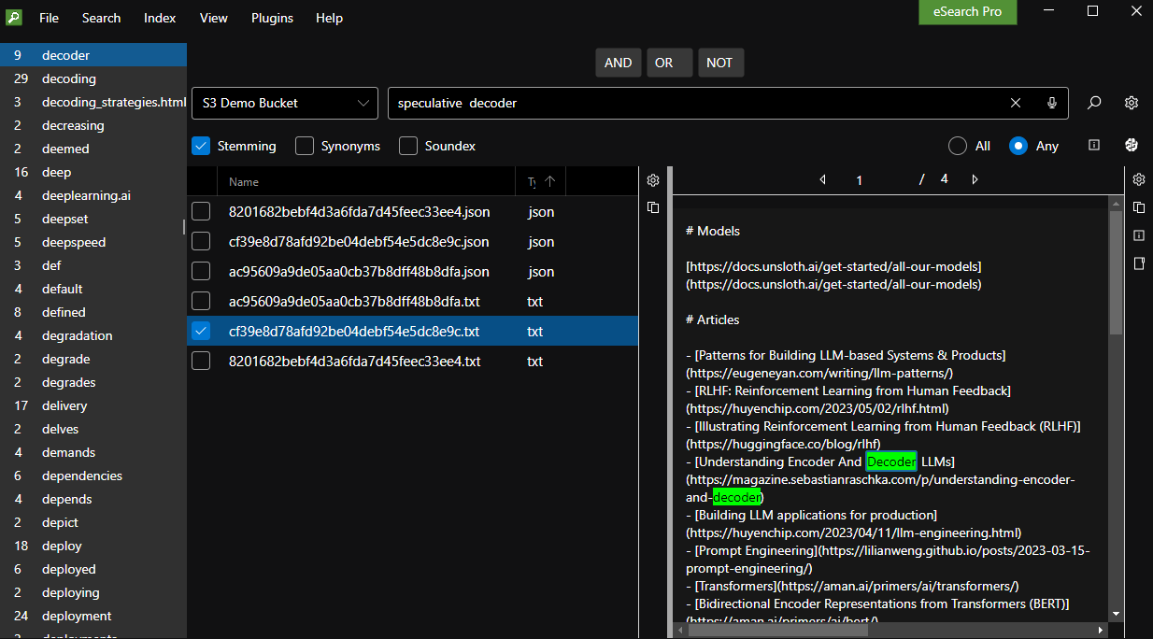Example of an ‘Any’ word search for the words speculative, decoder.
Settings:
Stemming: on. As a result, it will also find decoding.
View: Horizontal. Results Settings: Name & Type columns, Fit to Content.
Viewer Settings: Plain Text. Highlight (RGB): 00FF00 Font: Segoe UI 14pt.
Acknowledgement:
The files in the S3 bucket are a collection of files from the open-source and free course by Decoding ML here:
https://github.com/decodingml/second-brain-ai-assistant-course

Keyboard Shortcuts
Online Help – Press the F1 key.
Forward slash key / to put the cursor in the search bar.
Ctrl + Shift + V to toggle voice input.

UI Navigation
Use Tab or Shift + Tab keys to navigate between the menu bar, search query controls, toolbars, results and viewer frames. You can use the up/down keys to navigate between menu items, word list items, toolbar items, result rows, etc.

Menus
The menus use conventional ALT + hotkey shortcuts. Press the ALT key to see the underlined character to use as the hotkey. The English UI uses the first letter as the key by default, but other languages may differ to avoid duplicate keys. Users can also create their own English language file as an alternative to the built-in English (GB) defaults (e.g., US, AU, CA, or even GB if you prefer to add your own words or shortcuts).

Results grid
Use the Up/Down keys to navigate rows.
Use Shift + Up/Down keys to select multiple rows, CTRL + Up/down to move without selecting, then Shift + CTRL + Up/down to select further rows.
With the focus on the results panel, select all rows using Ctrl + A.
See also: File Explorer
Word List
Use the Up/Down keys to navigate through the list, and press Enter or double-click with a mouse to use the selected word in a search query.

User Translation

View menu
The User Interface (UI) Language is English by default, choose from the supplied languages by selecting From File…
The UI language changes instantly, no need to restart!

Language File Editor
Our aim is to make eSearch available in many languages. We provide sample translation files in several languages.
You can edit the language files to add missing translations or correct errors. You can also change shortcut keys or modify user interface wording to suit your preferences.
We offer a free Language File Editor to make translation quick and error-free! Download the free Language File Editor from https://searchcloudone.com/universal-desktop-search/

If you would like to donate translations for use by others, please send them zipped to support@electronart.co.uk. We will publish or distribute them free of charge on as AS-IS basis, with no warranty of accuracy or completeness. Please let us know if you have any questions.
See: https://github.com/electronart/esearch-project-translation

Registration
After the general release date, beta testers, early evaluators, and users of similar products will be offered free or discounted TARILIO licenses. You need to register your email address when you download eSearch Pro or Portable to be eligible for those offers or for technical support.

eSearch Pro
Available in Desktop or Portable. Free and open source for private non-commercial use from ‘July 2025’ release.
The Portable version can be run on a USB 3.x drive complete with documents and indexes as a portable library or to index and search files stored on the host machine.

Portable-search-only licenses allow you to publish searchable libraries to others, with no expiry. These require a serial number and a TARILIO Publish license.
See SearchCloudOne.com for more information and pricing.

Evaluation
eSearch Pro may be downloaded free from SearchCloudOne.com. Versions up to and including the June 2005 release, will revert to a free Lite mode with limited features. Version after that date will remain fully functional. You may use the eSearch versions for 30-day evaluation commercial use.

TARILIO versions.
If you have purchased a TARILIO license, enter the serial number to remove any limits and gain access to support and updates. To enter the serial number: go to Help menu > About > Serial… TARILIO versions require an annual subscription and revert to a Lite version after one year.

eSearch Lite
Lite version is free for personal and commercial use. For support and updates, please register your email address with support@electronart.co.uk. The Lite version has limited functionality, such as restrictions on the number of results or features available in the Pro version. These limits may change over time and will be published on our website or in user guides.

Support
TARILIO versions: Support is provided via email to a single point of contact within an organization. Always supply your serial number or details of when and where the product was purchased if it was not obtained directly from SearchCloudOne.com or ElectronArt Design Ltd.
Use the contact form on the About menu at http://SearchCloudOne.com or email support at support@electronart.co.uk.
Support Articles can be found here:
https://searchcloudone.com/esearch-support-articles/

Feedback
We welcome feedback, bug reports, suggestions, and translations at any time! Use the contact form at https://searchcloudone.com/contact-us/ or email support at support@electronart.co.uk.
If you experience problems, please describe the steps to recreate the issue, along with brief details of your computer hardware, operating system, and any specific file type causing the problem. Screenshots may help us understand the issue.

Error Log
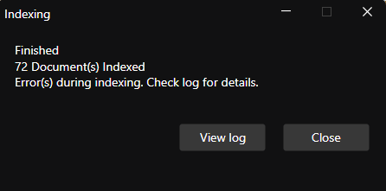
During indexing, if errors are detected an error log will be created. If you click on View log it will be opened in Notepad or your default text editor.
Copy and paste the text into an email. If the file is large, compress it into a Zip format and attach it to the email. To create a text file, see the File menu and select Save As…. Then, right-click the file and choose Compress to ZIP. Send the log (redacted if necessary) to support@electronart.co.uk.
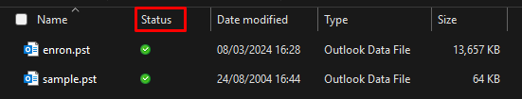
OneDrive
Ensure that Status is synchronized to ensure proper indexing.

Known Issues
Viewer Settings
View Large Files:
For large (except CSV or JSONL) files, such as 160MB Reuters headlines (TREC data), if “Fully” is selected, eSearch will become non-responsive until the file is read in, which can take several seconds. In contrast, large (multi-gigabyte) CSV or JSONL files are indexed as separate records and are handled without issues.
PDF
PDF Viewer has no hit highlighting. Choose Plain Text to view PDF files with hits highlighted.
Viewer/File support
File parsers are in continuous development, if you encounter issues, try downloading a later build and rebuilding your indexes to see if the problem has been resolved. For specific needs or unresolved issues, contact support at support@electronart.co.uk.
Hit count navigation was added in response to customer requests. While dtSearch Desktop lists the total number of hits in the results, it does not identify a particular hit when using 'next hit'/'previous hit' navigation. In contrast, eSearch Pro numbers each hit.

In extreme cases, such as when an index is created with stop words set to ‘none’ and a search is performed on a common word like 'a', there can be thousands of hits in a long English document. Since such a search is unlikely to be useful, we have limited the maximum number of hits counted to 1024. Documents are displayed immediately, but counting and highlighting 1024 hits can take 10 secs or more, depending on the document and the machine.

Plugins menu
The plugin API will allow developers to create plugins for connecting to external data sources. A demonstration plugin is available for download, see plugins, however the API has not yet been published (As of June 2025).
Accessibility
All controls respond to the Windows Narrator Screen Reader, which can be turned on or off with the keyboard shortcut Windows + Ctrl + Enter.
See: Keyboard shortcuts.
High Contrast option: See View > Theme menu items.

Search bar now has a voice input option. This works offline using the built-in Microsoft Windows technology.


You can also use applications like VoiceTyper. Use the ‘forward slash’ [/] key to put the cursor in the search bar before talking.

File menu > Launch at Start-up option

Command Line options
-s Disables Index menu.
-a Disables AI Mode.
-x Disables AI > AI Connections menu

Issue 38
eSearch Pro

Beta status
July 2025: eSearch Pro is now open sourced and is free of charge for private, non-commercial use. TARILIO includes additional closed source code and is the brand for commercial use.
https://github.com/electronart/esearch-project

dtSearch UK, Search Cloud ONE and Tarilio are trading names of ElectronArt Design Ltd. CRN: 01796515.

Copyright © 2024-2025 ElectronArt Design Ltd.
All Rights Reserved.

