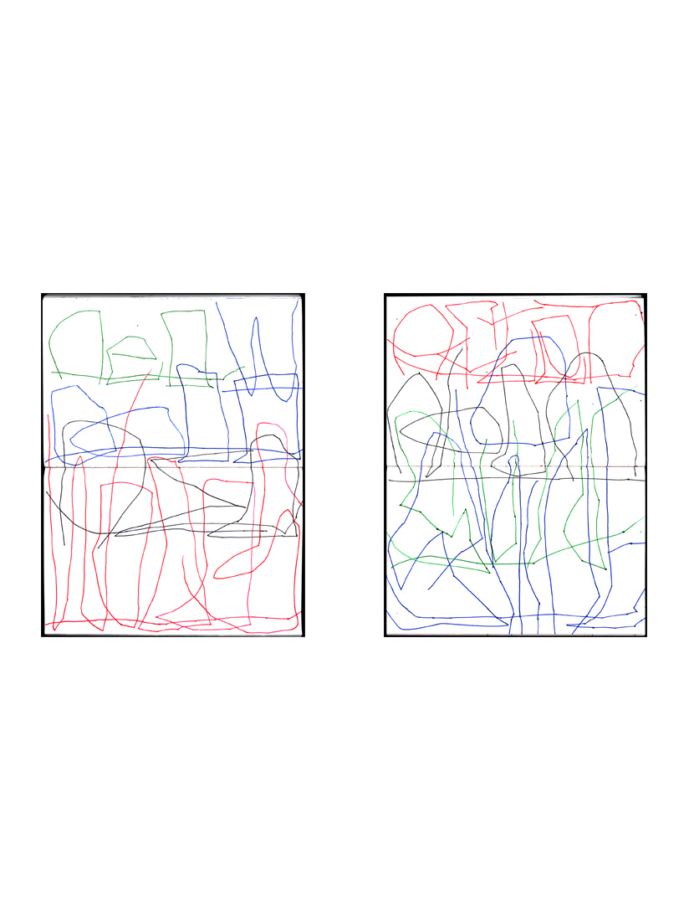

Robert Grenier Drawing Poems/'Rough' Translations
Red Wood / February 2004 Afternoon Sunshine / April 2004
RED W (green/blue)
OOOD (blue)
[OODD (blue)]
RED (black)
WOODS (red)

AFTER (red)
NOON (black)
SUN (green)
SHINE (blue)

Robert Grenier Drawing Poems/'Rough' Translations
Four Poems / February 2004
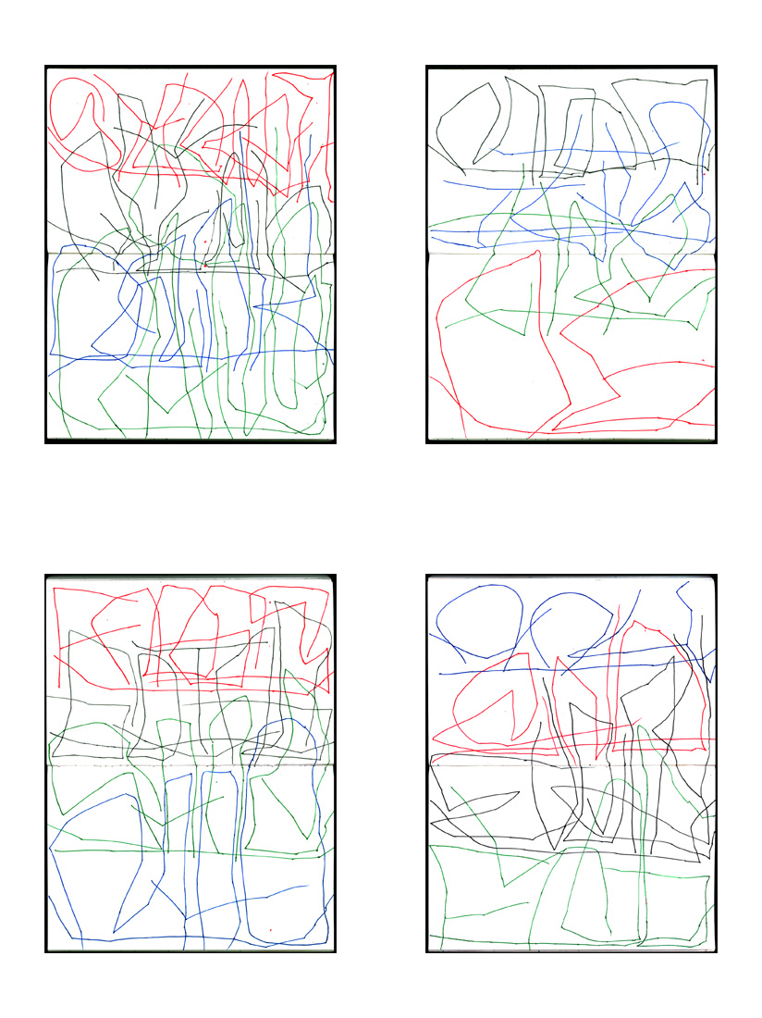
#1 SHOWER (red)
AFTER (black)
DARK (blue)
RAINS (green)
#2 MOON (black)
IT’S (blue)
THE (green)
RE (red)
#3 FROGS (red)
GOING (black)
SANE (green)
MAD (blue)
#4 ANY (blue)
AND (red)
EVERY (black)
FROG (green)

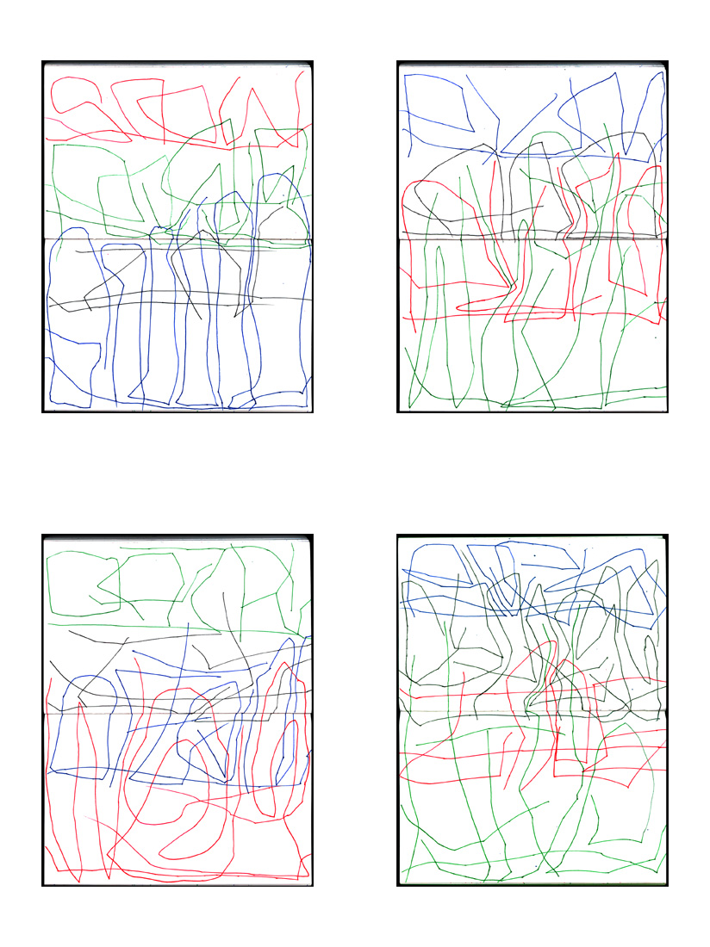

Robert Grenier Drawing Poems/'Rough' Translations
Four Poems / March 2004
#1 SNOW (red)
PEAS (green)
IN (black)
GROUND (blue)
#2 PLUM (blue)
AND (black)
PLUM (red)
WHITE (green)
#3 DARK (green)
IT (black)
OFTEN (blue)
WAS (red)
#4 BEES (blue)
CYPRESS (black)
TREE (red)
HIVE (green)

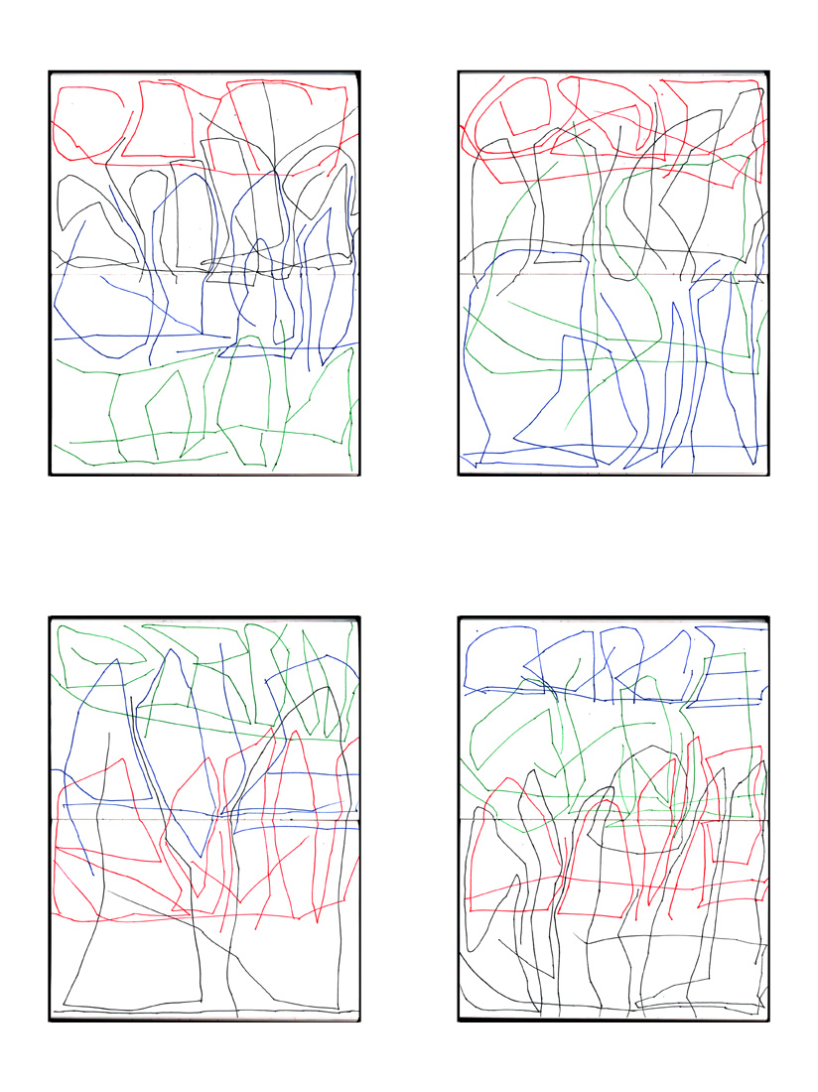
#1 CORN (red)
SHOOTS (black)
UP AN (blue)
INCH (green)
#2 LEAP (red)
ROUND (black)
UP (green)
DOWN (blue)
#3 ELBOW (green)
POLE (blue)
BEAN (red)
UP (black)
#4 DANCE (blue)
STEP (green)
COME (red)
SPRING (black)

Robert Grenier Drawing Poems/'Rough' Translations
Four Poems / April 2004

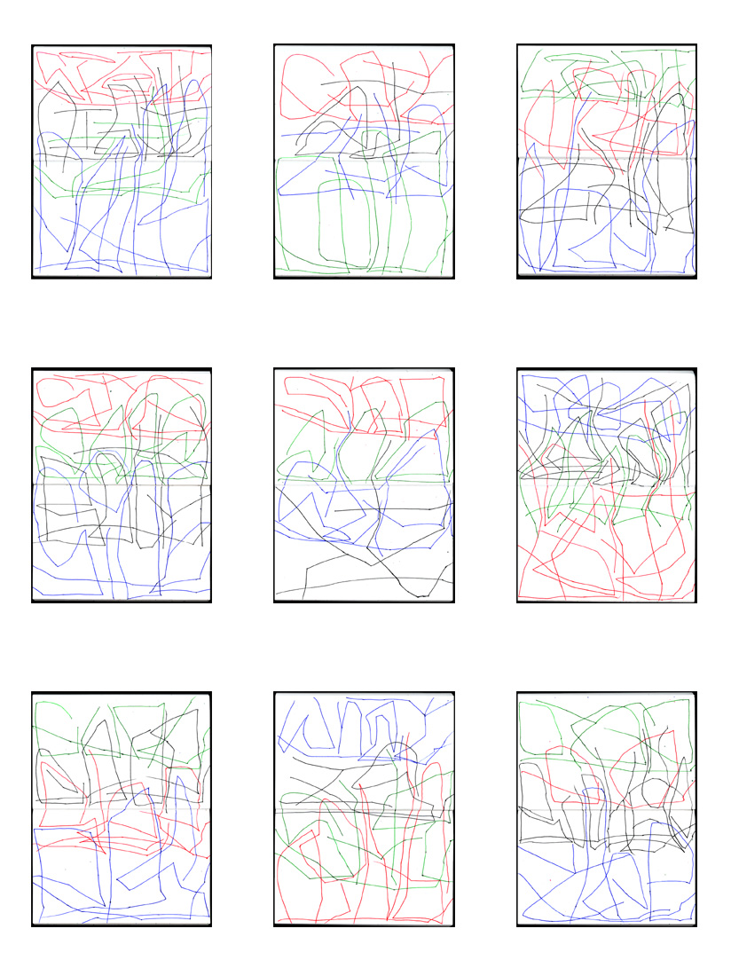

Robert Grenier Drawing Poems/'Rough' Translations
Nine Poems / December 2002
#1 SILENT (red)
NIGHT (black)
IT (green)
POURS (blue)
#2 CAT (red)
AT (black)
THE (blue)
DOOR (green)
#3 LIGHT (green)
NING (red)
THUD (black)
NDER (blue)
#4 STRE (red)
AMS (green)
BOTH (black)
SIDE (blue)
#5 STOP (red)
AND (green)
STA (blue)
RT (black)
#6 FROG (blue)
LATER (black)
MOON (green)
LIGHT (red)
#7 CURL (green)
ED UP (black)
SLEE (red)
PPS (blue)

#8 WHAT (blue)
IS (black)
SHI (green)
NING (red)

#9 DROP (green)
ON (red)
BUCKEYE (black)
TREE (blue)

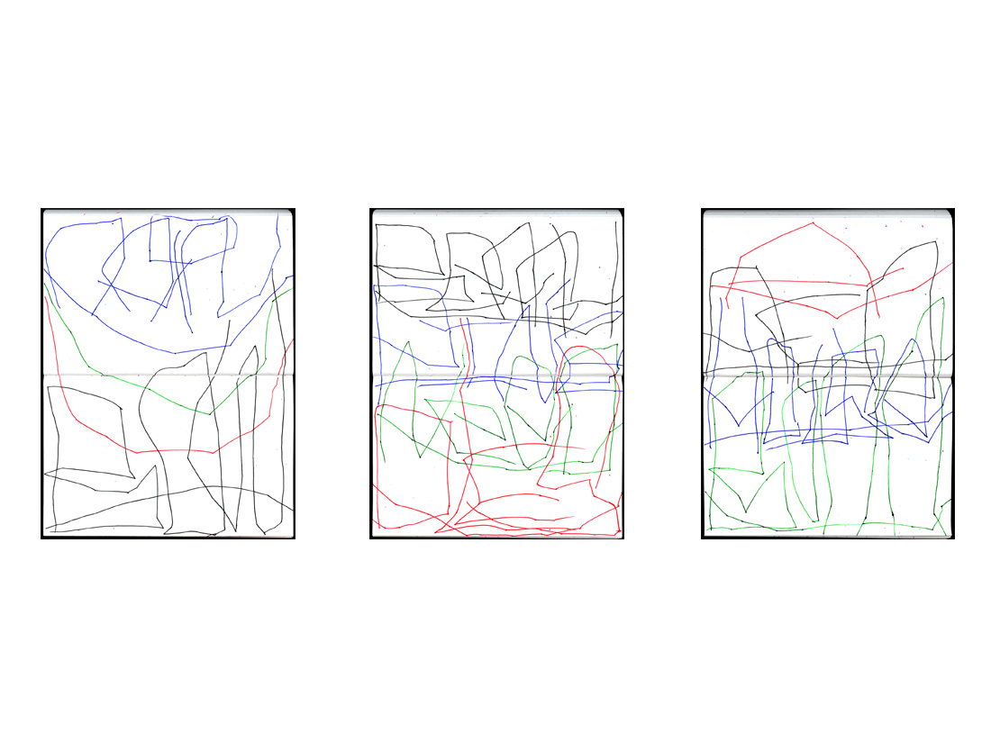
#1 RAIN (blue)
[Three curved lines] (blue, green, red)
BOW (black)
[One curved line] (black)
#2 BEACH (black)
PINE (blue)
NEED (green)
DLES (red)
#3 A (red)
RED (black)
HOUSE (blue)
BORN (green)

Robert Grenier Drawing Poems/'Rough' Translations

Three Poems / November 2002

Robert Grenier Drawing Poems/'Rough' Translations

Six Poems / November 2003 – January 2004

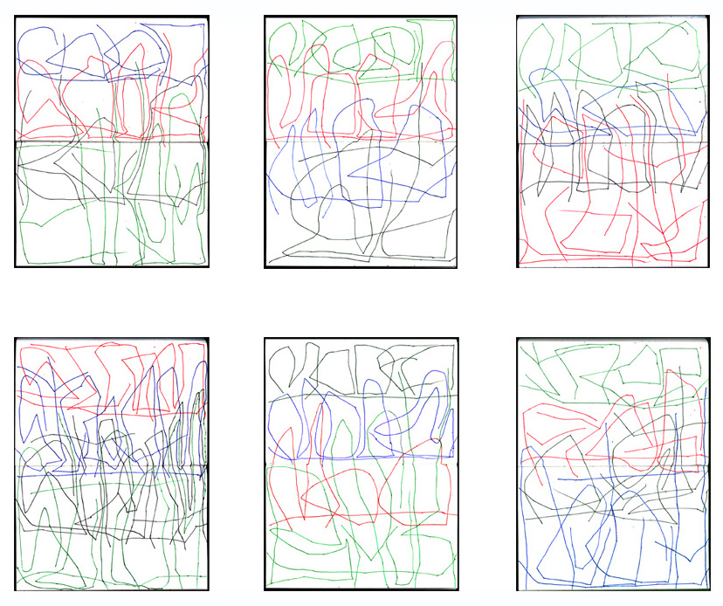
#1 COLOR (blue)
SOAK (red)
KED (black)
EUKES (green)
#2 MOOER (green)
MOOS (red)
MOO (blue)
AT (black)
#4 STROM (red)
STREAM (blue)
STREAM (black)
STROM (green)
#5 MOOER (black)
MOOS (blue)
MOO (red)
BACK (green)
#6 TREE (green)
FROG (red)
A ST (black)
RETCH (blue)
#3 MORE (green)
SO (blue)
MOON (black)
LIGHT (red)

