**Lab Report 1**

**Mahri Kadyrova, Carlos Cruz, Savannah Chiweshe, Elidice Mehdizadeh**

**The University of Texas at Arlington, TX, USA**

**Introduction:**

Most implants, surgical devices, and other medical tools have to be modeled before they are manufactured. CAD software such as SOLIDWORKS has opened up a vast number of possibilities in 3D modeling for engineers, researchers, and really anyone who's interested in designing anything. The purpose of these lab exercises was to expose us to some of the possibilities in the field of bioengineering by the modeling of Y conduits commonly used in nerve grafts. Digital modeling is useful - but without a way to make something from it, those models are just a bunch of pretty pixels. 3D printing provides the means of production for SOLIDWORKS, and we were lucky enough to see it in action with in-class demonstrations.

**Materials and Methods**:

Basic Y conduit and lofted conduits with customized geometries were designed using solid works. The designed piece was then exported in a 3D printable file format (STL or OBJ) then using the built-in software in the printer the digital mode was sliced into layers and was then ready to be printed.

ANYCUBIC SLA resin 3D printer was used to print the conduit. The ANYCUBIC printer uses a light-reactive thermoset resin which essentially solidifies or polymerizes when exposed to certain wave lengths of light. The build plate in this printer is dipped into a bath of resin and a layer of resin is cured using light then is dipped back again and this process goes on till the desired shape is formed. The ultimate 3D printed design still contained some uncured resin which was washed away using isopropyl alcohol. While printing our conduit in order to create enough support and for easy removal a support structure was used which was removed after the rinsing step.

**Results:**

Two figures were designed: basic Y conduit and lofted conduit

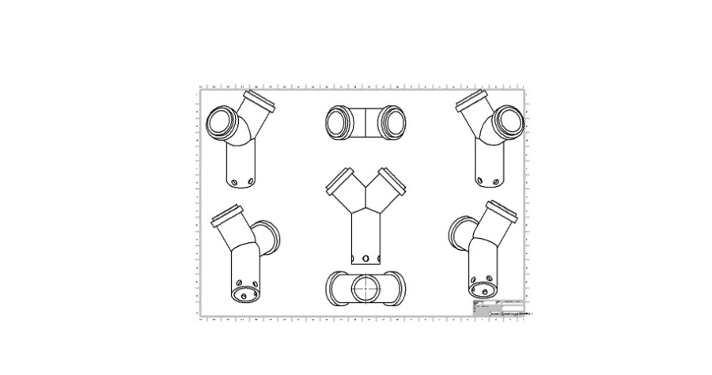

Figure 1. Basic Y Conduit

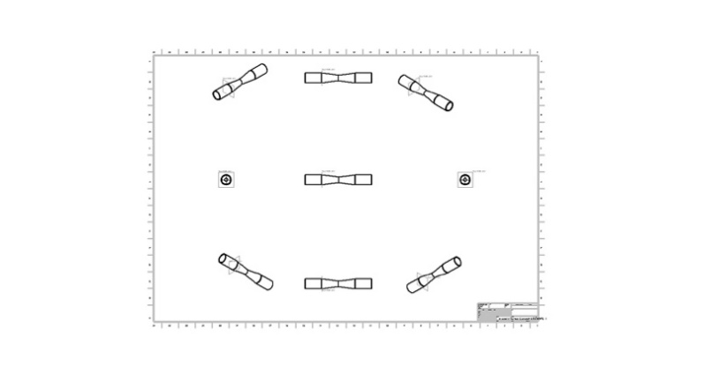

Figure 2. Lofted Conduit

**Discussion:** SolidWorks is useful as it allows you to sketch ideas and experiment with a multitude of designs when creating 3D models. Additionally, SolidWorks can be paired with other software to model and simulate fluid flow. This helps in saving money and time during the design and development phase as it allows you to model and test out designs beforehand.

There are two typical printers used in Biomedical applications of 3D printing and resin printing, Fused Deposition Modeling (FDM) printers and Stereolithography Apparatus (SLA) printers. FDM printers function by melting and extruding a filament of material for the printer to precisely deposit it into the workspace and SLA printers function by dipping a build plate into a bath UV sensitive resin which is then cured and attached to the build plate or previous layer of material.

FDM printing has more advantages in Biomedical applications as it is safer, has cheaper material costs, larger printing areas and stronger plastics compared to SLA printers. However, SLA printers have higher resolutions and print at faster speeds.