eLeDia.ai Tutor — Solution Overview
An agentic AI tutor for Moodle that actually knows your courses. A retrieval-augmented (RAG) assistant that lives inside Moodle and in any AI client your team already uses — grounded in your course content, able to act on live Moodle data, fully brandable to your institution, and powered by the language model of your choice.
Document: Solution Overview · Version: 2.0 · Date: 14 June 2026 · Prepared by: eLeDia GmbH, Berlin

Contents
1. What we offer
2. The learner experience in Moodle
3. Make it your own — branding, personas & “tutor profiles”
4. Who controls what — admin governance & teacher self-service
5. Two ways to use the same tutor
6. Agentic and grounded — not just a chatbot
7. Always current — automatic content ingestion
8. Insight for teachers — question analytics
9. Your model, your data — your choice
10. Security, privacy & data sovereignty
11. How it works
12. What you get
13. Why eLeDia
14. In plain words (glossary box)

1. What we offer
eLeDia combines several building blocks into one seamless learning assistant:
- eLeDia.ai Tutor — a polished, native chat experience embedded directly in Moodle, fully brandable and configurable per course or site-wide.
- Moodle MCP Server — a secure gateway that turns Moodle into a tool provider any AI agent can use, on behalf of the individual learner and strictly within their permissions.
- The agentic RAG / Tutor service — the “brain”: it retrieves knowledge from your course materials, reasons in multiple steps, calls Moodle when it needs live data, and answers in natural language — driven by the AI model you choose.
- Automatic content ingestion — keeps the tutor’s knowledge base current as your courses change (Section 7).
Together they deliver a tutor that is grounded (it cites real sources), connected (it looks things up in Moodle in real time), on-brand (it looks and speaks like your institution), and flexible (it runs on our models or yours).
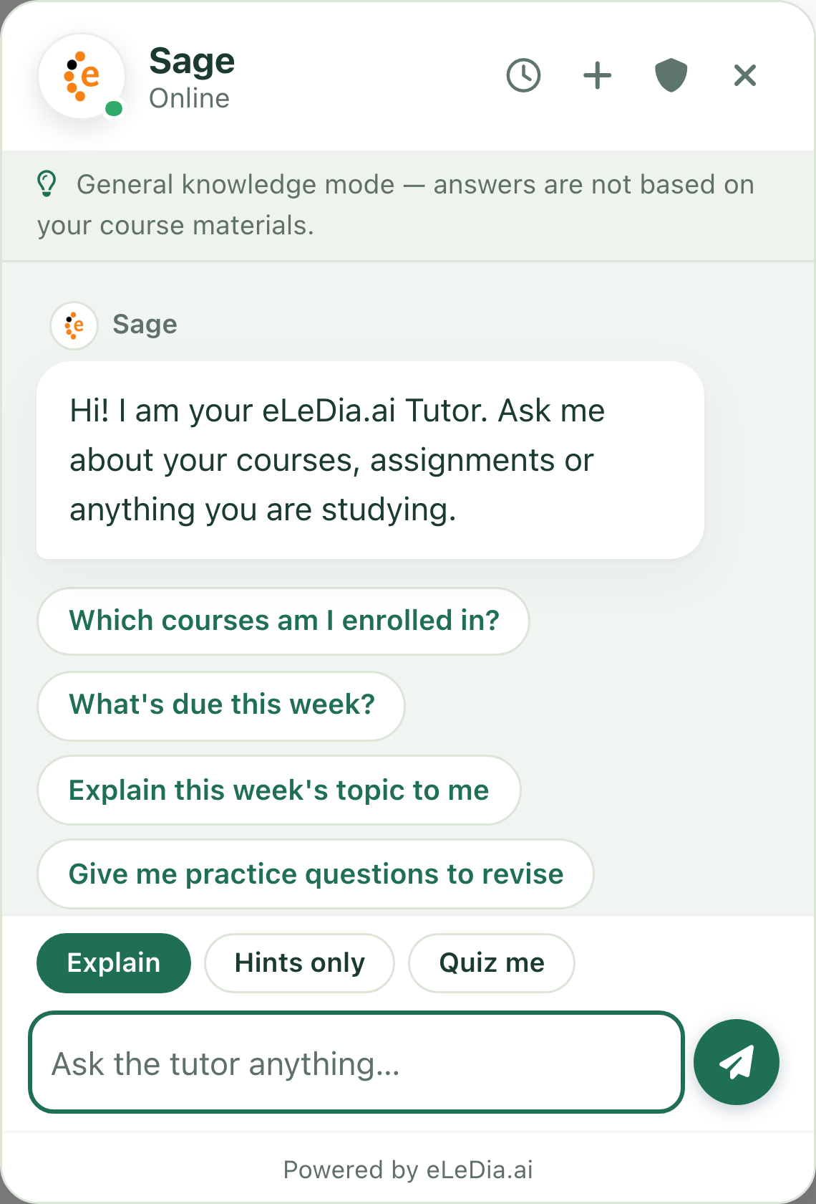
The eLeDia.ai Tutor open inside a Moodle course — the greeting, one-click prompt starters, the Explain / Hints only / Quiz me answer-style selector, and the composer.

2. The learner experience in Moodle
A beautiful, accessible chat assistant sits right inside the course. No new logins, no context switching — learners ask questions in plain language and get clear, formatted answers that link back to the right course resources.
- Display modes to fit any page. A docked floating panel (the default — a launch button that opens a tidy chat window), an embedded in-page panel, a centred modal, or full-screen. Choose per site and per course.
- Mobile and accessible. Responsive layouts, keyboard navigation, screen-reader labels and reduced-motion support throughout.
- Suggested questions (“prompt starters”). Greet learners with one-click starter questions so they always know how to begin.
- Answer styles. Switch the teaching mode between Explain (full explanations), Hints only (guides without giving the solution away), and Quiz me (practice questions) — teachers can pin a style or let learners choose.
- Conversation history. Learners can revisit and resume their earlier conversations; history is kept separately per course (or combined in a global placement).
- Privacy first. Before the first use, learners read and acknowledge your privacy guidelines; they can review them any time and delete their own data.
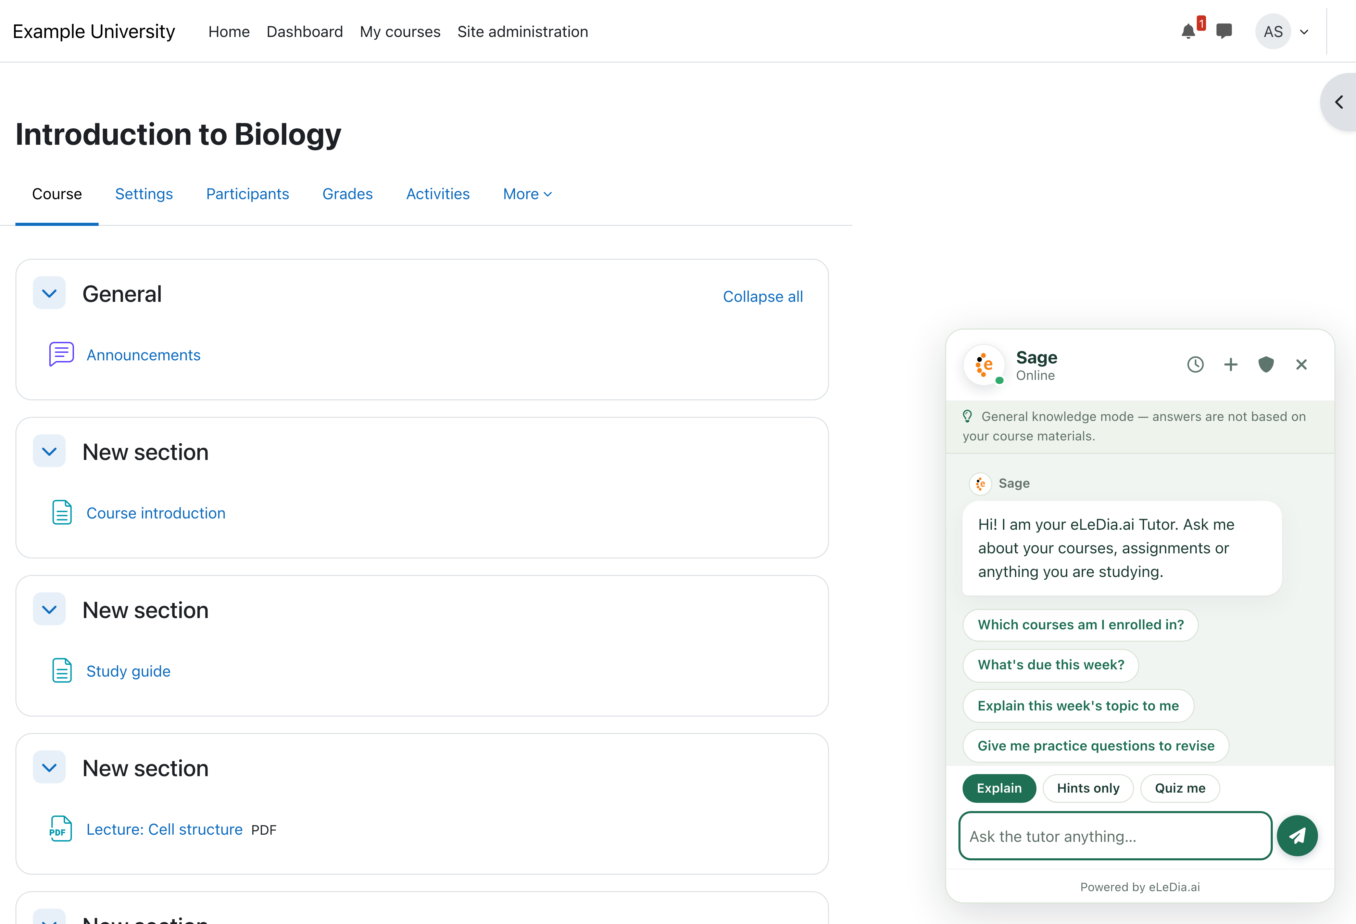
The default presentation: a docked floating panel that opens over any course page.

3. Make it your own — branding, personas & “tutor profiles”
The eLeDia.ai Tutor is fully brandable — it can look and sound like a natural part of your institution rather than a generic chatbot.

Every visual detail is a setting
Colours, surfaces, text, message bubbles, fonts, corner roundness, spacing, shadows, the avatar glow, the launcher button — every design detail is editable through friendly controls: real colour pickers (click a swatch or paste a hex code) and plain-language dropdowns (“Small / Medium / Large”, “Subtle / Strong”), never raw code. Each setting carries a short explanation and example.
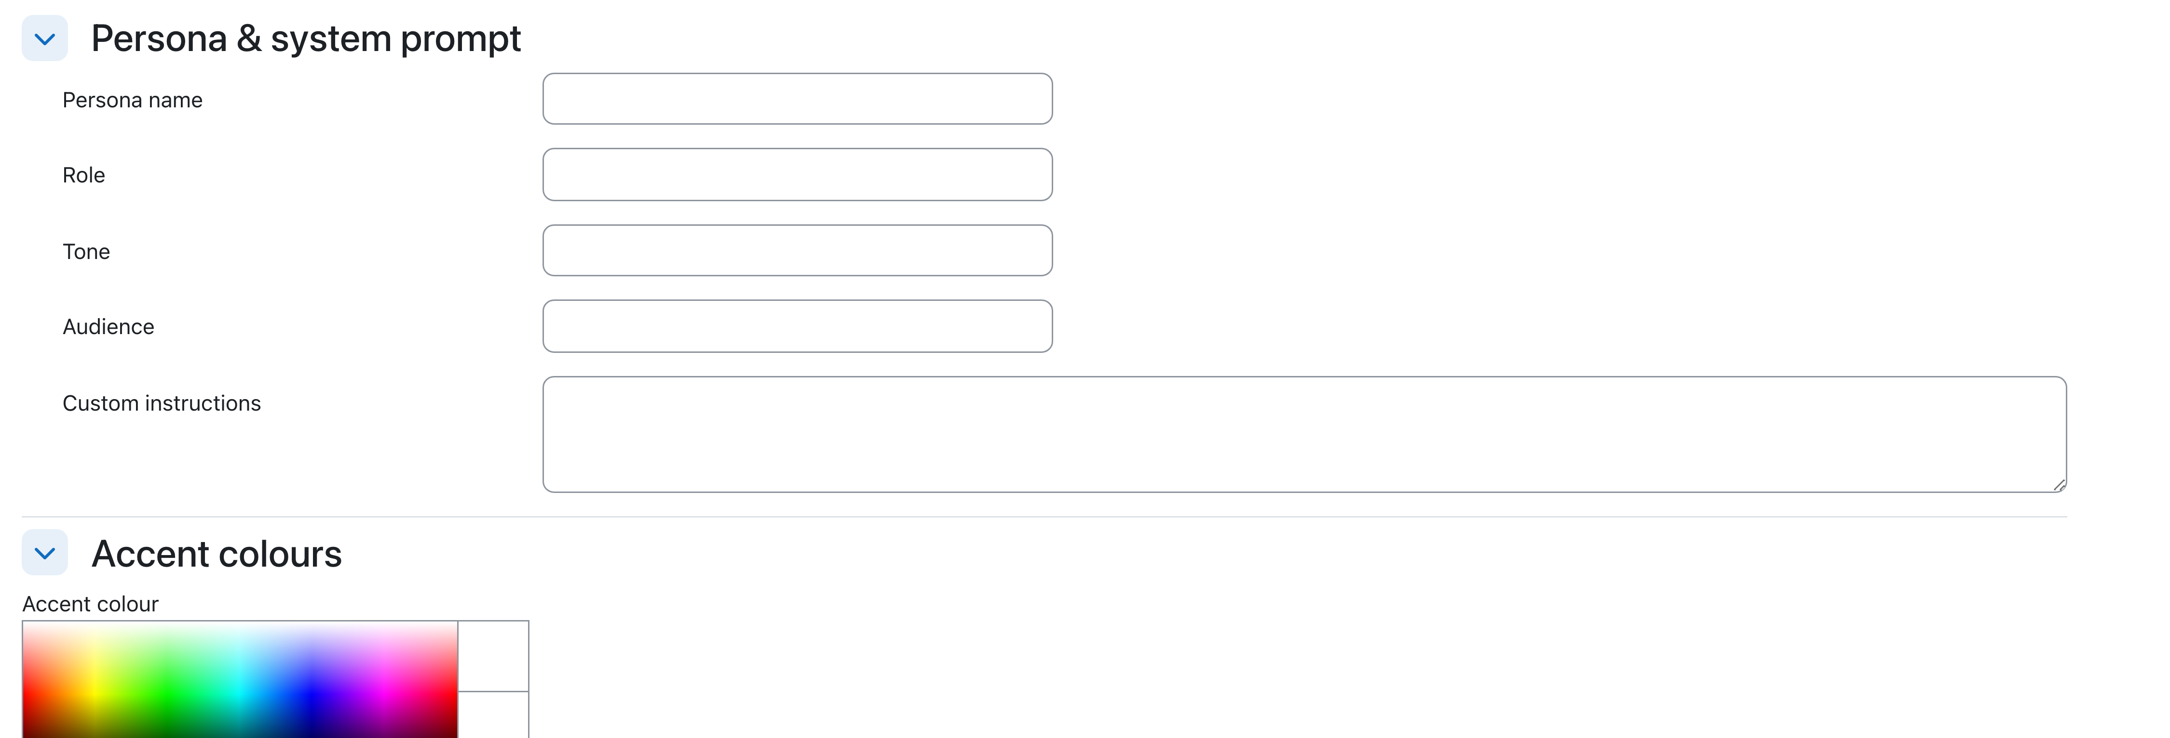
Friendly, no-code design controls in the tutor editor — the persona fields flow straight into a real colour picker (click a swatch or paste a hex code).

A custom persona & system prompt
Give the tutor a name, role, tone and audience, plus free-text instructions that shape how it speaks — e.g. “a patient first-year maths tutor; warm and encouraging.” This persona is sent to the AI as guidance (it never overrides safety or grounding rules).

Your logo and avatar
Upload your own tutor logo (header + launcher) and conversation avatar; they appear throughout the chat.

Ready-made looks — and a bit of fun
Ship with five built-in presets — eLeDia (default), Forest, Midnight, High contrast, and the playful HAL 9000 — each a complete, legible palette plus a starter persona. Apply one with a single click as your site default or to any individual block. Every preset opens as the docked floating panel.
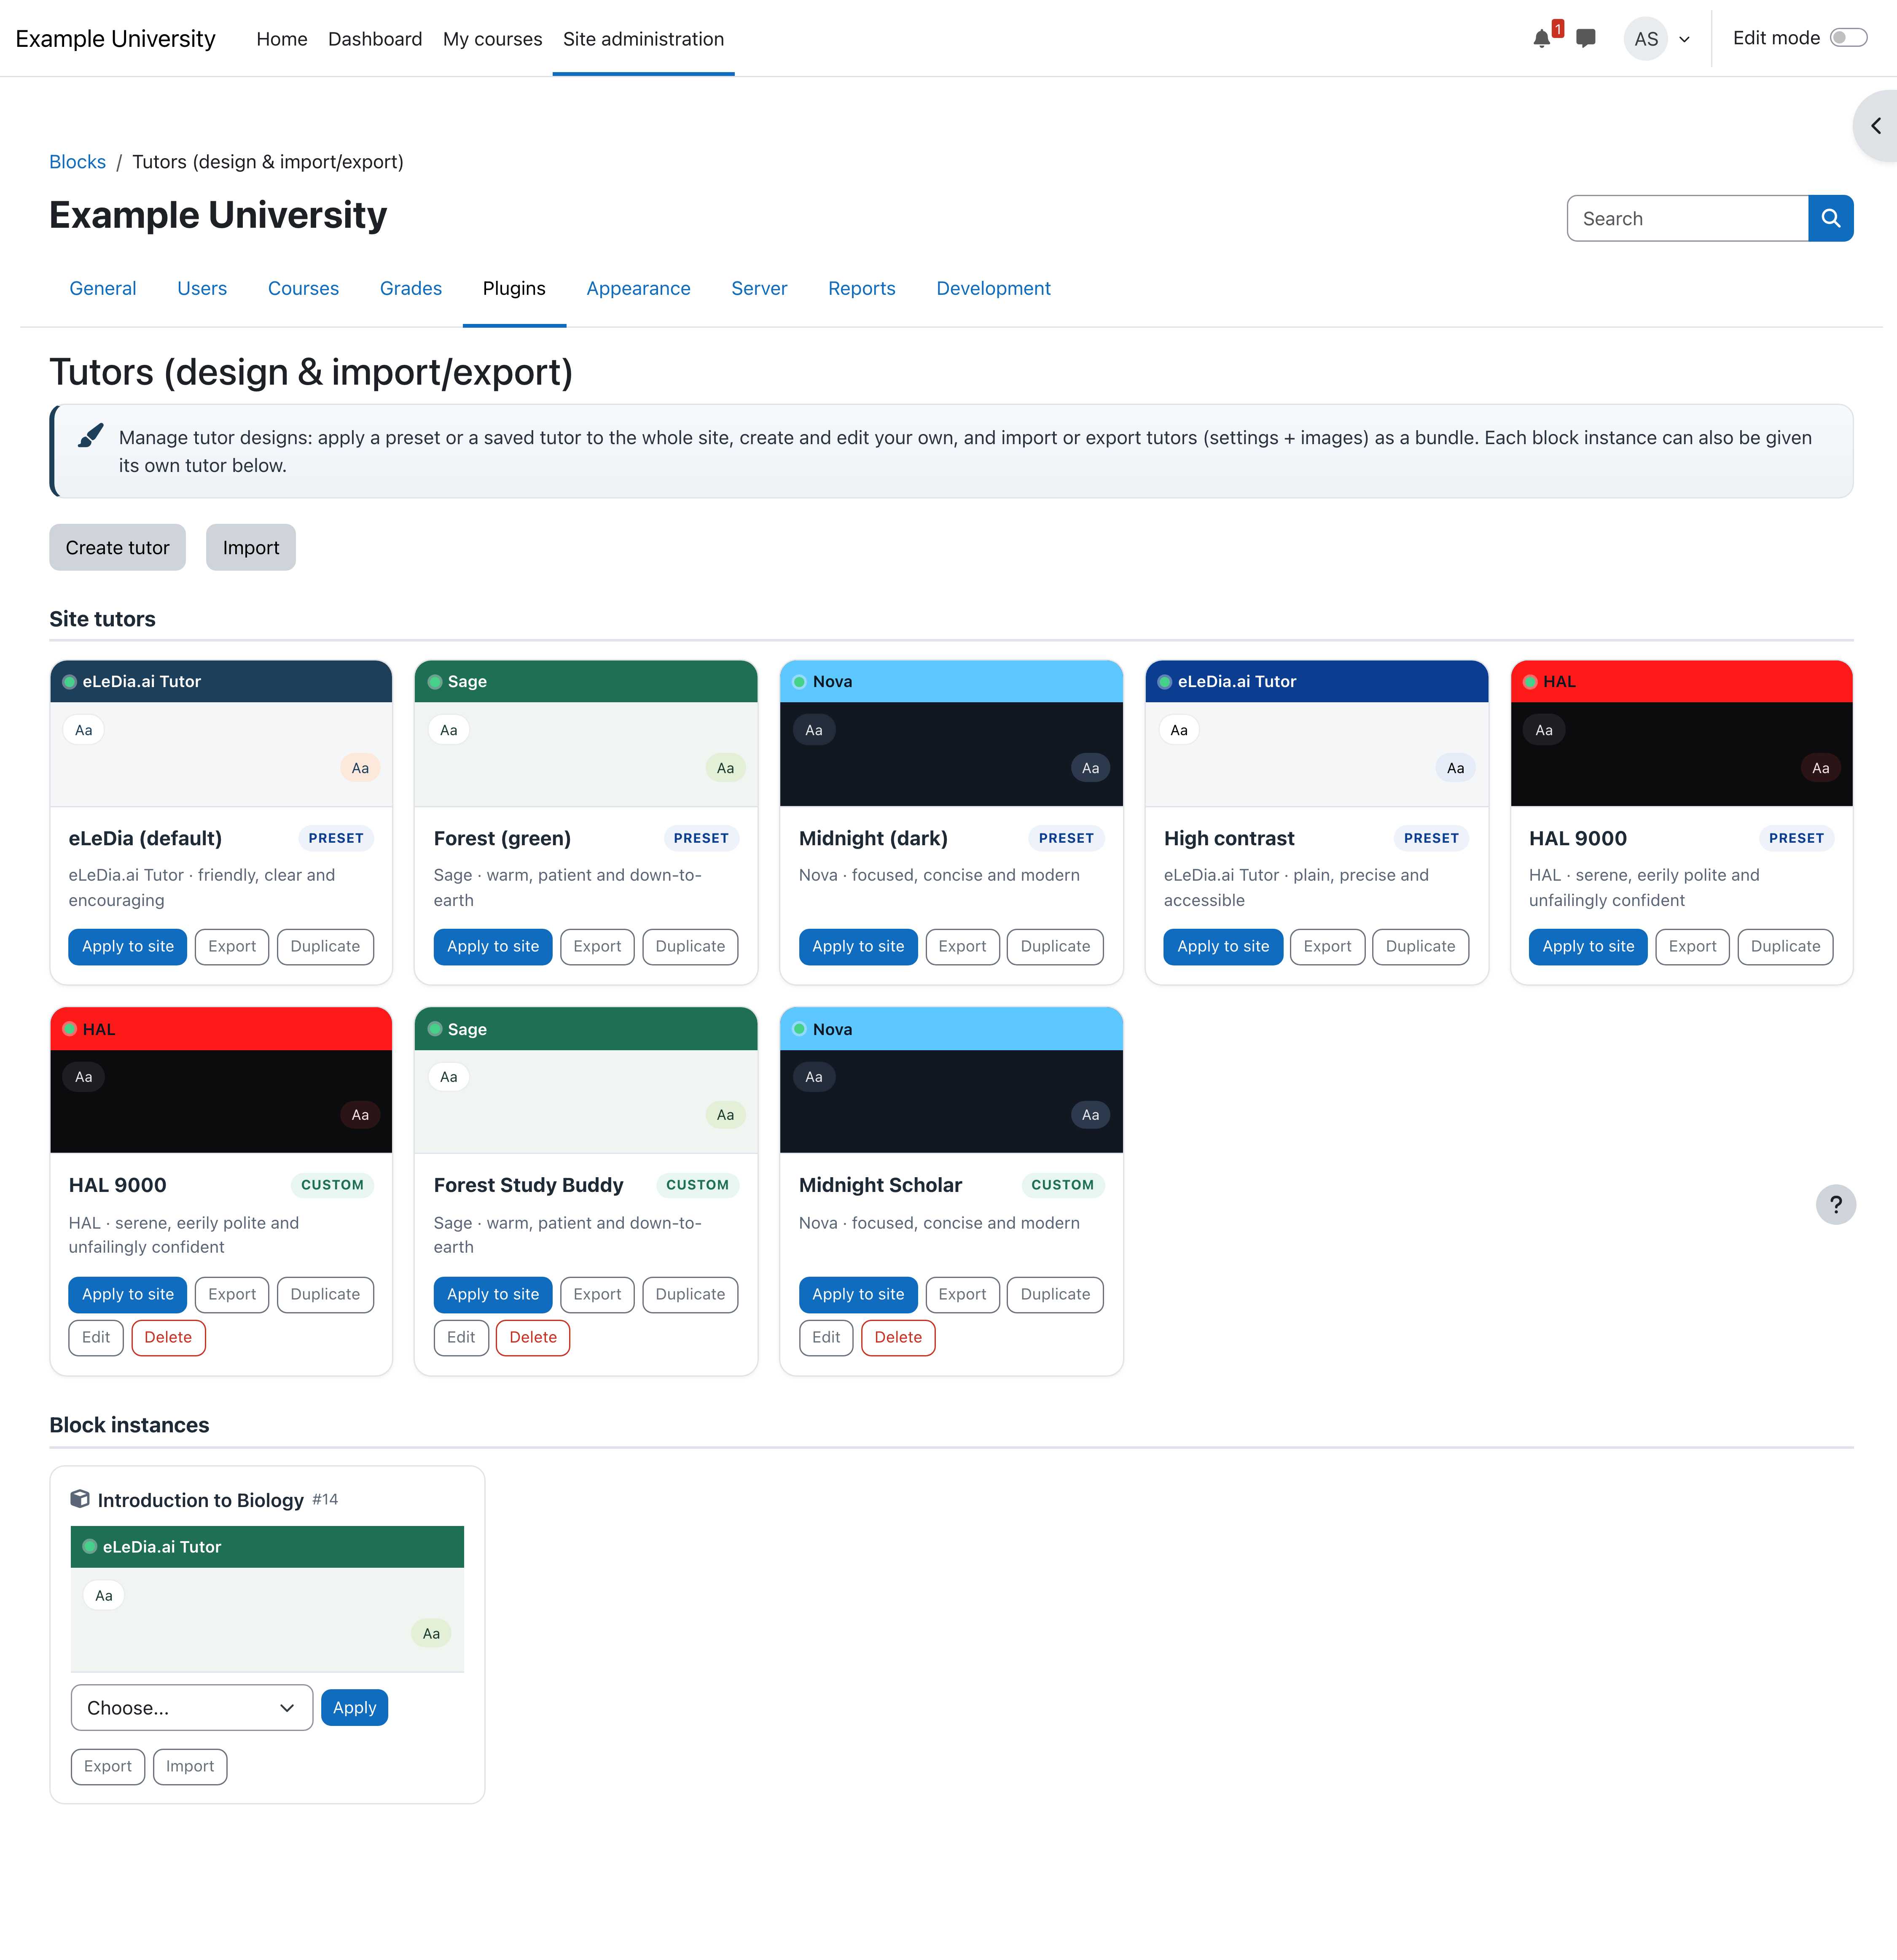
The Tutors library: built-in presets and your own saved profiles, each with a live palette preview — apply to the whole site or any single block, export or import in one click.

Save, share and reuse with “Tutor profiles”
Create your own named tutor profiles and export / import them as a single file — settings and images included. Build a look once and reuse it across courses or even other Moodle sites. Importing a profile snapshots it onto the target (no hidden links to break later).

White-label
Replace or hide the footer credit for a fully white-labelled assistant, and add institution-specific custom CSS where you want pixel-level control.

4. Who controls what — admin governance & teacher self-service
The tutor balances institutional consistency with course-level freedom.
- Admins set the site-wide default tutor and, for every setting, decide whether teachers may override it per course. By default all visual/persona settings are open to teachers; an admin can lock any of them down to keep a consistent look.
- Teachers tailor their course tutor using only the settings the admin has opened up — with the same friendly colour pickers and dropdowns.
- Teacher self-service import/export. From the block’s configuration, an editing teacher can export their tutor, import one they were sent, or apply one of the institution’s ready-made tutors — scoped to their own course.
- Central management. Admins manage the whole tutor library (presets and saved profiles), apply a tutor to the site or to any specific block, and import/export site-wide tutors — all from one page.
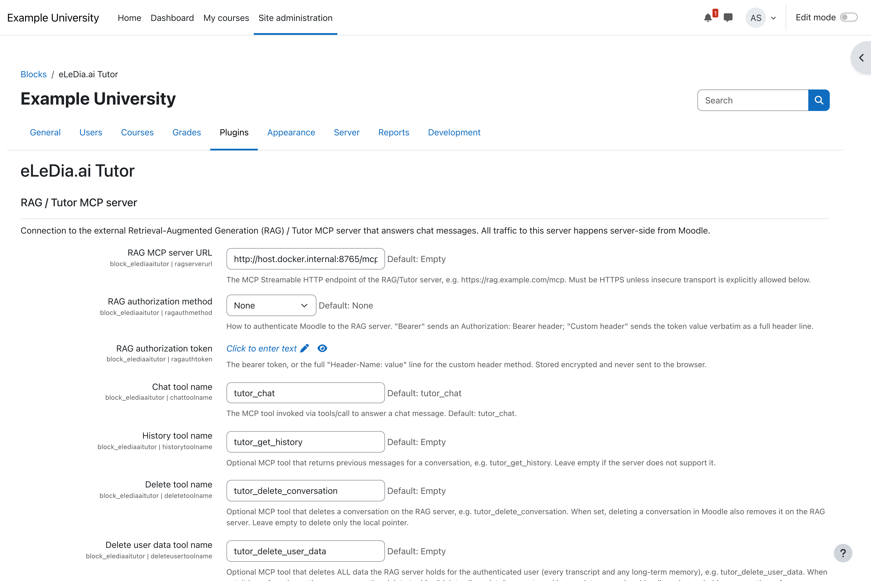
The block’s site settings: the secure connection to the RAG / Tutor service and the central place where admins configure the tutor and choose which settings teachers may override per course.

5. Two ways to use the same tutor
The same assistant is available wherever your users work.

In Moodle — for every learner and teacher
The native chat block (Sections 2–3), embedded directly in the course.

In any MCP host — for power users, staff and integrations
Because Moodle is exposed as a Model Context Protocol (MCP) server, the very same Moodle capabilities can be used from external AI clients — for example Claude Desktop, AI-enabled IDEs, or a custom MCP host you build. A staff member connects their preferred AI app and works with Moodle data directly, using a personal, permission-scoped token.

6. Agentic and grounded — not just a chatbot
- Retrieval-augmented (RAG): answers are based on your course content, not just the model’s training data — reducing hallucination and keeping responses on-curriculum. Sources are shown alongside the answer.
- Agentic: the tutor reasons in steps and uses tools — it can look up the learner’s enrolled courses, upcoming assignments and deadlines, grades, course contents and announcements, search content, and more — live, from Moodle.
- Permission-aware by design: every Moodle lookup runs under the learner’s own identity and capabilities. The tutor can never reveal data the user couldn’t already access themselves.
- General-knowledge mode. Where a course has no knowledge base yet, the tutor can still help from the model’s general knowledge (clearly indicated) — or be restricted to grounded answers only.
Example questions it handles well
- “Which courses am I enrolled in, and what should I focus on this week?”
- “What do I need to do for this week’s assignment, and when is it due?”
- “Explain this week’s topic and point me to the right resource in the course.”
- “How am I doing so far — what are my current grades?”

7. Always current — automatic content ingestion
A tutor is only as good as its knowledge. eLeDia’s ingestion continuously feeds your course content into the RAG knowledge base so answers stay grounded and up to date. It extracts the teaching text from your activities and resources and hands it to the RAG service — automatically on every change, and on demand via a bulk re-index.
- Broad coverage: Moodle’s core activities and resources (Book, Page, Lesson, Quiz, Glossary, Assignment, File, Folder, SCORM, IMS packages, H5P and more) plus popular add-ons.
- Automatic and incremental: new, changed or deleted content syncs straight away; a single re-index refreshes an entire course.
- Privacy-friendly: only teaching content is ingested — never learner submissions or answers.
- Multi-tenant clean: deterministic source identifiers keep the knowledge base tidy across many Moodle instances.
- Extensible: new activity types can be supported without changing core code.

8. Insight for teachers — question analytics
An opt-in, privacy-safe analytics report shows teachers what learners are asking — without any learner identities. It turns everyday questions into a picture of where a cohort needs help.
- At-a-glance stats: total questions, questions in the last 7 days, and how many answers were grounded in course materials.
- Confusion hotspots: questions clustered by topic / primary source, so you can see which materials trigger the most questions — linked to the activity.
- Trend over time and a recent-questions list (question text only, no names), with the answer style used.
- Data is retained only as long as you configure and is covered by the privacy tools.
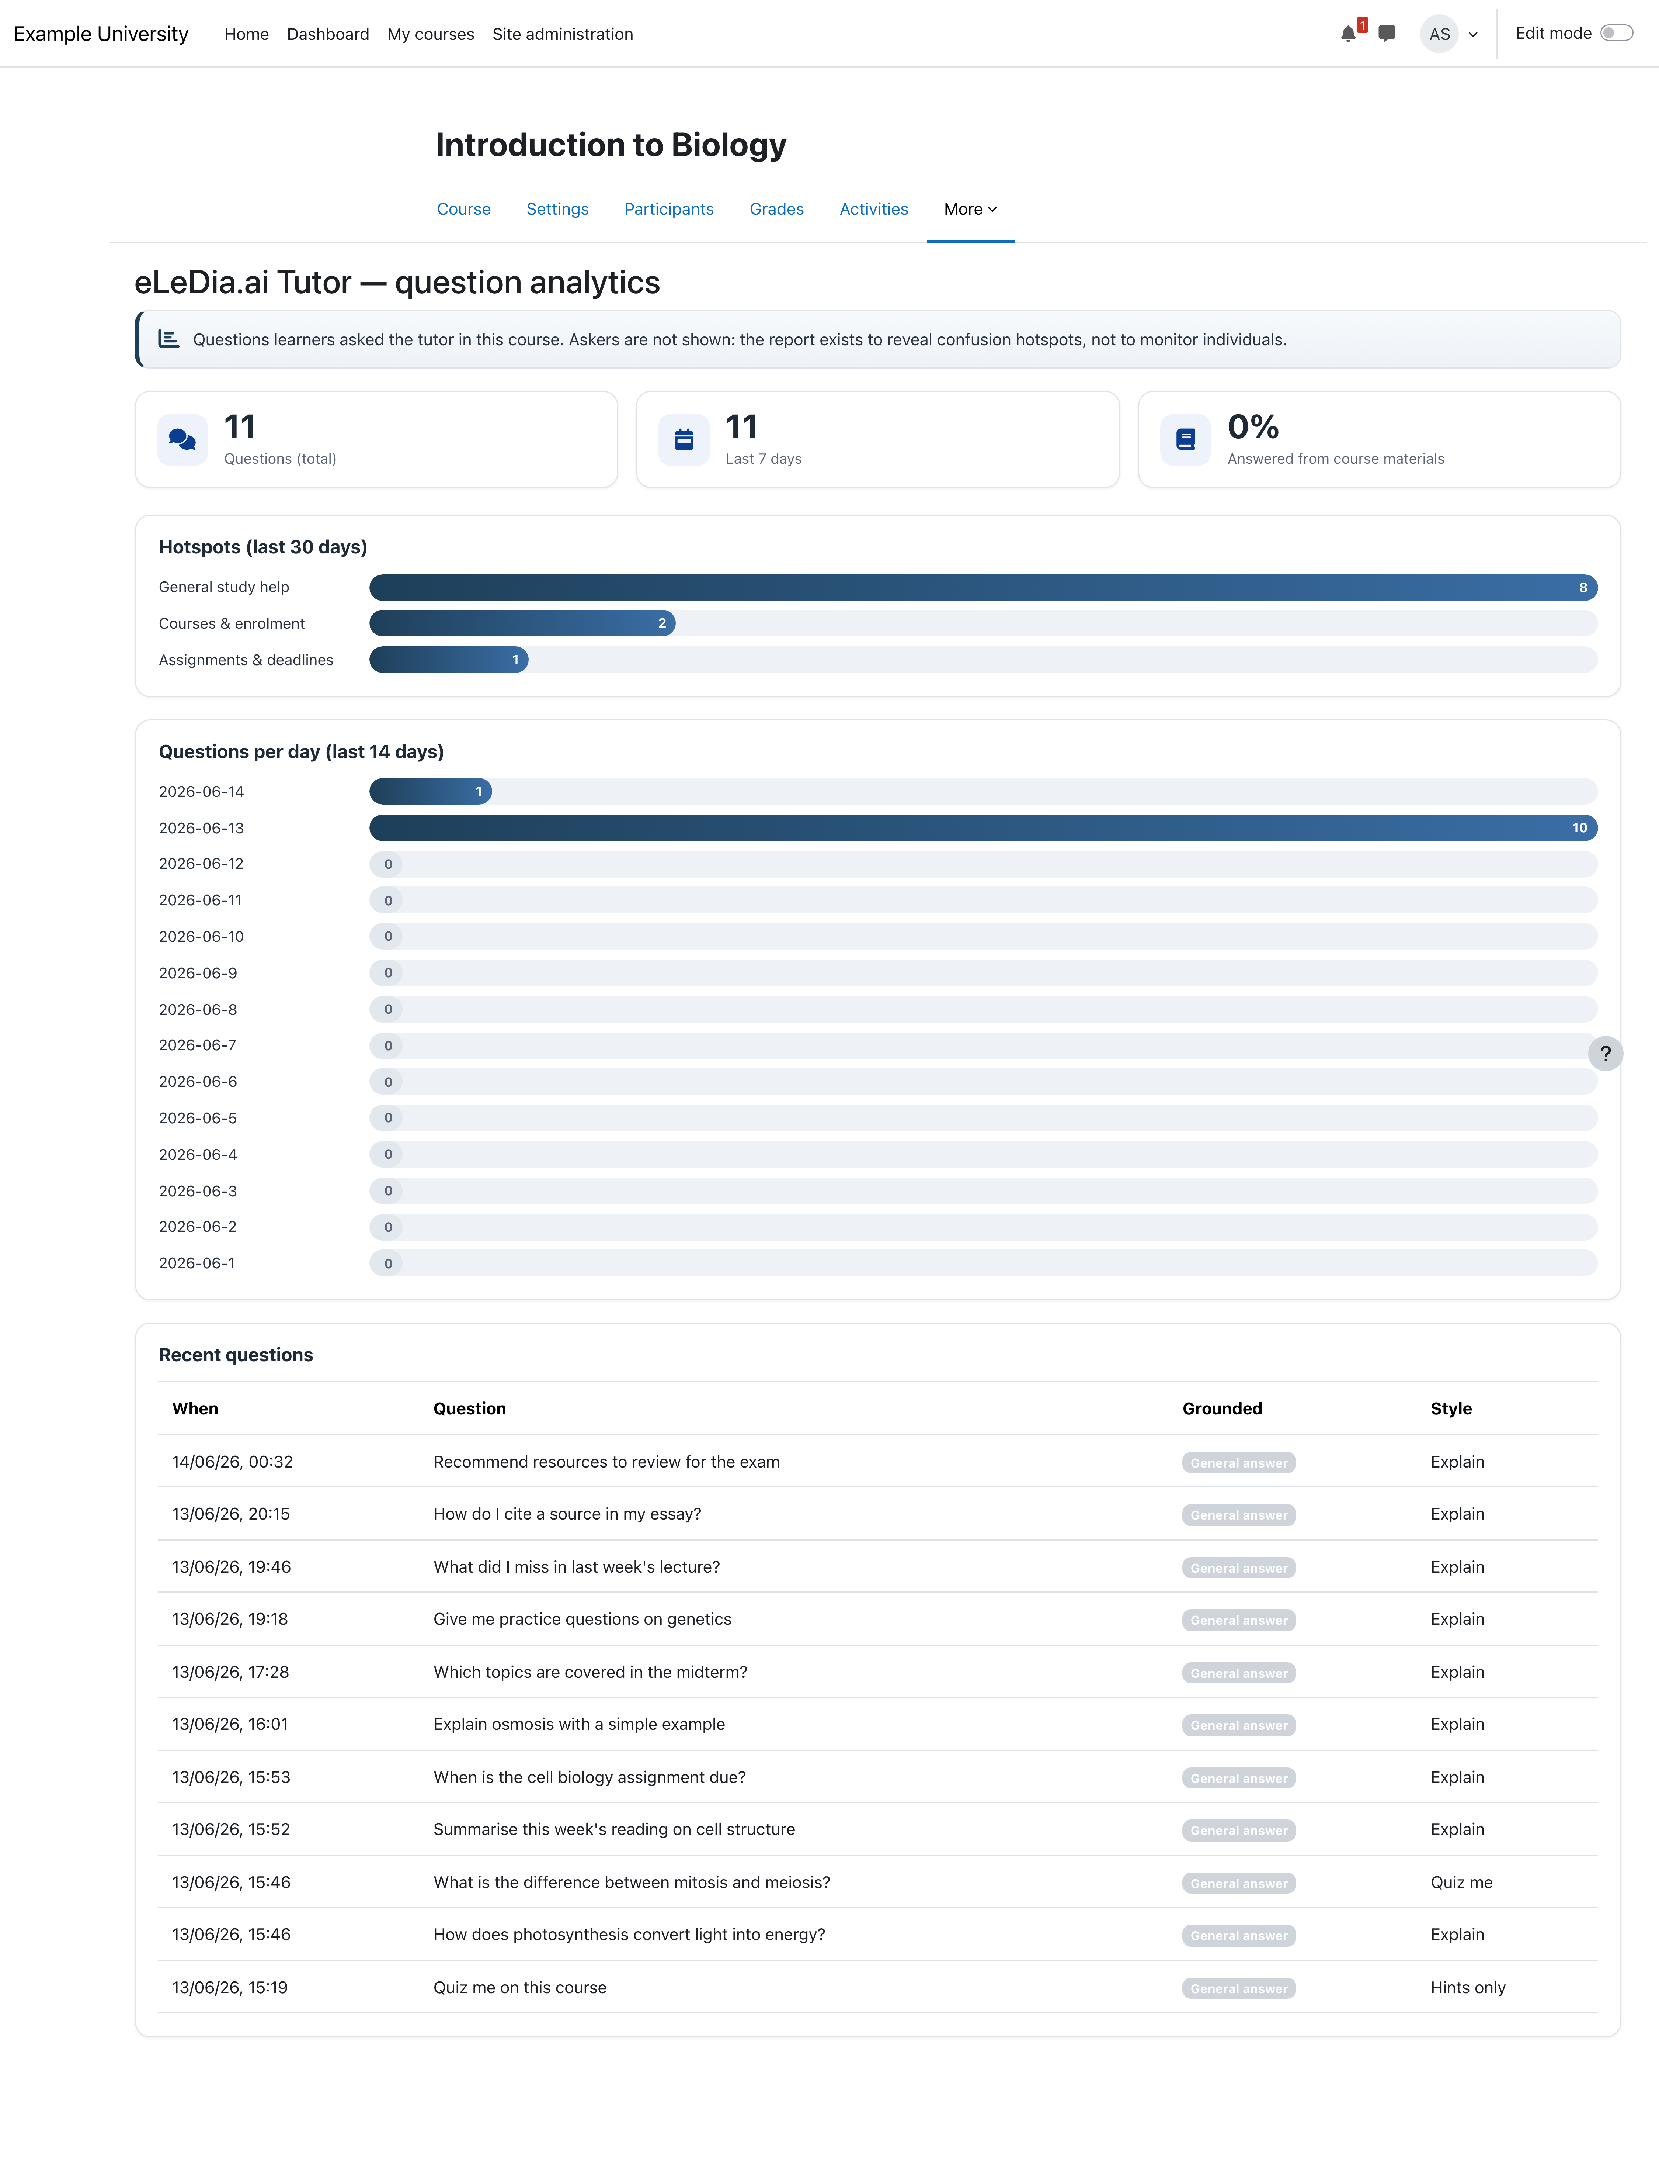
The privacy-safe question-analytics report: at-a-glance stats, confusion hotspots clustered by topic, a questions-per-day trend and the name-free recent-questions list.

9. Your model, your data — your choice
The RAG service connects to a LiteLLM gateway, giving you full control over which large language model powers the tutor:
- Use eLeDia-hosted models — we operate the gateway and provide access to leading models (for example OpenAI), with European hosting options.
- Bring your own provider — point the gateway at your own foundation-model subscription or a self-hosted/open model. Switch or mix providers without changing anything in Moodle.
This means no vendor lock-in at the model layer, predictable cost control, and the ability to meet data-residency and procurement requirements.

10. Security, privacy & data sovereignty
Built to Moodle and enterprise security standards from day one:
- Secrets stay server-side. Moodle tokens and model/provider credentials are never exposed to the browser; the learner’s app only ever talks to Moodle.
- User-scoped, short-lived tokens. Each AI interaction uses a token bound to the individual learner and the configured service — automatically provisioned, rotated, revoked and auditable.
- Least privilege. The tutor sees exactly what the learner sees — nothing more.
- Documented consent. First-use acknowledgement of your privacy guidelines, with self-service data deletion.
- GDPR-ready. Full Moodle Privacy API support; conversation data and its retention are transparent, exportable and erasable.
- You stay in control of the data flow. Choose where the RAG service and the models run; on-prem / EU hosting options are available.
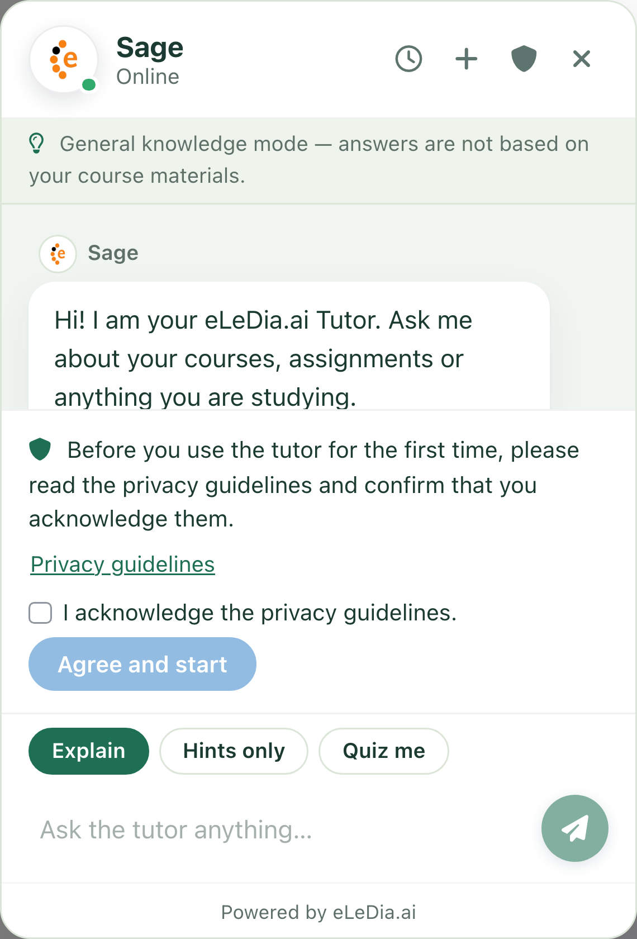
First-use privacy consent: before the first message, learners read and acknowledge your privacy guidelines; they can review them any time and delete their own data.

11. How it works
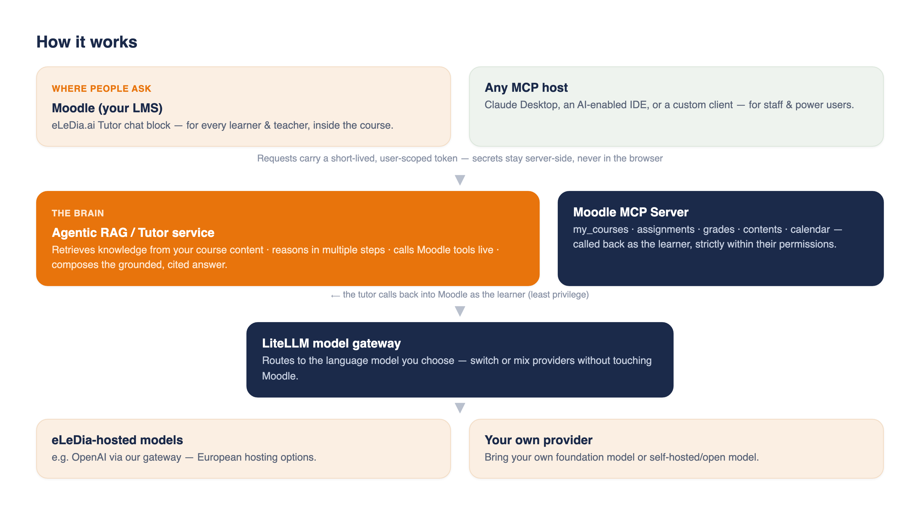
How the pieces fit together — from where people ask, through the agentic RAG service and the Moodle MCP server, to the model gateway and the model you choose.
Step by step, when a learner asks a question:
- They type into the eLeDia.ai Tutor block in Moodle (or their MCP client).
- Moodle hands the request to the agentic RAG service with a short-lived, user-scoped token — never exposed to the browser — and the tutor’s persona.
- The RAG service retrieves relevant passages from your course knowledge base and, when it needs live information (courses, deadlines, grades, a resource), calls back into Moodle through the MCP server — acting as that learner and only seeing what they’re allowed to see.
- It composes the answer using the language model you selected (via the LiteLLM gateway) and returns a grounded, cited response.

12. What you get
Component | Role
eLeDia.ai Tutor (Moodle block) | The in-Moodle chat experience, full branding & tutor profiles, and the secure connector.
Moodle MCP Server (web service) | Exposes Moodle as permission-scoped tools for any AI agent; self-service token management for users.
Agentic RAG / Tutor service | Retrieval over your content + multi-step reasoning + Moodle tool use.
Content ingestion | Extracts course content and feeds the RAG knowledge base — automatically and on demand.
LiteLLM model gateway | Routes to eLeDia-hosted models or your own provider.
Integration & onboarding | Setup, knowledge-base ingestion, model configuration, branding and training.

13. Why eLeDia
- A complete, integrated solution — not a bolt-on chatbot: the LMS, the agent, the tools and the model layer are designed to work together.
- On-brand: fully customisable look and persona, with shareable tutor profiles.
- Open standards (MCP): the same investment serves Moodle and external AI tooling.
- Model-agnostic and data-sovereign — you choose the AI and where it runs.
- Native, accessible, bilingual (English & German) Moodle plugins, CI-tested against current Moodle releases.
- Delivered and supported by eLeDia, a specialist Moodle partner.

14. In plain words (glossary box)
- MCP (Model Context Protocol): an open standard that lets AI assistants use external tools and data sources securely. We use it so any AI client can work with Moodle, and so the tutor can use Moodle as a toolset.
- RAG (Retrieval-Augmented Generation): grounding AI answers in your own content instead of relying solely on the model’s memory.
- Agentic: the AI takes multiple reasoning steps and calls tools (look things up, act) rather than producing a single one-shot reply.
- Tutor profile / preset: a complete, named look-and-persona for the tutor that can be applied, saved, exported and imported.
- LiteLLM: a gateway that gives a single, consistent way to connect to many language-model providers — so the model can be swapped or chosen freely.

*Prepared for sales enablement. Technical references — the plugin README, the

