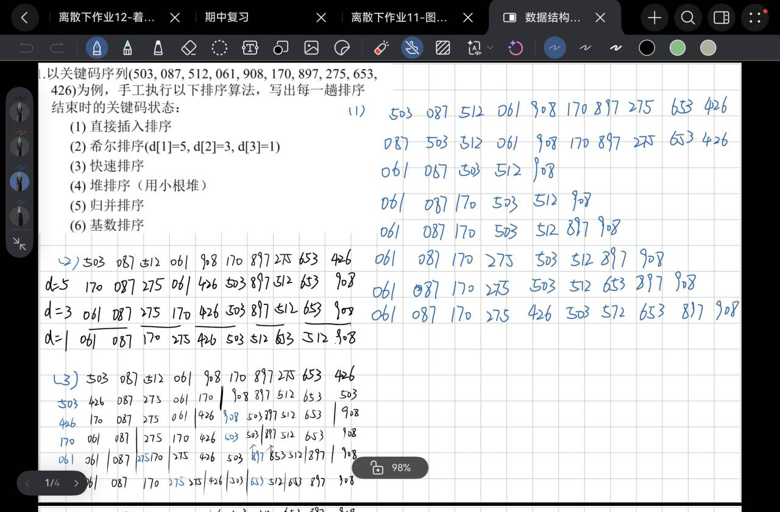
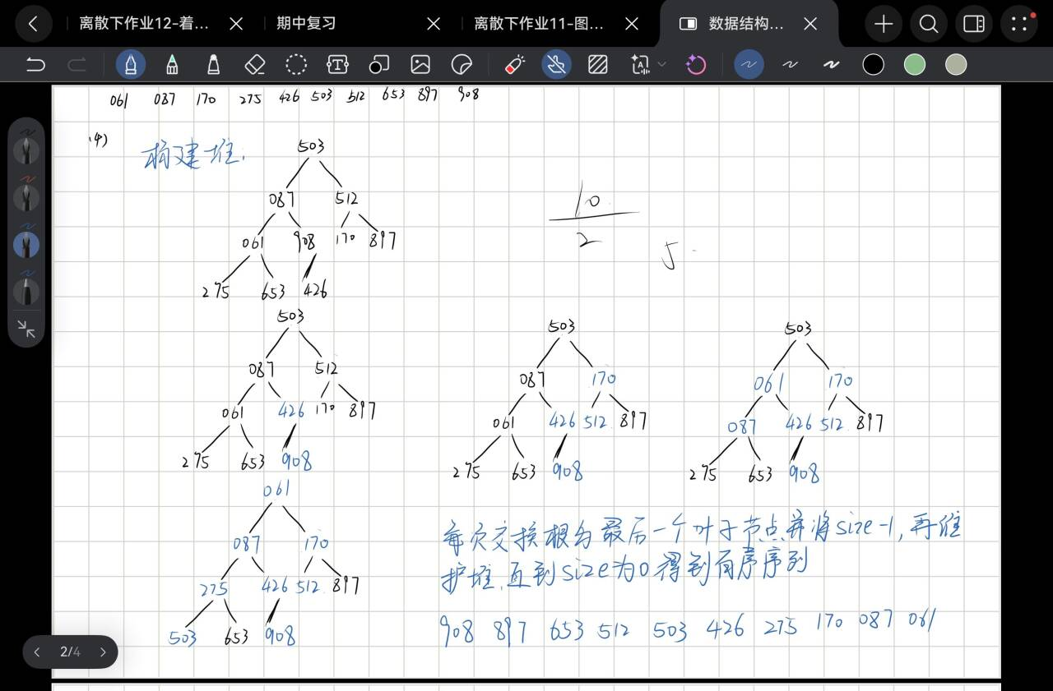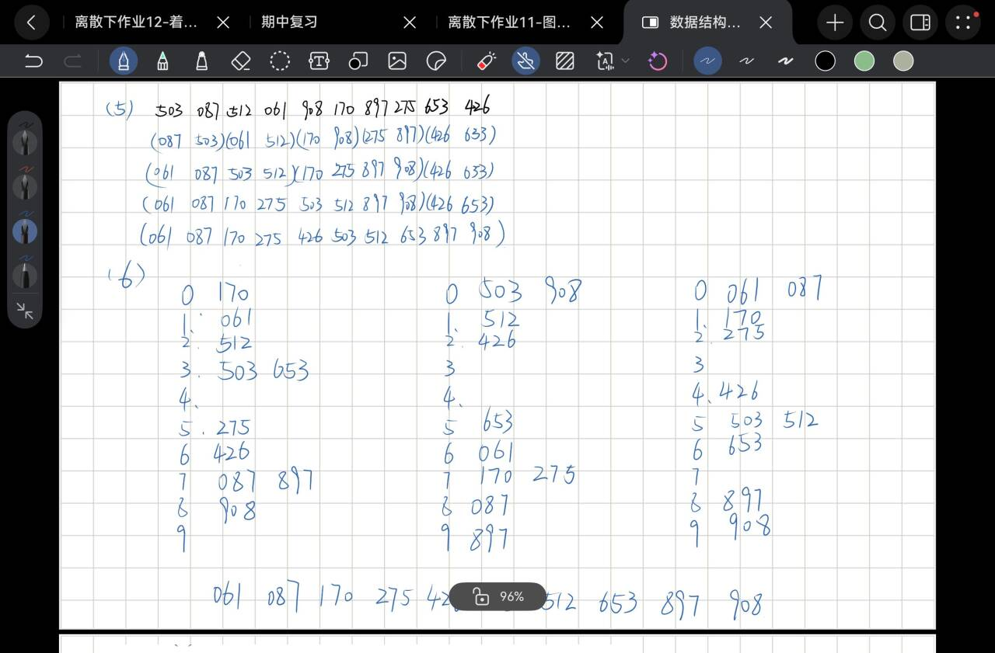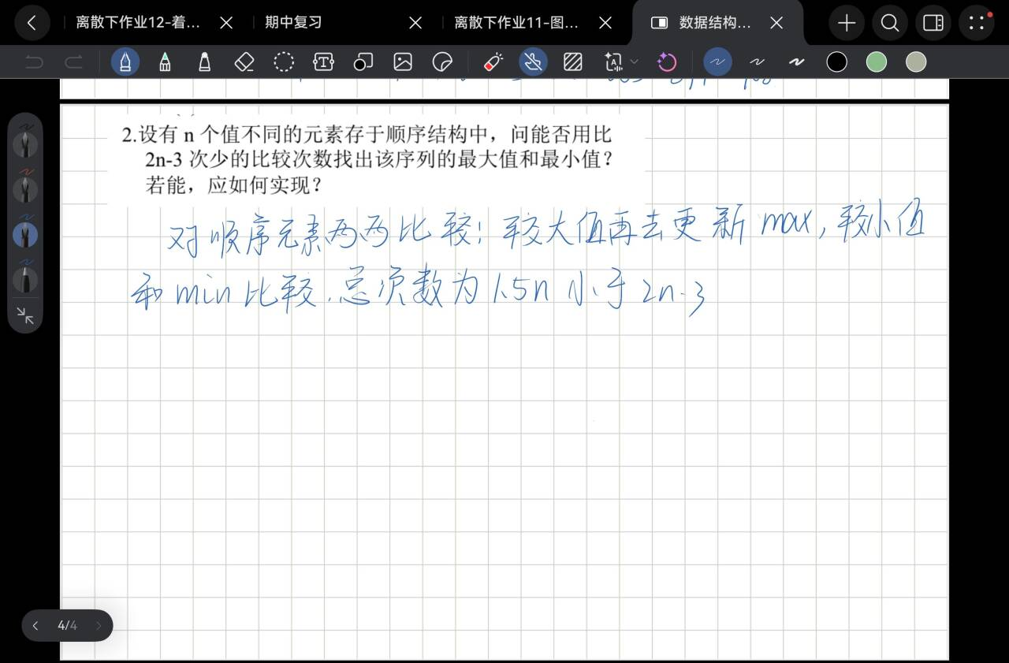
3.
#include <iostream> // 输入输出
#include <vector> // 动态数组
#include <algorithm> // 排序（sort函数）
#include <string> // 字符串（如果需要）
#include <iomanip>
using namespace std;

// 后续写Product结构体和排序逻辑

struct Product {
string id; // 商品编号
string name; // 商品名
string type; // 商品类型
double price; // 商品价格
string desc; // 商品描述信息
};

static void printProduct(const Product& p) {
cout << "商品编号: " << p.id << "\n";
cout << "商品名 : " << p.name << "\n";
cout << "类型 : " << p.type << "\n";
cout << "价格 : " << fixed << setprecision(2) << p.price << "\n";
cout << "描述 : " << p.desc << "\n";
}

// ====================== 双向链表 ======================
class DoublyList {
public:
struct Node {
Product data;
Node* prev{nullptr};
Node* next{nullptr};
explicit Node(Product p) : data(std::move(p)) {}
};

DoublyList() = default;
~DoublyList() { clear(); }

DoublyList(const DoublyList&) = delete;
DoublyList& operator=(const DoublyList&) = delete;

void push_back(const Product& p) {
Node* node = new Node(p);
if (!head_) {
head_ = tail_ = node;
} else {
tail_->next = node;
node->prev = tail_;
tail_ = node;
}
++size_;
}

void clear() {
Node* cur = head_;
while (cur) {
Node* nxt = cur->next;
delete cur;
cur = nxt;
}
head_ = tail_ = nullptr;
size_ = 0;
}

Node* head() const { return head_; }
Node* tail() const { return tail_; }
size_t size() const { return size_; }

// 将链表内容转存到顺序表
vector<Product> toVector() const {
vector<Product> a;
a.reserve(size_);
for (Node* cur = head_; cur; cur = cur->next) {
a.push_back(cur->data);
}
return a;
}

// 打印链表（可选）
void print() const {
int idx = 1;
for (Node* cur = head_; cur; cur = cur->next, ++idx) {
cout << "====== 第 " << idx << " 条 ======\n";
printProduct(cur->data);
}
}

// ------------------ 递归快速排序（链表版） ------------------
// 题目要求用“快速排序的递归算法”对查找表排序，这里在链表上通过“交换节点数据”实现。
void quickSortByPriceNondecreasing() {
if (!head_ || head_ == tail_) return;
quickSort(head_, tail_);
}

private:
Node* head_{nullptr};
Node* tail_{nullptr};
size_t size_{0};

static void swapData(Node* a, Node* b) {
std::swap(a->data, b->data);
}

// 分区：以 h 为枢轴(pivot)，按 price 升序（非递减）排列
static Node* partition(Node* l, Node* h) {
double pivot = h->data.price;
Node* i = l->prev; // i 指向“<= pivot 区”的最后一个节点

for (Node* j = l; j != h; j = j->next) {
if (j->data.price <= pivot) { // 升序：小的放左边
i = (i == nullptr) ? l : i->next;
swapData(i, j);
}
}
i = (i == nullptr) ? l : i->next;
swapData(i, h);
return i;
}

static void quickSort(Node* l, Node* h) {
if (!l || !h || l == h || l == h->next) return;

Node* p = partition(l, h);
// 递归处理枢轴左右两段
if (p && p->prev) quickSort(l, p->prev);
if (p && p->next) quickSort(p->next, h);
}
};

// ====================== 顺序表上的折半查找 ======================
// 数组已按 price 升序。查找指定 price，若有多条同价记录，返回全部下标（0-based）
static vector<int> binarySearchAll(const vector<Product>& a, double target) {
int n = (int)a.size();
int lo = 0, hi = n - 1;
int pos = -1;

// 先找任意一个匹配位置
while (lo <= hi) {
int mid = lo + (hi - lo) / 2;
if (a[mid].price == target) {
pos = mid;
break;
} else if (a[mid].price < target) {
lo = mid + 1;
} else {
hi = mid - 1;
}
}
if (pos == -1) return {};

// 向两边扩展，找出所有同价
int L = pos, R = pos;
while (L - 1 >= 0 && a[L - 1].price == target) --L;
while (R + 1 < n && a[R + 1].price == target) ++R;

vector<int> idx;
for (int i = L; i <= R; ++i) idx.push_back(i);
return idx;
}

// ====================== 主程序（菜单交互） ======================
static Product readOneProduct() {
Product p;
cout << "商品编号: ";
getline(cin, p.id);
cout << "商品名 : ";
getline(cin, p.name);
cout << "商品类型: ";
getline(cin, p.type);
cout << "价格 : ";
string priceLine;
getline(cin, priceLine);
p.price = stod(priceLine);
cout << "描述信息: ";
getline(cin, p.desc);
return p;
}

int main() {
ios::sync_with_stdio(false);
cin.tie(nullptr);

DoublyList list;
vector<Product> seq; // 顺序表

while (true) {
cout << "\n================ 菜单 ================\n";
cout << "1. 输入商品记录(存入双向链表)\n";
cout << "2. 快速排序(按价格非递减/升序)\n";
cout << "3. 转存到顺序表\n";
cout << "4. 折半查找(按价格查找)\n";
cout << "5. 打印链表\n";
cout << "6. 打印顺序表\n";
cout << "0. 退出\n";
cout << "请选择: ";

string opLine;
if (!getline(cin, opLine)) break;
if (opLine.empty()) continue;
int op = stoi(opLine);

if (op == 0) {
cout << "已退出。\n";
break;
} else if (op == 1) {
list.clear();
seq.clear();

cout << "请输入记录条数 n: ";
string nLine;
getline(cin, nLine);
int n = stoi(nLine);

cout << "请逐条输入记录（允许空格）。\n";
for (int i = 1; i <= n; ++i) {
cout << "\n---- 第 " << i << " 条 ----\n";
Product p = readOneProduct();
list.push_back(p);
}
cout << "输入完成，共 " << list.size() << " 条。\n";

} else if (op == 2) {
if (list.size() == 0) {
cout << "链表为空，请先输入数据。\n";
continue;
}
list.quickSortByPriceNondecreasing();
cout << "排序完成（链表已按价格升序）。\n";

} else if (op == 3) {
if (list.size() == 0) {
cout << "链表为空，请先输入数据。\n";
continue;
}
seq = list.toVector();
cout << "已转存到顺序表，共 " << seq.size() << " 条。\n";

} else if (op == 4) {
if (seq.empty()) {
cout << "顺序表为空：请先排序并转存到顺序表。\n";
continue;
}
cout << "请输入要查找的价格: ";
string tLine;
getline(cin, tLine);
double target = stod(tLine);

auto idx = binarySearchAll(seq, target);
if (idx.empty()) {
cout << "查找失败：顺序表中不存在价格为 " << fixed << setprecision(2) << target << " 的记录。\n";
} else {
cout << "查找成功，共找到 " << idx.size() << " 条记录。\n";
for (int id : idx) {
cout << "\n===== 位序(从1开始): " << (id + 1) << " =====\n";
printProduct(seq[id]);
}
}

} else if (op == 5) {
if (list.size() == 0) cout << "链表为空。\n";
else list.print();

} else if (op == 6) {
if (seq.empty()) {
cout << "顺序表为空。\n";
} else {
for (int i = 0; i < (int)seq.size(); ++i) {
cout << "====== 第 " << (i + 1) << " 条 ======\n";
printProduct(seq[i]);
}
}

} else {
cout << "无效选项。\n";
}
}
return 0;
}

