No Man's Sky Icon Pack
Charging Animation Setup Guide
Set your NMS animations as your lock screen when charging — Samsung Modes & Routines
NOTE: This guide is for Samsung Galaxy phones on One UI 4.0 or higher. If you do not see Modes and Routines in Settings, search for it in the Galaxy Store and install it free.

How It Works
When you plug your phone in to charge, Samsung Routines automatically changes your lock screen to one of your NMS charging animations. When you unplug, it resets back. Follow these 9 steps to set it up.

TIP: You can create two separate routines — one for wired charging and one for wireless — each showing a different NMS animation.

Step-by-Step
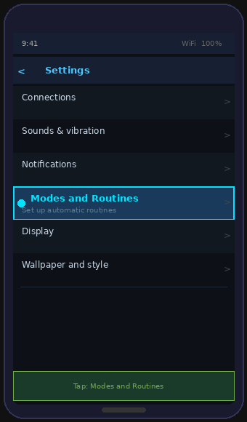 | STEP 1 Settings  Open Settings and tap Modes and Routines  Open the Settings app on your Samsung phone.  Scroll down the list until you see Modes and Routines.  It sits between Notifications and Display.  Tap it to open.

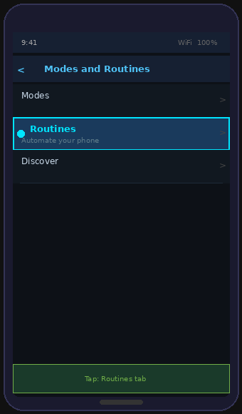 | STEP 2 Modes and Routines  Tap the Routines tab  At the top of the screen you will see two tabs.  Tap the Routines tab on the right.  This is where your automated actions live.

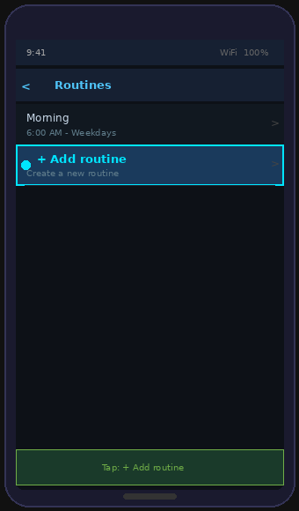 | STEP 3 Routines Screen  Tap + to add a new routine  You will see any existing routines listed.  Tap the blue + button or Add routine at the top.  This opens the routine builder.

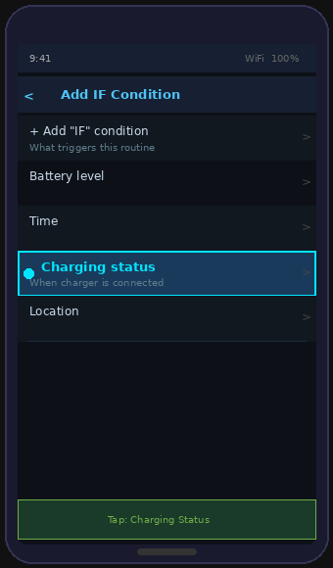 | STEP 4 Set the IF Condition  IF = Charging Status  Tap + Add IF condition.  Scroll down the list and tap Charging Status.  This is the trigger — what causes the routine to run.  In this case, it runs when a charger is connected.

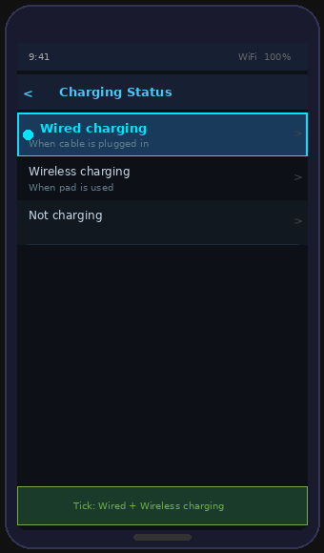 | STEP 5 Choose Charging Type  Tick Wired charging AND Wireless charging  Tick both Wired charging and Wireless charging.  This ensures the animation plays whether you use a  cable or a wireless charging pad.  Tap Done to confirm.

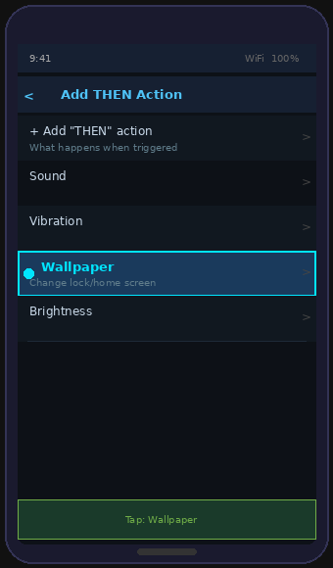 | STEP 6 Add the THEN Action  THEN = Wallpaper  Tap + Add THEN action.  Scroll down and tap Wallpaper.  This sets what happens when the charger is plugged in.  Your NMS animation will appear on the lock screen.

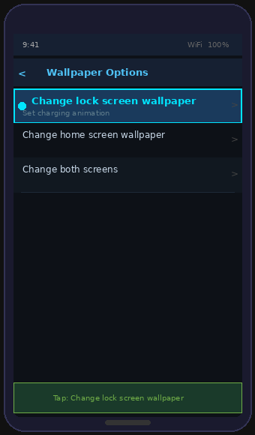 | STEP 7 Lock Screen Wallpaper  Tap Change lock screen wallpaper  Tap Change lock screen wallpaper.  On the next screen, tap Gallery.  Navigate to the NMS Charging Animations folder.  Tap the animation file you want to use.  Tap Set as wallpaper to confirm.

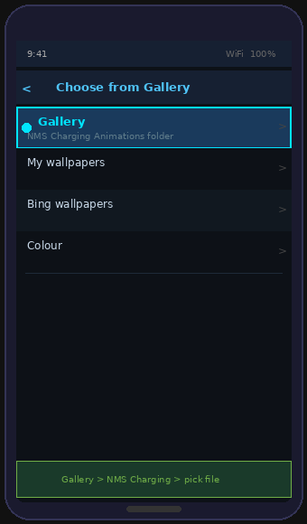 | STEP 8 Choose Your File  Gallery > NMS Charging Animations > pick file  In Gallery, open the NMS Charging Animations folder.  You will see 5 files — charging_1 to charging_5.  Tap the one you want — Samsung will preview it.  Tap Set as wallpaper when you are happy with it.

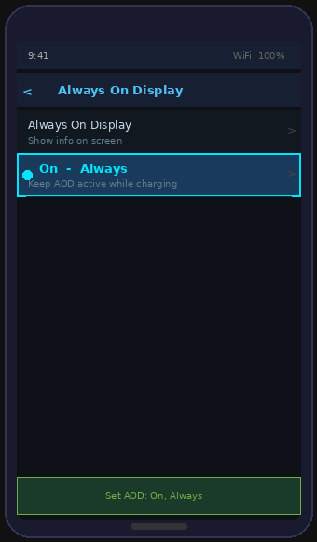 | STEP 9 Always On Display  Add THEN = Always On Display set to Always  Tap + Add THEN action again.  Tap Always On Display.  Set it to On and choose Always.  Leave the When routine ends section with its 2 default  actions — these reset your screen when you unplug.

Save and Test
- Give your routine a name — e.g. "NMS Charging"
- Tap Save in the top right corner
- Plug your phone in — your NMS animation should appear on the lock screen!

TIP: To change animation later, just edit the routine and swap the Gallery file. You can also duplicate the routine for a different animation on wired vs wireless charging.

Enjoy your NMS charging screen! 🚀

