No Man's Sky Icon Pack
Charging Animation Setup Guide
Set your NMS animations as your Samsung lock screen when charging — step by step with real screenshots
NOTE: Samsung Galaxy phones only — requires One UI 4.0 or higher. If you do not see Modes and Routines in Settings, search Galaxy Store and install it free.

How It Works
When you plug your phone in, Samsung Routines automatically changes your lock screen to your chosen NMS charging animation. When you unplug, it resets back automatically.

TIP: Set up two routines — one for wired, one for wireless — each with a different NMS animation for variety.

Step-by-Step Guide
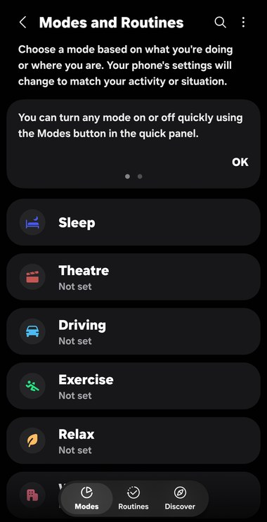 | STEP 1 Open Modes and Routines  Settings > Modes and Routines  Open your phone Settings app.  Scroll down until you see Modes and Routines.  It sits between Notifications and Display.  Tap it to open.  • You will see the Modes screen with Sleep, Theatre, Driving etc.  • Tap the Routines tab at the bottom to continue.

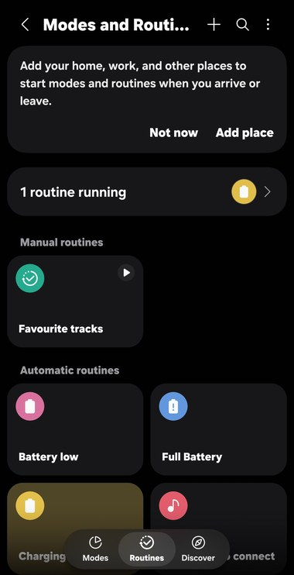 | STEP 2 Go to Routines  Tap the Routines tab at the bottom  At the bottom of the screen tap Routines.  You will see any existing routines listed here  (Battery low, Full Battery etc. may already be there).  • Tap the + button at the top right to create a new routine.

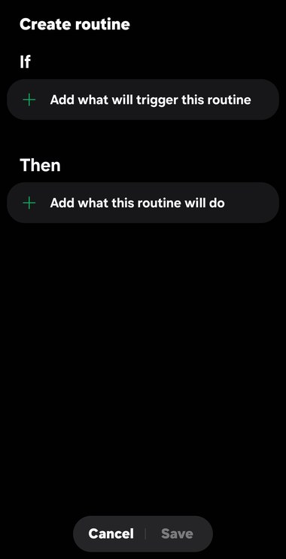 | STEP 3 Create a New Routine  Tap + Add what will trigger this routine  You will see the Create routine screen with two sections:  • IF — what triggers the routine  • THEN — what happens when triggered  Tap the + button under IF first.  This opens the condition list.

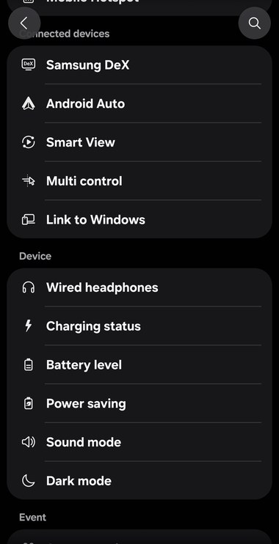 | STEP 4 Set IF = Charging Status  Scroll down to Device > tap Charging status  You will see a list of trigger conditions.  Scroll down past Connected devices to the Device section.  • Tap Charging status — this triggers the routine  whenever a charger is connected.

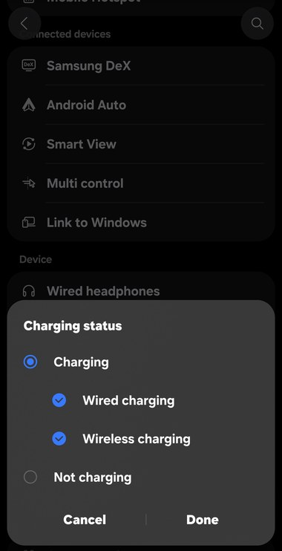 | STEP 5 Choose Charging Type  Tick Wired charging AND Wireless charging > Done  A popup appears showing Charging status options.  • Tick Wired charging ✓  • Tick Wireless charging ✓  • Leave Not charging unticked  Tap Done to confirm.  This means the animation plays on both cable and wireless pad.

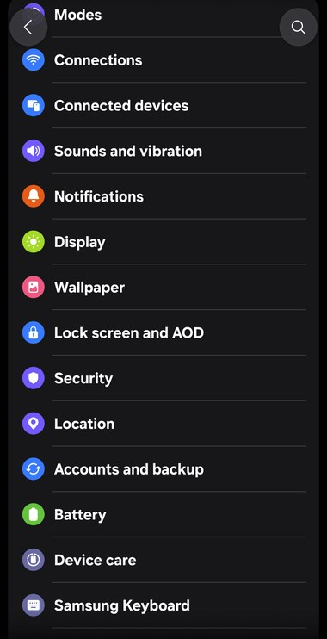 | STEP 6 Add THEN = Wallpaper  Tap + Add what this routine will do > Wallpaper  Now tap the + button under THEN.  A list of actions appears.  • Scroll down and tap Wallpaper  (you may need to scroll past Lock screen and AOD).  This sets what happens when your charger is connected.

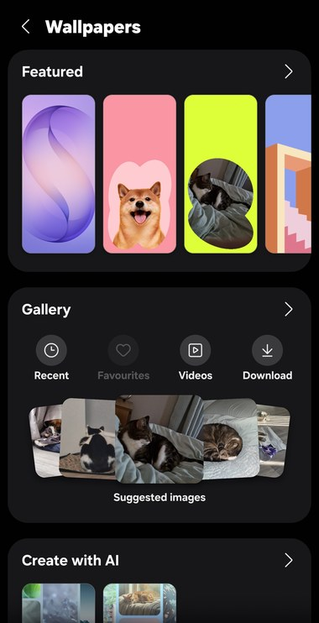 | STEP 7 Open Gallery  Tap Gallery > Videos or navigate to your folder  The Wallpapers screen opens.  • Tap Gallery in the middle section.  • Tap Videos or navigate to your  NMS Charging Animations folder.  Your downloaded NMS animations will appear here.

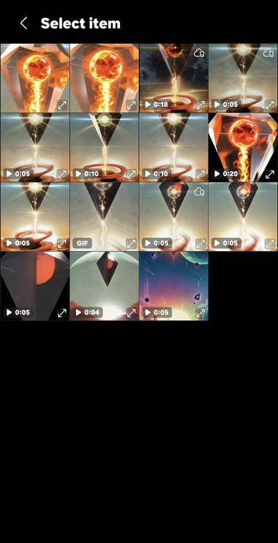 | STEP 8 Choose Your NMS Animation  Tap the animation you want as your charging screen  You will see your NMS animation files as thumbnails.  Each shows its duration (0:05, 0:10, 0:18 etc.).  • Tap the animation you want to use.  • Samsung will show a preview on your lock screen.  • Tap Done or Set as wallpaper to confirm.

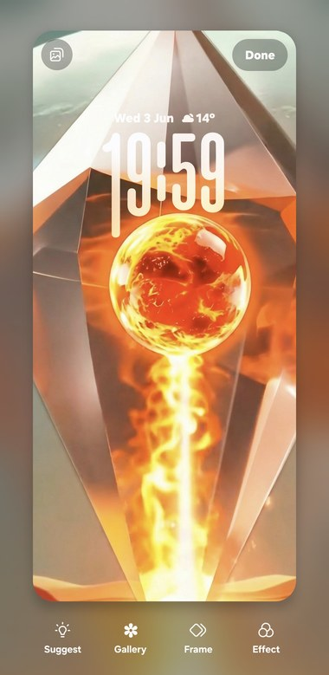 | STEP 9 Lock Screen Preview  Tap Done to confirm your animation  You will see a live preview of your NMS animation  on the lock screen with the time and date.  • If it looks good, tap Done in the top right.  • If you want a different one, tap Gallery again  and pick another file.  The animation is now set as your charging wallpaper!

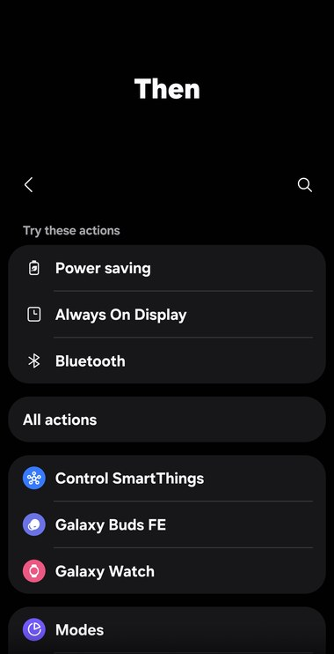 | STEP 10 Add THEN = Always On Display  Tap + Add action > Always On Display  Back on the routine screen, tap + Add action again.  • You will see suggested actions including  Always On Display at the top.  • Tap Always On Display.

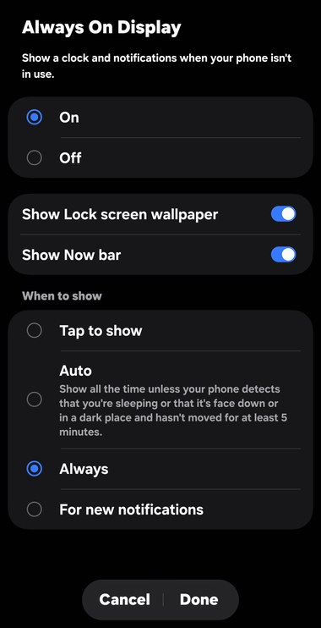 | STEP 11 Set Always On Display to Always  Select On > Always > Done  The Always On Display settings appear.  • Select On (blue radio button).  • Under When to show, select Always.  • Make sure Show Lock screen wallpaper is toggled ON.  Tap Done to confirm.

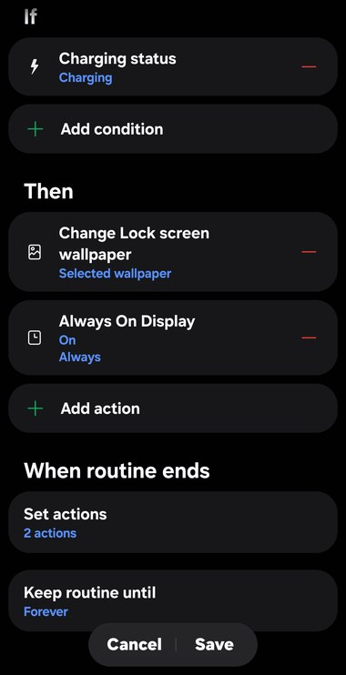 | STEP 12 Save Your Routine  Review the routine > tap Save  Your completed routine should show:  • IF: Charging status — Charging  • THEN: Change Lock screen wallpaper — Selected wallpaper  • THEN: Always On Display — On / Always  • When routine ends: Set actions — 2 actions  Tap Save at the bottom.  Plug your phone in to test — your NMS animation  should appear on the lock screen!

Final Tips
- Name your routine "NMS Charging" so it is easy to find later.
- To change the animation, just edit the routine and swap the Gallery file.
- Duplicate the routine to have a different animation for wired vs wireless charging.
- The When routine ends section resets your screen automatically when you unplug — leave it as 2 actions.

TIP: If the animation does not play when you plug in, check the routine is enabled (toggle is on) in Modes and Routines > Routines.

Enjoy your NMS charging screen! 🚀

