No Man's Sky Icon Pack
Charging Animation Setup Guide — iPhone
Set your NMS animations as your iPhone lock screen when charging using the Shortcuts app
NOTE: This guide works on iPhone running iOS 16 or higher. The Shortcuts app is pre-installed on all iPhones — no downloads needed. Screens shown are illustrated mockups as iPhone screenshots were not available.

NOTE: iOS LIMITATION: When you tap a Shortcuts automation, the app briefly flashes before opening. This is an Apple restriction. Turn off Ask Before Running in Step 9 to minimise this.

How It Works
The iPhone Shortcuts app lets you create automations that run when a charger is connected. We use this to automatically set your NMS charging animation as the lock screen wallpaper.

TIP: Unlike Samsung, iOS changes the wallpaper image rather than playing a live video. Use a screenshot or still frame from your NMS animation for best results on iPhone.

Step-by-Step Guide
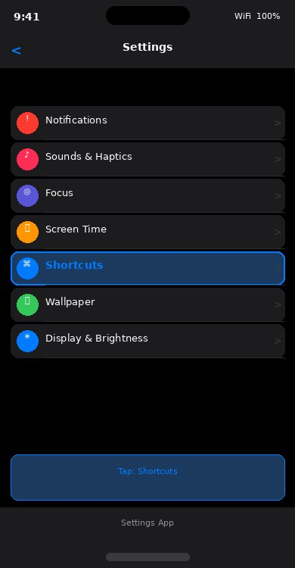 | STEP 1 Open Settings  Settings > Shortcuts  Open the Settings app on your iPhone.  Scroll down and tap Shortcuts.  • Make sure Allow Untrusted Shortcuts is turned ON.  • This allows your automation to run without prompting.  Then open the Shortcuts app itself (search for it  or find it on your home screen).

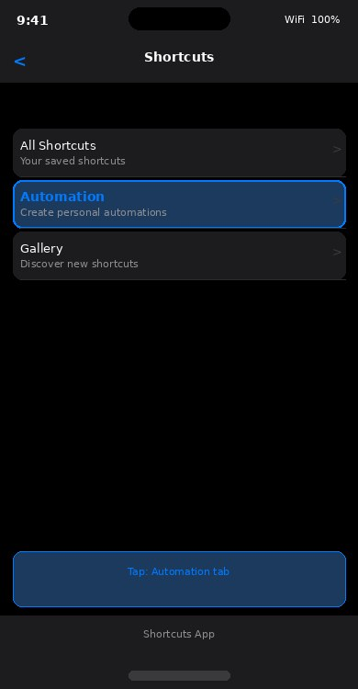 | STEP 2 Open Shortcuts App  Tap the Automation tab at the bottom  Open the Shortcuts app.  At the bottom you will see three tabs:  • Shortcuts — your saved shortcuts  • Automation — automatic triggers  • Gallery — discover new shortcuts  Tap Automation.

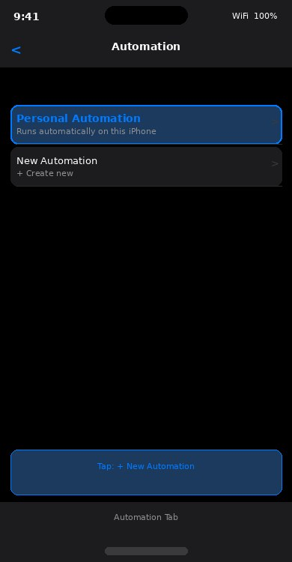 | STEP 3 Create New Automation  Tap + in the top right > New Automation  On the Automation screen, tap the + button  in the top right corner.  • Select Personal Automation.  • This creates an automation that runs  automatically on your iPhone.

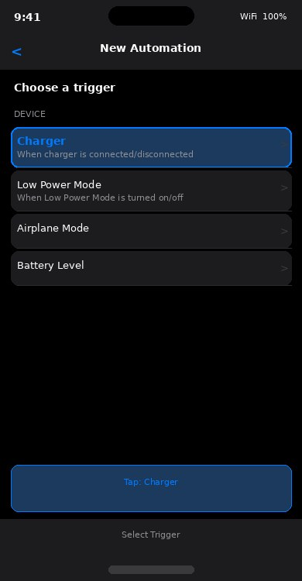 | STEP 4 Set Trigger = Charger  Scroll to Device > tap Charger  You will see a list of triggers.  Scroll down to the Device section.  • Tap Charger.  • This triggers the automation whenever  a charger is connected to your iPhone.

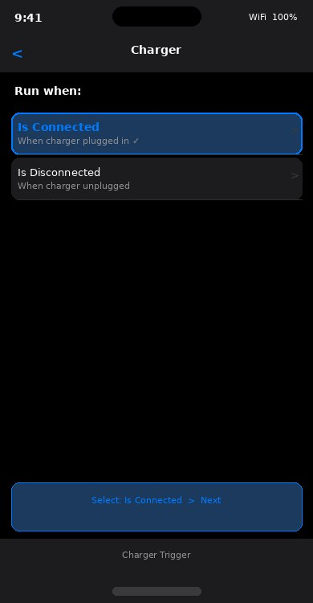 | STEP 5 Choose Is Connected  Select Is Connected > tap Next  Two options appear:  • Is Connected — runs when charger plugged in  • Is Disconnected — runs when charger removed  Select Is Connected.  Tap Next in the top right.

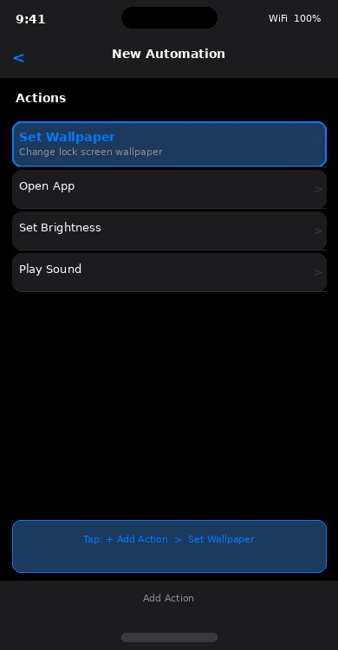 | STEP 6 Add Action = Set Wallpaper  Tap Add Action > search Set Wallpaper  The Actions screen appears.  • Tap the search bar and type Set Wallpaper.  • Tap Set Wallpaper from the results.  This is the action that changes your  lock screen when you plug in.

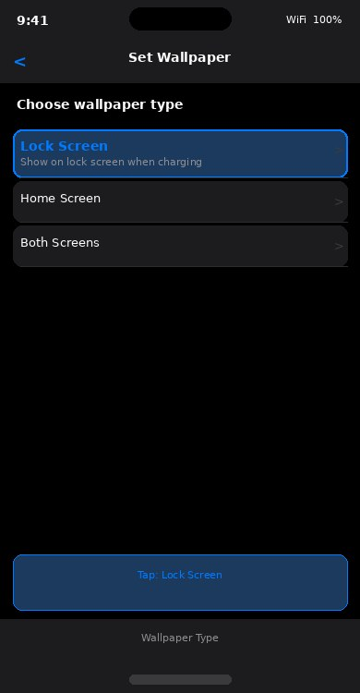 | STEP 7 Choose Lock Screen  Tap Set > choose Lock Screen  The Set Wallpaper action appears.  • Tap the blue Set button in the action.  • Choose Lock Screen.  Then tap the image slot to choose your  NMS charging animation still frame.  Navigate to your NMS Charging Animations folder  and select your chosen file.

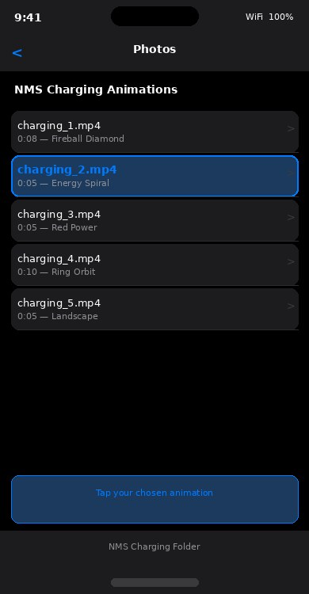 | STEP 8 Choose Your NMS File  Navigate to NMS Charging Animations > pick file  Your Photos library opens.  Navigate to the NMS Charging Animations folder.  • Tap the animation file you want.  • For best results on iPhone, use a still  frame or the first frame of the animation.  Tap Add or Done to confirm.

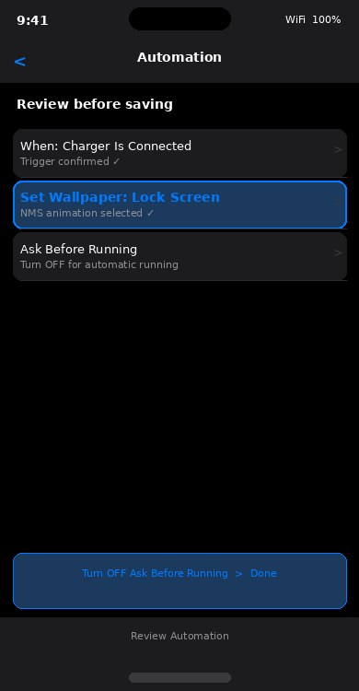 | STEP 9 Turn Off Ask Before Running  Toggle OFF Ask Before Running > Done  Before saving, review your automation:  • Trigger: Charger Is Connected ✓  • Action: Set Wallpaper Lock Screen ✓  IMPORTANT: Toggle OFF Ask Before Running.  If left ON, iPhone will ask permission every  time you plug in — turning it off makes it  run automatically and silently.  Tap Done.

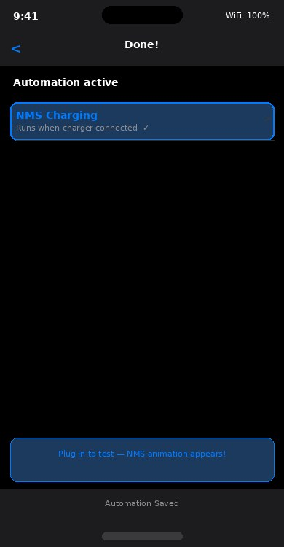 | STEP 10 Test It  Plug in your charger to test  Your automation is now saved and active!  • Plug your iPhone charger in.  • Your NMS image should appear on the  lock screen automatically.  To change the image later, just edit the  automation in Shortcuts > Automation and  swap the wallpaper file.

Important Notes for iPhone
- iOS does not support live video wallpapers from your own files — use a still image (screenshot) from your NMS animation for best results.
- If Ask Before Running is left ON, you will see a notification banner each time you plug in — tap it to allow. Turning it OFF removes this step.
- Create a second automation with trigger Is Disconnected to reset your wallpaper back to normal when you unplug.
- If the automation stops working after an iOS update, open Shortcuts > Automation and re-save it.

TIP: For the most authentic NMS look on iPhone, take a screenshot of your favourite frame from the charging animation and use that as the wallpaper image.

Enjoy your NMS charging screen on iPhone! 🚀

