PBS AI Featured PBS System


Prepared for: Flair Airlines
Prepared by: Zhiyong Ruan
Date: 9 June 2026

Contents
1. Overview
2. R’Bot — Conversational Board Control
2.1 What R’Bot does
2.2 Using R’Bot
2.3 Command reference
2.4 Capabilities and guardrails
2.5 How it works
3. AI in Regression Testing
3.1 The Regression workspace
3.2 From plain English to Playwright (AI code generation)
3.3 The quality gate (anti-illusion)
3.4 Pass conditions, entity intent, and the AI-illusion guard
3.5 Running, stability, and quarantine
3.6 Evidence, traces, and AI Diagnose
3.7 The whole loop at a glance
3.8 Controls reference
4. The Innovation — AI Linked to the Crew PBS System
5. R’Bot as Interactive Online Help — and Outlook
5.1 From static help pages to a conversational guide
5.2 Learning by doing — interactive feedback
5.3 Complementing — not replacing — the Help tab
5.4 Potential function outlook
6. Technical Summary

1. Overview
The PBS platform now embeds a dedicated Artificial Intelligence layer directly inside the crew-scheduling workspace. Rather than bolting a chatbot onto the side of the product, the AI is wired into the same data, panes, and controls that planners and crew already use — so a plain-English instruction becomes a real, scoped, and reversible action on the board.
Two production AI capabilities ship today:
• R’Bot — Conversational Board Control: a natural-language assistant that filters, sorts, and re-scopes the live roster / pairing / flight board on command, and answers questions about what is currently shown.
• AI in Regression Testing: a self-verifying quality system that turns plain-English test stories into runnable automated checks, runs them, scores their stability, and keeps versioned visual evidence — with built-in guards against “AI illusions”.
Both are delivered by a single, provider-agnostic AI service that can run on Anthropic Claude, Alibaba Qwen, or DeepSeek without any code change — the backend is selected per deployment.
Design principles
• Embedded, not bolted on — the AI reads the same board state the user sees.
• Safe by construction — AI suggestions apply as UI actions, never as silent database writes.
• Reversible — every applied action appears as a chip the user can undo.
• Provider-independent — the LLM backend is chosen by environment, not hard-coded.
• Auditable — every AI-generated test and run keeps a versioned, screenshot-backed record.

2. R’Bot — Conversational Board Control

2.1 What R’Bot does
R’Bot is a built-in AI assistant available in the bottom-left corner of every tab. The planner types a plain-English instruction; R’Bot translates it into a board action — applying a filter, sorting the roster, changing the planning date range, or clearing all active filters — and confirms in words exactly what it did.
R’Bot operates on the current board state: it sees the same data the user sees, and its suggestions are applied as canvas UI actions, not database writes.

2.2 Using R’Bot
Step 1. Click the chat-bubble icon in the bottom-left corner. The R’Bot panel slides open with example commands.
Step 2. Type your instruction in the Ask R’Bot… field — for example, show only Bangkok crew.
Step 3. Press Enter or Send. R’Bot shows Thinking… while it processes, then applies the action and shows a green confirmation chip describing exactly what was applied. Click the × on a chip to undo that action.
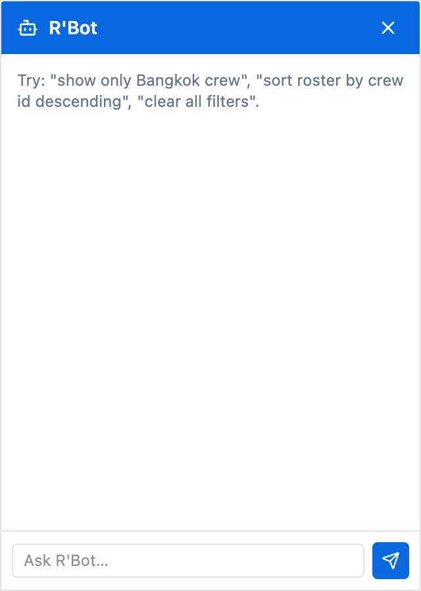 | 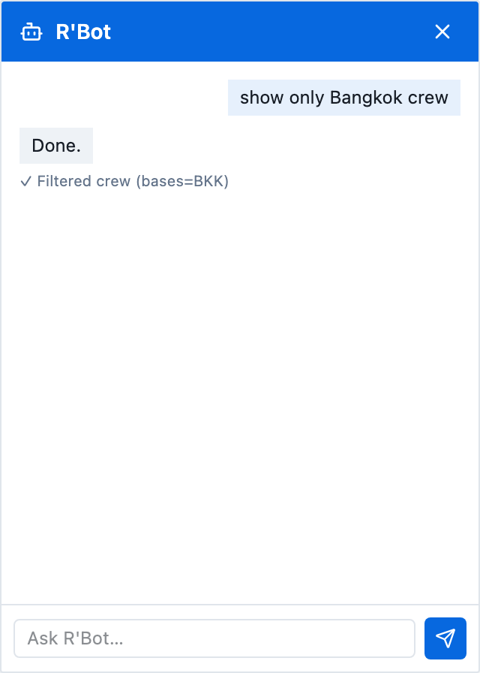
The R’Bot panel opens with example commands to get you started. | A green chip confirms exactly what R’Bot applied; click × to undo.

2.3 Command reference
R’Bot understands natural variations — you do not need to type the exact wording. Representative commands:
What to type | What it does
show only Bangkok crew | Filters the Crew Base to BKK.
show only pilots | Filters crew Division to P (Pilot).
filter crew base to YVR | Applies a Crew Base = YVR filter.
sort roster by crew id descending | Re-sorts the roster rows by crew ID, Z → A.
clear all filters | Removes every active filter from the board.
show fully crewed pairings only | Sets the Pairing filter to “Full only”.
show YEG crew sorted by crew id descending | Combo: filters Crew Base to YEG and re-sorts in one go.
set date range from 2026-07-01 to 2026-07-15 | Moves the planning period to that window and reloads.
show me next week only | Resolves “next week” against today and sets the date range.
how many crew are shown? | R’Bot reads the board and tells you the count.

2.4 Capabilities and guardrails
What R’Bot can do
• Apply crew, pairing, or flight filters.
• Sort the roster by a field and direction.
• Combine actions in one instruction (filter + sort together).
• Change the planning date range, resolving relative phrases like “next week”.
• Clear all active filters.
• Answer questions about what is currently shown on the board.
What R’Bot cannot do (by design)
• Make permanent schedule changes — it cannot move, add, or delete assignments.
• Access external systems or the internet.
• Modify scenario settings or run optimisations.

2.5 How it works
The front-end sends the recent conversation to the AI service (POST /ai/chat). The service calls the configured LLM with a constrained tool schema of six whitelisted tools — filter_crew, filter_pairing, filter_flight, sort_roster, set_date_range, and reset_filters. The model’s tool calls are validated and converted into typed board actions, which the front-end dispatches to the application state. Because only whitelisted actions are possible, the model cannot invent arbitrary operations. Conversation history is bounded (the most recent 12 messages, capped at 4,000 characters each), a single tool call may inject at most 50 filter values, and any LLM error is surfaced as a friendly message rather than a crash.

3. AI in Regression Testing
The Regression tab is an AI-powered Playwright test-management workspace. Anyone can build automated quality coverage by describing the expected behaviour in plain English; the AI writes the test code, the platform runs it, scores its stability, and keeps a versioned, screenshot-backed record of every outcome. The same LLM that powers R’Bot also generates the test code, extracts entities from conditions, and diagnoses failures — so the natural-language interface used to operate the system is also used to specify and verify it.

3.1 The Regression workspace
The tab opens on a catalog of tests grouped by category. Summary cards track Total, Passing, Failing, Not Run, High Priority, and User-Added counts, with a coverage bar above the list. The toolbar offers search, Category / Priority / Source / Status filters, Refresh, Import specs, Add Test, and Run All. Each row carries badges — priority, source (AI or User), fail count, “N% unstable”, and quarantine — and per-row actions: Run, Generate (wand), Quarantine (shield), and Delete.
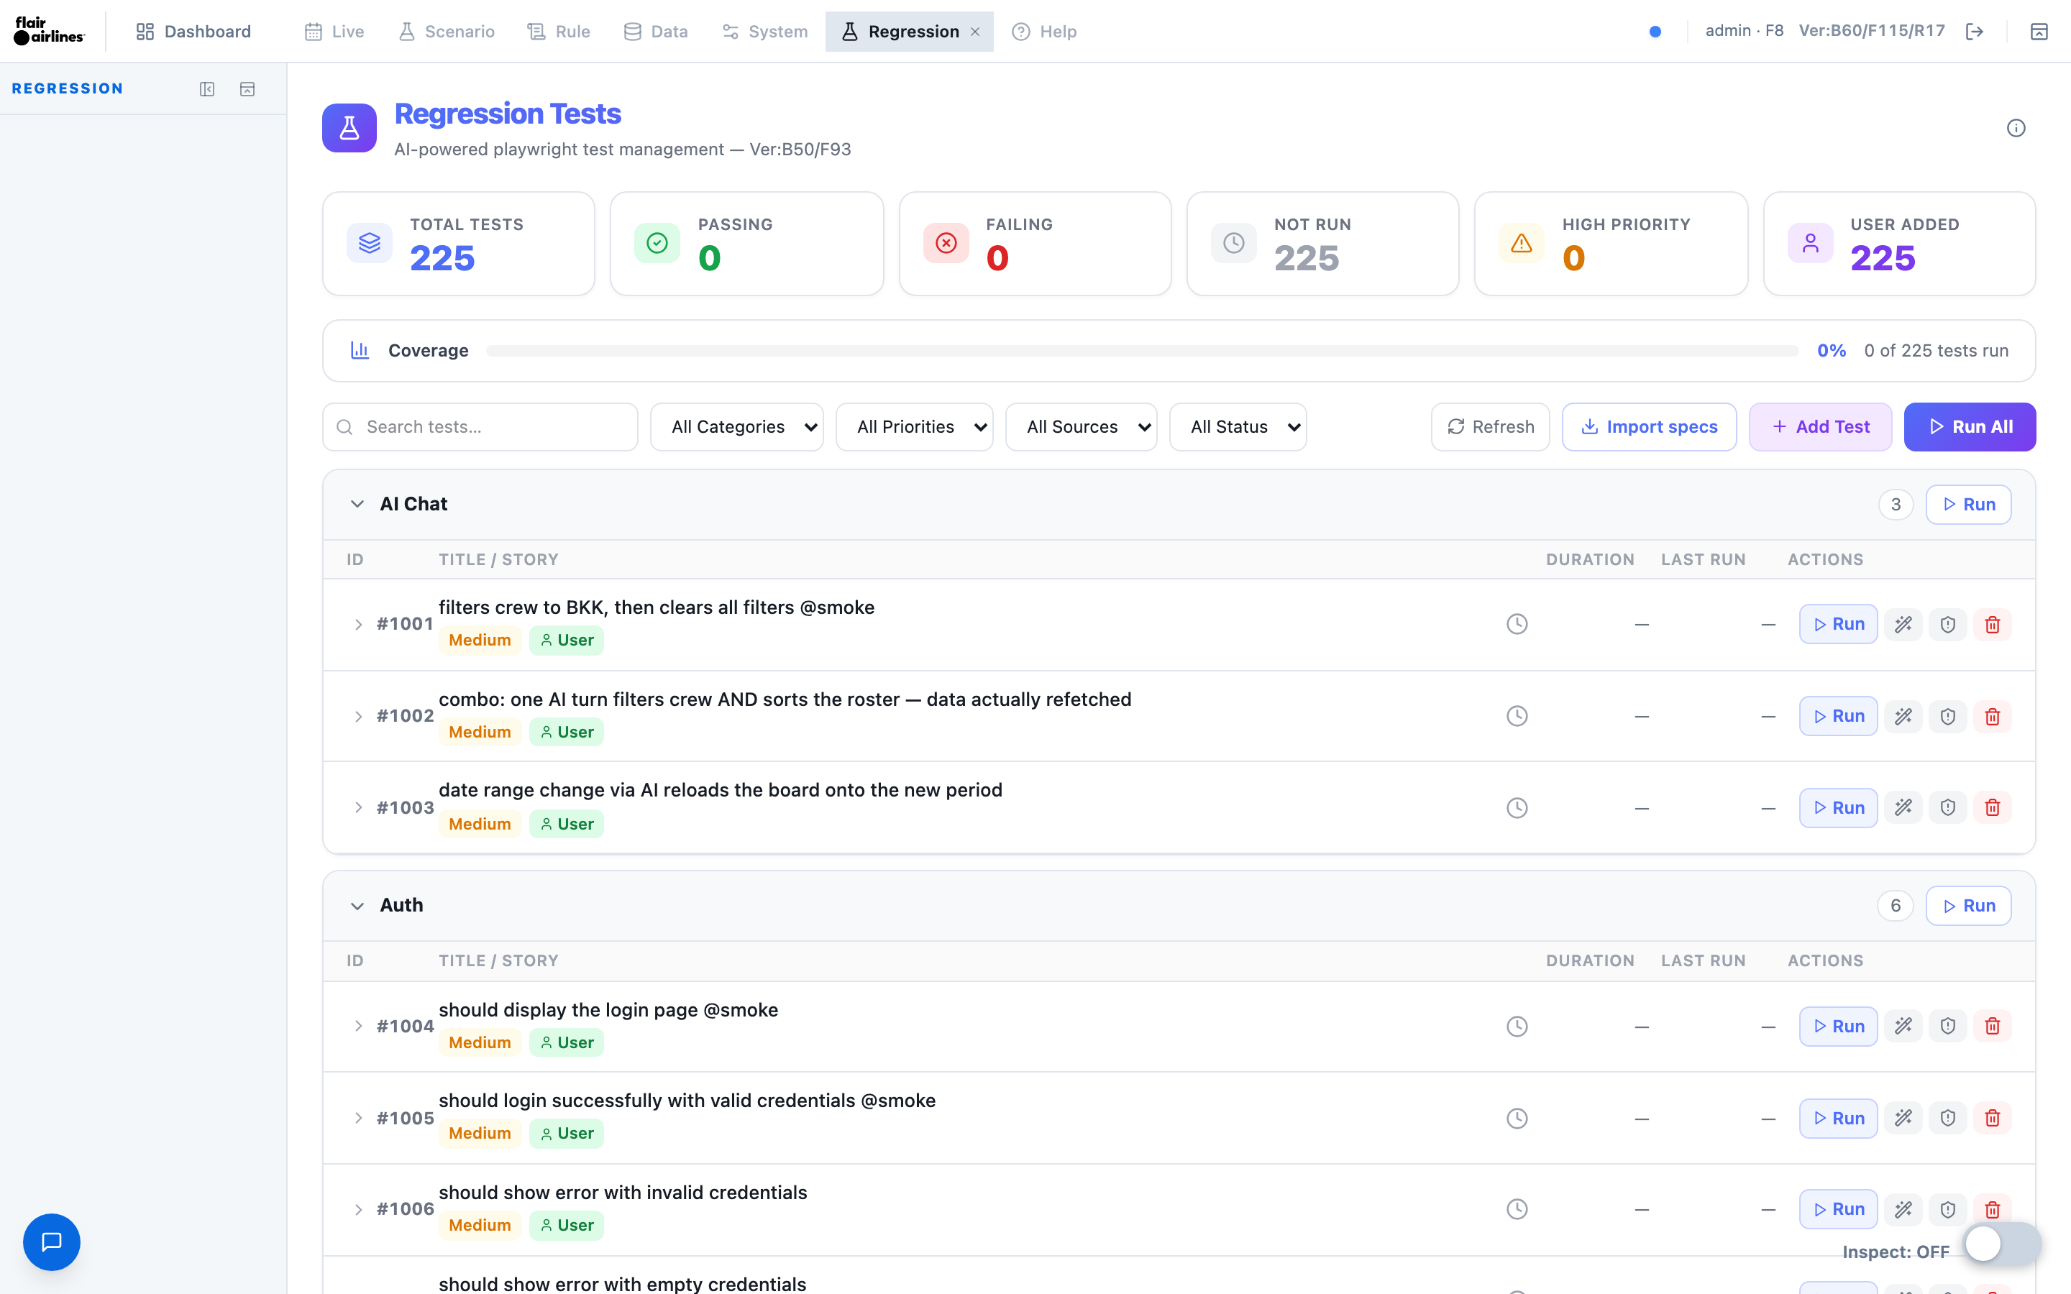
The Regression workspace — catalog grouped by category, summary cards, coverage bar, filters, and per-row AI / User source and priority badges.

3.2 From plain English to Playwright (AI code generation)
A test starts as a plain-English story. When you click the wand, the AI turns the story — plus any pass conditions and entity intents — into a single Playwright test block. A constrained system prompt forces the model to log in and seed first, use data-testid / role / text selectors and the Canvas test hook, and assert measured values (toHaveCount, toHaveText, toHaveValue, .status()). Hard sleeps are forbidden in favour of bounded retries (expect.poll / toPass), performance budgets are expressed as assertions, and every pass/fail condition from the story must be asserted. If the story is ambiguous, the AI returns clarifying questions instead of code; “Regenerate with fixes” feeds the previous code and any flagged issues back to the model.

3.3 The quality gate (anti-illusion)
Generated code must pass a deterministic quality gate before it can be applied — and the server re-checks it on apply (returning 422 if it fails). Rejections appear as red issue chips, and the Apply button stays disabled until the chips are gone. The gate rejects:
Rejected pattern | Why
waitForTimeout (hard sleep) | Flaky timing — use expect.poll / toPass with a timeout.
No expect( assertion | A test with no assertion proves nothing.
toBeVisible only | Visibility is not proof — add a measured assertion (count / text / status / < N ms).
xpath or raw CSS .locator() | Brittle selectors — use getByTestId / getByRole / getByText.
test.only, require, child_process, eval, process., non-PW imports | Unsafe or non-deterministic — forbidden.

This directly enforces the platform’s “prove it, don’t claim it” engineering standard.

3.4 Pass conditions, entity intent, and the AI-illusion guard
Expanding a test row reveals its Pass conditions (plain-English rules the test must verify) and its full version history — every code change creates a new version, and each run is recorded as a round under the active version, with AI / User provenance. When a pass condition names a specific value (a fleet code, crew ID, or flight number), an LLM extracts it and the entity-disambiguation panel asks whether the value is intentional:
• Condition A — UI must return data: the generated test asserts count > 0 and FAILS with “DATA GAP: <value> not found” if the result is empty. This is a truth probe — it catches missing data and the AI-illusion failure mode where a model assumes something exists that does not.
• Condition B — UI shows empty state: the test asserts the UI handles the absence gracefully (empty message, no crash) and PASSES only if it does. This tests resilience when expected data is deliberately absent.
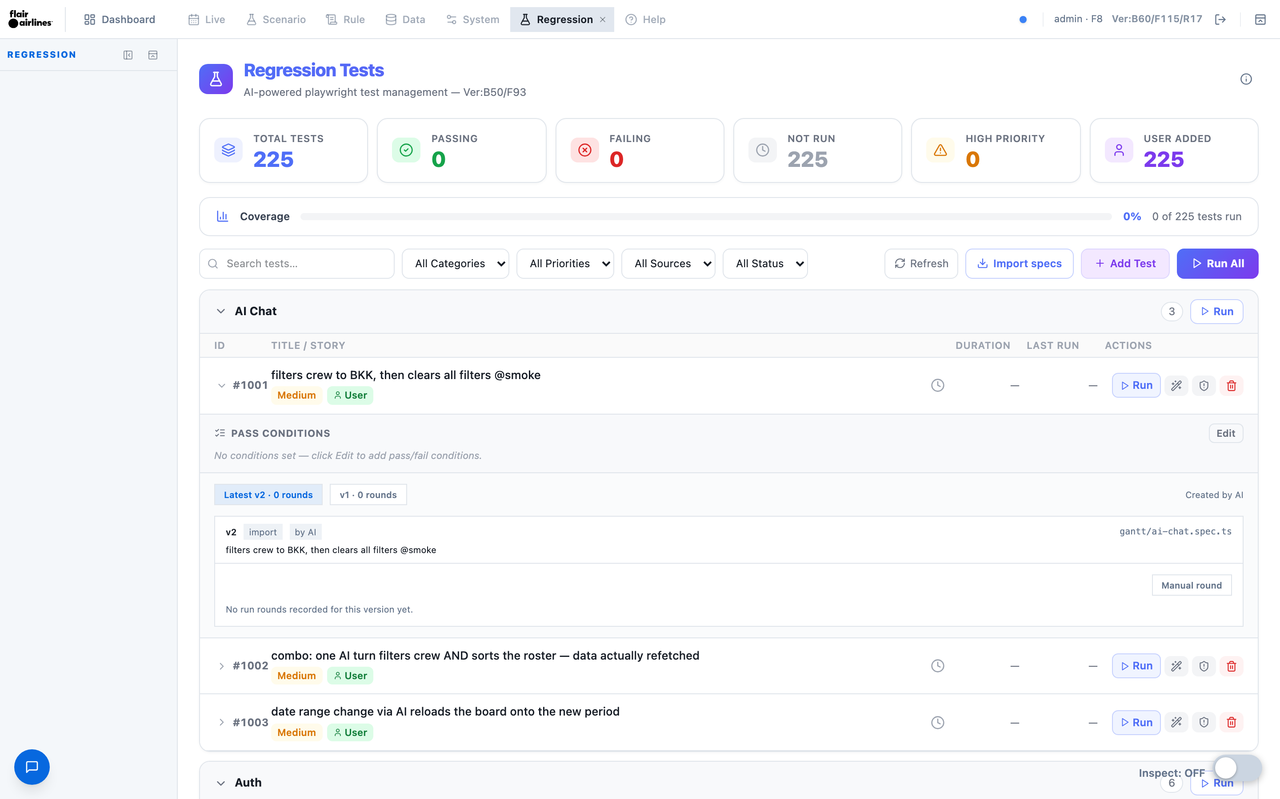
An expanded test row — plain-English Pass conditions, version history with rounds, and AI provenance for the generated script.

3.5 Running, stability, and quarantine
Run a single test, or “Run failing first” to run the catalog with the most-recently-failing tests ahead (a deterministic priority sort by fail count, flakiness, and last status). A scope ladder widens coverage from selected → related (same category) → all. Runs use one automatic retry: a test that passes only on retry is flagged flaky, and an “N% unstable” badge counts pass/fail flips over recent runs. Persistently unstable tests can be quarantined with the shield button — excluded from Run All until they pass five runs in a row, at which point they are released automatically.

3.6 Evidence, traces, and AI Diagnose
Every run records a round with an evidence snapshot — a screenshot captured at the assertion point (not at page load), so it proves the actual tested state — plus a downloadable Playwright trace. Failed rounds expose a Diagnose button, an LLM call that classifies the root cause and recommends a next step:
Diagnosis | Meaning
code_bug | The application code is broken.
data_issue | Expected test data is missing.
env_issue | Infrastructure / timeout / auth problem.
test_bug | The assertion itself is wrong or too strict.

3.7 The whole loop at a glance
The in-app “How it works” panel summarises the entire flow — Add Test → Conditions → Entity? → Generate → Run → PASS / FAIL → Diagnose — alongside the Condition A vs B decision tree, the diagnosis classes, and the badge legend.
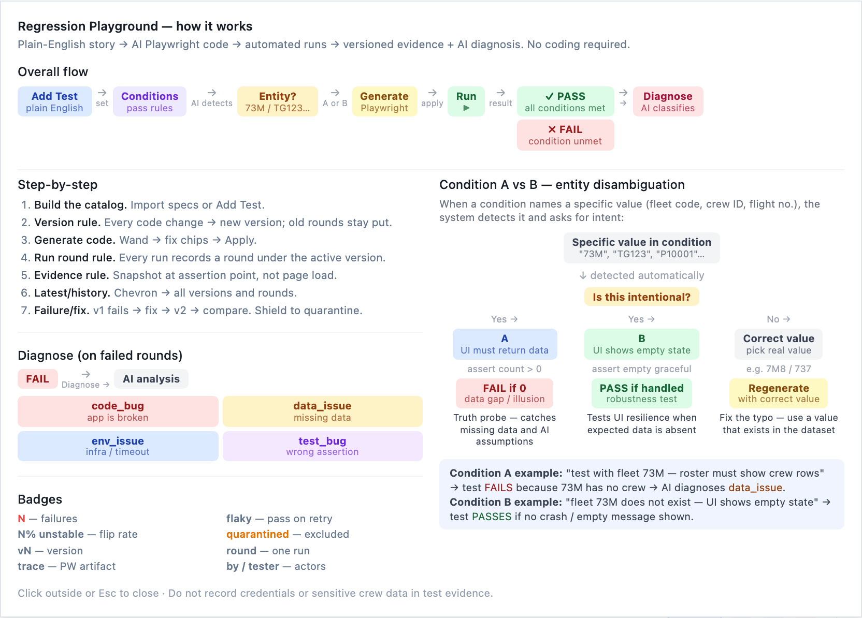
The built-in “How it works” panel: the end-to-end AI regression flow and the Condition A vs B entity-disambiguation decision tree.

3.8 Controls reference
Control | What it does
Import specs | Registers the existing automated tests as catalog entries (idempotent).
Add Test | Creates a test from a plain-English story — no coding required.
Generate (wand) | AI writes Playwright from the story and conditions; quality issues are flagged first.
Run / Run failing first | Runs one test or the whole catalog, most-recently-failing first, with live progress.
Quarantine (shield) | Excludes an unstable test from Run All; auto-released after 5 consecutive passes.
Chevron (expand) | Shows version history, rounds, pass conditions, snapshots, and diagnosis.
Pass conditions | Plain-English rules the AI converts to assertions; specific values trigger A/B intent.
Diagnose | AI classifies a failed run: code_bug / data_issue / env_issue / test_bug.
Evidence snapshot | Screenshot captured at the assertion point; click to enlarge, trash to delete.
trace | Downloads the Playwright trace.zip for a failed test.

4. The Innovation — AI Linked to the Crew PBS System
Crew scheduling has historically been form-driven and rigid. The innovation here is wiring a modern LLM directly into the operational crew / PBS system, so that natural language becomes a first-class way both to operate the system and to assure it — while keeping the safety guarantees a flight-operations product demands.
What makes it different
• Operating the board by conversation. R’Bot turns intent (“show fully crewed Vancouver pairings, sorted by crew ID”) into the exact filters and sorts a planner would otherwise click through — across crew, pairing, and flight panes at once.
• Safe, scoped, and reversible. the AI can only emit a fixed set of whitelisted board actions; it never writes to the schedule database. Every action is shown as a chip and can be undone, and input volume is capped.
• Quality that proves itself. AI Regression closes the loop — the same natural-language interface used to operate the system is used to specify and verify its behaviour, with an anti-illusion quality gate and entity-intent truth probes designed specifically to catch the failure mode unique to AI.
• Provider-independent and self-hostable. the AI service auto-detects its backend (Anthropic / Qwen / DeepSeek) from environment configuration, so an airline can choose its model and hosting without code changes — important for sensitive crew data.
• Auditable by design. tests, versions, run rounds, and screenshot evidence accumulate into a traceable QA record, satisfying the operational requirement that every behaviour be demonstrable, not merely claimed.

5. R’Bot as Interactive Online Help — and Outlook
The platform already ships a polished online Help system — a Help tab of topic articles with step-by-step instructions, screenshots, and a Controls Reference, kept in sync with the app. R’Bot points to a fundamentally different, complementary model of help: instead of reading about the system, the user converses with it. Because R’Bot sees the same board state and can call the same controls the user would, it can not only explain how to do something — it can do it, in context, and show the result.

5.1 From static help pages to a conversational guide
Traditional online help is read-and-find: the user leaves their task, searches for an article, and mentally maps generic steps onto their own screen. R’Bot inverts that loop. The user stays in context and asks in their own words — “how do I show only Vancouver pilots?” — and R’Bot answers and performs the action on the live board. The distance between an instruction and the result collapses from several manual steps to a single sentence.

5.2 Learning by doing — interactive feedback
R’Bot turns help into a feedback loop. Every request is confirmed in words and applied as a reversible chip, so a new planner watches their plain-English intent become a concrete filter or sort — and can undo it with one click. It also answers questions about the current view (“how many crew are shown?”), giving immediate situational feedback. Crucially, this is a safe place to learn: R’Bot only emits whitelisted UI actions, never writes to the schedule database, and every action is reversible, so users can explore freely without fear of breaking live data.

5.3 Complementing — not replacing — the Help tab
The static Help system remains the authoritative reference: versioned, screenshot-backed, and maintained alongside the code. R’Bot is the in-flow, just-in-time layer on top of it. The two reinforce each other — the Help articles describe the canonical workflow, and R’Bot lets the user try that workflow immediately, in their own data, without leaving the screen.

5.4 Potential function outlook
The following are forward-looking possibilities, not yet implemented. Each builds naturally on the existing architecture — tool-calling plus same-state access — and would stay inside the current safety model.
Potential capability | What it would add
Guided walkthroughs | Step a user through a multi-step task, highlighting each control and waiting for confirmation.
Explain-then-do | Answer a how-to question, then offer to perform it — or to open the exact Help article.
Context-aware tips | Proactively surface the relevant control when a user appears stuck (e.g. repeated empty filters).
Deep links into Help | Cite and open the precise Help topic / Controls Reference entry for the action just performed.
Read-only query tools | Answer operational questions (“which pairings are short-crewed tomorrow?”) by querying the board.
Scoped, reversible proposals | Behind permissions and explicit confirmation, propose schedule edits as draft chips — never silent writes.
Multilingual help | Answer in the user’s language via the existing i18n, while the UI stays in English per platform standard.
Role-aware onboarding | A first-run conversational tour tailored to the user’s role (planner vs crew).
Closing the QA loop | Turn “I couldn’t do X” conversations into help-content gaps and AI regression test stories.

Any such expansion would keep the guarantees that make R’Bot safe for flight operations: a whitelisted action surface, no silent database writes, reversible chips, capped inputs, and a provider-agnostic, self-hostable backend for sensitive crew data.

6. Technical Summary
The AI capabilities are served by ai-server, an independent FastAPI service (port 3005, reverse-proxied at /fpqe/ai).
Endpoint | Purpose
POST /ai/chat | R’Bot — natural language → board actions (6 tools).
GET /ai/health | Service health check.
… /ai/regression/tests | Create, list, update, and delete catalog tests.
POST /ai/regression/generate-playwright | NL story → Playwright code (asks clarifying questions if needed).
POST /ai/regression/tests/{id}/apply-generated | Write generated code after it passes the quality gate.
POST /ai/regression/runs | Run tests asynchronously (failure-first; quarantined excluded).
GET /ai/regression/runs/{id} | Poll run status and results.
GET /ai/regression/runs/{id}/trace/{test_id} | Download the Playwright trace for a failed test.

Provider configuration
• the backend is auto-detected from environment — an explicit AI_PROVIDER override, otherwise by key presence (DeepSeek → Qwen → Anthropic). Model and base URL are configurable per provider.
• API keys live only in environment configuration (.env), never committed to the repository.
• CORS is restricted to a configured origin allow-list.
Security posture
• No database writes occur on the AI path.
• Filter injection is capped (≤ 50 values per call) and conversation history is bounded.
• LLM errors degrade gracefully into a friendly in-app message.
• Test evidence must not record credentials or sensitive crew data.

