PBS AI Featured PBS System
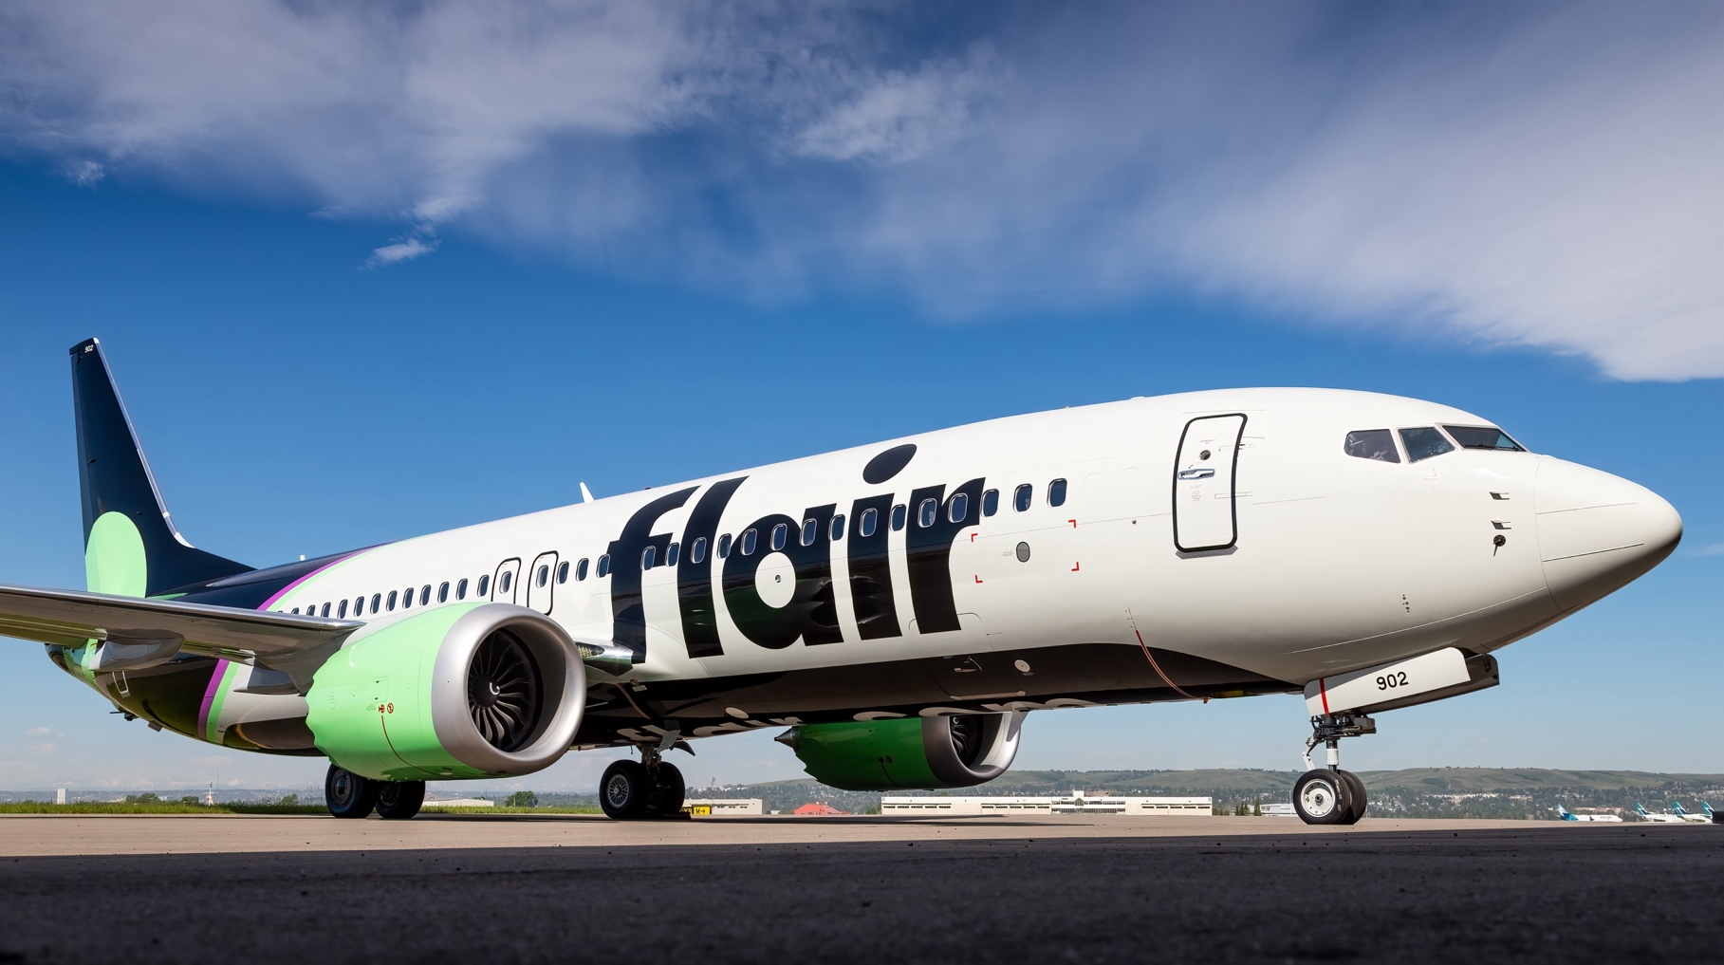

Prepared for: Flair Airlines
Prepared by: Zhiyong Ruan
Date: 3 May 2026

Contents
1. Overview 1
2. Bidding Request Feedback Functions 2

Overview

