# KeeUnloq

Open-source tools for exploring Microchip KeeLoq keyless remote systems (the old ones).

|  |  |
| --- | --- |
|  |  |
| *KUL FULL v1 PCB rev 0* | *KUL LITE v1 PCB rev 0* |

## Features

Device comes in two PCB variants: **KUL FULL** and **KUL LITE**.

Note: version **KUL FULL** contains RF receiver and transmitter while **KUL LITE** does not.

* Receiver module with optocouplers (only with PCB „KUL FULL“)
* Upgrading third-party insecure systems that use fixed-code HCS101 with rolling-code HCS versions (HCS200, HCS300, ...)
* Emulating HCS transmitter (only with PCB „KUL FULL“ or with external RF ASK transmitter)
* KeeLoq HCS series programmer tool (requires PC software)
* PC software for programming HCS series chips, upload & download of collected transmitter data and more
* Firmware upgrade via USB
* Powered externally or by USB
  + 5V DC or 9-24 AC/DC (PCB „KUL FULL“)
  + 5V DC (PCB „KUL LITE“)
* Open source

## Modes of operation/options

Devices with **FW v1** supports four selectable options during its operation:

1. **Option 1: Receiver module** with memory of up to 1000 remote transmitters
2. **Option 2: MITM upgrader** for upgrading third-party systems (insecure garage door openers)
3. **Option 3:** **Data collector** with memory of up to 200 remote transmitters and 500 transmissions
4. **Option 4:** **Transmitter emulator**

### Setting options

Each option can be enabled/disabled by holding down **button** **S0** and resetting the device (via **reset button** or by supplying power). In this state **LED A** will remain ON and device will report status of all options (enabled/disabled). Option can be selected with **button S1** and switching its state is done with **button S2**. When option is selected with **button S1** its current state (enabled/disabled) is shown on **LED C** (blinking **1 time** = **disabled**, blinking **2 times** = **enabled**).

Example 1: **LED B** blinks **2 times**, and **LED C** blinks **2 times**: Option **2** is **enabled**.

Example 2: **LED B** blinks **3 times**, and **LED C** blinks **1 time**: Option **3** is **disabled**.

If **buttons S1** or **S2** are not pressed within 15 seconds, the device will exit option-change procedure and start with operation with currently enabled options. If you need exit the procedure before the timeout, press **button S3**.

Upon startup the device will always report the state of all options on **LED A**.

Example: If options 1 and 3 are enabled, **LED A** will blink as: 1 time – pause – 3 times.

**Note:** When **Option 4** is enabled, it will automatically disable all other options.

### **Option 1**: Receiver module

Receiver module is used as a stand-alone receiver, which is capable of learning up to 1000 KeeLoq remote transmitters. It has 4 digital optocoupler **outputs S0-S3** (only PCB „KUL FULL“) which are usually connected to garage door and parking barrier motor controllers. It is also capable of learning fixed-code and rolling-code HCS series that require programming before usage.

Please refer to **Table 1** in *Programming remote transmitters and encoder ICs.*

### **Option 2**: MITM upgrader

Man-in-the-middle upgrader is a mode of operation where the goal is to upgrade a fixed-code insecure third-party system with a rolling-code transmitter. Rolling-code HCS series are pin-compatible with HCS101 fixed code encoder so modifying existing insecure transmitters should be an easy task by simply replacing ICs and programming new HCS with KeeUnloq device.

In order for this mode of operation to be successful, a third-party system must be modified as shown in the schematic diagram below.

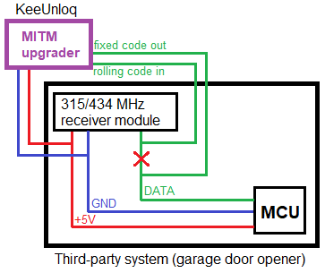

The data line of the third-party system must be intercepted so that any data received by the RF receiver is passed into the KeeUnloq device, and special data line from the KeeUnloq device passed into the third-party system.

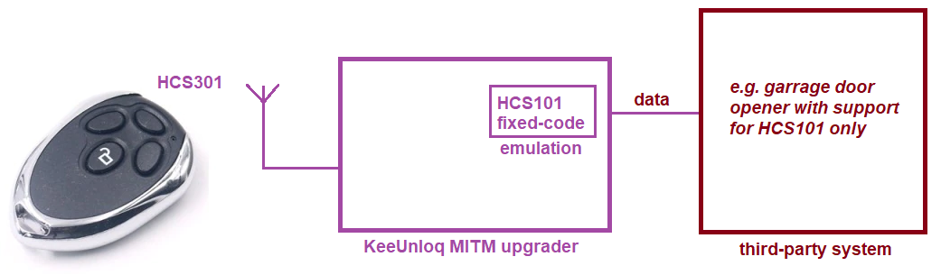

This means that KeeUnloq device must learn:

1. Fixed-code HCS101 remote control (**only one** HCS101) that third-party system **already recognizes** and works with
2. Rolling-code transmitter that will be learned by the KeeUnloq device (as many as required)

After installing the KeeUnloq MITM device into the third-party system, regular programming must take place with one exception: ~~The remote transmitter that has been last learned by the KeeUnloq device will be passed/proxied into the third-party system upon reception of a valid learned rolling-code remote transmitter.~~

Please refer to **Table 1** in *Programming remote transmitters and encoder ICs.*

### **Option 3**: Data collector

This option is intended for collecting KeeLoq data from the air in order to evaluate and study the security of third-party systems for vulnerabilities.

When device is in this state it will listen and collect transmissions into internal EEPROM memory. All data can be downloaded to PC software via USB connection for later analysis.

Pressing **button S0** on device will indicate how many **new** remote devices have been collected until device has started/booted.

Pressing **button S1** on device will indicate how many devices are collected in **entire** EEPROM memory.

Number of collected transmitters is reported by blinking the LEDs:

* **LED A** – hundreds
* **LED B** – tens
* **LED C** – ones

Example 1: **LED A** blinks **2 times**, **LED B** does **not** **blink**, **LED C** blinks **7 times**; the resulting number is **207**.

Example 2: **LED A** blinks **11 times**, **LED B** blinks **2 times**, **LED C** does **not blink**; the resulting number is **1120**.

### **Option 4**: Transmitter emulator

In this mode it is possible to emulate any of the HCS series encoders. It is required to previously program the “transmitter identity” via USB connection and PC software:

1. Type of encoder (HCS*)
2. Serial number
3. Encryption key (if applicable)
4. Counter value

Once device is in this mode, all four buttons are used to transmit the data (S0 – S3).

## Programming remote transmitters and encoder ICs

Programming is done by accessing **buttons S0-S3** or via PC software when device is connected via USB.

|  |  |
| --- | --- |
| **Program & learn** | To learn rolling-code encoder into the device memory, place programming clips on the HCS IC or place it on the PCB programming slot and hold it down firmly. Hold **button S0** to enter programming mode and **LED B** will turn ON. Within **20 seconds** press one of the buttons:   * S0 – program&enroll **66 bit** encoder (HCS200) * S1 – program&enroll **66 bit** encoder (HCS201) * S2 – program&enroll **66 bit** encoder (HCS300, HCS301, HCS320) * S3 – program&enroll **67 bit** encoder (HCS360, HCS361)   Each HCS encoder IC will be programmed with a **random serial number,** random **encryption key,** random **discrimination value** (except HCS360 & HCS361 which mirror the serial number value)andrandom **counter value** (but keptin the range of 0 – 255). This means that encoder ICs programmed using KeeUnloq device cannot be later enrolled using “**Learn from RF**” function in case KeeUnloq memory is later deleted - encoder ICs will need to be re-programmed. If it is required that all encoder ICs share the same encryption key, then use the PC tool to program them individually to the **master encryption key** of your choice. This master key resides in KeeUnloq memory.  The device will remain in this state for 20 seconds after the last transmitter has been programmed and will exit automatically. |
| **Learn from RF** | To learn a remote transmitter into the device memory from RF, hold **button S1** to enter programming mode and **LED B** will turn ON. Within 10 seconds press any button on a remote control and **LED B** will start blinking. Press again **the same button** on remote control within 5 seconds.  If learning process was successful **LED C** will blink:   * **2 times** if remote has been recognized using pre-configured master key as a rolling-code encoder * **5 times** if remote has been recognized as a fixed-code encoder or if using the pre-configured master key did not decrypt the data successfully so the encoder received will be treated as fixed-code type   If programming was not successful **LED A** will blink:   * **2 times** if remote is already programmed into the memory (you can try first deleting it and then learning it again) * **3 times** if device is in **Mode 2** and there is already HCS101 emulating encoder enrolled * **5 times** if remote failed to program because second reception did not match the first reception (you can simply try again) * **10 times** if this remote is not supported by current firmware   The device will remain in this state for 10 seconds after the last transmitter has been received and will exit automatically.  This process will enroll a fixed-code remote transmitter HCS101 any time, or a rolling-code transmitter with the **encryption key** that has been earlier loaded into the KeeUnloq device via USB and PC configuration tool. This also means that every remote transmitter must have this exact encryption key already programmed into them. It will also enroll a rolling-code transmitter even if the encryption key does not match, **however it will be treated as a fixed-code transmitter** where only serial number is used just like with HCS101. |
| **Remove transmitter from memory (one-by-one)** | In order to delete a specific remote transmitter from the memory, press and hold **button S2**. **LED B** will start blinking. Press any button on a remote transmitter that needs to be deleted from the memory. **LED A** will turn ON to indicate the successful reception of the code. When remote transmitter has been deleted from the memory, **LED C** will blink 2 times to confirm deletion, or **LED A** will blink 2 times to confirm that remote has not been found in memory.  The device will remain in this state for 10 seconds after the last transmitter has been received and will exit automatically. |
| **Clear all memory** | In order to clear all memory from the device, press and hold **button S3** until **LED A** starts blinking. Now within 5 seconds press and hold **button S2** until **LEDs B&C** turn on. Release all buttons and wait until all LEDs finally turn off – the memory is clear.  When options are enabled:   * **Option 1**: will delete learned/enrolled encoders that can operate the device * **Option 2**: will delete learned/enrolled MITM emulating encoder * **Option 3**: will delete entire grabbed/log table * **Option 4**: will delete nothing |

*Table 1: programming remote transmitters and encoder ICs*

## Appendix

Example of installation of **MITM Upgrader** into a garage door opener that supports HCS101. Before continuing make sure that garage door opener is programmed and controllable by the working remote transmitter that has HCS101 encoder inside.

Step 1: access the garage door openers RF receiver

Step 2: cut the **data** line and pass it through the KeeUnloq device and power up the garage door opener. Now change KeeUnloq mode into the **MITM Upgrader** (refer to the instructions in this document on how to change the operating mode)

Step 3: perform the **Program & learn** procedure of the existing HCS101 remote controller into the KeeUnloq

Step 4: order new remote transmitters with rolling-code HCS encoder IC (such as: HCS200, HCS300, …) or remove existing HCS101 encoder IC from your current remote controller

Step 5: perform the **Program & learn** procedure of the new HCS encoder IC by using the programming clips or by using the pads on KeeUnloq device (in case you haven’t already soldered new HCS encoder IC onto the remote transmitter)

Step 6: test for proper operation of garage door opener with KeeUnloq device and your new rolling-code transmitter