
Digital Madrasa: An Integrated Application That Will Manage Madrasas in Kenya
[STUDENT FULL NAME]
[REGISTRATION NUMBER]
This project is submitted in partial fulfillment of the requirements for the award of Bachelor of Science in Computer Science.
School of Business and Technology
Umma University
Kajiado, Kenya
[MONTH], 2026

This thesis is available for library use on the understanding that it is copyright material and that no quotation from the thesis may be published without proper acknowledgment.

DECLARATION
I [STUDENT FULL NAME] hereby declare that this document is entirely my own work and has not been submitted to any university or institution for the award of a degree. To the best of my knowledge, it does not include any material information authored or published by others except where it is acknowledged and referenced.
Student’s signature:

Name: [STUDENT FULL NAME] Registration number: [REGISTRATION NUMBER]
Signature: .................................................. Date: ..................................

This system project has been submitted for examination with my approval as university supervisor.
Supervisor’s signature:

Signature: .................................................. Date: ..................................
[SUPERVISOR NAME]
School of Business and Technology, Umma University,
Kenya

DEDICATION
I dedicate this work to my beloved parents and family for their love, prayers and support throughout my studies, and to my friends, mentors and siblings for their encouragement. I also dedicate it to the Muslim community of Kenya, especially the students, teachers and parents of our duksi and madrasas. May this work contribute in a small way to the teaching and memorisation of the Holy Quran.

ACKNOWLEDGEMENT
All praise is due to Allah (SWT) for granting me health, strength and perseverance to complete this project.
I sincerely thank my supervisor, [SUPERVISOR NAME], for the guidance and feedback given throughout the project. I thank my parents and family for their prayers, encouragement and support, and my relatives, friends and classmates for their motivation.
I am grateful to Umma University and the School of Business and Technology for the learning environment that made this work possible. May Allah (SWT) reward all who supported me. Ameen.

ABSTRACT
Madrasas and duksi in Kenya teach Quran recitation and memorisation to large numbers of children, but they are administered informally: attendance, memorisation progress and fees are recorded in exercise books or not at all, parents have little reliable information about their children, and fee payments are not linked to invoices. Existing Quran applications serve individual learners, while school management systems have no Quran-specific functions. This project developed Digital Madrasa, an integrated mobile application for managing madrasas in Kenya.
The system was developed using the Agile methodology with React Native (Expo) and TypeScript for the mobile application and Supabase (PostgreSQL, authentication, storage and Edge Functions) for the backend. Each madrasa is a separate tenant whose records are protected by Row Level Security on every table. The application serves madrasa owners, teachers, parents and students, and provides student admission, classes, manual and QR-code attendance, memorisation tracking, recitation recording with teacher review, parent–child linking approved by the madrasa, AI recitation feedback given only with a parent’s consent, fee invoicing with M-Pesa and card payment, notifications, and an interface in English, Kiswahili, Somali and Arabic.
Unit, functional and user interface testing showed that the core features work as required and that users cannot reach records outside their madrasa or role: all 112 unit tests and 78 functional test cases passed, and the installed app passed 30 of 31 interface checks. M-Pesa, card, e-mail and SMS payments and messages currently run on mock providers until live credentials are configured. The project shows that a secure, integrated madrasa management application for Kenya is feasible.
Keywords: Digital Madrasa, madrasa management, Quran memorisation, mobile application, React Native, Supabase, M-Pesa, Kenya.

Table of Contents
DECLARATION ii
DEDICATION iii
ACKNOWLEDGEMENT iv
ABSTRACT v
1. INTRODUCTION 1
1.1 Background of the Study 1
1.2 Problem Statement 2
1.3 Objectives 2
1.3.1 General Objective 2
1.3.2 Specific Objectives 2
1.4 Research Questions 3
1.5 Justification 3
1.6 Scope of the Project 3
1.7 Limitations 4
1.8 Summary 4
2. LITERATURE REVIEW 5
2.1 Introduction 5
2.2 Challenges in Traditional Madrasa Administration and Quran Learning 5
2.2.1 Informal Record Keeping and Lack of Standardisation 5
2.2.2 Limited Parental Visibility and Assessment Workload 6
2.2.3 Financial, Logistical and Communication Barriers 6
2.3 Review of Existing Madrasa Management and Quran Learning Applications 6
2.3.1 Overview of Existing Education Management and Quran Applications 6
2.3.2 Usability, Accessibility and Functional Limitations 7
2.3.3 Identified Gaps from Reviewed Systems 7
2.4 Development of a Mobile-Based Integrated Madrasa Management System 8
2.4.1 System Design and Architecture Overview 8
2.4.2 Implementation Using React Native (Expo) and Supabase 8
2.4.3 Integration of Administration and Quran Learning Modules 8
2.4.4 Expected Benefits to Kenyan Madrasas 9
2.5 Testing of the Digital Madrasa Mobile Application 9
2.5.1 Functionality and Performance Testing 9
2.5.2 Usability and User Experience Evaluation 9
2.5.3 Reliability and Field Testing Approach 9
2.6 Summary 10
3. SYSTEM DEVELOPMENT METHODOLOGY 11
3.1 Introduction 11
3.2 Methodological Approach 11
3.3 Agile Development Phases 12
3.3.1 Requirements Phase 12
3.3.2 Design Phase 13
3.3.3 Development Phase 13
3.3.4 Testing Phase 13
3.3.5 Deployment Phase 14
3.3.6 Review Phase 14
3.4 Summary 14
4. REQUIREMENTS GATHERING AND ANALYSIS 15
4.1 Introduction 15
4.2 Data Collection Approach 15
4.3 Data Collection Methods 15
4.4 Primary Data Collection 16
4.5 Data Analysis 16
4.5.1 Interview Data Summary 16
4.5.2 Questionnaire Analysis 17
4.6 Secondary Data Collection 22
4.7 Requirements and Stakeholders Identification 22
4.8 Challenges in Requirements Gathering and Analysis 23
4.9 Summary 24
5. SYSTEM DESIGN 25
5.1 Introduction 25
5.2 Structural Diagram 25
5.2.1 Class Diagram 25
5.2.2 Entity Relationship Diagram (ERD) 26
5.3 Behavioral Diagrams 28
5.3.1 Use Case Diagram 28
5.3.2 Sequence Diagram 29
5.3.3 Activity Diagram 30
5.4 Database Schema 31
5.5 Wireframes 32
5.6 Summary 33
6. SYSTEM DEVELOPMENT 34
6.1 Introduction 34
6.2 System Development Tools and Techniques 34
6.2.1 Integrated Development Environment (IDE) 34
6.2.2 Front-end Development 35
6.2.3 Database Management Tools 35
6.3 System Interfaces 36
6.4 Challenges Encountered During Development 41
6.4.1 Technical Complexities 41
6.4.2 User Adoption and Resistance 42
6.4.3 Economic Constraints 42
6.4.4 Continuous Updates and Supports 42
6.5 Summary 42
7. SYSTEM TESTING AND DEPLOYMENT 44
7.1 Introduction 44
7.2 System Testing and Validation 44
7.2.1 Unit Tests 44
7.2.2 Functional Testing 45
7.2.3 User Interface (UI) Testing 46
7.3 Testing Results 47
7.4 System Deployment 47
7.4.1 Current Deployment Methods 47
7.4.2 Future Deployment Plans 47
7.5 Summary 48
8. DISCUSSIONS, FUTURE WORKS AND RECOMMENDATIONS 49
8.1 Introduction 49
8.2 Discussions of Objectives 49
8.3 Future Work 50
8.3.1 Deployment to Google Play Store 50
8.3.2 Development of Web-Based Admin Dashboard 50
8.3.3 Integration of Push Notifications and Messaging 50
8.3.4 Smart Alerts and Recommendations 50
8.3.5 Enhanced Offline Functionality 51
8.4 Recommendations 51
8.4.1 Continuous User Engagement 51
8.4.2 Strengthening Data Security 51
8.4.3 Regular System Updates 51
8.4.4 Institutional and Government Collaboration 51
8.4.5 Optimization for Low-End Devices 51
8.5 Summary 52
Appendix 53
A.1: User Survey Questionnaire 53
Section A: Madrasa Owner and Teacher Questionnaire 53
Section B: Parent Questionnaire 53
Section C: Student Questionnaire 54
A.2: Work Plan and Schedule 54
A.3: Budget 55
A.4: My Project Repository 55
A.5: Plagiarism Report 56
REFERENCES 57

Table of figures
Figure 3.1 Agile Methodology 12
Figure 4.1 Recording Student Attendance 18
Figure 4.2 Memorisation Progress Tracking 18
Figure 4.3 Fee Collection Methods 19
Figure 4.4 Parent Access to Child Progress 20
Figure 4.5 Willingness to Pay Fees via M-Pesa 20
Figure 4.6 Recitation Assessment Methods 21
Figure 4.7 Digital Recitation Practice 22
Figure 5.1 Class Diagram 26
Figure 5.2 ERD Diagram 27
Figure 5.3 Use Case Diagram 29
Figure 5.4 Sequence Diagram 30
Figure 5.5 Activity Diagram 31
Figure 5.6 Database Schema 32
Figure 5.7 Wireframes 33
Figure 6.1 Visual Studio Code 35
Figure 6.2 Supabase Setup 36
Figure 6.3 App Interface Sign Up 37
Figure 6.4 Owner Dashboard 38
Figure 6.5 Teacher Dashboard 39
Figure 6.6 Parent Dashboard 40
Figure 6.7 Student Dashboard 41

Table of Tables
Table 4.1 Primary Data Collection 16
Table 4.2 Madrasa Owner and Teacher Interview Summary 16
Table 4.3 Parent Interview Summary 17
Table 4.4 Student Interview Summary 17
Table 7.1 Unit Testing 45
Table 7.2 Functional Testing 45
Table 7.3 User Interface Testing 46
Table 7.4 Testing Results 47

CHAPTER ONE

1. INTRODUCTION

1.1 Background of the Study
The Holy Quran is memorised and recited by Muslims as the word of Allah (SWT), and its memorisation (Hifz) together with the rules of correct recitation (tajweed) has been passed down through Quranic schools for centuries. Boyle (2004) describes these schools as institutions that both preserve a religious tradition and adapt to the societies around them. In Kenya, and particularly in the Coast, North Eastern and Nairobi regions, they are known as duksi or madrasa. They meet in mosques, homes and community buildings, admit children from about four years of age and teach recitation, memorisation and basic religious knowledge. Mwaura, Sylva and Malmberg (2008) evaluated the community Madrasa preschool programme in Kenya, Uganda and Zanzibar and found measurable cognitive benefits for participating children, showing that madrasa-based education can be structured and assessed.
The status of these institutions is changing. Ndzovu (2023) identifies the absence of a standardised syllabus and record-keeping as recurring concerns of the traditional madrassa system in Kenya, and in June 2026 the national government announced plans to integrate madrassa and duksi education into the national education system (Kihaki, 2026). Integration presupposes that a madrasa can produce reliable records of enrolment, attendance and learner progress, which most keep on paper or not at all.
The conditions for a mobile solution are present. The Communications Authority of Kenya (2023) reported 66.4 million mobile SIM subscriptions, a penetration rate of 131.3 per cent, and the Kenya National Digital Master Plan 2022–2032 makes the digitisation of services a national priority (Ministry of ICT and the Digital Economy, 2022). Consumer Quran applications already show that recitation practice can be supported on a phone, but they are built for individual learners and do not model the institution in which a teacher, a parent and a student share responsibility for a child’s progress. This project therefore developed Digital Madrasa, a mobile application that brings madrasa administration and Quran learning together in one secure platform.

1.2 Problem Statement
Madrasas in Kenya lack standardised systems for recording admission, attendance, memorisation progress and fees. Records are usually kept in exercise books held by individual teachers; they are easily lost, cannot be summarised for the institution and cannot be shared with parents. Parents therefore have little reliable information about whether their child attends, how far the child has memorised, or what fees are owed. Recitation can only be assessed when a teacher hears each learner in turn, so in large classes feedback is infrequent, and fees are collected in cash or by M-Pesa with no link to an invoice or receipt.
Existing software addresses only parts of this problem. Quran applications support individual practice but have no teacher role, parental access, attendance register or fee records, while general school management systems have no Quran-specific functions such as memorisation tracking by juz or recitation review. Neither is designed for many independent madrasas, each of which must be able to trust that its records cannot be seen by another. There is therefore a need for a secure, multi-tenant mobile application that unifies madrasa administration with Quran learning.

1.3 Objectives

1.3.1 General Objective
To develop an integrated mobile application for managing madrasas in Kenya that combines student administration, attendance, Quran memorisation and recitation review, parent involvement, and fee invoicing and payment within a single role-based platform.

1.3.2 Specific Objectives
- To analyse the administrative and learning challenges facing madrasas in Kenya.
- To review existing education management systems and Quran applications and identify their limitations.
- To design and develop a multi-tenant, role-based mobile application for madrasa owners, teachers, parents and students covering admission, attendance, memorisation, recitation review, parent linking, fees and M-Pesa payment.
- To test the developed system for functional correctness, data integrity and enforcement of authorisation between madrasas and roles.

1.4 Research Questions
- What administrative and learning challenges do madrasas in Kenya face?
- What are the limitations of existing education management systems and Quran applications for madrasas?
- How can a multi-tenant mobile application integrate madrasa administration with Quran learning while keeping each madrasa’s records private?
- To what extent does the developed system meet its functional and security requirements when tested?

1.5 Justification
Islam encourages seeking and spreading beneficial knowledge: “Allah will raise those who have believed among you and those who were given knowledge, by degrees” (Surah Al-Mujadilah 58:11). Within that motivation the project benefits each stakeholder. Madrasa owners gain institutional records of enrolment, attendance and fees, a practical precondition for integration into the national education system (Kihaki, 2026). Teachers have class rosters, attendance, recitation review and parent requests in one place. Parents see an approved child’s attendance, progress and fees; Fan and Chen (2001) found a meaningful relationship between parental involvement and academic achievement, and Epstein (2018) identifies regular school-to-home communication as a core form of involvement. Students can record a recitation for review without waiting for their turn in class.

1.6 Scope of the Project
The project covers the design, development and testing of an Android application and its cloud backend for madrasas in Kenya. It serves four roles: the madrasa owner, the teacher, the parent and the student. The implemented scope includes madrasa registration and sign-in; student admission with system-generated admission numbers; classes and staff; manual and QR-code attendance; parent–child linking approved by the madrasa; memorisation tracking, assignments, grades and certificates; recitation recording with private audio storage, AI feedback given only with a parent’s consent, and teacher review; fee invoices paid by M-Pesa or card; announcements, messages and notifications; and an interface in English, Kiswahili, Somali and Arabic. Curricula such as Tafsir and Fiqh, and the training of a dedicated tajweed recognition model, are outside the scope.

1.7 Limitations
M-Pesa, card payments, e-mail and SMS were exercised against mock providers that behave like the real services, because live Safaricom Daraja, Paystack and messaging credentials could not be obtained within the project. The installed app was tested on an Android emulator rather than a range of physical phones, and push notifications need a Firebase project to be configured before they can be delivered. The automated tajweed feedback comes from a general-purpose AI model (Google Gemini), not a validated tajweed assessor, so it is labelled provisional and the teacher’s review remains the authoritative assessment. No usability study with real users has yet been carried out, and the project evaluates whether the system works as specified, not its effect on memorisation over time.

1.8 Summary
This chapter introduced the role of madrasas in Quran education in Kenya and the record-keeping, visibility and assessment problems they face as their integration into the national education system is planned. It stated the objectives and research questions of the project and set out its justification, scope and limitations. Chapter Two reviews the literature and existing systems.
CHAPTER TWO

2. LITERATURE REVIEW

2.1 Introduction
This chapter reviews the literature on madrasa education and administration in Kenya, the challenges of traditional madrasa management, and existing education management systems and Quran applications. It then discusses how a mobile-based integrated system can be designed, implemented and tested to address the gaps identified.

2.2 Challenges in Traditional Madrasa Administration and Quran Learning

2.2.1 Informal Record Keeping and Lack of Standardisation
Quranic schools are among the oldest continuously operating educational institutions in the Muslim world. Boyle (2004) describes their core pedagogy as the memorisation and correct recitation of the Quran under the close supervision of a teacher. In Kenya this tradition is carried by the duksi, which concentrate on recitation and memorisation, and by madrasas, which add Arabic, Fiqh and Islamic history. Most are founded and run by communities, mosques or individual teachers rather than by the state.
Aden (2017) notes that Islamic and secular education in Kenya have largely developed in parallel, with learners attending the madrasa before or after the public school day. Ndzovu (2023) highlights the absence of a standardised syllabus as a persistent issue, and the same lack of standardisation extends to records. An owner or head teacher admits learners, allocates them to classes and collects fees, while each teacher keeps his or her own notebook of attendance and of how far each learner has memorised. Such records are easily lost, give the institution no single view of a learner, and cannot identify a child who moves between classes or madrasas. With madrasas now to be integrated into the national education system (Kihaki, 2026), reliable records have become a necessity. The community Madrasa preschool programme, evaluated by Mwaura et al. (2008), shows that madrasa-linked education can be organised and assessed when it is structured.

2.2.2 Limited Parental Visibility and Assessment Workload
Parents usually learn about attendance and progress informally, at pick-up or only when a problem has become serious. Fan and Chen (2001), in a meta-analysis, found a small to moderate but practically meaningful relationship between parental involvement and academic achievement, and Emerson et al. (2012) conclude that engagement is most effective when it is focused on the child’s own learning. Epstein (2018) identifies regular school-to-home communication as one of the core types of family involvement. A madrasa that cannot tell parents how their child is doing loses this support.
Recitation must be heard to be assessed, so a teacher’s capacity to give individual tajweed feedback is limited by class size and time. In large classes learners may recite to the teacher only occasionally, and persistent errors can go uncorrected between sessions.

2.2.3 Financial, Logistical and Communication Barriers
Madrasa fees are typically recorded by hand and reminded verbally. Payments made in cash or by M-Pesa are not linked to an invoice, which makes balances hard to reconcile and disputes hard to resolve. Communication between the madrasa and families relies on phone calls and word of mouth, and parents who speak Kiswahili, Somali or Arabic rather than English may be excluded from written notices. At the same time Kenya is highly connected: the Communications Authority of Kenya (2023) reported a mobile penetration of 131.3 per cent, and the Kenya National Digital Master Plan 2022–2032 commits the government to the digitisation of services (Ministry of ICT and the Digital Economy, 2022). The phone that parents already use for M-Pesa is therefore a practical channel for records, payments and notices.

2.3 Review of Existing Madrasa Management and Quran Learning Applications

2.3.1 Overview of Existing Education Management and Quran Applications
National Education Management Information System (NEMIS). The Ministry of Education operates NEMIS, which links each learner to a unique identifier and reports national indicators for registered institutions (Ministry of Education, n.d.); a replacement, the Kenya Education Management Information System, was announced in 2025 (Tongola, 2025). It serves national reporting rather than the day-to-day running of a madrasa.
Learning management systems. Moodle and Google Classroom provide courses, assignments, grading and messaging. Moodle was designed around social-constructivist learning communities (Dougiamas & Taylor, 2003).
School administration software. Commercial products used in Kenyan schools focus on fee collection, examinations and communication for primary and secondary schools following the national curriculum.
Quran applications. Tarteel listens to a user’s recitation, follows along in the text and flags memorisation mistakes such as skipped words (Tarteel AI, n.d.). Quran.com and similar readers provide the text, translations and audio by recognised reciters (Quran.com, n.d.). Masalha and Hirzallah (2014) proposed a student attendance system in which learners scan a QR code to register their presence.

2.3.2 Usability, Accessibility and Functional Limitations
Al-Fraihat et al. (2020) found that system, information and support quality together explain much of learners’ satisfaction with e-learning systems, and Coates, James and Baldwin (2005) caution that learning management systems tend to impose a generic model of teaching. None of the management systems reviewed tracks memorisation by juz, handles recitation audio or links a parent to a child through an approval process, and most are available only in English. Quran applications, in turn, are individual tools with no teacher, parent or institutional role and no attendance or fee records.
Automated recitation assessment also has clear limits. Al-Ayyoub, Damer and Hmeidi (2018) reported over 97 per cent accuracy in classifying eight recitation rules on an in-house dataset, but Al-Kharusi et al. (2025) argue that the field relies on small and demographically biased datasets, and Alsharhan and Ramsay (2020) show that speaker gender, dialect and training size materially affect Arabic speech recognition. Automated tajweed feedback can therefore support, but not replace, the teacher. A static attendance QR code can be photographed and shared, so it proves presence only if it changes and is verified by the server.

2.3.3 Identified Gaps from Reviewed Systems
The review identified the following gaps:
- No reviewed system combines madrasa administration with Quran learning.
- Parents have no structured, child-specific view of attendance, progress and fees.
- Fee payments are not linked to invoices and receipts.
- Automated tajweed assessment is not reliable enough to be authoritative.
- Shared platforms must keep each institution’s records separate.
- Interfaces are rarely available in the languages of Kenyan madrasa communities.

2.4 Development of a Mobile-Based Integrated Madrasa Management System

2.4.1 System Design and Architecture Overview
Where many independent organisations share one application, the application is multi-tenant. Bezemer and Zaidman (2010) observe that multi-tenancy reduces operating cost but makes isolation between tenants a central engineering concern, and Alkhalil, Sahandi and John (2017) found that perceived security shapes the decision to move records into the cloud. Within each tenant, role-based access control assigns permissions to roles rather than individuals (Sandhu et al., 2000), which matches the owner, teacher, parent and student roles of a madrasa. The proposed system is therefore a single mobile application backed by a managed cloud database, in which each madrasa is a separate tenant and every user acts in one role.

2.4.2 Implementation Using React Native (Expo) and Supabase
Cross-platform frameworks allow one codebase to serve several mobile platforms (Biørn-Hansen et al., 2018). The system uses React Native with the Expo toolchain and TypeScript for the application, and Supabase for the backend: a PostgreSQL database, authentication, file storage for recitation audio, and server functions for privileged operations such as payments. PostgreSQL Row Level Security lets the database itself decide which rows each user may read or change (PostgreSQL Global Development Group, n.d.), so one madrasa’s records stay private even if the application code contains an error.

2.4.3 Integration of Administration and Quran Learning Modules
The administration module covers admission, classes, staff, attendance, fees and communication; the learning module covers memorisation, assignments, grades, certificates and recitation review. They share one student record, so attendance, memorisation and fees appear together on the teacher’s and the parent’s screens. Holmes, Bialik and Fadel (2019) argue that artificial intelligence in education should augment rather than replace the teacher. VanLehn (2011) found that intelligent tutoring approached the effectiveness of human tutoring, and Neri, Cucchiarini and Strik (2008) showed that automatic pronunciation feedback improved learners’ speech. The system accordingly labels any automated recitation feedback as provisional and makes the teacher’s review final.

2.4.4 Expected Benefits to Kenyan Madrasas
The integrated system is expected to give madrasas reliable records of enrolment, attendance and progress; give approved parents timely information about their children; reduce teachers’ clerical work; link fee payments to invoices and receipts through M-Pesa; and reach families in English, Kiswahili, Somali and Arabic.

2.5 Testing of the Digital Madrasa Mobile Application

2.5.1 Functionality and Performance Testing
Sommerville (2016) distinguishes development testing of components, release testing against requirements, and user testing. For a multi-tenant system the most important functional tests are those that prove a user cannot reach another madrasa’s records or act outside their role; these must test refusals as well as successes. Performance testing checks that screens load quickly over mobile networks.

2.5.2 Usability and User Experience Evaluation
Usability can be measured with the System Usability Scale, a ten-item questionnaire that yields a score from 0 to 100 (Brooke, 1996). It suits users with limited experience of mobile applications and can be administered in the local language.

2.5.3 Reliability and Field Testing Approach
Reliability depends on the system behaving correctly with real data and devices. Testing against the deployed backend with test accounts for every role, followed by field testing in a pilot madrasa on the phones its teachers and parents already own, gives confidence that the system will work outside the development environment.

2.6 Summary
This chapter reviewed madrasa education and administration in Kenya and the challenges of informal records, limited parental visibility, assessment workload and fee management. Existing education management systems and Quran applications each address only part of the problem, and none combines madrasa administration with Quran learning under strict separation of institutions. The chapter outlined how a multi-tenant mobile system built with React Native and Supabase can close this gap and how it should be tested. Chapter Three describes the development methodology.
CHAPTER THREE

3. SYSTEM DEVELOPMENT METHODOLOGY

3.1 Introduction
This chapter presents the methodology adopted in developing Digital Madrasa. It describes the software development approach and the phases followed in building a working system that addresses the challenges faced by madrasas in Kenya. Because the system serves four different roles and combines administration with Quran learning, a flexible and iterative approach was needed to accommodate refinement at every stage. For this reason the Agile software development methodology was adopted.

3.2 Methodological Approach
Agile emphasises working software, collaboration and responding to change over following a fixed plan (Beck et al., 2001). It delivers a usable version of the software early and improves it in short cycles called sprints, each ending with a working increment that can be reviewed (Schwaber & Sutherland, 2020). Unlike the Waterfall model, in which each phase is completed before the next begins, Agile allows requirements to be refined as the system takes shape (Sommerville, 2016).
Agile suits this project because madrasa practices vary and many requirements, such as how parents should be linked to children or how fees should be targeted, became clear only when a working version could be tried. Each sprint delivered one complete capability, from the database rules to the screens, and was verified against the live backend before the next began.
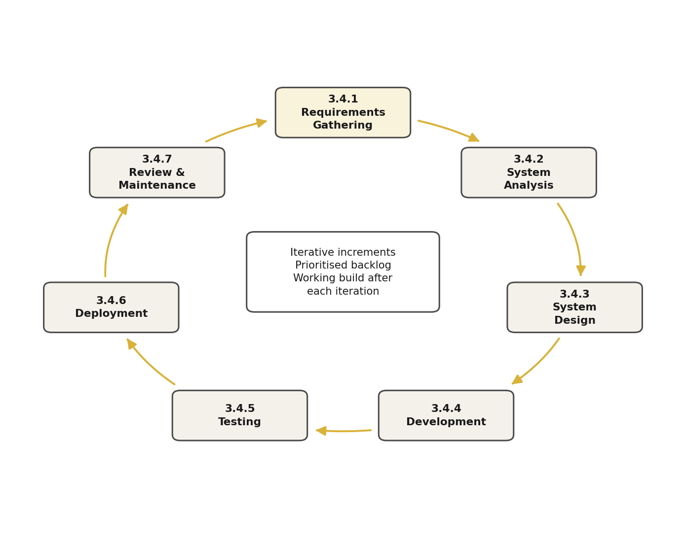
Figure 3.1 Agile Methodology

3.3 Agile Development Phases
The development of Digital Madrasa followed six Agile phases: requirements, design, development, testing, deployment and review. Each phase contributed incrementally to the project’s objectives.

3.3.1 Requirements Phase
Requirements were identified from the literature on madrasa education and parental involvement, from a review of existing education management systems and Quran applications, and from the questionnaire and interview instruments prepared for madrasa stakeholders (Appendix A.1). They were organised into two modules:
- Administration module: madrasa registration, student admission, classes, staff, attendance, fees and payments, announcements and messages.
- Quran learning module: memorisation progress, assignments, grades, recitation recording and review, and certificates.

3.3.2 Design Phase
The design phase translated the requirements into the models presented in Chapter Five: the class diagram, the entity relationship diagram and database schema, use case, sequence and activity diagrams, and wireframes of the main screens. The architecture was built around React Native with Expo for the mobile interface and Supabase for authentication, the PostgreSQL database, file storage and server functions. Security rules were designed into the database from the start, so that each madrasa’s records are isolated by Row Level Security.

3.3.3 Development Phase
Development proceeded in sprints recorded in the project’s Git history. The first sprint (23 August 2026) produced the multi-tenant database, authentication and the screens for all four roles. The second (16 September) added the server functions, automated backups and continuous integration. Later sprints connected the live backend and the recitation storage workflow (19 September), teacher recitation review and parent access to a child’s recitations (22–23 September), QR attendance (23 September) and targeted invoicing (24 September). The sprint of 25–30 September added written work and certificates, M-Pesa payments, push, e-mail and SMS notifications, and complete Kiswahili, Somali and Arabic translations. The final sprint (30 September – 2 October) connected Google Gemini for recitation feedback and a hosted AI assistant, added parental consent for AI feedback, card payments through Paystack, and fixes found by testing the installed app.

3.3.4 Testing Phase
Testing was carried out after each sprint to verify that new features worked and did not break existing ones. The testing types included:
- Unit testing: verifying individual functions such as input validation, QR token signing and M-Pesa callback handling.
- Functional testing: scripted calls to the deployed backend as each role, checking that permitted actions succeed and forbidden ones are refused.
- User interface testing: checking each screen on an Android emulator and in the web build at phone size.
- Performance testing: measuring response times of the main screens and database queries.

3.3.5 Deployment Phase
The database, storage and server functions were deployed to a hosted Supabase project from the first sprint, so every increment was tested against the real backend. During development the mobile application ran through Expo Go; at the end, Expo Application Services built an installable Android package (APK), which was installed and tested on an Android emulator.

3.3.6 Review Phase
At the end of each sprint the working increment was reviewed against the requirements, and defects found in testing were fixed before new work began. Reviews led, for example, to the rotating QR code for attendance, to requiring the madrasa’s approval before a parent can see a child, and to a faster form of the database access rules after performance testing.

3.4 Summary
The Agile methodology was adopted because it allows flexibility, continuous review and delivery of working software in short cycles. Through its six phases of requirements, design, development, testing, deployment and review, the project was developed iteratively, with each sprint delivering and verifying one complete capability of the system.
CHAPTER FOUR

4. REQUIREMENTS GATHERING AND ANALYSIS

4.1 Introduction
This chapter outlines the process of requirements gathering and analysis for Digital Madrasa. The objective of this phase was to identify the needs of the system’s users, namely madrasa owners and teachers, parents and students, in order to develop a practical and user-centred mobile solution. Requirements were gathered through questionnaires, interviews, observation and a review of the literature and existing systems. The process focused on how madrasas currently record attendance, memorisation and fees, how parents follow their children’s progress, and how recitation is assessed. The insights obtained informed the system’s architecture, database structure and role-based functions.

4.2 Data Collection Approach
A mixed approach was adopted. Structured questionnaires give comparable answers that can be counted and presented as charts, while interviews and observation explain how and why practices differ between madrasas. Combining the two ensures that the requirements are based both on how common a problem is and on the real experience of the people who face it.

4.3 Data Collection Methods
Both primary and secondary data collection methods were used. Primary data were collected directly from madrasa owners, teachers, parents and students using the questionnaire and interview guide in Appendix A.1, and by observing how attendance is taken and recitation is assessed in madrasa sessions. Secondary data were collected from published studies, government reports and a review of existing systems, as presented in Chapter Two.
The main techniques used were:
- Questionnaires for madrasa owners and teachers, parents and students
- Interviews with madrasa owners and senior teachers
- Observation of attendance taking and recitation assessment
- Review of relevant studies, reports and similar systems

4.4 Primary Data Collection
Primary data collection focused on obtaining direct insights from the people who run and use madrasas. A total of [INSERT] participants were involved in the study, comprising:

Stakeholder | Number of Respondents
Madrasa owners and teachers | [INSERT]
Parents | [INSERT]
Students | [INSERT]
Total | [INSERT]
Table 4.1 Primary Data Collection

4.5 Data Analysis
Questionnaire responses were summarised as counts and presented as pie charts, while interview and observation notes were analysed for recurring themes, challenges and expectations. Each finding was then mapped to a feature of the system.

4.5.1 Interview Data Summary
The following tables summarise the interview responses from each stakeholder group.
Madrasa Owner and Teacher Interview Summary

Theme | Key Insights from Madrasa Owner and Teachers
Record keeping | [INSERT ACTUAL FINDINGS HERE]
Attendance | [INSERT ACTUAL FINDINGS HERE]
Memorisation tracking | [INSERT ACTUAL FINDINGS HERE]
Fee collection | [INSERT ACTUAL FINDINGS HERE]
Communication with parents | [INSERT ACTUAL FINDINGS HERE]
Expectations | [INSERT ACTUAL FINDINGS HERE]
Table 4.2 Madrasa Owner and Teacher Interview Summary
Parent Interview Summary

Theme | Key Insights from Parents
Knowledge of attendance | [INSERT ACTUAL FINDINGS HERE]
Knowledge of progress | [INSERT ACTUAL FINDINGS HERE]
Fee payment | [INSERT ACTUAL FINDINGS HERE]
Communication with the madrasa | [INSERT ACTUAL FINDINGS HERE]
Expectations | [INSERT ACTUAL FINDINGS HERE]
Table 4.3 Parent Interview Summary
Student Interview Summary

Theme | Key Insights from Students
Recitation practice | [INSERT ACTUAL FINDINGS HERE]
Feedback from the teacher | [INSERT ACTUAL FINDINGS HERE]
Use of phones | [INSERT ACTUAL FINDINGS HERE]
Expectations | [INSERT ACTUAL FINDINGS HERE]
Table 4.4 Student Interview Summary

4.5.2 Questionnaire Analysis
Madrasa Owner and Teacher Questionnaire Analysis
A total of [INSERT] madrasa owners and teachers participated in the survey. The objective was to understand how attendance, memorisation progress and fees are currently managed.
Question 1: How is student attendance currently recorded in your madrasa?

[INSERT PIE CHART HERE]
Pie chart of responses to: “How is student attendance currently recorded in your madrasa?”
Figure 4.1 Recording Student Attendance
Chart to be inserted from the questionnaire results.
Analysis
[INSERT ACTUAL SURVEY RESULTS HERE]
System Solution
The system provides a digital attendance register for each class and QR-code attendance, in which a student scans a code on the teacher’s phone that changes every 30 seconds, so attendance is recorded once, cannot be forged and is summarised on the dashboard.
Question 2: How is a student’s Quran memorisation progress recorded?

[INSERT PIE CHART HERE]
Pie chart of responses to: “How is a student’s Quran memorisation progress recorded?”
Figure 4.2 Memorisation Progress Tracking
Chart to be inserted from the questionnaire results.
Analysis
[INSERT ACTUAL SURVEY RESULTS HERE]
System Solution
Teachers record memorisation surah by surah in the app. The system calculates the juz completed and the passages due for revision, and shows them to the student and the approved parent.
Question 3: How are fees recorded and communicated to parents?

[INSERT PIE CHART HERE]
Pie chart of responses to: “How are fees recorded and communicated to parents?”
Figure 4.3 Fee Collection Methods
Chart to be inserted from the questionnaire results.
Analysis
[INSERT ACTUAL SURVEY RESULTS HERE]
System Solution
The owner defines fee structures and issues numbered invoices to the whole madrasa, a class or one student. Parents see each invoice and pay it by M-Pesa, and the system issues a receipt and updates the balance automatically.
Parent Questionnaire Analysis
A total of [INSERT] parents participated in the survey. The questionnaire focused on how parents follow their children’s madrasa education and pay fees.
Question 1: How do you currently learn about your child’s attendance and progress?

[INSERT PIE CHART HERE]
Pie chart of responses to: “How do you currently learn about your child’s attendance and progress?”
Figure 4.4 Parent Access to Child Progress
Chart to be inserted from the questionnaire results.
Analysis
[INSERT ACTUAL SURVEY RESULTS HERE]
System Solution
A parent links to a child using the admission number and date of birth; once the madrasa approves the link, the parent sees the child’s attendance, memorisation, grades, recitations and fees, and receives notifications.
Question 2: Would you pay madrasa fees through M-Pesa in a mobile application?

[INSERT PIE CHART HERE]
Pie chart of responses to: “Would you pay madrasa fees through M-Pesa in a mobile application?”
Figure 4.5 Willingness to Pay Fees via M-Pesa
Chart to be inserted from the questionnaire results.
Analysis
[INSERT ACTUAL SURVEY RESULTS HERE]
System Solution
The parent pays one or several invoices through an M-Pesa prompt on their phone. The amount is calculated by the server, and the receipt appears in the app as soon as payment is confirmed.
Student Questionnaire Analysis
A total of [INSERT] students participated in the survey, with the consent of their parents. The purpose was to understand how recitation is practised and assessed.
Question 1: How does your teacher assess your recitation?

[INSERT PIE CHART HERE]
Pie chart of responses to: “How does your teacher assess your recitation?”
Figure 4.6 Recitation Assessment Methods
Chart to be inserted from the questionnaire results.
Analysis
[INSERT ACTUAL SURVEY RESULTS HERE]
System Solution
Students record a recitation in the app. The recording is stored privately, the teacher listens and gives a score and comments, and the student and approved parent see the review.
Question 2: Would recording your recitation on a phone help you practise?

[INSERT PIE CHART HERE]
Pie chart of responses to: “Would recording your recitation on a phone help you practise?”
Figure 4.7 Digital Recitation Practice
Chart to be inserted from the questionnaire results.
Analysis
[INSERT ACTUAL SURVEY RESULTS HERE]
System Solution
The app lets students record as often as they need, shows the passages due for revision, and provides the Quran text for reading offline.

4.6 Secondary Data Collection
Secondary data provided background that complemented the primary data. A review of academic literature, government reports and existing systems (Chapter Two) showed that madrasa records in Kenya are largely informal and unstandardised (Ndzovu, 2023), that the government plans to integrate madrasa education into the national system (Kihaki, 2026), and that parental involvement is associated with better achievement (Fan & Chen, 2001). It also showed that Kenya’s mobile penetration makes a phone-based system practical (Communications Authority of Kenya, 2023) and that automated tajweed assessment is not yet reliable enough to replace the teacher (Al-Kharusi et al., 2025). These findings reinforced the need for an integrated system that combines madrasa administration, Quran learning, parental access and fee management.

4.7 Requirements and Stakeholders Identification
Based on the analysed data, the requirements were categorised as follows.
Functional Requirements
The system shall allow a madrasa owner to register the madrasa, admit students with automatically generated admission numbers, create classes, add teachers, define fee structures and issue invoices. Teachers shall take attendance manually or by QR code, record memorisation, set and mark assignments, grade students, review recitations and award certificates. Parents shall request a link to their child, view the approved child’s attendance, progress and invoices, pay fees by M-Pesa and message the madrasa. Students shall scan attendance codes, record recitations, hand in work and view their own progress. The system shall send notifications for announcements, invoices, payments and reviews, and provide role-based dashboards.
Non-Functional Requirements
The system shall keep each madrasa’s records private from every other madrasa and allow each user only the actions of their role. It shall respond quickly on mobile networks, protect passwords and data in transit, and store recitation audio privately. It shall be easy to use for people with limited experience of mobile applications and be available in English, Kiswahili, Somali and Arabic. Payments shall be settled exactly once for the amount the server calculates, and important actions shall be recorded in an audit log.
Stakeholders Identification
Madrasa owners register the madrasa, manage students, staff and fees, and oversee operations. Teachers take attendance, track memorisation, review recitations and communicate with parents. Parents follow their children’s progress and pay fees. Students record recitations, scan attendance and follow their own progress. A platform administrator oversees the madrasas using the service. Government education authorities influence the system indirectly through the plans to integrate madrasa education into the national system.

4.8 Challenges in Requirements Gathering and Analysis
Several challenges influenced the requirements gathering process.
Diverse stakeholder needs: owners prioritise records and fees, teachers prioritise simple attendance and review, and parents want timely information. Features were prioritised by how many roles they serve and how directly they address the problem statement.
Limited stakeholder availability: madrasa sessions run early in the morning, in the evening and at weekends, which limited the time available for interviews and observation.
Sensitivity of children’s data: information about minors requires consent and care. Questions were framed neutrally, students took part only with parental consent, and the system was designed so that a parent sees a child only after the madrasa approves the link.
Technical constraints: features such as a validated tajweed recognition model and live M-Pesa credentials were beyond the project’s resources, so the system was designed to accept them later without redesign.
Variations in madrasa practice: madrasas differ in class levels, fee structures and languages, so the system lets each madrasa define its own classes and fees and offers four languages.

4.9 Summary
This chapter described how the requirements of Digital Madrasa were gathered and analysed from madrasa owners and teachers, parents, students and the literature. The system must provide secure sign-in, digital attendance, memorisation tracking, recitation review, parent access approved by the madrasa, fee invoicing with M-Pesa payment, notifications and role-based dashboards, while keeping each madrasa’s data private. These requirements form the foundation of the design presented in Chapter Five.
CHAPTER FIVE

5. SYSTEM DESIGN

5.1 Introduction
This chapter presents the design of Digital Madrasa. From the structure of the data and the database schema to the interactions between users and the system and the layout of the user interfaces, each part of the design was planned to meet the requirements identified in Chapter Four. Particular attention was given to role-based access for owners, teachers, parents and students, and to keeping each madrasa’s records separate from every other madrasa.

5.2 Structural Diagram
Structural diagrams describe the static architecture of the system by showing its components, such as classes and their relationships (Sommerville, 2016). They provide a blueprint of how data and objects are organised and help developers understand how the parts of the system fit together.

5.2.1 Class Diagram
The class diagram in Figure 5.1 shows the main classes of the system, their attributes and operations, and the relationships between them. A Madrasa has many students, teachers, classes, fee structures and announcements. A Student belongs to one madrasa and has attendance records, memorisation progress, recitations and invoices, and a Parent is connected to a Student through a ParentStudentLink that the madrasa approves. Each Recitation may receive TajweedFeedback, which the teacher reviews.
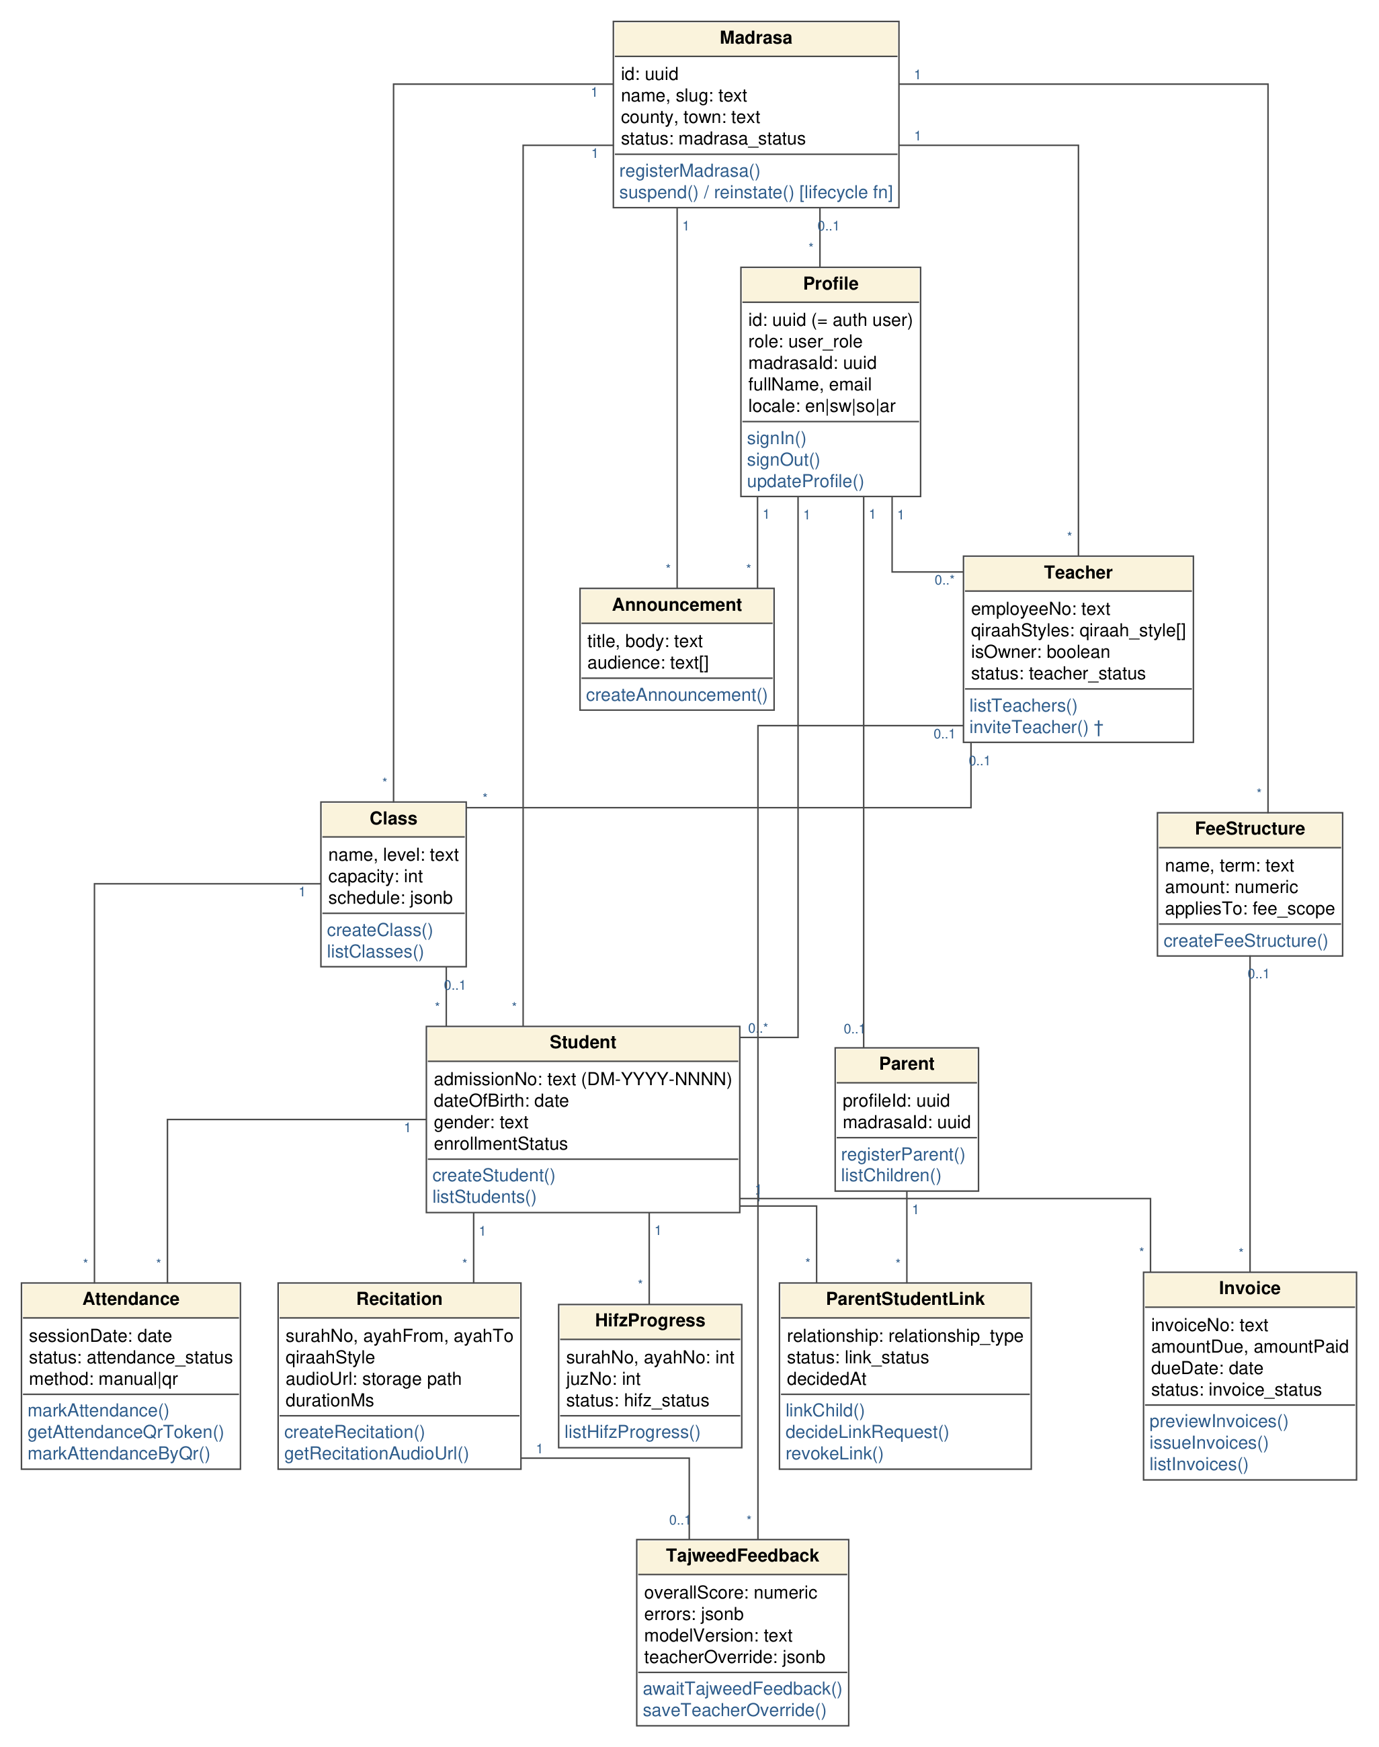
Figure 5.1 Class Diagram

5.2.2 Entity Relationship Diagram (ERD)
The Entity Relationship Diagram in Figure 5.2 represents the core data of the system: the entities, their key attributes and the relationships between them, with cardinalities (1 and N). It was generated from the live database, so it matches the implemented schema. Every record carries the identifier of its madrasa, which is how the database keeps each madrasa’s data separate.
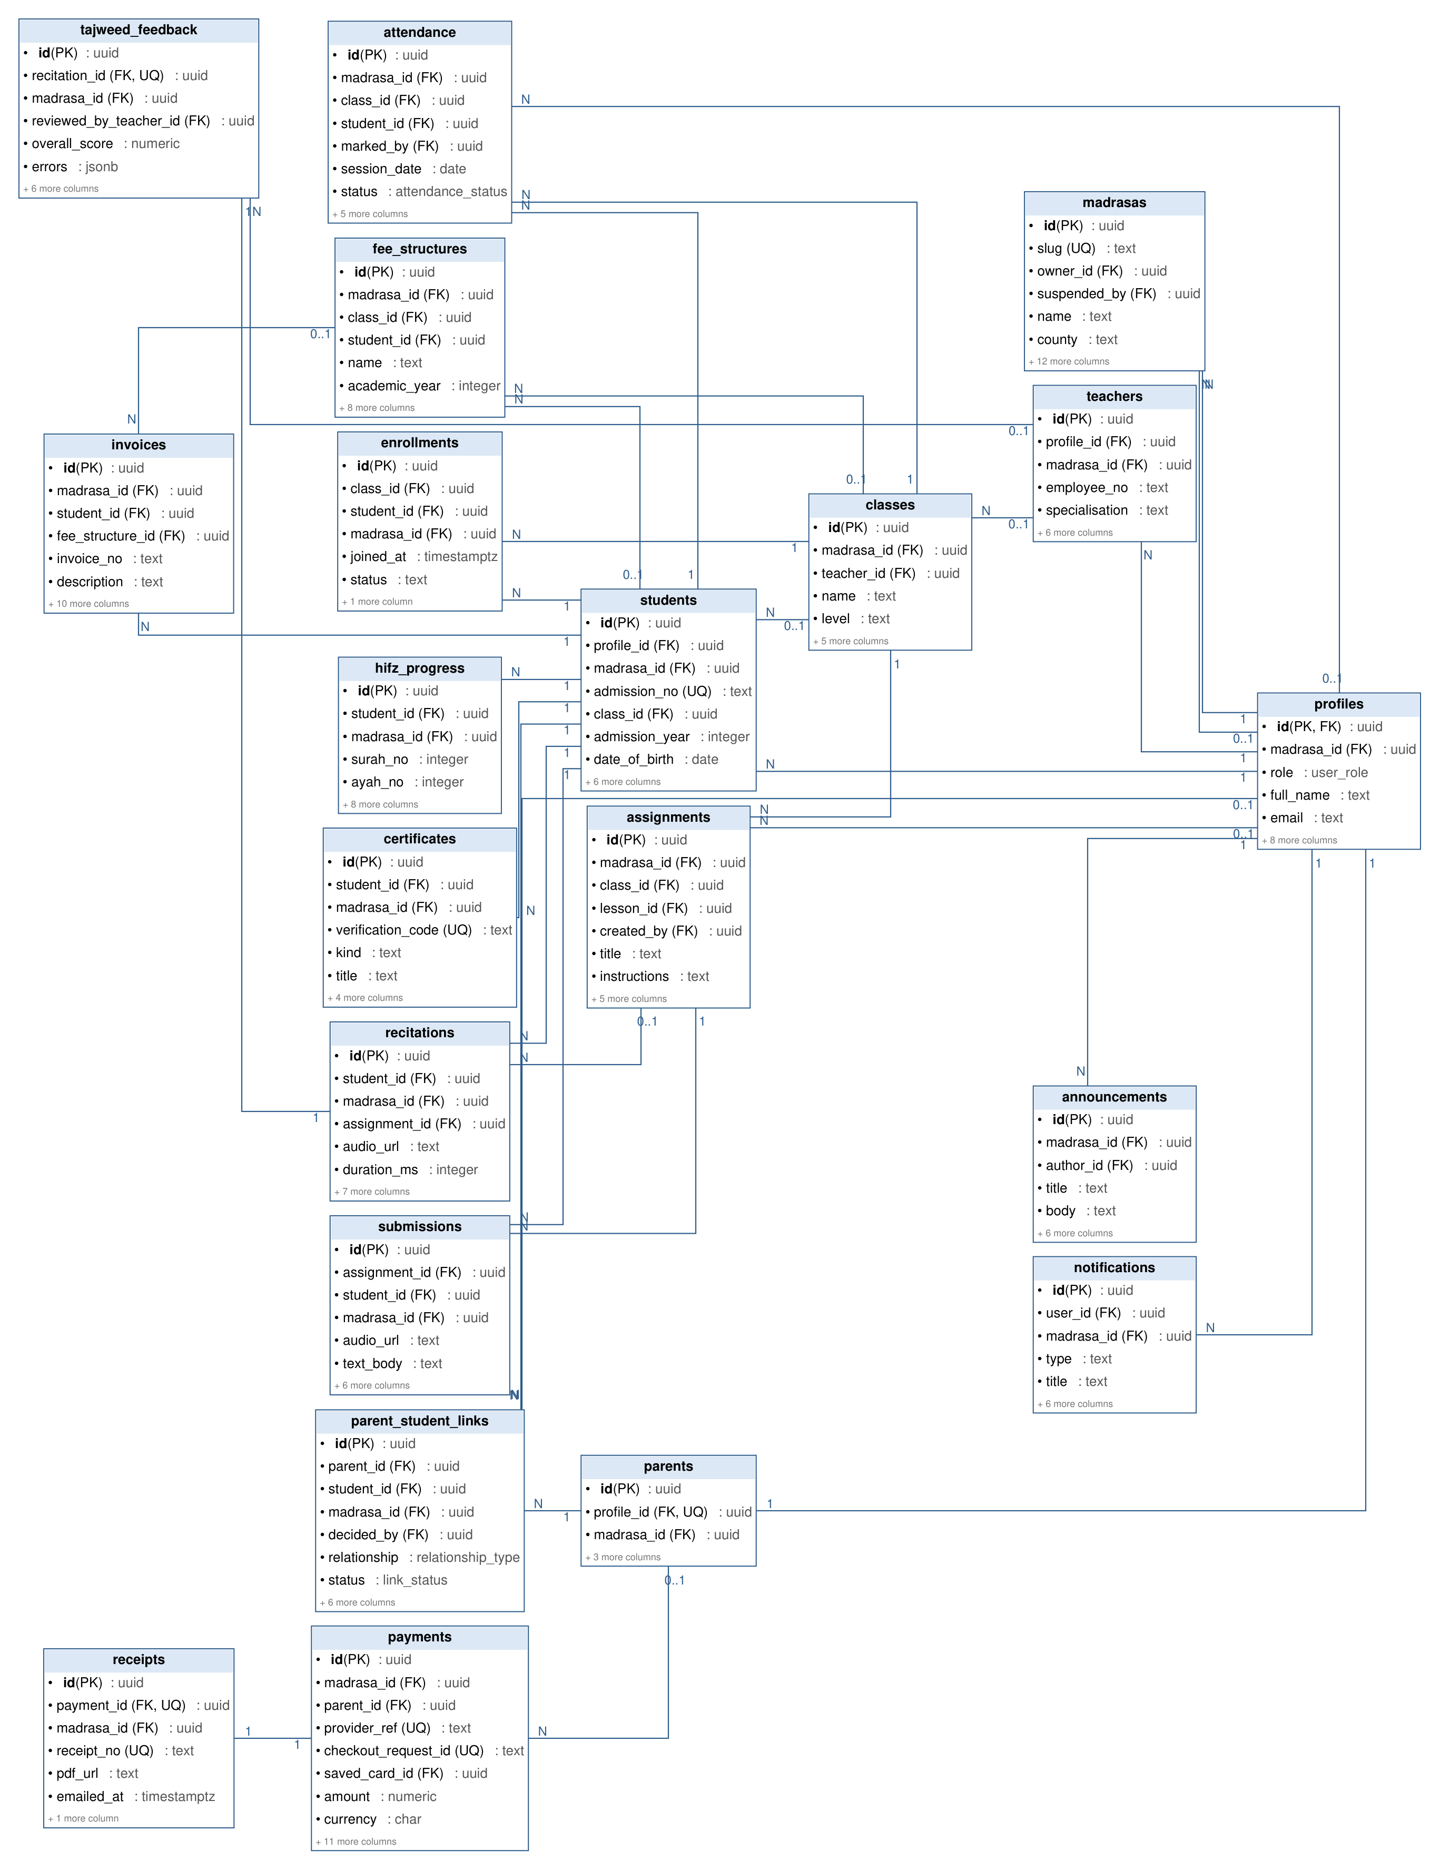
Figure 5.2 ERD Diagram

5.3 Behavioral Diagrams
Behavioural diagrams illustrate how the system responds to user actions and internal events. They show the flow of activities, the order of operations and how each actor interacts with the system, and guide implementation decisions.

5.3.1 Use Case Diagram
The system has four main users: the madrasa owner, the teacher, the parent and the student, with a platform administrator who oversees the madrasas. The owner registers the madrasa, admits students, manages classes and staff, and defines fees and issues invoices; because an owner is also a teacher, the owner can do everything a teacher does. Teachers take attendance, display the rotating QR code, record grades and assignments, review recitations and decide parent link requests. Students scan the class QR code, record recitations and view their progress. Parents create an account, request a link to their child, view the child’s progress and invoices and message the madrasa. Figure 5.3 shows these interactions.
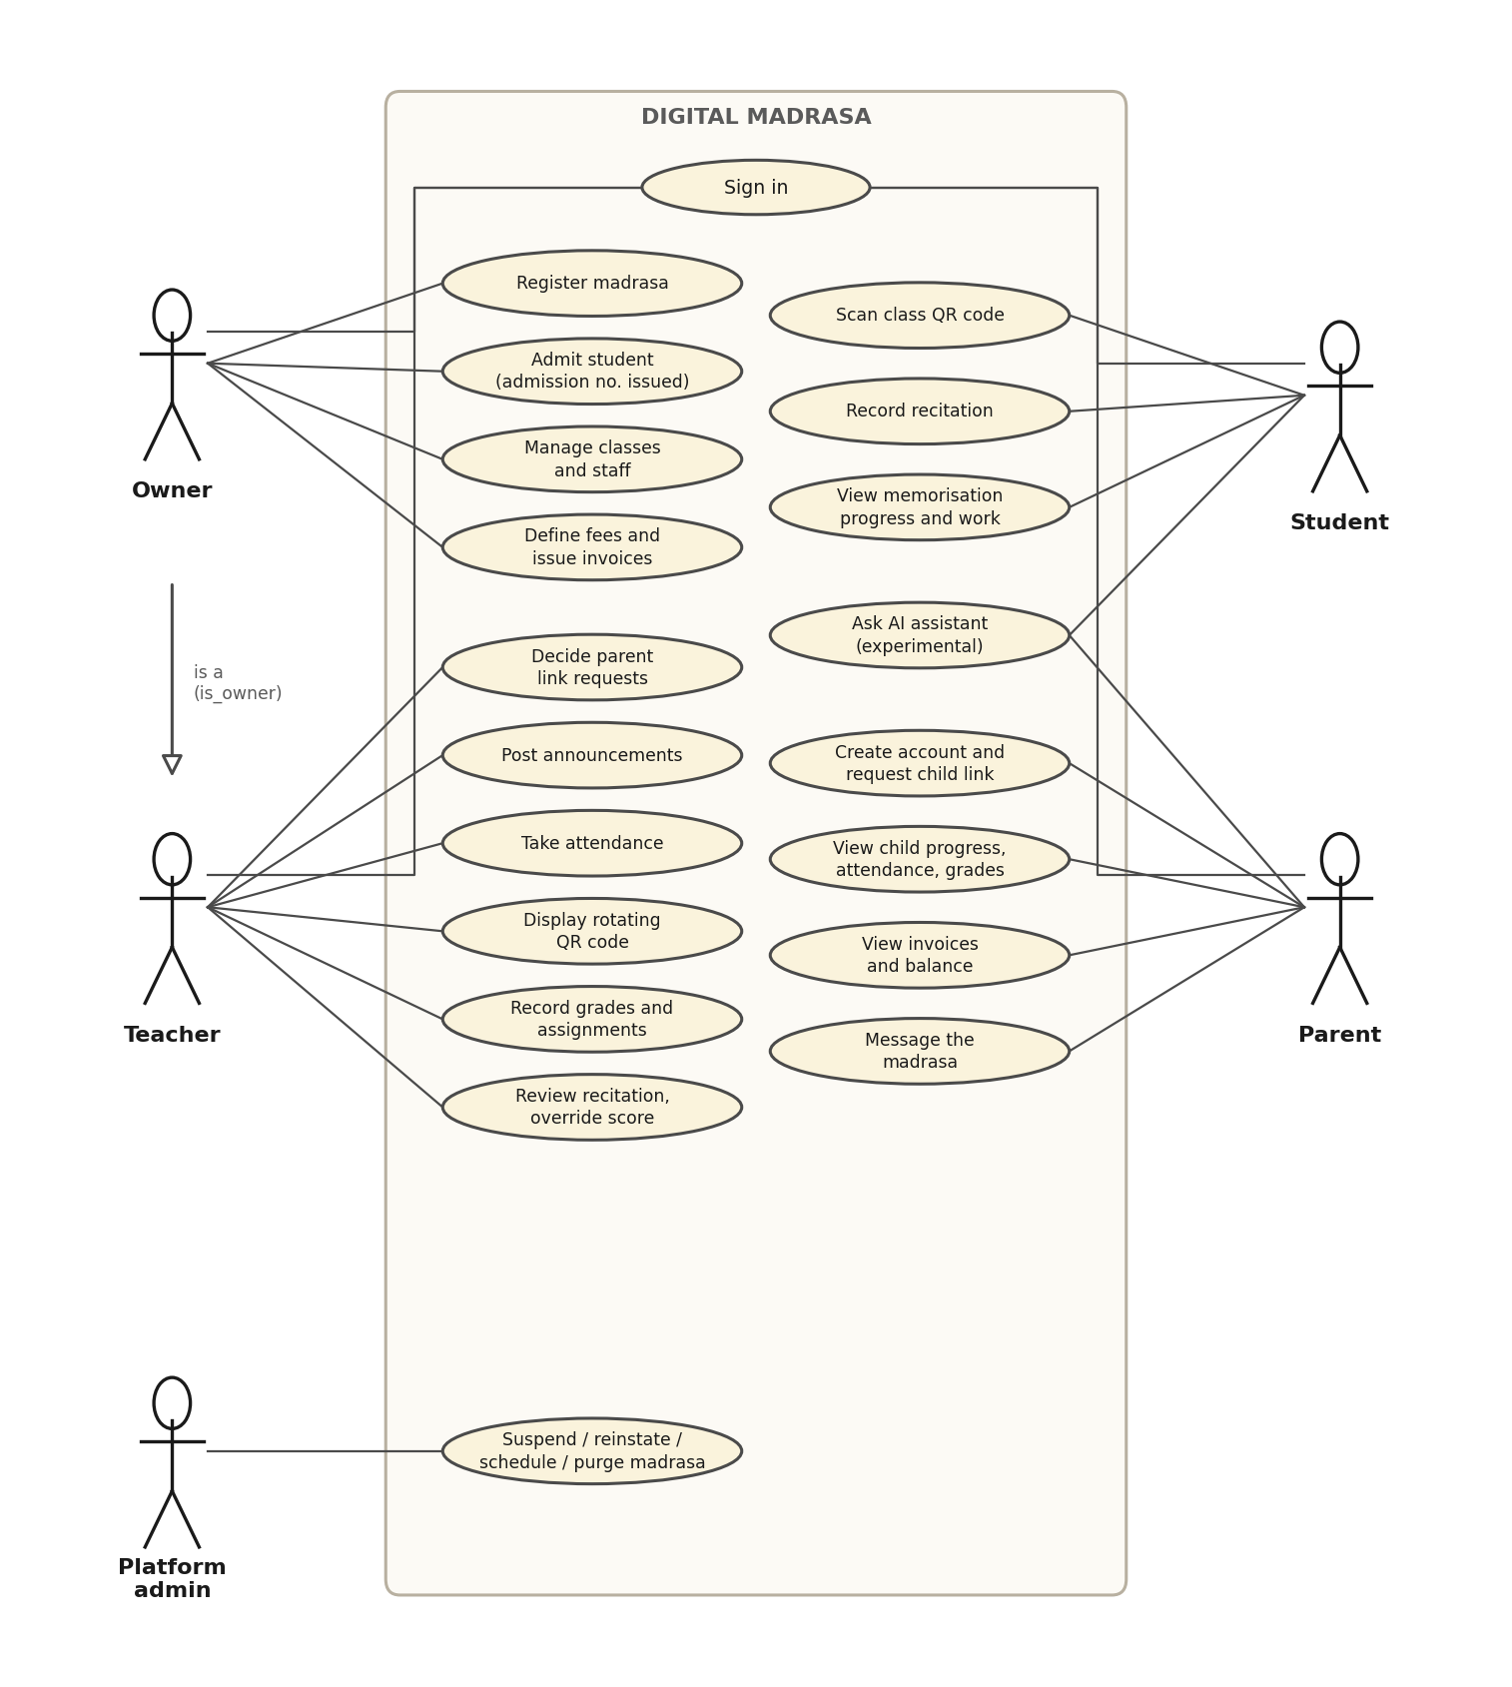
Figure 5.3 Use Case Diagram

5.3.2 Sequence Diagram
Sequence diagrams show the interactions between objects over time. Figure 5.4 shows recitation submission and review. The student’s app requests a private upload link, uploads the audio to storage and asks the server to evaluate it; the server stores the recitation and a provisional result. The teacher then opens the review queue, plays the recording through a short-lived link and saves a score, which the student and the approved parent can see.
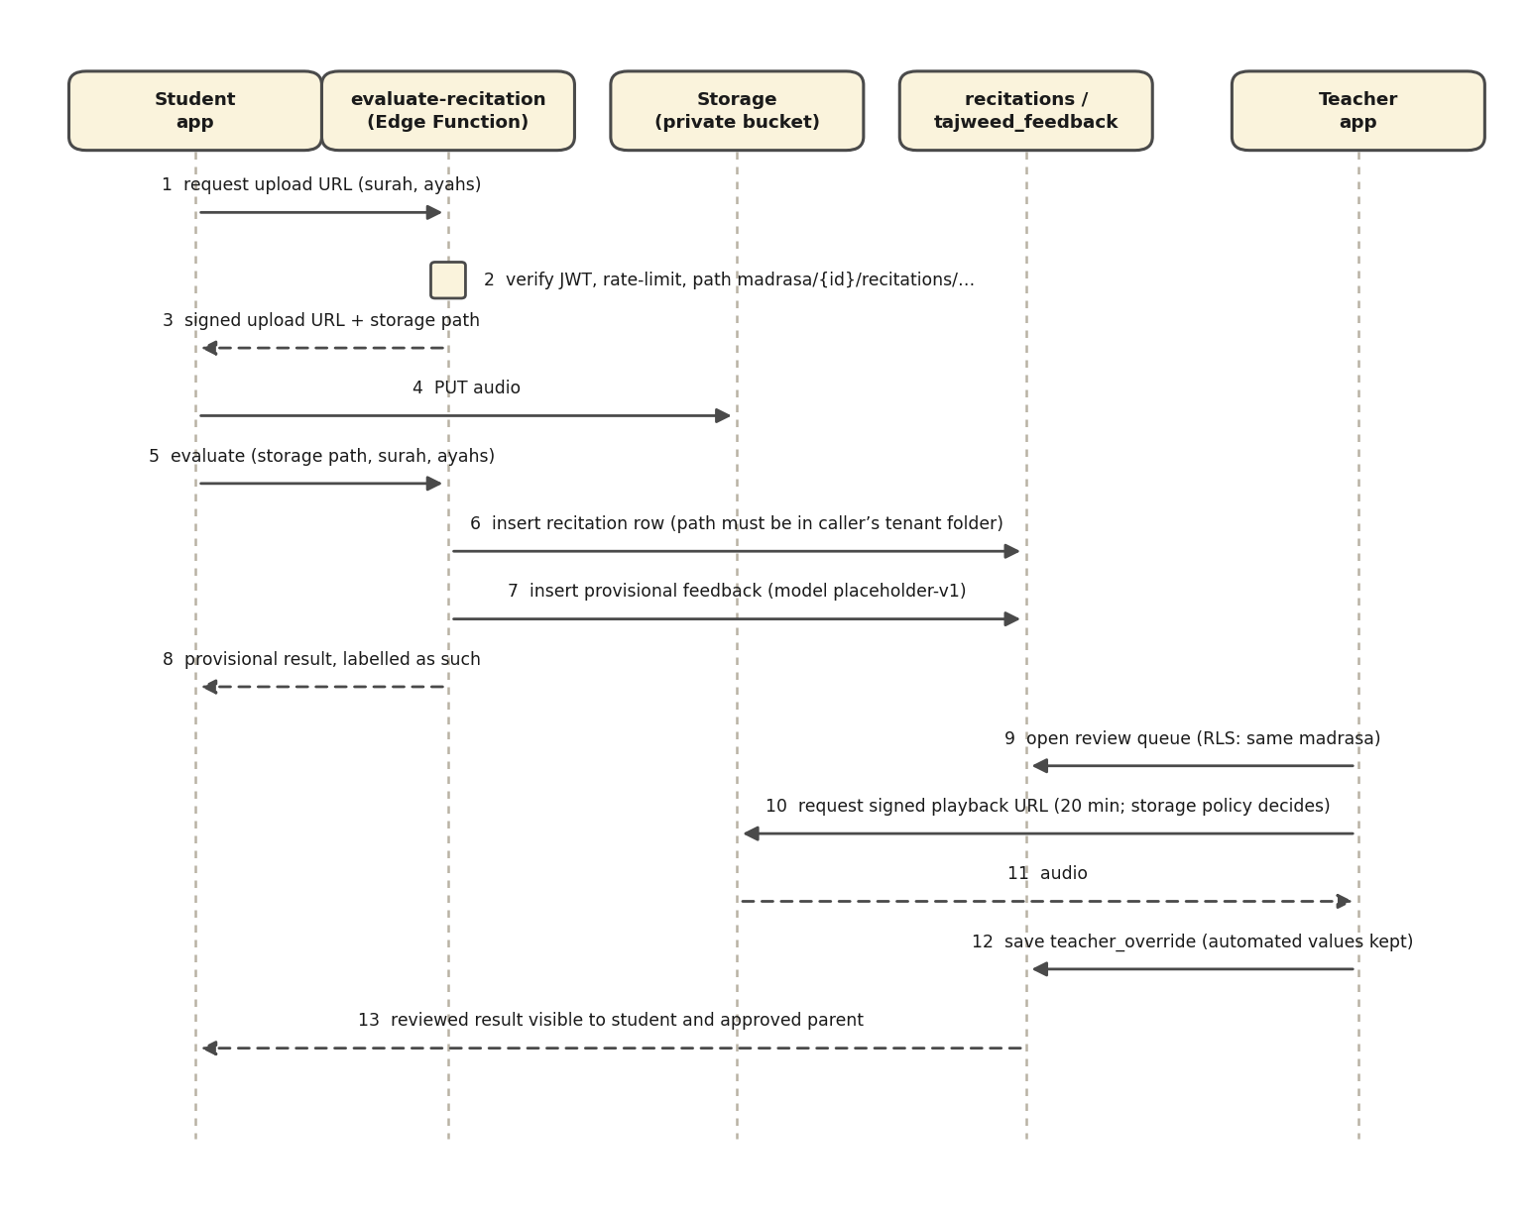
Figure 5.4 Sequence Diagram

5.3.3 Activity Diagram
The activity diagram in Figure 5.5 shows QR attendance. The teacher opens the class attendance screen and the system displays a signed code that changes every 30 seconds. A student scans the code, and the server checks the signature, the time window, the class and the student’s role before recording the student as present; an expired or wrong code is refused.
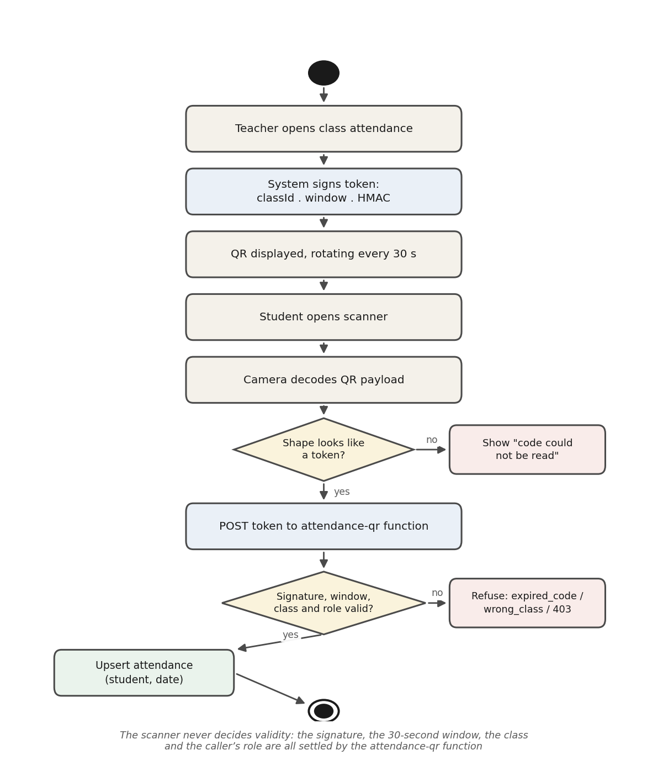
Figure 5.5 Activity Diagram

5.4 Database Schema
The database schema defines how data is organised and stored. Digital Madrasa uses a PostgreSQL database of 40 tables grouped into functional areas: tenancy and identity, access control, learning, attendance, recitation, finance, subscription, communication and operations, as shown in Figure 5.6. Every table that belongs to a madrasa carries its madrasa identifier, and Row Level Security is enabled on all 40 tables so that users can read and change only the records their role allows.
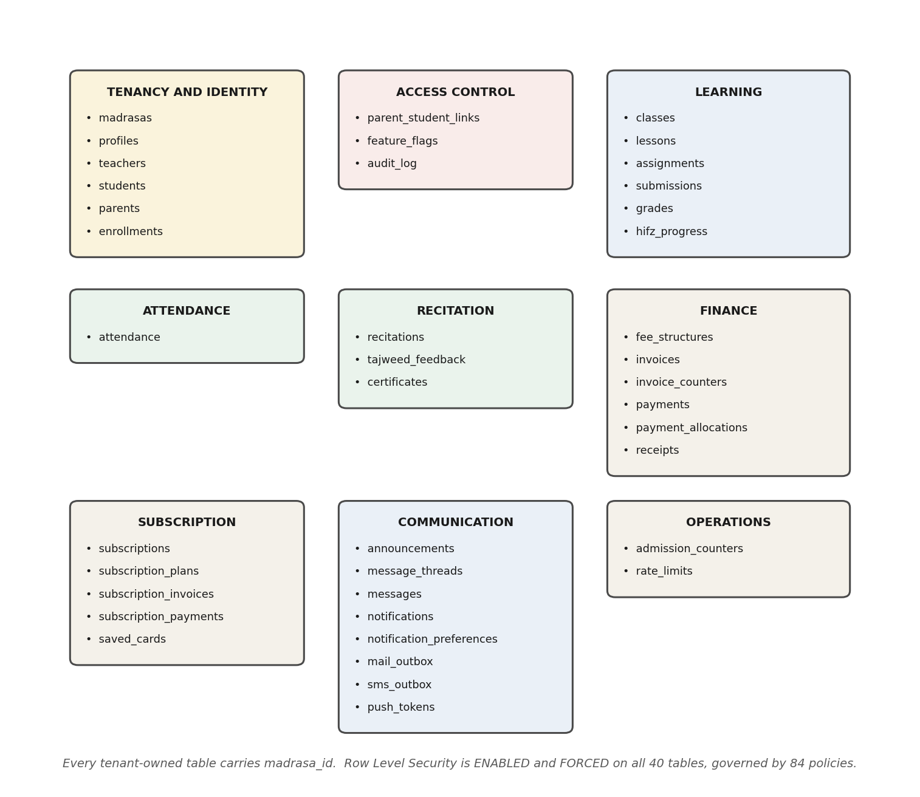
Figure 5.6 Database Schema

5.5 Wireframes
The wireframes in Figure 5.7 illustrate the core user interfaces of the application: the sign-in screen, the teacher dashboard with attendance and fee summaries, QR attendance scanning, and the review screen shown before invoices are issued. They set out the main navigation and the flow of interaction that the implemented screens follow.
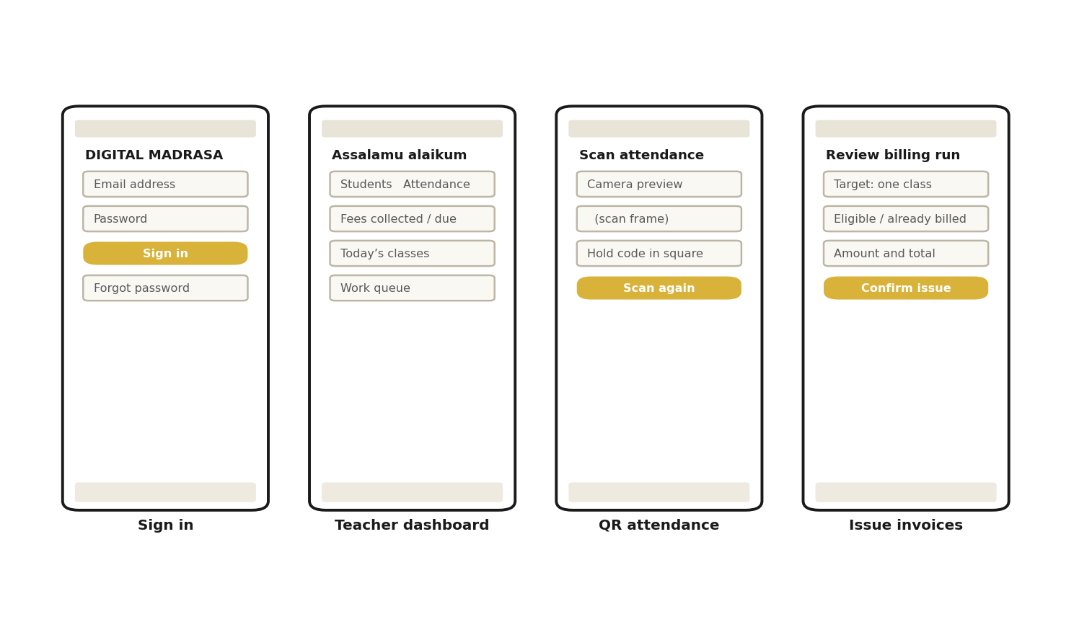
Figure 5.7 Wireframes

5.6 Summary
This chapter presented the design of Digital Madrasa. The class diagram and ERD define the main entities and their relationships, the use case diagram shows what each user can do, the sequence and activity diagrams describe recitation review and QR attendance, the database schema organises the 40 tables, and the wireframes give a visual overview of the interface. Together these form the blueprint for the development described in Chapter Six.
CHAPTER SIX

6. SYSTEM DEVELOPMENT

6.1 Introduction
This chapter presents the development of Digital Madrasa. It outlines the tools, technologies and techniques used, describes the interfaces through which each user interacts with the system, and discusses the challenges encountered during development and how they were addressed. The aim is to show how the designs of Chapter Five were turned into a working mobile application.

6.2 System Development Tools and Techniques
The system was built with tools chosen for cross-platform mobile development, secure data management and low cost. The front end is a single React Native codebase and the back end is a hosted Supabase project, so the same application serves every role while the database enforces what each role may see and do.

6.2.1 Integrated Development Environment (IDE)
Visual Studio Code was used as the main integrated development environment. It provides TypeScript language support that reports errors as code is written, an integrated terminal for running the Expo development server and the test scripts, and Git integration for version control. The Android emulator from Android Studio was used to run the application during development, and the web build was used to check screens at phone size.

[INSERT SCREENSHOT HERE]
VS Code with the Digital Madrasa project open (explorer showing apps, packages and supabase)
Figure 6.1 Visual Studio Code
Screenshot to be inserted by the developer.

6.2.2 Front-end Development
The front end was developed with React Native and the Expo toolchain (SDK 54) in TypeScript, which lets one codebase run on Android devices and in a web browser. Expo Router organises the screens into separate groups for the owner, teacher, parent and student, so each user sees a dashboard tailored to their role. TanStack Query keeps data from the server up to date, and i18next provides the interface in English, Kiswahili, Somali and Arabic. The front end includes sign-up and sign-in screens, dashboards, student admission and class management, attendance with a QR scanner, recitation recording, fee and payment screens, and announcements, messages and notifications.

6.2.3 Database Management Tools
Supabase was used to manage the data collected by the app. It provides a PostgreSQL database, user authentication, private file storage for recitation audio, and Edge Functions that run privileged operations, such as issuing invoices, starting M-Pesa payments and delivering notifications, on the server. The database schema was created through 29 version-controlled migrations, and Row Level Security policies on every table keep each madrasa’s records private. Two outside services are called only from these server functions: Google Gemini, which listens to a recitation (when a parent has given consent) and answers the AI assistant’s questions, and Paystack, whose hosted page takes card payments so that card numbers never pass through the app.

[INSERT SCREENSHOT HERE]
Supabase dashboard showing the project’s tables (Table Editor) or Edge Functions
Figure 6.2 Supabase Setup
Screenshot to be inserted by the developer.

6.3 System Interfaces
Digital Madrasa provides interfaces tailored to each user role. All screens follow the same layout, with a bottom navigation bar, clear headings and summary cards, so that users with different levels of experience can move through the application easily. The following screenshots, captured on an Android phone screen, show the interfaces that users interact with.
Sign Up Interface
A new user chooses to register a madrasa or to create a parent account. Figure 6.3 shows the parent sign-up form, which collects the parent’s name, e-mail address, phone number and password, and asks for consent under the Kenya Data Protection Act 2019.
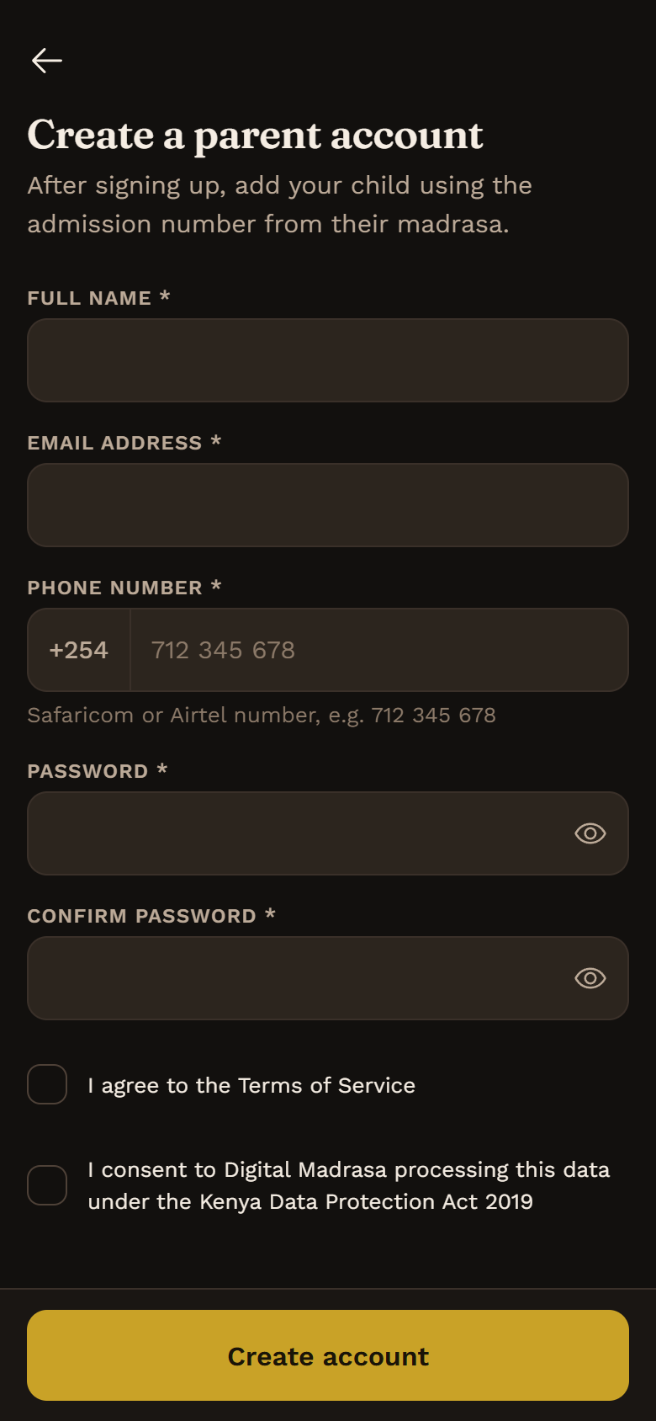
Figure 6.3 App Interface Sign Up
Owner Interface
The owner’s dashboard (Figure 6.4) shows the number of students, attendance for the week, fees collected and outstanding, pending parent link requests and today’s classes, with tabs for students, classes, fees and more.
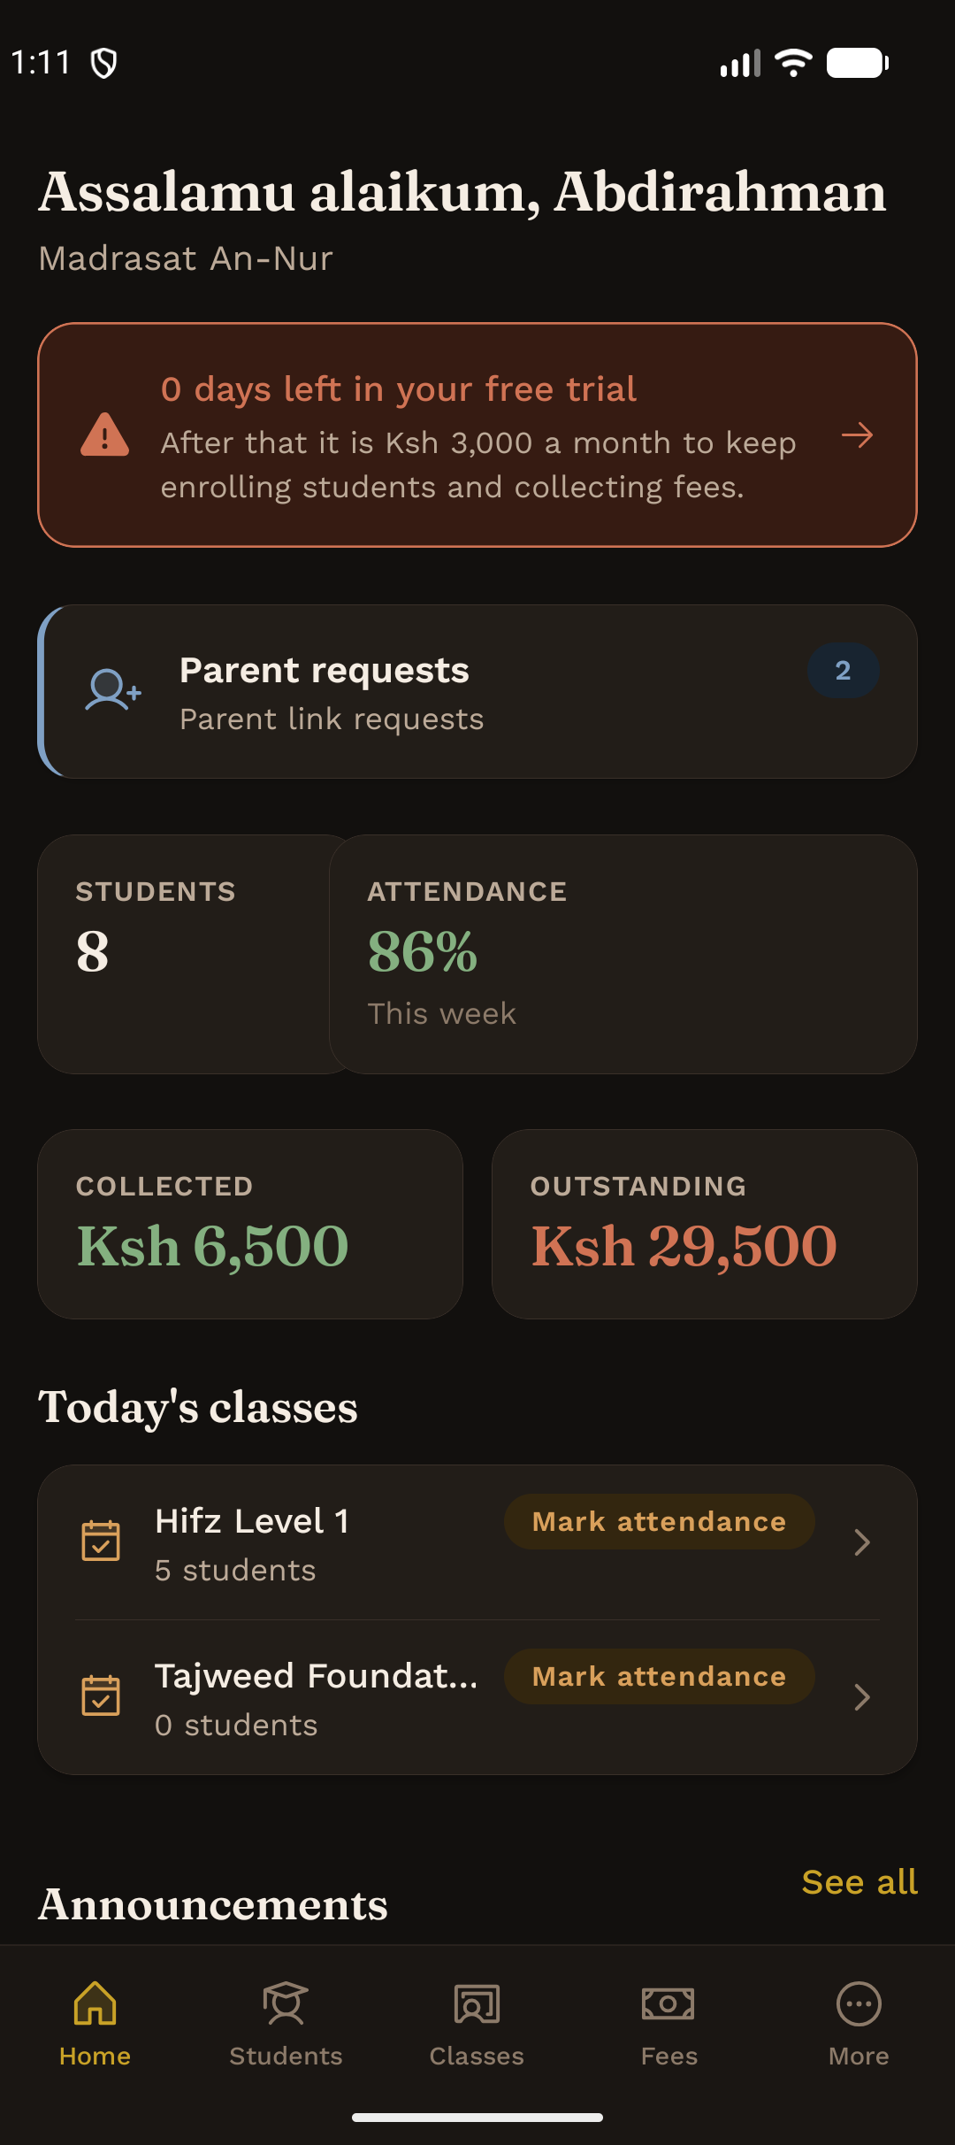
Figure 6.4 Owner Dashboard
Teacher Interface
The teacher’s dashboard (Figure 6.5) lists the teacher’s classes with a shortcut to mark attendance, together with parent requests and summary figures for the madrasa.
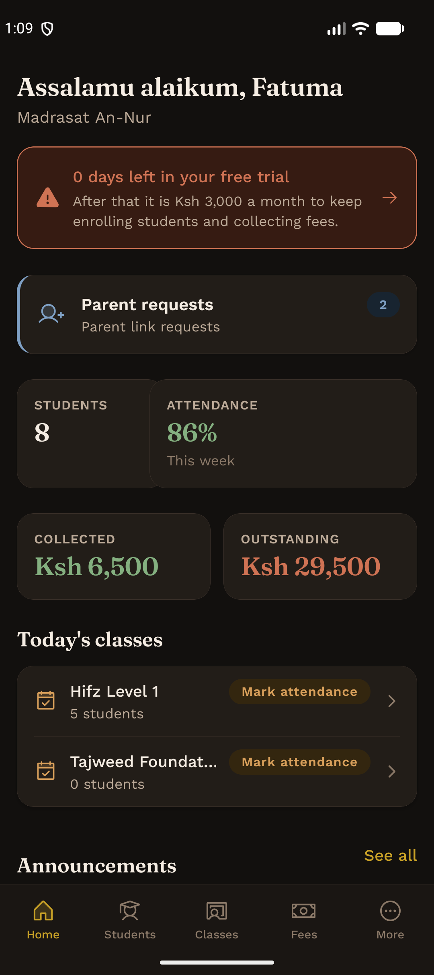
Figure 6.5 Teacher Dashboard
Parent Interface
The parent’s dashboard (Figure 6.6) lets a parent switch between approved children and see each child’s admission number, memorisation, attendance rate, outstanding balance and recent attendance, with tabs for fees, the inbox and messages.
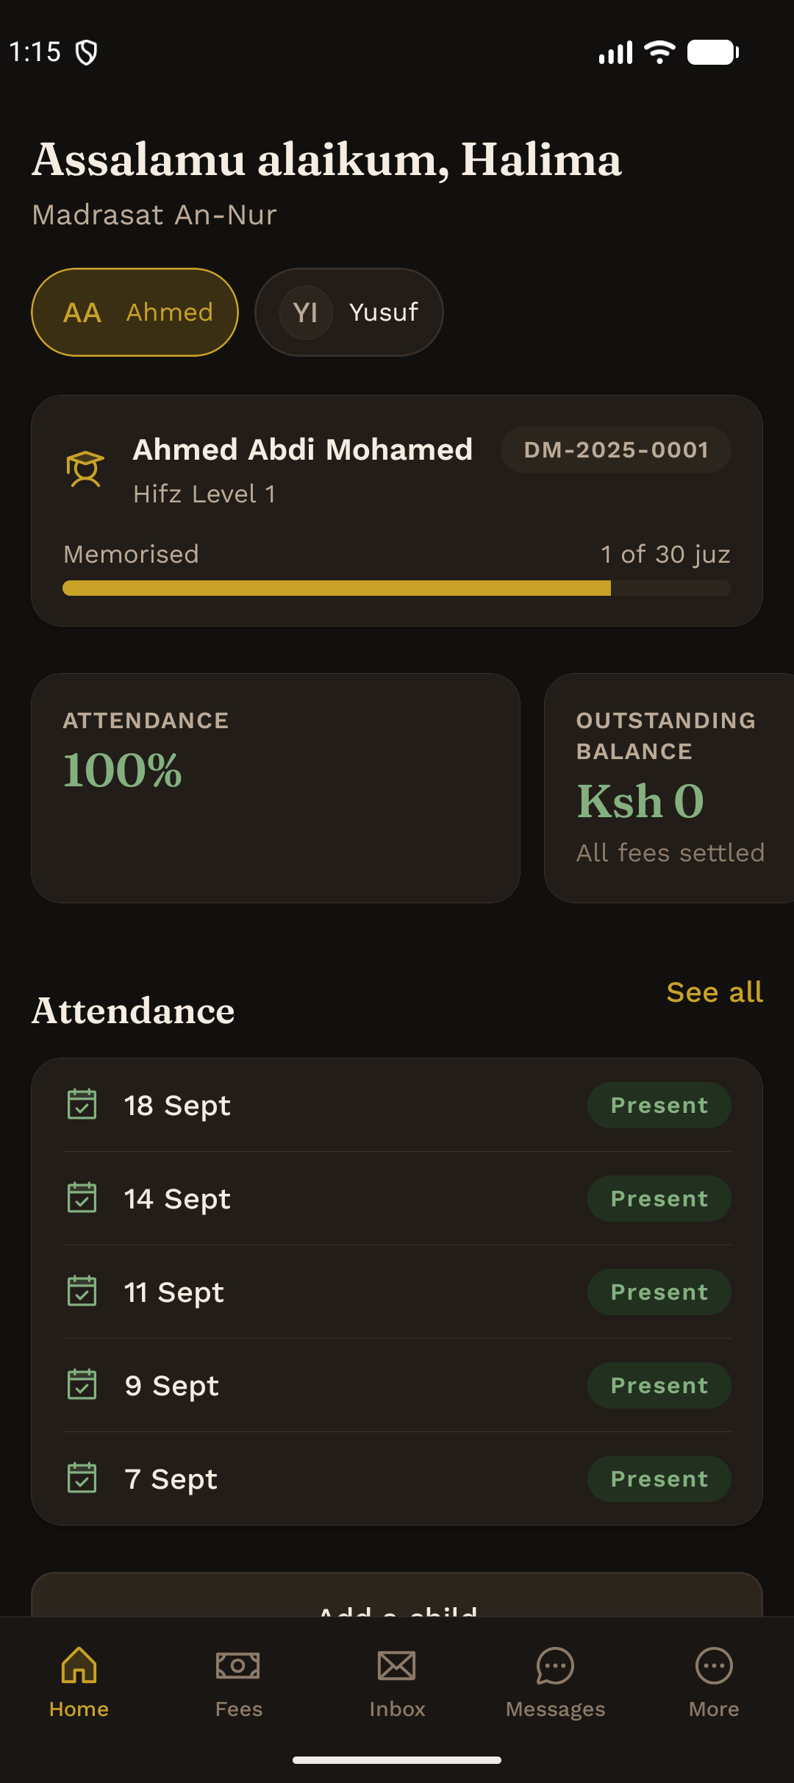
Figure 6.6 Parent Dashboard
Student Interface
The student’s dashboard (Figure 6.7) shows the passages due for revision with a button to start a recitation, the juz memorised, attendance, overall progress and assignments.
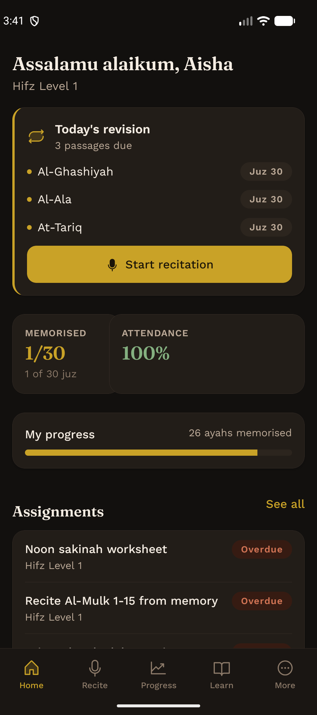
Figure 6.7 Student Dashboard

6.4 Challenges Encountered During Development
Several challenges arose during development and were addressed as follows.

6.4.1 Technical Complexities
Supporting many madrasas and four roles in one system required every rule about who may see what to be written into the database as Row Level Security policies, and tested with accounts for every role. Performance testing showed that the original rule for reading a child’s records became slower as the platform grew, so it was rewritten to be evaluated once per query and proven by a test to allow exactly the same records. Handling money also required care: the app never sends an amount, and a payment is settled on the server exactly once. Some features cannot be tested in Expo Go and needed an installable build; testing that build revealed that Arabic headings were drawn on the wrong side because React Native swaps left and right in a right-to-left layout, which was then fixed. A general AI model also had to be kept honest: given silence and the expected text, one model reported a perfect recitation, so the audio is now first transcribed without the text and checked in code before any score is given.

6.4.2 User Adoption and Resistance
Some owners, teachers and parents have little experience with mobile applications and may prefer familiar paper registers. To encourage adoption the interfaces were kept simple, with large buttons and clear summaries, the application was translated into Kiswahili, Somali and Arabic, and payment uses M-Pesa, which families already use, or a card. AI feedback on a child’s voice is off until a parent turns it on.

6.4.3 Economic Constraints
Limited resources affected the choice of tools. Free and open-source tools were used throughout: Expo, React Native, Visual Studio Code, the free tier of Supabase and the free tier of Google Gemini. M-Pesa, card payments, e-mail and SMS were developed against mock providers so that no paid accounts were needed; the same code switches to the real services when credentials are configured.

6.4.4 Continuous Updates and Supports
Long-term use requires ongoing maintenance. Database changes are made through numbered migrations, automated checks run on every change pushed to GitHub, and the database is backed up every three days. Keeping Expo, React Native and Supabase up to date and responding to feedback from madrasas will keep the system reliable.

6.5 Summary
This chapter described the development of Digital Madrasa: Visual Studio Code as the development environment, React Native with Expo for the front end, and Supabase for the database, authentication, storage and server functions. It presented the sign-up screen and the dashboards for owners, teachers, parents and students, and discussed the challenges of technical complexity, user adoption, limited resources and continuous maintenance, together with how each was addressed.
CHAPTER SEVEN

7. SYSTEM TESTING AND DEPLOYMENT

7.1 Introduction
Testing and deployment are critical phases in the development of Digital Madrasa. Testing ensures that the application meets its functional and security requirements and gives owners, teachers, parents and students a reliable experience. Deployment makes the system available to its users. This chapter describes the testing carried out, its results, and how the system is deployed now and will be deployed in future.

7.2 System Testing and Validation
The system was tested at several levels: unit testing of individual functions, functional testing of complete features against the deployed backend as each role, and user interface testing of the screens. Because the most important requirement is that no madrasa can see another’s records and no user can act outside their role, tests checked that forbidden actions are refused as well as that permitted ones succeed.

7.2.1 Unit Tests
Unit testing examines individual components in isolation. Unit tests were written with Vitest for the logic that does not need a server: input validation, QR token signing, M-Pesa and card payment handling, notification rules, memorisation totals, recitation assessment and the AI assistant’s check on figures. All 112 unit tests in 10 test files passed when run on 2 October 2026. Table 7.1 shows representative cases.

Test Case ID | Module | Test Case Description | Expected Result | Actual Result | Status
UT01 | Validation | A payment request that includes an amount | Amount removed; server derives it | As expected | Pass
UT02 | QR tokens | Token from an old window, or forged | Token rejected | As expected | Pass
UT03 | M-Pesa callback | Customer cancels the payment prompt | Recorded as failed; nothing credited | As expected | Pass
UT04 | Memorisation | Overlapping memorisation records | Each juz counted once | As expected | Pass
UT05 | Notifications | User has switched SMS off | No SMS sent | As expected | Pass
Table 7.1 Unit Testing

7.2.2 Functional Testing
Functional testing verifies that each feature works as the requirements specify. Scripts signed in as test accounts for every role and called the deployed backend; in total 78 functional test cases were run and all passed. Key functionalities tested include:
- Sign-in and role-based access: each role reaches its own dashboard and is refused actions of other roles.
- Attendance, invoicing, M-Pesa and card payment, notifications, written work, certificates, and AI recitation feedback only with consent.

Test Case ID | Feature | Test Scenario | Expected Outcome | Actual Outcome | Status
FT01 | Admission | Owner admits a student; a parent tries to | Number DM-YYYY-NNNN issued; parent refused | As expected | Pass
FT02 | QR attendance | Student scans a valid code, then an expired one | Marked present once; expired code refused | As expected | Pass
FT03 | Invoicing | Owner issues invoices to one class | One invoice per student of that class | As expected | Pass
FT04 | M-Pesa payment | Parent pays an invoice | Invoice paid; receipt issued; parent notified | As expected | Pass
FT05 | AI feedback | Recitation from a pupil without parental consent | Nothing sent to the AI; no score given | As expected | Pass
Table 7.2 Functional Testing

7.2.3 User Interface (UI) Testing
User interface testing checks that the application is easy to use and visually consistent. It was carried out on an Android emulator, in the web build at phone size, and finally on the installed Android package (APK) built by Expo Application Services. Key areas tested were:
- Navigation: tabs and buttons lead to the correct screens for each role.
- Forms and input fields: admission, invoice and payment forms validate input and show clear messages.
- Languages: labels fit and read correctly in English, Kiswahili, Somali and Arabic.
- Visual consistency: fonts, colours, icons and buttons are consistent across screens.
On the installed app, recording, the offline library with the network switched off, the mirrored Arabic layout, camera permissions, confirmation dialogs, the AI assistant, parental consent and card payment were all exercised. Six defects found during UI testing were fixed: the parent inbox failed to display some notification types; tab labels were cut off in some languages; Arabic headings were drawn on the wrong side; the scanner did not notice a camera permission granted in Settings; the microphone message was not translated; and an unassessed recording was praised. Push notifications remain to be verified, because they need a Firebase project to be configured.

Test Case ID | UI Element | Test Scenario | Expected Result | Actual Result | Status
UI01 | Sign-in screen | Layout at phone size | Clean and responsive | As expected | Pass
UI02 | Dashboard | Role-based display | Correct dashboard per role | As expected | Pass
UI03 | Arabic layout | Installed app in Arabic | Screens mirrored right to left | As expected after fix | Pass
UI04 | Forms | Data entry and validation | Easy input and clear feedback | As expected | Pass
UI05 | Inbox | Display of notifications | All notices shown correctly | As expected after fix | Pass
Table 7.3 User Interface Testing

7.3 Testing Results
Testing produced positive results across all major parts of the system. Table 7.4 summarises the results. Of the 31 user interface checks, 30 passed, six of them after a defect was fixed; push notifications are still to be verified once Firebase is configured.

Testing Type | Total Test Cases | Passed | Failed | Success Rate
Unit Testing | 112 | 112 | 0 | 100%
Functional Testing | 78 | 78 | 0 | 100%
UI Testing | 31 | 30 | 0 | 100% of tests run (1 pending)
Table 7.4 Testing Results

7.4 System Deployment
Deployment prepares the system for real use. The backend of Digital Madrasa is deployed on a hosted Supabase project: the database with its 29 migrations and security policies, private storage for recitation audio, and 14 Edge Functions for operations such as invoicing, payments, notifications, AI feedback and the AI assistant. Automated checks run on GitHub for every change, and the database is backed up every three days.

7.4.1 Current Deployment Methods
The mobile application is built as an installable Android package (APK) with Expo Application Services (EAS) and connects to the live backend. The APK is distributed directly:
- Direct APK sharing: the APK file is shared through Google Drive, Bluetooth or USB, and users install it by allowing installation from unknown sources.
- WhatsApp distribution: the APK is shared as a document on WhatsApp, which madrasa owners, teachers and parents already use.

7.4.2 Future Deployment Plans
- Google Play Store: publishing the app will make installation easier and more trusted, and provide automatic updates.
- Live payment and messaging services: connecting the Safaricom Daraja M-Pesa service, Paystack for cards, the e-mail and SMS providers, and Firebase for push notifications, with real credentials.
- Web-based dashboard: hosting the platform administrator’s web console so that the madrasas on the platform can be managed from a browser.

7.5 Summary
This chapter presented the testing and deployment of Digital Madrasa. Unit, functional and user interface testing showed that the core features, including sign-in, admission, attendance, invoicing, M-Pesa and card payment, AI feedback with consent and parent access, work as required on the installed app, and that users cannot reach records outside their madrasa or role. The backend is deployed on Supabase, the app is shared as an APK, and future plans include the Google Play Store, live payment and messaging services, and a hosted web dashboard.
CHAPTER EIGHT

8. DISCUSSIONS, FUTURE WORKS AND RECOMMENDATIONS

8.1 Introduction
This chapter reflects on the outcomes of Digital Madrasa in relation to the objectives of the project. It evaluates how far the system addresses the challenges of madrasa administration and Quran learning in Kenya, and identifies future work and recommendations.

8.2 Discussions of Objectives
Objective 1
The project analysed the challenges facing madrasas in Kenya: informal and unstandardised records, limited parental visibility, the workload of assessing recitation, and fees that are not linked to invoices. The system addresses them with digital records of admission, attendance and memorisation, parent access approved by the madrasa, recorded recitations for teacher review, and invoices with M-Pesa payment. The questionnaire results in Chapter Four are to be completed from the fieldwork.
Objective 2
The review of existing systems showed that Quran applications serve individual learners while education management systems have no Quran-specific functions, and that none keeps many independent madrasas separate. Digital Madrasa combines both in one platform, with each madrasa’s records isolated by the database and an interface in four languages.
Objective 3
The system was developed with React Native and Expo for the front end and Supabase for the backend. Owners, teachers, parents and students each have a dedicated dashboard, and admission, classes, manual and QR attendance, memorisation, assignments, recitation review with AI feedback, certificates, invoicing, M-Pesa and card payment, and notifications were implemented against the live backend.
Objective 4
Unit, functional and user interface testing confirmed that the core features work as required: all 112 unit tests and 78 functional test cases passed, the installed app passed 30 of 31 interface checks, and the tests showed that users cannot reach records outside their madrasa or role. A usability study with real users, push notifications and testing on a range of physical phones remain to be done.

8.3 Future Work
Although the system meets its main objectives, several enhancements would improve its reach and usefulness.

8.3.1 Deployment to Google Play Store
Building the Android package and publishing the app on the Google Play Store would make installation easier and more trusted, provide automatic updates and allow feedback to be collected from users.

8.3.2 Development of Web-Based Admin Dashboard
The platform administrator’s web console should be hosted and extended with reports, so that the madrasas on the platform, their subscriptions and their activity can be monitored from a browser.

8.3.3 Integration of Push Notifications and Messaging
Push, e-mail and SMS notifications are built. Configuring a Firebase project for push, connecting the real e-mail and SMS providers, Safaricom’s M-Pesa service and Paystack, and confirming delivery on physical phones would give parents timely alerts about attendance, fees and reviews.

8.3.4 Smart Alerts and Recommendations
The system could remind students of passages due for revision using spaced repetition (Kornell, 2009), alert teachers to learners who fall behind, and replace the general AI model now used for recitation feedback with a tajweed model validated, with consent, on recordings of Kenyan learners.

8.3.5 Enhanced Offline Functionality
Many madrasas have unreliable internet access. Offline attendance and memorisation records that synchronise when a connection returns, in addition to the offline Quran text, would make the system usable in such areas.

8.4 Recommendations
To ensure the long-term success and adoption of the system, the following recommendations are proposed.

8.4.1 Continuous User Engagement
Feedback should be collected regularly from owners, teachers, parents and students, beginning with a pilot in one madrasa, so that the system continues to meet real needs.

8.4.2 Strengthening Data Security
Because the system holds children’s records, authorisation must remain in the database, every change to an access rule should be tested before deployment, and the Kenya Data Protection Act 2019 must be followed.

8.4.3 Regular System Updates
The application should be updated regularly to fix defects, keep Expo, React Native and Supabase current, and add features requested by users.

8.4.4 Institutional and Government Collaboration
Collaboration with madrasa associations and the Ministry of Education would support adoption and help align the system’s records with the planned integration of madrasa education into the national system (Kihaki, 2026; Tongola, 2025).

8.4.5 Optimization for Low-End Devices
The application should be optimised for the low-cost smartphones common among families, by reducing its size and data usage and testing it on such devices.

8.5 Summary
This chapter discussed how Digital Madrasa addressed the challenges of madrasa administration and Quran learning in Kenya. The system brings records, attendance, memorisation, recitation review, parent access and fee payment into one secure platform. Future work includes publishing on the Google Play Store, a hosted web dashboard, live notifications and payments, smart revision alerts and better offline support, while the recommendations emphasise user engagement, data security, regular updates, institutional collaboration and optimisation for low-end devices.

Appendix

A.1: User Survey Questionnaire

Section A: Madrasa Owner and Teacher Questionnaire
Question 1: How is student attendance currently recorded in your madrasa?
☐ Exercise book or register
☐ Wall chart
☐ Teacher’s memory only
☐ Not recorded
☐ Other (please specify): __________
Question 2: How is a student’s Quran memorisation progress recorded?
☐ Written in a book
☐ Teacher remembers
☐ Told to the parent verbally
☐ Not recorded
☐ Other (please specify): __________
Question 3: How are fees recorded and communicated to parents?
☐ Written receipt book
☐ Verbal reminder
☐ M-Pesa messages only
☐ No formal record
☐ Other (please specify): __________

Section B: Parent Questionnaire
Question 1: How do you currently learn about your child’s attendance and progress?
☐ Told at pick-up
☐ Phone call from the teacher
☐ Parents’ meeting
☐ I am not informed
☐ Other (please specify): __________
Question 2: Would you pay madrasa fees through M-Pesa in a mobile application?
☐ Yes
☐ Maybe
☐ No

Section C: Student Questionnaire
Question 1: How does your teacher assess your recitation?
☐ I recite to the teacher in class
☐ The teacher listens to a group together
☐ Rarely assessed
☐ Other (please specify): __________
Question 2: Would recording your recitation on a phone help you practise?
☐ Strongly agree
☐ Agree
☐ Neutral
☐ Disagree
☐ Strongly disagree

A.2: Work Plan and Schedule

Task | Start Date | End Date | Duration | Development Description
Requirement Gathering | [INSERT DATE] | [INSERT DATE] | [INSERT] | Identify user roles and madrasa requirements; literature review
System Design & Wireframing | [INSERT DATE] | [INSERT DATE] | [INSERT] | Diagrams, database schema and wireframes
Supabase Setup & Core Platform | [INSERT DATE] | 2026-08-23 | [INSERT] | Multi-tenant database, authentication and screens for all roles
Edge Functions, CI & Backups | 2026-08-24 | 2026-09-16 | 24 days | Server functions, build configuration, automated checks and backups
Backend Integration & Recitation | 2026-09-17 | 2026-09-23 | 7 days | Live backend, recitation storage, teacher review and parent access
QR Attendance & Invoicing | 2026-09-23 | 2026-09-24 | 2 days | Rotating QR attendance and targeted invoices
Learning, Payments & Notifications | 2026-09-25 | 2026-09-29 | 5 days | Written work, certificates, M-Pesa payments, notifications and translations
System Testing & Validation | 2026-09-19 | 2026-09-30 | 12 days | Unit, functional, user interface and performance testing
Final Documentation & Deployment | 2026-09-30 | [INSERT DATE] | [INSERT] | Report, APK build and presentation
Table 8.1: Work Plan and Schedule

A.3: Budget

Items | Quantity | Cost (KES) | Total Cost (KES) | Notes
Internet data bundles | 3 months | 2,000 | 6,000 | Development, testing and backend access
Transport & field data collection | – | – | 4,000 | Visiting madrasas for questionnaires and interviews
Printing, binding & documentation | – | – | 3,500 | Final report copies
Google Play developer registration | 1 | 3,250 | 3,250 | One-time US$ 25, when the app is published
Supabase backend services | 1 | 0 | 0 | Free plan
M-Pesa, e-mail & SMS services | – | – | 0 | Mock providers during development; pay per use when live
Development tools (VS Code, Expo, GitHub) | – | 0 | 0 | Free and open source
Test device (Android phone) | 1 | [INSERT] | [INSERT] | Existing device, or cost if purchased
Contingency (unexpected costs) | – | – | 1,675 | 10% of paid items
Total Estimated Budget |  |  | 18,425 | Plus a test device if purchased
Table 8.2: Budget

A.4: My Project Repository
Repository link: [INSERT GITHUB REPOSITORY LINK]

[INSERT SCREENSHOT HERE]
GitHub repository home page after the final push

A.5: Plagiarism Report

[INSERT PLAGIARISM REPORT HERE]
Similarity report issued by the university’s plagiarism checker

REFERENCES
1. Aden, A. A. (2017). Integration of Islamic and secular education in Kenya: A synthesis of the literature. International Journal of Social Science and Humanities Research, 5(3), 67–75.
2. Al-Ayyoub, M., Damer, N. A., & Hmeidi, I. (2018). Using deep learning for automatically determining correct application of basic Quranic recitation rules. The International Arab Journal of Information Technology, 15(3A), 620–625.
3. Al-Fraihat, D., Joy, M., Masa’deh, R., & Sinclair, J. (2020). Evaluating e-learning systems success: An empirical study. Computers in Human Behavior, 102, 67–86.
4. Al-Kharusi, M. H., Hayat, K., Al Ruqeishi, K. B., & Lone, H. R. (2025). A critical review of the need for knowledge-centric evaluation of Quranic recitation (arXiv:2510.12858). arXiv. https://arxiv.org/abs/2510.12858
5. Alkhalil, A., Sahandi, R., & John, D. (2017). An exploration of the determinants for decision to migrate existing resources to cloud computing using an integrated TOE-DOI model. Journal of Cloud Computing, 6(1). https://doi.org/10.1186/s13677-016-0072-x
6. Alsharhan, E., & Ramsay, A. (2020). Investigating the effects of gender, dialect, and training size on the performance of Arabic speech recognition. Language Resources and Evaluation, 54, 975–998.
7. Beck, K., Beedle, M., van Bennekum, A., Cockburn, A., Cunningham, W., Fowler, M., Grenning, J., Highsmith, J., Hunt, A., Jeffries, R., Kern, J., Marick, B., Martin, R. C., Mellor, S., Schwaber, K., Sutherland, J., & Thomas, D. (2001). Manifesto for Agile software development. Agile Alliance. https://agilemanifesto.org/
8. Bezemer, C.-P., & Zaidman, A. (2010). Multi-tenant SaaS applications: Maintenance dream or nightmare? In Proceedings of the Joint ERCIM Workshop on Software Evolution (EVOL) and International Workshop on Principles of Software Evolution (IWPSE) (pp. 88–92). ACM. https://doi.org/10.1145/1862372.1862393
9. Biørn-Hansen, A., Grønli, T.-M., & Ghinea, G. (2018). A survey and taxonomy of core concepts and research challenges in cross-platform mobile development. ACM Computing Surveys, 51(5), Article 108. https://doi.org/10.1145/3241739
10. Boyle, H. N. (2004). Quranic schools: Agents of preservation and change. RoutledgeFalmer.
11. Brooke, J. (1996). SUS: A “quick and dirty” usability scale. In P. W. Jordan, B. Thomas, B. A. Weerdmeester, & I. L. McClelland (Eds.), Usability evaluation in industry (pp. 189–194). Taylor & Francis.
12. Coates, H., James, R., & Baldwin, G. (2005). A critical examination of the effects of learning management systems on university teaching and learning. Tertiary Education and Management, 11(1), 19–36.
13. Communications Authority of Kenya. (2023). Sector statistics report Q4 2022/2023. Communications Authority of Kenya.
14. Dougiamas, M., & Taylor, P. C. (2003). Moodle: Using learning communities to create an open source course management system. In Proceedings of EdMedia: World Conference on Educational Media and Technology 2003 (pp. 171–178). AACE.
15. Emerson, L., Fear, J., Fox, S., & Sanders, E. (2012). Parental engagement in learning and schooling: Lessons from research. Australian Research Alliance for Children and Youth for the Family–School and Community Partnerships Bureau.
16. Epstein, J. L. (2018). School, family, and community partnerships: Preparing educators and improving schools (2nd ed.). Routledge.
17. Fan, X., & Chen, M. (2001). Parental involvement and students’ academic achievement: A meta-analysis. Educational Psychology Review, 13(1), 1–22. https://doi.org/10.1023/A:1009048817385
18. Holmes, W., Bialik, M., & Fadel, C. (2019). Artificial intelligence in education: Promises and implications for teaching and learning. Center for Curriculum Redesign.
19. Kihaki, M. (2026, June 1). Madrassa and Duksi to be integrated into the education system. The Standard.
20. Kornell, N. (2009). Optimising learning using flashcards: Spacing is more effective than cramming. Applied Cognitive Psychology, 23(9), 1297–1317. https://doi.org/10.1002/acp.1537
21. Masalha, F., & Hirzallah, N. (2014). A students attendance system using QR code. International Journal of Advanced Computer Science and Applications, 5(3), 75–79. https://doi.org/10.14569/IJACSA.2014.050310
22. Ministry of Education. (n.d.). NEMIS. Republic of Kenya. Retrieved September 26, 2026, from https://www.education.go.ke/nemis
23. Ministry of ICT and the Digital Economy. (2022). The Kenya national digital master plan 2022–2032. Government of Kenya.
24. Mwaura, P. A. M., Sylva, K., & Malmberg, L.-E. (2008). Evaluating the Madrasa preschool programme in East Africa: A quasi-experimental study. International Journal of Early Years Education, 16(3), 237–255. https://doi.org/10.1080/09669760802357121
25. Ndzovu, H. (2023). The madrassa system and the Islamic-integrated schools: Competing spaces for learning and the ambivalent relations with secular education in Kenya. Journal for Islamic Studies, 41(1). https://doi.org/10.25159/2957-9163/15080
26. Neri, A., Cucchiarini, C., & Strik, H. (2008). The effectiveness of computer-based speech corrective feedback for improving segmental quality in L2 Dutch. ReCALL, 20(2), 225–243.
27. PostgreSQL Global Development Group. (n.d.). Row security policies. In PostgreSQL 17 documentation. Retrieved September 26, 2026, from https://www.postgresql.org/docs/17/ddl-rowsecurity.html
28. Quran.com. (n.d.). Quran.com [Website]. Retrieved September 26, 2026, from https://quran.com
29. Sandhu, R., Ferraiolo, D., & Kuhn, R. (2000). The NIST model for role-based access control: Towards a unified standard. In Proceedings of the Fifth ACM Workshop on Role-Based Access Control (pp. 47–63). ACM. https://doi.org/10.1145/344287.344301
30. Schwaber, K., & Sutherland, J. (2020). The Scrum guide. Scrum.org. https://scrumguides.org/
31. Sommerville, I. (2016). Software engineering (10th ed.). Pearson.
32. Tarteel AI. (n.d.). Tarteel: AI Quran memorization [Mobile application]. Google Play. Retrieved September 26, 2026, from https://play.google.com/store/apps/details?id=com.mmmoussa.iqra
33. Tongola, M. (2025, May 15). New education data system to replace NEMIS unveiled. The Standard. https://standardmedia.co.ke/article/2001519176/new-education-data-system-to-replace-nemis-unveiled
34. VanLehn, K. (2011). The relative effectiveness of human tutoring, intelligent tutoring systems, and other tutoring systems. Educational Psychologist, 46(4), 197–221. https://doi.org/10.1080/00461520.2011.611369

