
Digital Madrasa: An Integrated Application That Will Manage Madrasas in Kenya
MOHAMMEDNUR SUKYAN
BSCS/2024/52324
This project is submitted in partial fulfillment of the requirements for the award of Bachelor of Science in Computer Science.
School of Business and Technology
Umma University
Kajiado, Kenya
November 2026
This project report is available for library use on the understanding that it is copyright material and that no quotation from it may be published without proper acknowledgment.

DECLARATION
I Mohammednur Sukyan, hereby declare that this document is entirely my own work and has not been submitted to any university or institution for the award of a degree. To the best of my knowledge, it does not include any material previously published or written by another person, except where due reference has been made in the text.
Student’s signature:
Name ........................................ Signature ........................................
Date ........................................
This system project has been submitted for examination with my approval as university supervisor.
Supervisor’s signature:
Signature ........................................ Date ........................................
MR. PATRICK MUCHIRI ALIANDA
School of Business and Technology, Umma University,
Kenya

DEDICATION
I dedicate this work to my beloved parents and family for their love, prayers and support throughout my studies, and to my friends, mentors and siblings for their encouragement. I also dedicate it to the Muslim community of Kenya, especially the students, teachers and parents of our duksi and madrasas. May this work contribute in a small way to the teaching and memorisation of the Holy Quran.

ACKNOWLEDGEMENT
All praise is due to Allah (SWT) for granting me health, strength, and perseverance to complete this project. I sincerely thank my supervisor, Mr. Patrick Muchiri Alianda, for his guidance and feedback throughout the project. I thank my parents and family for their prayers, encouragement, and support, as well as my relatives, friends, and classmates for their motivation. I am grateful to Umma University and the School of Business and Technology for providing the learning environment that made this work possible. May Allah (SWT) reward all those who supported me. Ameen.

ABSTRACT
Madrasas and duksi in Kenya teach Quran recitation and memorisation to large numbers of children, but they are administered informally: attendance, memorisation progress and fees are recorded in exercise books or not at all, parents have little reliable information about their children, and fee payments are not linked to invoices. Existing Quran applications serve individual learners, while school management systems have no Quran-specific functions. This project developed the Digital Madrasa Mobile Application, an integrated mobile application for managing madrasas in Kenya, implemented under the brand ILMORA (Integrated Qur’an & Madrasa Learning).
The system was developed using the Agile methodology with React Native (Expo) and TypeScript for the mobile application and Supabase (PostgreSQL, authentication, storage and Edge Functions) for the backend. Each madrasa is a separate tenant whose records are protected by Row Level Security on every table. The application serves madrasa owners, teachers, parents and students, and provides student admission, classes, manual and QR-code attendance, memorisation tracking, recitation recording with teacher review, parent–child linking approved by the madrasa, AI recitation feedback given only with a parent’s consent, master-reciter comparison, hifz streaks and badges, a live reading room with scheduled lessons, a teacher-chosen Quran video library, fee invoicing with M-Pesa and card payment, parent–teacher messaging, offline attendance, notifications, and an interface in English, Kiswahili, Somali and Arabic.
Unit, functional and user interface testing showed that the core features work as required and that users cannot reach records outside their madrasa or role: all 185 unit tests and 78 functional test cases passed, 21 database suites proved 145 security guarantees, and the installed app passed 30 of 31 interface checks. M-Pesa runs on Safaricom’s Daraja sandbox, while card, e-mail and SMS run on mock providers until live credentials are configured. The project shows that a secure, integrated madrasa management application for Kenya is feasible.
Keywords: Digital Madrasa, ILMORA, Madrasa Management, Quran Memorisation, Mobile Application, Multi-Tenancy, React Native, Supabase, M-Pesa, Kenya.
Table of Contents
DECLARATION i
DEDICATION ii
ACKNOWLEDGEMENT iii
ABSTRACT iv
LIST OF ABBREVIATIONS xiv
CHAPTER ONE: INTRODUCTION 1
1.1 Background of the Study 1
1.2 Problem Statement 2
1.3 Objectives 2
1.3.1 General Objective 2
1.3.2 Specific Objectives 2
1.4 Research Questions 3
1.5 Justification 3
1.6 Scope of the Project 4
1.7 Limitations 4
1.8 Summary 5
CHAPTER TWO: LITERATURE REVIEW 6
2.1 Introduction 6
2.2 Challenges in Traditional Madrasa Administration and Quran Learning 6
2.2.1 Informal Record Keeping and Lack of Standardisation 6
2.2.2 Limited Parental Visibility and Assessment Workload 7
2.2.3 Financial, Logistical and Communication Barriers 7
2.3 Review of Existing Systems Related to Madrasa Management and Quran Learning 8
2.3.1 National Education Management Information System (NEMIS) 8
2.3.2 QuranPortal 9
2.3.3 Origin E Madarsa 10
2.3.4 Alif Cloud 11
2.3.5 Sudoor HMS 12
2.3.6 Other Related Learning and Quran Applications 13
2.3.7 Comparison of Reviewed Systems 14
2.3.8 Usability, Accessibility and Functional Limitations 14
2.3.9 Identified Gaps from Reviewed Systems 15
2.4 Concepts and Technologies Underpinning Integrated Education Systems 15
2.4.1 Multi-Tenancy and Role-Based Access Control 16
2.4.2 Cross-Platform Mobile Development and Cloud Backends 16
2.4.3 Technology Support for Quran Learning 16
2.4.4 Evaluation of Education Management Applications 16
2.5 Summary 17
CHAPTER THREE: SYSTEM DEVELOPMENT METHODOLOGY 18
3.1 Introduction 18
3.2 Methodological Approach 18
3.3 Agile Development Phases 19
3.3.1 Requirements Phase 19
3.3.2 Design Phase 20
3.3.3 Development Phase 20
3.3.4 Testing Phase 21
3.3.5 Deployment Phase 21
3.3.6 Review Phase 21
3.4 Summary 22
CHAPTER FOUR: REQUIREMENTS GATHERING AND ANALYSIS 23
4.1 Introduction 23
4.2 Data Collection Approach 23
4.3 Data Collection Methods 23
4.4 Primary Data Collection 24
4.5 Data Analysis 24
4.5.1 Interview Data Summary 25
4.5.2 Questionnaire Analysis 26
4.6 Secondary Data Collection 34
4.7 Requirements and Stakeholders Identification 34
4.8 Challenges in Requirements Gathering and Analysis 36
4.9 Summary 37
CHAPTER FIVE: SYSTEM DESIGN 38
5.1 Introduction 38
5.2 Structural Diagrams 38
5.2.1 Class Diagram 38
5.2.2 Object Diagram 39
5.2.3 Component Diagram 40
5.3 Behavioural Diagrams 41
5.3.1 Use Case Diagram 41
5.3.2 Sequence Diagram 43
5.3.3 Activity Diagram 43
5.4 Database Schema 44
5.4.1 Entity Relationship Diagram (ERD) 45
5.4.2 Database Tables 46
5.5 Wireframes 48
5.6 Summary 49
CHAPTER SIX: SYSTEM DEVELOPMENT AND IMPLEMENTATION 50
6.1 Introduction 50
6.2 System Development Tools and Techniques 50
6.2.1 Integrated Development Environment (IDE) 51
6.2.2 Front-end Development 51
6.2.3 Backend and Database Management Tools 52
6.3 System Interfaces 53
6.4 Challenges Encountered During Development 60
6.4.1 Technical Complexities 60
6.4.2 User Adoption and Resistance 61
6.4.3 Economic Constraints 61
6.4.4 Continuous Updates and Support 61
6.5 Summary 62
CHAPTER SEVEN: TESTING AND DEPLOYMENT 63
7.1 Introduction 63
7.2 System Testing and Validation 63
7.2.1 Unit Tests 63
7.2.2 Functional Testing 65
7.2.3 User Interface (UI) Testing 66
7.3 Testing Results 67
7.4 System Deployment 68
7.4.1 Current Deployment Methods 68
7.4.2 Future Deployment Plans 69
7.5 Summary 69
CHAPTER EIGHT: DISCUSSIONS, CONCLUSIONS, FUTURE WORKS AND RECOMMENDATIONS 70
8.1 Introduction 70
8.2 Discussion of Objectives 70
8.3 Conclusion 71
8.4 Future Work 72
8.4.1 Deployment to Google Play Store 72
8.4.2 Development of Web-Based Admin Dashboard 72
8.4.3 Integration of Push Notifications and Messaging 72
8.4.4 Smart Alerts and Recommendations 73
8.4.5 Enhanced Offline Functionality 73
8.5 Recommendations 73
8.5.1 Continuous User Engagement 73
8.5.2 Strengthening Data Security 73
8.5.3 Regular System Updates 73
8.5.4 Institutional and Government Collaboration 73
8.5.5 Optimisation for Low-End Devices 74
8.6 Summary 74
APPENDIX: SUPPORTING MATERIALS 75
APPENDIX 1: User Survey Questionnaire 75
Section A: Madrasa Owner and Teacher Questionnaire 75
Section B: Parent Questionnaire 76
Section C: Student Questionnaire 76
Section D: Interview Guide for Madrasa Owners and Senior Teachers 77
Section E: Post-Use Evaluation Questionnaire 77
APPENDIX 2: Work Plan and Schedule 78
APPENDIX 3: Budget 78
APPENDIX 4: My Project Repository 79
APPENDIX 5: Plagiarism Report 80
REFERENCES 81

Table of Figures
Figure 2.1 NEMIS portal sign-in page (Source: Ministry of Education, n.d.) 9
Figure 2.2 QuranPortal teacher workspace (Source: QuranPortal, n.d.) 10
Figure 2.3 Origin E Madarsa administrator interface (Source: Origin Softwares, n.d.) 11
Figure 2.4 Alif Cloud administrator dashboard (Source: Alif Cloud, n.d.-a) 12
Figure 2.5 Sudoor HMS screens in its official product image (Source: Sudoor HMS, 2026) 13
Figure 3.1 Agile development methodology used in the project 19
Figure 4.1 Recording student attendance 26
Figure 4.2 Memorisation progress tracking 27
Figure 4.3 Fee collection methods 27
Figure 4.4 Willingness to adopt a madrasa management application 28
Figure 4.5 Parent access to child progress 29
Figure 4.6 Willingness to pay fees via M-Pesa 29
Figure 4.7 Receipts for fee payments 30
Figure 4.8 Preferred language for notices (parents) 31
Figure 4.9 Recitation assessment methods 31
Figure 4.10 Digital recitation practice 32
Figure 4.11 How students choose passages to revise 33
Figure 4.12 Time taken to receive feedback 33
Figure 5.1 Class diagram 39
Figure 5.2 Object diagram of one student's records 40
Figure 5.3 Component diagram 41
Figure 5.4 Use case diagram 42
Figure 5.5 Sequence diagram for recitation submission and review 43
Figure 5.6 Activity diagram for QR attendance 44
Figure 5.7 Entity relationship diagram 46
Figure 5.8 Database schema 47
Figure 5.9 Share of database tables by functional area 48
Figure 5.10 Wireframes of the main screens 49
Figure 6.1 The Digital Madrasa project in Visual Studio Code 51
Figure 6.2 Supabase project dashboard 52
Figure 6.3 Parent sign-up screen 54
Figure 6.4 Owner dashboard 55
Figure 6.5 Teacher dashboard 56
Figure 6.6 Parent dashboard 57
Figure 6.7 Student dashboard 58
Figure 6.8 Recitation, live learning and badge interfaces 59
Figure 6.9 Payment, messaging and offline interfaces 60
Figure 7.1 Distribution of the 185 unit tests by area 64
Figure 7.2 Deployment diagram 68
Figure A.1 Project repository on GitHub 79
Figure A.2 Plagiarism report 80

Table of Tables
Table 2.1 Comparison of existing systems related to madrasa management 14
Table 4.1 Primary data collection participants 24
Table 4.2 Madrasa owner and teacher interview summary 25
Table 4.3 Parent interview summary 25
Table 4.4 Student interview summary 26
Table 4.5 Functional requirements 35
Table 4.6 Non-functional requirements 36
Table 6.1 Development tools and technologies 50
Table 7.1 Unit testing 65
Table 7.2 Functional and security testing 66
Table 7.3 User interface testing 67
Table 7.4 Testing results 67
Table A.1 Post-use evaluation questionnaire 77
Table A.2 Work plan and schedule 78
Table A.3 Budget 79

LIST OF ABBREVIATIONS
Abbreviation | Meaning
AI | Artificial Intelligence
API | Application Programming Interface
APK | Android Package Kit
CI | Continuous Integration
CLI | Command-Line Interface
DPA | Data Protection Act, 2019 (Kenya)
EAS | Expo Application Services
ERD | Entity Relationship Diagram
HMAC | Hash-based Message Authentication Code
HMS | Hifz Management System
HTTPS | Hypertext Transfer Protocol Secure
i18n | Internationalisation
IDE | Integrated Development Environment
IEC | International Electrotechnical Commission
ISO | International Organization for Standardization
JWT | JSON Web Token
KES | Kenya Shillings
LMS | Learning Management System
NEMIS | National Education Management Information System
OMG | Object Management Group
QR | Quick Response (code)
RBAC | Role-Based Access Control
RLS | Row Level Security
SDK | Software Development Kit
SMS | Short Message Service
SQL | Structured Query Language
STK | SIM Toolkit (M-Pesa payment prompt)
SUS | System Usability Scale
SWT | Subhanahu wa Ta'ala
UI | User Interface
UML | Unified Modeling Language
UPI | Unified Payments Interface (India)
USSD | Unstructured Supplementary Service Data

CHAPTER ONE: INTRODUCTION

1.1 Background of the Study
The Holy Quran is memorised and recited by Muslims as the word of Allah (SWT), and its memorisation (Hifz) together with the rules of correct recitation (tajweed) has been passed down through Quranic schools for centuries. Boyle (2004) describes these schools as institutions that both preserve a religious tradition and adapt to the societies around them. In Kenya, and particularly in the Coast, North Eastern and Nairobi regions, they are known as duksi or madrasa. They meet in mosques, homes and community buildings, admit children from about four years of age and teach recitation, memorisation and basic religious knowledge. Mwaura, Sylva and Malmberg (2008) evaluated the community Madrasa preschool programme in Kenya, Uganda and Zanzibar and found measurable cognitive benefits for participating children, showing that madrasa-based education can be structured and assessed.
The status of these institutions is changing. Ndzovu (2023) identifies the absence of a standardised syllabus and record-keeping as recurring concerns of the traditional madrassa system in Kenya, and in June 2026 the national government announced plans to integrate madrassa and duksi education into the national education system (Kihaki, 2026). Integration presupposes that a madrasa can produce reliable records of enrolment, attendance and learner progress, which most keep on paper or not at all.
The conditions for a mobile solution are present. The Communications Authority of Kenya (2023) reported 66.4 million mobile SIM subscriptions, a penetration rate of 131.3 per cent, and the Kenya National Digital Master Plan 2022–2032 makes the digitisation of services a national priority (Ministry of ICT and the Digital Economy, 2022). Consumer Quran applications already show that recitation practice can be supported on a phone, but they are built for individual learners and do not model the institution in which a teacher, a parent and a student share responsibility for a child’s progress. This project therefore developed the Digital Madrasa Mobile Application, a mobile application that brings madrasa administration and Quran learning together in one secure platform. Its branded implementation, ILMORA (Integrated Qur’an & Madrasa Learning), is the name users see in the application and in the screenshots of this report.

1.2 Problem Statement
Madrasas in Kenya lack standardised systems for recording admission, attendance, memorisation progress and fees. Records are usually kept in exercise books held by individual teachers; they are easily lost, cannot be summarised for the institution and cannot be shared with parents. Parents therefore have little reliable information about whether their child attends, how far the child has memorised, or what fees are owed. Recitation can only be assessed when a teacher hears each learner in turn, so in large classes feedback is infrequent, and fees are collected in cash or by M-Pesa with no link to an invoice or receipt.
Existing software addresses only parts of this problem. Quran applications support individual practice but have no teacher role, parental access, attendance register or fee records, while general school management systems have no Quran-specific functions such as memorisation tracking by juz or recitation review. Neither is designed for many independent madrasas, each of which must be able to trust that its records cannot be seen by another.
The problem this project addresses is therefore the absence of a secure, multi-tenant mobile application that unifies madrasa administration with Quran learning and gives owners, teachers, parents and students the information each of them needs.

1.3 Objectives
To design and develop an AI-powered Digital Madrasa system for managing Quran learning, tracking student progress, and enhancing collaboration among teachers, students, and parents.

1.3.1 General Objective
To develop an integrated mobile application for managing madrasas in Kenya that combines student administration, attendance, Quran memorisation and recitation review, parent involvement, and fee invoicing and payment within a single role-based platform.

1.3.2 Specific Objectives
1. To analyse the administrative and learning challenges facing madrasas in Kenya.
2. To review existing education management systems and Quran applications and identify their limitations.
3. To design and develop a multi-tenant, role-based mobile application for madrasa owners, teachers, parents and students covering admission, attendance, memorisation, recitation review, live lessons, parent linking, parent–teacher messaging, fees and M-Pesa payment.
4. To test the developed system for functional correctness, data integrity and enforcement of authorisation between madrasas and roles.

1.4 Research Questions
1. What administrative and learning challenges do madrasas in Kenya face?
2. What are the limitations of existing education management systems and Quran applications for madrasas?
3. How can a multi-tenant mobile application integrate madrasa administration with Quran learning while keeping each madrasa’s records private?
4. To what extent does the developed system meet its functional and security requirements when tested?

1.5 Justification
Islam encourages seeking and spreading beneficial knowledge: "Allah will raise those who have believed among you and those who were given knowledge, by degrees" (Surah Al-Mujadilah 58:11). Within that motivation the project benefits each stakeholder. Madrasa owners gain institutional records of enrolment, attendance and fees, a practical precondition for integration into the national education system (Kihaki, 2026). Teachers have class rosters, attendance, recitation review and parent requests in one place.
Parents see an approved child's attendance, progress and fees; Fan and Chen (2001) found a meaningful relationship between parental involvement and academic achievement, and Epstein (2018) identifies regular school-to-home communication as a core form of involvement. Students can record a recitation for review without waiting for their turn in class. The project also demonstrates in practice how a secure, multi-tenant cloud application can be built with modern cross-platform tools at very low cost.

1.6 Scope of the Project
The project covers the design, development and testing of an Android application and its cloud backend for madrasas in Kenya. It serves four roles: the madrasa owner, the teacher, the parent and the student. The implemented scope includes madrasa registration and sign-in; student admission with system-generated admission numbers; classes and staff; manual and QR-code attendance; parent–child linking approved by the madrasa; memorisation tracking, assignments, grades and certificates; recitation recording with private audio storage, AI feedback given only with a parent’s consent, and teacher review; comparison with a master reciter, recite-along practice, a daily hifz plan, hifz streaks and badges and a class mistake map; a live reading room with scheduled sessions on Google Meet or Zoom; a library of teacher-chosen Quran videos; fee invoices paid by M-Pesa or card with receipts; sponsorship of pupils; announcements, parent–teacher messaging, notifications and spoken progress reports; attendance that can be marked offline; USSD access for basic phones; an impact dashboard; a web console for the platform administrator; and an interface in English, Kiswahili, Somali and Arabic. Curricula such as Tafsir and Fiqh, and the training of a dedicated tajweed recognition model, are outside the scope.

1.7 Limitations
M-Pesa runs on Safaricom’s Daraja sandbox, which sends a real payment prompt to a Safaricom phone but moves only test money; accepting real fees needs a registered Paybill or Till number. Card payments, e-mail and SMS were exercised against mock providers that behave like the real services, because live Paystack and messaging credentials could not be obtained within the project. Video in live lessons is provided through Google Meet or Zoom links, because in-app video needs a paid provider; it is built but switched off. The installed app was tested on an Android emulator rather than a range of physical phones, and push notifications need a Firebase project to be configured before they can be delivered. The automated tajweed feedback comes from a general-purpose AI model (Google Gemini), not a validated tajweed assessor, so it is labelled provisional and the teacher’s review remains the authoritative assessment. No usability study with real users has yet been carried out, and the project evaluates whether the system works as specified, not its effect on memorisation over time.

1.8 Summary
This chapter introduced the role of madrasas in Quran education in Kenya and the record-keeping, visibility and assessment problems they face as their integration into the national education system is planned. It stated the objectives and research questions of the project and set out its justification, scope and limitations. The next chapter reviews the literature and existing systems that informed the design.

CHAPTER TWO: LITERATURE REVIEW

2.1 Introduction
This chapter reviews the literature on madrasa education and administration in Kenya and the challenges of traditional madrasa management. It then reviews existing systems related to madrasa management and Quran learning, namely the National Education Management Information System (NEMIS), QuranPortal, Origin E Madarsa, Alif Cloud and Sudoor HMS, together with general learning platforms and Quran applications, compares their documented features and identifies the gaps they leave. Finally, it reviews the concepts and technologies on which shared, multi-institution education systems are built. The review draws on academic research in education and software engineering (Sommerville, 2016), government publications and the official documentation of each system reviewed.

2.2 Challenges in Traditional Madrasa Administration and Quran Learning
Traditional madrasa administration and Quran learning in Kenya face several challenges that affect the efficiency of institutional management and the monitoring of students' academic progress. Most madrasas are founded and run by communities, mosques or individual teachers and rely on manual administrative procedures (Boyle, 2004; Aden, 2017), which can make record keeping, attendance tracking, fee management and communication between teachers and parents difficult. Additionally, the absence of standardised syllabi and records limits the ability of teachers and administrators to maintain accurate and accessible student records (Ndzovu, 2023). These challenges highlight the need to examine existing administrative practices and identify areas where digital technologies could improve the management and delivery of madrasa education (Ministry of ICT and the Digital Economy, 2022).

2.2.1 Informal Record Keeping and Lack of Standardisation
Quranic schools are among the oldest continuously operating educational institutions in the Muslim world. Boyle (2004) describes their core pedagogy as the memorisation and correct recitation of the Quran under the close supervision of a teacher. In Kenya this tradition is carried by the duksi, which concentrate on recitation and memorisation, and by madrasas, which add Arabic, Fiqh and Islamic history. Most are founded and run by communities, mosques or individual teachers rather than by the state.
Aden (2017) notes that Islamic and secular education in Kenya have largely developed in parallel, with learners attending the madrasa before or after the public school day. Ndzovu (2023) highlights the absence of a standardised syllabus as a persistent issue, and the same lack of standardisation extends to records. An owner or head teacher admits learners, allocates them to classes and collects fees, while each teacher keeps his or her own notebook of attendance and of how far each learner has memorised. Such records are easily lost, give the institution no single view of a learner, and cannot identify a child who moves between classes or madrasas. With madrasas now to be integrated into the national education system (Kihaki, 2026), reliable records have become a necessity. The community Madrasa preschool programme, evaluated by Mwaura et al. (2008), shows that madrasalinked education can be organised and assessed when it is structured.

2.2.2 Limited Parental Visibility and Assessment Workload
Parents usually learn about attendance and progress informally, at pick-up or only when a problem has become serious. Fan and Chen (2001), in a meta-analysis, found a small to moderate but practically meaningful relationship between parental involvement and academic achievement, and Emerson et al. (2012) conclude that engagement is most effective when it is focused on the child's own learning. Epstein (2018) identifies regular school-to-home communication as one of the core types of family involvement. A madrasa that cannot tell parents how their child is doing loses this support.
Recitation must be heard to be assessed, so a teacher's capacity to give individual tajweed feedback is limited by class size and time; in the traditional method each learner recites in turn under the close supervision of the teacher (Boyle, 2004). In large classes learners may therefore recite to the teacher only occasionally, and persistent errors can go uncorrected between sessions.

2.2.3 Financial, Logistical and Communication Barriers
Because madrasas are administered informally (Ndzovu, 2023), fees are typically recorded by hand and reminded verbally. Payments made in cash or by M-Pesa are not linked to an invoice, which makes balances hard to reconcile and disputes hard to resolve. Communication between the madrasa and families relies on phone calls and word of mouth, and parents who speak Kiswahili, Somali or Arabic rather than English may be excluded from written notices. At the same time Kenya is highly connected: the Communications Authority of Kenya (2023) reported a mobile penetration of 131.3 per cent, and the Kenya National Digital Master Plan 2022–2032 commits the government to the digitisation of services (Ministry of ICT and the Digital Economy, 2022). The phone that parents already use for MPesa is therefore a practical channel for records, payments and notices.

2.3 Review of Existing Systems Related to Madrasa Management and Quran Learning
This section reviews existing systems that are related to madrasa management and Quran learning, beginning with Kenya's national education information system and continuing with four dedicated madrasa and hifz management systems: QuranPortal, Origin E Madarsa, Alif Cloud and Sudoor HMS. For each system it describes the purpose, target users and documented features as stated on the system's official pages, followed by its strengths and limitations in relation to madrasa management and Quran learning. General learning management systems, school administration software and Quran applications are then reviewed briefly, and the systems are compared in Table 2.1. Reviewing existing systems in this way helps to establish which requirements are already met and which remain unmet (Sommerville, 2016).

2.3.1 National Education Management Information System (NEMIS)
The Ministry of Education operates NEMIS, which links each learner to a unique identifier and reports national indicators for registered institutions (Ministry of Education, n.d.); a replacement, the Kenya Education Management Information System, was announced in 2025 (Tongola, 2025). NEMIS is described as a web-based data management solution that collects data from education institutions, processes and reports on designated indicators, and tracks the performance and mobility of learners and teaching staff (Ministry of Education, n.d.).
Strengths and limitations. The strength of NEMIS is its national coverage: every learner in a registered institution has a unique identifier that follows the learner between schools. It serves national planning and reporting, however, rather than the day-to-day running of an institution. It does not record Quran memorisation or recitation, offers no parent view or fee management, and does not yet cover community madrasas and duksi, whose integration into the national education system has only recently been announced (Kihaki, 2026). Figure 2.1 shows the NEMIS portal.
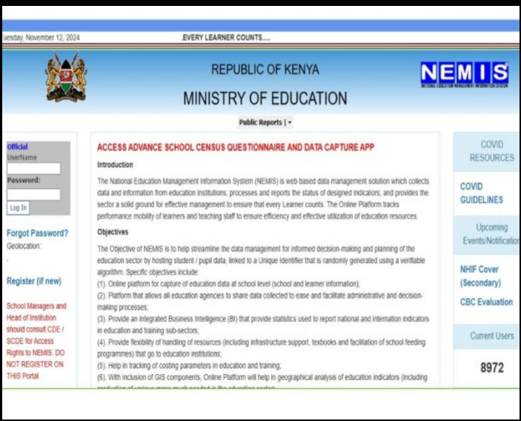
Figure 2.1 NEMIS portal sign-in page (Source: Ministry of Education, n.d.)

2.3.2 QuranPortal
QuranPortal is a free web application for managing Quran memorisation in schools, maktabs and hifdh programmes, founded by Jibran Kalia, which aims to replace paper registers, spreadsheets and WhatsApp threads (QuranPortal, n.d.). It serves teachers, students and families, and also offers a personal hifdh tracker for individual huffaz. Teachers plan assignments classified as New Lesson, New Revision and Old Review, grade each recitation as Pass, Redo or Pending, and mark mistakes and hesitations word by word on a digital mushaf. A class overview shows a week of work for the whole class on one screen, each student keeps a full history "since day one", Qaidah learners can be tracked as well as hifdh students, and parents receive an automatic daily summary by e-mail without the teacher typing a message (QuranPortal, n.d.).
Strengths and limitations. QuranPortal's strengths are its fine-grained, word-level memorisation tracking, its automatic parent updates and the fact that it is free for unlimited students, teachers and assignments. In relation to madrasa management, however, its official pages do not document attendance, admission, fees or payments, or any interface language other than English, and recitation is graded by the teacher as the student recites rather than recorded for later review (QuranPortal, n.d.).
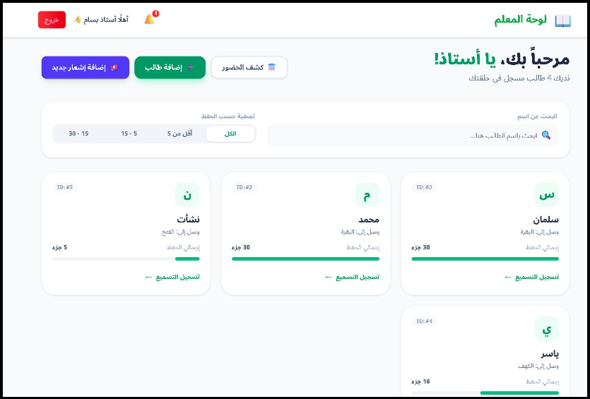
Figure 2.2 QuranPortal teacher workspace (Source: QuranPortal, n.d.)

2.3.3 Origin E Madarsa
Origin E Madarsa is an Islamic educational management system developed by Origin Softwares and offered as a multi-tenant web and mobile service, in which each madarsa receives an isolated workspace with its own administrators, students, identification series and branding (Origin Softwares, n.d.). It serves madarsa administrators, teachers (ustads), students and families. The daily Quran curriculum is followed through Qaida Progress, Nazeera Progress and Hifz Progress modules, the last recording Sabaq, Prev Sabaq, Para Sabaq and Manzil, and auto-numbered Hifz milestone certificates are issued as PDFs. Other modules cover student and teacher attendance, Exam Evaluations with starrated grading of Makharij, Tajweed, Fluency and Accent, Live Classes and Quran Live sessions, fee dues and invoices with online collection through Razorpay, UPI or bank transfer, and student, class and daily reports exported to PDF or Excel. The interface is available in English, Arabic, Urdu, Hindi and Telugu, and access is controlled by role-based permissions with an activity log (Origin Softwares, n.d.).
Strengths and limitations. Origin E Madarsa's strengths are its close fit to the hifz curriculum, its comprehensive administration and its separation of each madarsa's data. Its limitations for Kenyan madrasas are that online payment relies on Razorpay, UPI and bank transfer, which are Indian payment channels, rather than M-Pesa; that its languages do not include Kiswahili or Somali; and that recitation is assessed in live sessions rather than through recordings that the teacher can review later (Origin Softwares, n.d.). Figure 2.3 shows one of its interface views.
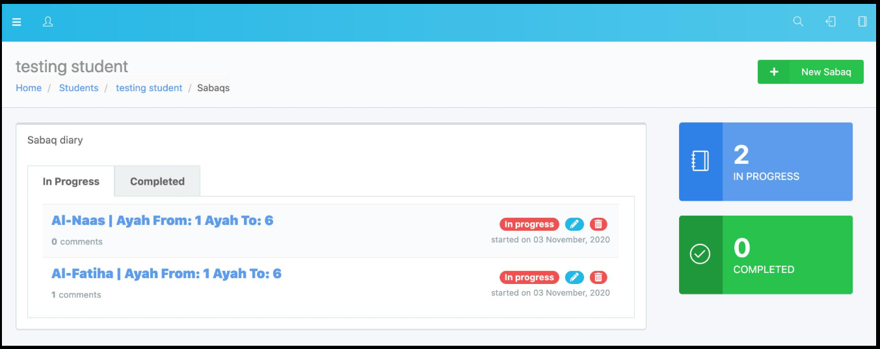
Figure 2.3 Origin E Madarsa administrator interface (Source: Origin Softwares, n.d.)

2.3.4 Alif Cloud
Alif Cloud is cloud-based school management software for madrasahs, dugsi, weekend schools, hifz programmes and full-time Islamic schools, and states that it serves Islamic schools across North America (Alif Cloud, n.d.-a, n.d.-b). It gives separate access to administrators, office staff, teachers, parents and students across eight modules. Enrollment & Registration supports parent self-registration, signed agreements and waiting lists; School Management keeps student and family records with rolebased access and pickup lists; Quran & Islamic Curriculum tracks memorisation by surah and ayah range with pass marks, teacher feedback and daily recitation logs; Attendance & Student Support records present, absent, late and excused statuses with automatic parent alerts; Billing & Finance issues recurring invoices with online payment through Stripe; and Communication provides two-way SMS, e-mail and announcements. Mobile applications for iOS and Android deliver push notifications to parents and staff (Alif Cloud, n.d.-a).
Strengths and limitations. Alif Cloud's strengths are the breadth of its administration modules and its well-developed parent portal. Its limitations for Kenyan madrasas are that it is designed for North American schools, that payments run through Stripe card and bank payments rather than M-Pesa, that its product page does not document interface languages, and that recitation is logged by the teacher rather than recorded by the student for review (Alif Cloud, n.d.-a). Figure 2.4 shows the administrator dashboard, which summarises parents, students, teachers and classes, the number of students attending that day and unpaid invoices.
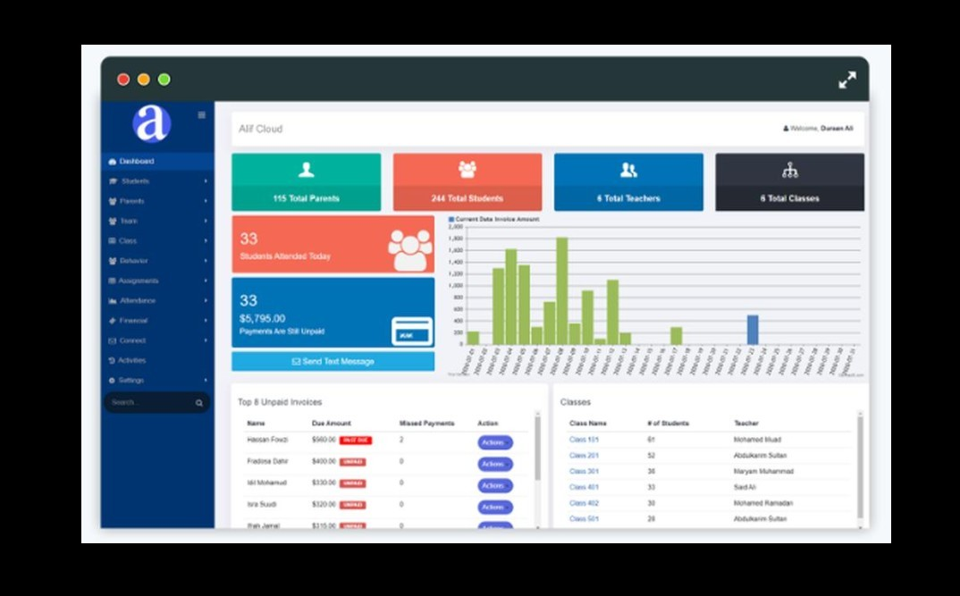
Figure 2.4 Alif Cloud administrator dashboard (Source: Alif Cloud, n.d.-a)

2.3.5 Sudoor HMS
Sudoor HMS is a hifz management system for madrasas and Quran academies that tracks Sabaq, Sabaqi and Manzil, the new lesson, recent revision and long-term revision of the traditional hifz method, together with attendance, examinations and finance (Sudoor HMS, 2026). Its official product image, reproduced in Figure 2.5, shows a separate administrator dashboard with staff and classattendance summaries, a teacher dashboard listing the teacher's assigned students, and a sign-in screen on which the user chooses the administrator, teacher or student role, beneath a welcome message in Urdu, Arabic and English.
Strengths and limitations. Sudoor HMS's strength is its focus on the Sabaq–Sabaqi–Manzil cycle used in many hifz schools. Its public pages, however, do not document a parent role, a fee-payment method or Kiswahili and Somali interfaces, and its sign-in screen offers only administrator, teacher and student roles (Sudoor HMS, 2026).
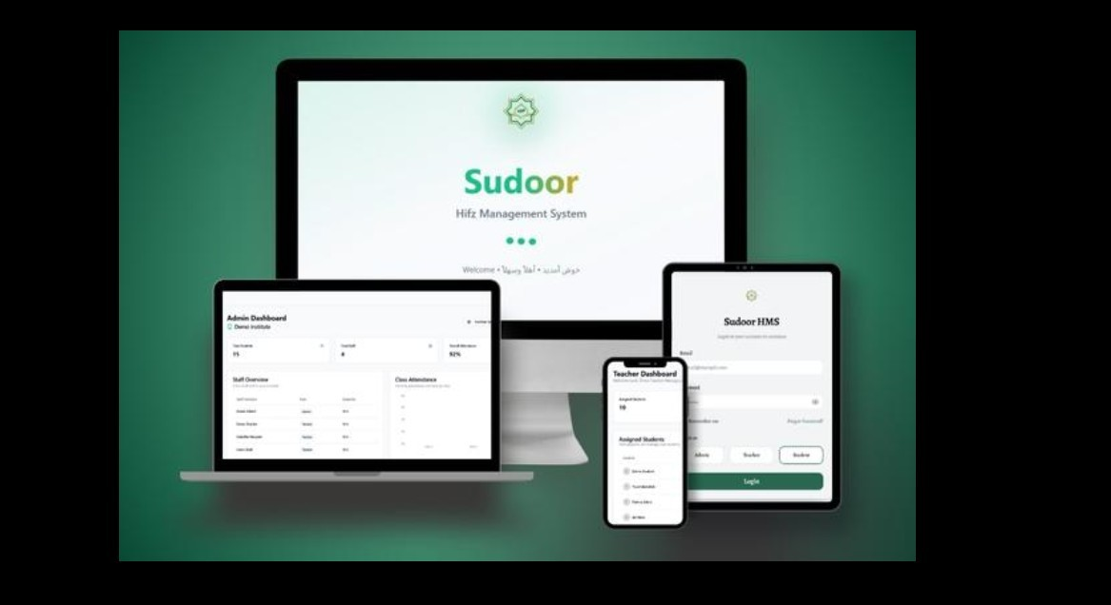
Figure 2.5 Sudoor HMS screens in its official product image (Source: Sudoor HMS, 2026)

2.3.6 Other Related Learning and Quran Applications
Learning management systems. Moodle and Google Classroom provide courses, assignments, grading and messaging (Google, n.d.). Moodle was designed around social-constructivist learning communities (Dougiamas & Taylor, 2003). Neither has functions for Quran memorisation, recitation review or madrasa fees.
School administration software. Commercial products used in Kenyan schools, such as Zeraki, focus on school administration, learning analytics and fee management for schools following the national curriculum; Zeraki Finance, for example, provides cashflow summaries, receipting, pledge tracking and expense reporting (Zeraki, n.d.). These products are not designed to track Quran memorisation or recitation.
Quran applications. Tarteel listens to a user's recitation, follows along in the text and flags memorisation mistakes such as skipped words (Tarteel AI, n.d.). Quran.com and similar readers provide the text, translations and audio by recognised reciters (Quran.com, n.d.). These are tools for individual learners with no teacher, parent or institutional role. Masalha and Hirzallah (2014) proposed a student attendance system in which learners scan a QR code to register their presence.

2.3.7 Comparison of Reviewed Systems
Table 2.1 compares the reviewed systems against the needs of Kenyan madrasas identified in Section 2.2. Only features documented on each system's official pages are recorded; "Not documented" means that the feature is not described there, not that it is known to be absent.
Feature (as documented) | NEMIS | QuranPortal | Origin E Madarsa | Alif Cloud | Sudoor HMS
Primary market | Kenya | Not stated | India (Razorpay, UPI) | North America | Not stated
Quran memorisation tracking | No | Yes (word level) | Yes (Qaida, Nazeera, Hifz) | Yes (surah and ayah) | Yes (Sabaq, Sabaqi, Manzil)
Attendance | No | Not documented | Yes | Yes | Yes
Fee invoicing and payment | No | Not documented | Yes (Razorpay, UPI, bank) | Yes (Stripe) | Finance module
M-Pesa payment | No | No | No | No | Not documented
Parent access | No | Yes (daily email) | Yes | Yes (portal and app) | Not documented
Recorded recitation for later teacher review | No | No (graded live) | No (live sessions) | No (teacher logs) | Not documented
Kiswahili or Somali interface | No | Not documented | No | Not documented | Not documented
Separate workspace per institution | National registry | Not documented | Yes | Yes | Not documented
Table 2.1 Comparison of existing systems related to madrasa management

2.3.8 Usability, Accessibility and Functional Limitations
Al-Fraihat et al. (2020) found that system, information and support quality together explain much of learners' satisfaction with e-learning systems, and Coates, James and Baldwin (2005) caution that learning management systems tend to impose a generic model of teaching. General systems such as NEMIS, Moodle, Google Classroom and Zeraki do not track memorisation by juz or handle recitation at all. The dedicated madrasa systems (QuranPortal, Origin E Madarsa, Alif Cloud and Sudoor HMS) do track memorisation, but they are designed for other markets: none documents M-Pesa payment, none offers a Kiswahili or Somali interface, and none documents students recording their recitation for later review by the teacher (Alif Cloud, n.d.-a; Origin Softwares, n.d.; QuranPortal, n.d.; Sudoor HMS, 2026). Quran applications, in turn, are individual tools with no teacher, parent or institutional role and no attendance or fee records.
Automated recitation assessment also has clear limits. Al-Ayyoub, Damer and Hmeidi (2018) reported over 97 per cent accuracy in classifying eight recitation rules on an in-house dataset, but AlKharusi et al. (2025) argue that the field relies on small and demographically biased datasets, and
Alsharhan and Ramsay (2020) show that speaker gender, dialect and training size materially affect Arabic speech recognition. Automated tajweed feedback can therefore support, but not replace, the teacher. A static attendance QR code can be photographed and shared, so it proves presence only if it changes and is verified by the server.

2.3.9 Identified Gaps from Reviewed Systems
The review identifies the following gaps in existing systems:
1. Not designed for Kenyan payments. None of the reviewed madrasa systems documents MPesa; they rely on Razorpay, UPI or Stripe (Alif Cloud, n.d.-a; Origin Softwares, n.d.).
2. Language. None offers Kiswahili or Somali, the languages of many Kenyan madrasa communities.
3. National systems omit madrasas. NEMIS serves registered institutions and does not record Quran memorisation, recitation or madrasa fees (Ministry of Education, n.d.).
4. No recorded recitation review. Recitation is graded live or logged by the teacher; no system documents student recordings that the teacher reviews later.
5. Unreliable automated assessment. Automated tajweed assessment is not yet reliable enough to be authoritative (Al-Kharusi et al., 2025).
6. Fragmented features. Free tools such as QuranPortal cover memorisation and parent summaries but not attendance or fees, while the comprehensive platforms are built around foreign payment gateways.

2.4 Concepts and Technologies Underpinning Integrated Education Systems
Beyond individual products, the literature describes the architectural and technological concepts on which shared, multi-institution education platforms are built. This section reviews these concepts independently of any particular system.

2.4.1 Multi-Tenancy and Role-Based Access Control
Where many independent organisations share one application, the application is multi-tenant. Bezemer and Zaidman (2010) observe that multi-tenancy reduces operating cost but makes isolation between tenants a central engineering concern, and Alkhalil, Sahandi and John (2017) found that perceived security shapes the decision to move records into the cloud. Within each tenant, role-based access control assigns permissions to roles rather than to individuals (Sandhu et al., 2000), which suits institutions such as madrasas in which owners, teachers, parents and students need different access. Database-level mechanisms such as PostgreSQL Row Level Security allow the database itself to decide which rows each user may read or change (PostgreSQL Global Development Group, n.d.).

2.4.2 Cross-Platform Mobile Development and Cloud Backends
Cross-platform frameworks allow one codebase to serve several mobile platforms, at the cost of some access to platform-specific features (Biørn-Hansen et al., 2018). React Native is one such framework, in which applications written in JavaScript or TypeScript render native interface components (React Native, 2026). Managed backend platforms such as Supabase provide a hosted PostgreSQL database, authentication, file storage and server-side functions as services (Supabase, 2026), which reduces the infrastructure a small development team must operate.

2.4.3 Technology Support for Quran Learning
Holmes, Bialik and Fadel (2019) argue that artificial intelligence in education should augment rather than replace the teacher. VanLehn (2011) found that intelligent tutoring approached the effectiveness of human tutoring, and Neri, Cucchiarini and Strik (2008) showed that automatic pronunciation feedback improved learners' speech. Kornell (2009) found that spacing study over time is more effective than cramming, which supports scheduled revision of memorised passages. Together with the limits of automated tajweed assessment noted in Section 2.3.8, these findings suggest that recitation technology should support the teacher's judgement rather than replace it.

2.4.4 Evaluation of Education Management Applications
Sommerville (2016) distinguishes development testing of components, release testing against requirements, and user testing. For applications shared by many institutions, the most important functional tests are those that prove a user cannot reach another institution's records or act outside their role, so refusals must be tested as well as successes. Usability can be measured with the System Usability Scale, a ten-item questionnaire that yields a score from 0 to 100 (Brooke, 1996) and suits users with limited experience of mobile applications, while field testing with real users on their own devices shows whether a system works outside the development environment (Sommerville, 2016).

2.5 Summary
This chapter reviewed madrasa education and administration in Kenya and the challenges of informal records, limited parental visibility, assessment workload and fee management. It then reviewed existing related systems: NEMIS serves national reporting, QuranPortal focuses on memorisation tracking, and Origin E Madarsa, Alif Cloud and Sudoor HMS offer fuller madrasa or hifz management, while general learning platforms, school administration software and Quran applications support teaching, administration or individual practice. None of the reviewed systems is designed for Kenyan madrasas: none documents M-Pesa payment, none offers a Kiswahili or Somali interface, and none documents recorded recitation review by the teacher. Finally, the chapter reviewed multi-tenancy, rolebased access control, cross-platform development and teacher-centred recitation technology. The next chapter describes the development methodology.

CHAPTER THREE: SYSTEM DEVELOPMENT METHODOLOGY

3.1 Introduction
A development methodology defines how the work of building a system is organised: how requirements are gathered, how design and implementation proceed, and how the product is checked and delivered. This chapter explains why an Agile approach was chosen for Digital Madrasa and describes each phase of the development cycle as it was applied in the project.

3.2 Methodological Approach
Agile emphasises working software, collaboration and responding to change over following a fixed plan (Beck et al., 2001). It delivers a usable version of the software early and improves it in short cycles called sprints, each ending with a working increment that can be reviewed (Schwaber & Sutherland, 2020). Unlike the Waterfall model, in which each phase is completed before the next begins, Agile allows requirements to be refined as the system takes shape (Sommerville, 2016).
Agile suits this project because madrasa practices vary and many requirements, such as how parents should be linked to children or how fees should be targeted, became clear only when a working version could be tried. Each sprint delivered one complete capability, from the database rules to the screens, and was verified against the live backend before the next began. Figure 3.1 shows the cycle.
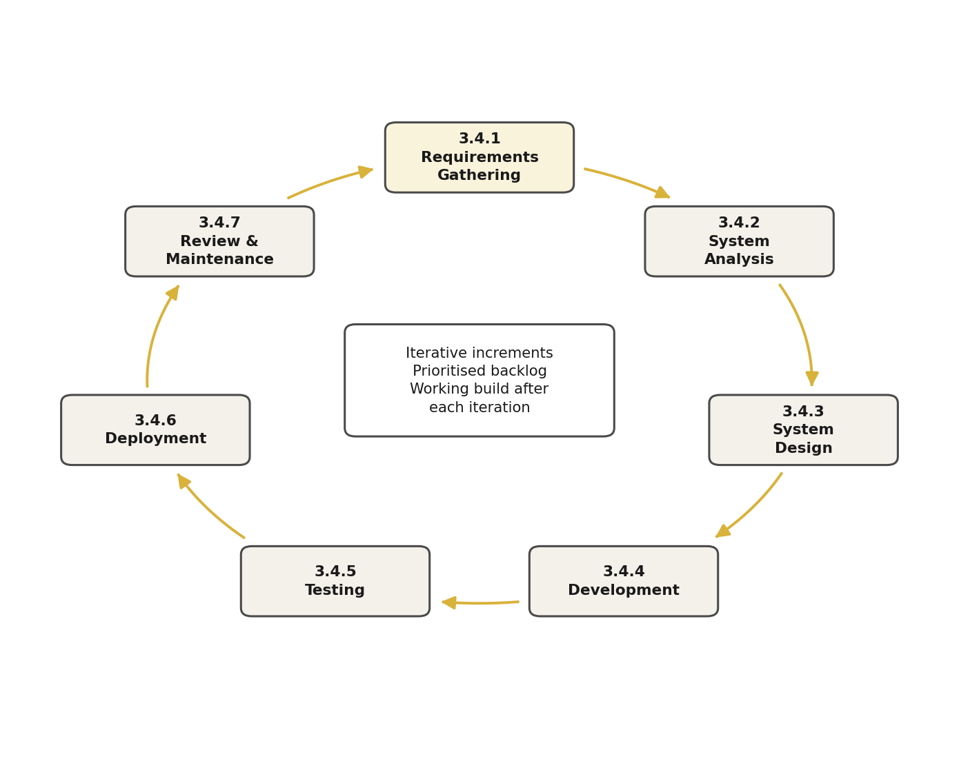
Figure 3.1 Agile development methodology used in the project

3.3 Agile Development Phases
The development of the Digital Madrasa application followed the Agile methodology, which supports iterative development, continuous evaluation, and improvement throughout the software development lifecycle. The process was organised into several phases, each addressing a specific aspect of system development, from identifying user requirements to designing, implementing, testing, and reviewing the application. This approach enabled the development process to remain organised while ensuring that the system's features aligned with the needs of madrasa owners, teachers, parents, and students. Feedback, testing results, and identified issues were used to guide improvements during development. The following subsections describe the key phases undertaken in developing the Digital Madrasa application, including requirements gathering, system design, implementation, testing, deployment, and review.

3.3.1 Requirements Phase
Requirements were identified from the literature on madrasa education and parental involvement, from a review of existing education management systems and Quran applications, and from the questionnaires and interviews with madrasa stakeholders (Appendix 1). They were written as user stories, for example "As a parent, I want to see my child's attendance and fees so that I do not have to wait for pick-up", prioritised into a product backlog, and organised into two modules:
- Administration module: madrasa registration, student admission, classes, staff, attendance, fees and payments, announcements and messages.
- Quran learning module: memorisation progress, assignments, grades, recitation recording and review, and certificates.

3.3.2 Design Phase
The design phase translated the requirements into the models presented in Chapter Five: the class diagram, the entity relationship diagram and database schema, use case, sequence and activity diagrams, and wireframes of the main screens. The architecture was built around React Native with Expo for the mobile interface and Supabase for authentication, the PostgreSQL database, file storage and server functions. Security rules were designed into the database from the start, so that each madrasa's records are isolated by Row Level Security.

3.3.3 Development Phase
Development proceeded in sprints recorded in the project’s Git history. The first sprint (23 August 2026) produced the multi-tenant database, authentication and the screens for all four roles. The second (16 September) added the server functions, automated backups and continuous integration. Later sprints connected the live backend and the recitation storage workflow (19 September), teacher recitation review and parent access to a child’s recitations (22–23 September), QR attendance (23 September) and targeted invoicing (24 September). The sprint of 25–30 September added written work and certificates, M-Pesa payments, push, e-mail and SMS notifications, and complete Kiswahili, Somali and Arabic translations. The final sprint (30 September – 2 October) connected Google Gemini for recitation feedback and a hosted AI assistant, added parental consent for AI feedback, card payments through Paystack, and fixes found by testing the installed app.
Further sprints recorded in the Git history extended the system. On 4 October they added the Hijri date, printable certificates with a verification QR code and ijazah certificates carrying the teacher’s sanad, the Sabaq–Sabqi–Manzil daily hifz plan, a tajweed mistake map and weekly insights for teachers, spoken progress reports for parents, a USSD menu for basic phones, anonymous fee sponsorship and recite-along practice. Between 12 and 13 October the application received its ILMORA brand identity, comparison with a master reciter, M-Pesa prompts and receipts on Safaricom’s Daraja sandbox, a library of teacher-chosen Quran videos, a live reading room, scheduled live sessions and two-way parent–teacher messaging. On 15 October the last sprint added an impact dashboard, a one-command security report, attendance that can be marked offline, and hifz streaks and badges.

3.3.4 Testing Phase
Testing was carried out within every sprint to verify that new features worked and did not break existing ones. The testing types included:
- Unit testing: verifying individual functions such as input validation, QR token signing and MPesa callback handling.
- Functional testing: scripted calls to the deployed backend as each role, checking that permitted actions succeed and forbidden ones are refused.
- User interface testing: checking each screen on an Android emulator and in the web build at phone size.
- Performance testing: measuring response times of the main screens and database queries.

3.3.5 Deployment Phase
The database, storage and server functions were deployed to a hosted Supabase project from the first sprint, so every increment was tested against the real backend. During development the mobile application ran through Expo Go; at the end, Expo Application Services built an installable Android package (APK), which was installed and tested on an Android emulator. The web build was later published on Expo’s hosting service so that the platform administrator’s console can be used from a browser.

3.3.6 Review Phase
At the end of each sprint the working increment was reviewed against the requirements, and defects found in testing were fixed before new work began. Reviews led, for example, to the rotating QR code for attendance, to requiring the madrasa's approval before a parent can see a child, and to a faster form of the database access rules after performance testing.

3.4 Summary
This chapter explained the choice of an Agile methodology for Digital Madrasa and described its six phases as applied in the project: requirements, design, development, testing, deployment and review. The iterative approach allowed the system to adapt to the needs of four different roles while delivering a working, tested increment at the end of every sprint. The next chapter presents the requirements gathering and analysis in detail.

CHAPTER FOUR: REQUIREMENTS GATHERING AND ANALYSIS

4.1 Introduction
This chapter describes how the requirements for Digital Madrasa were gathered and analysed. It explains the data collection approach and methods, summarises the evidence gathered from madrasa owners and teachers, parents, students and secondary sources, and derives the functional and non-functional requirements and the stakeholders of the system. It closes with the challenges met during requirements gathering.
The process aimed to understand how madrasas currently record attendance, memorisation and fees, how parents follow their children's progress, and how recitation is assessed, and which technical and legal constraints the system must respect.

4.2 Data Collection Approach
A mixed-methods approach was adopted, combining qualitative and quantitative data so that the strengths of each compensate for the limitations of the other (Creswell & Plano Clark, 2018). Qualitative data came from in-depth interviews with madrasa owners and senior teachers, informal interviews with parents and students, and observation of how attendance is taken and recitation is assessed. Quantitative data came from structured questionnaires for each stakeholder group (Appendix 1). Document analysis of published studies, government reports and the documentation of Supabase, Expo and Safaricom Daraja supplied the technical constraints (Supabase, 2026; Expo, 2026; Safaricom, 2026).
The qualitative data explained why madrasas work as they do, while the questionnaires indicated how common each practice and problem is. Together they ensured that the requirements reflected real madrasa practice rather than assumptions.

4.3 Data Collection Methods
Both primary and secondary data collection methods were used. Primary data are collected directly from participants for the purpose of the study, while secondary data are existing data collected for other purposes (Saunders, Lewis & Thornhill, 2019). Primary data was collected directly from madrasa owners, teachers, parents and students. Secondary data came from published research, government reports and technical documentation. The main techniques were:
- Questionnaires for madrasa owners and teachers, parents and students.
- In-depth interviews with madrasa owners and senior teachers.
- Informal interviews with parents and, with parental consent, students.
- Observation of attendance taking and recitation assessment in madrasa sessions.
- Review of relevant studies, government reports and similar systems.

4.4 Primary Data Collection
Primary data collection focused on the people who run and use madrasas. Participants were selected by purposive sampling, which deliberately selects people who have direct experience of the subject being studied (Etikan, Musa & Alkassim, 2016). A total of 47 participants were involved in the study from madrasas in Kajiado and Nairobi counties. Table 4.1 shows the participants.
Stakeholder | Method | Number of Respondents
Madrasa owners and teachers | Questionnaire and in-depth interviews | 12
Parents | Questionnaire and informal interviews | 20
Students | Questionnaire (with parental consent) | 15
Total |  | 47
Table 4.1 Primary data collection participants
Interviews were semi-structured, which allows the researcher to cover a set of themes while following up on participants' answers (Saunders, Lewis & Thornhill, 2019), and focused on how participants record attendance, memorisation and fees, how parents are kept informed, how recitation is assessed, and what would make them trust a madrasa application. The questionnaires used closed questions so that responses could be summarised in charts.

4.5 Data Analysis
Interview and observation notes were analysed thematically, by identifying, analysing and reporting patterns within the data (Braun & Clarke, 2006): statements were grouped into recurring themes, and each theme was mapped to a system requirement. Questionnaire responses were counted per option and presented as pie charts, each followed by an interpretation and the feature of the system that responds to it. Twelve questions were analysed in total: four for madrasa owners and teachers, four for parents and four for students.

4.5.1 Interview Data Summary
Table 4.2 summarises the requirements expressed by madrasa owners and teachers, which were the primary input to the design. Tables 4.3 and 4.4 summarise the themes from interviews with parents and students.
Theme | Key Insights from Madrasa Owners and Teachers
Record keeping | Each teacher keeps his own exercise book. When a teacher leaves or a book is lost, the history of the class goes with it, and the owner has no single list of all enrolled students.
Attendance | Attendance is called out at the start of the session and ticked in a register, often only in the morning session. Weekly or monthly totals are rarely calculated.
Memorisation tracking | Most teachers know from memory how far each child has reached, surah by surah. Revision of earlier juz is planned informally, so weaker students fall behind unnoticed.
Fee collection | Fees are paid in cash or by M-Pesa to the owner's personal number. Matching an M-Pesa message to a child and a month is manual, and balances are disputed at the end of the term.
Communication with parents | Notices are given verbally to children or sent by phone call and WhatsApp. Parents who do not come to the madrasa miss most announcements.
Expectations | A simple phone app, usable by teachers with little computer experience, that keeps the madrasa's records private, issues receipts automatically and works in Kiswahili and Somali as well as English.
Table 4.2 Madrasa owner and teacher interview summary
Theme | Key Insights from Parents
Knowledge of attendance | Most parents assume their child attends and learn about absences only when the teacher calls, often weeks later.
Knowledge of progress | Parents know roughly which surah the child is on from the child himself; few have seen a written record of juz completed or revision due.
Fee payment | Parents already pay most bills by M-Pesa and would prefer to pay fees the same way, provided they receive a receipt and can see the balance.
Communication with the madrasa | Parents want to receive notices and to message the teacher without having to visit the madrasa, and prefer notices in Kiswahili or Somali.
Expectations | A private view of their own children only, with attendance, progress and fees in one place, and assurance that other parents cannot see their child's records.
Table 4.3 Parent interview summary
Theme | Key Insights from Students
Recitation practice | Students practise at home by reading aloud or listening to recordings of well-known reciters, but no one hears them until the next class.
Feedback from the teacher | In large classes a student may recite individually only once or twice a week, and corrections are sometimes forgotten before the next session.
Use of phones | Most students use a parent's or older sibling's smartphone, mainly for Quran audio and WhatsApp, usually in the evening.
Expectations | To record a recitation at home, receive the teacher's comments, and see how many juz they have memorised and what is due for revision.
Table 4.4 Student interview summary

4.5.2 Questionnaire Analysis
Madrasa Owner and Teacher Questionnaire Analysis
A total of twelve madrasa owners and teachers completed the questionnaire. Its purpose was to understand how attendance, memorisation progress and fees are currently managed, and how ready madrasas are to adopt a mobile application. The four questions are reproduced in Appendix 1, Section A.
Question 1: How is student attendance currently recorded in your madrasa?
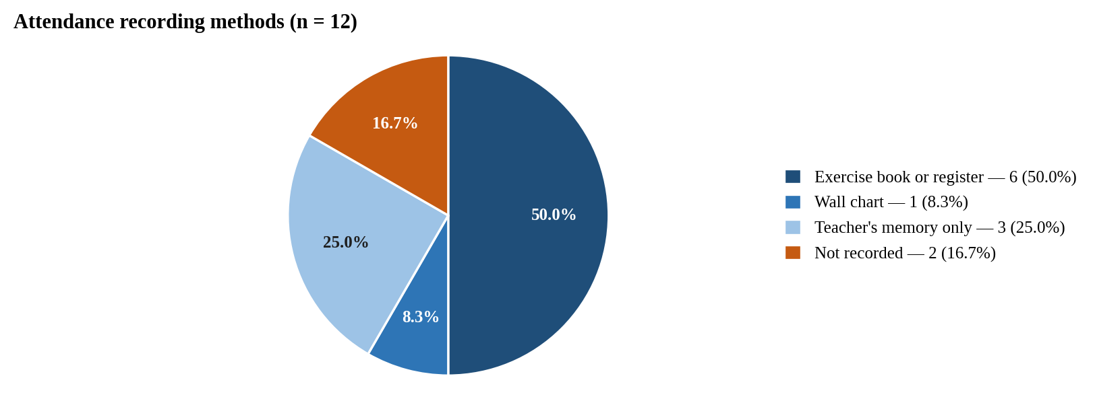
Figure 4.1 Recording student attendance
Analysis: Attendance records are weak or absent. Half of the respondents, 6 of the 12 (50.0%), use an exercise book or register, and 1 (8.3%) uses a wall chart. A further 3 (25.0%) rely on the teacher's memory alone and 2 (16.7%) do not record attendance at all, so in 5 of the 12 madrasas (41.7%) there is no written record of whether a child attended. No respondent chose "Other".
System solution: The system provides a digital attendance register for each class and QR-code attendance, in which a student scans a code on the teacher's phone that changes every 30 seconds, so attendance is recorded once, cannot be forged and is summarised on the dashboard.
Question 2: How is a student's Quran memorisation progress recorded?
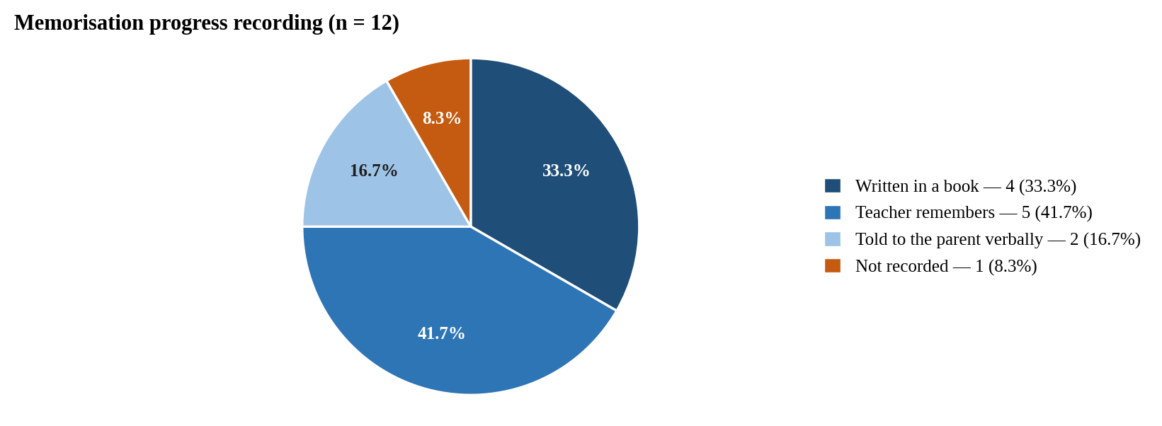
Figure 4.2 Memorisation progress tracking
Analysis: Memorisation progress is held mainly in teachers' heads. The most common answer was that the teacher remembers (5, 41.7%), followed by writing it in a book (4, 33.3%). Two respondents (16.7%) tell the parent verbally and 1 (8.3%) does not record progress. In total, 8 of the 12 (66.7%) keep no written record of how far each child has memorised.
System solution: Teachers record memorisation surah by surah in the app. The system calculates the juz completed and the passages due for revision, and shows them to the student and the approved parent.
Question 3: How are fees recorded and communicated to parents?
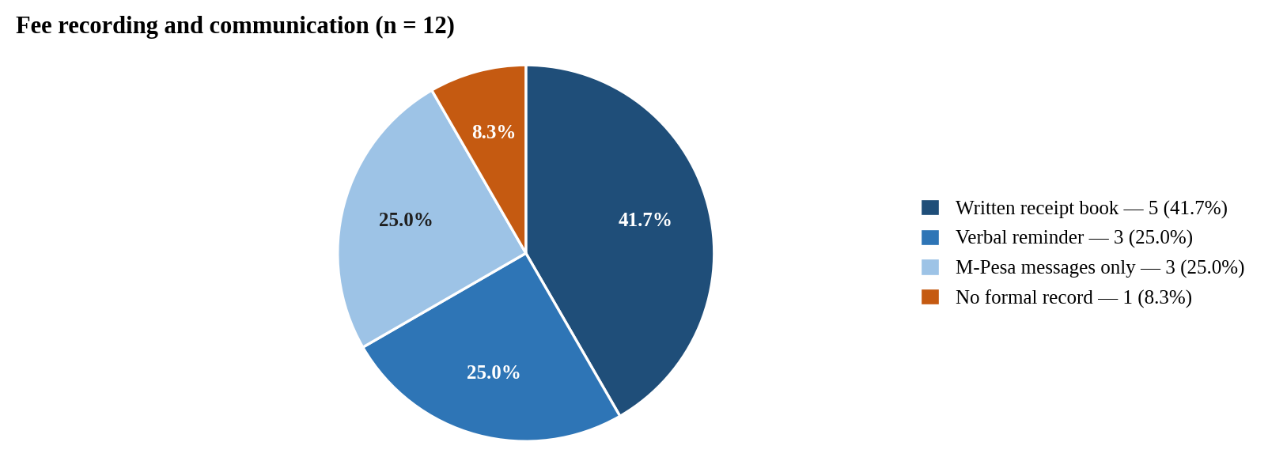
Figure 4.3 Fee collection methods
Analysis: Fee records are fragmented. Five respondents (41.7%) use a written receipt book, 3 (25.0%) rely on verbal reminders, 3 (25.0%) rely only on M-Pesa messages and 1 (8.3%) keeps no formal record. None of the methods links a payment to an invoice, which explains the balance disputes reported in the interviews.
System solution: The owner defines fee structures and issues numbered invoices to the whole madrasa, a class or one student. Parents see each invoice and pay it by M-Pesa, and the system issues a receipt and updates the balance automatically.
Question 4: Would you use a mobile application to manage your madrasa?
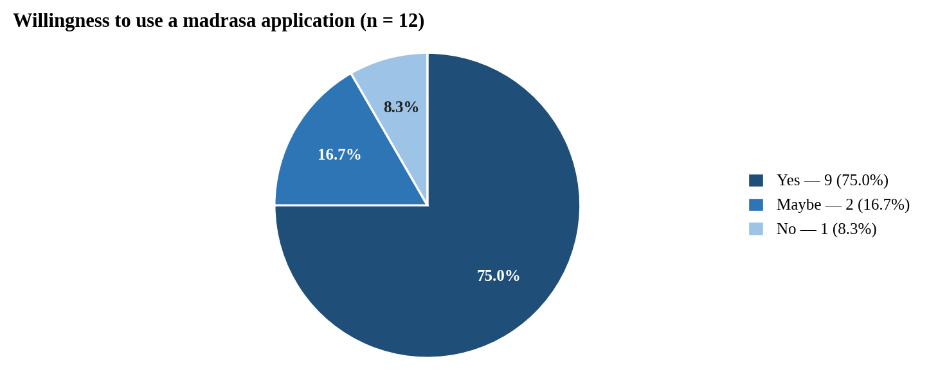
Figure 4.4 Willingness to adopt a madrasa management application
Analysis: There is strong willingness to adopt: 9 of the 12 respondents (75.0%) would use a mobile application to manage their madrasa and 2 (16.7%) might, while only 1 (8.3%) would not. The respondent who declined cited unfamiliarity with apps.
System solution: The system combines admission, attendance, memorisation, recitation review, fees and communication in one application with simple screens, large buttons and clear summaries to support adoption.
Parent Questionnaire Analysis
A total of twenty parents completed the questionnaire. It focused on how parents follow their children's madrasa education, receive receipts for fees and would like to be informed (Appendix 1, Section B).
Question 1: How do you currently learn about your child's attendance and progress?
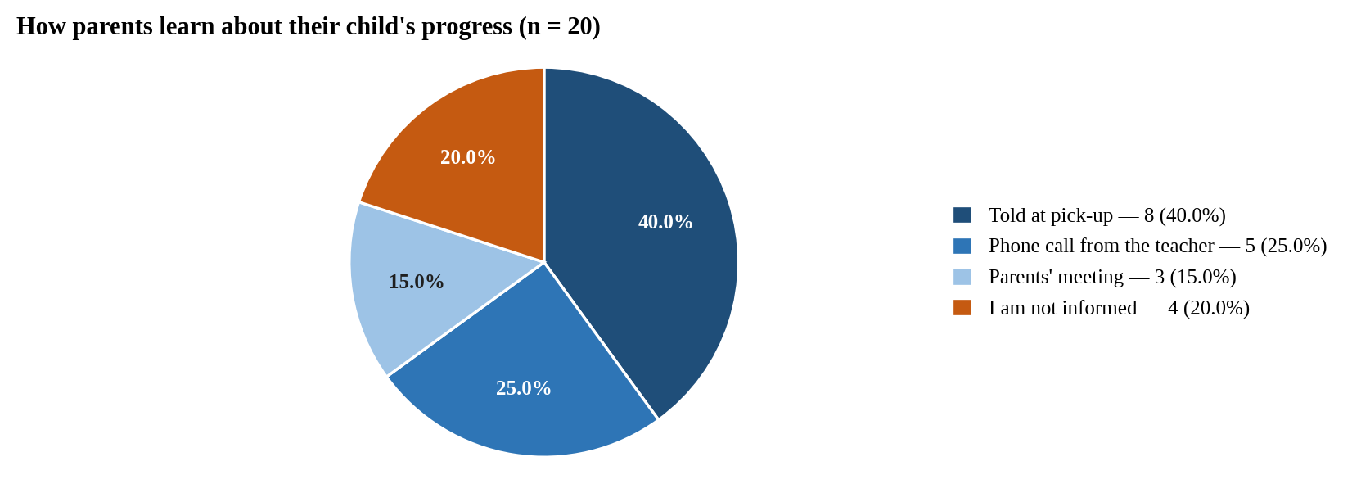
Figure 4.5 Parent access to child progress
Analysis: Parents are informed informally or not at all. The largest group, 8 of the 20 (40.0%), learn about their child at pick-up, 5 (25.0%) through a phone call from the teacher and 3 (15.0%) at parents' meetings. Four parents (20.0%) said they are not informed. No parent receives a written or regular report.
System solution: A parent links to a child using the admission number and date of birth; once the madrasa approves the link, the parent sees the child's attendance, memorisation, grades, recitations and fees, and receives notifications.
Question 2: Would you pay madrasa fees through M-Pesa in a mobile application?
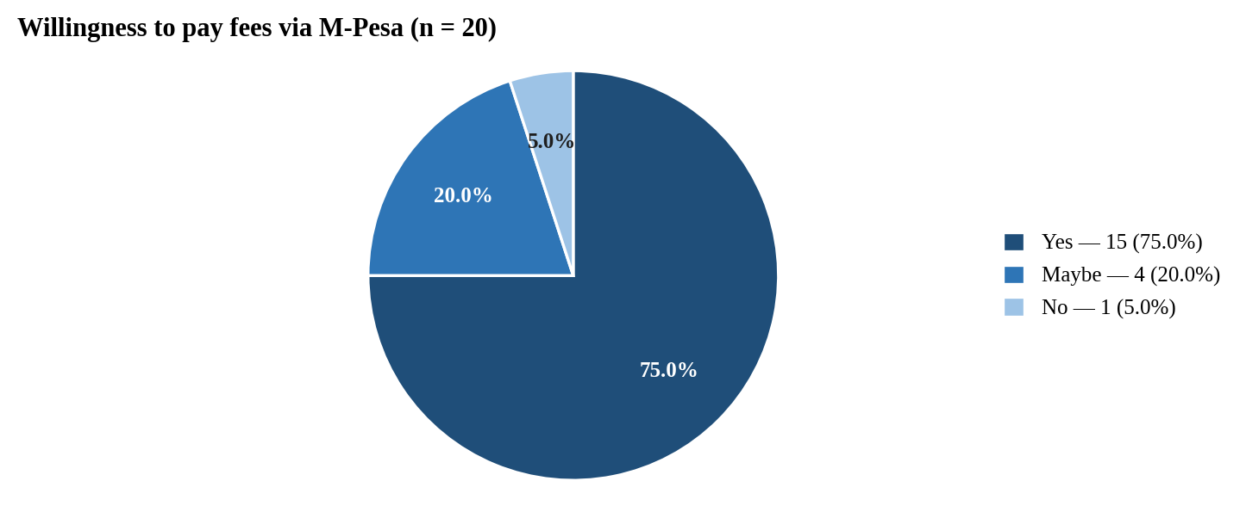
Figure 4.6 Willingness to pay fees via M-Pesa
Analysis: There is strong demand for mobile payment: 15 of the 20 parents (75.0%) would pay fees through M-Pesa in an application and 4 (20.0%) might, while only 1 (5.0%) would not. In total, 19 of the 20 (95.0%) were open to the feature.
System solution: The parent pays one or several invoices through an M-Pesa prompt on their phone. The amount is calculated by the server, and the receipt appears in the app as soon as payment is confirmed.
Question 3: Do you receive a receipt when you pay fees?
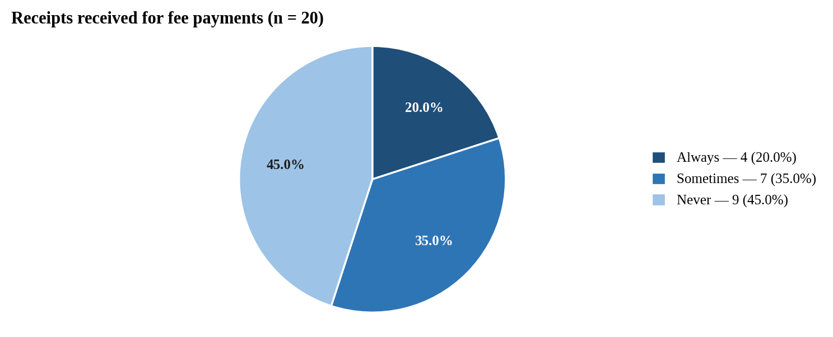
Figure 4.7 Receipts for fee payments
Analysis: Receipts are rarely issued. Nine parents (45.0%) never receive a receipt and 7 (35.0%) only sometimes, so only 4 (20.0%) always have proof of payment. This explains the balance disputes reported by owners in the interviews.
System solution: A receipt is issued automatically as soon as an M-Pesa payment is confirmed, and the parent can see every receipt and the remaining balance in the app.
Question 4: Which language do you prefer for notices from the madrasa?
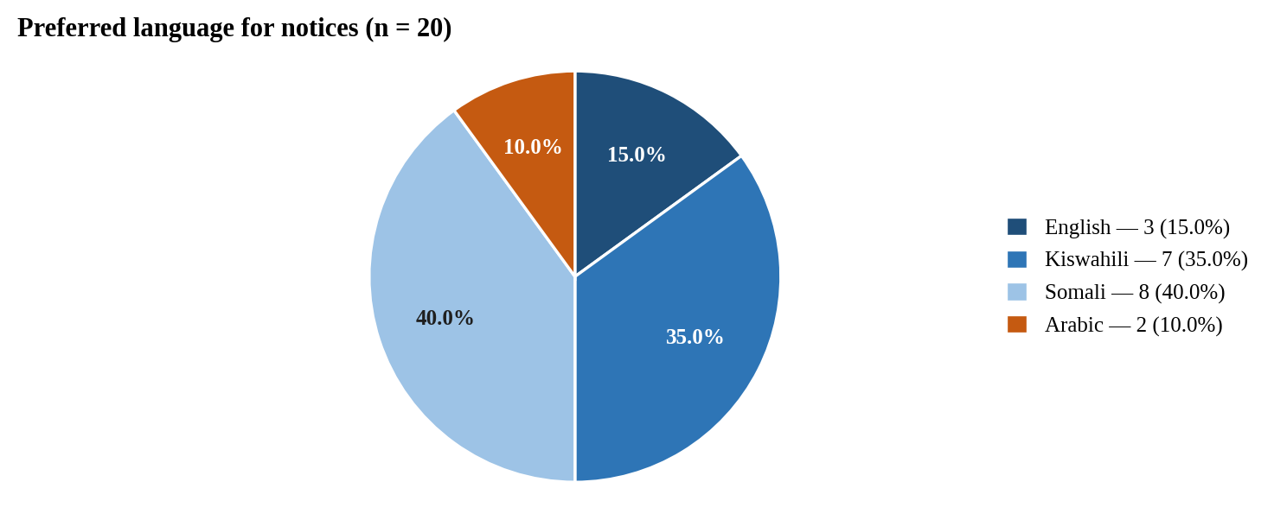
Figure 4.8 Preferred language for notices (parents)
Analysis: Most parents prefer a language other than English. Somali was chosen by 8 parents (40.0%) and Kiswahili by 7 (35.0%), while 3 (15.0%) chose English and 2 (10.0%) Arabic. Written notices in English alone would not reach 85.0% of these parents in their preferred language.
System solution: Parents choose Kiswahili, Somali, Arabic or English for the whole interface, including their inbox and notifications.
Student Questionnaire Analysis
A total of fifteen students completed the questionnaire, with the consent of their parents (Republic of Kenya, 2019). The purpose was to understand how recitation is practised, assessed and revised (Appendix 1, Section C).
Question 1: How does your teacher assess your recitation?
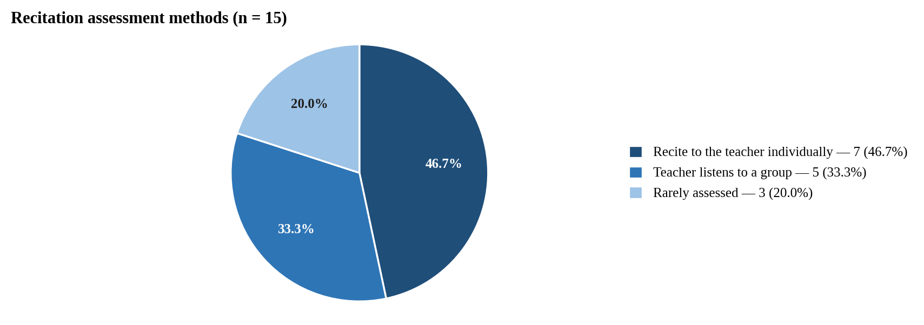
Figure 4.9 Recitation assessment methods
Analysis: Individual assessment is not universal. Seven students (46.7%) recite to the teacher individually, 5 (33.3%) are heard only as part of a group and 3 (20.0%) said their recitation is rarely assessed. More than half of the students (53.3%) therefore receive little individual feedback on their recitation.
System solution: Students record a recitation in the app. The recording is stored privately, the teacher listens and gives a score and comments, and the student and approved parent see the review.
Question 2: Would recording your recitation on a phone help you practise?
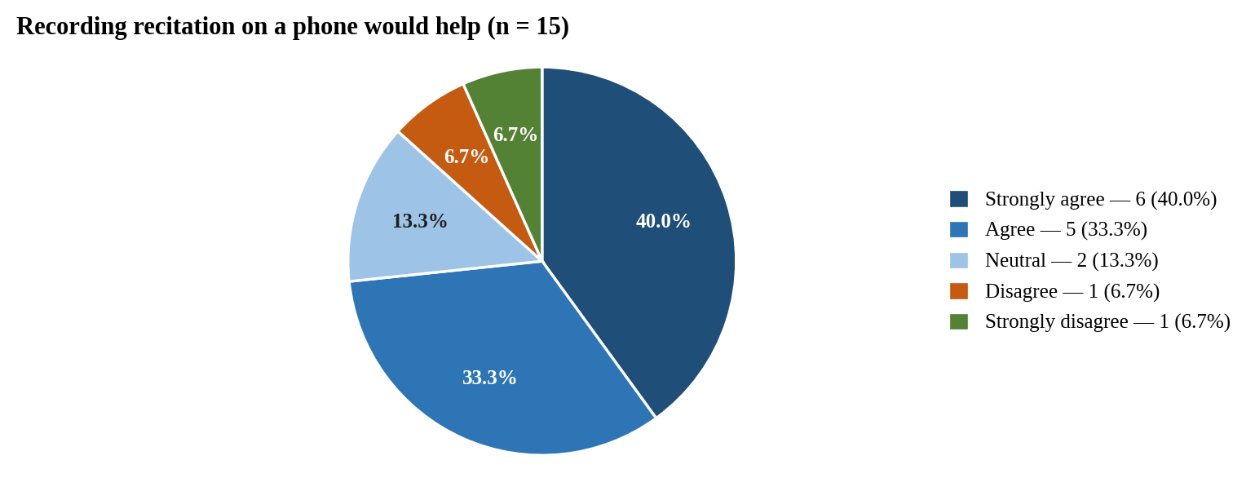
Figure 4.10 Digital recitation practice
Analysis: Students welcome recorded practice: 6 (40.0%) strongly agree and 5 (33.3%) agree that recording on a phone would help, a combined 73.3%. Two (13.3%) were neutral, and 1 (6.7%) disagreed and 1 (6.7%) strongly disagreed, mainly because they do not have regular access to a phone.
System solution: The app lets students record as often as they need, shows the passages due for revision, and provides the Quran text for reading offline.
Question 3: How do you know which passages to revise?
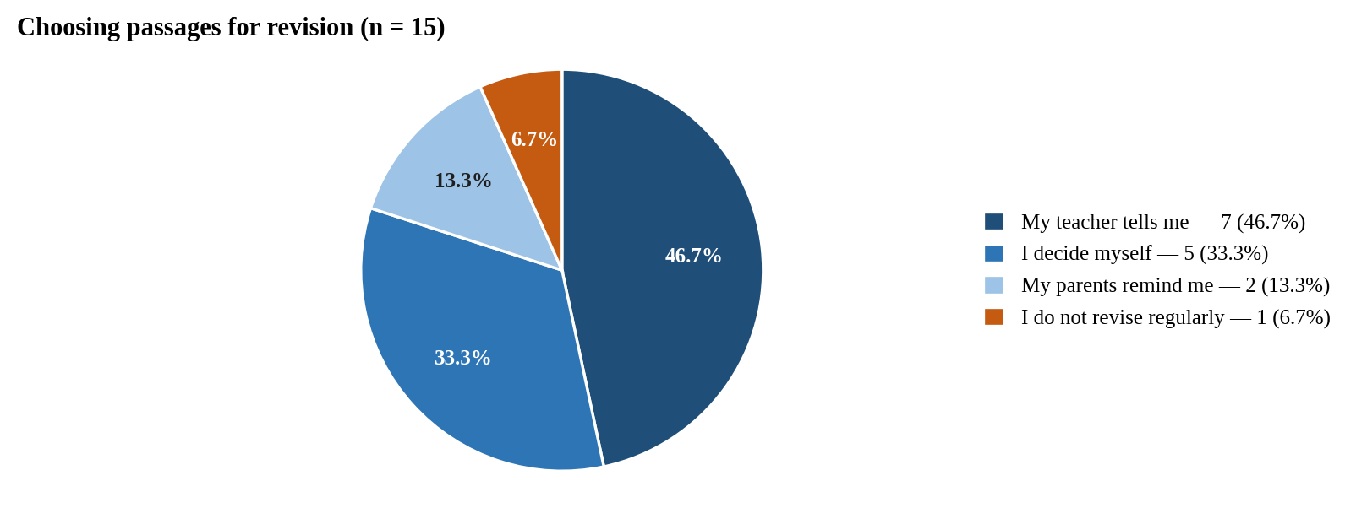
Figure 4.11 How students choose passages to revise
Analysis: Revision is guided mainly by the teacher (7, 46.7%), while 5 students (33.3%) decide for themselves, 2 (13.3%) are reminded by their parents and 1 (6.7%) does not revise regularly. Students who plan their own revision have no record to tell them which passages they are forgetting.
System solution: The student dashboard lists the passages due for revision today, calculated from the memorisation the teacher has recorded.
Question 4: How soon after reciting do you get feedback from your teacher?
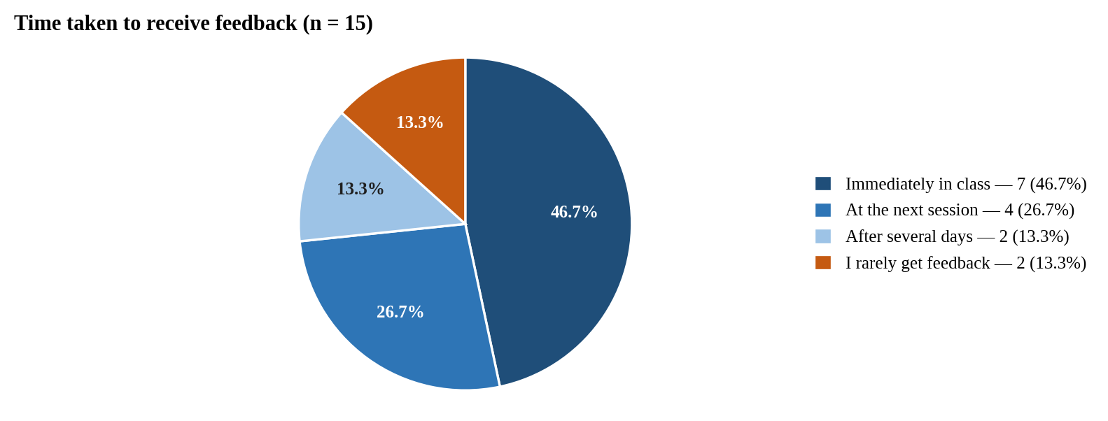
Figure 4.12 Time taken to receive feedback
Analysis: Feedback is often delayed: although 7 students (46.7%) receive it immediately in class, 4 (26.7%) wait until the next session, 2 (13.3%) several days and 2 (13.3%) rarely receive any.
System solution: When the teacher reviews a recording, the score and comments appear in the student's app straight away and remain available to re-read.

4.6 Secondary Data Collection
Secondary data provided background that complemented the primary data. A review of academic literature, government reports and existing systems (Chapter Two) showed that madrasa records in Kenya are largely informal and unstandardised (Ndzovu, 2023), that the government plans to integrate madrasa education into the national system (Kihaki, 2026), and that parental involvement is associated with better achievement (Fan & Chen, 2001). It also showed that Kenya's mobile penetration makes a phone-based system practical (Communications Authority of Kenya, 2023), that existing madrasa systems do not support M-Pesa or Kiswahili and Somali (Alif Cloud, n.d.-a; Origin Softwares, n.d.), and that automated tajweed assessment is not yet reliable enough to replace the teacher (Al-Kharusi et al., 2025).
Technical documentation shaped the feasible scope. The Supabase free plan provides the database, authentication, storage and server functions without a billing account, which made it possible to build the whole backend at no cost (Supabase, 2026). Safaricom's Daraja documentation defined how an STK push payment is started and confirmed through a callback (Safaricom, 2026), and the Kenya Data Protection Act 2019 required consent and care in handling children's records (Republic of Kenya, 2019). These findings reinforced the need for an integrated system that combines madrasa administration, Quran learning, parental access and fee management.

4.7 Requirements and Stakeholders Identification
Based on the analysed data, the requirements were grouped into functional and non-functional requirements, and the stakeholders were identified. Functional requirements describe the services a system should provide, while non-functional requirements are constraints on those services, such as security, performance and usability (Sommerville, 2016); the non-functional requirements were framed using the quality characteristics of ISO/IEC 25010 (International Organization for Standardization, 2011).
Functional Requirements
ID | Requirement
FR1 | The system shall allow a madrasa owner to register a madrasa and allow users to sign up, sign in, sign out and reset a forgotten password by e-mail.
FR2 | The system shall give owners, teachers, parents and students separate interfaces, determined by the role stored in the database.
FR3 | The system shall allow the owner to admit students with automatically generated admission numbers (DM-YYYY-NNNN), create classes and add teachers.
FR4 | The system shall allow teachers to take attendance manually or by a signed QR code that changes every 30 seconds, which students scan with their phones.
FR5 | The system shall allow teachers to record memorisation surah by surah, and calculate the juz completed and the passages due for revision.
FR6 | The system shall allow teachers to set and mark assignments, record grades and award certificates.
FR7 | The system shall allow students to record a recitation, store it privately and let the teacher play it back, score it and comment on it.
FR8 | The system shall allow a parent to request a link to a child by admission number and date of birth, and show the child's records only after the madrasa approves the link.
FR9 | The system shall allow the owner to define fee structures and issue numbered invoices to the whole madrasa, a class or one student.
FR10 | The system shall allow parents to pay one or more invoices by M-Pesa, with the amount calculated by the server, and issue a receipt when payment is confirmed.
FR11 | The system shall send announcements, messages and notifications by in-app inbox, push, e-mail and SMS according to each user's preferences.
FR12 | The system shall provide role-based dashboards and an interface in English, Kiswahili, Somali and Arabic.
Table 4.5 Functional requirements
Non-Functional Requirements
Quality | Requirement
Security | Every table shall be protected by Row Level Security so that each madrasa's records are private and each user can perform only the actions of their role; secrets shall exist only on the server.
Privacy | Children's records shall be handled under the Kenya Data Protection Act 2019; recitation audio shall be stored privately and played only through short-lived signed links.
Performance | Dashboards should load in under 3 seconds on a 3G/4G mobile connection; access rules shall be written so that they are evaluated once per query.
Integrity | Payments shall be settled exactly once for the amount the server calculates; admission and invoice numbers shall be unique within a madrasa.
Usability | The interface shall be simple enough for users with limited experience of mobile applications, with large buttons, clear summaries and four languages.
Reliability | Failure of an external service shall produce a clear message rather than a crash; the database shall be backed up every three days.
Maintainability | The code shall be strictly typed, the schema managed through numbered migrations, and automated checks run on every change.
Accountability | Important actions, such as approvals, invoices and payments, shall be recorded in an audit log.
Table 4.6 Non-functional requirements
Stakeholders Identification
Stakeholders are the people and organisations who are affected by a system or can influence its requirements (Sommerville, 2016). Madrasa owners register the madrasa, manage students, staff and fees, and oversee operations. Teachers take attendance, track memorisation, review recitations and communicate with parents. Parents follow their children's progress and pay fees. Students record recitations, scan attendance and follow their own progress. A platform administrator oversees the madrasas using the service. External service providers (Supabase for the backend, Safaricom for M-Pesa, and the e-mail, SMS and push providers) supply the services on which the system depends. Government education authorities influence the system indirectly through the plans to integrate madrasa education into the national system (Kihaki, 2026).

4.8 Challenges in Requirements Gathering and Analysis
Several challenges influenced the requirements gathering process.
Diverse stakeholder needs: owners prioritise records and fees, teachers prioritise simple attendance and review, and parents want timely information. Features were prioritised by how many roles they serve and how directly they address the problem statement.
Limited stakeholder availability: madrasa sessions run early in the morning, in the evening and at weekends, which limited the time available for interviews and observation.
Sensitivity of children's data: information about minors requires consent and care under the Kenya Data Protection Act 2019 (Republic of Kenya, 2019). Questions were framed neutrally, students took part only with parental consent, and the system was designed so that a parent sees a child only after the madrasa approves the link.
Technical constraints: features such as a validated tajweed recognition model and live M-Pesa credentials were beyond the project's resources, so the system was designed to accept them later without redesign.
Variations in madrasa practice: madrasas differ in class levels, fee structures and languages, so the system lets each madrasa define its own classes and fees and offers four languages.

4.9 Summary
This chapter described how the requirements of Digital Madrasa were gathered through questionnaires, interviews, observation and document review, and how they were analysed. The findings that 41.7% of madrasas keep no written attendance, 66.7% keep no written memorisation record, 20.0% of parents are not informed at all and 95.0% of parents are open to paying by M-Pesa shaped the functional requirements, while security, privacy and payment integrity shaped the non-functional requirements. The next chapter presents the system design.

CHAPTER FIVE: SYSTEM DESIGN

5.1 Introduction
System design translates the requirements of Chapter Four into a blueprint for implementation. This chapter presents the design of Digital Madrasa using Unified Modeling Language (UML) diagrams and related models. Structural diagrams (the class, object and component diagrams) describe the static organisation of the system, while behavioural diagrams (use case, sequence and activity diagrams) describe how it responds to users and events (Object Management Group, 2017). The chapter also presents the database schema, including the entity relationship diagram, and the wireframes of the main screens. Particular attention was given to role-based access and to keeping each madrasa's records separate from every other madrasa.

5.2 Structural Diagrams
The Unified Modeling Language (UML) is a standard graphical language for visualising, specifying, constructing and documenting the artefacts of a software system (Booch, Rumbaugh & Jacobson, 2005). UML 2.5.1 divides its diagrams into structure diagrams and behaviour diagrams: structure diagrams show the static structure of the objects in a system, independent of time (Object Management Group, 2017). They provide a blueprint of how data and objects are organised and help developers understand how the parts of the system fit together (Sommerville, 2016). Three structural diagrams are presented: the class diagram, the object diagram and the component diagram.

5.2.1 Class Diagram
A class diagram shows a set of classes, interfaces and collaborations and the relationships among them, and is the diagram most commonly used to model the static design view of a system (Booch, Rumbaugh & Jacobson, 2005). The class diagram in Figure 5.1 shows the main classes of the system, their attributes and operations, and the relationships between them. A Madrasa has many students, teachers, classes, fee structures and announcements. A Student belongs to one madrasa and has attendance records, memorisation progress, recitations and invoices, and a Parent is connected to a Student through a ParentStudentLink that the madrasa approves. Each Recitation may receive TajweedFeedback, which the teacher reviews.
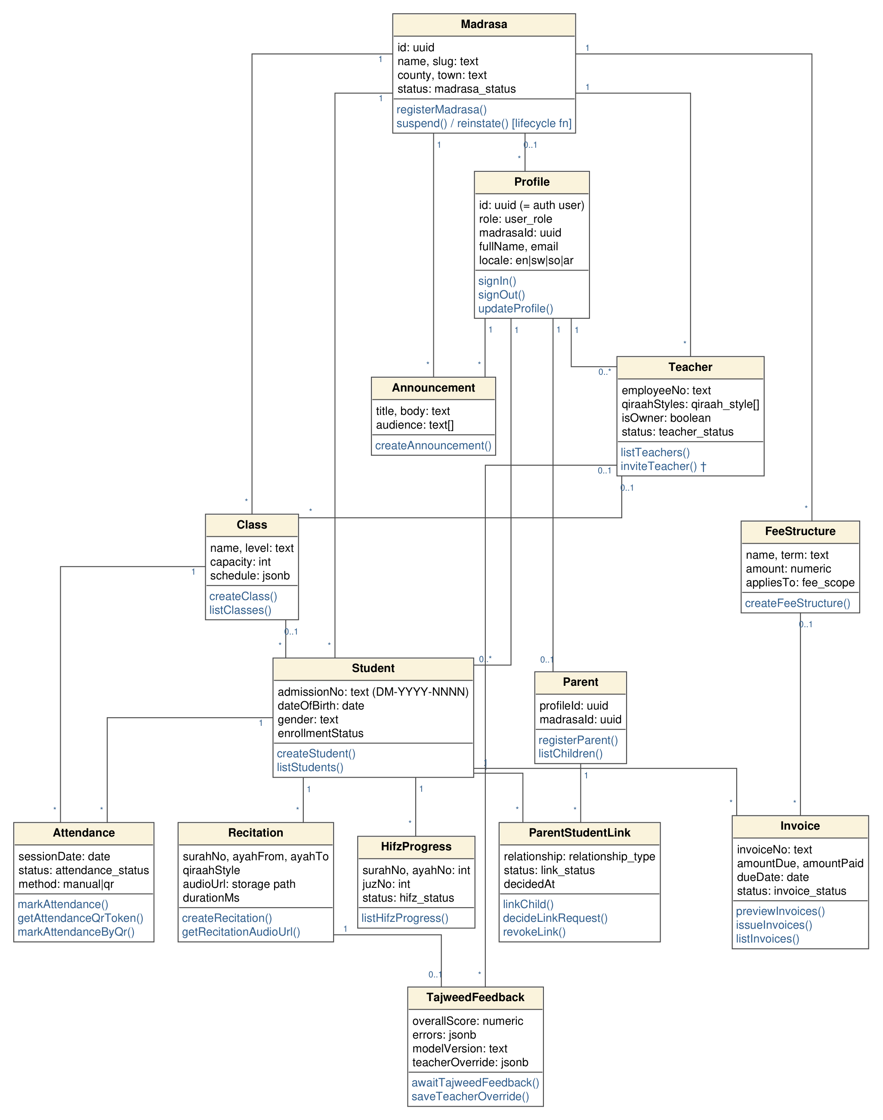
Figure 5.1 Class diagram

5.2.2 Object Diagram
An object diagram shows a set of objects and their relationships at a point in time; it is a snapshot of instances of the classes in a class diagram and is useful for illustrating a structure with concrete examples (Booch, Rumbaugh & Jacobson, 2005; Fowler, 2004). Figure 5.2 shows the objects that exist for one student of one madrasa: the madrasa anNur, its class hifz1 and teacher fatuma, the student ahmed with admission number DM-2025-0001, the approved ParentStudentLink that connects him to his mother halima, and one record each of his attendance, memorisation progress, recitation, tajweed feedback and invoice. Every object belongs, directly or through the student, to the same madrasa, which illustrates how each madrasa's records are kept within one tenant.
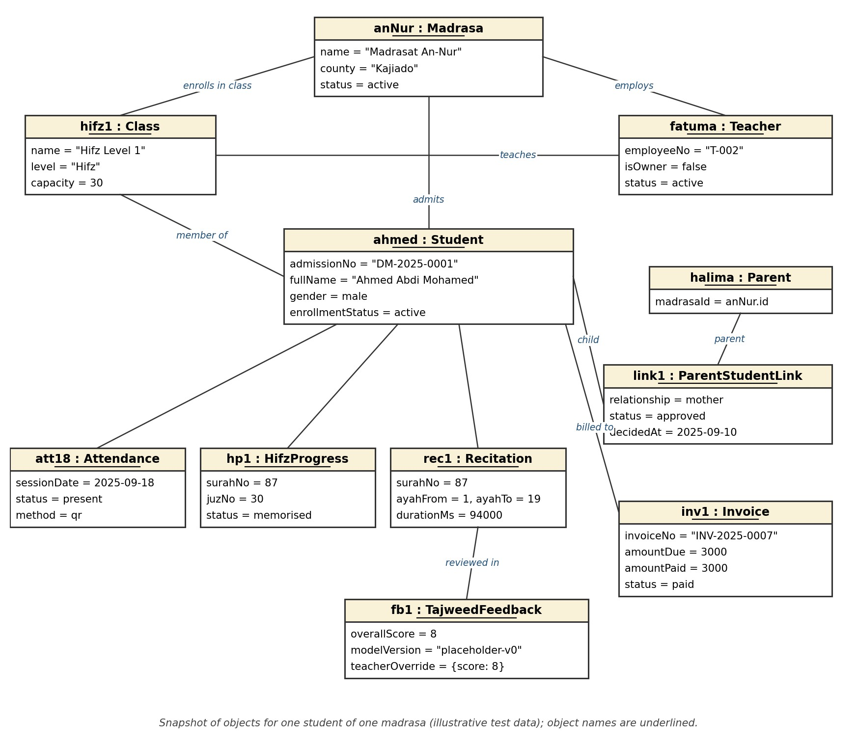
Figure 5.2 Object diagram of one student's records

5.2.3 Component Diagram
A component diagram shows the organisation of and dependencies among a set of components, where a component is a modular, replaceable part of a system that provides and requires interfaces (Object Management Group, 2017; Booch, Rumbaugh & Jacobson, 2005). Figure 5.3 shows the two subsystems of Digital Madrasa. In the mobile app, the owner, teacher, parent and student user interfaces depend on a shared localisation component and an API client. The API client uses four interfaces provided by the Supabase backend: authentication, the data API of the PostgreSQL database, storage for recitation audio and the Edge Functions. The Edge Functions in turn use the database and storage, and they are the only components that call the external Safaricom Daraja and messaging services, so no secret key is held in the app.
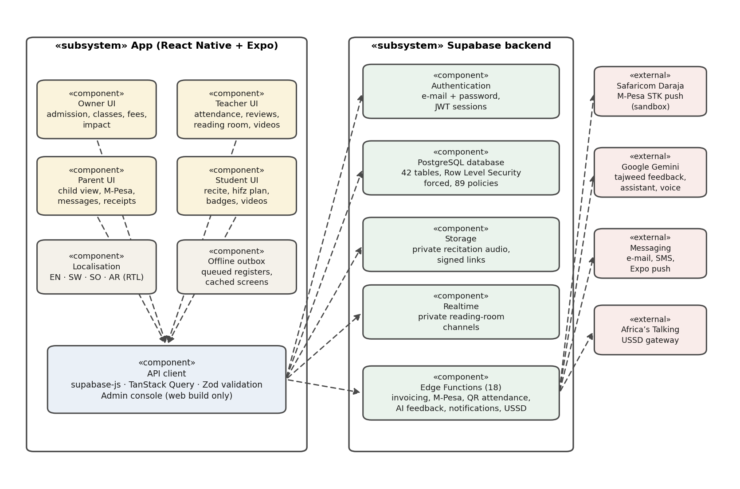
Figure 5.3 Component diagram

5.3 Behavioural Diagrams
Behaviour diagrams show the dynamic behaviour of the objects in a system, including their interactions and changes of state over time (Object Management Group, 2017). They show the flow of activities, the order of operations and how each actor interacts with the system, and guide implementation decisions. Three behavioural diagrams are presented: the use case, sequence and activity diagrams.

5.3.1 Use Case Diagram
A use case diagram shows a set of use cases and actors and their relationships, and is used to model the functional requirements of a system from the point of view of its users (Booch, Rumbaugh & Jacobson, 2005). The system has four main users: the madrasa owner, the teacher, the parent and the student, with a platform administrator who oversees the madrasas. The owner registers the madrasa, admits students, manages classes and staff, and defines fees and issues invoices; because an owner is also a teacher, the owner can do everything a teacher does. Teachers take attendance, display the rotating QR code, record grades and assignments, review recitations and decide parent link requests. Students scan the class QR code, record recitations and view their progress. Parents create an account, request a link to their child, view the child's progress and invoices and message the madrasa. Figure 5.4 shows these interactions.
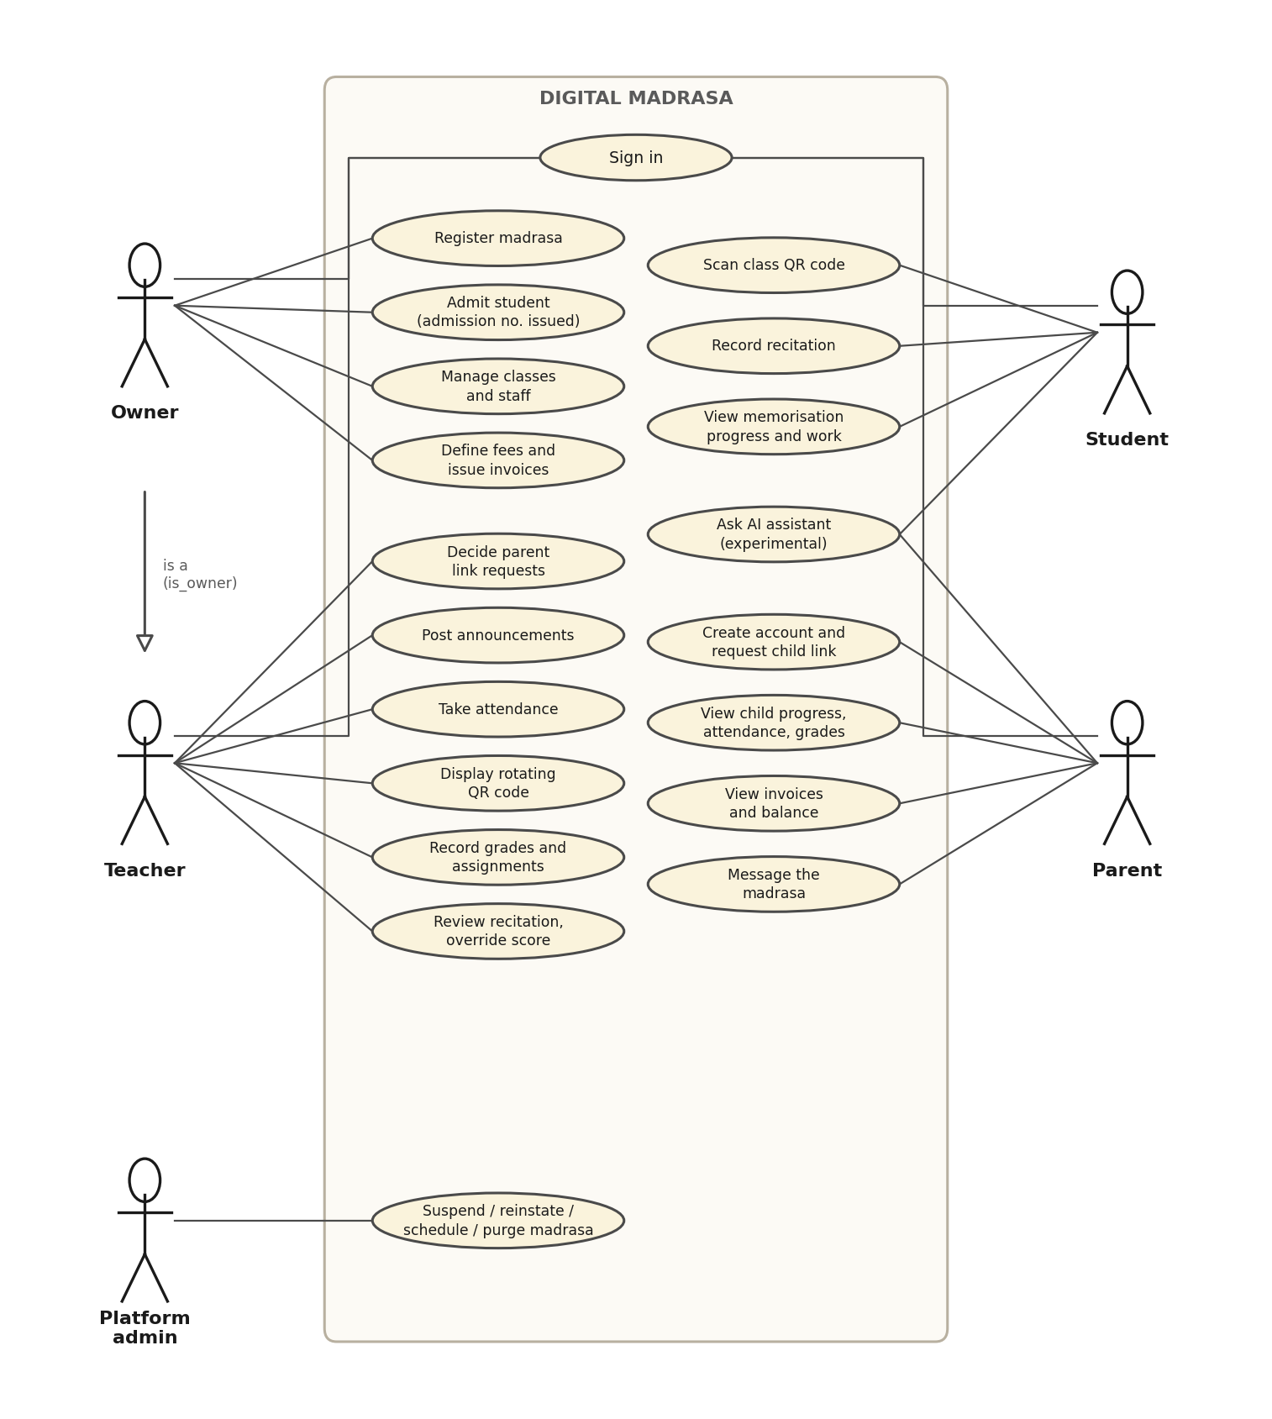
Figure 5.4 Use case diagram

5.3.2 Sequence Diagram
A sequence diagram is an interaction diagram that emphasises the time ordering of the messages exchanged between objects (Booch, Rumbaugh & Jacobson, 2005). Figure 5.5 shows recitation submission and review. The student's app requests a private upload link, uploads the audio to storage and asks the server to evaluate it; the server stores the recitation and a provisional result. The teacher then opens the review queue, plays the recording through a short-lived link and saves a score, which the student and the approved parent can see.
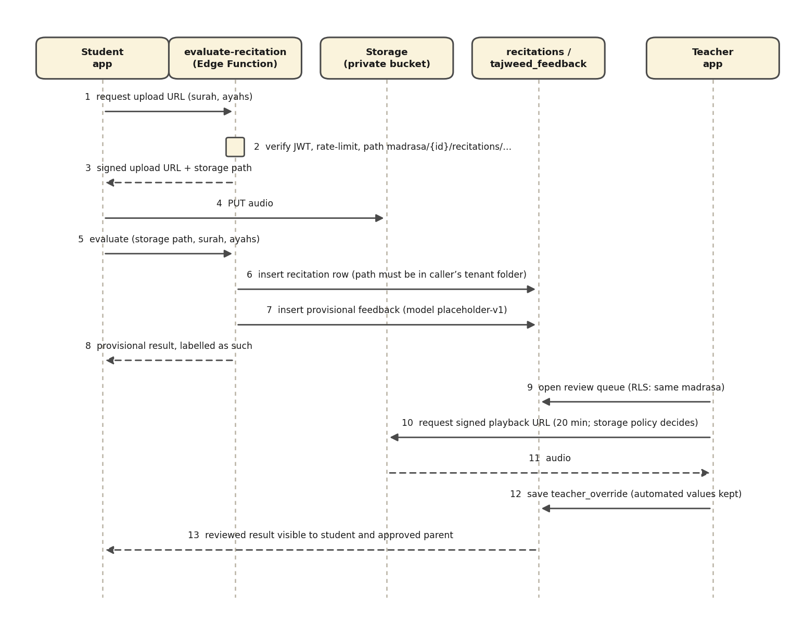
Figure 5.5 Sequence diagram for recitation submission and review

5.3.3 Activity Diagram
An activity diagram shows the flow from activity to activity within a process, including decisions and alternative paths, and is used to model workflows (Booch, Rumbaugh & Jacobson, 2005). The activity diagram in Figure 5.6 shows QR attendance. The teacher opens the class attendance screen and the system displays a signed code that changes every 30 seconds. A student scans the code, and the server checks the signature, the time window, the class and the student's role before recording the student as present; an expired or wrong code is refused.
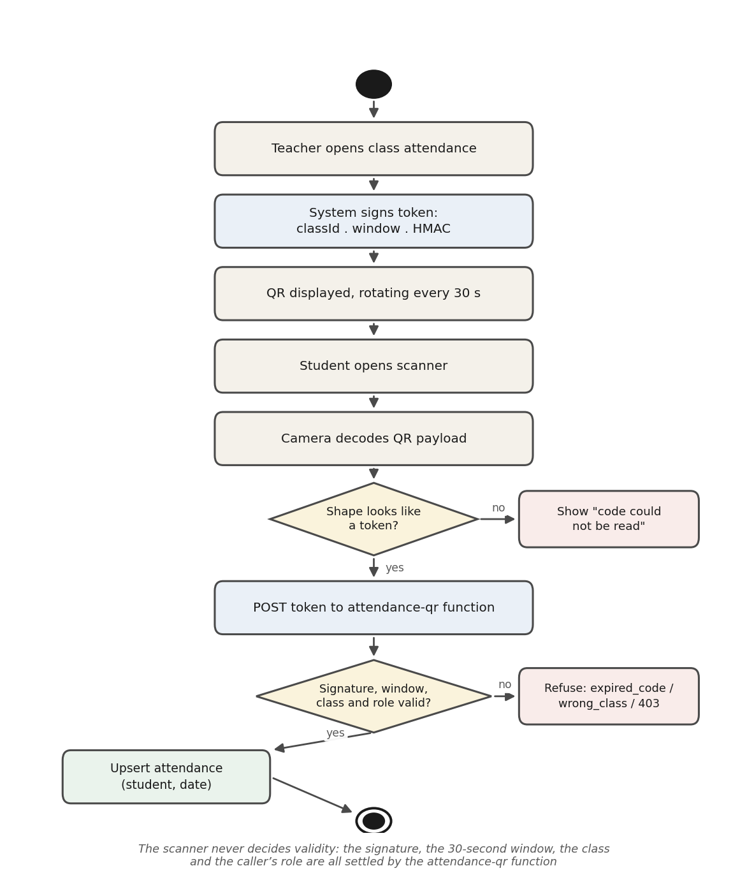
Figure 5.6 Activity diagram for QR attendance

5.4 Database Schema
A database schema is the description of a database, specified during design, that defines its tables, attributes, data types and constraints (Elmasri & Navathe, 2016). The schema of Digital Madrasa was designed from an entity relationship model. The entity relationship diagram, introduced by Chen (1976), represents entities, their attributes and the relationships between them; it is a data-modelling notation rather than one of the UML diagram types (Elmasri & Navathe, 2016), and it is therefore presented here as part of the database design rather than among the UML structural diagrams.

5.4.1 Entity Relationship Diagram (ERD)
The entity relationship diagram in Figure 5.7 represents the core data of the system: the entities, their key attributes and the relationships between them, with cardinalities (1 and N). It was generated from the live database, so it matches the implemented schema. Every record carries the identifier of its madrasa, which is how the database keeps each madrasa's data separate.
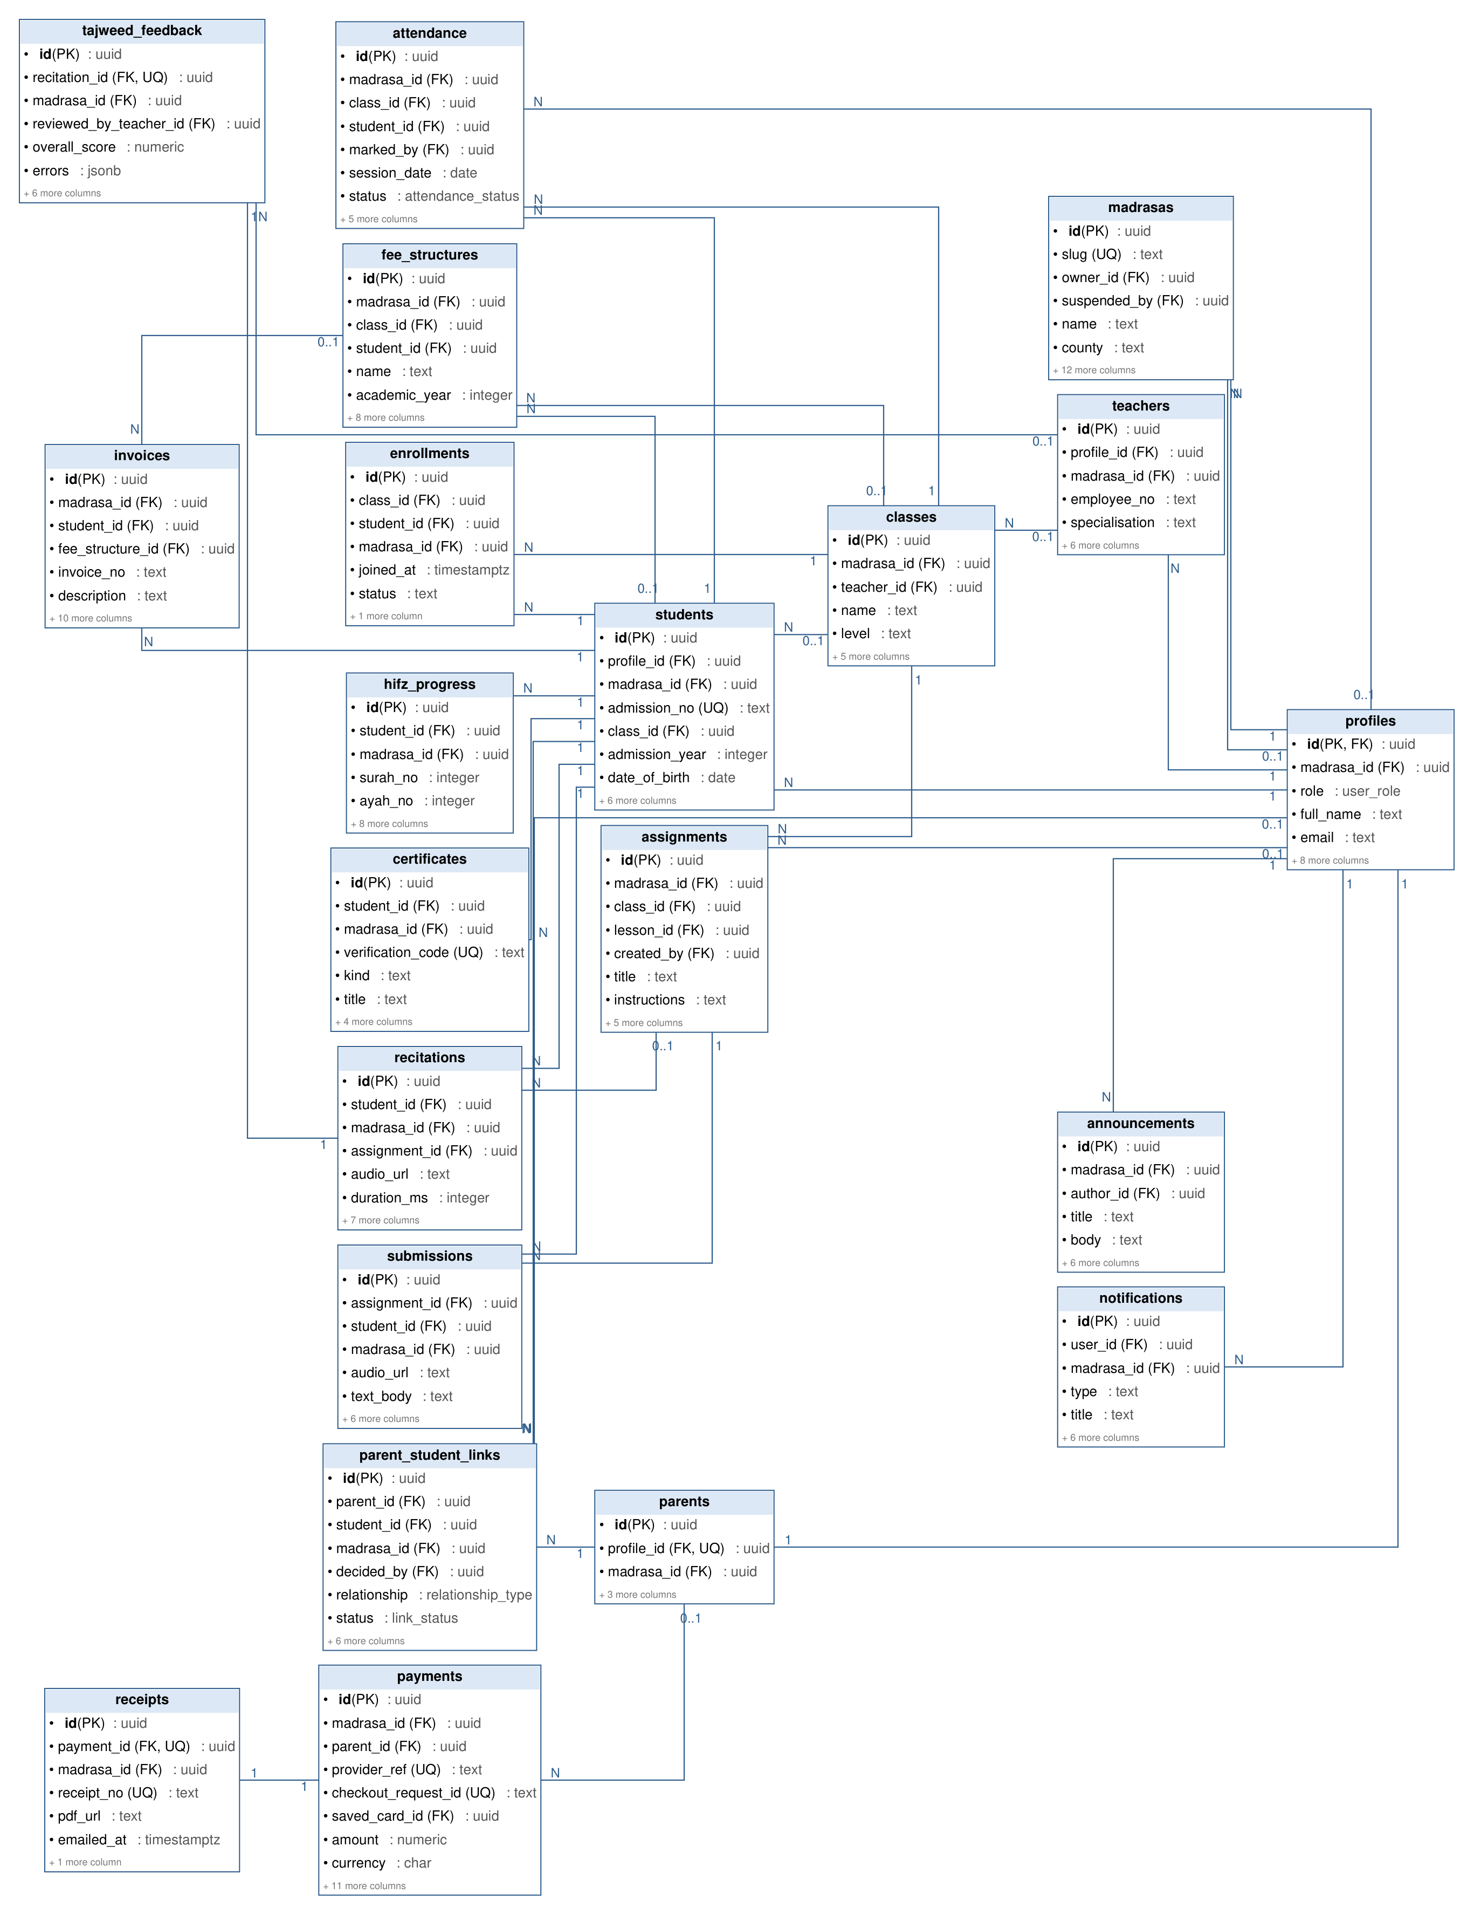
Figure 5.7 Entity relationship diagram

5.4.2 Database Tables
Digital Madrasa uses a PostgreSQL database of 42 tables grouped into nine functional areas: tenancy and identity, access control, learning, attendance, recitation, finance, subscription, communication and operations, as shown in Figure 5.8. Every table that belongs to a madrasa carries its madrasa identifier, and Row Level Security is enabled and forced on all 42 tables, governed by 89 policies, so that users can read and change only the records their role allows (PostgreSQL Global Development Group, n.d.).
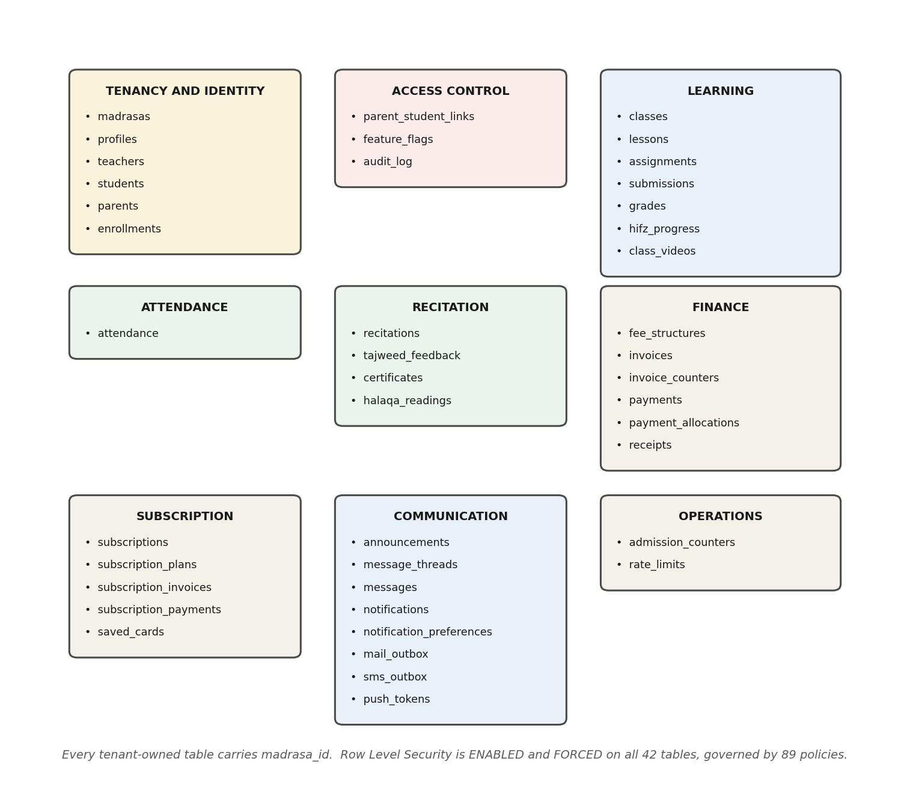
Figure 5.8 Database schema
Figure 5.9 shows how the 42 tables are distributed across the functional areas. Communication is the largest area (8 tables, 19.0%), because announcements, messages, notification preferences and the outboxes for e-mail, SMS and push each need their own table. Learning has 7 tables (16.7%), including the class video library, and tenancy and identity and finance each account for 6 tables (14.3%), reflecting the three core concerns of the system: who belongs to which madrasa, what students learn, and what families owe and pay.
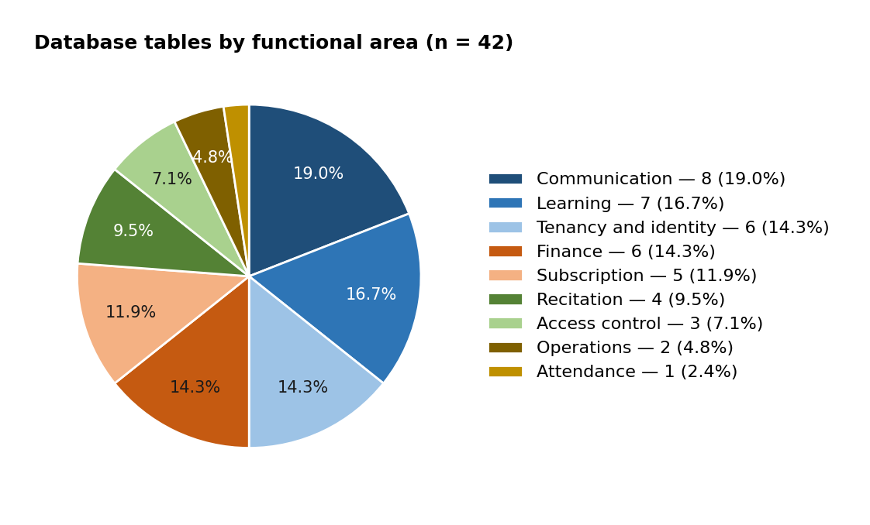
Figure 5.9 Share of database tables by functional area

5.5 Wireframes
A wireframe is a low-fidelity visual guide that arranges the elements of a screen, showing its structure and navigation without visual styling (Garrett, 2011). Wireframes were drawn for the main screens before implementation to agree the layout and flow. Figure 5.10 shows the wireframes for the sign-in screen, the teacher dashboard with attendance and fee summaries, QR attendance scanning, and the review screen shown before invoices are issued. The implemented interfaces are shown in Chapter Six.
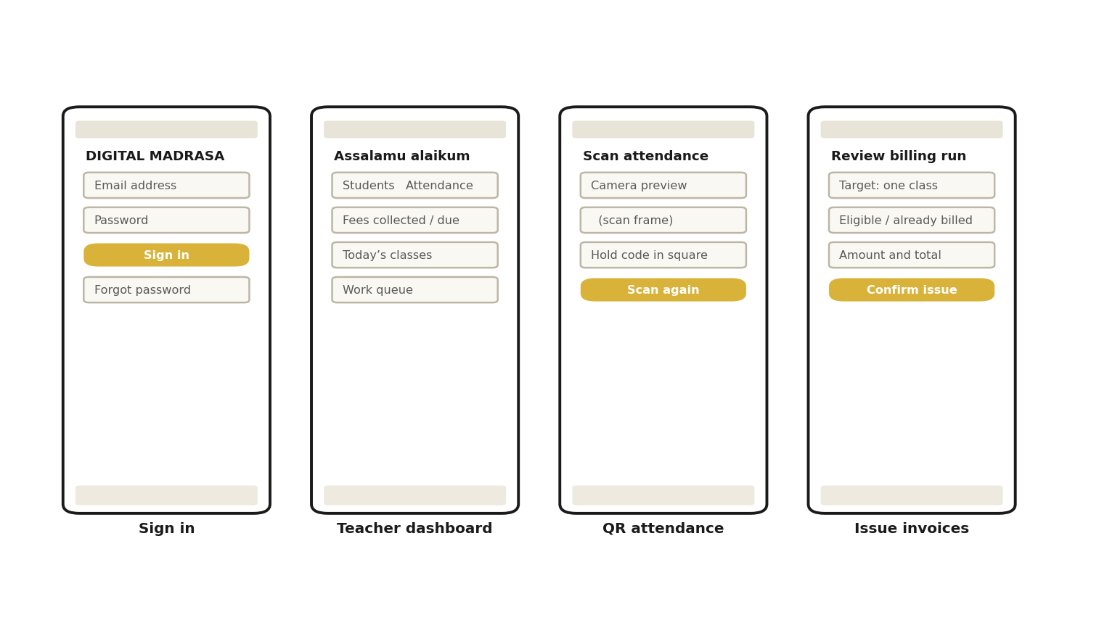
Figure 5.10 Wireframes of the main screens

5.6 Summary
This chapter presented the design of Digital Madrasa. The class diagram defines the main entities and their relationships, the object diagram gives a concrete snapshot of their instances for one student, and the component diagram shows the software components and the interfaces between them. The use case diagram shows what each user can do, the sequence and activity diagrams describe recitation review and QR attendance, the database schema, designed from the ERD, organises the 42 tables into nine protected functional areas, and the wireframes give a visual overview of the interface. The next chapter describes how this design was implemented.

CHAPTER SIX: SYSTEM DEVELOPMENT AND IMPLEMENTATION

6.1 Introduction
This chapter presents the development of the Digital Madrasa Mobile Application, implemented under the brand ILMORA. It outlines the tools, technologies and techniques used, describes the interfaces through which each user interacts with the system, and discusses the challenges encountered during development and how they were addressed. The aim is to show how the designs of Chapter Five were turned into a working mobile application.

6.2 System Development Tools and Techniques
The system was built with tools chosen for cross-platform mobile development, secure data management and low cost. The front end is a single React Native codebase and the back end is a hosted Supabase project, so the same application serves every role while the database enforces what each role may see and do. Table 6.1 summarises the main tools and technologies.
Area | Tools and technologies
Language | TypeScript (strict mode) for the app and Edge Functions; SQL (PostgreSQL) for the schema, policies and database functions
Client framework | React Native with Expo SDK 54, Expo Router (file-based navigation, separate route groups per role), React Native Web
State and validation | TanStack Query for server state, caching and the offline outbox; Zod for form and payload validation
Languages | i18next with English, Kiswahili, Somali and Arabic (right-to-left) translations
Device features | expo-camera (QR scanning), expo-av (recitation recording and playback), expo-notifications (push), expo-secure-store (session storage), speech recognition for recite-along
Backend | Supabase: PostgreSQL with Row Level Security, Auth, Storage (private audio bucket), Realtime (reading room), 18 Edge Functions (Deno), scheduled jobs
External services | Safaricom Daraja M-Pesa STK push (sandbox); Google Gemini (recitation feedback, assistant, spoken reports); Paystack (cards, mock); Africa’s Talking (USSD); YouTube embedded player; Google Meet or Zoom links; e-mail, SMS and Expo push providers
Quality | Vitest (185 unit tests), 21 SQL verification suites, scripted functional checks against the live backend, TypeScript compiler
Build and hosting | Expo Application Services: EAS Build (Android APK) and EAS Hosting (web build); Supabase CLI (migrations, functions, secrets)
Version control | Git with a GitHub repository; automated checks on every push; database backup every three days
Table 6.1 Development tools and technologies

6.2.1 Integrated Development Environment (IDE)
Visual Studio Code was used as the main integrated development environment. It provides TypeScript language support that reports errors as code is written, an integrated terminal for running the Expo development server, the Supabase CLI and the test scripts, and Git integration for version control. The Android emulator from Android Studio was used to run the application during development, and the web build was used to check screens at phone size. Figure 6.1 shows the project open in the editor.
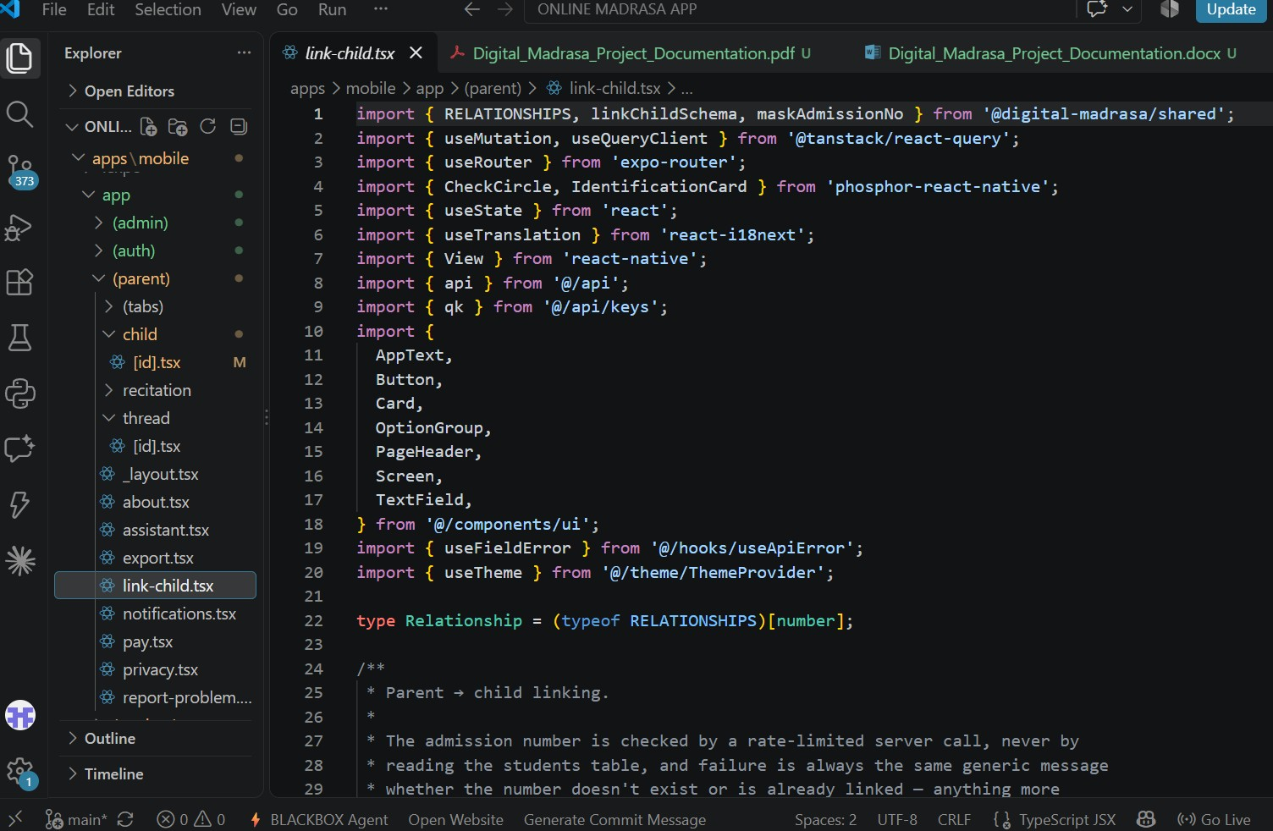
Figure 6.1 The Digital Madrasa project in Visual Studio Code

6.2.2 Front-end Development
The front end was developed with React Native and the Expo toolchain (SDK 54) in TypeScript, which lets one codebase run on Android devices and in a web browser. Expo Router organises the screens into separate groups for the owner, teacher, parent and student, so each user sees a dashboard tailored to their role. TanStack Query keeps data from the server up to date, and i18next provides the interface in English, Kiswahili, Somali and Arabic. The front end includes sign-up and sign-in screens, dashboards, student admission and class management, attendance with a QR scanner that also works offline, recitation recording and practice, the live reading room, the video library, fee and payment screens with receipts, and announcements, messages and notifications.

6.2.3 Backend and Database Management Tools
Supabase was used to manage the data collected by the app. It provides a PostgreSQL database, user authentication, private file storage for recitation audio, and Edge Functions that run privileged operations, such as issuing invoices, starting M-Pesa payments and delivering notifications, on the server. The database schema was created through 41 version-controlled migrations, and Row Level Security policies on every table keep each madrasa’s records private. Supabase Realtime carries the live reading room on private channels that only the class may join. Outside services are called only from the server functions: Google Gemini, which listens to a recitation (when a parent has given consent), answers the AI assistant’s questions and speaks progress reports; Safaricom Daraja, which sends the M-Pesa payment prompt to the parent’s phone; and Paystack, whose hosted page takes card payments so that card numbers never pass through the app. Quran videos are played through YouTube’s embedded player from links the teacher chooses, so no YouTube API key is needed.
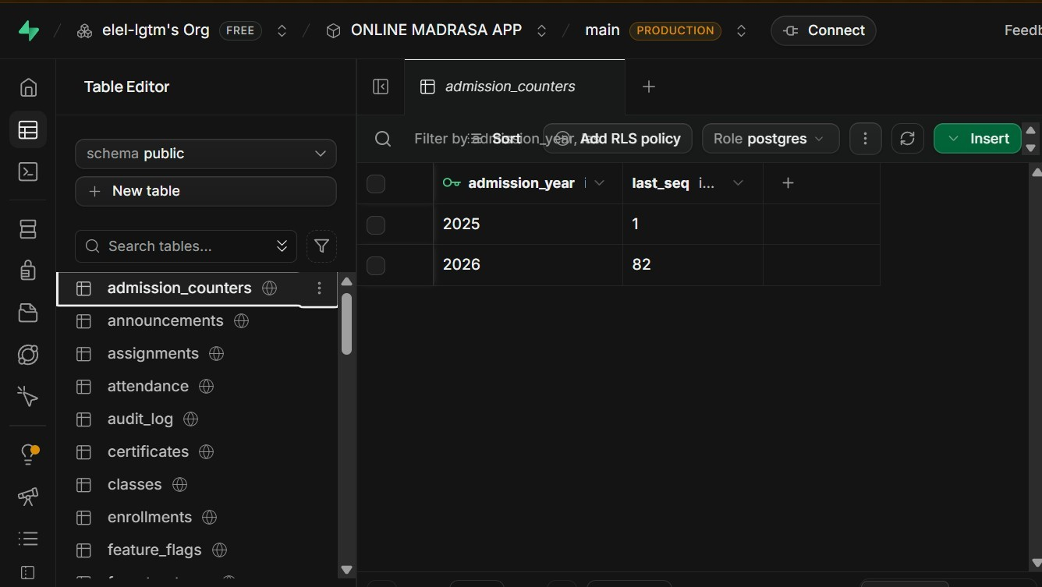
Figure 6.2 Supabase project dashboard

6.3 System Interfaces
ILMORA, the branded implementation of the Digital Madrasa Mobile Application, provides interfaces tailored to each user role. All screens follow the same layout, with a bottom navigation bar, clear headings and summary cards, so that users with different levels of experience can move through the application easily. The following screenshots, captured from the running application on an Android emulator connected to the live backend and, for some panels of Figures 6.8 and 6.9, from the web build at phone size, show the interfaces that users interact with.
Sign Up Interface
A new user chooses to register a madrasa or to create a parent account. Figure 6.3 shows the parent sign-up form, which collects the parent’s name, e-mail address, phone number and password, and asks for consent under the Kenya Data Protection Act 2019.
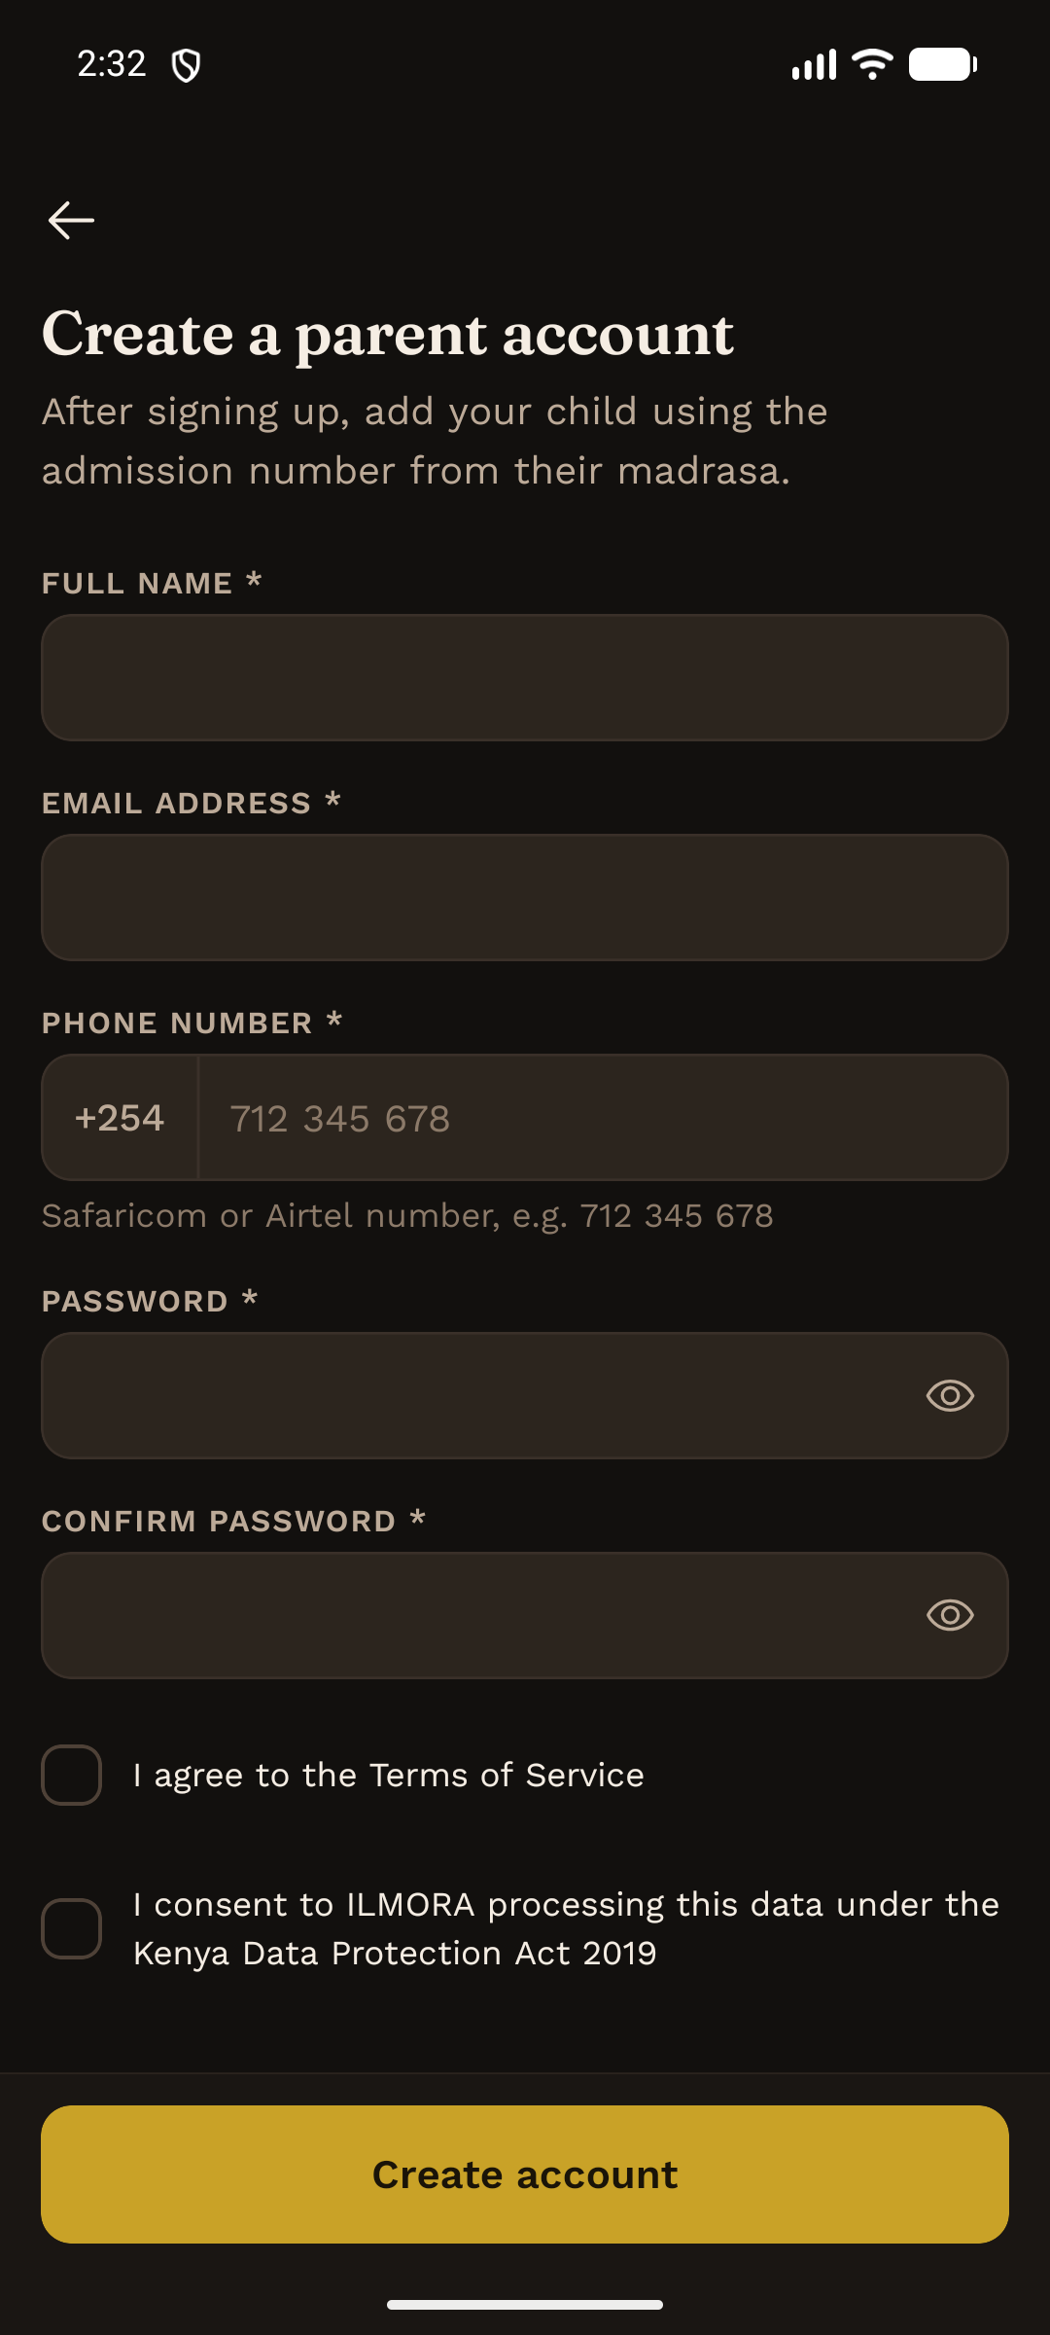
Figure 6.3 Parent sign-up screen
Owner Interface
The owner’s dashboard (Figure 6.4) shows the number of students, attendance for the week, fees collected and outstanding, pending parent link requests and today’s classes, with tabs for students, classes, fees and more.
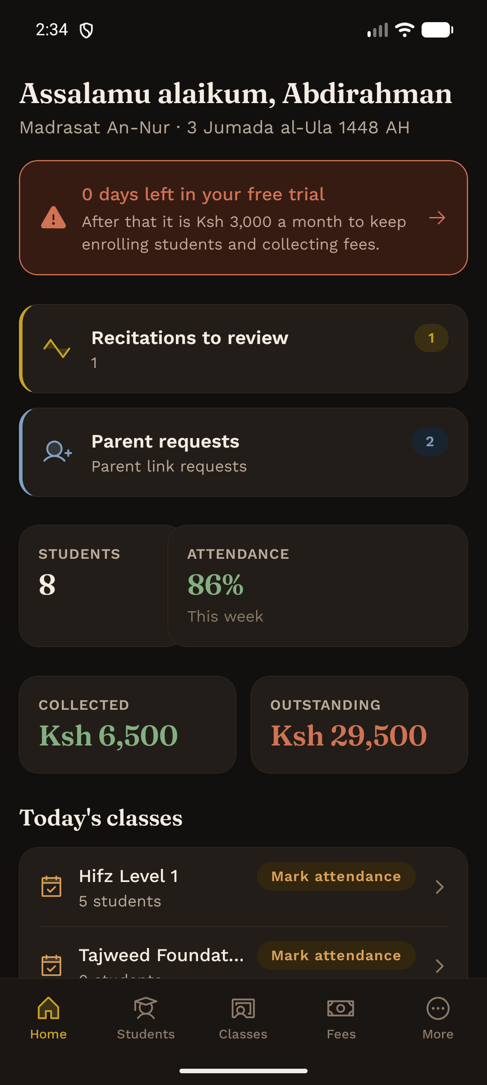
Figure 6.4 Owner dashboard
Teacher Interface
The teacher’s dashboard (Figure 6.5) lists the teacher’s classes with a shortcut to mark attendance, together with parent requests and summary figures for the madrasa.
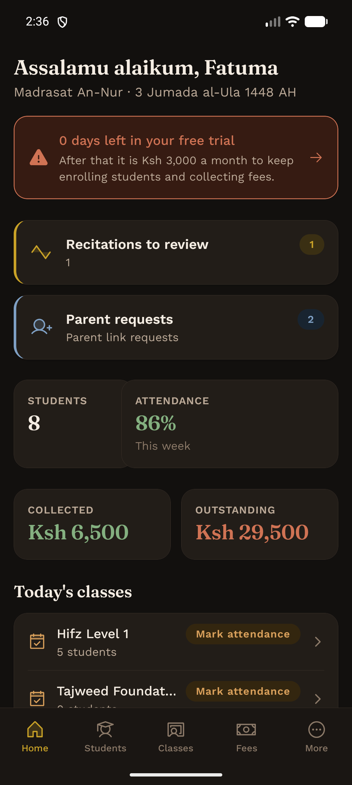
Figure 6.5 Teacher dashboard
Parent Interface
The parent’s dashboard (Figure 6.6) lets a parent switch between approved children and see each child’s admission number, memorisation, attendance rate, outstanding balance and recent attendance, with tabs for fees, the inbox and messages.
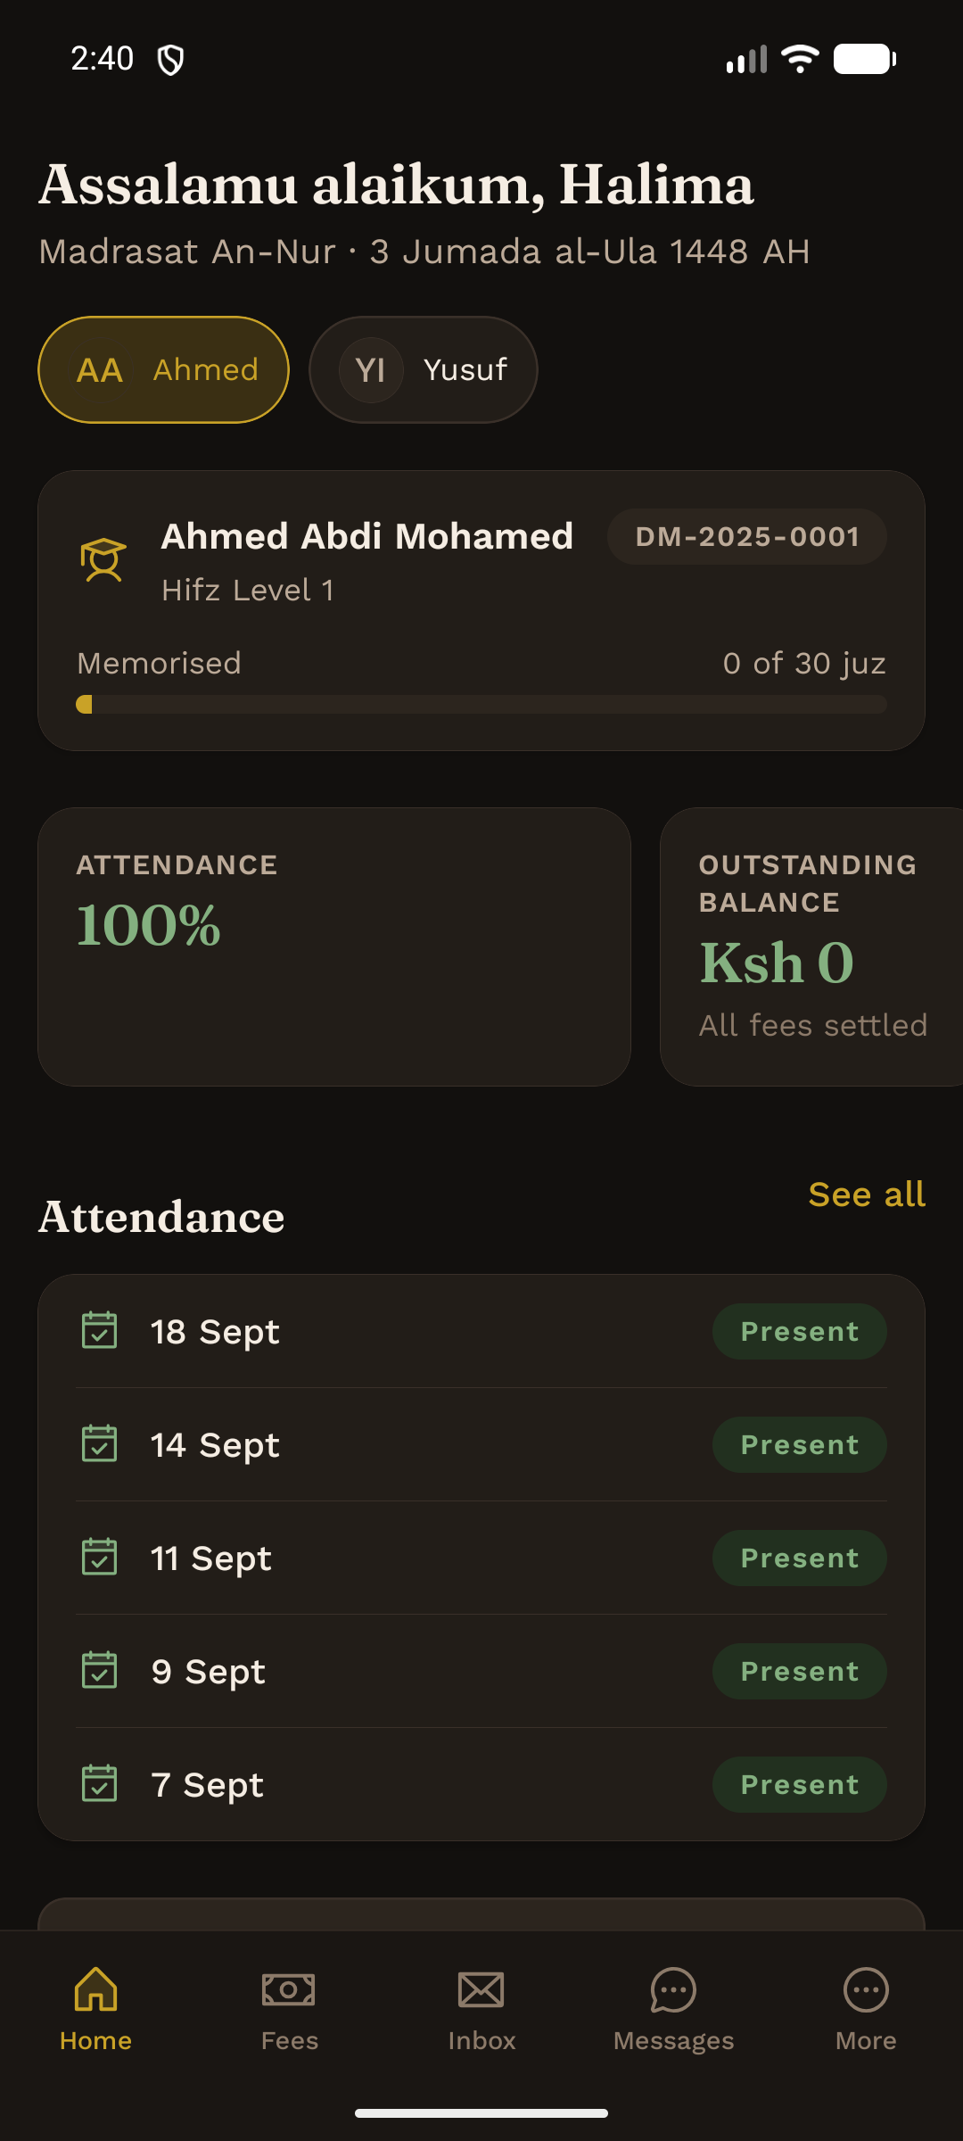
Figure 6.6 Parent dashboard
Student Interface
The student’s dashboard (Figure 6.7) shows the passages due for revision with a button to start a recitation, the juz memorised, attendance, overall progress and assignments.
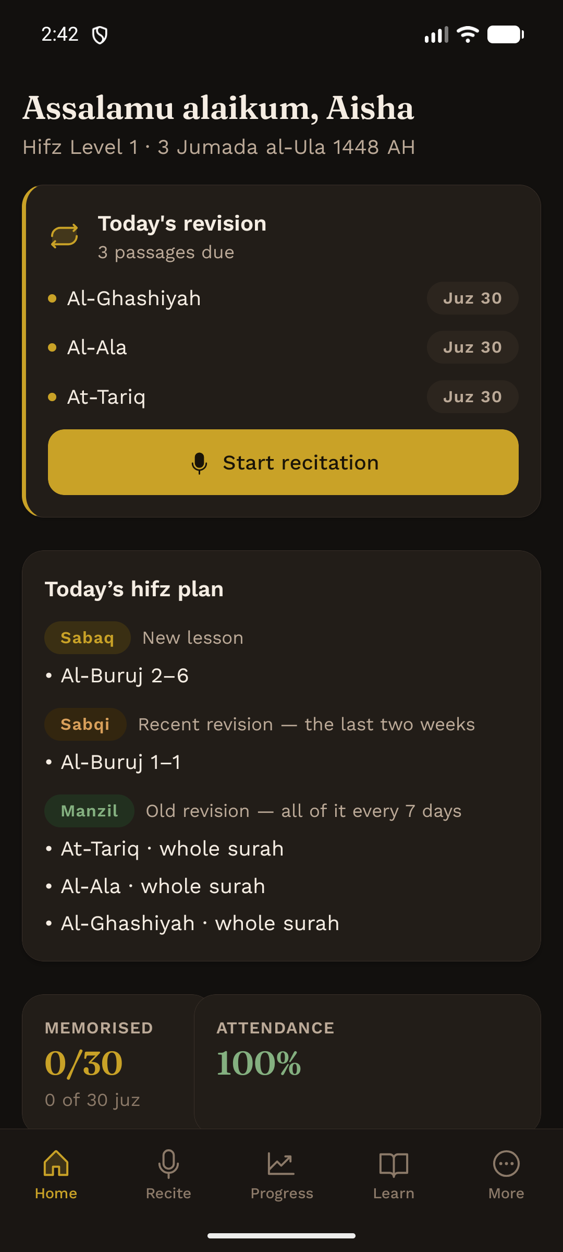
Figure 6.7 Student dashboard
Recitation, Live Learning and Badge Interfaces
Figure 6.8 shows the learning features. A teacher reviewing a recitation can play the pupil and a master reciter ayah by ayah; in the live reading room pupils raise their hands, the teacher chooses a reader, the ayah is highlighted on every phone and the teacher marks the reading; the video library plays the Quran videos the teacher has chosen for the class; and badges, worked out from the pupil’s own records, encourage the pupil.
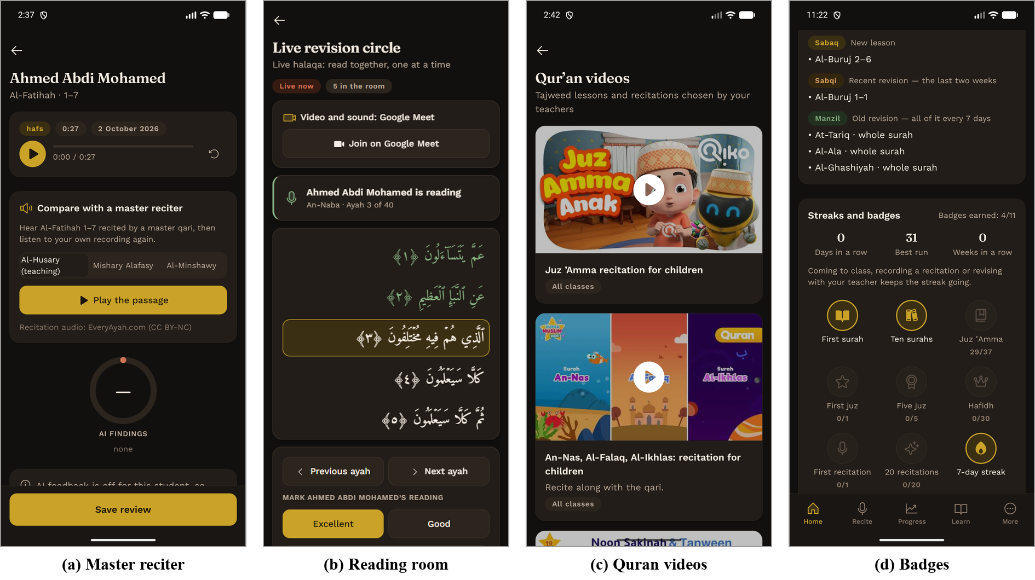
Figure 6.8 Recitation, live learning and badge interfaces
Payment, Messaging and Offline Interfaces
Figure 6.9 shows the parent paying a fee by M-Pesa, the receipt with its M-Pesa transaction code, a conversation between a parent and a teacher, and the attendance register saved on the phone while offline and sent when the connection returns.
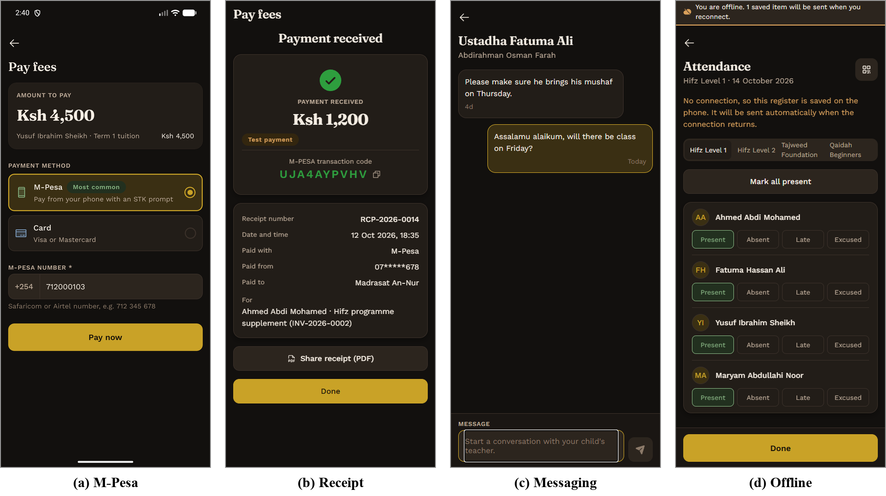
Figure 6.9 Payment, messaging and offline interfaces

6.4 Challenges Encountered During Development
Several technical, practical and economic challenges arose during development. This section describes them and how each was addressed.

6.4.1 Technical Complexities
Multi-tenant security. Supporting many madrasas and four roles in one system required every rule about who may see what to be written into the database as Row Level Security policies, and tested with accounts for every role.
Performance of access rules. Performance testing showed that the original rule for reading a child's records became slower as the platform grew, so it was rewritten to be evaluated once per query and proven by a test to allow exactly the same records.
Handling money. The app never sends an amount; the server derives it from the invoices, and a payment is settled on the server exactly once, even if the M-Pesa callback arrives more than once.
Device-only features. Some features, such as push notifications, cannot be tested in Expo Go and need an installable build.
Right-to-left layout. Testing the installed build revealed that Arabic headings were drawn on the wrong side, because React Native swaps left and right in a right-to-left layout; this was then fixed.
Keeping AI feedback honest. Given silence and the expected text, one AI model reported a perfect recitation, so the audio is now first transcribed without the text and checked in code before any score is given, and no recording is assessed without a parent’s consent.
Live features and offline use. A reading-room channel had to admit only the pupils, parents and teachers of that class, so access is decided by a database rule. Attendance saved without a connection was at first held back until the network returned, so the register is now kept on the phone and sent automatically on reconnection. On the web, where there is no secure key store, the session is kept in the browser tab.

6.4.2 User Adoption and Resistance
Some owners, teachers and parents have little experience with mobile applications and may prefer familiar paper registers. To encourage adoption the interfaces were kept simple, with large buttons and clear summaries, the application was translated into Kiswahili, Somali and Arabic, and payment uses M-Pesa, which families already use, or a card. AI feedback on a child’s voice is off until a parent turns it on.

6.4.3 Economic Constraints
Limited resources affected the choice of tools. Free and open-source tools were used throughout: Expo, React Native, Visual Studio Code, the free tier of Supabase, the free tier of Google Gemini and Safaricom’s free Daraja sandbox. The in-app video provider that was evaluated required a payment card, so live lessons use free Google Meet or Zoom links, and the video code was kept separate so it can be switched on when funding allows. Card payments, e-mail and SMS were developed against mock providers; the same code switches to the real services when credentials are configured.

6.4.4 Continuous Updates and Support
Long-term use requires ongoing maintenance. Database changes are made through numbered migrations, automated checks run on every change pushed to GitHub, and the database is backed up every three days. Keeping Expo, React Native and Supabase up to date and responding to feedback from madrasas will keep the system reliable.

6.5 Summary
This chapter described the implementation of the Digital Madrasa Mobile Application, branded ILMORA, with Visual Studio Code, React Native with Expo, and Supabase. It presented the sign-up screen, the dashboards for owners, teachers, parents and students, and the learning, payment, messaging and offline interfaces, and discussed the main development challenges: multi-tenant security, performance of access rules, payment integrity, right-to-left layout, honest AI feedback, live and offline features, user adoption, limited resources and continuous maintenance. The next chapter describes how the system was tested and deployed.

CHAPTER SEVEN: TESTING AND DEPLOYMENT

7.1 Introduction
Testing establishes whether the system does what its requirements say, and deployment makes it available to its users. This chapter describes the testing of Digital Madrasa at three levels: unit tests of individual functions, functional and security tests of the deployed backend as each role, and user interface tests of the screens. It then summarises the results and describes the current and planned deployment.

7.2 System Testing and Validation
Because the most important requirement is that no madrasa can see another's records and no user can act outside their role, tests checked that forbidden actions are refused as well as that permitted ones succeed.

7.2.1 Unit Tests
Unit testing examines individual components in isolation. Unit tests were written with Vitest for the logic that does not need a server: input validation, QR token signing, M-Pesa and card payment handling, notification rules, memorisation totals, recitation assessment, the AI assistant’s check on figures, the hifz plan, master-reciter timing, video links, the offline attendance queue, and streaks and badges. All 185 unit tests in 23 test files passed when run on 16 October 2026. Figure 7.1 shows their distribution by area, and Table 7.1 lists representative cases.
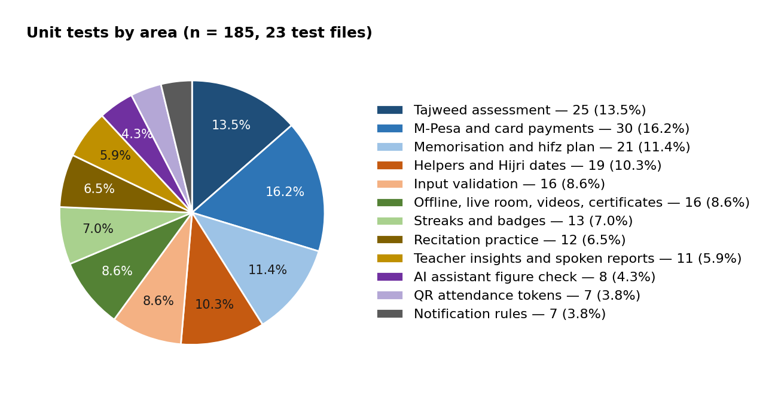
Figure 7.1 Distribution of the 185 unit tests by area
ID | Module | Test case description | Expected result | Actual result | Status
UT01 | Validation | A payment request that includes an amount | Amount removed; server derives it | As expected | Pass
UT02 | Validation | Admission form with a future date of birth | Rejected with a clear message | As expected | Pass
UT03 | Validation | Sign-up password shorter than 8 characters | Rejected with a clear message | As expected | Pass
UT04 | QR tokens | Token from an old window, or forged | Token rejected | As expected | Pass
UT05 | QR tokens | Token for class A presented for class B | Token rejected as wrong class | As expected | Pass
UT06 | M-Pesa | Phone number entered as 0712…, +254712… or 254712… | Normalised to 2547XXXXXXXX | As expected | Pass
UT07 | M-Pesa callback | Customer cancels the payment prompt | Recorded as failed; nothing credited | As expected | Pass
UT08 | M-Pesa callback | Same successful callback received twice | Invoice settled only once | As expected | Pass
UT09 | Memorisation | Overlapping memorisation records | Each juz counted once | As expected | Pass
UT10 | Notifications | User has switched SMS off | No SMS sent | As expected | Pass
UT11 | Invoicing | Invoice number generated for a new year | Sequence restarts at 0001 for the madrasa | As expected | Pass
UT12 | Translations | Every English key present in SW, SO and AR files | No missing keys | As expected | Pass
UT13 | Video library | A link that is not from YouTube | Link refused | As expected | Pass
UT14 | Offline queue | Register saved with no connection | Kept on the phone; sent once on reconnect | As expected | Pass
UT15 | Streaks and badges | A surah still being learned | Not counted towards a badge | As expected | Pass
Table 7.1 Unit testing

7.2.2 Functional Testing
Functional testing verifies that each feature works as the requirements specify. Scripts signed in as test accounts for every role and called the deployed backend; in total 78 functional test cases were run and all passed. In addition, 21 database verification suites, run against the live database on 15 October 2026, proved 145 security guarantees, such as that a parent sees only their own children and that a pupil cannot join another class’s reading room; all passed. Key functionalities tested include:
- Sign-in and role-based access: each role reaches its own dashboard and is refused actions of other roles.
- Attendance, invoicing, M-Pesa and card payment, notifications, written work, certificates, and AI recitation feedback only with consent.
- Live lessons, the reading room, the video library, parent–teacher messaging, sponsorship and the impact dashboard, each limited to the right madrasa, class and role.
ID | Feature | Test scenario | Expected outcome | Actual outcome | Status
FT01 | Admission | Owner admits a student; a parent tries to admit one | Number DM-YYYY- NNNN issued; parent refused | As expected | Pass
FT02 | Tenant isolation | Owner of madrasa A requests students of madrasa B | No rows returned | As expected | Pass
FT03 | Role control | Student tries to change own role to owner | Change blocked by the database | As expected | Pass
FT04 | QR attendance | Student scans a valid code, | Marked present once; | As | Pass
FT05 | Manual attendance | Teacher marks a class he does not teach | Refused | As expected | Pass
FT06 | Memorisation | Teacher records surahs for a student | Juz total and revision list updated | As expected | Pass
FT07 | Recitation | Student uploads a recording; teacher reviews it | Score and comment visible to student and parent | As expected | Pass
FT08 | Recitation | Student B requests student A's audio link | Refused; no signed link issued | As expected | Pass
FT09 | Parent linking | Unlinked parent views a child's recitations | Nothing shown until the link is approved | As expected | Pass
FT10 | Invoicing | Owner issues invoices to one class | One invoice per student of that class | As expected | Pass
FT11 | M-Pesa payment | Parent pays an invoice | Invoice paid; receipt issued; parent notified | As expected | Pass
FT12 | Notifications | Owner posts an announcement to parents | Inbox entry created for each parent | As expected | Pass
FT13 | M-Pesa failure | Customer cancels or lacks funds | Payment failed with the reason; invoice still due | As expected | Pass
FT14 | Messaging | Parent writes to a teacher of another child | Message refused | As expected | Pass
Table 7.2 Functional and security testing

7.2.3 User Interface (UI) Testing
User interface testing checks that the application is easy to use and visually consistent. It was carried out on an Android emulator, in the web build at phone size, and finally on the installed Android package (APK) built by Expo Application Services. Key areas tested were:
- Navigation: tabs and buttons lead to the correct screens for each role.
- Forms and input fields: admission, invoice and payment forms validate input and show clear messages.
- Languages: labels fit and read correctly in English, Kiswahili, Somali and Arabic.
- Visual consistency: fonts, colours, icons and buttons are consistent across screens.
- Offline use: with the connection cut, the last screens stay visible and the attendance register is saved on the phone, then sent when the connection returns.
On the installed app, recording, the offline library with the network switched off, the mirrored Arabic layout, camera permissions, confirmation dialogs, the AI assistant, parental consent and card payment were all exercised. Six defects found during UI testing were fixed: the parent inbox failed to display some notification types; tab labels were cut off in some languages; Arabic headings were drawn on the wrong side; the scanner did not notice a camera permission granted in Settings; the microphone message was not translated; and an unassessed recording was praised. Push notifications remain to be verified, because they need a Firebase project to be configured.
ID | UI element | Test scenario | Expected result | Actual result | Status
UI01 | Sign-in screen | Layout at phone size | Clean and responsive | As expected | Pass
UI02 | Sign-up form | Submit without dataprotection consent | Form refuses and explains | As expected | Pass
UI03 | Dashboard | Role-based display | Correct dashboard per role | As expected | Pass
UI04 | Tab bar | Labels in four languages | Labels fully visible | As expected after fix | Pass
UI05 | Arabic layout | Switch language to Arabic | Screens mirror righttoleft | As expected | Pass
UI06 | Forms | Data entry and validation | Easy input and clear feedback | As expected | Pass
UI07 | QR screen | Teacher opens class | Code refreshes every 30 | As expected | Pass
UI08 | Recitation | Record, stop and play back | Timer, waveform and playback work | As expected | Pass
UI09 | Inbox | Display of notifications | All notices shown correctly | As expected after fix | Pass
UI10 | Installed APK | App opened in Arabic on the APK | Headings and layout mirrored correctly | As expected after fix | Pass
UI11 | Offline banner | Connection cut while marking attendance | Banner shown; register kept and later sent | As expected | Pass
Table 7.3 User interface testing

7.3 Testing Results
Testing produced positive results across all major parts of the system. Table 7.4 summarises the results. Of the 31 user interface checks, 30 passed, six of them after a defect was fixed; push notifications are still to be verified once Firebase is configured. In-app video was not tested because it is switched off.
Testing Type | Total Test Cases | Passed | Failed | Success Rate
Unit Testing | 185 | 185 | 0 | 100%
Functional Testing | 78 | 78 | 0 | 100%
Database Security Guarantees | 145 | 145 | 0 | 100%
UI Testing | 31 | 30 | 0 | 100% of tests run (1 pending)
Table 7.4 Testing results
These results show that the system works as specified and that users cannot reach records outside their madrasa or role. They do not yet measure how the system is received by real users; a pilot in one madrasa, using the post-use evaluation questionnaire in Appendix 1 (Section E), is planned once the APK is installed on participants' phones.

7.4 System Deployment
Deployment prepares the system for real use. The backend of Digital Madrasa is deployed on a hosted Supabase project: the database with its 41 migrations and security policies, private storage for recitation audio, and 18 Edge Functions for operations such as invoicing, M-Pesa payments, notifications, AI feedback, spoken reports, USSD and the AI assistant. Automated checks run on GitHub for every change, and the database is backed up every three days. Figure 7.2 shows the deployment.
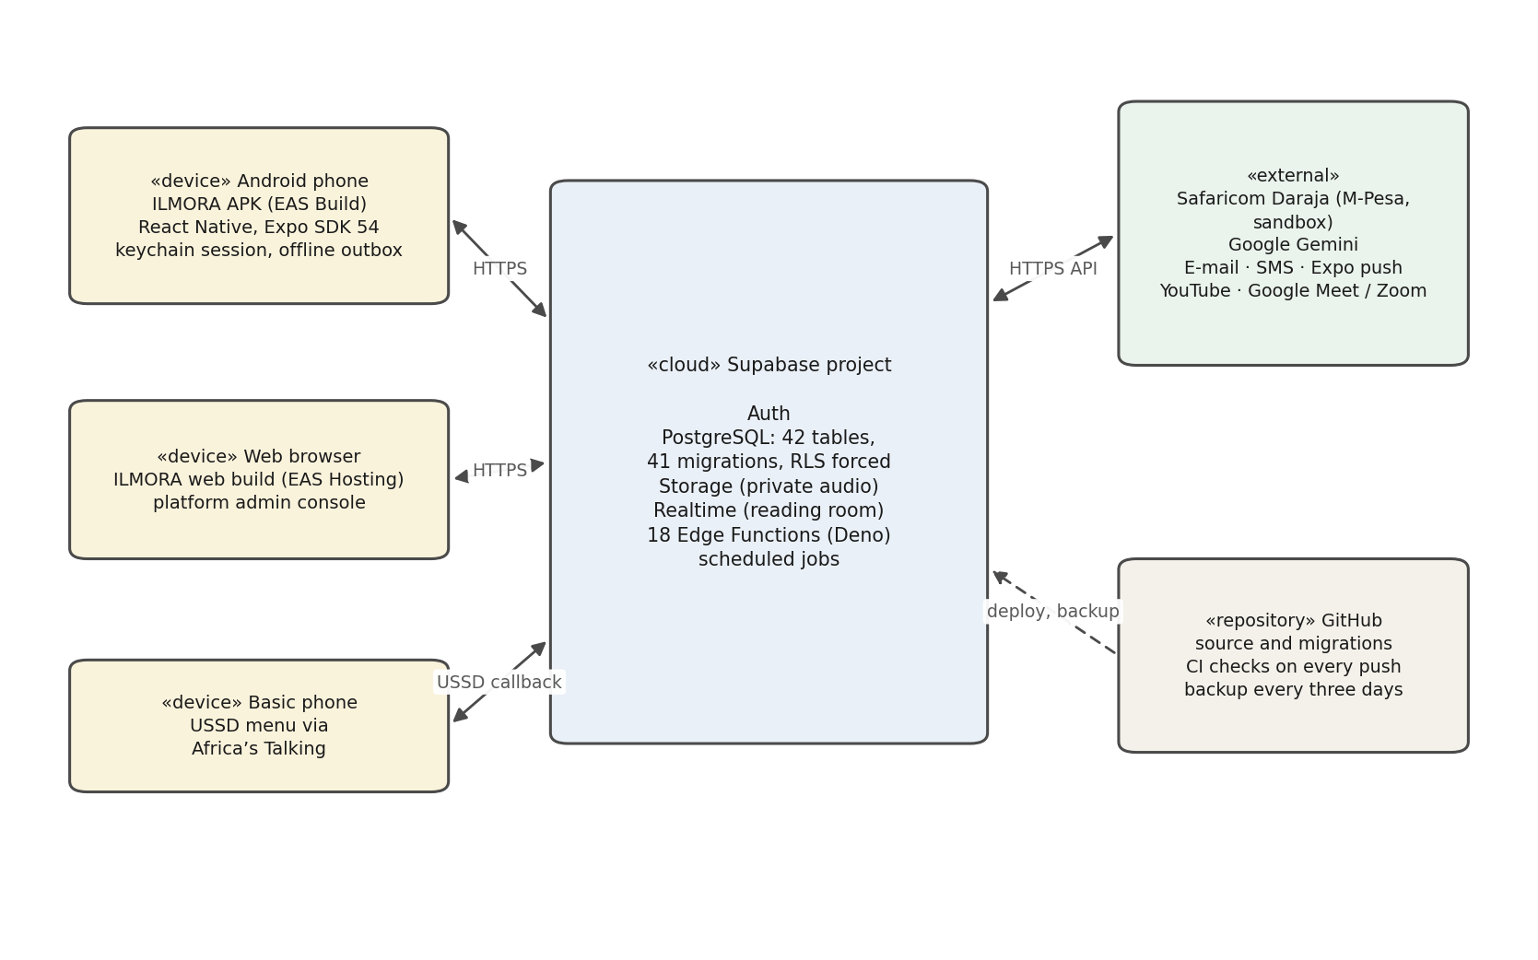
Figure 7.2 Deployment diagram

7.4.1 Current Deployment Methods
Backend. The database schema, security policies and server functions were deployed to the hosted Supabase project with the Supabase CLI, and secrets were set on the server so that they never appear in the app or the repository.
Mobile application. The application is built as an installable Android package (APK) with Expo Application Services (EAS) and connects to the live backend. The APK is distributed directly:
- Direct APK sharing: the APK file is shared through Google Drive, Bluetooth or USB, and users install it by allowing installation from unknown sources.
- WhatsApp distribution: the APK is shared as a document on WhatsApp, which madrasa owners, teachers and parents already use.
Web. The same codebase is published as a website on Expo’s free hosting (EAS Hosting) at https://https-ilmora-expo-app.expo.app, where the platform administrator’s console runs and owners, teachers and parents can also sign in.

7.4.2 Future Deployment Plans
- Google Play Store: publishing the app will make installation easier and more trusted, and provide automatic updates.
- Live payment and messaging services: moving M-Pesa from the Daraja sandbox to a registered Paybill or Till, and connecting Paystack for cards, the e-mail and SMS providers, and Firebase for push notifications, with real credentials.
- In-app video: switching on the built in-app video for live lessons once a funded video provider account is available.

7.5 Summary
This chapter presented the testing and deployment of the Digital Madrasa Mobile Application (ILMORA). Unit, functional, database security and user interface testing showed that the core features, including sign-in, admission, attendance, invoicing, M-Pesa and card payment, AI feedback with consent and parent access, work as required on the installed app, and that users cannot reach records outside their madrasa or role. The backend runs on Supabase, the app is shared as an APK and a website, and future plans include the Play Store, live payments and in-app video.

CHAPTER EIGHT: DISCUSSIONS, CONCLUSIONS, FUTURE WORKS AND RECOMMENDATIONS

8.1 Introduction
This chapter reflects on the outcomes of the project. It discusses how far each objective was achieved, outlines the work planned to take Digital Madrasa further, and makes recommendations for its continued development and use.

8.2 Discussion of Objectives
Objective 1: to analyse the challenges facing madrasas. The literature review and the requirements gathering confirmed that madrasa records are informal and unstandardised, that parents have limited visibility, that assessing recitation places a heavy workload on teachers, and that fees are not linked to invoices. The questionnaires quantified these problems: 41.7% of the madrasas surveyed keep no written attendance record, 66.7% keep no written memorisation record, and 20.0% of parents receive no information about their child at all.
Objective 2: to review existing systems. The review showed that Quran applications serve individual learners while education management systems have no Quran-specific functions, and that none keeps many independent madrasas separate or offers the languages of Kenyan madrasa communities. These gaps defined Digital Madrasa's design.
Objective 3: to design and develop the application. This objective was achieved. The system was developed with React Native and Expo for the front end and Supabase for the backend. Owners, teachers, parents and students each have a dedicated dashboard, and admission, classes, manual and QR attendance, memorisation, assignments, recitation review with AI feedback, certificates, invoicing, M-Pesa and card payment, and notifications were implemented against the live backend. The application, branded ILMORA, also offers master-reciter comparison, recite-along practice, a daily hifz plan, hifz streaks and badges, a web console for the platform administrator, a live reading room with scheduled Meet or Zoom sessions, a teacher-chosen Quran video library, parent–teacher messaging, pupil sponsorship, spoken reports, USSD access, offline attendance and an impact dashboard.
Objective 4: to test the system. Unit, functional and user interface testing confirmed that the core features work as required: all 185 unit tests and 78 functional test cases passed, 21 database suites proved 145 security guarantees, and the installed app passed 30 of 31 interface checks. M-Pesa is connected to Safaricom’s Daraja sandbox. The tests showed that users cannot reach records outside their madrasa or role. A usability study with real users, push notifications and testing on a range of physical phones remain to be done.

8.3 Conclusion
This project, implemented under the brand ILMORA, set out to address the challenges facing madrasas in Kenya, particularly in the Northeastern region (Mandera, Wajir and Garissa), where Quran learning institutions continue to rely largely on manual record-keeping, paper-based fee tracking and limited communication between teachers and parents. These practices make it difficult to monitor student progress, manage admissions and fees, and give parents a clear picture of their children’s learning. In response, the project developed Digital Madrasa, an integrated cross-platform application for managing madrasas in Kenya.
The system was built with React Native for the client application and Supabase for authentication, database management and backend services. Supabase was chosen over alternatives such as Firebase because it removed the need for a billing account, making the solution more affordable for institutions with limited resources. The application supports four user roles, the madrasa owner, teacher, parent and student, together with a platform administrator. Each role has a dedicated interface suited to its responsibilities. A multi-tenant design keeps each madrasa’s data isolated, while features such as auto-generated admission numbers, parentto-child linking by admission number and M-Pesa fee payments address the day-to-day administrative needs of these institutions.
Beyond administration, the system supports the core purpose of a madrasa, which is learning the Quran. It provides a recitation feedback module aimed at helping students improve their tajweed, along with dashboards that let teachers track learner progress and let parents follow their children’s development remotely. This bridges the communication gap between the madrasa and the home, which was one of the key problems identified at the start of the project.
During development, several technical challenges were encountered and resolved. These included configuration errors in connecting to the Supabase backend, row-level security policies blocking user profile creation, and API rate-limit errors during authentication. They were overcome by using a database trigger to create profiles automatically and by refining the authentication flow. Resolving these issues strengthened both the reliability of the system and the researcher’s practical understanding of secure, cloud-based application development.
In conclusion, the project achieved its main aim of developing a digital solution that modernises how madrasas in Kenya manage students, teachers, parents and fees while supporting Quran learning. Digital Madrasa shows that affordable, locally relevant technology can improve the efficiency, transparency and accountability of Islamic educational institutions in underserved communities.
Although some features can be extended further, as outlined in the recommendations and future work sections, the system provides a solid foundation for the digital transformation of madrasa education in Kenya.

8.4 Future Work

8.4.1 Deployment to Google Play Store
Building the Android package and publishing the app on the Google Play Store would make installation easier and more trusted, provide automatic updates and allow feedback to be collected from users.

8.4.2 Development of Web-Based Admin Dashboard
The platform administrator’s web console is now hosted and shows every madrasa, the platform’s impact and an audit log. It should be extended with downloadable reports and subscription management, so that the madrasas on the platform, their subscriptions and their activity can be monitored and acted on from a browser.

8.4.3 Integration of Push Notifications and Messaging
Push, e-mail and SMS notifications and parent–teacher messaging are built. Configuring a Firebase project for push, connecting the real e-mail and SMS providers, a registered M-Pesa Paybill and Paystack, switching on in-app video for live lessons when a video provider can be funded, and confirming delivery on physical phones would give parents timely alerts about attendance, fees and reviews.

8.4.4 Smart Alerts and Recommendations
The daily hifz plan and the teacher’s co-pilot already point to passages due for revision and to learners who fall behind. These could be extended into reminders based on spaced repetition (Kornell, 2009), and the general AI model now used for recitation feedback could be replaced with a tajweed model validated, with consent, on recordings of Kenyan learners.

8.4.5 Enhanced Offline Functionality
Many madrasas have unreliable internet access. Attendance can already be marked offline and is sent when the connection returns, and USSD serves parents with basic phones. Extending this to memorisation records and recordings would make the system fully usable in such areas.

8.5 Recommendations

8.5.1 Continuous User Engagement
Feedback should be collected regularly from owners, teachers, parents and students, beginning with a pilot in one madrasa, so that the system continues to meet real needs.

8.5.2 Strengthening Data Security
Because the system holds children's records, authorisation must remain in the database, every change to an access rule should be tested before deployment, and the Kenya Data Protection Act 2019 must be followed. Multi-factor authentication should be offered, especially for owner and administrator accounts.

8.5.3 Regular System Updates
The application should be updated regularly to fix defects, keep Expo, React Native and Supabase current, and add features requested by users.

8.5.4 Institutional and Government Collaboration
Collaboration with madrasa associations and the Ministry of Education would support adoption and help align the system's records with the planned integration of madrasa education into the national system (Kihaki, 2026; Tongola, 2025).

8.5.5 Optimisation for Low-End Devices
The application should be optimised for the low-cost smartphones common among families, by reducing their size and data usage and testing it on such devices.

8.6 Summary
This chapter discussed how the Digital Madrasa Mobile Application (ILMORA) addressed the challenges of madrasa administration and Quran learning in Kenya. The system brings records, attendance, memorisation, recitation review, parent access and fee payment into one secure platform. Future work includes publishing on the Google Play Store, reports in the web console, live notifications and payments, in-app video, smart revision alerts and fuller offline support, while the recommendations emphasise user engagement, data security, regular updates, institutional collaboration and optimisation for low-end devices.

APPENDIX: SUPPORTING MATERIALS

APPENDIX 1: User Survey Questionnaire
This questionnaire was used to collect data from madrasa owners, teachers, parents and students for the Digital Madrasa project. Participation is voluntary and anonymous, students took part only with the consent of their parents, and responses are used only for academic purposes.

Section A: Madrasa Owner and Teacher Questionnaire
Question 1: How is student attendance currently recorded in your madrasa?
☐ Exercise book or register
☐ Wall chart
☐ Teacher's memory only
☐ Not recorded
☐ Other (please specify): __________
Question 2: How is a student's Quran memorisation progress recorded?
☐ Written in a book
☐ Teacher remembers
☐ Told to the parent verbally
☐ Not recorded
☐ Other (please specify): __________
Question 3: How are fees recorded and communicated to parents?
☐ Written receipt book
☐ Verbal reminder
☐ M-Pesa messages only
☐ No formal record
☐ Other (please specify): __________
Question 4: Would you use a mobile application to manage your madrasa?
☐ Yes
☐ Maybe
☐ No

Section B: Parent Questionnaire
Question 1: How do you currently learn about your child's attendance and progress?
☐ Told at pick-up
☐ Phone call from the teacher
☐ Parents' meeting
☐ I am not informed
☐ Other (please specify): __________
Question 2: Would you pay madrasa fees through M-Pesa in a mobile application?
☐ Yes
☐ Maybe
☐ No
Question 3: Do you receive a receipt when you pay fees?
☐ Always
☐ Sometimes
☐ Never
Question 4: Which language do you prefer for notices from the madrasa?
☐ English
☐ Kiswahili
☐ Somali
☐ Arabic

Section C: Student Questionnaire
Question 1: How does your teacher assess your recitation?
☐ I recite to the teacher in class
☐ The teacher listens to a group together
☐ Rarely assessed
☐ Other (please specify): __________
Question 2: Would recording your recitation on a phone help you practise?
☐ Strongly agree
☐ Agree
☐ Neutral
☐ Disagree
☐ Strongly disagree
Question 3: How do you know which passages to revise?
☐ My teacher tells me
☐ I decide myself
☐ My parents remind me
☐ I do not revise regularly
Question 4: How soon after reciting do you get feedback from your teacher?
☐ Immediately in class
☐ At the next session
☐ After several days
☐ I rarely get feedback

Section D: Interview Guide for Madrasa Owners and Senior Teachers
1. Describe how a new student is admitted and allocated to a class.
2. How do you record attendance and memorisation today, and who keeps those records?
3. How are fees set, collected and followed up, and what problems arise?
4. How do you inform parents about their child's attendance and progress?
5. Who should be allowed to see a child's records, and how should a parent be linked to a child?
6. Which languages do the parents in your madrasa prefer for written notices?
7. What would make you stop using a madrasa application?

Section E: Post-Use Evaluation Questionnaire
Rate each statement from 1 (strongly disagree) to 5 (strongly agree).
Statement | 1 | 2 | 3 | 4 | 5
The app was easy to use.
Taking attendance with the QR code was quick.
I could easily see my child's attendance, progress and fees.
Paying fees through M-Pesa in the app was simple.
The app was clear in my preferred language.
I would recommend Digital Madrasa to another madrasa.
Table A.1 Post-use evaluation questionnaire

APPENDIX 2: Work Plan and Schedule
Task | Start date | End date | Duration | Description
Requirements gathering | 01/06/26 | 28/06/26 | 4 weeks | Identify user roles and madrasa requirements; questionnaires, interviews and literature review
System design and wireframing | 29/06/26 | 26/07/26 | 4 weeks | Architecture, UML diagrams, database schema and wireframes
Supabase setup and core platform | 27/07/26 | 23/08/26 | 4 weeks | Multi-tenant database, authentication and screens for all roles
Edge Functions, CI and backups | 24/08/26 | 16/09/26 | 24 days | Server functions, build configuration, automated checks and backups
Backend integration and recitation | 17/09/26 | 23/09/26 | 7 days | Live backend, recitation storage, teacher review and parent access
QR attendance and invoicing | 23/09/26 | 24/09/26 | 2 days | Rotating QR attendance and targeted invoices
Learning, payments and notifications | 25/09/26 | 29/09/26 | 5 days | Written work, certificates, M-Pesa payments, notifications and translations
System testing and validation | 19/09/26 | 30/09/26 | 12 days | Unit, functional, user interface and performance testing
APK build and pilot | 01/10/26 | 23/10/26 | 3 weeks | Android APK build, installation on physical phones, pilot in one madrasa
Feature extensions and ILMORA brand | 01/10/26 | 16/10/26 | 16 days | AI feedback, certificates, hifz plan, USSD, M-Pesa sandbox, live reading room and sessions, videos, messaging, offline attendance, impact, badges, web console (from the Git history)
Final documentation and presentation | 30/09/26 | 06/11/26 | 5 weeks | Project report and presentation
Table A.2 Work plan and schedule

APPENDIX 3: Budget
Item | Quantity | Cost (KES) | Total cost (KES) | Notes
Internet data bundles | 5 months | 2,000 | 10,000 | Development, testing and backend access
Transport and field data collection | 6 trips | 800 | 4,800 | Visiting madrasas for questionnaires and interviews
Test device (Android phone) | 1 | 12,000 | 12,000 | Low-cost phone for APK and push-notification testing
Printing, binding and documentation | 3 copies | 1,500 | 4,500 | Final report copies
Google Play developer registration | 1 | 3,250 | 3,250 | One-time US$ 25, when the app is published
Supabase backend services | 1 | 0 | 0 | Free plan
M-Pesa, e-mail and SMS services | – | 0 | 0 | Daraja sandbox and mock providers during development; pay per use when live
Development tools (VS Code, Expo, GitHub) | – | 0 | 0 | Free and open source
Contingency (unexpected costs) | – | – | 3,455 | 10% of paid items
Total estimated budget |  |  | 38,005
Table A.3 Budget

APPENDIX 4: My Project Repository
The complete source code for both applications, together with the database migration files and the supporting documentation, is held in the project repository.
Repository address: https://github.com/elel-lgtm/Digital-Madrasa/
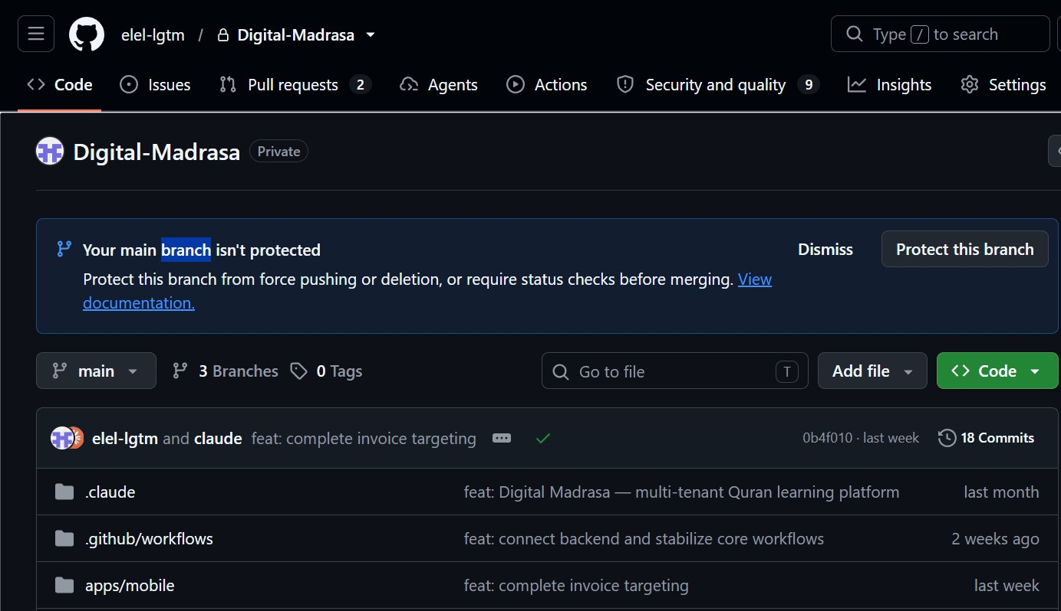
Figure A.1 Project repository on GitHub

APPENDIX 5: Plagiarism Report
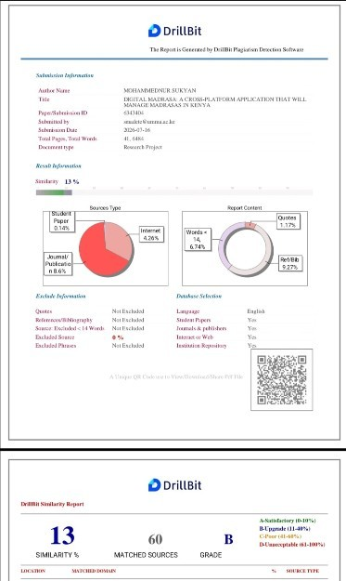
Figure A.2 Plagiarism report

REFERENCES
Aden, A. A. (2017). Integration of Islamic and secular education in Kenya: A synthesis of the literature. International Journal of Social Science and Humanities Research, 5(3), 67–75.
Al-Ayyoub, M., Damer, N. A., & Hmeidi, I. (2018). Using deep learning for automatically determining correct application of basic Quranic recitation rules. The International Arab Journal of Information Technology, 15(3A), 620–625.
Al-Fraihat, D., Joy, M., Masa'deh, R., & Sinclair, J. (2020). Evaluating e-learning systems success: An empirical study. Computers in Human Behavior, 102, 67–86.
Alif Cloud. (n.d.-a). Islamic school software features: Madrasah and dugsi management. Retrieved October 12, 2026, from https://www.alifcloud.com/product
Alif Cloud. (n.d.-b). About Alif Cloud. Retrieved October 12, 2026, from https://www.alifcloud.com/about
Alkhalil, A., Sahandi, R., & John, D. (2017). An exploration of the determinants for decision to migrate existing resources to cloud computing using an integrated TOE-DOI model. Journal of Cloud Computing, 6(1). https://doi.org/10.1186/s13677-016-0072-x
Al-Kharusi, M. H., Hayat, K., Al Ruqeishi, K. B., & Lone, H. R. (2025). A critical review of the need for knowledge-centric evaluation of Quranic recitation (arXiv:2510.12858). arXiv. https://arxiv.org/abs/2510.12858
Alsharhan, E., & Ramsay, A. (2020). Investigating the effects of gender, dialect, and training size on the performance of Arabic speech recognition. Language Resources and Evaluation, 54, 975–998.
Beck, K., Beedle, M., van Bennekum, A., Cockburn, A., Cunningham, W., Fowler, M., Grenning, J., Highsmith, J., Hunt, A., Jeffries, R., Kern, J., Marick, B., Martin, R. C., Mellor, S., Schwaber, K., Sutherland, J., & Thomas, D. (2001). Manifesto for Agile software development. Agile Alliance. https://agilemanifesto.org/
Bezemer, C.-P., & Zaidman, A. (2010). Multi-tenant SaaS applications: Maintenance dream or nightmare? In Proceedings of the Joint ERCIM Workshop on Software Evolution (EVOL) and International Workshop on Principles of Software Evolution (IWPSE) (pp. 88–92). ACM. https://doi.org/10.1145/1862372.1862393
Biørn-Hansen, A., Grønli, T.-M., & Ghinea, G. (2018). A survey and taxonomy of core concepts and research challenges in cross-platform mobile development. ACM Computing Surveys, 51(5), Article 108. https://doi.org/10.1145/3241739
Booch, G., Rumbaugh, J., & Jacobson, I. (2005). The unified modeling language user guide (2nd ed.). Addison-Wesley.
Boyle, H. N. (2004). Quranic schools: Agents of preservation and change. RoutledgeFalmer.
Braun, V., & Clarke, V. (2006). Using thematic analysis in psychology. Qualitative Research in Psychology, 3(2), 77–101. https://doi.org/10.1191/1478088706qp063oa
Brooke, J. (1996). SUS: A "quick and dirty" usability scale. In P. W. Jordan, B. Thomas, B. A. Weerdmeester, & I. L. McClelland (Eds.), Usability evaluation in industry (pp. 189–194). Taylor & Francis.
Chen, P. P.-S. (1976). The entity-relationship model: Toward a unified view of data. ACM Transactions on Database Systems, 1(1), 9–36. https://doi.org/10.1145/320434.320440
Coates, H., James, R., & Baldwin, G. (2005). A critical examination of the effects of learning management systems on university teaching and learning. Tertiary Education and Management, 11(1), 19–36.
Communications Authority of Kenya. (2023). Sector statistics report Q4 2022/2023. Communications Authority of Kenya.
Creswell, J. W., & Plano Clark, V. L. (2018). Designing and conducting mixed methods research (3rd ed.). SAGE.
Dougiamas, M., & Taylor, P. C. (2003). Moodle: Using learning communities to create an open source course management system. In Proceedings of EdMedia: World Conference on Educational Media and Technology 2003 (pp. 171–178). AACE.
Elmasri, R., & Navathe, S. B. (2016). Fundamentals of database systems (7th ed.). Pearson.
Emerson, L., Fear, J., Fox, S., & Sanders, E. (2012). Parental engagement in learning and schooling: Lessons from research. Australian Research Alliance for Children and Youth for the Family–School and Community Partnerships Bureau.
Epstein, J. L. (2018). School, family, and community partnerships: Preparing educators and improving schools (2nd ed.). Routledge.
Etikan, I., Musa, S. A., & Alkassim, R. S. (2016). Comparison of convenience sampling and purposive sampling. American Journal of Theoretical and Applied Statistics, 5(1), 1–4. https://doi.org/10.11648/j.ajtas.20160501.11
Expo. (2026). Expo documentation. https://docs.expo.dev
Fan, X., & Chen, M. (2001). Parental involvement and students' academic achievement: A meta-analysis. Educational Psychology Review, 13(1), 1–22. https://doi.org/10.1023/A:1009048817385
Fowler, M. (2004). UML distilled: A brief guide to the standard object modeling language (3rd ed.). Addison-Wesley.
Garrett, J. J. (2011). The elements of user experience: User-centered design for the web and beyond (2nd ed.). New Riders.
Google. (n.d.). Google Classroom. Retrieved October 12, 2026, from https://edu.google.com/workspace-for-education/classroom/
Holmes, W., Bialik, M., & Fadel, C. (2019). Artificial intelligence in education: Promises and implications for teaching and learning. Center for Curriculum Redesign.
International Organization for Standardization. (2011). ISO/IEC 25010:2011 Systems and software engineering — Systems and software Quality Requirements and Evaluation (SQuaRE) — System and software quality models. ISO.
Kihaki, M. (2026, June 1). Madrassa and Duksi to be integrated into the education system. The Standard.
Kornell, N. (2009). Optimising learning using flashcards: Spacing is more effective than cramming. Applied Cognitive Psychology, 23(9), 1297–1317. https://doi.org/10.1002/acp.1537
Masalha, F., & Hirzallah, N. (2014). A students attendance system using QR code. International Journal of Advanced Computer Science and Applications, 5(3), 75–79. https://doi.org/10.14569/IJACSA.2014.050310
Ministry of Education. (n.d.). NEMIS. Republic of Kenya. Retrieved September 26, 2026, from https://www.education.go.ke/nemis
Ministry of ICT and the Digital Economy. (2022). The Kenya national digital master plan 2022–2032. Government of Kenya.
Mwaura, P. A. M., Sylva, K., & Malmberg, L.-E. (2008). Evaluating the Madrasa preschool programme in East Africa: A quasi-experimental study. International Journal of Early Years Education, 16(3), 237–255. https://doi.org/10.1080/09669760802357121
Ndzovu, H. (2023). The madrassa system and the Islamic-integrated schools: Competing spaces for learning and the ambivalent relations with secular education in Kenya. Journal for Islamic Studies, 41(1). https://doi.org/10.25159/2957-9163/15080
Neri, A., Cucchiarini, C., & Strik, H. (2008). The effectiveness of computer-based speech corrective feedback for improving segmental quality in L2 Dutch. ReCALL, 20(2), 225–243.
Object Management Group. (2017). OMG Unified Modeling Language (OMG UML), version 2.5.1. https://www.omg.org/spec/UML/2.5.1
Origin Softwares. (n.d.). Origin E Madarsa: Islamic educational management system — product demo. Retrieved October 12, 2026, from https://www.originemadarsa.com/demo.html
PostgreSQL Global Development Group. (n.d.). Row security policies. In PostgreSQL 17 documentation. Retrieved September 26, 2026, from https://www.postgresql.org/docs/17/ddl-rowsecurity.html
Quran.com. (n.d.). Quran.com [Website]. Retrieved September 26, 2026, from https://quran.com
QuranPortal. (n.d.). Free Quran school management for maktabs and hifdh programs. Retrieved October 12, 2026, from https://quranportal.io/
React Native. (2026). React Native documentation. https://reactnative.dev/docs
Republic of Kenya. (2019). The Data Protection Act, No. 24 of 2019. Government Printer.
Safaricom. (2026). Daraja API documentation: M-Pesa Express (STK push). https://developer.safaricom.co.ke
Sandhu, R., Ferraiolo, D., & Kuhn, R. (2000). The NIST model for role-based access control: Towards a unified standard. In Proceedings of the Fifth ACM Workshop on Role-Based Access Control (pp. 47–63). ACM. https://doi.org/10.1145/344287.344301
Saunders, M., Lewis, P., & Thornhill, A. (2019). Research methods for business students (8th ed.). Pearson.
Schwaber, K., & Sutherland, J. (2020). The Scrum guide. Scrum.org. https://scrumguides.org/
Sommerville, I. (2016). Software engineering (10th ed.). Pearson.
Sudoor HMS. (2026). Sudoor HMS — Hifz management system for madrasas. Retrieved October 12, 2026, from https://www.sudoor.org/blog/best-madrasa-management-software-2026
Supabase. (2026). Supabase documentation. https://supabase.com/docs
Tarteel AI. (n.d.). Tarteel: AI Quran memorization [Mobile application]. Google Play. Retrieved September 26, 2026, from https://play.google.com/store/apps/details?id=com.mmmoussa.iqra
Tongola, M. (2025, May 15). New education data system to replace NEMIS unveiled. The Standard. https://standardmedia.co.ke/article/2001519176/new-education-data-system-to-replace-nemis-unveiled
VanLehn, K. (2011). The relative effectiveness of human tutoring, intelligent tutoring systems, and other tutoring systems. Educational Psychologist, 46(4), 197–221. https://doi.org/10.1080/00461520.2011.611369
Zeraki. (n.d.). Zeraki: School management made easy. Retrieved October 12, 2026, from https://zeraki.app/

