This is a small guide that describes how to compile and sign your theme in Eclipse.

1. Create a sign key, there are several ways to do it, a good start is to read this documentation >>>>>>
http://developer.android.com/tools/publishing/app-signing.html

but I think most people solve this part perfectly and I will not go into more detail on that part.

2. Let's start then, there are probably 100's of guides on how to setup Eclipse and I will not go into more detail on that part either.

Some preparation, you need of course a Theme and it can be found here as a template >>> https://github.com/elelinux/GreatFreedom download the template and extract and place it in some folder where you found it later, when this is done start Eclipse, when Eclipse have load finished it looks like this.

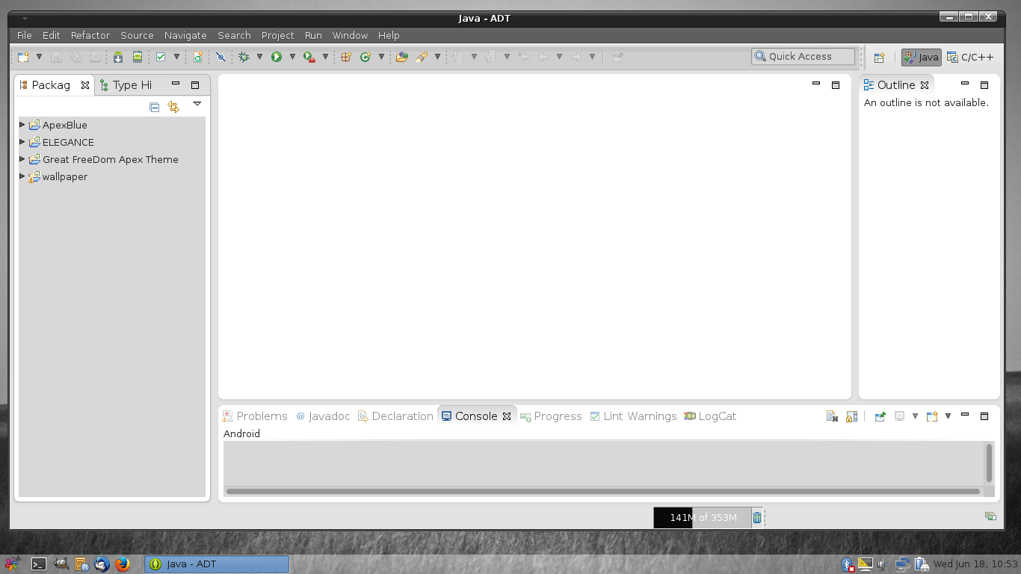

Now we start a new project and it's easily done by pressing the file >> project

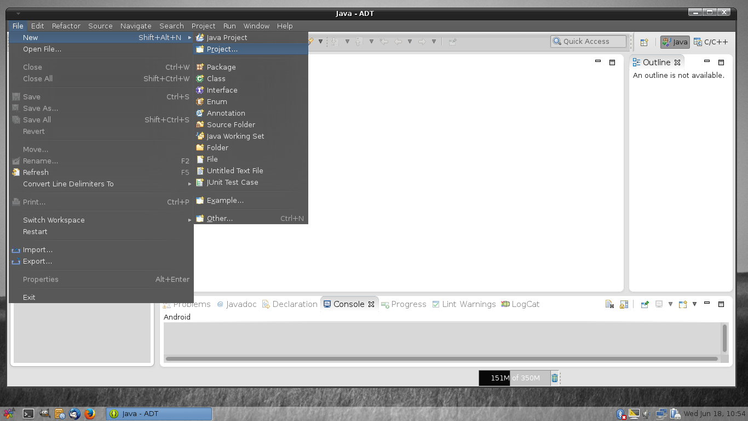

Then choose Android Project from Existing Code and press next

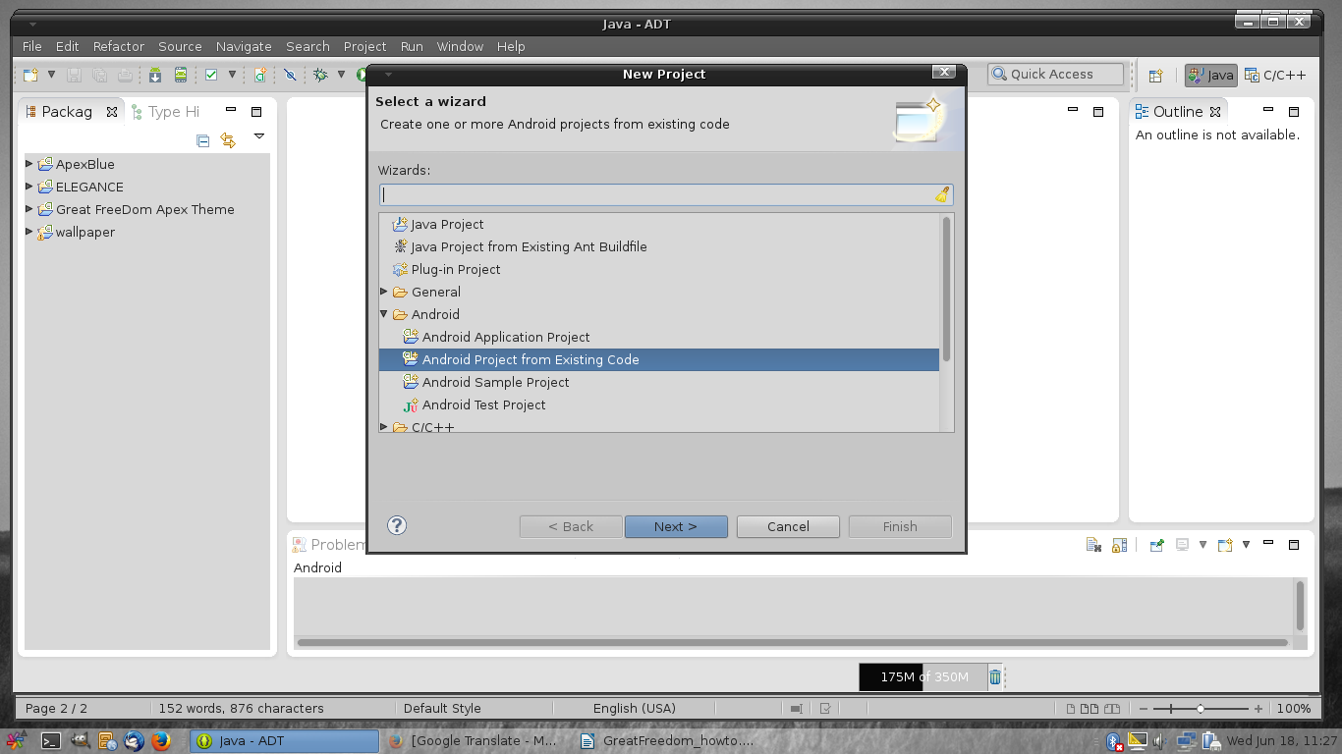

Browse to that folder where you placed the Great Freedom file that you unzipped and press Ok

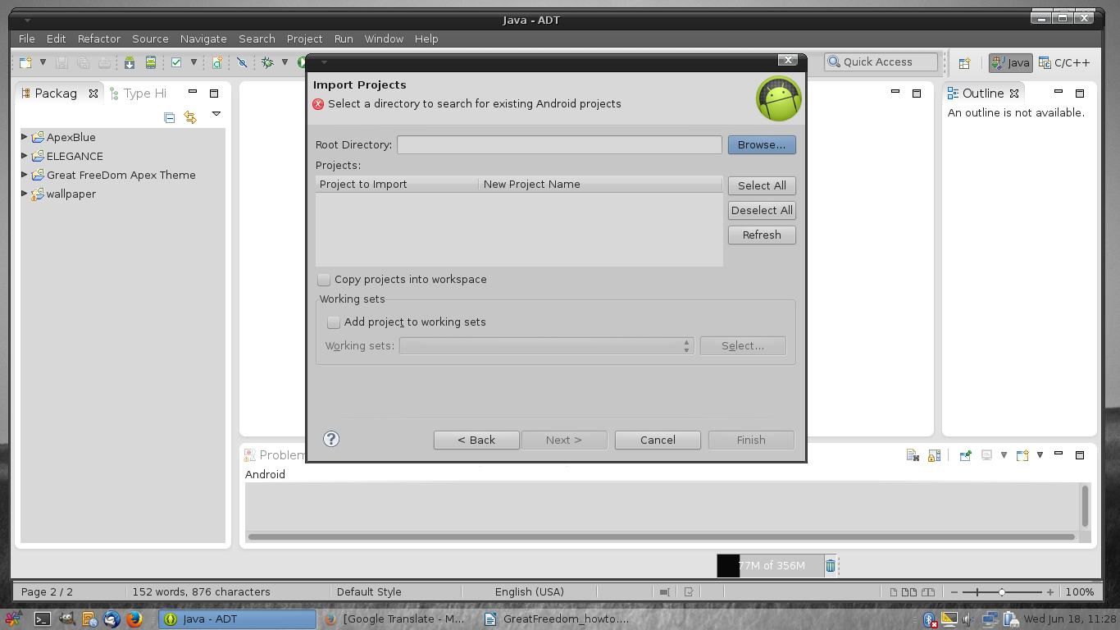
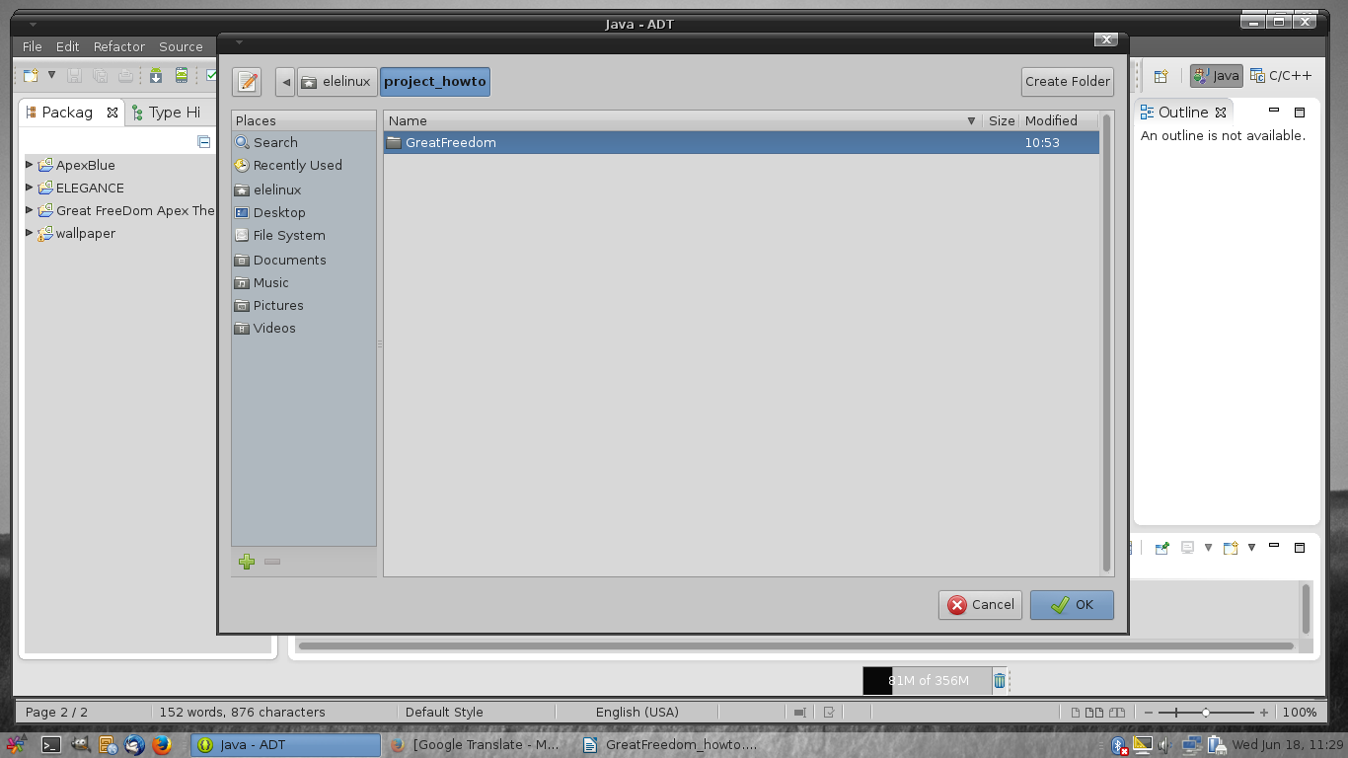
and press Finish

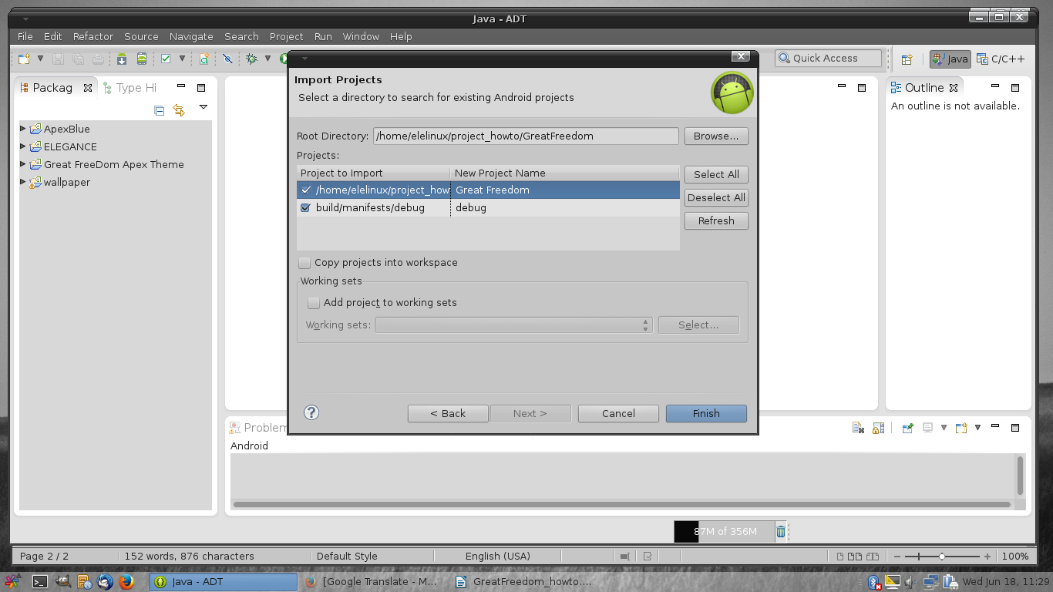

Here's how it looks when it's finished, you see the theme and now you can start playing with it editing etc..

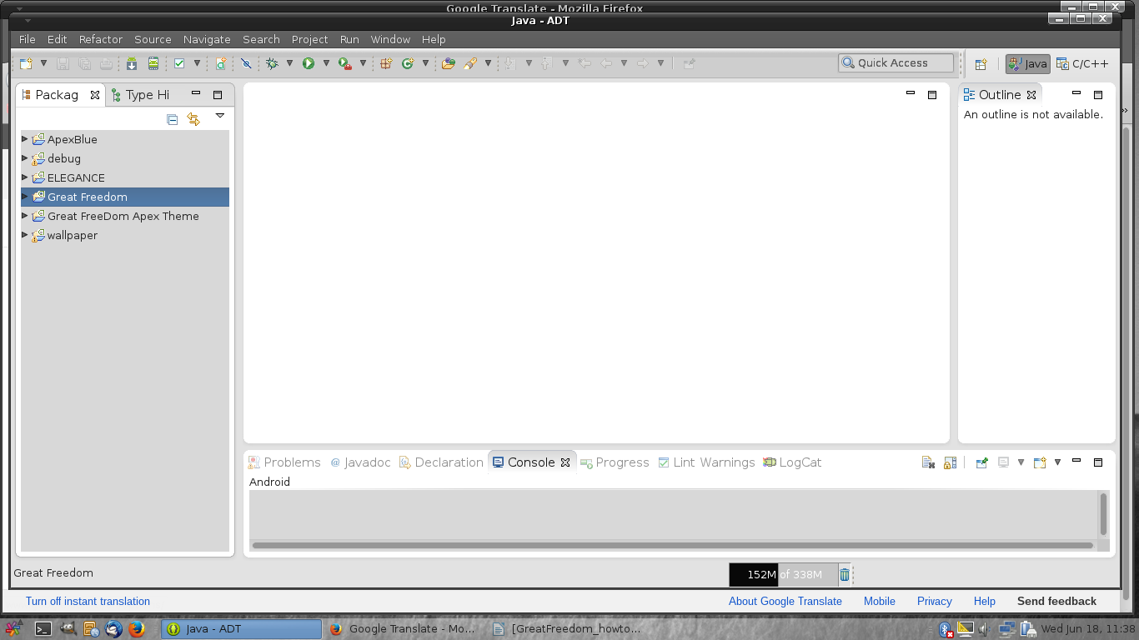

I personally seldom editing in Eclipse, I do it directly in the folder where I placed the theme.

The tools I use is

* Gimp for images
* Gedit, pluma or simular tools in linux, for Windows I prefer notepad++ , to edit in xml files
* To create 9.png images I use draw9patch it is a tool that is available in android-sdk

Notes on the Great Freedom is a template and may not be used for commercial use only private purpose.

Now we play that we have made some changes and it's time to compile the theme, it becomes a slideshow I'm too lazy to write a lot :)

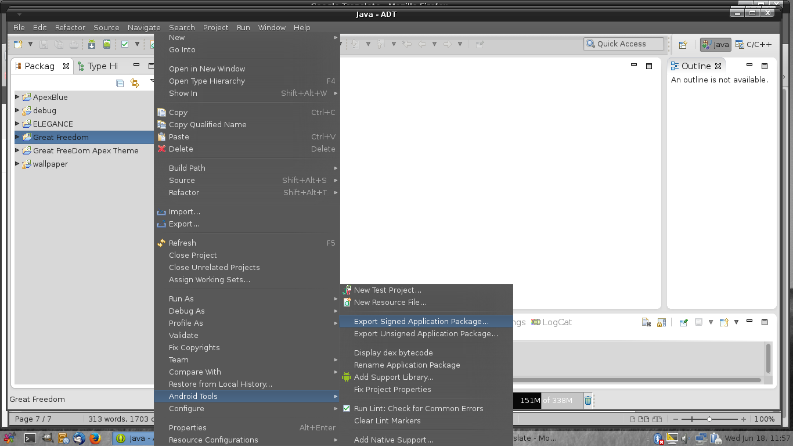

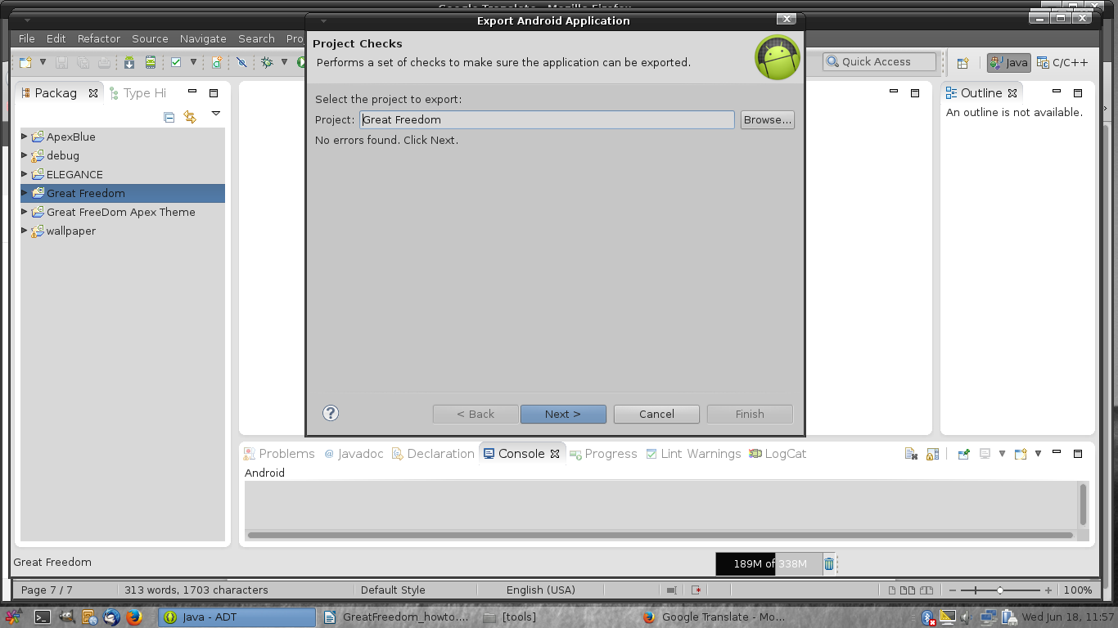
note: browse for your signing key in the first tab

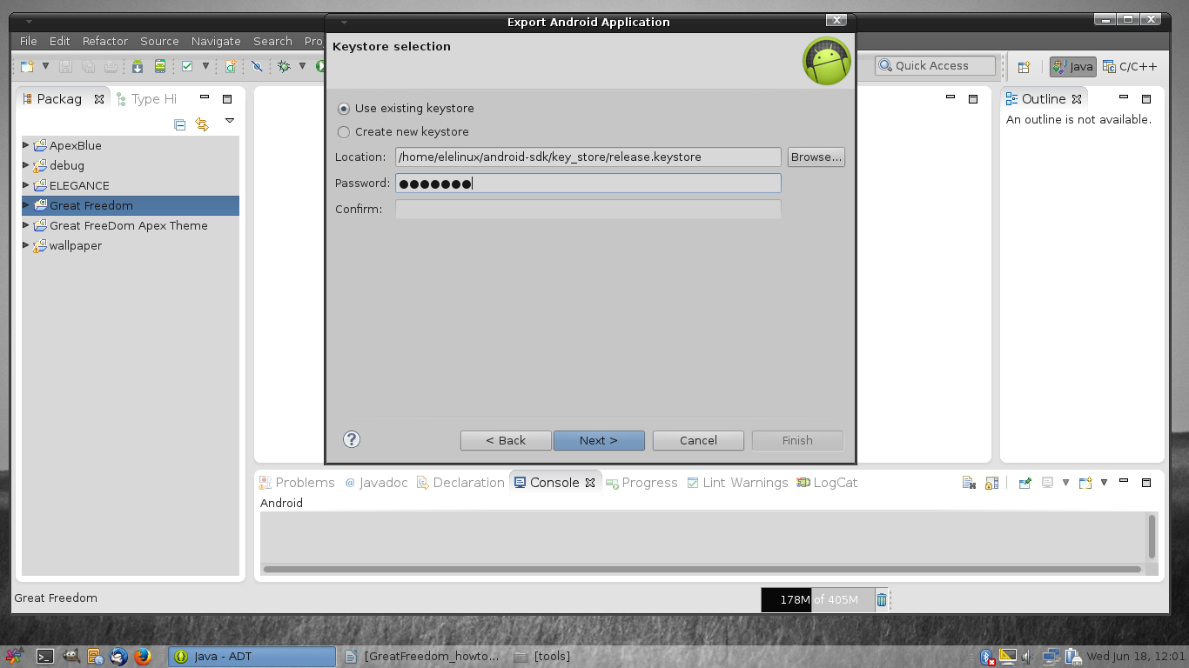
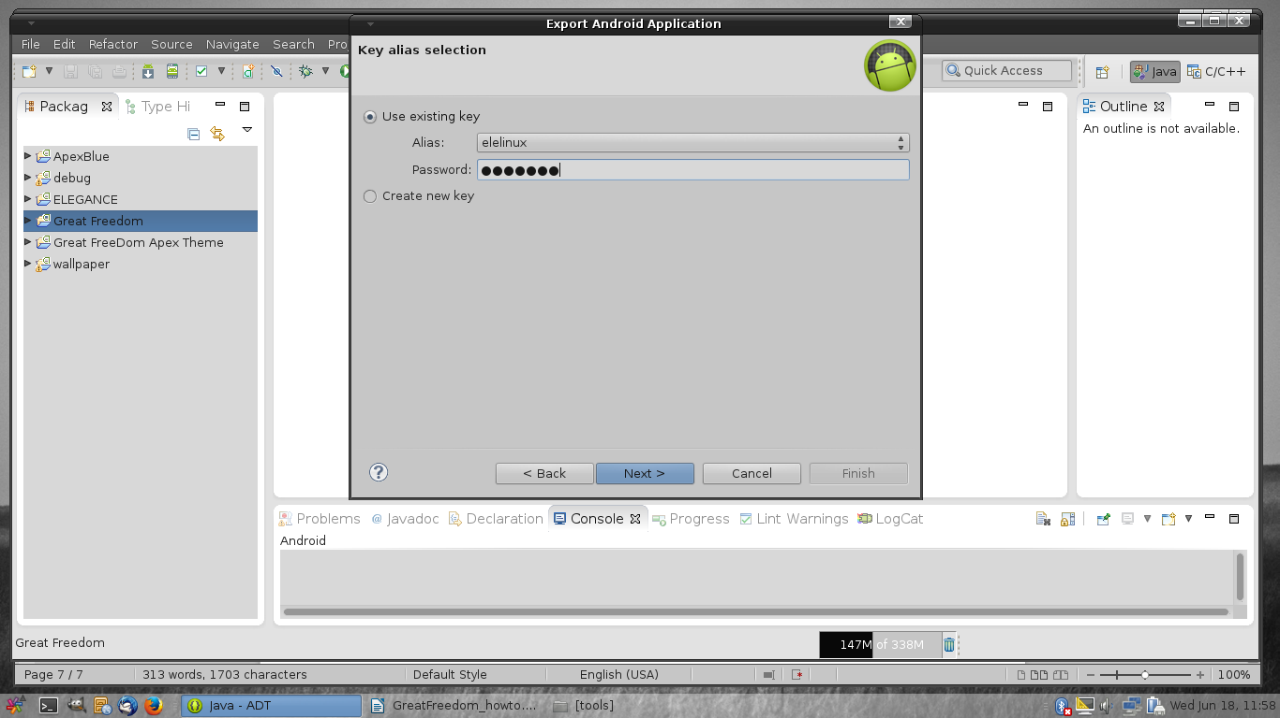

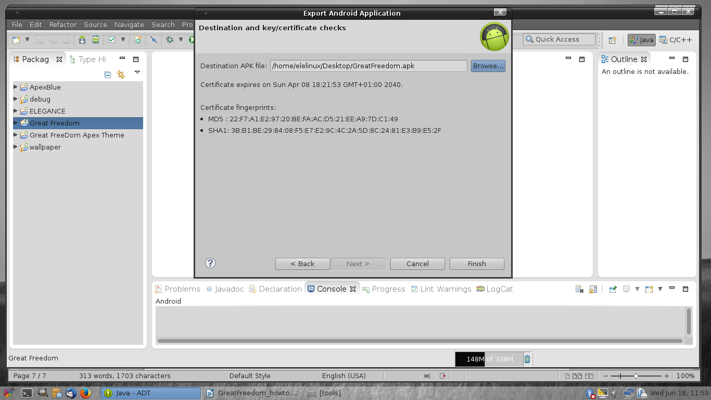

Voila, now it is ready and can be tested :)

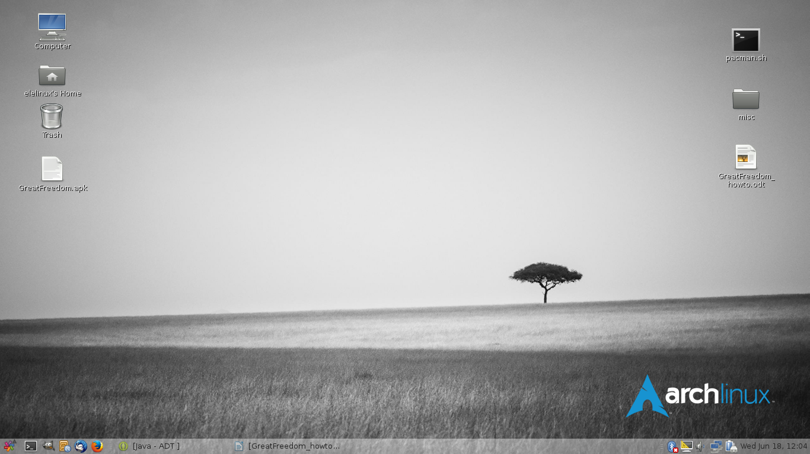

As I wrote in the beginning that this is only a small guide and hopefully a little help for beginners, if you have questions start by googling and if you can not find what you were looking for, I reply to emails when I have time

Good Luck!

Regards Esa Laukkanen <ele.linux@gmail.com>

