REST Url's

URI | HTTP  Method | Data | Operation | Description
/users/register | POST | user | create | Create a new user
/users | GET | user | retrieve | Get all users
/users/{useremail} | GET | user | retrieve | Get information about user {useremail}
/users | POST | user | update | Update a users details
/users/connect/{useremail1}/with/{useremail2} | POST | user | create | Connect {useremail1} with {useremail2}
/alerts/send | POST | alert | create | Send an alert
/alerts/respond | POST |  | create | Send a response to an alert
/alerts/to/{useremail} | GET | alert | retrieve | get all alerts sent to user {useremail}
/alerts/from/{useremail} | GET | alert | retrieve | get all alerts sent from user {useremail}
/sensors/reading | POST | sensor_reading | create | create a new sensor reading

Data store:

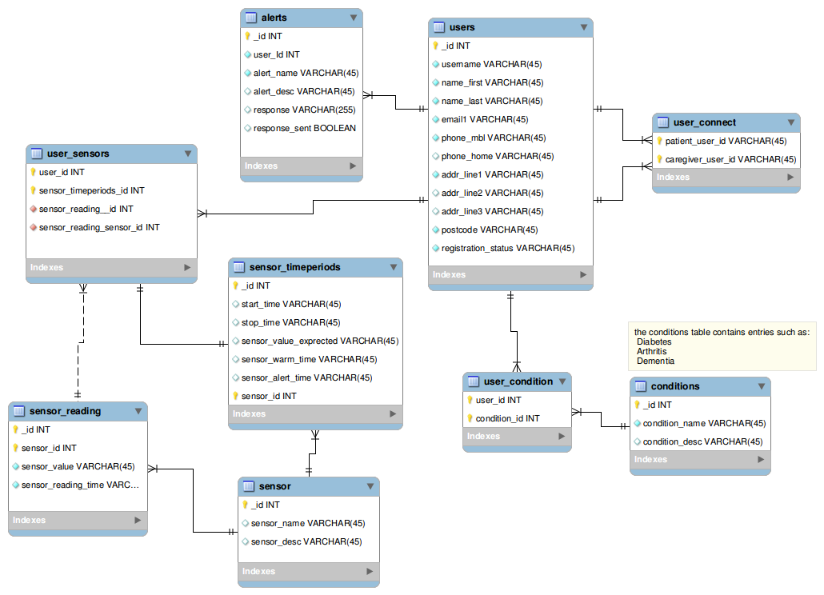
Smartphone App:

On initial startup the app will display a welcome screen that will allow the user to enter their details and submit them to the server.

Class File : Welcome1Fragment.java
layout : activity_welcome_1.xml

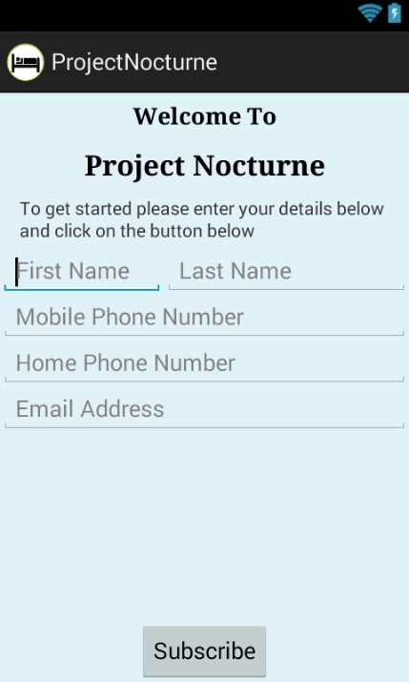
When the user has entered their details and pressed the Subscribe button the app will send a subscribe message to the server and then the following screen will be displayed

Class File : Welcome2Fragment.java
layout : activity_welcome_2.xml

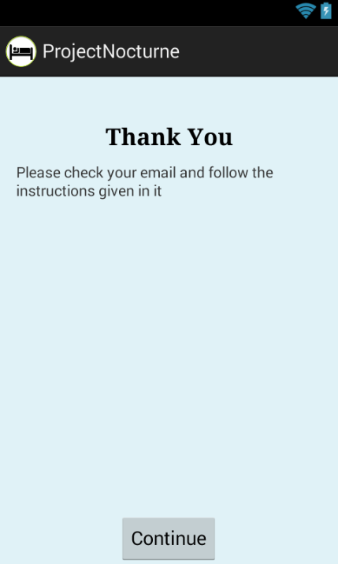

The user will now need to check the email address that they entered, and click on the link enclosed in that email to verify that it was entered correctly.

Once a user registration has been accepted (possibly by a server web page) a notification is sent to all other users that a new user has registered?

On subsequent invocations the app will display a status screen :

Class File : Status1Fragment.java
layout : activity_status_1.xml

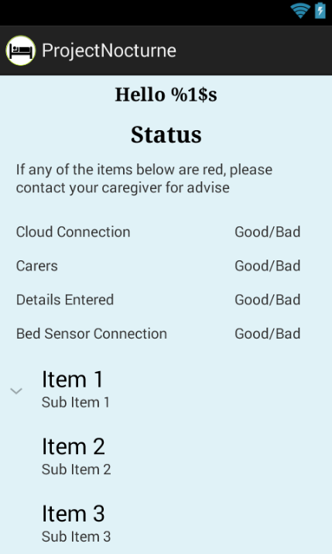
This will show the user whether the app has a connection to the server located on the internet, whether they (as a patient) have connected with carer(s), and whether their details have been entered and verified correctly.

During normal operation the smartphone app will be polling the sensors and comparing the values gathered with alert parameters.

Once an alert situation has been detected the following screen will be display for a configurable amount of minutes. This gives the user a chance to stop the alert from being sent, or to send the alert immediately:

Class File : AlertDetectedFragment.java
layout : activity_alert_detected.xml

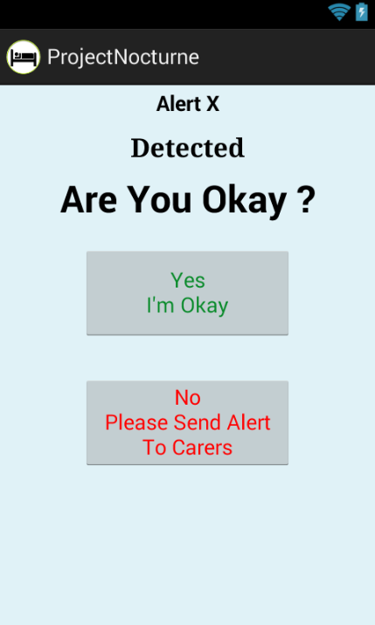
If the user presses the “I'm Okay” button then the smartphone will record that the user is okay, and go back into a 'polling sensors' mode.

If the user presses the “Send Alert” button then the smartphone will send an alert to the server.

The server will take the alert and send out alerts to all relevant carers.

The carers will then be shown a screen that will allow them to respond to the alert

Class File : AlertCarerFragment.java
layout : activity_alert_carer.xml

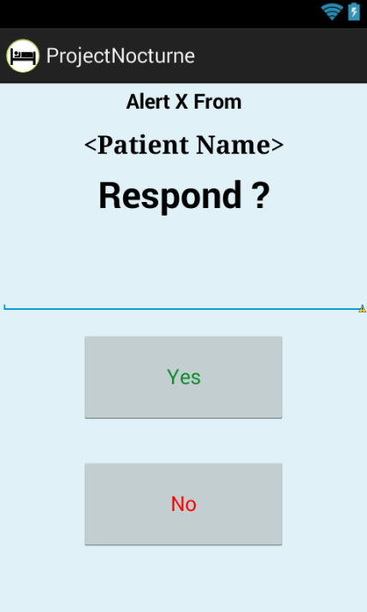

To decide which carers to alert for a given patient the users must 'connect' with other users:

Class File : ConnectFragment.java
layout : activity_connect.xml

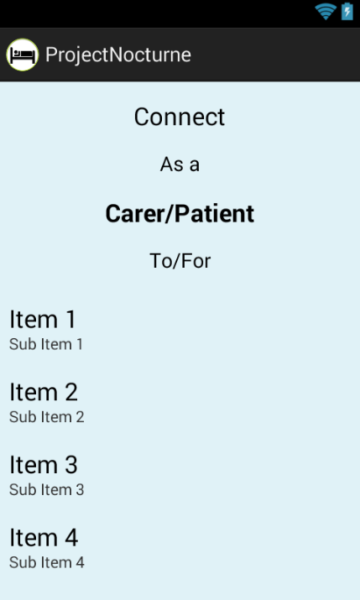
where each Item (Item1, Item2, etc...) would be a user in the system.

The user has to select the connection relationship (will they be the carer or patient in this relationship) and the user they want to connect to.

The 'other' user will then receive a connection requested notification

Class File : ConnectionRequestFragment.java
layout : activity_connection_request.xml

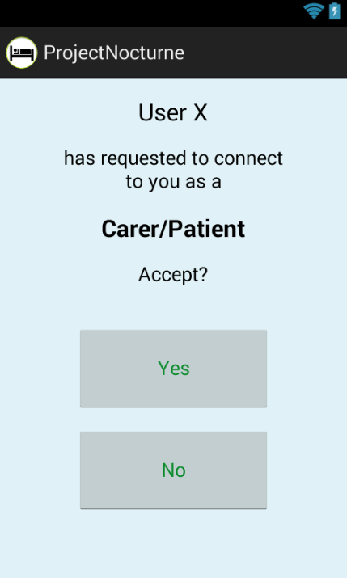

Android App Startup Sequence:

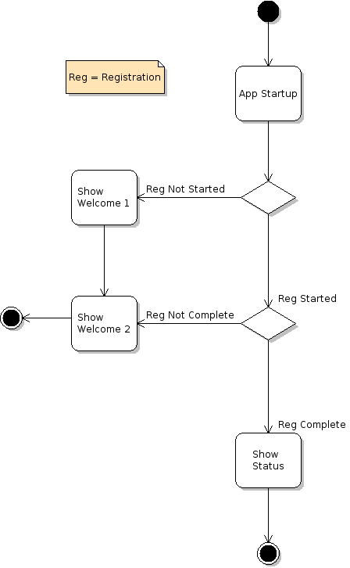

Poll Sensor Activity:

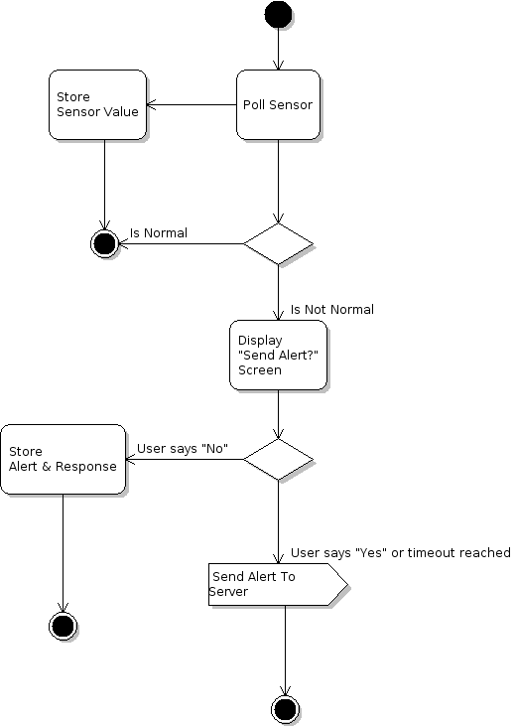

Object Interaction

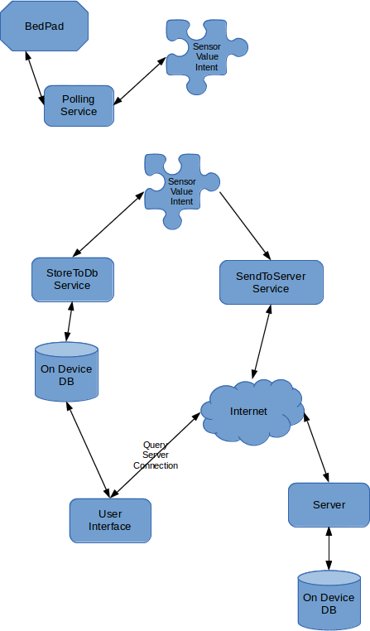

Sequence Diagrams:

User Registration:

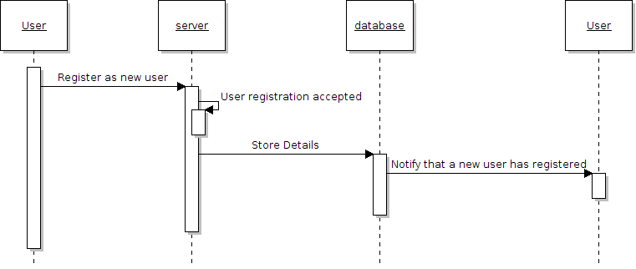

User connect:

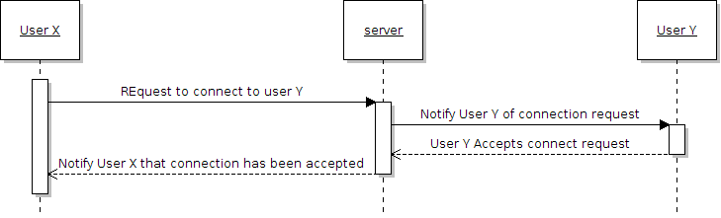

Send Alert:

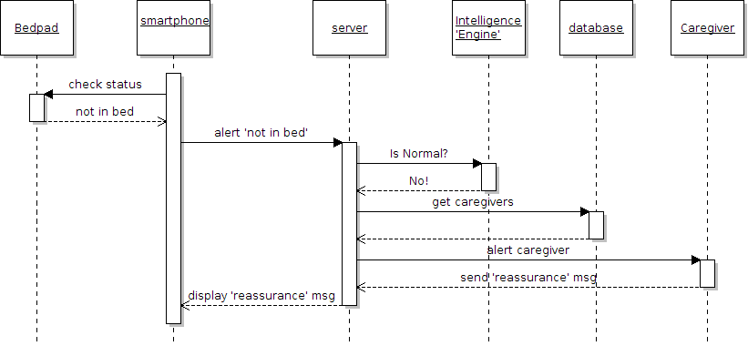
and/or:

