Computational Methods Chapter 3
Solving Non-linear Equations (finding roots)

Bracketed Methods
Bisection
Note the following shows the first two iterations.
- On an interval of [a,b] that is known to bracket the root, find ,
- Is x_{NS1} to the left or to the right of the root:
  - f(a)*f( x_{NS1}) < 0?
    - True: Root is between a and x_{NS1}.
    - False: Root is between x_{NS1} and b.
- Replace a or b (depending on result of above) to establish a new bracket for root.
- Find
- Find relative fractional error:

- Repeat this process until Note the stopping criterion is established by the needs for the solution to meet some specified precision.
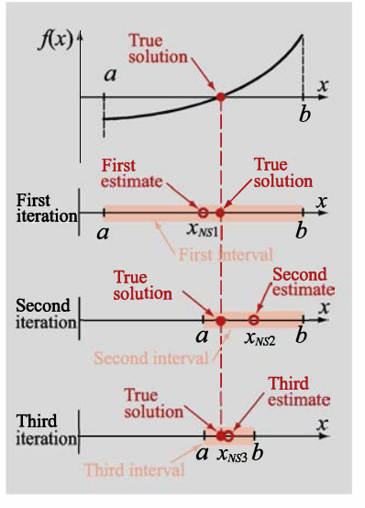

False Position
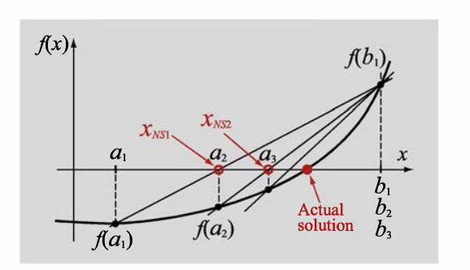
Note the following shows the first two iterations.
- See above… Connect (a,f(a)) to (b,f(b)) with a line.
- Solve for where this line crosses the x-axis:

- Is x_{NS1} to the left or to the right of the root:
  - f(a)*f( x_{NS1}) < 0?
    - True: Root is between a and x_{NS1}.
    - False: Root is between x_{NS1} and b.
- Replace a or b (depending on result of above) to establish a new bracket for root.
- Find
- Find relative fractional error:

- Repeat this process until Note the stopping criterion is established by the needs for the solution to meet some specified precision.

Sometimes the function is concave up or down… then a or b ends up staying the same throughout the iterations. There are some ways to force the iterations to approach from both sides.

Open Methods
Newton's Method (Newton-Raphson)

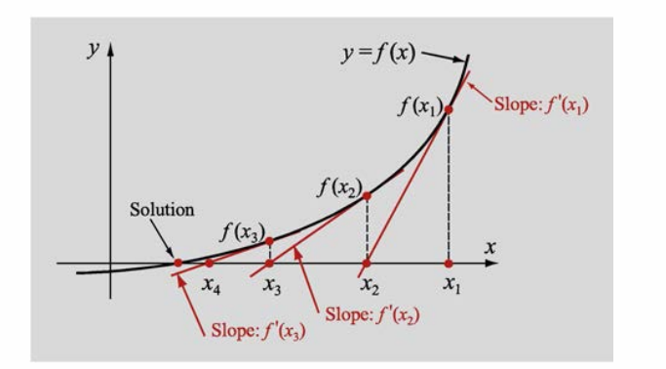

- See above… Choose a point x₁ as first estimate
- Extend a tangent from the function at f(x₁) – the location where this crosses the x-axis will be x₂

- Find relative fractional error:

- Repeat this process until Note the stopping criterion is established by the needs for the solution to meet some specified precision.

ISSUES
MAY NOT CONVERGE
HAVE TO KNOW f'(x)

Secant Method
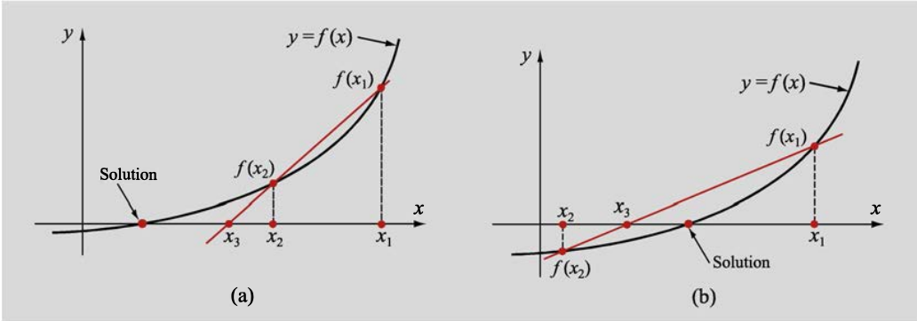

Uses two points to get secant of function… extends the secant to the x-axis to estimate the root.
- See above… Choose two points x₁ and x₂
- Extend a line that joins f(x₁) and f(x₂) – a secant
- Find x₃
- Note we will always use the previous two x-values to calculate the newest estimate of x (x_{i+1}).
- Find relative fractional error:

- Repeat this process until Note the stopping criterion is established by the needs for the solution to meet some specified precision.
NOTES:
Do not need to be able to find f'(x) to use secant method.
In Secant method -you are replacing f'(x) from Newton's method with which is an estimate of the derivative.

Fixed Point Iteration

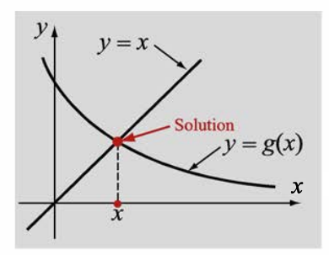
Rewrite f(x) = 0 as x = g(x)…

would be rewritten as
So here,

In the image on left note that the solution to x = g(x) is found at the intersection of the line y = x and g(x).

Quick convergence, but not guaranteed to converge.
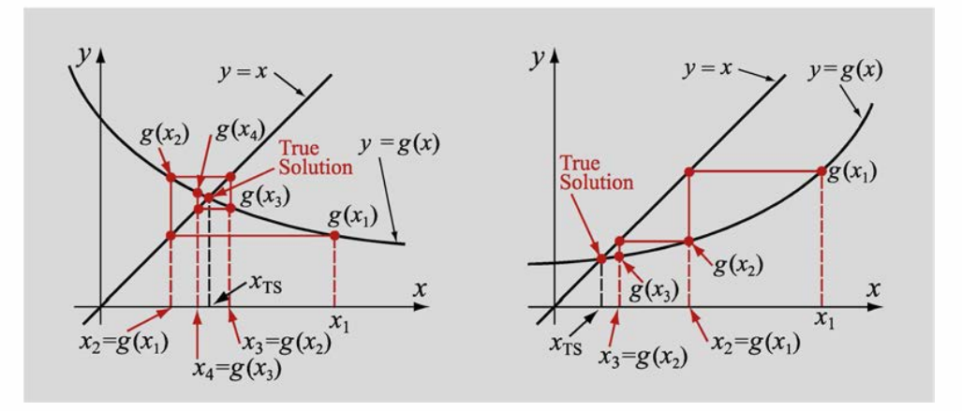
Note may need to consider the following:

This is the condition for convergence for fixed point iteration.

Example: Has a solution between x = 1 and 2. Try writing g(x) three different ways:

- Which gives: and
  - Now test g'(x) at 1 and 2:
    - IT WILL NEVER CONVERGE!
- Now try Which gives:
  - Now test g'(x) at 1 and 2:
    - CONVERGES!
- Which gives:
  - Now test g'(x) at 1 and 2:
    - SPLIT DECISION!

Note this example would only be the start of the process for fixed point iteration… once you determine that a point is a good starting point, then you have to create an algorithm that follows the figure above.

