Prostate_P1_H2_5 Visium
Histological annotation
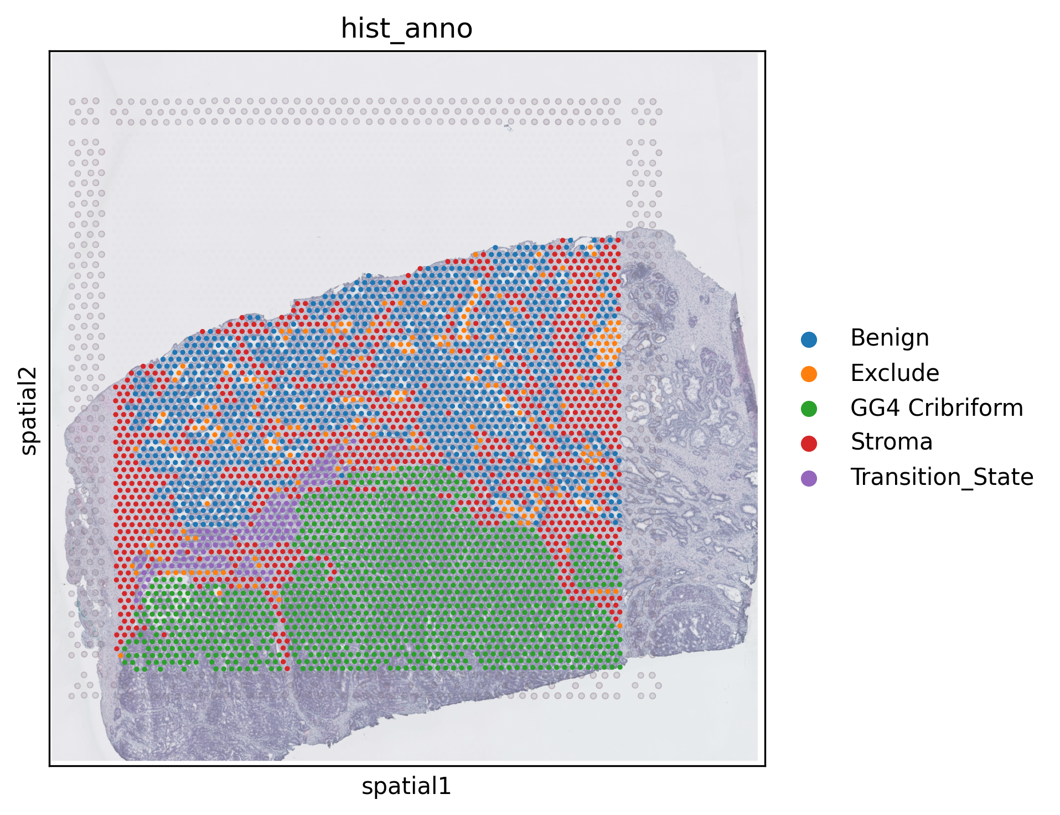
InferCNV by Rongting (past PhD student of Dr. Huang)
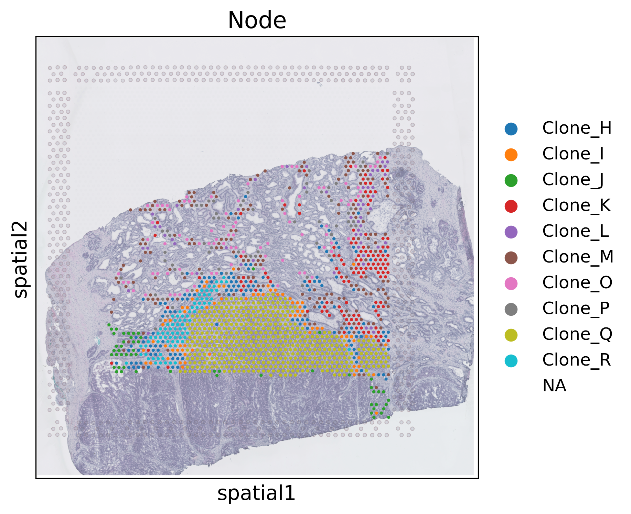

XClone by Rongting
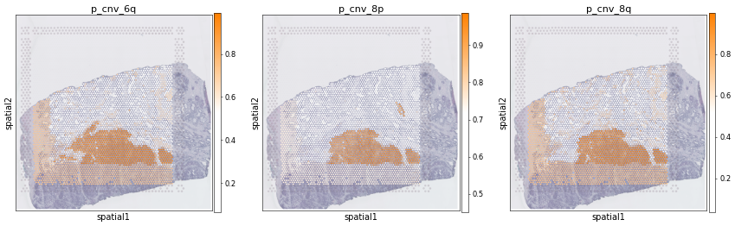
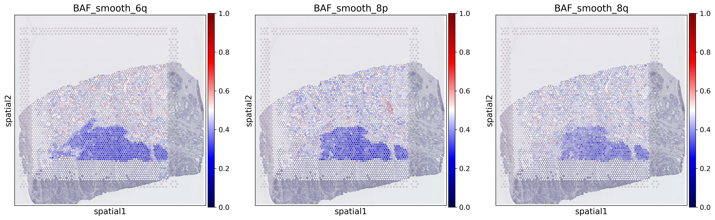
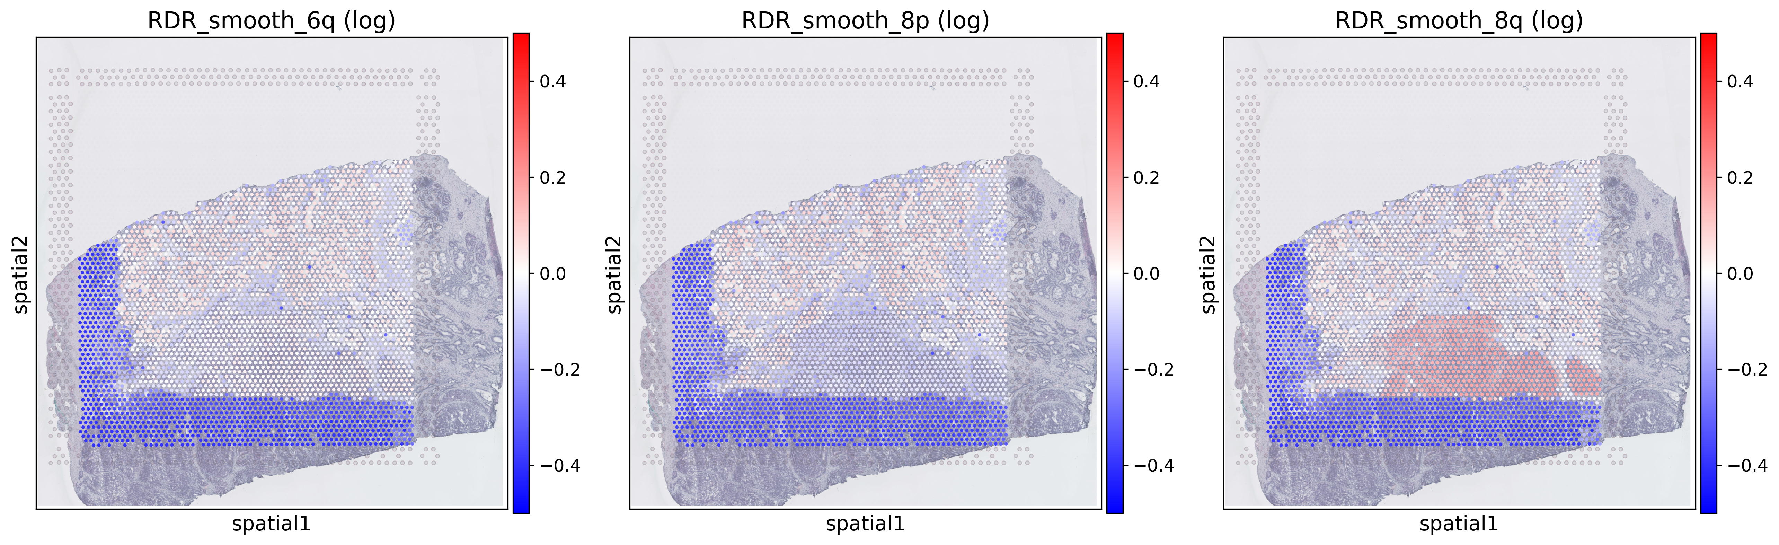

SNPmanifold on high-DP SNVs called by GATK Mutect2
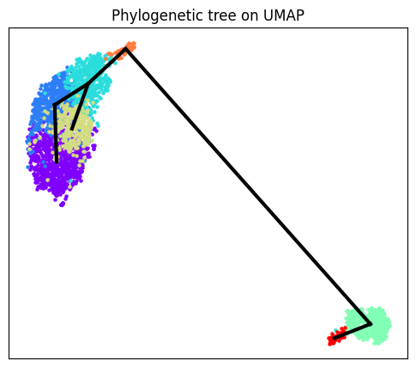SNPmanifold UMAP
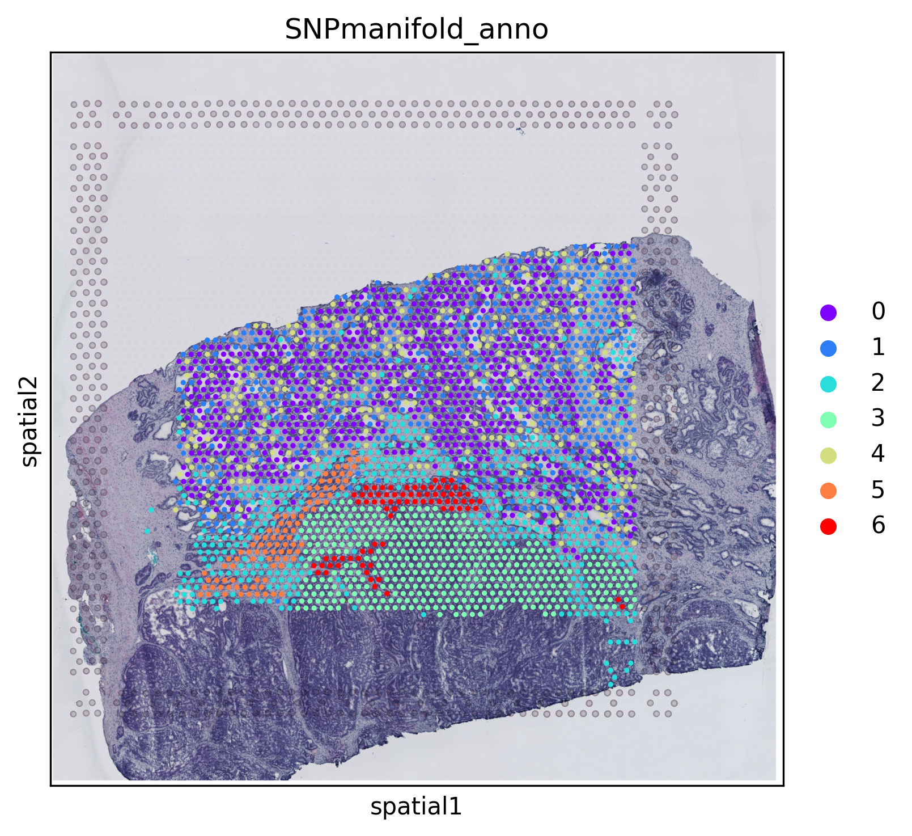
Good agreement with histological annotation and CNV (also phylogeny). There is one additional SNV cluster 6 not detected by CNV.
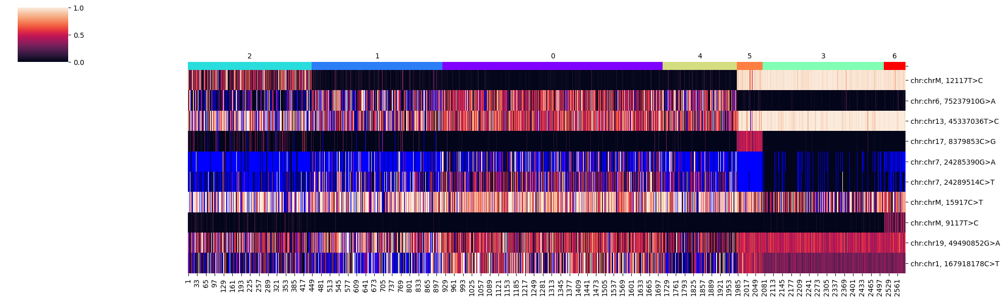
Tumor SNV clusters 3, 5, 6 all possess chrM:12117T>C (maybe second and third SNVs also?). Cluster 5 possess chr17:8379853C>G. Cluster 6 possess ChrM:9117T>C.

