Assignment : Web Development
csy1018n
Submission Date:15.01.2017

ELENA IULIANA COJANU
ID:16441605
Github link : https://elena1iuliana1cojanu.github.io/csy1018-assign1/

CONTENTS:

Home page

Logo (as icon)

Full name

Photo

Menu bar

Link to CV page

Link to Bio page

Link to Contact page

# this project is made for Assignment 1: Web Development
# it uses html, html5, css and css3
# uses roboto font from google fonts api and includes normal and bold versions
# free license image is from www.freeimages.com
# favicon in generated at this url: http://www.antifavicon.com/
# images are compressed at www.tinypng.com
# the pictures on the Home page have box-shadow: 3px 3px 5px rgba(0, 0, 0, 0.5); inspired of https://material.io/guidelines/
# scroll menu with color changed when is touched (w3schools.com)
#as Icon I used a free licence image which is going to the home page (the sun/logo)

System Navigation Diagram
HOME
CV
BIO
CONTACT

I was working on this project in Atom from begin taking as a first example https://joel.sh/cv ..after I started to work in Sublime Text and push some work in GitHub when I had almost all the assignment .
I was adding the pages Bio Contact Cv and Index .
I was starting looking for models and I set up the ideas and I started to work .
The css was created first for the home page, after I finished with the home page I was just going and copy paste the header and footer and add images and another features specific to the pages .
Alt tags are present for all images. Structural layout includes header, footer, and nav. There are no frameworks or JavaScript files added. The code is very well commented in both the HTML and CSS. Structure and presentation are separate.
I used folders for :
o csy1018-assign1/ - All html files (.html)
o csy1018-assign1/images - All website image files (.gif .jpg)
o csy1018-assign1/css - All css files (.css)
o csy1018-assign1/README - Read me file

Used the https://validator.w3.org/nu/ for the pages :

HOMEPAGE

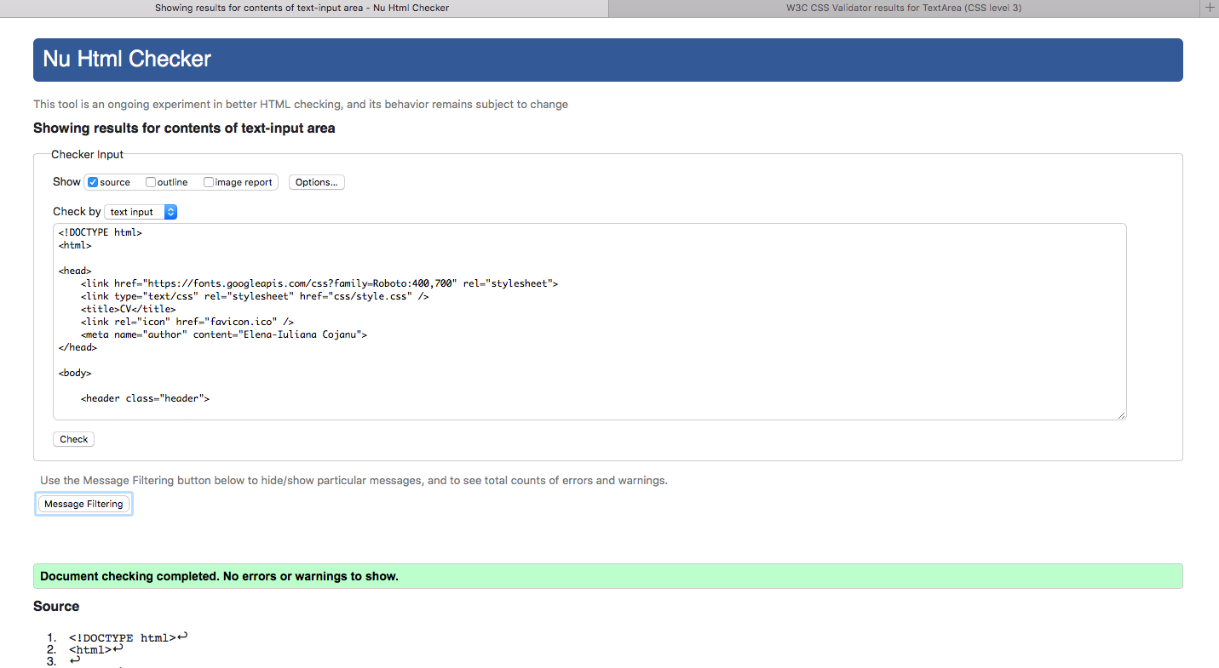

BIO PAGE

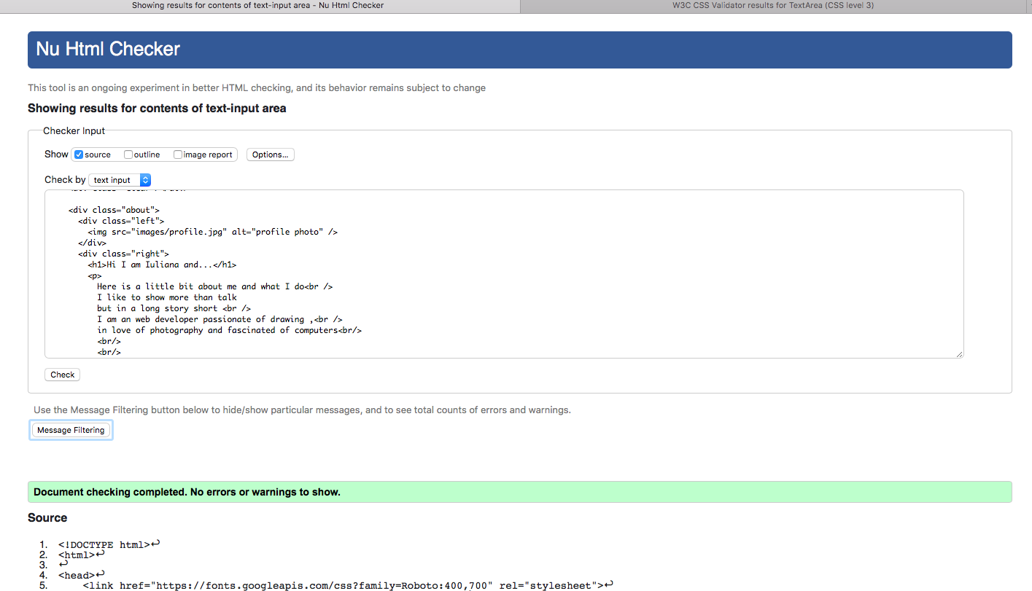

CV PAGE

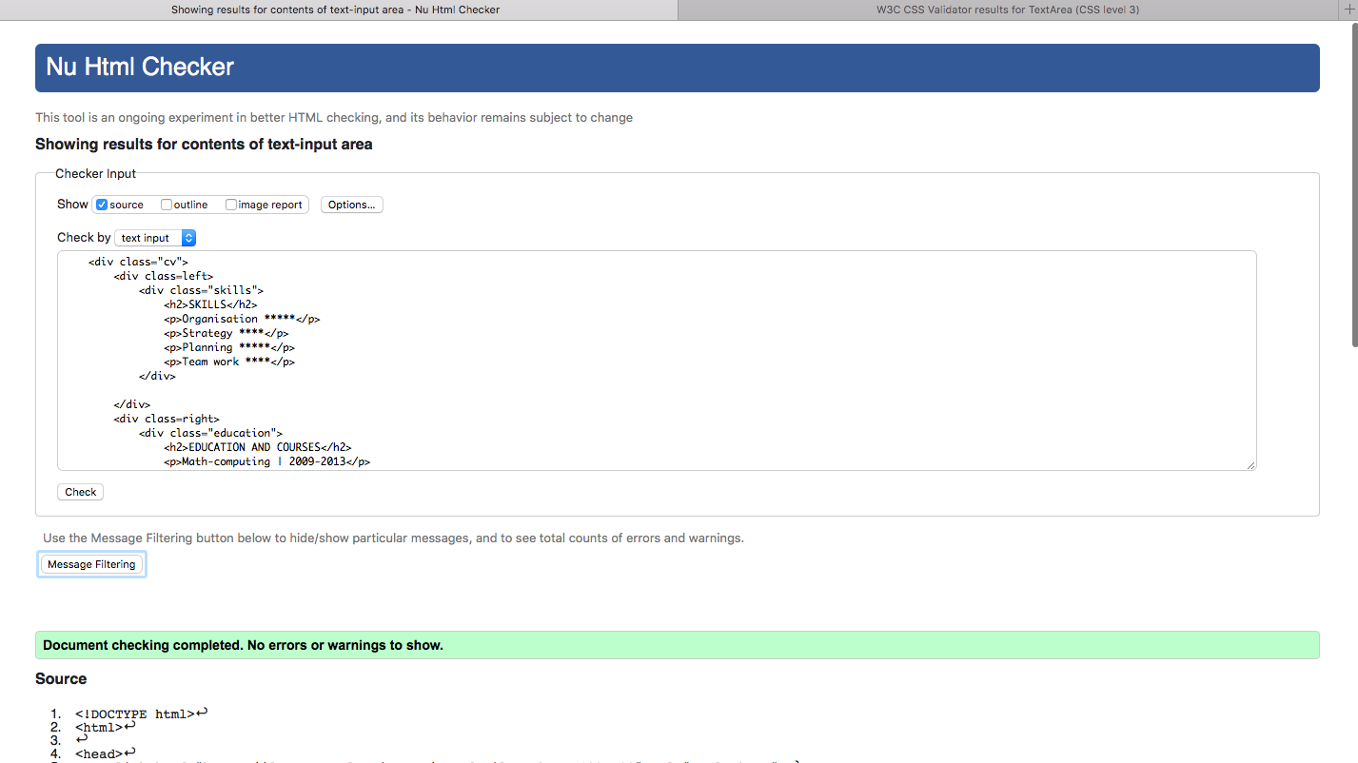

CONTACT PAGE
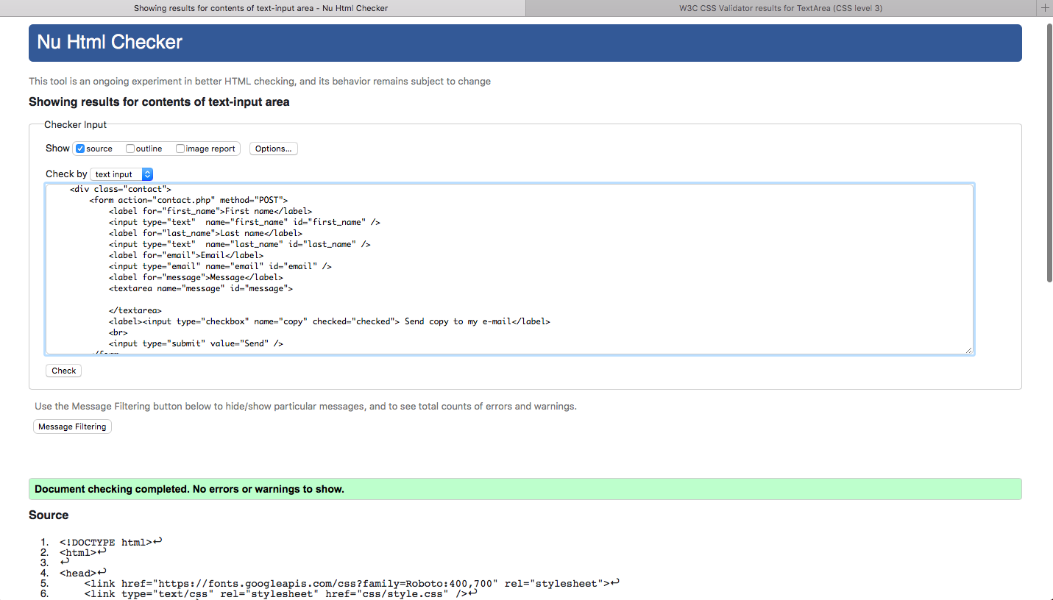

…and for CSS page https://jigsaw.w3.org/css-validator/

