**Proiectarea retelelor de calculatoare**

**Coordonator: Studentă:**

**Prof. Cristian Niculita Parteni Elena**

**Grupa: 22C31B**

**Cerințele proiectului**

- Harta logică a reţelei

o Visio

- Harta fizică a reţelei

o Visio

- Harta logică a serviciilor

o Visio

- Lista echipamentelor de reţea (switchuri, rutere, modem-uri, convertoare, etc.)

o model, nr. porturi, descriere a funcţionării în cadrul reţelei

- Configuraţiile pentru echipamentele de reţea

o Fişiere text cu configuraţiile sau fişiere text explicative asupra configuraţiei

- Lista serverelor o Model, caracteristici tehnice

o Serverele se află în NOC

- Configuraţiile serverelor

o Fişiere text descriptive sau fişiere text explicative

- Tabel cu calculul de preţ

o Subtotaluri pentru fiecare categorie în parte (cablare, comutare, rutare, servicii)

- Servicii care sunt necesare în reţea

o Partajare de resurse disc ( câte 2 share-uri pentru reţelele „1” şi „2”)

Clasa IP ISP: **30.125.17.176/28**

Clasa IP Privată: **10.81.216.0/21**

Segmente nealocabile: **10.81.216.128/27**

**10.81.220.0/24**

**10.81.223.0/24**

Nr. reţele clădirea A: **5**

Nr. calculatoare/reţea: **37/16/53/68/53**

Suprafaţă clădirea A: **56x56**

Nr. nivele clădirea A: **3**

Nr. reţele clădirea B: **5**

Nr. calculatoare/reţea: **59/29/44/73/53**

Suprafaţă clădirea B: **32x38**

Nr. nivele clădirea B **2**

Nr. reţele clădirea C: **5**

Nr. calculatoare/reţea: **51/23/44/65/60**

Suprafaţă clădirea C: **32x34**

Nr. nivele clădirea C: **3**

Nr. reţele clădirea D: **5**

Nr. calculatoare/reţea: **52/59/37/65/23**

Suprafaţă clădirea D: **34x41**

Nr. nivele clădirea D: **3**

Locaţie NOC: **Clădirea B**

Reţeaua „1” se extinde în clădirile: **A B C D**

Reţeaua „2” se extinde în clădirile: **A B C D**

**HARTA LOGICA A RETELEI**

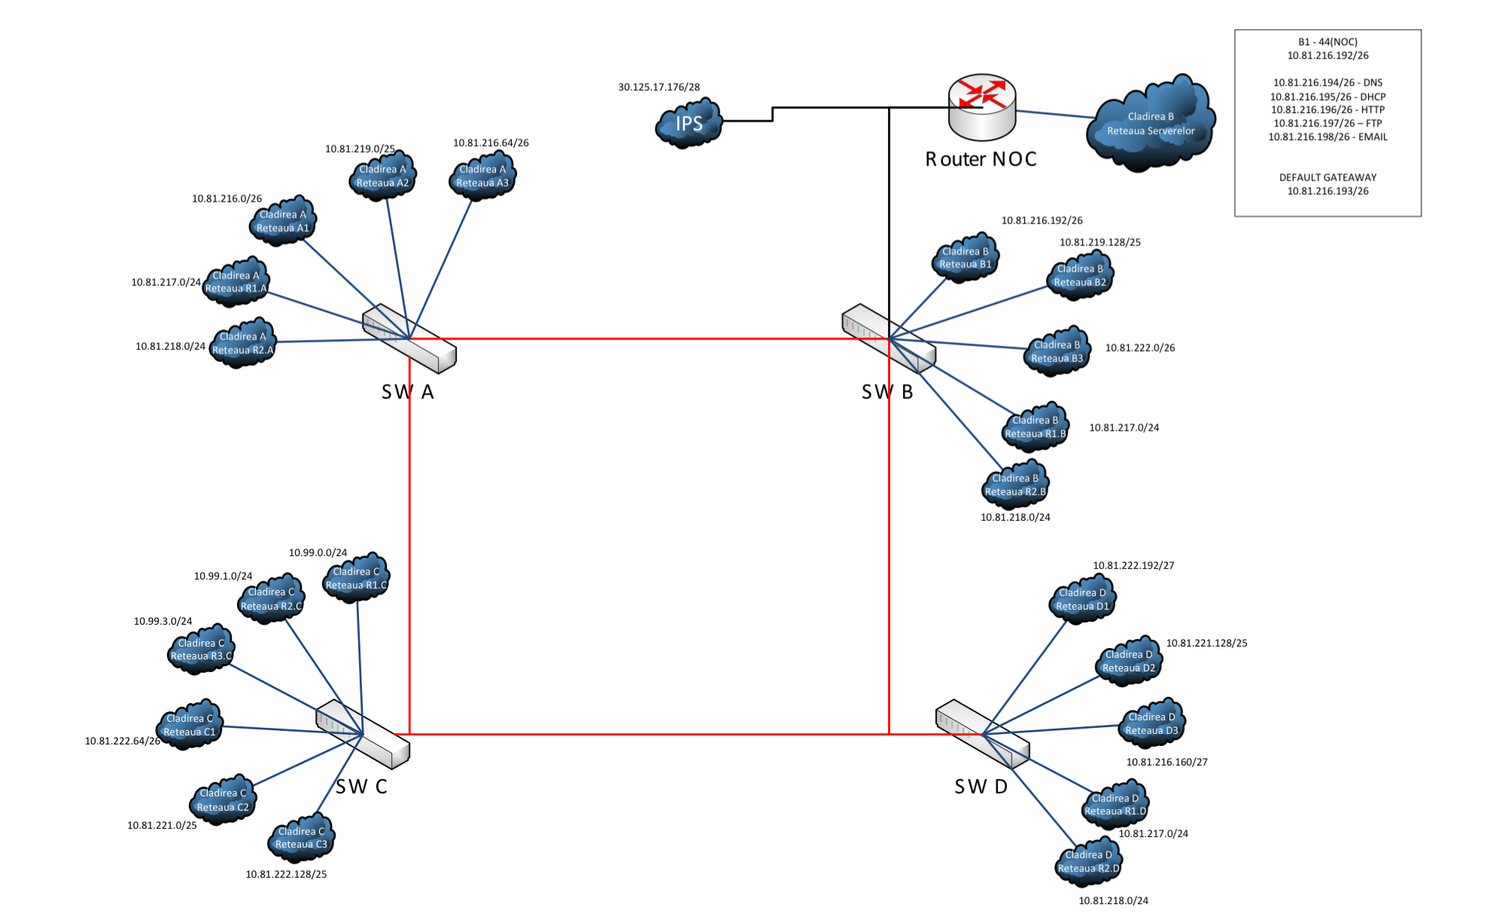

**HARTA FIZICA A RETELEI**

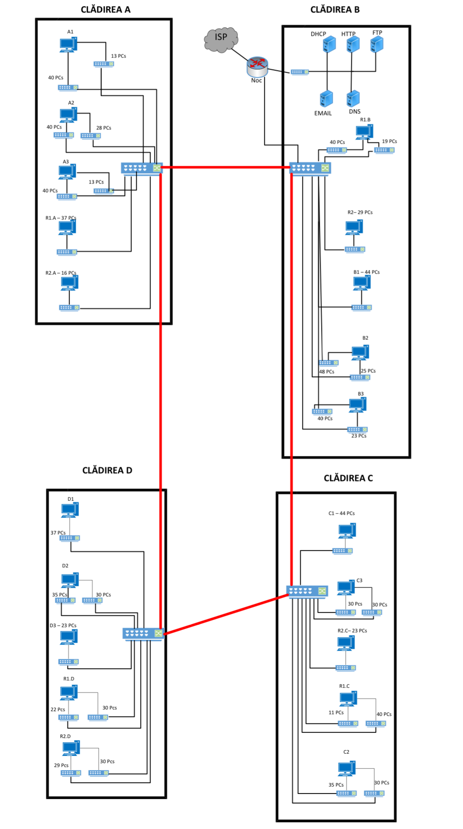

**HARTA LOGICA A SERVICIILOR**

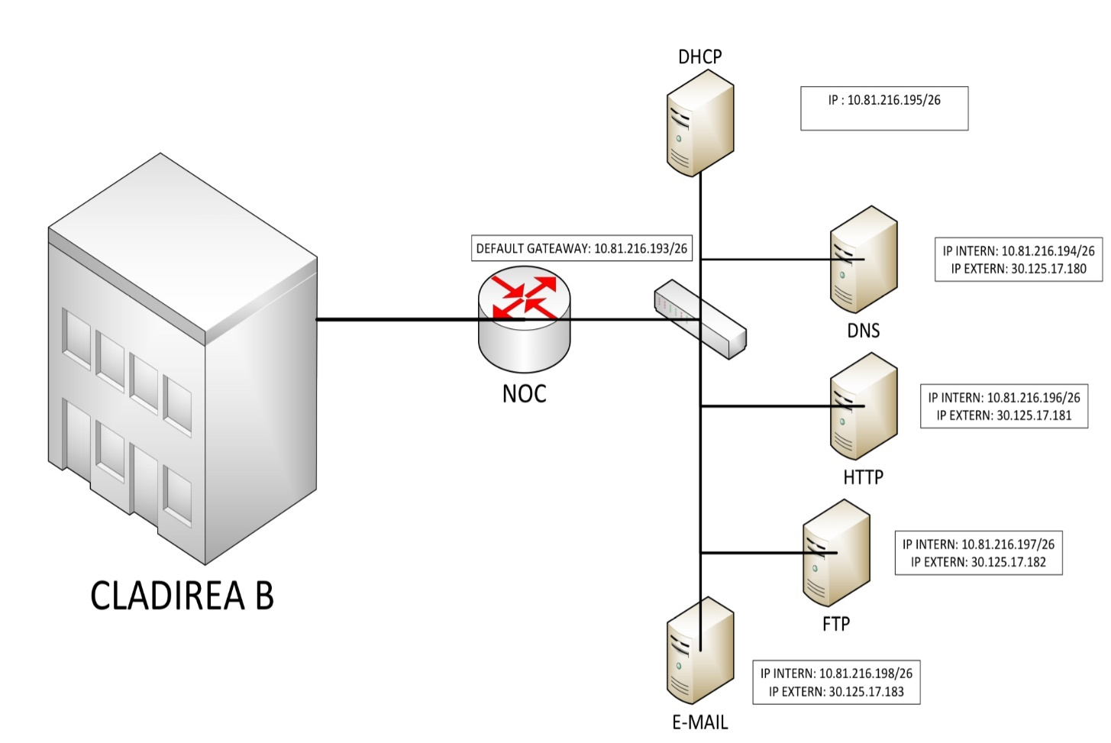

**ALOCAREA ADRESELOR IP**

|  |  |  |  |  |  |
| --- | --- | --- | --- | --- | --- |
| RETEA | Nr Statii | DIMENSIUNE BLOC IP | Netmask | MASK | IP |
| R1 | **201** | **256** | **255.255.255.0** | **/24** | **10.81.217.0 -10.81.217.255** |
| R2 | **129** | **256** | **255.255.255.0** | **/24** | **10.81.218.0 -10.81.218.255** |
| A1 | **53** | **64** | **255.255.255.192** | **/26** | **10.81.216.0 -**  **10.81.216.63** |
| A2 | **68** | **128** | **255.255.255.128** | **/25** | **10.81.219.0 -**  **10.163.87.127** |
| A3 | **53** | **64** | **255.255.255.192** | **/26** | **10.81.216.64 -10.81.216.127** |
| B1 | **44** | **64** | **255.255.255.192** | **/26** | **10.81.216.192 -10.81.216.255** |
| B2 | **73** | **128** | **255.255.255.128** | **/25** | **10.81.219.128 -10.81.219.255** |
| B3 | **53** | **64** | **255.255.255.192** | **/26** | **10.81.222.0 - 10.81.222.63** |
| C1 | **44** | **64** | **255.255.255.192** | **/26** | **10.81.222.64 -10.81.222.127** |
| C2 | **65** | **128** | **255.255.255.128** | **/25** | **10.81.221.0 -10.81.221.127** |
| C3 | **60** | **64** | **255.255.255.192** | **/26** | **10.81.222.128 -10.81.222.191** |
| D1 | **37** | **64** | **255.255.255.192** | **/26** | **10.81.222.192 -10.81.222.255** |
| D2 | **65** | **128** | **255.255.255.128** | **/25** | **10.81.221.128 -10.81.221.255** |
| D3 | **23** | **32** | **255.255.255.224** | **/27** | **10.81.216.160 -10.81.221.191** |

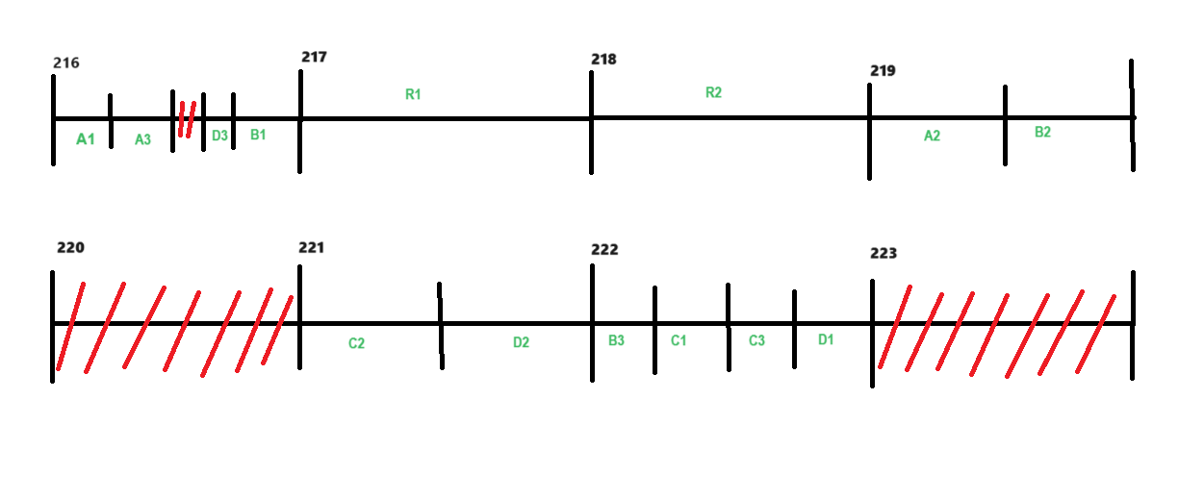

Serverele se află în B1 (NOC). Alocarea IP-urilor pentru servere este în mod Static, iar pentru PC-uri în mod DHCP.

**RETEAUA SIMULATA IN CISCO PACKET TRACER**

**Cladirea A**

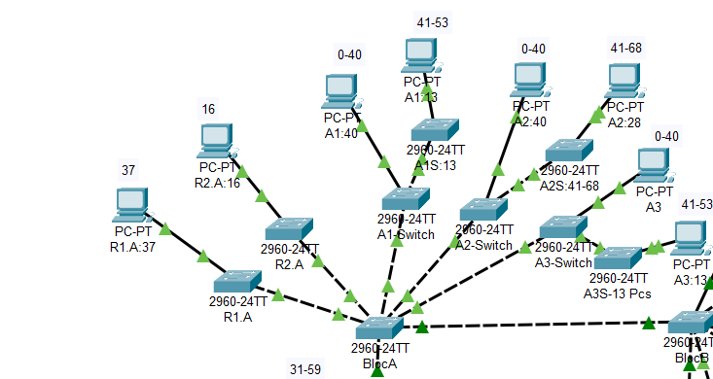

**Cladirea B**

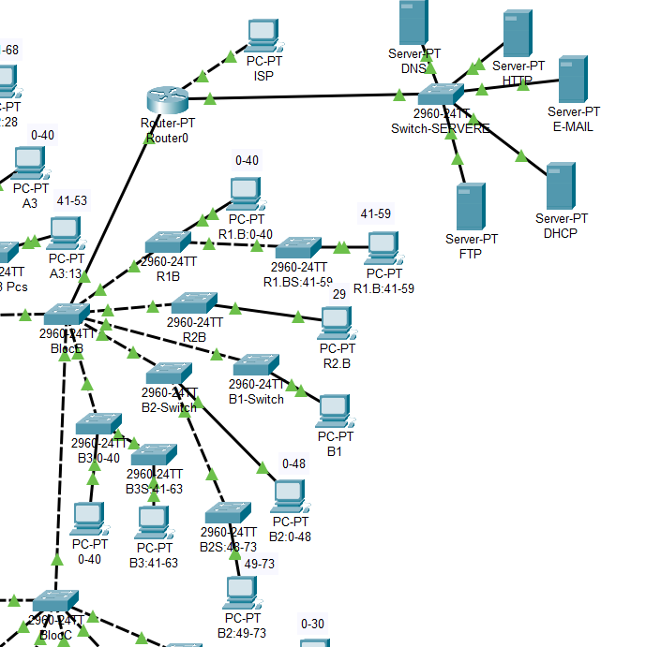

**Cladirea C**

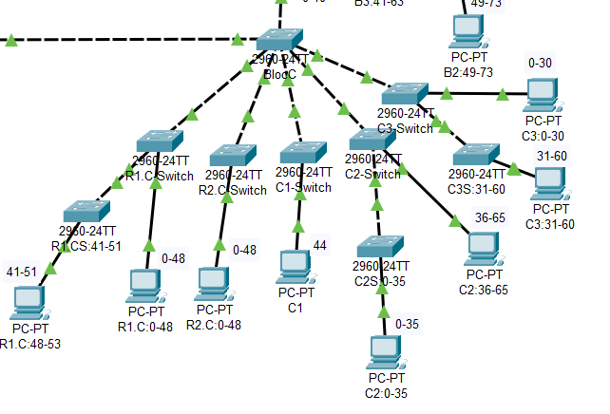

**Cladirea D**

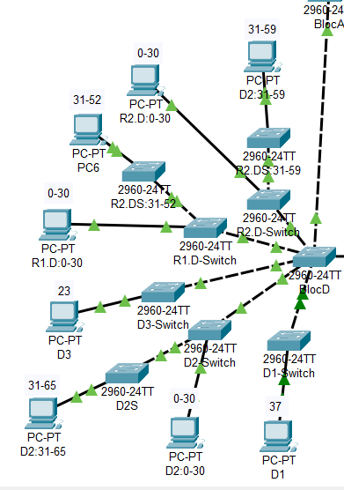

**ECHIPAMENT UTILIZAT**

|  |  |  |  |  |  |
| --- | --- | --- | --- | --- | --- |
|  | Denumire echipament | Numar echipament | Amplasare echipament | Preţ bucată echipament RON | Preţ total echipament RON |
| Tip echipament | Switch Cisco SG 200-08HP-K9-EU | | | | |
|  | SG 200-08 | 1 | Servere | 838,03 RON | 838,03 RON |
| Ofertant | https://www.senetic.ro/product/SG250-08HP-K9-EU | | | | |
| Tip echipament | Server HP ProLiant ML350 Gen10 Tower, Procesor Intel® Xeon® Silver 4208 2.1GHz Cascade Lake, 16GB RAM RDIMM DDR4, no HDD, Dynamic Smart Array E208i-a, 4x Hot Plug LFF | | | | |
|  | P11050-421 | 5 | Servere: DHCP, DNS, FTP, HTTP,E-MAIL | 14.962,22 | 74.811,1 |
| Ofertant | http://www.pcgarage.ro/servere/cisco/ucs-c220-m3-procesor-intel-xeon-e5-2609-24ghz-sandy-bridge-ep-1x-8gb-ddr3-1600mhz-fara-hdd-sff-25-inch/ | | | | |
|  | ST4000NM0023 | 5 | Servere: DHCP, DNS, FTP, HTTP, E-MAIL | 416,50 | 2.082,5 |
| Ofertant | https://www.itstoc.ro/hard-disk-server/hard-disk-server-seagate-constellation-es3-st4000nm0023-4tb-72k-35.html | | | | |
| Tip echipament | Router Huawei Gigabit AC6508 | | | | |
|  | 02354FRJ | 1 | Router: NOC | 4.162,06 | 4.162,06 |
| Ofertant | https://www.pcgarage.ro/routere/huawei/gigabit-ac6508/ | | | | |
| Tip echipament | Switch HPE Gigabit Aruba IOn 1830 24G 2SFP 195W | | | | |
|  | JL813A | 4 | SW A, SW B, SW C,  SW D | 2.053,30 | 8.213,20 |
| Ofertant | http://www.pcgarage.ro/switch-uri/tp-link/tl-sg3424p-1/ | | | | |
| Tip echipament | Switch Cisco Gigabit CBS350-16T-2G | | | | |
|  | SLM2024T-EU | 36 |  | 1.996,16 | 71.861,76 |
| Ofertant | https://www.pcgarage.ro/switch-uri/cisco/gigabit-cbs350-16t-2g/ | | | | |
| Tip echipament | Cablu UTP Cat6 Rola 500 metri SCHRACK | | | | |
|  | Cablu UTP | 7 | Cabluri interior | 1.454,99 | 8.729,94 |
| Ofertant | https://www.a2t.ro/accesorii-supraveghere/cablu-utp-cat6-rola-500-metrii-schrack.html?gclid=CjwKCAiAqt-dBhBcEiwATw-ggJJnFEU3ieHcy1TVp-cnOzF4rxL4EOEwDGQj8fNd3a_Sd5J54KIg_xoCK0oQAvD_BwE | | | | |
| Tip echipament | SET 100 MUFE RJ45 CAT 6 UTP PENTRU FIR SOLID, GEMBIRD LC-8P8C-002/100 | | | | |
|  | Mufe RJ-45 | 20 | La capetele cablurilor UTP | 42,10 | 842 |
| Ofertant | http://www.conectica.ro/retelistica/accesorii-pentru-retelistica/mufe-rj-45-utp-roline-cat6-ecranate-set-10-buc-21173061 | | | | |
| Tip echipament | Fibra optica FTTH 2 fibre cu sufa - Tambur 500m | | | | |
|  | Cablu fibra optica | 4 | Cabluri exterior | 369,99 | 1.479,96 |
| Ofertant | http://www.accesoriifibraoptica.ro/shop/ro_RO/product/124-LR-AF-1000-AL$002fFC.html | | | | |
| Tip echipament | Conector mecanic fibra optica SM SC/UPC | | | | |
|  | Conector fibra | 20 | Cablu fibra optic | 16,99 | 339,80 |
| Ofertant | https://www.a2t.ro/retele-si-telefonie/conector-mecanic-fibra-optica-sm-sc-upc.html | | | | |
| Tip echipament | Pachet YATO, Trusa scule profesionala, 216buc + Set imbus canelate, 40buc | | | | |
|  | Trusa de scule | 1 | montare | 599,99 | 599,99 |
| Ofertant | https://www.sculeaz.ro/pachet-yato-trusa-scule-profesionala-216buc-set-imbus-canelate-40buc.html?gclid=CjwKCAiAqt-dBhBcEiwATw-ggOfemULnzNUfaLtyBcnMi03hsGIMgCEMmPGe34fZlHgc602CS4pX1BoCVvcQAvD_BwE | | | | |
|  |  |  |  | **Total** | **179.948,82** |
|  |  |  |  |  |  |
|  |  |  |  |  |  |

**CONFIGURARE ECHIPAMENT**

**ROUTER NOC:**

R#sh runn

Building configuration...

Current configuration : 3279 bytes

!

version 12.2

no service timestamps log datetime msec

no service timestamps debug datetime msec

no service password-encryption

!

hostname R

no ip cef

no ipv6 cef

!

interface FastEthernet0/0

no ip address

duplex auto

speed auto

!

interface FastEthernet0/0.11

encapsulation dot1Q 11

ip address 10.81.216.1 255.255.255.192

ip helper-address 10.81.126.195

ip nat inside

!

interface FastEthernet0/0.12

encapsulation dot1Q 12

ip address 10.81.219.1 255.255.255.128

ip helper-address 10.81.216.195

ip nat inside

!

interface FastEthernet0/0.13

encapsulation dot1Q 13

ip address 10.81.216.65 255.255.255.192

ip helper-address 10.81.216.195

ip nat inside

!

interface FastEthernet0/0.22

encapsulation dot1Q 22

ip address 10.81.219.129 255.255.255.128

ip helper-address 10.81.216.195

ip nat inside

!

interface FastEthernet0/0.23

encapsulation dot1Q 23

ip address 10.81.222.1 255.255.255.192

ip helper-address 10.81.216.195

ip nat inside

!

interface FastEthernet0/0.31

encapsulation dot1Q 31

ip address 10.81.222.65 255.255.255.192

ip helper-address 10.81.216.195

ip nat inside

!

interface FastEthernet0/0.32

encapsulation dot1Q 32

ip address 10.81.221.1 255.255.255.128

ip helper-address 10.81.216.195

ip nat inside

!

interface FastEthernet0/0.33

encapsulation dot1Q 33

ip address 10.81.222.129 255.255.255.192

ip helper-address 10.81.216.195

ip nat inside

!

interface FastEthernet0/0.41

encapsulation dot1Q 41

ip address 10.81.222.193 255.255.255.192

ip helper-address 10.81.216.195

ip nat inside

!

interface FastEthernet0/0.42

encapsulation dot1Q 42

ip address 10.81.221.129 255.255.255.128

ip helper-address 10.81.216.195

ip nat inside

!

interface FastEthernet0/0.43

encapsulation dot1Q 43

ip address 10.81.216.161 255.255.255.224

ip helper-address 10.81.216.195

ip nat inside

!

interface FastEthernet0/0.100

encapsulation dot1Q 100

ip address 10.81.217.1 255.255.255.0

ip helper-address 10.81.216.195

ip nat inside

!

interface FastEthernet0/0.200

encapsulation dot1Q 200

ip address 10.81.218.1 255.255.255.0

ip helper-address 10.81.216.195

ip nat inside

!

interface FastEthernet1/0

ip address 10.81.216.193 255.255.255.192

ip nat inside

duplex auto

speed auto

!

interface Serial2/0

no ip address

clock rate 2000000

shutdown

!

interface Serial3/0

no ip address

clock rate 2000000

shutdown

!

interface FastEthernet4/0

no ip address

shutdown

!

interface FastEthernet5/0

no ip address

shutdown

!

interface FastEthernet6/0

ip address 30.125.17.178 255.255.255.240

ip access-group 100 in

ip access-group 30 out

ip nat outside

duplex auto

speed auto

!

router rip

!

ip nat inside source list 10 interface FastEthernet1/0 overload

ip nat inside source static 10.81.216.194 30.125.17.180

ip nat inside source static 10.81.216.197 30.125.17.182

ip nat inside source static 10.81.216.198 30.125.17.183

ip nat inside source static 10.81.216.196 30.125.17.181

ip classless

!

ip flow-export version 9

!

!

access-list 100 deny ip any 10.0.0.0 0.255.255.255

access-list 100 permit ip any any

access-list 30 deny 10.0.0.0 0.255.255.255

access-list 30 permit any

access-list 10 permit 10.81.0.0 0.0.255.255

!

line con 0

!

line aux 0

!

line vty 0 4

login

!

end

**SWITCH A:**

BlocA(config)#do sh runn

Building configuration...

Current configuration : 1781 bytes

!

version 12.2

no service timestamps log datetime msec

no service timestamps debug datetime msec

no service password-encryption

!

hostname BlocA

!

spanning-tree mode pvst

spanning-tree extend system-id

!

interface FastEthernet0/1

switchport trunk allowed vlan 11-13,22-23,31-33,41-43,51-52,100,200,300

switchport mode trunk

!

interface FastEthernet0/2

switchport trunk allowed vlan 11-13,22-23,31-33,41-43,51-52,100,200,300

switchport mode trunk

!

interface FastEthernet0/3

switchport access vlan 100

switchport mode trunk

!

interface FastEthernet0/4

switchport access vlan 200

switchport mode trunk

!

interface FastEthernet0/5

switchport mode access

!

interface FastEthernet0/6

switchport access vlan 11

switchport trunk allowed vlan 2-11,14-21,24-30,34-40,44-99,101-199,201-1001

switchport mode trunk

!

interface FastEthernet0/7

switchport access vlan 12

switchport trunk allowed vlan 2-10,12,14-21,24-30,34-40,44-99,101-199,201-1001

switchport mode trunk

!

interface FastEthernet0/8

switchport access vlan 13

switchport trunk allowed vlan 2-10,13-21,24-30,34-40,44-99,101-199,201-1001

switchport mode trunk

!

interface Vlan1

no ip address

shutdown

!

line con 0

!

line vty 0 4

login

line vty 5 15

login

!

End

**SWITCH B:**

BlocB(config)#do sh runn

Building configuration...

Current configuration : 1646 bytes

!

version 12.2

no service timestamps log datetime msec

no service timestamps debug datetime msec

no service password-encryption

!

hostname BlocB

!

spanning-tree mode pvst

spanning-tree extend system-id

!

interface FastEthernet0/1

switchport trunk allowed vlan 11-13,22-23,31-33,41-43,51-52,100,200,300

switchport mode trunk

!

interface FastEthernet0/2

switchport trunk allowed vlan 11-13,22-23,31-33,41-43,51-52,100,200,300

switchport mode trunk

!

interface FastEthernet0/3

switchport trunk allowed vlan 11-13,22-23,31-33,41-43,51-52,100,200,300

switchport mode trunk

!

interface FastEthernet0/4

switchport access vlan 100

switchport mode trunk

!

interface FastEthernet0/5

switchport access vlan 200

switchport mode trunk

!

interface FastEthernet0/6

switchport access vlan 22

switchport mode trunk

!

interface FastEthernet0/7

!

interface FastEthernet0/8

switchport access vlan 23

switchport trunk allowed vlan 2-10,14-21,23-30,33-40,44-99,101-199,201-1001

switchport mode trunk

!

interface Vlan1

no ip address

shutdown

!

line con 0

!

line vty 0 4

login

line vty 5 15

login

!

End

**SWITCH C:**

BlocC(config)#do sh runn

Building configuration...

Current configuration : 1771 bytes

!

version 12.2

no service timestamps log datetime msec

no service timestamps debug datetime msec

no service password-encryption

!

hostname BlocC

!

spanning-tree mode pvst

spanning-tree extend system-id

!

interface FastEthernet0/1

switchport trunk allowed vlan 11-13,22-23,31-33,41-43,51-52,100,200,300

switchport mode trunk

!

interface FastEthernet0/2

switchport trunk allowed vlan 11-13,22,31-33,41-43,51-52,100,200,300

switchport mode trunk

!

interface FastEthernet0/3

switchport access vlan 33

switchport trunk allowed vlan 2-10,14-21,24-30,33-40,44-99,101-199,201-1001

switchport mode trunk

!

interface FastEthernet0/4

switchport access vlan 200

switchport trunk allowed vlan 2-10,14-21,24-30,32,34-40,44-99,101-199,201-1001

switchport mode trunk

!

interface FastEthernet0/5

switchport access vlan 31

switchport mode trunk

!

interface FastEthernet0/6

switchport access vlan 200

switchport trunk allowed vlan 2-10,14-21,24-30,34-40,44-99,101-1001

switchport mode trunk

!

interface FastEthernet0/7

switchport mode access

!

interface FastEthernet0/8

switchport access vlan 100

switchport mode trunk

!

interface Vlan1

no ip address

shutdown

!

line con 0

!

line vty 0 4

login

line vty 5 15

login

!

End

**SWITCH D:**

BlocD(config)#DO SH RUNN

Building configuration...

Current configuration : 1523 bytes

!

version 12.2

no service timestamps log datetime msec

no service timestamps debug datetime msec

no service password-encryption

!

hostname BlocD

!

spanning-tree mode pvst

spanning-tree extend system-id

!

interface FastEthernet0/1

switchport trunk allowed vlan 11-13,22-23,31-33,41-43,51-52,100,200,300

switchport mode trunk

!

interface FastEthernet0/2

switchport trunk allowed vlan 11-13,22-23,31-33,41-43,51-52,100,200,300

switchport mode trunk

!

interface FastEthernet0/3

switchport access vlan 42

switchport mode trunk

!

interface FastEthernet0/4

switchport access vlan 43

switchport mode trunk

!

interface FastEthernet0/5

switchport access vlan 100

switchport mode trunk

!

interface FastEthernet0/6

switchport access vlan 200

switchport mode trunk

!

interface FastEthernet0/7

switchport access vlan 41

switchport mode trunk

!

interface Vlan1

no ip address

shutdown

!

line con 0

!

line vty 0 4

login

line vty 5 15

login

!

End

**Configurare DHCP**

Serverul DHCP conține câte un pool pentru fiecare rețea. Astfel cu ajutorul lui toate PC-urile își iau IP-urile automat. Acest lucru este foarte comod și facilitează administrarea rețelelor. Serverul este configurat în modul următor.

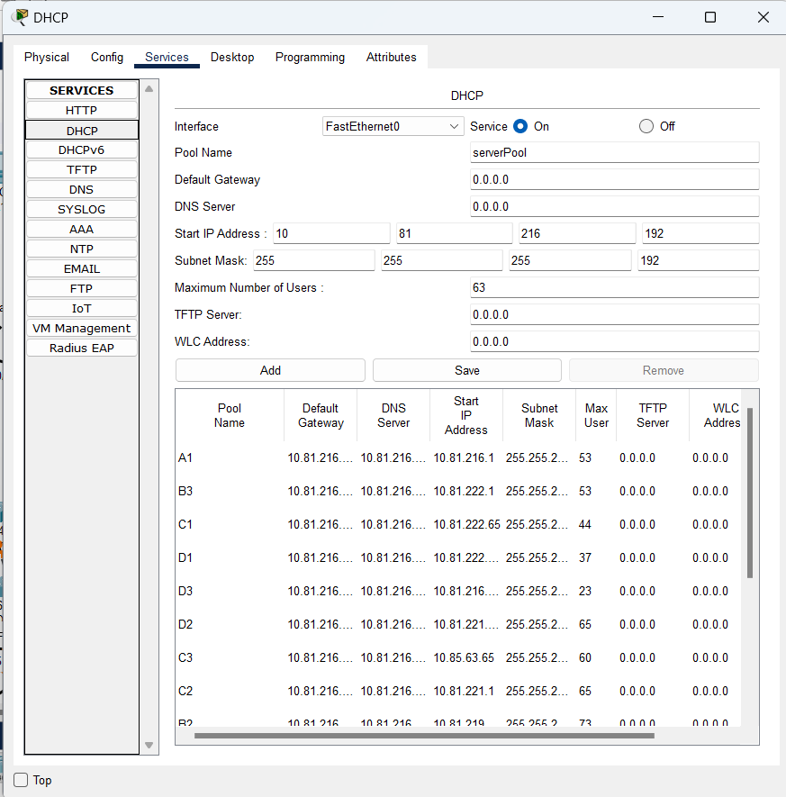

**CONFIGURARE DNS**

Serverul DNS conține o înregistrare de tip Record [*www.home.ro*](http://www.home.ro)cu adresa serverului HTTP și [*www.files.ro*](http://www.files.ro) cu adresa serverului FTP. Acesta permite utilizatorilor să acceseze conținutul paginilor HTML accesându-le simplu în browserul web, precum și simplifică accesul la serverul FTP.

Serverul HTTP are conținutul siteului[*www.home.ro*](http://www.home.ro) . Orice fișier poate fi modificat pentru a acualiza informațiile necesare.

**CONFIGURARE EMAIL:**

Serverul EMAIL conține două înregistrări pentru utilizatorii c1 și d3 cu domeniul *home.ro*. Chiar dacă acești useri se află în rețele diferite, ei pot comunica cu ajutorul serviciului EMAIL. Testarea serviciului este arătată în imaginea de mai jos.

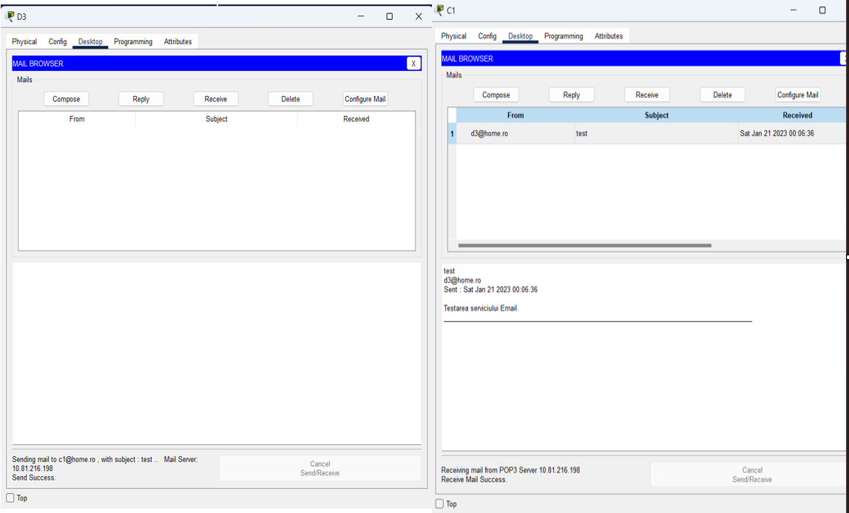

**CONFIGURARE FTP:**

Serverul FTP are o înregistrare cu toate permisiunile de prelucrare a fișierelor (Write, Read, Delete, Rename, List). Pot fi adăugați și alți useri cu orice fel de permisiune. Testarea serverului FTP se face de pe orice calculator în felul următor.

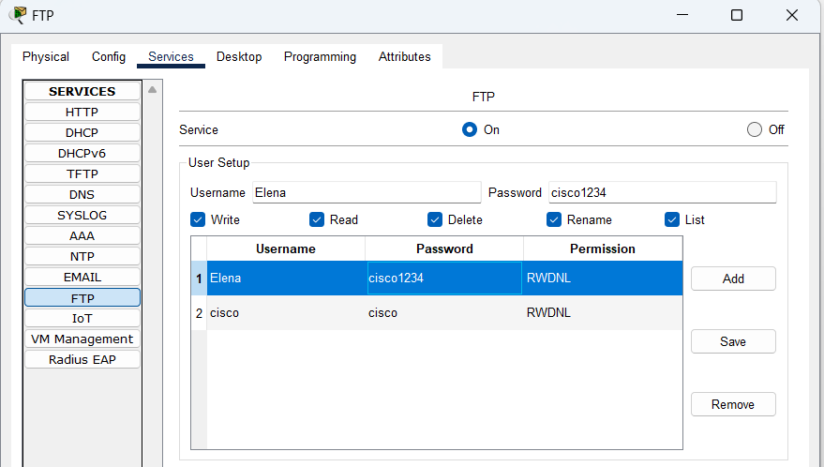

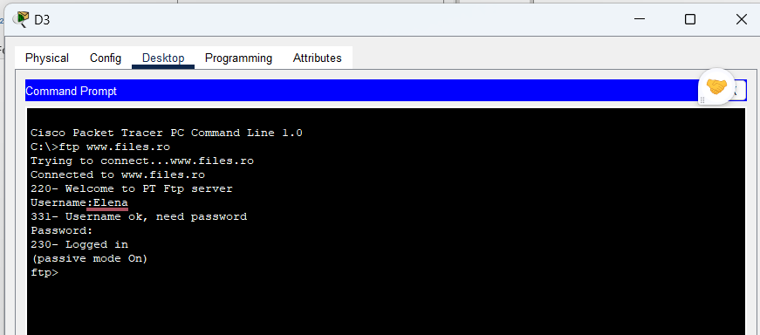

**DESCRIEREA FUNCȚIONĂRII REȚELEI**

Rețeaua are IP-ul privat 10.81.216.0/21 și este împărțită în 14 subrețele. Fiecare subrețea este plasată într-un VLAN. Toate dispozitivele, cu excepția NOC, își iau adresele IP prin DHCP, iar serverele din NOC au adrese IP statice. Calculatoarele au acces doar la serverele din NOC, la dispozitivele din propriul VLAN.

În concluzie, cu argumentele aduse mai sus reţeaua satisface cerinţele de implementare fiind complet funcţională şi fiind prevăzută cu serviciile necesare efectuării operaţiunilor necesare în cadrul acesteia.

