Sisteme de gestiune a bazelor de date Proiect final – 2023

**GESTIUNEA UNEI BAZE HOTELIERE**

Lect. Dr. Gabriela Mihai

Student: Georgescu Elena- Alexandra

Seria 23, Grupa 231

Anul II, Semestrul I

1. Descrierea modelului

In cadrul acestui proiect vom analiza gestiunea unui lant hotelier. Modelul prezentat cuprinde mai multe hoteluri cu acelasi nume, situate in orase diferite ale Romaniei. Cu ajutorul bazei de date proiectata, putem tine o evidenta clara a angajatilor din toate hotelurile, a rezervarilor facute, a clientilor care calca pragul hotelurilor, a platilor si a facturilor efectuate pentru sejururi.

Reguli de functionare:

* Fiecare angajat din cadrul hotelului are un job si un salariu bine definit.
* Salariul unui angajat este determinat strict de locul de munca pe care acesta il ocupa.
* Pretul unei camere/unui apartament variaza in functie de tipul acesteia/ acestuia.
* Rezervarea cuprinde o serie de informatii esentiale: obiectul rezervat, persoana care a facut rezervarea, data rezervarii, perioada care se doreste rezervata, tipul de sejur pentru care se opteaza si factura emisa.
* Factura furnizeaza informatii cu privire la plata efectuata si data efectuarii acesteia.
* Un client isi poate alege tipul de serviciu extra dorit in functie de preferinte. De asemenea, serviciile pot lipsi din pachetul unui client, intrucat sunt optionale. In cazul alegerii unui serviciu, pretul acestuia va fi adaugat la pretul pe care il are de platit, iar serviciul va fi disponibil pe toata durata sederii clientului.
* Clientii pot opta pentru unul dintre serviciile de masa: room-only, mic dejun, demipensiune (ce cuprinde mic dejun si cina), pensiune completa sau all-inclusive.
* Clientii pot rezerva camere de tip single, double sau triple sau apartamente cu doua, trei sau patru camere.
* Rezervarile se fac, bineinteles, pe baza disponibilitatii camerelor si apartamentelor detinute de hotel.

1. Diagrama Entitate- Relatie

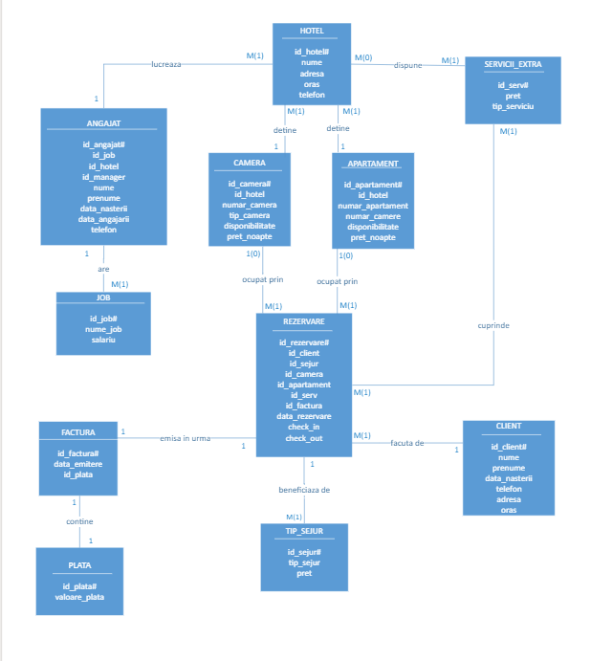

1. Diagrama conceptuala

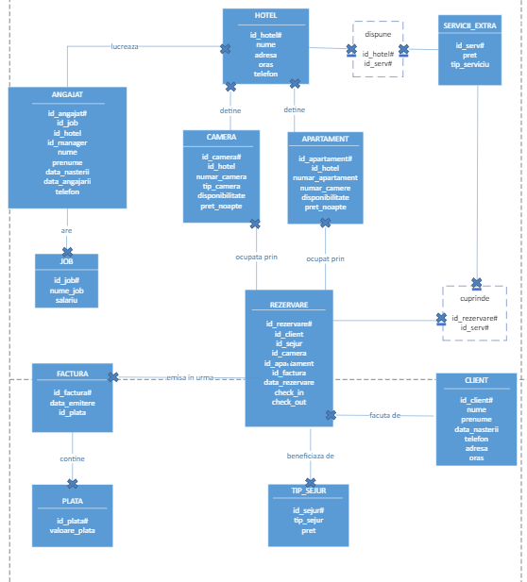

1. Creare tabele

Entitatea ANGAJAT

CREATE TABLE ANGAJAT

(

ID_ANGAJAT NUMBER(9) PRIMARY KEY,

ID_JOB NUMBER(9) NOT NULL REFERENCES JOB(ID_JOB),

ID_HOTEL NUMBER(9) NOT NULL REFERENCES HOTEL(ID_HOTEL),

ID_MANAGER NUMBER(9) REFERENCES ANGAJAT(ID_ANGAJAT),

NUME VARCHAR2(30) NOT NULL,

PRENUME VARCHAR2(30) NOT NULL,

DATA_NASTERII DATE NOT NULL,

DATA_ANGAJARII DATE NOT NULL,

TELEFON CHAR(10) NOT NULL

);

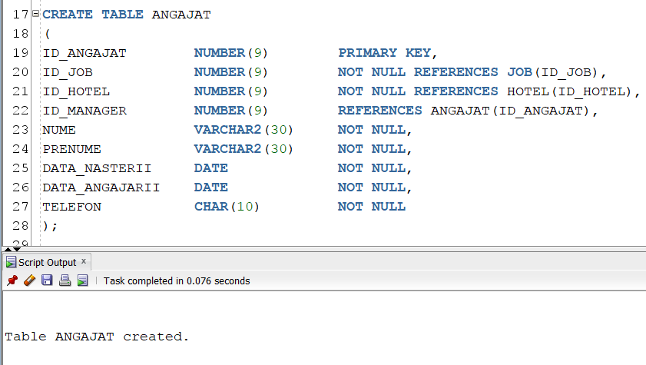

Entitatea APARTAMENT

CREATE TABLE APARTAMENT

(

ID_APARTAMENT NUMBER(9) PRIMARY KEY,

ID_HOTEL NUMBER(9) NOT NULL REFERENCES HOTEL(ID_HOTEL),

NUMAR_APARTAMENT NUMBER(9) NOT NULL,

NUMAR_CAMERE NUMBER CHECK(NUMAR_CAMERE>1 AND NUMAR_CAMERE<5) NOT NULL,

DISPONIBILITATE CHAR(2) CHECK (DISPONIBILITATE='DA' OR DISPONIBILITATE='NU') NOT NULL,

PRET_NOAPTE NUMBER(9) NOT NULL

);

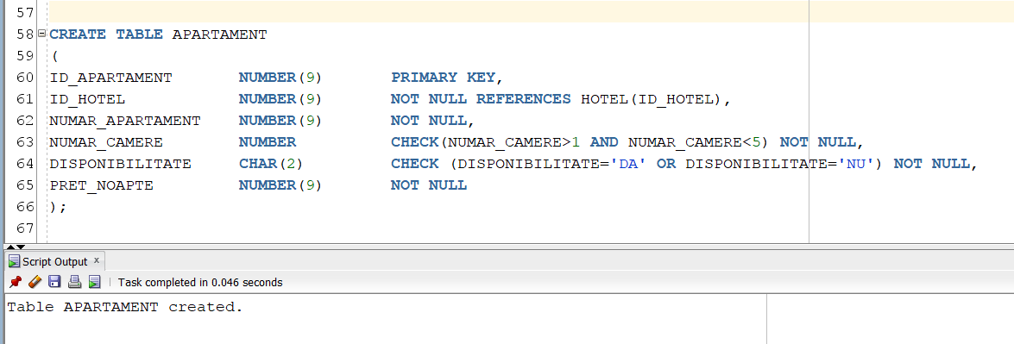

Entitatea CAMERA

CREATE TABLE CAMERA

(

ID_CAMERA NUMBER(9) PRIMARY KEY,

ID_HOTEL NUMBER(9) NOT NULL REFERENCES HOTEL(ID_HOTEL),

NUMAR_CAMERA NUMBER(9) NOT NULL,

TIP_CAMERA VARCHAR2(10) NOT NULL,

DISPONIBILITATE CHAR(2) CHECK (DISPONIBILITATE='DA' OR DISPONIBILITATE='NU') NOT NULL,

PRET_NOAPTE NUMBER(9) NOT NULL

);

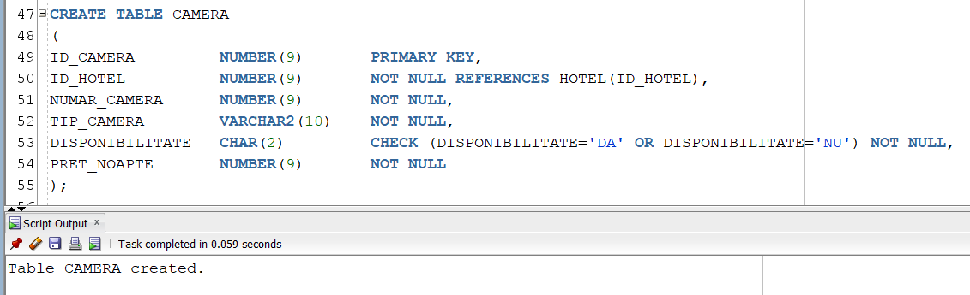

Entitatea CLIENT

CREATE TABLE CLIENT

(

ID_CLIENT NUMBER(9) PRIMARY KEY,

NUME VARCHAR2(30) NOT NULL,

PRENUME VARCHAR2(30) NOT NULL,

DATA_NASTERII DATE NOT NULL,

TELEFON CHAR(10) NOT NULL,

ADRESA VARCHAR2(30) NOT NULL,

ORAS VARCHAR2(20) NOT NULL);

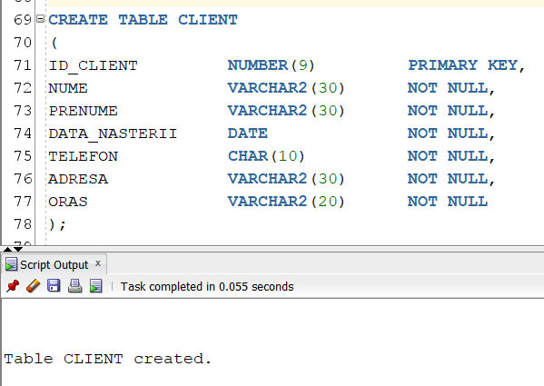

Entitatea CUPRINDE

CREATE TABLE CUPRINDE

(

ID_REZERVARE NUMBER(9) NOT NULL REFERENCES REZERVARE(ID_REZERVARE),

ID_SERV NUMBER(9) NOT NULL REFERENCES SERVICII_EXTRA(ID_SERV),

CONSTRAINT PK_CUPRINDE PRIMARY KEY(ID_REZERVARE, ID_SERV)

);

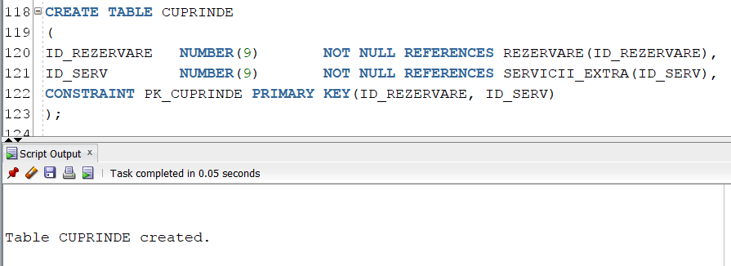

Entitatea DISPUNE

CREATE TABLE DISPUNE

(

ID_HOTEL NUMBER(9) NOT NULL REFERENCES HOTEL(ID_HOTEL),

ID_SERV NUMBER(9) NOT NULL REFERENCES SERVICII_EXTRA(ID_SERV),

CONSTRAINT PK_DISPUNE PRIMARY KEY(ID_HOTEL, ID_SERV)

);

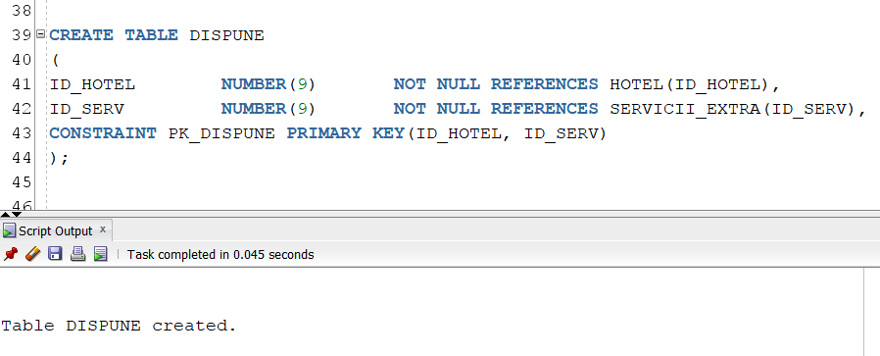

Entitatea FACTURA

CREATE TABLE FACTURA

(

ID_FACTURA NUMBER(9) PRIMARY KEY,

DATA_EMITERE DATE NOT NULL,

ID_PLATA NUMBER(9) NOT NULL REFERENCES PLATA(ID_PLATA)

);

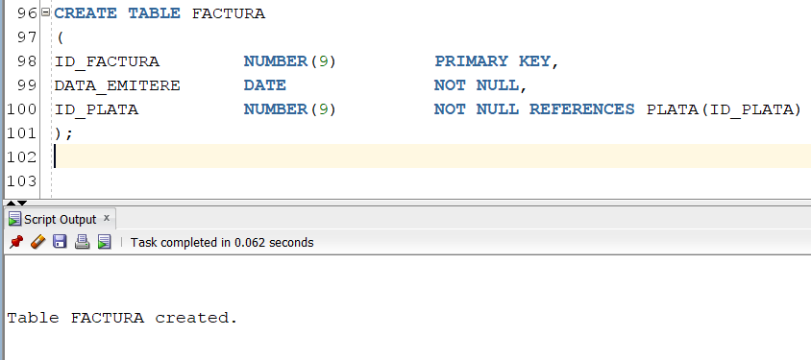

Entitatea HOTEL

CREATE TABLE HOTEL

(

ID_HOTEL NUMBER(9) PRIMARY KEY,

NUME VARCHAR2(20) NOT NULL,

ADRESA VARCHAR2(30) NOT NULL,

ORAS VARCHAR2(20) NOT NULL,

TELEFON CHAR(10) NOT NULL

);

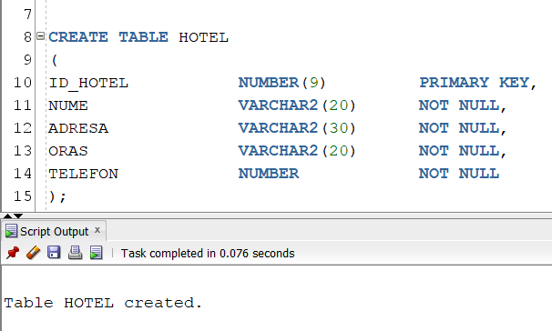

Entitatea JOB

CREATE TABLE JOB

(

ID_JOB NUMBER(9) PRIMARY KEY,

NUME_JOB VARCHAR2(20) NOT NULL,

SALARIU NUMBER(9) NOT NULL

);

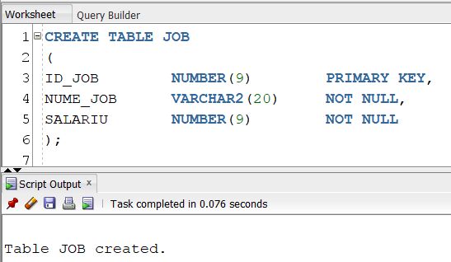

Entitatea PLATA

CREATE TABLE PLATA

(

ID_PLATA NUMBER(9) PRIMARY KEY,

VALOARE_PLATA NUMBER(9) NOT NULL

);

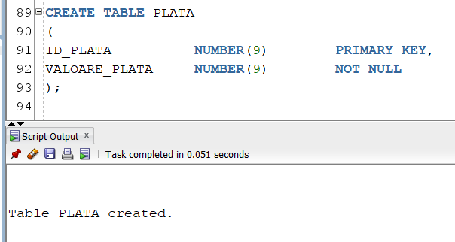

Entitatea REZERVARE

CREATE TABLE REZERVARE

(

ID_REZERVARE NUMBER(9) PRIMARY KEY,

ID_CLIENT NUMBER(9) NOT NULL REFERENCES CLIENT(ID_CLIENT),

ID_SEJUR NUMBER(9) NOT NULL REFERENCES TIP_SEJUR(ID_SEJUR),

ID_CAMERA NUMBER(9) REFERENCES CAMERA(ID_CAMERA),

ID_APARTAMENT NUMBER(9) REFERENCES APARTAMENT(ID_APARTAMENT),

ID_FACTURA NUMBER(9) NOT NULL REFERENCES FACTURA(ID_FACTURA),

DATA_REZERVARE DATE NOT NULL,

CHECK_IN DATE NOT NULL,

CHECK_OUT DATE NOT NULL

);

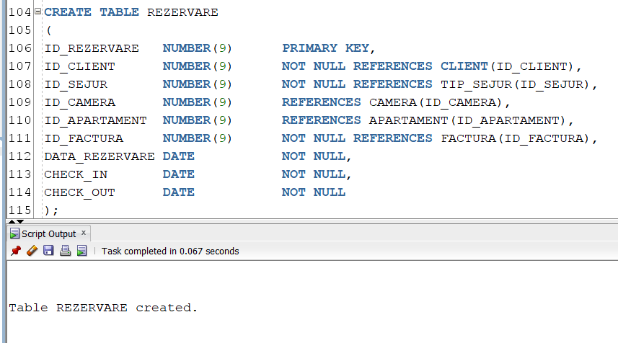

Entitatea TIP SEJUR

CREATE TABLE TIP_SEJUR

(

ID_SEJUR NUMBER(9) PRIMARY KEY,

TIP_SEJUR VARCHAR2(20) NOT NULL,

PRET NUMBER(9) NOT NULL

);

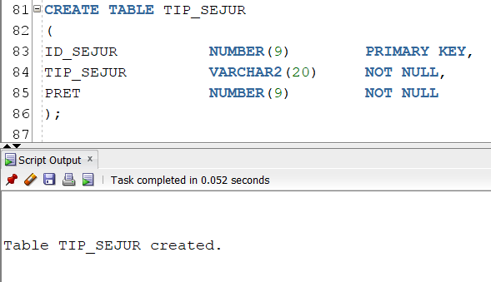

Entitatea SERVICII EXTRA

CREATE TABLE SERVICII_EXTRA

(

ID_SERV NUMBER(9) PRIMARY KEY,

TIP_SERVICIU VARCHAR2(30) NOT NULL,

PRET NUMBER(9) NOT NULL

);

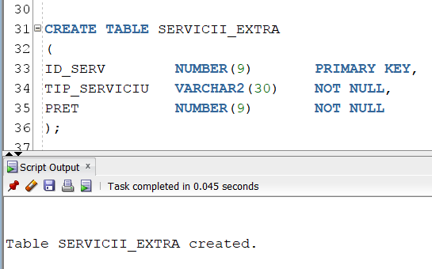

1. Inserari in tabele

Entitatea ANGAJAT

insert into angajat values

(101,16,1,NULL,'Vasilica','Iacob','26-SEP-1984','18-JUL-2018','0771760402');

insert into angajat values

(102,16,2,NULL,'Nicu','Elena','22-JUN-1977','21-JUL-2016','0700760402');

insert into angajat values

(103,16,3,NULL,'Olga','Nicoleta','08-JUN-1981','16-JAN-2013','0708760402');

insert into angajat values

(104,16,4,NULL,'Fane','Horia','01-MAY-1985','27-JUL-2015','0731760402');

insert into angajat values

(105,16,5,NULL,'Tiberiu','Emil','03-OCT-1975','27-FEB-2014','0751760402');

insert into angajat values

(106,11,1,101,'Fabian','Tudor','18-APR-1972','02-NOV-2016','0711760402');

insert into angajat values

(107,11,2,102,'Dacian','Diana','04-MAY-1983','03-JUN-2014','0761760402');

insert into angajat values

(108,11,3,103,'Stan','Ciprian','15-MAR-1978','31-JUL-2013','0781760402');

insert into angajat values

(109,12,5,105,'Ruxandra','Andrei','08-MAR-1978','03-OCT-2013','0701760402');

insert into angajat values

(110,11,4,104,'Nicu','Elena','22-JUN-1977','21-JUL-2016','0700760402');

insert into angajat values

(111,12,1,101,'Lazar','Violeta','17-MAR-1982','07-JUL-2015','0702760402');

insert into angajat values

(112,12,2,102,'Alexandrina','Margareta','08-MAR-1984','27-NOV-2013','0704760402');

insert into angajat values

(113,12,3,103,'Romeo','Adam','29-NOV-1972','21-APR-2016','0705760402');

insert into angajat values

(114,12,4,104,'Miron','Cezar','09-MAY-1979','16-APR-2019','0706760402');

insert into angajat values

(115,12,5,105,'Matei','Laurentiu','05-APR-1974','08-MAY-2014','0707760402');

insert into angajat values

(116,13,1,101,'Rodica','Dragos','11-DEC-1979','03-MAR-2014','0701660402');

insert into angajat values

(117,13,2,102,'Victoria','Tatiana','22-DEC-1977','20-JUN-2014','0701860402');

insert into angajat values

(118,13,3,103,'Mihai','Augustin','08-APR-1985','29-SEP-2016','0701960402');

insert into angajat values

(119,13,4,104,'Estera','Danut','01-AUG-1972','28-JUL-2014','0701200402');

insert into angajat values

(120,13,5,105,'Atanasie','Narcisa','17-JUN-1977','31-JUL-2018','0701201402');

insert into angajat values

(121,14,1,101,'Adam','Radu','19-JUL-1979','17-MAR-2015','0701711402');

insert into angajat values

(122,14,2,102,'Petre','Marius','16-JUN-1981','02-APR-2014','0701811402');

insert into angajat values

(123,14,3,103,'Petrut','David','11-JUL-1985','17-DEC-2014','0701911402');

insert into angajat values

(124,14,4,104,'Carol','Lorena','24-AUG-1970','10-APR-2018','0701205402');

insert into angajat values

(125,14,5,105,'Stan','Andrei','17-MAR-1982','29-SEP-2015','0701206402');

insert into angajat values

(126,15,1,101'Floriana','Antonia','24-DEC-1982','03-MAY-2016','0701209402');

insert into angajat values

(127,15,2,102,'Costin','Isabela','21-JUN-1979','10-AUG-2018','0701230402');

insert into angajat values

(128,15,3,103,'Valentin','Mihaela','07-APR-1983','17-OCT-2016','0701231402');

insert into angajat values

(129,15,4,104,'Marin','Albert','29-NOV-1977','10-JAN-2018','0701232402');

insert into angajat values

(130,15,5,105,'Octavian','Sorina','27-OCT-1970','07-FEB-2019','0701233402');

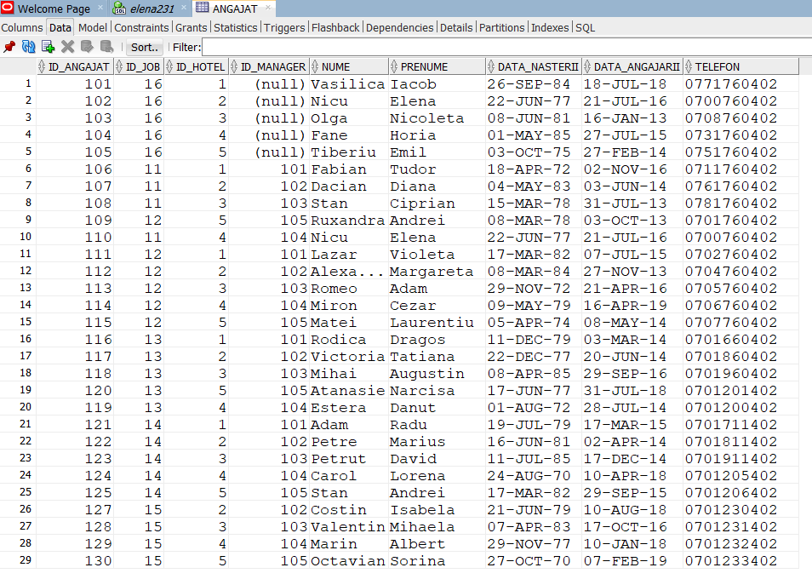

Entitatea APARTAMENT

insert into apartament values

(150,1,50,2,'NU',250);

insert into apartament values

(151,2,51,2,'NU',250);

insert into apartament values

(152,3,52,2,'DA',250);

insert into apartament values

(153,4,53,2,'DA',250);

insert into apartament values

(154,5,54,2,'DA',250);

insert into apartament values

(155,1,55,3,'NU',340);

insert into apartament values

(156,2,56,3,'NU',340);

insert into apartament values

(157,3,57,3,'DA',340);

insert into apartament values

(158,4,58,3,'DA',340);

insert into apartament values

(159,5,59,3,'NU',340);

insert into apartament values

(160,1,60,4,'DA',480);

insert into apartament values

(161,2,61,4,'NU',480);

insert into apartament values

(162,3,62,4,'NU',480);

insert into apartament values

(163,4,63,4,'DA',480);

insert into apartament values

(164,5,64,4,'NU',480);

insert into apartament values

(165,2,65,3,'NU',340);

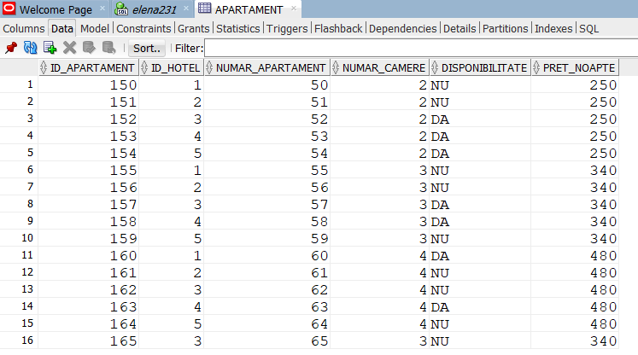

Entitatea CAMERA

insert into camera values

(110,1,10,'Single','DA',120);

insert into camera values

(111,2,11'Single','DA',120);

insert into camera values

(112,3,12'Single','NU',120);

insert into camera values

(113,4,13,'Single','NU',120);

insert into camera values

(114,5,14,'Single','NU',120);

insert into camera values

(115,1,15,'DOUBLE','NU',175);

insert into camera values

(116,2,16,'DOUBLE','NU',175);

insert into camera values

(117,3,17,'DOUBLE','NU',175);

insert into camera values

(118,4,18,'DOUBLE','NU',175);

insert into camera values

(119,5,19,'DOUBLE','DA',175);

insert into camera values

(120,1,20,'TRIPLE','DA',230);

insert into camera values

(121,2,21,'TRIPLE','NU',230);

insert into camera values

(122,3,22,'TRIPLE','NU',230);

insert into camera values

(123,4,23,'TRIPLE','NU',230);

insert into camera values

(124,5,24,'TRIPLE','NU',230);

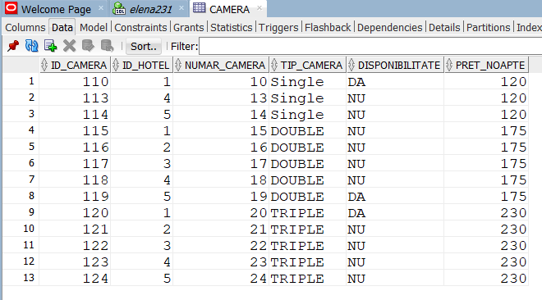

Entitatea CLIENT

insert into client values

(650,'Nelu','Paul','17-MAY-1978','0712873082','Strada Brazdei nr.21-31','Cluj-Napoca');

insert into client values

(651,'Nicolae','Cosmina','30-AUG-1979','0732873082','Strada Dorobanti,22','Fagaras');

insert into client values

(652,'Costache','Raluca','28-FEB-1985','0742873082','Strada Valea Calugareasca nr.3','Tulcea');

insert into client values

(653,'Anisoara','Lidia','09-FEB-1982','0752873082','Strada Balcescu Nicolae nr.6','Oradea');

insert into client values

(654,'Chitoiu','Marius','20-MAY-1990','0703873582','Strada Cirezarilor,12','Braila');

insert into client values

(655,'Sandu','Victor','06-APR-1971','0772873082','Strada Grigorescu Eremia,15','Deva');

insert into client values

(656,'Nicu','Simion','20-JAN-1976','0782873082','Strada Fluturilor,25','Piatra Neamt');

insert into client values

(657,'Catina','Iulia','08-JUN-1972','0792873082','Strada Vacantei nr.30-T,7','Hunedoara');

insert into client values

(658,'Nicusor','Georgeta','21-AUG-1985','0701873082','Strada Spicului nr.33-T','Buzau');

insert into client values

(659,'Horatiu','Sorina','27-MAY-1985','0703873082','Strada Goraslau,16','Alba Iulia');

insert into client values

(670,'Popescu','Radu','07-FEB-1982','0783873082','Strada Nicoara Moise','Ramnicu Valcea');

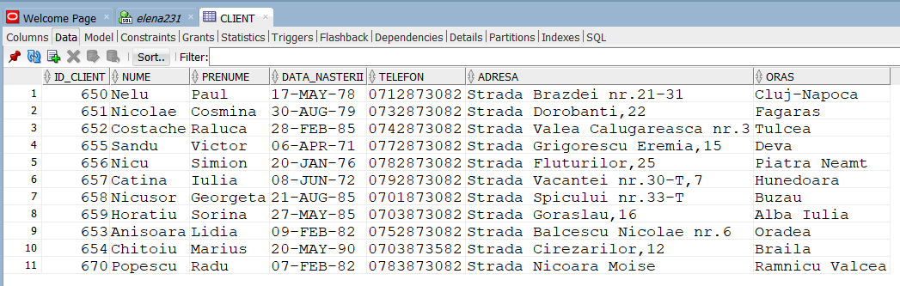

Entitatea CUPRINDE

insert into cuprinde values

(10651,1103);

insert into cuprinde values

(10652,1103);

insert into cuprinde values

(10655,1101);

insert into cuprinde values

(10655,1100);

insert into cuprinde values

(10656,1100);

insert into cuprinde values

(10657,1101);

insert into cuprinde values

(10657,1102);

insert into cuprinde values

(10658,1104);

insert into cuprinde values

(10659,1100);

insert into cuprinde values

(10659,1103);

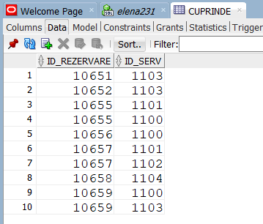

Entitatea DISPUNE

insert into dispune values

(1,1100);

insert into dispune values

(2,1100);

insert into dispune values

(3,1100);

insert into dispune values

(4,1100);

insert into dispune values

(5,1100);

insert into dispune values

(1,1101);

insert into dispune values

(2,1101);

insert into dispune values

(3,1101);

insert into dispune values

(4,1101);

insert into dispune values

(5,1101);

insert into dispune values

(1,1102);

insert into dispune values

(2,1102);

insert into dispune values

(3,1103);

insert into dispune values

(4,1103);

insert into dispune values

(1,1104);

insert into dispune values

(2,1104);

insert into dispune values

(3,1104);

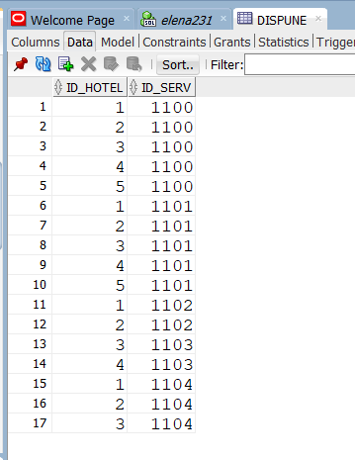

Entitatea FACTURA

insert into factura values

(1010650,'12-APR-2021',110650);

insert into factura values

(1010651,'10-MAY-2021',110651);

insert into factura values

(1010652,'30-APR-2021',110652);

insert into factura values

(1010653,'03-JUN-2021',110653);

insert into factura values

(1010654,'18-AUG-2021',110654);

insert into factura values

(1010655,'15-SEP-2021',110655);

insert into factura values

(1010656,'12-MAR-2021',110656);

insert into factura values

(1010657,'13-MAR-2021',110657);

insert into factura values

(1010658,'27-SEP-2021',110658);

insert into factura values

(1010659,'01-JUN-2021',110659);

insert into factura values

(1010670,'15-JUN-2021',110659);

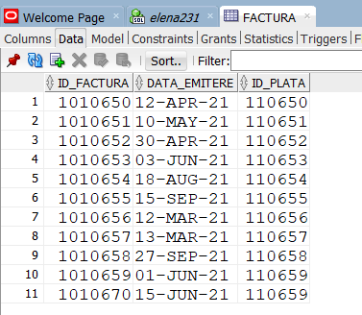

Entitatea HOTEL

insert into hotel values

(1,'Glimpse','Strada Crinului, 15', 'Constanta', '0725415471');

insert into hotel values

(2,'Glimpse','Strada Raului nr.279-T, 25,', 'Sighisoara','0725415472');

insert into hotel values

(3,'Glimpse','Strada Diminetii,21', 'Brasov', '0725415473');

insert into hotel values

(4,'Glimpse','Strada Mihai Viteazul nr.2,13', 'Timisoara', '0725415474');

insert into hotel values

(5,'Glimpse','Strada Consecventei nr.1-T,8', 'Bucuresti', '0725415475');

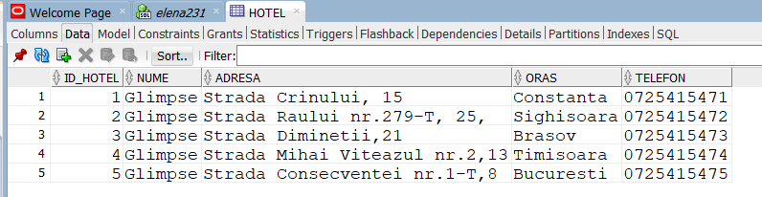

Entitatea JOB

INSERT INTO JOB VALUES

(11,'Paznic',2000);

INSERT INTO JOB VALUES

(16,'Ospatar',1800);

INSERT INTO JOB VALUES

(12,'Bucatar',3300);

INSERT INTO JOB VALUES

(13,'Ospatar',1800);

INSERT INTO JOB VALUES

(14,'Receptionist',2300);

INSERT INTO JOB VALUES

(15,'Personal curatenie',1300);

INSERT INTO JOB VALUES

(16,'Manager',4000);

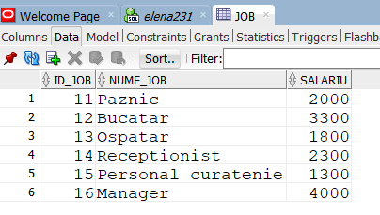

Entitatea PLATA

insert into plata values

(110650,510);

insert into plata values

(110651,2220);

insert into plata values

(110652,500);

insert into plata values

(110653,1760);

insert into plata values

(110654,1200);

insert into plata values

(110655,1150);

insert into plata values

(110656,1720);

insert into plata values

(110657,1500);

insert into plata values

(110658,2120);

insert into plata values

(110659,1330);

insert into plata values

(110670,1360);

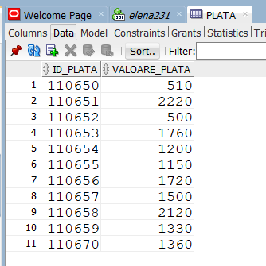

Entitatea REZERVARE

insert into rezervare values

(10651,651,192,NULL,163,1010651,'10-MAY-2021','04-JUL-2021','08-JUL-2021');

insert into rezervare values

(10652,652,191,115,NULL,1010652,'30-APR-2021','11-JUN-2021','13-JUN-2021');

insert into rezervare values

(10653,653,191,110,NULL,1010653,'25-APR-2021','11-JUN-2021','13-JUN-2021');

insert into rezervare values

(10654,654,193,120,NULL,1010654,'02-APR-2021','15-JUL-2021','19-JUL-2021');

insert into rezervare values

(10655,655,193,116,NULL,1010655,'23-JUN-2021','15-SEP-2021','21-SEP-2021');

insert into rezervare values

(10656,656,194,NULL,157,1010656,'12-MAR-2021','20-MAY-2021','24-MAY-2021');

insert into rezervare values

(10657,657,192,115,NULL,1010657,'13-MAR-2021','19-JUN-2021','25-JUN-2021');

insert into rezervare values

(10658,658,190,NULL,160,1010658,'25-AUG-2021','27-SEP-2021','01-OCT-2021');

insert into rezervare values

(10659,659,193,NULL,159,1010659,'06-MAY-2021','01-JUN-2021','05-JUN-2021');

insert into rezervare values

(10670,670,190,NULL,165,1010670,'15-JUN-2021','20-SEP-2021','24-SEP-2021');

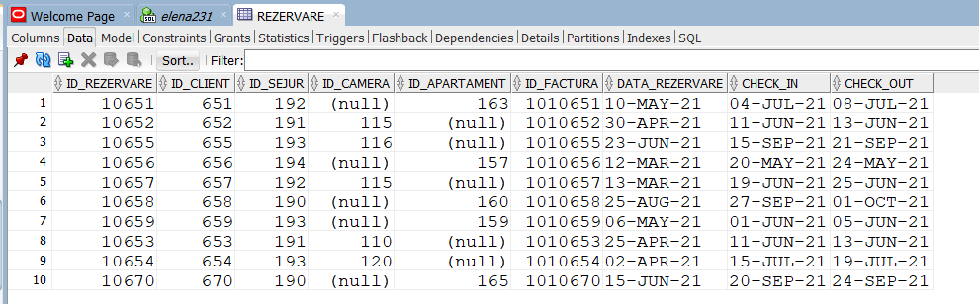

Entitatea TIP SEJUR

insert into tip_sejur values

(190,'Mic dejun',100);

insert into tip_sejur values

(191,'Room only',0);

insert into tip_sejur values

(192,'Demipensiune',150);

insert into tip_sejur values

(193,'Pensiune completa',280);

insert into tip_sejur values

(194,'All-Inclusive',310);

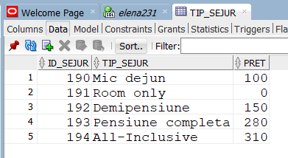

Entitatea SERVICII EXTRA

insert into servicii_extra values

(1100,'Sala de sport', 50);

insert into servicii_extra values

(1101,'Piscina', 100);

insert into servicii_extra values

(1102,'Sauna', 100);

insert into servicii_extra values

(1103,'Jacuzzi', 100);

insert into servicii_extra values

(1104,'Excursie', 150);

insert into servicii_extra values

(1105,'Sala de jocuri', 120);

insert into servicii_extra values

(1106,'Loc de joaca’, 70);

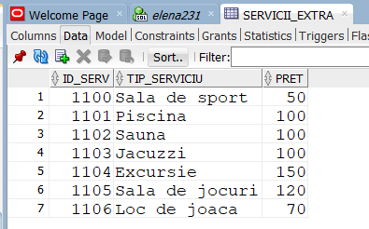

1. Procedura SERVICII HOTEL

-- Afisati toate serviciile de care dispune un hotel dintr-un oras dat ca parametru.

create or replace procedure servicii_hotel

(oras_hotel hotel.oras%TYPE) as

TYPE servicii IS TABLE OF SERVICII_EXTRA%ROWTYPE INDEX BY PLS_INTEGER;

t servicii;

TYPE tablou_imbricat IS TABLE OF SERVICII_EXTRA.ID_SERV%TYPE;

v_serv tablou_imbricat:= tablou_imbricat();

serviciu SERVICII_EXTRA%ROWTYPE;

cod_oras hotel.id_hotel%TYPE;

i number:=0;

j number:=0;

begin

select id_hotel into cod_oras

from hotel

where upper(oras_hotel)=upper(oras);

select id_serv bulk collect into v_serv

from dispune

where cod_oras=id_hotel;

for j in v_serv.first..v_serv.last loop

select id_serv, tip_serviciu, pret into serviciu

from servicii_extra

where id_serv = v_serv(j);

t(i):=serviciu;

i := i+1;

end loop;

dbms_output.put_line('Hotelul "Glimpse" din orasul ' || oras_hotel || ' dispune de urmatoarele servicii: ');

for i in t.first..t.last loop

dbms_output.put_line(t(i).tip_serviciu);

end loop;

end servicii_hotel;

execute servicii_hotel('Constanta');

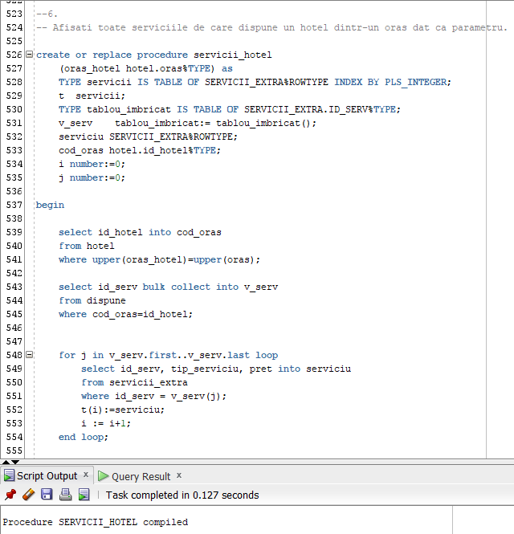

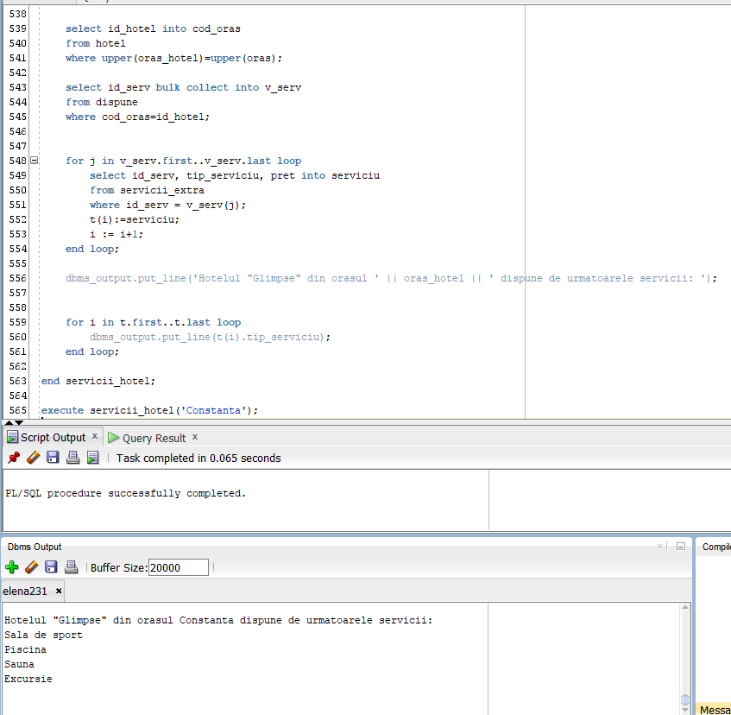

1. Procedura ANGAJATI

-- Afisati toti angajatii subordonati unui manager al carui nume si prenume este dat de la tastatura. Dintre acestia, afisati job-ul celui mai vechi angajat.

create or replace procedure angajati

(nume_manager angajat.nume%TYPE,

prenume_manager angajat.prenume%TYPE) as

cod_manager angajat.id_angajat%type;

nume_angajat angajat.nume%TYPE;

prenume_angajat angajat.prenume%TYPE;

job_nume job.nume_job%TYPE;

salariu_ang job.salariu%TYPE;

angajare angajat.data_angajarii%TYPE;

nr number(4);

cursor c_lista_sub (cod_man angajat.id_angajat%type) is

select nume, prenume

from angajat

where id_manager=cod_man;

cursor c_job is

select j.nume_job

from job j, angajat a

where a.data_angajarii=angajare and a.id_job=j.id_job;

begin

select id_angajat into cod_manager

from angajat

where upper(nume)=upper(nume_manager) and upper(prenume)=upper(prenume_manager);

dbms_output.put_line('cod ' || cod_manager);

select min(data_angajarii) into angajare

from angajat

where id_manager=cod_manager;

dbms_output.put_line('Lista angajatilor subordonati lui ' || nume_manager || ' ' || prenume_manager || ' sunt:');

open c_lista_sub(cod_manager);

loop

--dbms_output.put_line(cod_manager);

fetch c_lista_sub into nume_angajat, prenume_angajat;

exit when c_lista_sub%NOTFOUND;

dbms_output.put_line(nume_angajat || ' ' || prenume_angajat);

end loop;

close c_lista_sub;

open c_job;

loop

fetch c_job into job_nume;

exit when c_job%NOTFOUND;

end loop;

close c_job;

dbms_output.put_line('Angajatul cu cea mai mare vechime are ca job ' || job_nume);

end angajati;

/

execute angajati('Tiberiu', 'Emil');

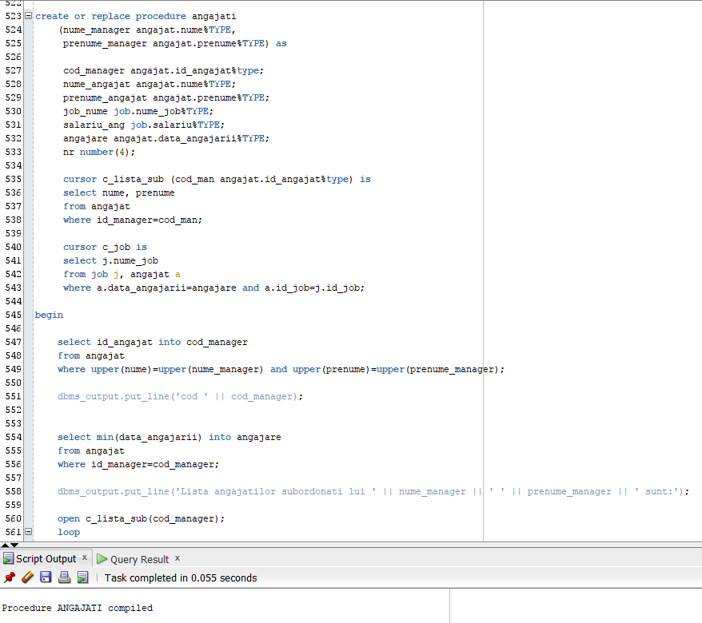

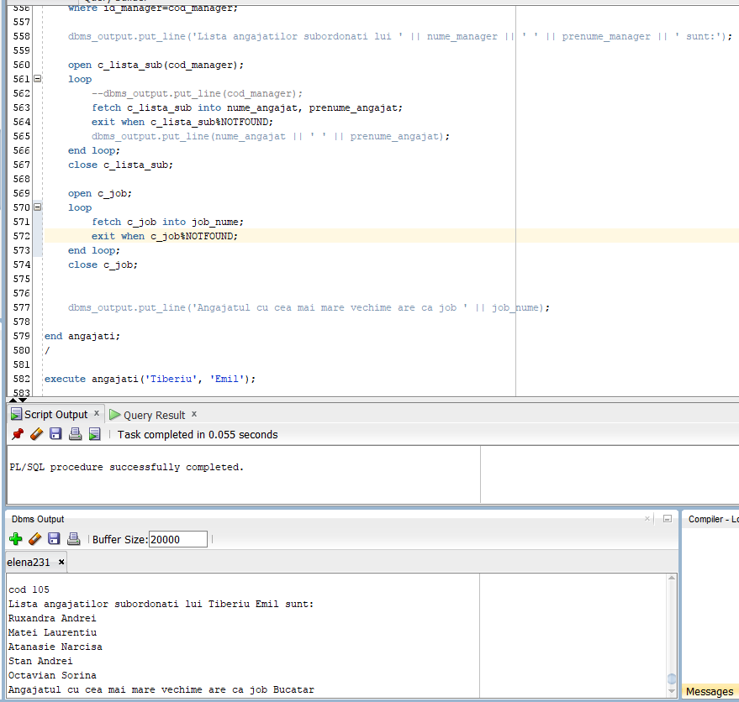

1. Functia TIP_CAMERA

--Afisati care este tipul camerei rezervate de catre un client al carui nume incepe cu litera 'C', rezervarea fiind facuta intr-o luna data ca parametru dintr-un hotel dat ca parametru.

create or replace function tip_camera (oras_h hotel.oras%TYPE,

luna number)

return varchar2 is camera1 camera.tip_camera%type;

nume client.nume%TYPE;

cod_h hotel.id_hotel%TYPE;

luna_invalida exception;

begin

if luna<1 or luna> 12 then

raise luna_invalida;

end if;

select id_hotel into cod_h

from hotel

where upper(oras_h)=upper(oras);

select c.tip_camera into camera1

from camera c

join rezervare r on c.id_camera=r.id_camera

join client cc on cc.id_client=r.id_client

where extract (MONTH from r.data_rezervare)=luna and cc.nume like ('C%');

dbms_output.put_line('Camera rezervata in luna ' || luna || ' la hotelul din ' || oras_h || ' este de tip: ');

return camera1;

EXCEPTION

WHEN luna_invalida THEN

RAISE_APPLICATION_ERROR(-20999,'Luna introdusa este invalida!');

WHEN NO_DATA_FOUND THEN

RAISE_APPLICATION_ERROR(-20999, 'In istoricul de rezervari nu exista nicio camera rezervata la hotelul din ' || oras_h || ' in luna ' || luna);

WHEN TOO_MANY_ROWS THEN

RAISE_APPLICATION_ERROR(-20999,'Mai multe camere au fost rezervate la hotelul din ' || oras_h || ' in luna ' || luna);

end tip_camera;

/

--eroare: luna invalida

begin

dbms_output.put_line(tip_camera('Constanta',14));

end;

/

--eroare: TOO MANY ROWS

begin

dbms_output.put_line(tip_camera('Constanta',4));

end;

/

--eroare: NO DATA FOUND

begin

dbms_output.put_line(tip_camera('Constanta',12));

end;

/

--output corect

begin

dbms_output.put_line(tip_camera('Constanta',3));

end;

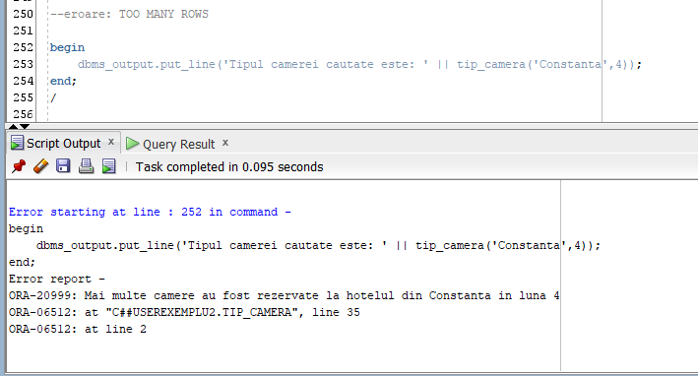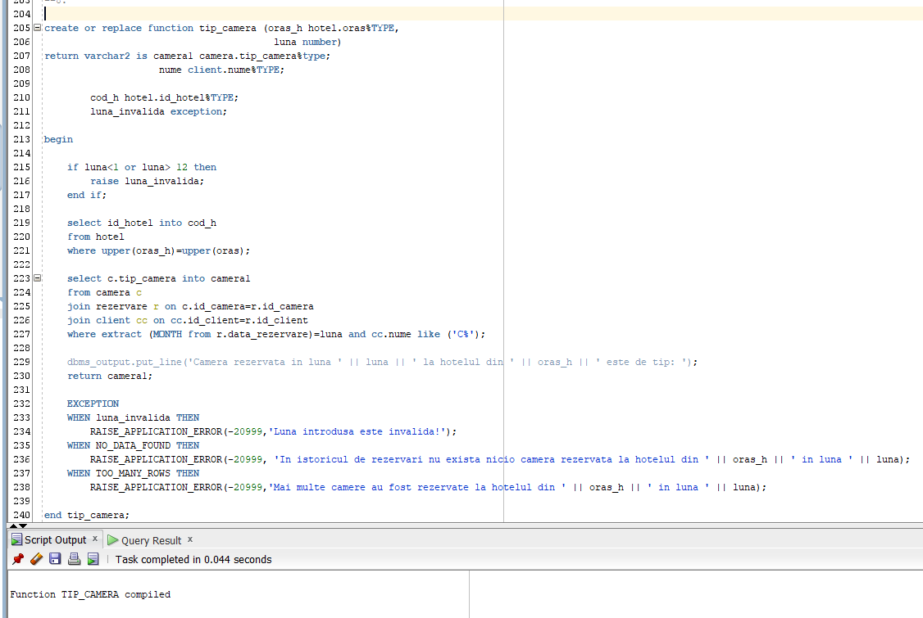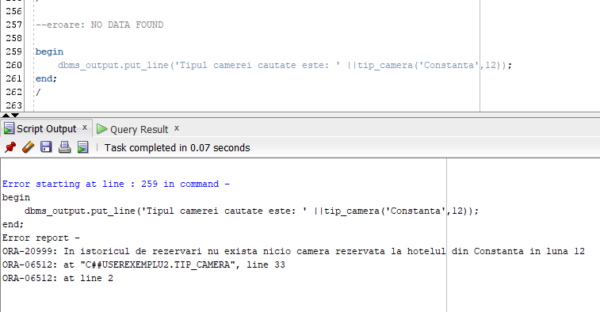

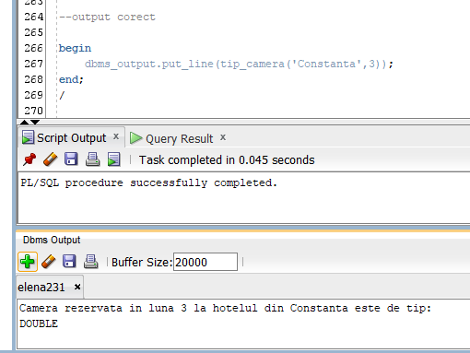

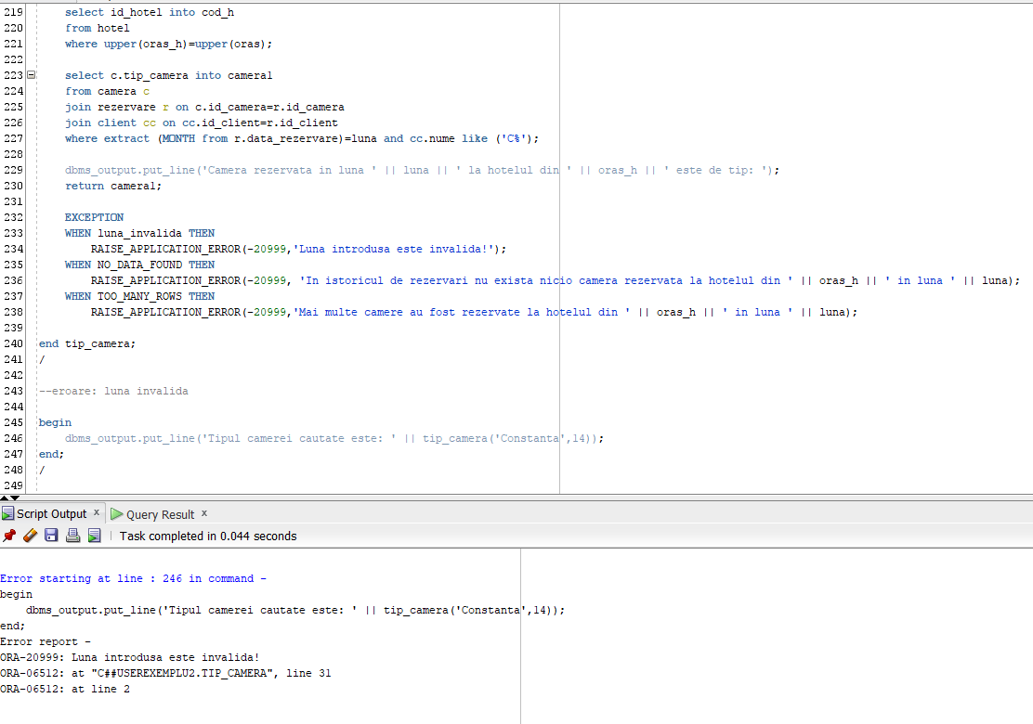

1. Procedura VAL_PLATA

--Afisati valoarea de plata a clientului care a rezervat un apartament cu 3 camere in hotelul al carui id este furnizat, a carui valoare a tipului de sejur trebuie sa fie mai mare decat o valoare

--data iar check-in-ul trebuie sa se fi facut intr-o zi data ca parametru.

create or replace procedure val_plata (cod_h hotel.id_hotel%TYPE,

zi number,

pret_s tip_sejur.pret%TYPE) as

rezultat plata.valoare_plata%TYPE;

zi_invalida exception;

begin

if zi<1 or zi>31 then

raise zi_invalida;

end if;

select p.valoare_plata into rezultat

from plata p

join factura f on p.id_plata = f.id_plata

join rezervare r on r.id_factura=f.id_factura

join apartament a on a.id_apartament=r.id_apartament

join tip_sejur t on r.id_sejur=t.id_sejur

where a.id_hotel=cod_h and a.numar_camere=3 and EXTRACT (DAY from r.check_in)=zi and t.pret>pret_s;

dbms_output.put_line('Valoarea de plata cautata este ' || rezultat);

exception

when zi_invalida then

RAISE_APPLICATION_ERROR(-20009, 'Ziua transmisa ca parametru este invalida!');

when NO_DATA_FOUND then

RAISE_APPLICATION_ERROR(-20009, 'Nu exista nicio rezervare cu aceste date!');

when TOO_MANY_ROWS then

RAISE_APPLICATION_ERROR(-20009, 'Exista mai multe rezervari cu aceste date!');

when others then

RAISE_APPLICATION_ERROR(-20009, 'Am intampinat o eroare');

end val_plata;

/

--OUTPUT CORECT

execute val_plata(5,1,50);

--eroare: NO_DATA_FOUND

execute val_plata(7,25,50);

--eroare: zi invalida

execute val_plata(3,36,50);

--eroare: TOO_MANY_ROWS

execute val_plata(3,20,50);

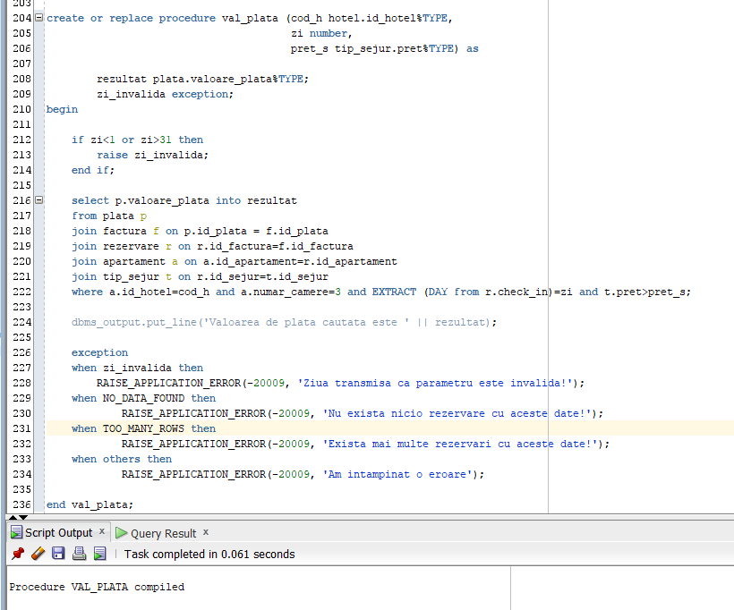

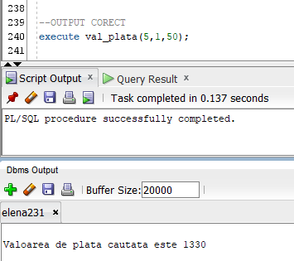

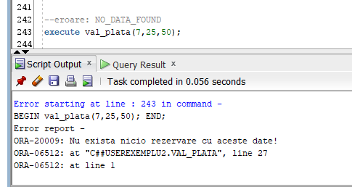

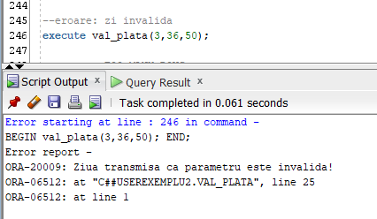

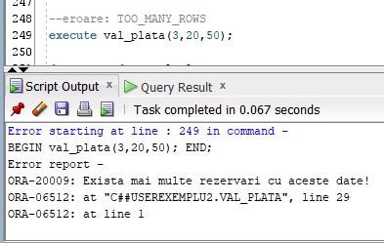

1. Trigger LMD la nivel de comanda

-- Creati un trigger de tip LMD la nivel de comanda care sa nu permita existenta unui numar mai mare de 10 servicii extra.

create or replace trigger trigex10 before insert on servicii_extra

declare

nr_serv number;

begin

select count(id_serv) into nr_serv

from servicii_extra;

if nr_serv>10 then

raise_application_error(-20009, 'Nu mai putem adauga alte servicii extra');

end if;

end;

--declansare trigger

begin

for i in 1..11 loop

insert into servicii_extra values(100+i, 'Serviciul ' || i, 100);

end loop;

end;

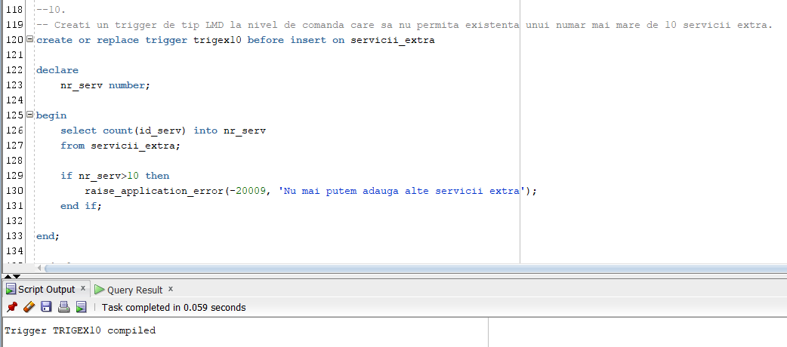

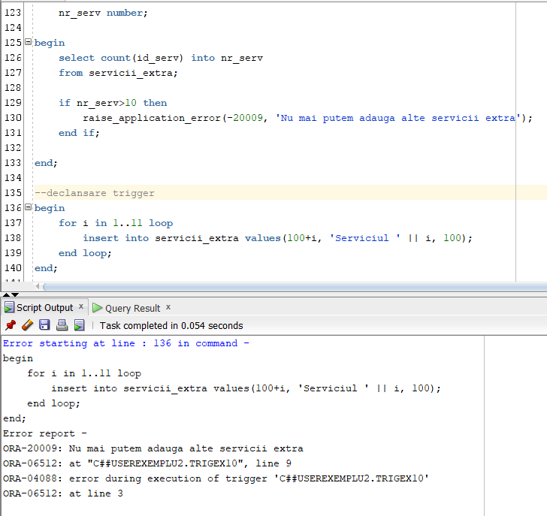

1. Trigger de tip LMD la nivel de linie

--Creati un trigger de tip LMD la nivel de linie astfel incat pretul tipurilor de sejur sa nu poata fi crescute cu mai mult de 50 de lei.

create or replace trigger trigex11 before update of pret on tip_sejur for each row

begin

if(:NEW.pret > :OLD.pret + 50) then

raise_application_error(-20009, 'Pretul tipurilor de masa nu pot fi crescute cu mai mult de 50 de lei');

end if;

end;

/

--declansare trigger

update tip_sejur

set pret = pret + 60;

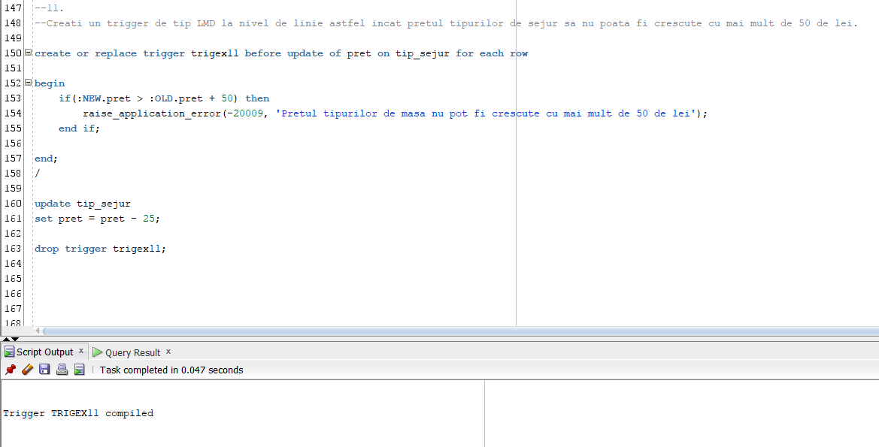

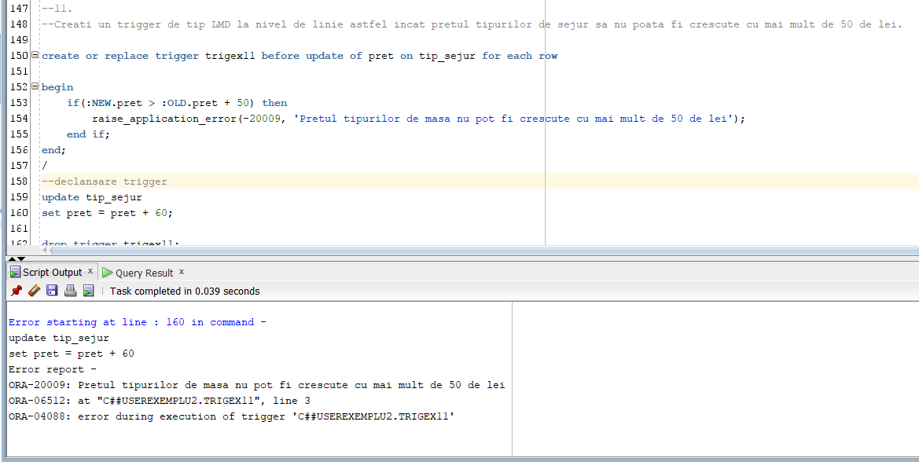

1. Trigger de tip LDD

-- Creati un trigger de tip LDD care dupa fiecare modificare a schemei salveaza modificarile in tabelul "actiuni".

-- Modificarile la nivel LDD pot fi facute doar de userul admin ('C##USEREXEMPLU2').

create table actiuni (

utilizator VARCHAR2(30),

nume_bd VARCHAR2(50),

eveniment VARCHAR2(20),

nume_obiect VARCHAR2(30),

data DATE);

create or replace trigger trigex12 after create or drop or alter on schema

begin

if USER!='C##USEREXEMPLU2' then

raise_application_error(-20009, 'Nu aveti voie sa faceti modificari asupra bazei de date!');

end if;

insert into actiuni values

(SYS.LOGIN_USER, SYS.DATABASE_NAME, SYS.SYSEVENT, SYS.DICTIONARY_OBJ_NAME, SYSDATE);

end;

--declansare trigger

create table testare_trig

( column1 number,

column2 varchar2(20),

column3 date);

alter table testare_trig

modify column3 number;

select * from actiuni;

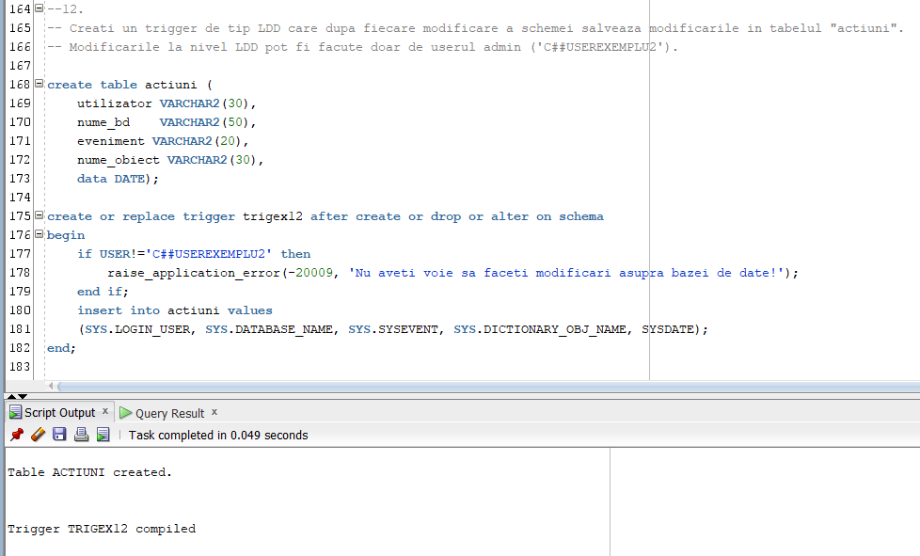

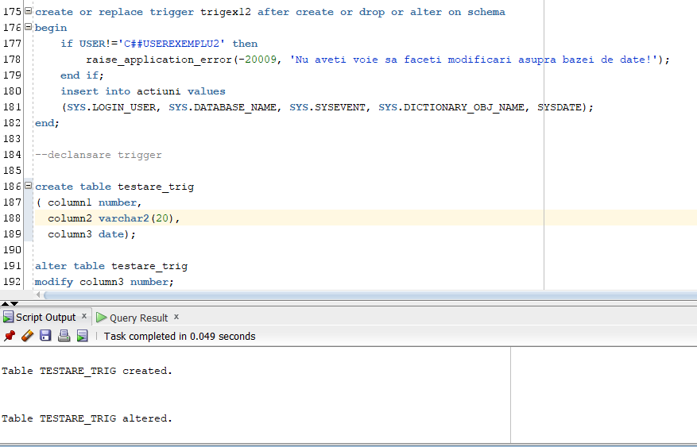

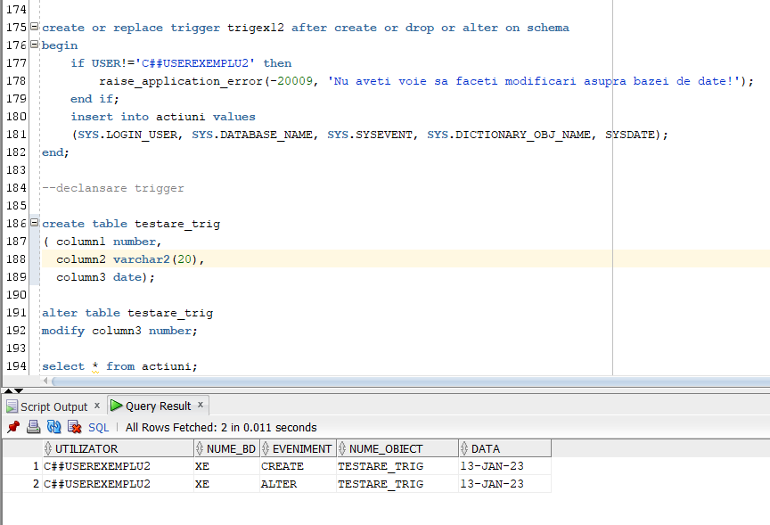

1. Pachet cu obiectele anterior definite

create or replace package ex13_ege as

--6.

procedure servicii_hotel

(oras_hotel hotel.oras%TYPE);

--7.

procedure angajati

(nume_manager angajat.nume%TYPE,

prenume_manager angajat.prenume%TYPE);

--8.

function tip_camera (oras_h hotel.oras%TYPE,

luna number)

return varchar2;

--9.

procedure val_plata (cod_h hotel.id_hotel%TYPE,

zi number,

pret_s tip_sejur.pret%TYPE);

end ex13_ege;

/

create or replace package body ex13_ege as

--6.

procedure servicii_hotel

(oras_hotel hotel.oras%TYPE) is

TYPE servicii IS TABLE OF SERVICII_EXTRA%ROWTYPE INDEX BY PLS_INTEGER;

t servicii;

TYPE tablou_imbricat IS TABLE OF SERVICII_EXTRA.ID_SERV%TYPE;

v_serv tablou_imbricat:= tablou_imbricat();

serviciu SERVICII_EXTRA%ROWTYPE;

cod_oras hotel.id_hotel%TYPE;

i number:=0;

j number:=0;

begin

select id_hotel into cod_oras

from hotel

where upper(oras_hotel)=upper(oras);

select id_serv bulk collect into v_serv

from dispune

where cod_oras=id_hotel;

for j in v_serv.first..v_serv.last loop

select id_serv, tip_serviciu, pret into serviciu

from servicii_extra

where id_serv = v_serv(j);

t(i):=serviciu;

i := i+1;

end loop;

dbms_output.put_line('Hotelul "Glimpse" din orasul ' || oras_hotel || ' dispune de urmatoarele servicii: ');

for i in t.first..t.last loop

dbms_output.put_line(t(i).tip_serviciu);

end loop;

end servicii_hotel;

--7.

procedure angajati

(nume_manager angajat.nume%TYPE,

prenume_manager angajat.prenume%TYPE) as

cod_manager angajat.id_angajat%type;

nume_angajat angajat.nume%TYPE;

prenume_angajat angajat.prenume%TYPE;

job_nume job.nume_job%TYPE;

salariu_ang job.salariu%TYPE;

angajare angajat.data_angajarii%TYPE;

nr number(4);

cursor c_lista_sub (cod_man angajat.id_angajat%type) is

select nume, prenume

from angajat

where id_manager=cod_man;

cursor c_job is

select j.nume_job

from job j, angajat a

where a.data_angajarii=angajare and a.id_job=j.id_job;

begin

select id_angajat into cod_manager

from angajat

where upper(nume)=upper(nume_manager) and upper(prenume)=upper(prenume_manager);

dbms_output.put_line('cod ' || cod_manager);

select min(data_angajarii) into angajare

from angajat

where id_manager=cod_manager;

dbms_output.put_line('Lista angajatilor subordonati lui ' || nume_manager || ' ' || prenume_manager || ' sunt:');

open c_lista_sub(cod_manager);

loop

--dbms_output.put_line(cod_manager);

fetch c_lista_sub into nume_angajat, prenume_angajat;

exit when c_lista_sub%NOTFOUND;

dbms_output.put_line(nume_angajat || ' ' || prenume_angajat);

end loop;

close c_lista_sub;

open c_job;

loop

fetch c_job into job_nume;

exit when c_job%NOTFOUND;

end loop;

close c_job;

dbms_output.put_line('Angajatul cu cea mai mare vechime are ca job ' || job_nume);

end angajati;

--8.

function tip_camera (oras_h hotel.oras%TYPE,

luna number)

return varchar2 is camera1 camera.tip_camera%type;

nume client.nume%TYPE;

cod_h hotel.id_hotel%TYPE;

luna_invalida exception;

begin

if luna<1 or luna> 12 then

raise luna_invalida;

end if;

select id_hotel into cod_h

from hotel

where upper(oras_h)=upper(oras);

select c.tip_camera into camera1

from camera c

join rezervare r on c.id_camera=r.id_camera

join client cc on cc.id_client=r.id_client

where extract (MONTH from r.data_rezervare)=luna and cc.nume like ('C%');

dbms_output.put_line('Camera rezervata in luna ' || luna || ' la hotelul din ' || oras_h || ' este de tip: ');

return camera1;

EXCEPTION

WHEN luna_invalida THEN

RAISE_APPLICATION_ERROR(-20999,'Luna introdusa este invalida!');

WHEN NO_DATA_FOUND THEN

RAISE_APPLICATION_ERROR(-20999, 'In istoricul de rezervari nu exista nicio camera rezervata la hotelul din ' || oras_h || ' in luna ' || luna);

WHEN TOO_MANY_ROWS THEN

RAISE_APPLICATION_ERROR(-20999,'Mai multe camere au fost rezervate la hotelul din ' || oras_h || ' in luna ' || luna);

end tip_camera;

--9.

procedure val_plata (cod_h hotel.id_hotel%TYPE,

zi number,

pret_s tip_sejur.pret%TYPE) as

rezultat plata.valoare_plata%TYPE;

zi_invalida exception;

begin

if zi<1 or zi>31 then

raise zi_invalida;

end if;

select p.valoare_plata into rezultat

from plata p

join factura f on p.id_plata = f.id_plata

join rezervare r on r.id_factura=f.id_factura

join apartament a on a.id_apartament=r.id_apartament

join tip_sejur t on r.id_sejur=t.id_sejur

where a.id_hotel=cod_h and a.numar_camere=3 and EXTRACT (DAY from r.check_in)=zi and t.pret>pret_s;

dbms_output.put_line('Valoarea de plata cautata este ' || rezultat);

exception

when zi_invalida then

RAISE_APPLICATION_ERROR(-20009, 'Ziua transmisa ca parametru este invalida!');

when NO_DATA_FOUND then

RAISE_APPLICATION_ERROR(-20009, 'Nu exista nicio rezervare cu aceste date!');

when TOO_MANY_ROWS then

RAISE_APPLICATION_ERROR(-20009, 'Exista mai multe rezervari cu aceste date!');

when others then

RAISE_APPLICATION_ERROR(-20009, 'Am intampinat o eroare');

end val_plata;

end ex13_ege;

begin

dbms_output.put_line('Exericitiul 6:');

ex13_ege.servicii_hotel('Constanta');

dbms_output.put_line(' ');

dbms_output.put_line('Exericitiul 7:');

ex13_ege.angajati('Tiberiu', 'Emil');

dbms_output.put_line(' ');

dbms_output.put_line('Exericitiul 8:');

dbms_output.put_line(ex13_ege.tip_camera('Constanta',3));

dbms_output.put_line(' ');

dbms_output.put_line('Exericitiul 9:');

ex13_ege.val_plata(5,1,50);

end;

