ITC 4214 – Internet Programming
Summer Term 2026
Professor: Leonardos Mageiros
Student: Eleni Batsogianni
Date: 21/6/2026
Midterm Project

DanceFit Studio Website
Introduction
The goal of the project is to create a task management application for a company which will be fully responsive and inclusive for everyone. This website is created by using HTML, CSS / Bootstrap and JavaScript. The name of the company is DanceFit Studio, and it is a gym studio that offers different services such as dance classes, fitness programs and it organizes upcoming events for the community.
Description of the Task Allocation System
This website introduces the company to the users, and they may learn important information about company’s services. They can get quick access to the company, browse upcoming events, find contact information and manage tasks through the task allocation system. All pages are straightforward such as tasks page which is one of the most important pages of the website. In this page, there are the most functionalities such as creation of tasks, edit existing tasks, deletion of tasks and they are able to see a table summary for the tasks they have already created. All tasks include a name, description, due date, priority level and status. In addition, the system can filter tasks by status and sort them by name or due date. It makes users’ experience better because they do not have to go through all tasks at once. Users are able to see a tasks chart bar with statistics taken from the summary cards. The system updates the page dynamically and the user does not have to reload the page to see the result.
Detailed documentation of coding decisions
For the tasks management page, tasks are stored in an array named “tasks” using JavaScript, so the system generate the content dynamically. Every task has several objects such as name, description, date, priority and status and they are added to the table at the end of the page. JavaScript is helpful because the table has different table cells for the objects, different rows for each task and action buttons for making changes. The action buttons are connected with the summary cards and chart bar, so everything is updated automatically. The user experience becomes more engaging by letting users filter and sort their tasks. In the sorting functionality, the task is sorted alphabetically by the name or due date. The order of the tasks may matter to users because they may want an organized table, thus I created a task analytics dashboard to provide data to users visually. They are able to see their tasks based on the filter they selected comparing pending and completed tasks. This functionality makes the website more consistent and usable.
Latest Activity Section: It can be found at the end of the homepage next to the motivational quote. The goal of this section is to present recent activities to users and announcements. Users can be quickly informed about the latest events without searching for hours. The latest activity was built through Bootstrap’s grid system with a two column layout, and it provides more details for anyone who is interested in learning more about the company.
API integration was used for displaying a motivational quote dynamically. JavaScript requests a random quote from a link with random quotes, it receives json data and it extracts the content which is the quote and the author. I created a backup quote in case it does not work when the user enters the page. The quote is inside a box, so the user can distinguish it from the content. It is worth saying that the functionality for the quote is inside main.js because users can see it only on this page.
In the About Page, I created a Bootstrap Carousel with several images to make the website more interesting. It can be rotated through the arrows by the users, and the choice was taken because multiple images can be displayed in the same area. The content of the page represents the goals, mission, values, staff and services in an organized manner. As the user scrolls down the page, they see all details in service cards which were created with grid classes such as “col-md-4” so the layout will not change in any case.
The Events Page allows users to browse the upcoming events and register to as many events as possible. The event cards make every event unique, and users can find the event quickly. The most important functionality in this page is the registration system. I used the “querySelector” and “querySelectorAll()” method because there are many registration buttons. The variable count stores the total number of registrations. When the user clicks on the button, an event listener is triggered, the counter increases by 1 and the number is displayed at the top immediately. In addition, the button changes form into “Registered” and it becomes disabled, so the system prevents double registration on the same event accidentally. Finally, a message appears when the user is registered as a form of feedback. The purpose of DOM manipulation in this page is to update actions without obliging the user to reload the page. Instant confirmation creates a sense of trust to users, and the website is considered trustworthy.
The Contact Page includes a form submission for users to send a message or a question to the company. The form has the following fields: name, email, subject, message and it was created with Bootstrap components. However, form validation was needed to prevent users from submitting incorrect information because the company would not understand the purpose of the form. The validation checks if all fields are completed and if they have the correct format. For better responsiveness, error messages appear if they do not follow the proper format, so they cannot submit the form if they have wrong input. Google Maps was also integrated at the end of the page, but it does not loading due to restrictions.
GitHub Repository
Git & GitHub was used for version control. More specifically, it was used to track changes and save them into the repository. While I was creating the website and developing code, I created commits in Git and GitHub desktop. In this way, the local project in my desktop was synchronized with GitHub so anyone could see all actions taken and all changes I made. It is important to mention that when I fixed errors, GitHub on desktop would display exactly the lines of the code for users to see the difference between them. Another positive thing about GitHub is that it keeps old versions of the code, so when I made a mistake in tasks.html, I lost the code and I restored it from commit history.
The GitHub Repository link:
Google Chrome LightHouse was used to evaluate website’s accessibility, SEO and performance when it was complete. In the screenshots, we can see the results from the audits which confirm that the website uses the necessary elements to have accessibility and responsiveness. In the code, the first thing I added was alt text for all images and semantic HTML elements (nav, main, header, section, footer). These elements create an organized structure of the page. This description allows screen readers to explain the content of an image to blind people. Next, I put labels when I was creating form fields, so the purpose of the form could be more understandable, and users could see what they need to write in each field. In order for the website to be fully responsive, the design should include colors and different style. For that reason, all buttons have different colors for a different meaning. For example, the “Complete” button is green, the “Edit” button .is yellow and the “Delete” button is red. I searched on google the code for colors to use them in CSS/Bootstrap file.
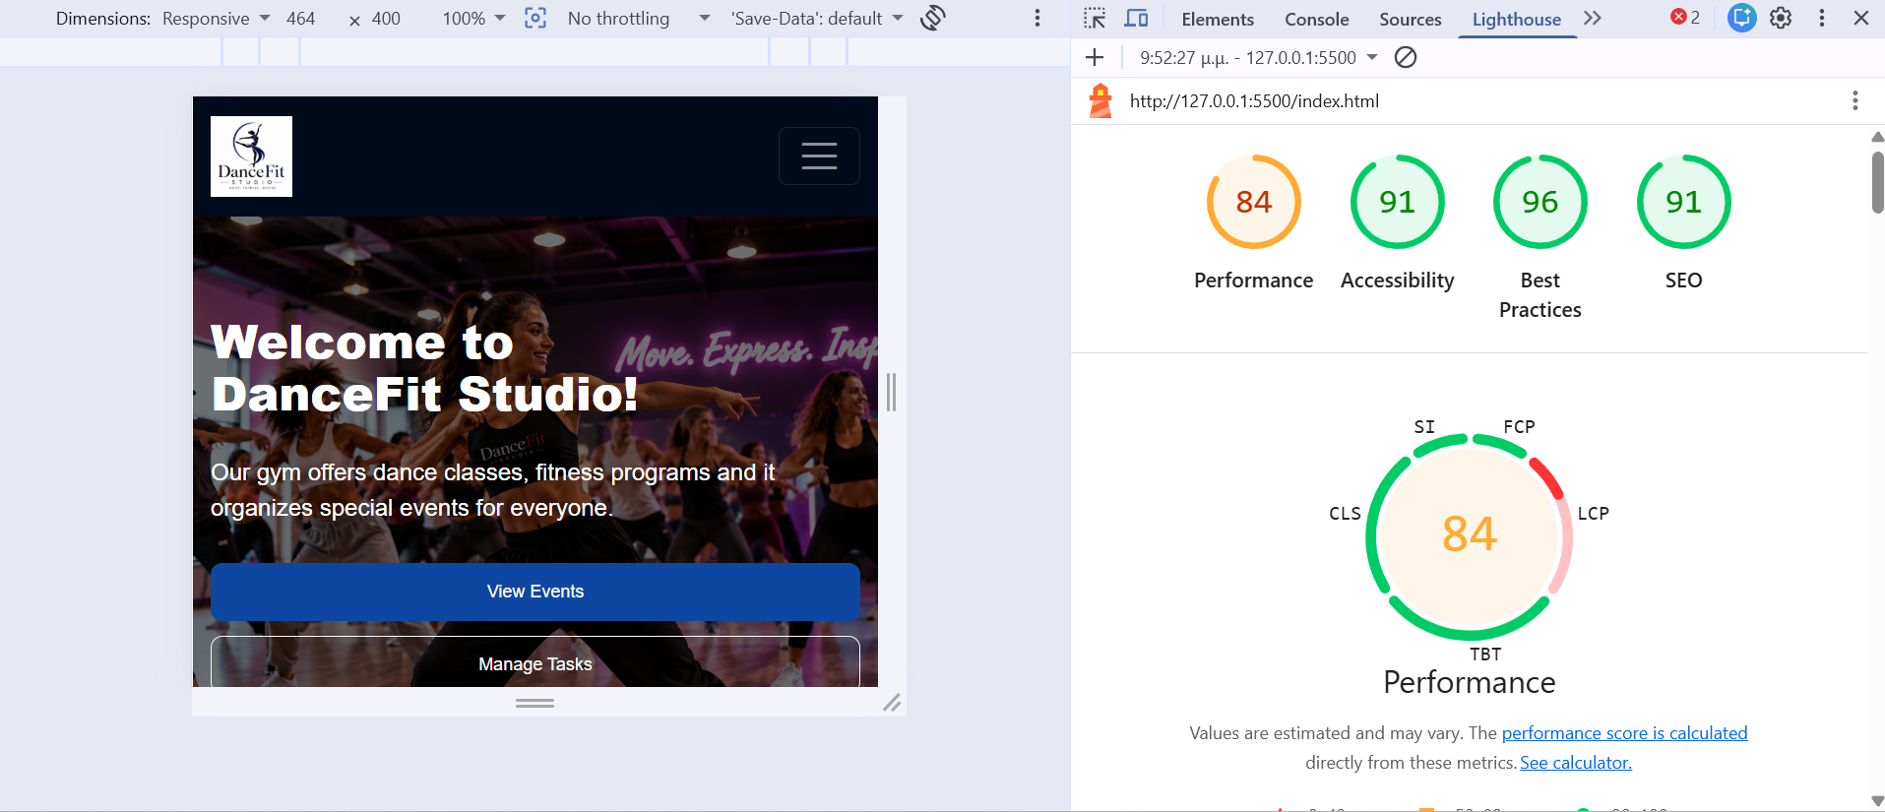
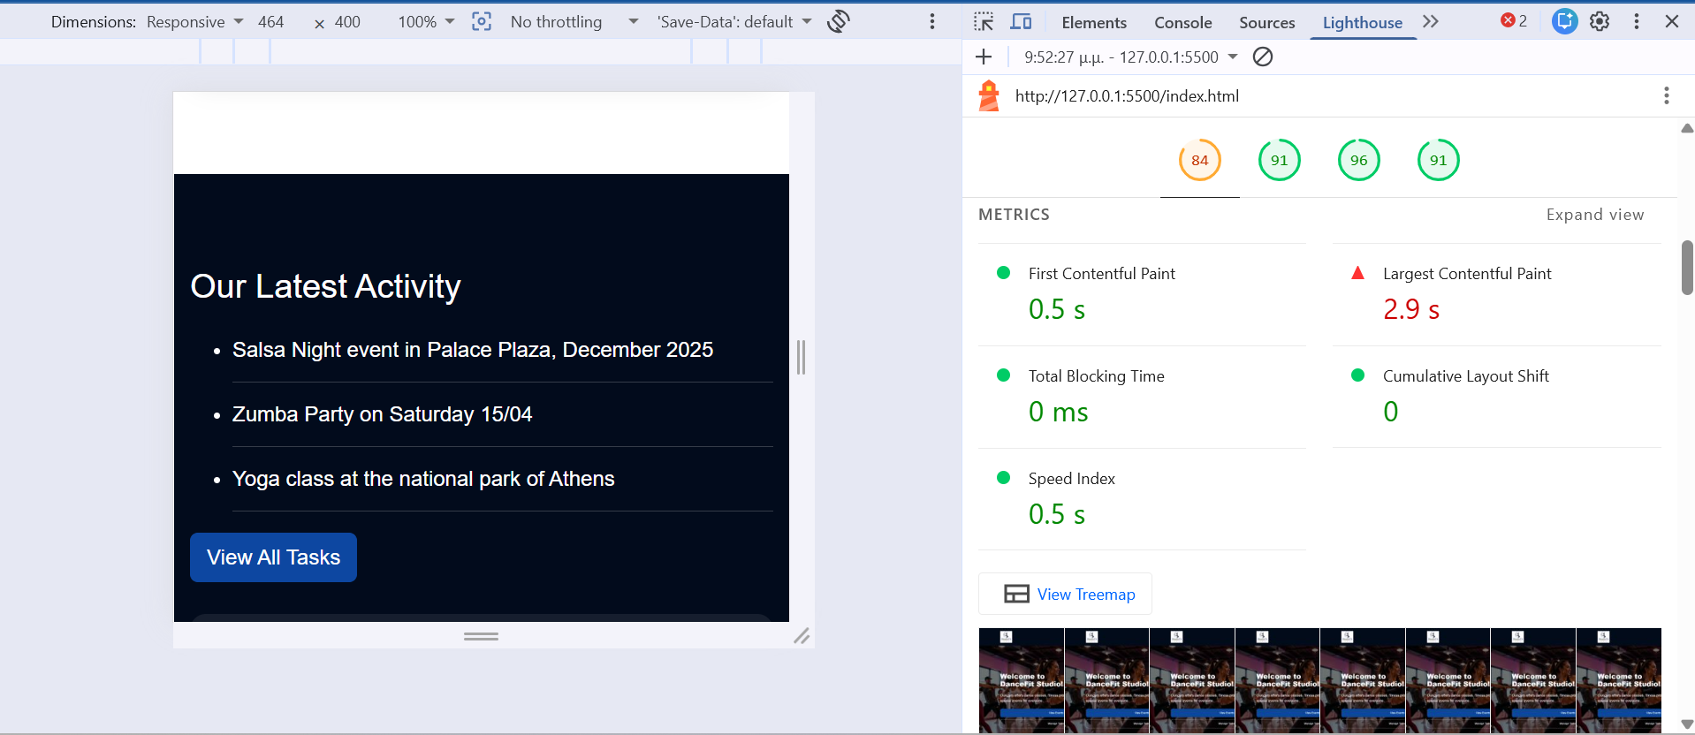
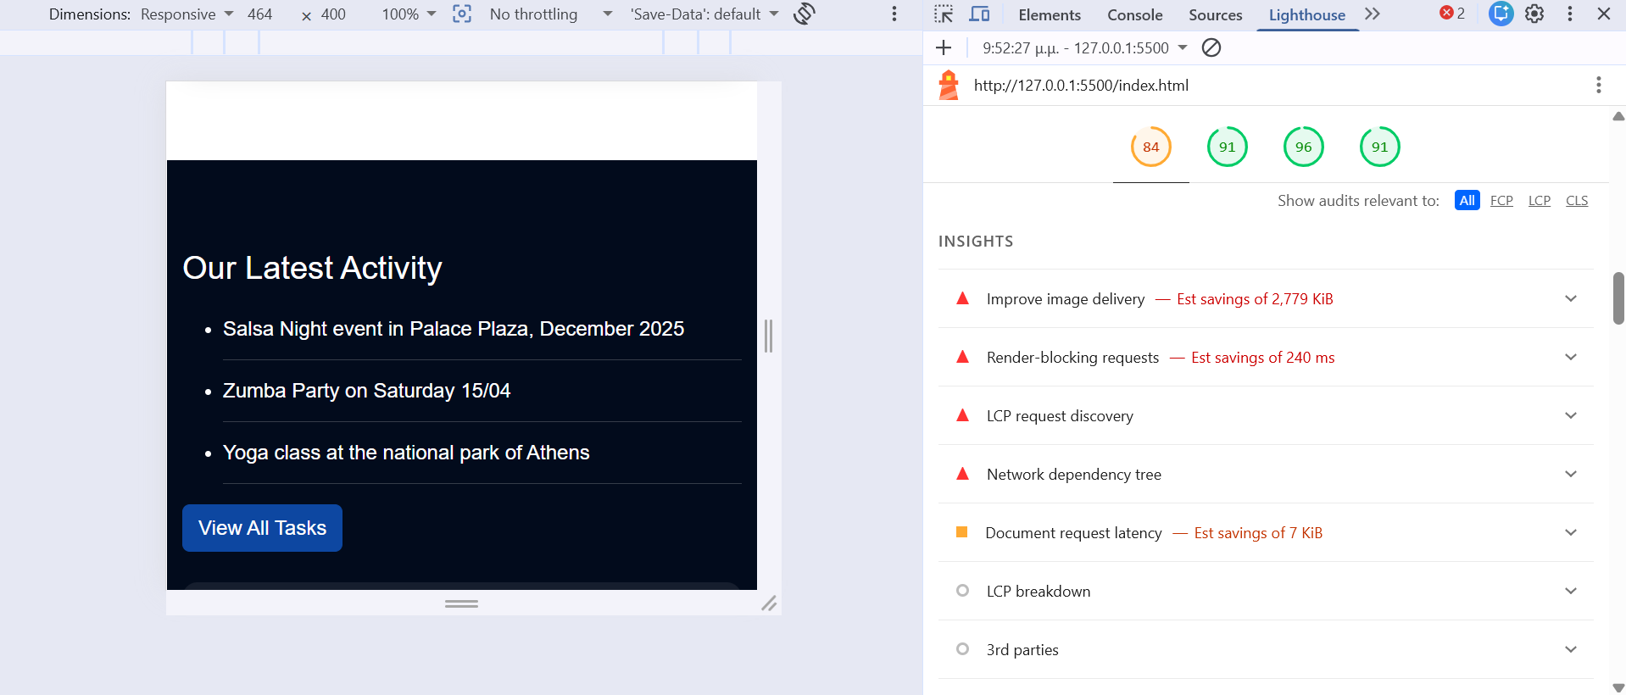
Dark mode and light mode were implemented because dark mode help users read the content more easily at night hours. When the user presses dark mode, the background color is black with white text. JavaScript dynamically adds or removes the class “dark-mode” from the body element. Afterwards, CSS runs background colors for all sections such as cards, tables, forms and paragraphs. The style.css file contains all styles applied in pages. At first, I had written the CSS rules for each page separately, but then I realized that all pages have common names, so I wrote them one time.
Bootstrap which was loaded through a CDN was the perfect choice for responsive design because grid system was used such as “col-md-4”, “container”. The content can be adapted to all screens and users do not have to scroll horizontally to see information. The website was tested to desktop screen and mobile screen to make sure that it works correctly, and the content was visible appropriately. Images are resized when the user switches to mobile device. The meta tag was also used in the code for mobile devices.
SEO (Search Engine Optimization)
Each page includes titles and subtitles that represent the content of the page. SEO helps the search engine to interpret the website. The search engine can understand what the page is all about and these practices improve overall performance. Each page has unique names, titles, and descriptive content; hence the engine finds the requested data instantly. All pages have the following heading hierarchy: H1 (titles), H2 (subtitles), H3 and H4 (paragraphs, service cards). If the hierarchy was missing, the page layout would be chaotic.
Challenges & Personal Reflection
While I was developing the website, several challenges occurred which needed to be addressed. The most challenging page was the tasks page because it needed many functionalities such as table summary, visual chart, filters and sorting tasks. I had to test them constantly to make sure that all components were functioning properly. The first problem was when I created filters for the table summary, I created action buttons (complete, edit, delete) but they were not visible to the users when the filter by status was not “All”. Furthermore, the visual representation did not contain all data, and I had to find a way to take the “filter by status” into consideration.
Another challenge was dark mode implementation across all pages. When I pressed the dark mode button, the page became dark except title sections such as “Our Beliefs” in About Page. Instead of seeing black background with white text, the user could see a white box. This issue was fixed by retyping the CSS file from scratch because I had made a wrong rule without noticing. Service cards and forms were converted smoothly.
Making commits to git bash was challenging because I had to understand how they are connected with my local repository and how they are synchronized. While I was trying to add a new commit, it did not always find the changes I made in Visual Studio Code. However, the version control was extremely useful because I was able to see all changes from the start until the end.
Each time I was adding a new function to a page, I had to test it in Chrome Developer Tools because it was displayed differently in each screen size. Images were large in mobile devices as well as cards and bootstrap helped me fix them.
Finally, I struggled creating the form validation on the Contact page. At first, the form accepted invalid input from the user such as numbers on the name field and email without symbols “@” and “.”. When the user entered invalid information, the message for successful submission still appeared and this was wrong. I tried multiple validation rules to find the correct one and many tests were done to ensure that the user had filled all fields and they followed the guidelines. Error messages appear as a guide to redirect users until they write correct information. Apart from this problem, google maps does not load and it displays connection/embedding error because some map links require specific URLs. I tried to add different links and iframe sources, but the map still crashes.
Overall, this project helped me understand HTML, CSS, JavaScript, Bootstrap and APIs and the importance of connecting them for a great result. I used accessibility principles in order for the website to be fully responsive to everyone and version control using GitHub for all changes being made during development. Testing the website to different screen sizes is essential because the user may open it from multiple devices. The user experience is extremely important because users are customers. The website reflects the professionalism and the trustworthiness of the company. If the design or the activities are complicated, then the user will leave the website. All challenges I faced through the process helped me become better and I learnt how to search for solutions even if it seems difficult. Some images I used for the website were created by ChatGPT AI and I found other images on google, more specifically on unsplash.com. I also searched for functions and methods on W3schools which explain code on programming languages.
Sources
https://www.w3schools.com/js/js_validation.asp
https://getbootstrap.com/docs/4.1/getting-started/introduction/
https://unsplash.com/s/photos/fitness-event?license=free

