B2 - Oral Mediation 1: Teacher’s Notes
Learning a Foreign Language
Before starting the mediation activity, ask students to read the task and the poster
carefully to make the aim of the activity clear.
Your Danish friend, Calvin, is going to move to Girona for the next 6 months on an Erasmus programme. He cannot speak Spanish and he does not want to study it either. You have read this poster and, based on the information it contains, you send your friend a voice message telling him how important it is to learn a foreign language.

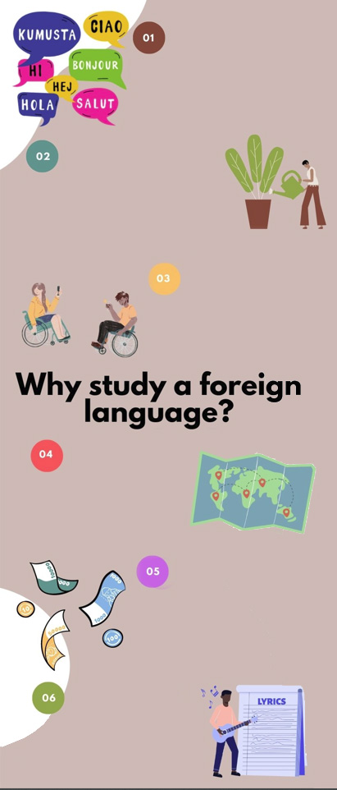
BETTER UNDERSTANDING OF YOUR NATIVE LANGUAGE AND OTHERS
- The more languages you
know, the better you can analyse your own.
- Once you learn a second language, it will be easier to learn other.
SELF-IMPROVEMENT AND
EXTRA SKILLS
- To open your mind and
expand your personality.
- To help gain self-confidence.
- To train your and make better decisions.
- To acquire problem-solving, memory
and reading skills among others.
- To acquire self-discipline.
COMMUNICATION
- Helps make new friends of romantic relationships.
- Learning a foreign language makes you more attractive.
TRAVELLING
- Travelling becomes
more enjoyable.
- To experiment and
understand different
cultures.
- To allow you to help
foreigners in your country.
CAREER AND EARNING OPPORTUNITIES
- Companies take into account language skills when hiring.
- People who know at least one
foreign language earn more than people who don’t.
- To improve possibilities of living, working or studying abroad.
ARTS
- To figure out books or films
in their original language
and understand dialogues, jokes and meaning.
- To listen to music and understanding the lyrics.
You have 5 minutes to prepare the task. Your conversation should last between 2 to 3 minutes.

In oral mediation,
you need to
interpret the
content of the infographics and be able to explain and give your opinion, if asked, in an informal or colloquial way.
Refer to the infographic. But do not read it aloud. Paraphrase the ideas there.

Let’s get ready!
In this section, you will help students to get ready for the task. First of all, they will learn what to do (Analyse the task) and later, they will work on the information (Analyse the information). You can give them the Learning Sequence worksheet to work on.
1. Analyse the task
Tell students they are going to think about the receiver of the message, the reason and the information included. This will help them to use the proper register (formal or informal).
a. Read the task carefully and answer these questions. They will help you choose the register of the mediation task.
- Who is the receiver of the message? your Danish friend Calvin
- Why are you going to send him a message? To tell him how important it is to learn language.
- What information does the addressee need? Some of the reasons provided in the poster.
b. After analysing the task, choose the best answer.
- Register is the way a person speaks or writes in relation to their audience / message.
- In this mediation task, I have to use formal / informal register.
- Oral language is more / less formal than written language.
2. Analyse the information
Now tell students to think about the relevant information on the poster they will have to use.
Read the information in the poster carefully.
- What is the important information in the poster that your friend needs?
Possible answer:
Learning a foreign language helps you understand your mother tongue better, gives you other skills such as problem solving, increases self-esteem, provides you with career and earning opportunities and helps when you travel abroad.
- Underline the ideas that you think can be most effective to convince your friend to study Spanish.
Accept all logical answers.

Let’s prepare the language!
In this section, students will learn structures and language suitable for the task.
Discuss advantages and benefits
1. Read this text where a person is explaining the advantages of watching films in their original language. Underline all the expressions he or she uses to present the benefits.
Films are an excellent way to learn a foreign language. Keep in mind that watching films in the original version is not the same as watching films in Spanish with subtitles. There are lots of advantages. One benefit is that sometimes, you will find that an English translation does not always make a good job of conveying the “essence” of the film or the original language. On top of that, watching films teaches you more than just vocabulary. So, another advantage is that it also helps you learn how people in that culture might act or what they might say in certain circumstances. From what I have heard, people who understand the original language better have a much more satisfying and rewarding time watching it. In my experience, watching a film in its original language gives you an ideal opportunity to learn about its background and culture. Furthermore, watching films in the original language is a good way to immerse yourself in another culture.

Do not use the same expressions all the time. It is important to vary the language to show you have a good vocabulary.

Other Useful Language
I can imagine that …
There are other advantages, too.
… is beneficial for / because …
One advantage … has over … is …
2. Can you think of other ways of saying “an advantage”? For example, “an argument in favour of …” a benefit, a positive aspect, a good point
Give reasons and examples
1. Give a reason and an example that support each of the statements below.
a) There are many reasons why it is a good idea to study a foreign language.
Travelling is more enjoyable since you can speak to the locals and learn about their country from them.
b) Some people believe that being able to speak a foreign language makes it easy to find a job.
In fact, language skills are a requirement in a lot of jobs because most companies have relationships with businesses abroad.

Let’s mediate!
Make sure students understand the task and you can summarise the tips below:
Your Danish friend, Calvin, is going to move to Girona for the next 6 months on an Erasmus programme. He cannot speak Spanish and he does not want to study it either. You have read this poster and, based on the information it contains , you send your friend a voice message telling him how important it is to learn a foreign language.
1. Content
Content
Look at the poster and read the information there carefully again. Select the information you are going to tell your friend. You can use the following questions:
- Apart from the language itself, what other things can we learn when studying a foreign language?
- When we live abroad temporarily, why should we learn the language of that place?
2. Language
Language
Use your own words. Simplify or paraphrase the information.
Remember to adapt your register to the task and addressee.
Vary the language you use. Look at the Other Useful Language on page 3.
Refer students to the task again and tell them to pay special attention to the Quick Tip. Make sure that the students read the rubric, so that they know what is important.

Let’s evaluate!
Rubrics for assessment
 Oral Mediation
 | Excellent | Good | Acceptable | Unsuitable
Clarity | The information is clear and easy to follow. The main points are clear. | The information is clear to follow but sometimes it is not easy to understand what the main points are. | Some of the information selected is not relevant, lacks coherence and may include contradictions. | The information selected is not relevant, not clear, not easy to follow and includes contradictions.
Relevancy and processing | The student has summarised and paraphrased the main ideas without copying literally. No information has been added. | The student has summarised the main ideas but has not paraphrased them. No information has been added. | The student conveys some appropriate information by summarising the main ideas, but not all. | The student doesn’t convey much appropriate information or has copied it from the text. Extra information may have been added.
Flow | The student speaks confidently without many pauses. The speech is fluent. | The student mostly speaks confidently without many pauses. The speech is fluent. | The student speaks confidently part of the time with several pauses. The speech is not always fluent. | The student doesn’t speak confidently and often pauses. The speech is not fluent.
Vocabulary | The student uses a wide rage of appropriate vocabulary. | The student mostly uses appropriate and varied vocabulary. | The student uses appropriate vocabulary but it is not varied. | The student doesn’t use varied vocabulary or is not able to paraphrase.
Grammar | The student uses a wide range of correct grammatical structures. | The student uses a wide range of grammatical structures but not always correctly. | The student uses basic but correct grammatical structures. | The student uses basic grammatical structures but not always correctly.
Pronunciation and intonation | The student uses understandable pronunciation and intonation. | The student mostly uses understandable pronunciation and intonation. | The student uses understandable pronunciation and intonation with a strong foreign accent. | The student doesn’t use understandable pronunciation and intonation.

