B2 - Oral Mediation 1: Learning Sequence
Learning a Foreign Language
Your Danish friend, Calvin, is going to move to Girona for the next 6 months on an Erasmus programme. He cannot speak Spanish and he does not want to study it either. You have read this poster and, based on the information it contains, you send your friend a voice message telling him how important it is to learn a foreign language.

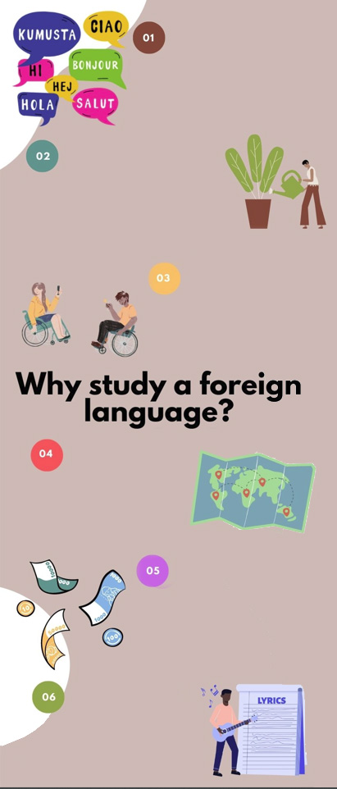
BETTER UNDERSTANDING OF YOUR NATIVE LANGUAGE AND OTHERS
- The more languages you
know, the better you can analyse your own.
- Once you learn a second language, it will be easier to learn other.
SELF-IMPROVEMENT AND
EXTRA SKILLS
- To open your mind and
expand your personality.
- To help gain self-confidence.
- To train your and make better decisions.
- To acquire problem-solving, memory
and reading skills among others.
- To acquire self-discipline.
COMMUNICATION
- Helps make new friends of romantic relationships.
- Learning a foreign language makes you more attractive.
TRAVELLING
- Travelling becomes
more enjoyable.
- To experiment and
understand different
cultures.
- To allow you to help
foreigners in your country.
CAREER AND EARNING OPPORTUNITIES
- Companies take into account language skills when hiring.
- People who know at least one
foreign language earn more than people who don’t.
- To improve possibilities of living, working or studying abroad.
ARTS
- To figure out books or films
in their original language
and understand dialogues, jokes and meaning.
- To listen to music and understanding the lyrics.
You have 5 minutes to prepare the task. Your conversation should last between 2 to 3 minutes.

In oral mediation,
you need to
interpret the
content of the infographics and be able to explain and give your opinion, if asked, in an informal or colloquial way.
Refer to the infographic. But do not read it aloud. Paraphrase the ideas there.

Let’s get ready!
1. Analyse the task
a. Read the task carefully and answer these questions. They will help you choose the register of the mediation task.
- Who is the receiver of the message?
- Why are you going to send him a message?
- What information does the addressee need?
b. After analysing the task, choose the best answer.
- Register is the way a person speaks or writes in relation to their audience / message.
- In this mediation task, I have to use formal / informal register.
- Oral language is more / less formal than written language.
2. Analyse the information
Read the information in the poster carefully.
- What is the important information in the poster that your friend needs?
- Underline the ideas that you think can be most effective to convince your friend to study Spanish.
Let’s prepare the language!
Discuss advantages and benefits
1. Read this text where a person is explaining the advantages of watching films in their original language. Underline all the expressions he or she uses to present the benefits.
Films are an excellent way to learn a foreign language. Keep in mind that watching films in the original version is not the same as watching films in Spanish with subtitles. There are lots of advantages. One benefit is that sometimes, you will find that an English translation does not always make a good job of conveying the “essence” of the film or the original language. On top of that, watching films teaches you more than just vocabulary. So, another advantage is that it also helps you learn how people in that culture might act or what they might say in certain circumstances. From what I have heard, people who understand the original language better have a much more satisfying and rewarding time watching it. In my experience, watching a film in its original language gives you an ideal opportunity to learn about its background and culture. Furthermore, watching films in the original language is a good way to immerse yourself in another culture.


Do not use the same expressions all the time. It is important to vary the language to show you have a good vocabulary.

Other Useful Language
I can imagine that …
There are other advantages, too.
… is beneficial for / because …
One advantage … has over … is …

2. Can you think of other ways of saying “an advantage”? For example, “an argument in favour of …”
Give reasons and examples
1. Give a reason and an example that support each of the statements below.
a) There are many reasons why it is a good idea to study a foreign language. _________________________________________________________________
b) Some people believe that being able to speak a foreign language makes it easy to find a job. _________________________________________________________________

Let’s mediate!

Your Danish friend, Calvin, is going to move to Girona for the next 6 months on an Erasmus programme. He cannot speak Spanish and he does not want to study it either. You have read this poster and, based on the information it contains, you send your friend a voice message telling him how important it is to learn a foreign language.

1. Content
Content
Look at the poster and read the information there carefully again. Select the information you are going to tell your friend. You can use the following questions:
- Apart from the language itself, what other things can we learn when studying a foreign language?
- When we live abroad temporarily, why should we learn the language of that place?
2. Language
Language
Use your own words. Simplify or paraphrase the information.
Remember to adapt your register to the task and addressee.
Vary the language you use. Look at the Other Useful Language above.

