B2 - Oral Mediation 1: Task
Learning a Foreign Language
Your Danish friend, Calvin, is going to move to Girona for the next 6 months on an Erasmus programme. He cannot speak Spanish and he does not want to study it either. You have read this poster and, based on the information it contains, you send your friend a voice message telling him how important it is to learn a foreign language.

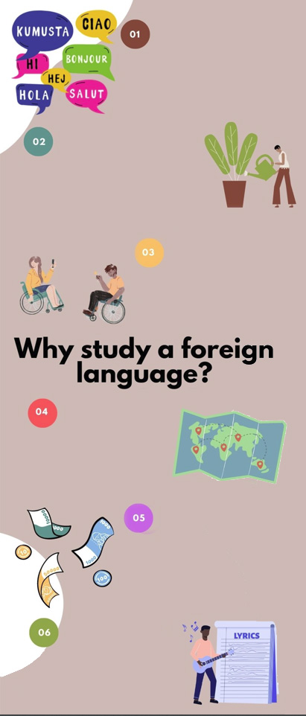
BETTER UNDERSTANDING OF YOUR NATIVE LANGUAGE AND OTHERS
- The more languages you
know, the better you can analyse your own.
- Once you learn a second language, it will be easier to learn other.
SELF-IMPROVEMENT AND
EXTRA SKILLS
- To open your mind and
expand your personality.
- To help gain self-confidence.
- To train your and make better decisions.
- To acquire problem-solving, memory
and reading skills among others.
- To acquire self-discipline.
COMMUNICATION
- Helps make new friends of romantic relationships.
- Learning a foreign language makes you more attractive.
TRAVELLING
- Travelling becomes
more enjoyable.
- To experiment and
understand different
cultures.
- To allow you to help
foreigners in your country.
CAREER AND EARNING OPPORTUNITIES
- Companies take into account language skills when hiring.
- People who know at least one
foreign language earn more than people who don’t.
- To improve possibilities of living, working or studying abroad.
ARTS
- To figure out books or films
in their original language
and understand dialogues, jokes and meaning.
- To listen to music and understanding the lyrics.
You have 5 minutes to prepare the task. Your conversation should last between 2 to 3 minutes.

In oral mediation,
you need to
interpret the
content of the infographics and be able to explain and give your opinion, if asked, in an informal or colloquial way.
Refer to the infographic. But do not read it aloud. Paraphrase the ideas there.

