B2 - Oral Mediation 2: Teacher’s Notes
Ordering Food at a Restaurant
Before starting the mediation activity, ask students to read the task and the menu carefully to make the aim of the activity clear.
You and your friend are on a trip to the United States. Your friend does not understand English, so when you go to a restaurant, you have to order for her. She is vegetarian and allergic to nuts. She loves pasta and eggs.
You have read the menu and based on its information, order for her. Record what you say to the waiter.
You have 5 minutes to prepare the task. Your conversation should last between 2 to 3 minutes.
bacon strips, potatoes, clam juice, clams
pumpkin, cream, bread
clam spaghetti, garlic, olive oil, chilli
beef spaghetti, meatballs, tomato sauce
macaroni, shredded cheese, cream, eggs
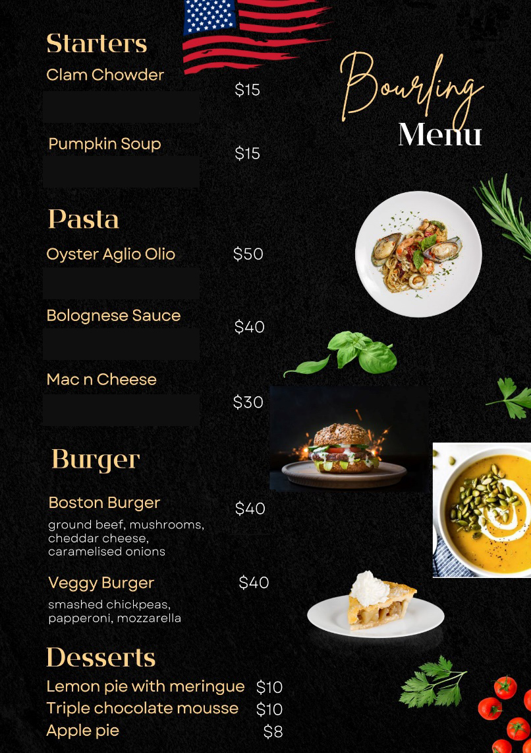

In this oral mediation, you need to read the menu carefully and be able to explain what you and your friend would like in an informal or colloquial way.

Refer to the menu. But do not read it aloud. Use your own words.
Let’s get ready!
In this section, you will help students to get ready for the task. First of all, they will learn what to do (Analyse the task) and later, they will work on the information (Analyse the information). You can give them the Learning Sequence worksheet to work on.
1. Analyse the task
Tell students they are going to think about who the message is for, where it takes place and the reason for the message. This will help them to use the proper register (formal or informal).
Read the task carefully and complete the table below.
What do you have to do? | Order food for my friend.
Where does the conversation take place? | at a restaurant
Who are you talking to? | a waiter at the restaurant
2. Analyse the information
Now tell students to think about which foods their friend eats and to list them.
Make a list of what your friend eats or does not eat.
Can eat | Can’t eat
pasta  eggs  etc. | meat  fish  nuts
Now tell students to write down what their friend can eat from the menu.
Now, read the menu and find out which dishes your friend can eat. Write them down here
Pumpkin soup
Mac n Cheese
Veggy burger
Lemon pie with meringue
Triple chocolate mousse
Apple pie
Finally, decide, what you are going to order for your friend. Choose a starter, a main course and a dessert. Underline them in the list above.
Students can choose from the dishes above freely.

Let’s prepare the language!
In this section, students will learn structures and language suitable for the task.
Talking about food
1. Find 10 words we can use to describe food in this puzzle. Words can go in any direction and can share letters as they cross over each other.
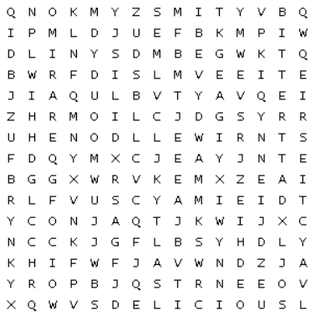
2. Read the food you are going to order for your friend and for you and try to figure out what you can say about it.
Let students think for a couple of minutes and ask some of them, so that they can give examples to the other students in class.

It’s easy to use basic words in this activity, but you have to show that you have more words than the basic ones. Use some of the words from the puzzle in your task.

Ordering food
1. Read this dialogue where a person is ordering food at a restaurant. Underline all the expressions they use to ask for food.
WAITER: Are you ready to order?
CUSTOMER: We were wondering about a couple of things. How spicy is the Mexican dish?
WAITER: It’s rather spicy, but I can tell the chef if you want it less spicy. Do you have any allergies?
CUSTOMER: Well, yes, my partner actually has a minor nut allergy.
WAITER: Don’t get the duck pate then because there are traces of nuts in it. So, what will you have?
CUSTOMER: I’ll have the enchiladas, please.
WAITER: You’re going to go for the enchiladas.
CUSTOMER: Yes, yes. And I think everyone else, apart from me, will have guacamole.
WAITER: Can I bring you any desserts?
CUSTOMER: I’m awfully stuffed, but I do know that my friend has a sweet tooth.
WAITER: Was everything to your liking, sir?
CUSTOMER: Exquisite. Thanks. Can I get the bill please?
WAITER: Cash or card?
CUSTOMER: Cash, please. Is service included in the bill?
WAITER: Yes, there is a 5% service charge and then you can add any extra money you want as a tip. Well, I hope to see you again soon. Thank you for coming. I hope you’ve enjoyed your food.

Other Useful Language
I’d like …
I’ll have …
Can I have …?
If it’s not too spicy …
We’ll have …. to share.
For starter / appetiser / main course …
2. Read the dialogue in Exercise 1 again. Circle all the expressions they use to talk about food.
See answers in Exercise 1 above.
Do not use the same expressions all the time. It is important to vary the language to show you have a great repertoire.
Let’s mediate!
Make sure students understand the task and you can summarise the tips below.
You and your friend are on a trip to the United States. Your friend does not understand English, so when you go to a restaurant, you have to order for her. She is vegetarian and allergic to nuts. She loves pasta and eggs.
You have read the menu and based on its information, order for her. Record what you say to the waiter.
1. Content
Content
Look at the menu and read the information there carefully again. You have already chosen what to order. Think about how to start and end the order.
- How do you address the waiter?
- Do they need to know about your friend’s allergy?
2. Language
Language
You can use the name of the dish, but for the rest, use your own words.
Remember to adapt your register to the task and addressee.
Vary the language you use. Look at the dialogue and Other Useful Language
on page 4.
Refer students to the task again and tell them to pay special attention to the Quick Tip. Make sure that the students read the rubric, so that they know what is important.

Let’s evaluate!
Rubrics for assessment
 Oral Mediation
 | Excellent | Good | Acceptable | Unsuitable
Clarity | The information is clear and easy to follow. The main points are clear. | The information is clear to follow but sometimes it is not easy to understand what the main points are. | Some of the information selected is not relevant, lacks coherence and may include contradictions. | The information selected is not relevant, not clear, not easy to follow and includes contradictions.
Relevancy and processing | The student has summarised and paraphrased the main ideas without copying literally. No information has been added. | The student has summarised the main ideas but has not paraphrased them. No information has been added. | The student conveys some appropriate information by summarising the main ideas, but not all. | The student doesn’t convey much appropriate information or has copied it from the text. Extra information may have been added.
Flow | The student speaks confidently without many pauses. The speech is fluent. | The student mostly speaks confidently without many pauses. The speech is fluent. | The student speaks confidently part of the time with several pauses. The speech is not always fluent. | The student doesn’t speak confidently and often pauses. The speech is not fluent.
Vocabulary | The student uses a wide rage of appropriate vocabulary. | The student mostly uses appropriate and varied vocabulary. | The student uses appropriate vocabulary but it is not varied. | The student doesn’t use varied vocabulary or is not able to paraphrase.
Grammar | The student uses a wide range of correct grammatical structures. | The student uses a wide range of grammatical structures but not always correctly. | The student uses basic but correct grammatical structures. | The student uses basic grammatical structures but not always correctly.
Pronunciation and intonation | The student uses understandable pronunciation and intonation. | The student mostly uses understandable pronunciation and intonation. | The student uses understandable pronunciation and intonation with a strong foreign accent. | The student doesn’t use understandable pronunciation and intonation.

