B2 - Oral Mediation 2: Learning Sequence
Ordering Food at a Restaurant
You and your friend are on a trip to the United States. Your friend does not understand English, so when you go to a restaurant, you have to order for her. She is vegetarian and allergic to nuts. She loves pasta and eggs.
You have read the menu and based on its information, order for her. Record what you say to the waiter.
You have 5 minutes to prepare the task. Your conversation should last between 2 to 3 minutes.
bacon strips, potatoes, clam juice, clams
pumpkin, cream, bread
clam spaghetti, garlic, olive oil, chilli
beef spaghetti, meatballs, tomato sauce
macaroni, shredded cheese, cream, eggs
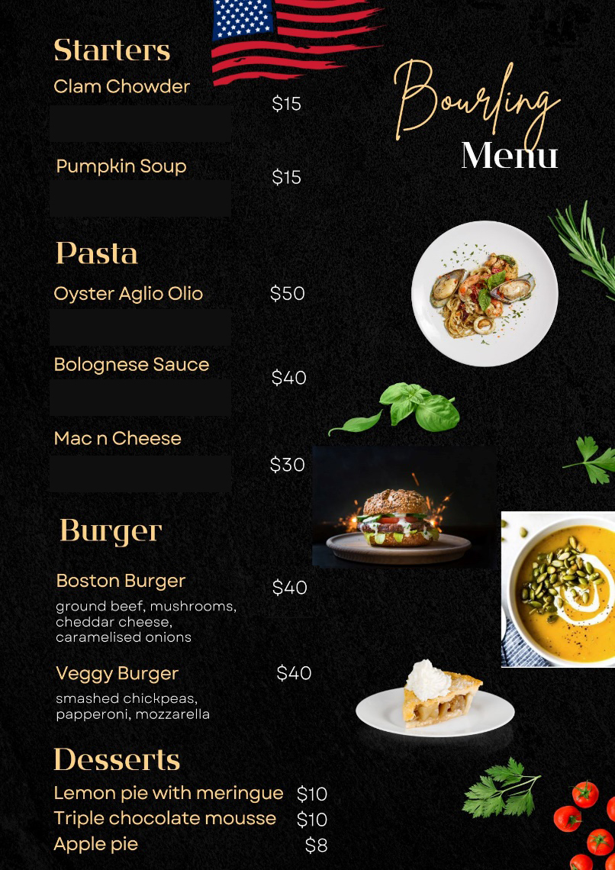

In this oral mediation, you need to read the menu carefully and be able to explain what you and your friend would like in an informal or colloquial way.

Refer to the menu. But do not read it aloud. Use your own words.

Let’s get ready!
1. Analyse the task
Read the task carefully and complete the table below.
What do you have to do?
Where does the conversation take place?
Who are you talking to?
2. Analyse the information
Make a list of what your friend eats or does not eat.
Can eat | Can’t eat
Now, read the menu and find out which dishes your friend can eat. Write them down here.
Finally, decide, what you are going to order for your friend. Choose a starter, a main course and a dessert. Underline them in the list above.
Let’s prepare the language!
Talking about food
1. Find 10 words we can use to describe food in this puzzle. Words can go in any direction and can share letters as they cross over each other.

2. Read the food you are going to order for your friend and for yourself and try to figure out what you can say about it.

It’s easy to use basic words in this activity, but you have to show that you have more words than the basic ones. Use some of the words from the puzzle (page 2) in your task.
Ordering food
1. Read this dialogue between a customer and waiter at a restaurant. Underline all the expressions they use to ask for food.
WAITER: Are you ready to order?
CUSTOMER: We were wondering about a couple of things. How spicy is the Mexican dish?
WAITER: It’s rather spicy, but I can tell the chef if you want it less spicy. Do you have any allergies?
CUSTOMER: Well, yes, my partner actually has a minor nut allergy.
WAITER: Don’t get the duck pate then because there are traces of nuts in it. So, what will you have?
CUSTOMER: I’ll have the enchiladas, please.
WAITER: You’re going to go for the enchiladas.
CUSTOMER: Yes, yes. And I think everyone else, apart from me, will have guacamole.
WAITER: Can I bring you any desserts?
CUSTOMER: I’m awfully stuffed, but I do know that my friend has a sweet tooth.
WAITER: Was everything to your liking, sir?
CUSTOMER: Exquisite. Thanks. Can I get the bill please?
WAITER: Cash or card?
CUSTOMER: Cash, please. Is service included in the bill?
WAITER: Yes, there is a 5% service charge and then you can add any extra money you want as a tip. Well, I hope to see you again soon. Thank you for coming. I hope you’ve enjoyed your food.

Other Useful Language
I’d like …
I’ll have …
Can I have …?
If it’s not too spicy …
We’ll have …. to share.
For starter / appetiser / main course …
2. Read the dialogue in Exercise 1 again. Circle all the expressions they use to talk about food.
Do not use the same expressions all the time. It is important to vary the language to show you have a great repertoire.
Let’s mediate!
You and your friend are on a trip to the United States. Your friend does not understand English, so when you go to a restaurant, you have to order for her. She is vegetarian and allergic to nuts. She loves pasta and eggs.
You have read the menu and based on its information, order for her. Record what you say to the waiter.
1. Content
Content
Look at the menu and read the information there carefully again. You have already chosen what to order. Think about how to start and end the order.
- How do you address the waiter?
- Do they need to know about your friend’s allergy?
2. Language
Language
You can use the name of the dish, but for the rest, use your own words.
Remember to adapt your register to the task and addressee.
Vary the language you use. Look at the Other Useful Language on this page.

