B2 - Oral Mediation 2: Task
Ordering Food at a Restaurant
You and your friend are on a trip to the United States. Your friend does not understand English, so when you go to a restaurant, you have to order for her. She is vegetarian and allergic to nuts. She loves pasta and eggs.
You have read the menu and based on its information, order for her. Record what you say to the waiter.
You have 5 minutes to prepare the task. Your conversation should last between 2 to 3 minutes.
bacon strips, potatoes, clam juice, clams
pumpkin, cream, bread
clam spaghetti, garlic, olive oil, chilli
beef spaghetti, meatballs, tomato sauce
macaroni, shredded cheese, cream, eggs
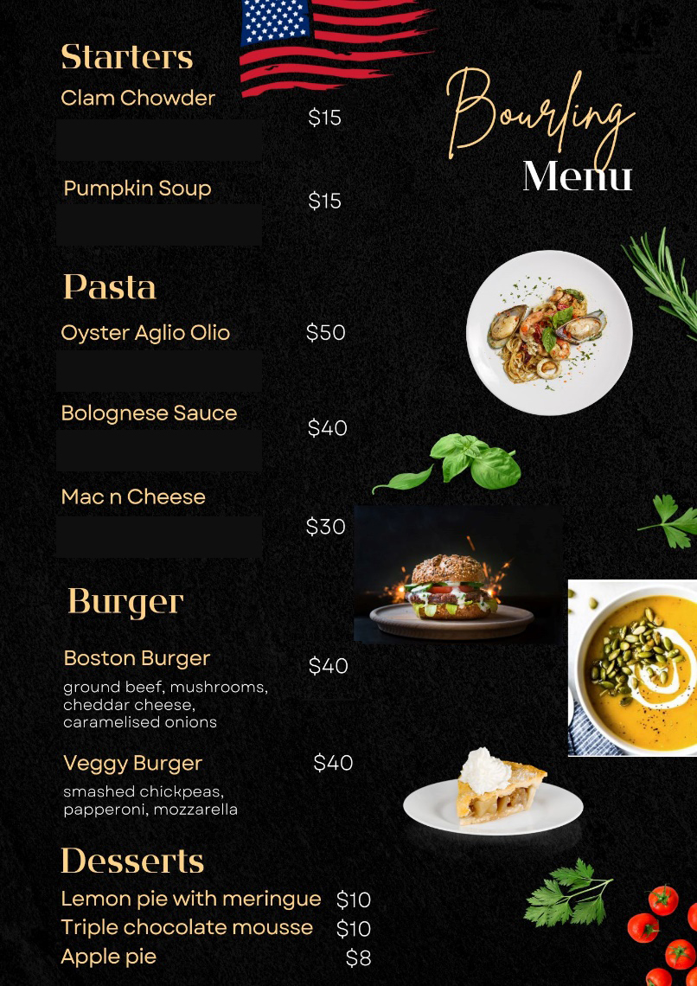

In this oral mediation, you need to read the menu carefully and be able to explain what you and your friend would like in an informal or colloquial way.

Refer to the menu. But do not read it aloud. Use your own words.

