B2 - Oral Mediation 3: Teacher’s Notes
Becoming a Member of a Gym
Before starting the mediation activity, ask students to read the task and the gym membership rules carefully to make the aim of the activity clear.
Your friend is going to spend a school year in Dublin to improve his English, which is not very good. He wants to become a member of a gym, so he has read its membership rules online, but is not quite sure he understands them well.
Read the rules and send your friend a voice message telling him what he can or cannot do as a member of this gym.
You have 5 minutes to prepare the task. Your message should last between 2 to 3 minutes.
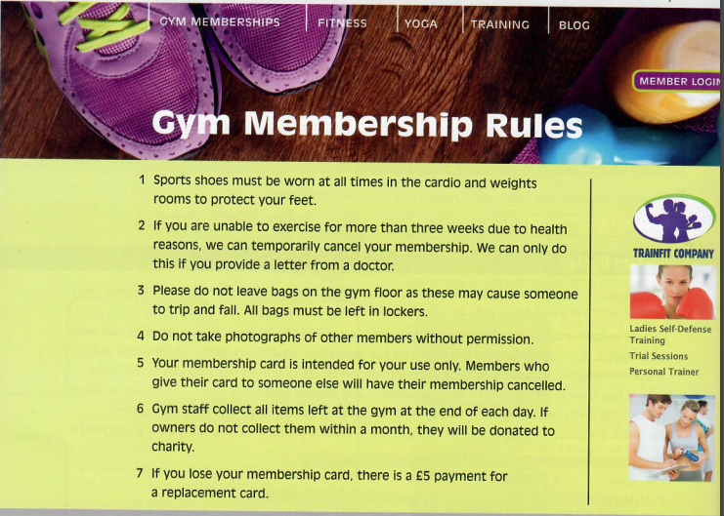

In this oral mediation, you need to paraphrase the gym rules and tell your friend about them in an informal way.
Mention the rules on the website and make sure it is clear why you are talking about it.

Let’s get ready!
In this section, you will help students to get ready for the task. First of all, they will learn what to do (Analyse the task) and later, they will work on the information (Analyse the information). You can give them the Learning Sequence worksheet to work on.
1. Analyse the task
Tell students they are going to think about who the message is for, the reason and the information included. This will help them to use the proper register (formal or informal).
Read the task carefully and complete this text.
I have to send a voice message to my friend, so I will use informal English. He does not understand / speak English very well, so he wants to be sure he understands the gym rules.
2. Analyse the information
Now tell students to think about the information in the gym rules. This can give them ideas of how to convey the rules.
A. Read the gym rules and match the rules to these categories:
a) Lost property c) Safety e) Medical
b) Fees and charges d) Privacy f) Membership cards
Sports shoes must be worn at all times in the cardio and weights rooms to protect your feet. | Safety
If you are unable to exercise for more than three weeks due to health reasons, we can temporally cancel your membership. We can only do this if you provide a letter from a doctor. | Medical
Please do not leave bags on the gym floor as this may cause someone to trip and fall. All bags must be left in lockers. | Safety
Do not take photographs of other members without permission | Privacy
Your membership card is intended for your use only. Members who give their card to someone else will have their membership cancelled. | Membership cards
Gym staff collect all items left at the gym at the end of each day. If owners do not collect them within a month, they will be donated to charity. | Lost property
If you lose your membership card, there is a £5 payment for a replacement card. | Fees and charges / Membership cards

B.- Ed is an employee at the gym. Read these situations. Were Ed’s actions right or wrong, according to the gym rules?
1. Ed collected items left in the gym last night and donated them to charity. Wrong
2. Ed told Sabrina she couldn’t use the weights while wearing sandals. Right
3. Anne didn’t enjoy the gym, so she gave her friend her card. Ed informed Anne that she had to pay a £5 fine. Wrong
4. Matt was taking photos of his friend in the swimming pool. Ed told Matt that this was against the rules. Right
5. Mike tripped and hurt his leg when he fell over Jo’s gym bag. Ed cancelled Jo’s membership. Wrong
6. Michelle has pneumonia. She won’t be able come to the gym for at least a month. Ed told her that she should bring confirmation from her doctor, so he could cancel her membership temporarily. Right
Let’s prepare the language!
In this section, students will learn structures and language suitable for the task.
1. Talking about rules
These two exercises are a quick revision of some basic modal verbs to talk about rules.
- Which of these sentences express obligation, prohibition or lack of obligation?
a) You must wear a helmet if you go skiing. Obligation
b) You don’t have to go to the weights room. Lack of obligation
c) You can’t play ball games here. Prohibition
d) Baggage must not be left unattended. Prohibition
e) Seat belts must be worn by all passengers. Obligation
f) You don't have to wear a tie in our office. Lack of obligation
- Complete the rule:
We use the base form of the verb after a modal verb.
2. Paraphrasing
Paraphrasing is a must when students mediate. These tips and exercise will help students to learn how to do it. These are just some of the possibilities. Therefore, there are more than one correct answer.
When you are asked to mediate, you have to paraphrase some of the ideas in the text given. Paraphrasing means expressing the meaning of something written or spoken using different words. Good paraphrasing shows you understand other people’s ideas and can explain them in a way that makes sense.
You can paraphrase by using synonyms:
Original: More than half of the people who attend the gym lose their membership cards.
Paraphrase: The majority of the people who go to the gym lose their membership cards.
You can paraphrase by changing nouns to verbs:
Original: The police conducted an investigation into the robbery.
Paraphrase: The police investigated the robbery.
You can paraphrase by changing the register:
Original: Any exercise in the gym should first include a visit to the doctor.
Paraphrase: Be sure to visit a doctor before joining the gym.
You can paraphrase by changing the connector:
Original: You shouldn’t take pills without seeing a doctor first.
Paraphrase: You had better not take pills before you see a doctor.
Let students think for a couple of minutes and ask some of them so that they can give examples to the other students in class. There are many possible answers.
Now, try to do it:
Possible answers:
a) He left his bag at home so he could not go to the gym.
He could not go to the gym because he left his bag home.
b) Would you like to go to a Harry Styles’ concert next week?
Are you coming to a Harry Styles’ concert next week?
c) The place was very crowded.
There were lots of people there.
d) It’s compulsory to wear a helmet if you ride a bicycle.
You have to wear a helmet if you ride a bicycle.
e) He felt uneasy, but he didn’t know why.
He felt anxious, but he didn’t know why.

Use your own words.
Don’t repeat sentence structure or copy words.
Vary the sentence structure.
Use synonyms or alternative phrases.
Don’t add new information to your paraphrasing.
Stick to the main
points in the text.

Let’s mediate!
Make sure students understand the task and you can summarise the tips below:
Your friend is going to spend a school year in Dublin to improve his English, which is not very good. He wants to become a member of a gym, so he has read its membership rules online but is not quite sure he understands them well.
Read the rules and send your friend a voice message telling him what he can or cannot do as a member of this gym.
1. Content
Content
Look at the gym rules and read the information there carefully again. You already know what the gym rules are. Think about how to start and end the voice message.
- How do you greet your friend and say goodbye?
- What order are you going to follow to tell him about the rules?
2. Language
Language
Paraphrase the rules and use your own words.
Remember to adapt your register to the task and addressee.
Vary the language you use. Look at the useful language on pages 3
and 4.
Refer students to the task again and tell them to pay special attention to the Quick Tip. Make sure that students read the rubric, so that they know what is important.

Let’s evaluate!
Rubrics for assessment
 Oral Mediation
 | Excellent | Good | Acceptable | Unsuitable
Clarity | The information is clear and easy to follow. The main points are clear. | The information is clear to follow but sometimes it is not easy to understand what the main points are. | Some of the information selected is not relevant, lacks coherence and may include contradictions. | The information selected is not relevant, not clear, not easy to follow and includes contradictions.
Relevancy and processing | The student has summarised and paraphrased the main ideas without copying literally. No information has been added. | The student has summarised the main ideas but has not paraphrased them. No information has been added. | The student conveys some appropriate information by summarising the main ideas, but not all. | The student doesn’t convey much appropriate information or has copied it from the text. Extra information may have been added.
Flow | The student speaks confidently without many pauses. The speech is fluent. | The student mostly speaks confidently without many pauses. The speech is fluent. | The student speaks confidently part of the time with several pauses. The speech is not always fluent. | The student doesn’t speak confidently and often pauses. The speech is not fluent.
Vocabulary | The student uses a wide rage of appropriate vocabulary. | The student mostly uses appropriate and varied vocabulary. | The student uses appropriate vocabulary but it is not varied. | The student doesn’t use varied vocabulary or is not able to paraphrase.
Grammar | The student uses a wide range of correct grammatical structures. | The student uses a wide range of grammatical structures but not always correctly. | The student uses basic but correct grammatical structures. | The student uses basic grammatical structures but not always correctly.
Pronunciation and intonation | The student uses understandable pronunciation and intonation. | The student mostly uses understandable pronunciation and intonation. | The student uses understandable pronunciation and intonation with a strong foreign accent. | The student doesn’t use understandable pronunciation and intonation.

