B2 - Oral Mediation 3: Learning Sequence
Becoming a Member of a Gym
Your friend is going to spend a school year in Dublin to improve his English, which is not very good. He wants to become a member of a gym, so he has read its membership rules online, but is not quite sure he understands them well.
Read the rules and send your friend a voice message telling him what he can or cannot do as a member of this gym.
You have 5 minutes to prepare the task. Your message should last between 2 to 3 minutes.
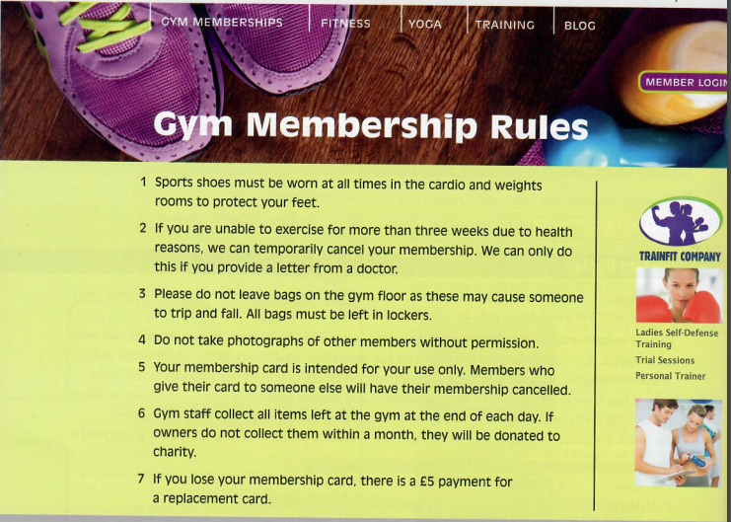

In this oral mediation, you need to paraphrase the gym rules and tell your friend about them in an informal way.
Mention the rules on the website and make sure it is clear why you are talking about it.

Let’s get ready!
1. Analyse the task
Read the task carefully and complete this text.
I have to send a _______________ message to my friend, so I will use _______________ English. He does not _______________English very well, so he wants to be sure he understands the gym _______________.
2. Analyse the information
A. Read the gym rules and match the rules to these categories:
a) Lost property c) Safety e) Medical
b) Fees and charges d) Privacy f) Membership cards
Sports shoes must be worn at all times in the cardio and weights rooms to protect your feet.
If you are unable to exercise for more than three weeks due to health reasons, we can temporally cancel your membership. We can only do this if you provide a letter from a doctor.
Please do not leave bags on the gym floor as this may cause someone to trip and fall. All bags must be left in lockers.
Do not take photographs of other members without permission
Your membership card is intended for your use only. Members who give their card to someone else will have their membership cancelled.
Gym staff collect all items left at the gym at the end of each day. If owners do not collect them within a month, they will be donated to charity.
If you lose your membership card, there is a £5 payment for a replacement card.
B. Ed is an employee at the gym. Read these situations. Were Ed’s actions right or wrong, according to the gym rules?
1. Ed collected items left in the gym last night and donated them to charity. __________
2. Ed told Sabrina she couldn’t use the weights while wearing sandals. __________
3. Anne didn’t enjoy the gym, so she gave her friend her card. Ed informed Anne that she had to pay a £5 fine. __________
4. Matt was taking photos of his friend in the swimming pool. Ed told Matt that this was against the rules. __________
5. Mike tripped and hurt his leg when he fell over Jo’s gym bag. Ed cancelled Jo’s membership. __________
6. Michelle has pneumonia. She won’t be able come to the gym for at least a month. Ed told her that she should bring confirmation from her doctor, so he could cancel her membership temporarily. __________
Let’s prepare the language!
1. Talking about rules
1. Which of these sentences express obligation, prohibition or lack of obligation?
a) You must wear a helmet if you go skiing. __________
b) You don’t have to go to the weights room. __________
c) You can’t play ball games here. __________
d) Baggage must not be left unattended. __________
e) Seat belts must be worn by all passengers. __________
f) You don't have to wear a tie in our office. __________
2. Complete the rule:
We use the __________ form of the verb after a modal verb.
2. Paraphrasing
When you are asked to mediate, you have to paraphrase some of the ideas in the text given. Paraphrasing means expressing the meaning of something written or spoken using different words. Good paraphrasing shows you understand other people’s ideas and can explain them in a way that makes sense.
You can paraphrase by using synonyms:
Original: More than half of the people who attend the gym lose their membership cards.
Paraphrase: The majority of the people who go to the gym lose their membership cards.
You can paraphrase by changing nouns to verbs:
Original: The police conducted an investigation into the robbery.
Paraphrase: The police investigated the robbery.
You can paraphrase by changing the register:
Original: Any exercise in the gym should first include a visit to the doctor.
Paraphrase: Be sure to visit a doctor before joining the gym.
You can paraphrase by changing the connector:
Original: You shouldn’t take pills without seeing a doctor first.
Paraphrase: You had better not take pills before you see a doctor.

Now, try to do it:
a) He left his bag at home so he could not go to the gym.
__________________________________________________________________
b) Would you like to go to a Harry Styles’ concert next week?
__________________________________________________________________
c) The place was very crowded.
__________________________________________________________________
d) It’s compulsory to wear a helmet if you ride a bicycle.
__________________________________________________________________
e) He felt uneasy, but he didn’t know why.
__________________________________________________________________

Use your own words.
Don’t repeat sentence structure or copy words.
Vary the sentence structure.
Use synonyms or alternative phrases.
Don’t add new information to your paraphrasing.
Stick to the main points in the text.

Let’s mediate!
Your friend is going to spend a school year in Dublin to improve his English, which is not very good. He wants to become a member of a gym, so he has read its membership rules online but is not quite sure he understands them well.
Read the rules and send your friend a voice message telling him what he can or cannot do as a member of this gym.
1. Content
Content
Look at the gym rules and read the information there carefully again. You already know what the gym rules are. Think about how to start and end the voice message.
- How do you greet your friend and say goodbye?
- What order are you going to follow to tell him about the rules?
2. Language
Language
Paraphrase the rules and use your own words.
Remember to adapt your register to the task and addressee.
Vary the language you use. Look at the useful language on pages 3
and 4.

