B2 - Oral Mediation 3: Task
Becoming a Member of a Gym
Your friend is going to spend a school year in Dublin to improve his English, which is not very good. He wants to become a member of a gym, so he has read its membership rules online, but is not quite sure he understands them well.
Read the rules and send your friend a voice message telling him what he can or cannot do as a member of this gym.
You have 5 minutes to prepare the task. Your message should last between 2 to 3 minutes.
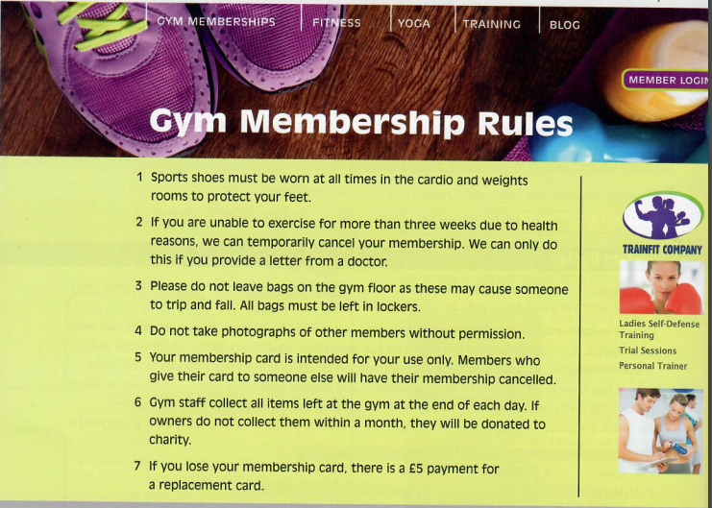

In this oral mediation, you need to paraphrase the gym rules and tell your friend about them in an informal way.
Mention the rules on the website and make sure it is clear why you are talking about it.

