B2 - Oral Mediation 4: Teacher’s Notes
How to be a Good Friend
Your Mexican friend, Juan Antonio, is going to move to Canada for the next six months as part of an Erasmus programme. His English is not great, but he wants to improve it. He is also worried that he may not make good friends. You have read this poster and, based on the information it contains, you send your friend a voice message telling him how to be a good friend. Do it in English so that he can practise his English.
You have 5 minutes to prepare the task. Your message should last between 2 to 3 minutes.
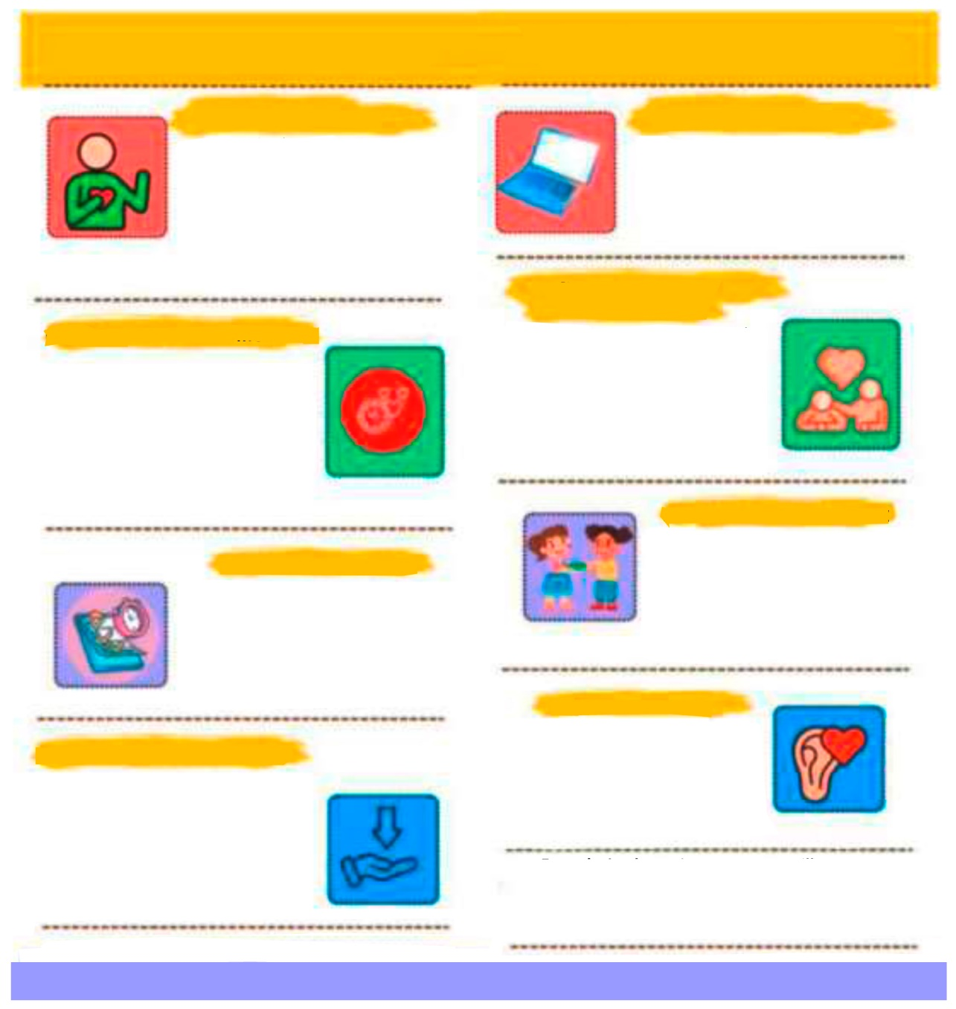
HOW TO BE A GOOD FRIEND HOW TO BE A GOOD FRIEND
BE OPEN AND HONEST
USE TECH TO STAY CLOSE
STAY FLEXABLE AND UNDERSTANDING
FOCUS ON MEANINGFUL MOMENTS
MAKE TIME ON PURPOSE
SHARE THE THINGS YOU LOVE
BE THERE WHEN THEY NEED YOU
LISTEN WITH HEART
Even during busy times, you can still nurture friendships. Reach out to someone today – say “hello”, make a plan or share this message:
“This made me think of you”.
You don’t need to fix everything. Sometimes the best thing you can do is listen, be kind and show you care. A true friend understands before they try to provide solutions.
If a friend is going through something tough, show your support however you can. Listen, send a sweet message, or remind them they’re not alone. Even small acts of kindness mean a lot.
Good friendships don’t just “happen” – they grow when you make time for them. Plan a call, set a date or send a message. Treat it like something important because it is.
Friendship grows when you share fun activities. Cook together, read the same book, watch a show, craft or go for a walk. Sharing hobbies creates memories and brings joy.
You don’t need long hangouts
to stay close. A quick text, a short call or a small update can make
a big difference. It’s the quality
of the time you share, not how long it is, that keeps friendships alive.
Life gets busy. Your friends might have work, family or responsibilities you don’t see. Try to be patient, understanding and kind when plans change. Good friends give each other room to breathe.
Share what’s really going on in your life – your successes, your worries and everything in between. Let friends know when you’re free and when you’re busy. Being honest about your time and your feelings helps friendships stay strong and real.
When you can’t meet in person, use your phone to stay connected. Chat, call, send voice notes or video chat. You can show love and support from anywhere.

In this oral mediation, you need to paraphrase the tips on how to become a good friend and tell your friend about them in an informal way.  Mention the tips on the poster and make sure it is clear why you are talking about them. | 

Let’s get ready!
In this section, you will help students to get ready for the task. First of all, they will learn what to do (Analyse the task) and later, they will work on the information (Analyse the information). You can give them the Learning Sequence worksheet to work on.
1. Analyse the task
Tell students they are going to think about who the message is for, the reason for the message and the information included. This will help them to use the proper register (formal or informal).
Read the task carefully and complete this text.
I have to send a voice message to my friend, so I will use informal English. He does not understand / speak English very well, but he wants to practise it. You want him to understand how to be a good friend.
2. Analyse the information
Now, tell students to think about the information in the poster. This can give them ideas of how to convey the rules.
Michael and Raimon are friends. Read these situations. Are they good friends, according to the tips on the poster?
1. Michael had a problem with one of his teachers and phoned Raimon to tell him about it. Raimon was playing a video game and could not stop to talk to him. He told him that he would phone him back later. Not good friends
2. Raimon has been living in Denmark for six months. Michael sends voice messages every now and then. Good friends
3. Raimon saw Michael’s girlfriend kissing another boy. Raimon does not tell Michael because he does not want to upset him. Not good friends
4. Michael understands when Raimon has to look after his young brother and cannot go to the gym with him. Good friends
5. Raimon only wants to meet Michael when they have an hour or more to share.
Good Friends

Let’s prepare the language!
In this section, students will learn structures and language suitable for the task.
1. Giving tips or advice
These two exercises are a quick revision of some basic modal verbs to give advice.
When giving tips or advice, English commonly uses modal verbs: “You should listen to your friends.” “You can help them when they need support.” “You shouldn’t talk behind their backs.”
1. What is the difference in strength and tone?
a. You should apologise. General advice
b. You had better apologise. Strong suggestion with consequences
c. You might want to apologise. Softer and more polite, suggestion
GIVING ADVICE
should / shouldn’t
ought to
had better
could
might want to …
It would be wise to
It may help if you …
If I were you, I would …
2. Read these scenarios and, in pairs, discuss the situation and write three pieces of nuanced advice. Try to use three different ways of giving advice. The first one is done for you. There is more than one possible answer.
a. You have two close friends who have stopped talking to each other. Both expect you to take their side.
Possible answer:
If I were you, I’d talk to both friends separately. You might want to explain that you don’t want to choose sides. Also, you should encourage them to resolve the issue together. But you had better avoid spreading information between them, or the conflict could get worse.
b. A friend shared something you had told them in confidence. You feel hurt, but don’t want to lose the friendship.
Possible answers
You should tell them calmly how their actions made you feel and explain why confidentiality matters to you. Why don’t you suggest setting clearer boundaries about what is private so it doesn’t happen again? It might help to ask them why they shared it, giving them a chance to explain before you judge the situation.

c. A friend constantly relies on you for emotional support and doesn’t respect your boundaries.
Possible answer:
You could gently remind them that you also need space and can’t always be available. If I were you, I’d recommend they talk to a counsellor or another trusted person so the emotional load isn’t all on you. It might be a good idea to set specific boundaries.
d. Your friend has started hanging out with people who encourage risky behaviour.
Possible answer:
You should express your concern honestly, focusing on their safety rather than judging their new friends. Why don’t you invite them to spend time with you doing something positive to keep the connection strong? It might help to ask open-ended questions to understand why they’re drawn to the group instead of assuming the worst.
e. You always initiate contact and make plans. Your friend rarely puts in effort to do this.
Possible answer:
You could let them know you’ve noticed the imbalance and ask how they feel about the friendship. If I were you, I’d stop initiating for a while to see if they take the initiative when given space. It might be worth suggesting a shared activity you both enjoy to make reconnecting easier.
f. You said something that offended a friend from a different cultural background, without realising it.
Possible answer:
You should apologise sincerely and acknowledge that you didn’t intend to cause harm. Why don’t you ask them – respectfully – what part of the comment felt offensive so you can understand better? It might help to learn more about their cultural context to avoid similar misunderstandings in the future.
2. Paraphrasing
Paraphrasing is essential when students mediate. These tips and exercises will help students to learn how to do it. These are just some of the possibilities. Therefore, there is more than one correct answer.
When you are asked to mediate, you have to paraphrase some of the ideas in the text given. Paraphrasing means saying the same idea in different words. You keep the original meaning, but you change the vocabulary and the structure of the sentence.
REMEMBER!
Don’t change the meaning.
Don’t copy more than two or three words in a row from the original.
Keep the sentence clear and simple.
Check that your new version still makes sense.

You can paraphrase:
- by using synonyms:
Original: He is very tired. Paraphrase: He is really exhausted.
- by changing the verb form or using a different structure:
Original: People believe that exercise is important. Paraphrase: It is believed that exercise is important.
- by changing the order of information:
Original: She went home because she felt ill. Paraphrase: Because she felt ill, she went home.
- by using more general or more specific words:
Original: My neighbour bought a BMW. Paraphrase: My neighbour bought a car.
Let students think for a couple of minutes and ask some of them to answer so that they can give examples to the other students in class. There are many possible answers.
Now, try to do it:
a) My friend always listens to me when I have a problem.
My friend is always there to listen to me when something is wrong.
b) We sometimes argue, but we solve our problems quickly.
We have disagreements now and then, but we sort things out fast.
c) I trust my best friend more than anyone else.
I have more confidence in my best friend than in any other person.
d) She supported me when I was going through a difficult time.
She helped me a lot while I was experiencing a hard period.
e) He gets annoyed when I cancel our plans at the last minute.
He becomes irritated if I change our plans right before we meet.
f) Our friendship grew stronger after we had hung out together during the summer.
We became closer friends after spending the summer together.
g) I like spending time with people who make me feel comfortable.
I enjoy being with friends who help me feel relaxed.

Use your own words.
Don’t repeat sentence structure or copy words.
Vary the sentence structure.
Use synonyms or alternative phrases.
Don’t add new information to your paraphrasing.
Stick to the main points in the text.

Let’s mediate!

Make sure students understand the task, and you can summarise the tips below:
Your Mexican friend, Juan Antonio, is going to move to Canada for the next six months as part of an Erasmus programme. His English is not great, but he wants to improve it. He is also worried that he may not make good friends. You have read this poster and, based on the information it contains, you send your friend a voice message telling him how to be a good friend. Do it in English so that he can practise his English.

1. Content
Look at the tips and read the information there carefully again. You now have some ideas to share with your friend. Think about how to start and end the voice message.
- How do you greet your friend and say goodbye?
- What order are you going to follow to tell him about the tips?
Content
2. Language
Paraphrase the tips and use your own words.
Remember to adapt your register to the task and addressee.
Vary the language you use. Look at the useful language on pages 2, 3 and 4.
Language
Refer students to the task again and tell them to pay special attention to the Quick Tip. Make sure that students read the rubric so that they know what is important.

Let’s evaluate!
Rubrics for assessment
 Oral Mediation
 | Excellent | Good | Acceptable | Unsuitable
Clarity | The information is clear and easy to follow. The main points are clear. | The information is clear to follow, but sometimes it is not easy to understand what the main points are. | Some of the information selected is not relevant, lacks coherence and may include contradictions. | The information selected is not relevant, not clear, not easy to follow, and includes contradictions.
Relevancy and processing | The student has summarised and paraphrased the main ideas without copying literally. No information has been added. | The student has summarised the main ideas, but has not paraphrased them. No information has been added. | The student conveys some appropriate information by summarising the main ideas, but not all. | The student doesn’t convey much appropriate information or has copied it from the text. Extra information may have been added.
Flow | The student speaks confidently without many pauses. The speech is fluent. | The student mostly speaks confidently without many pauses. The speech is fluent. | The student speaks confidently part of the time with several pauses. The speech is not always fluent. | The student doesn’t speak confidently and often pauses. The speech is not fluent.
Vocabulary | The student uses a wide range of appropriate vocabulary. | The student mostly uses appropriate and varied vocabulary. | The student uses appropriate vocabulary, but it is not varied. | The student doesn’t use varied vocabulary, or is not able to paraphrase.
Grammar | The student uses a wide range of correct grammatical structures. | The student uses a wide range of grammatical structures, but not always correctly. | The student uses basic, but correct, grammatical structures. | The student uses basic grammatical structures, but not always correctly.
Pronunciation and intonation | The student uses understandable pronunciation and intonation. | The student mostly uses understandable pronunciation and intonation. | The student uses understandable pronunciation and intonation with a strong foreign accent. | The student doesn’t use understandable pronunciation and intonation.

