B2 - Oral Mediation 4: Learning Sequence
How to be a Good Friend
Your Mexican friend, Juan Antonio, is going to move to Canada for the next six months as part of an Erasmus programme. His English is not great, but he wants to improve it. He is also worried that he may not make good friends. You have read this poster and, based on the information it contains, you send your friend a voice message telling him how to be a good friend. Do it in English so that he can practise his English.
You have 5 minutes to prepare the task. Your message should last between 2 to 3 minutes.
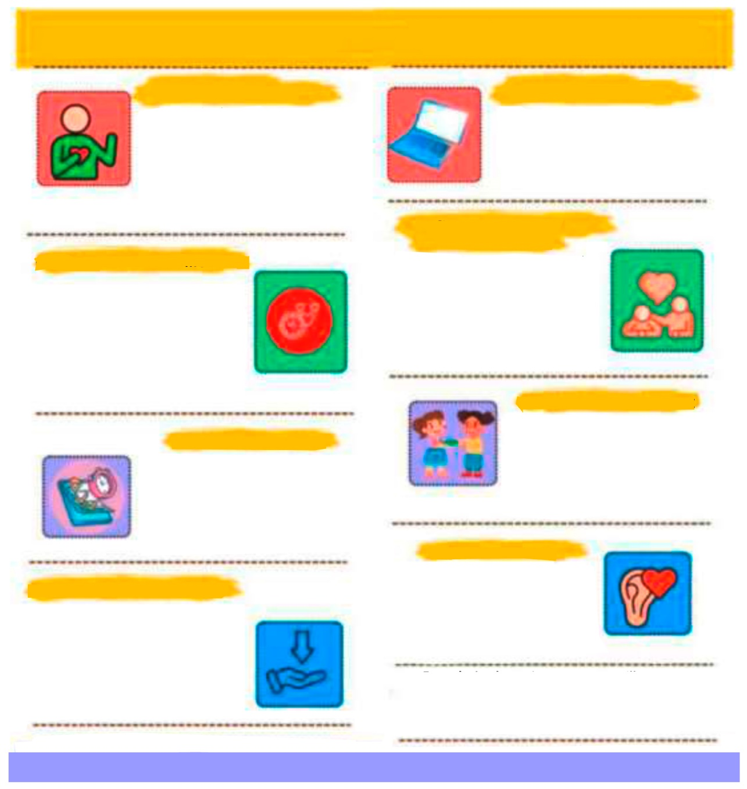
HOW TO BE A GOOD FRIEND HOW TO BE A GOOD FRIEND
BE OPEN AND HONEST
USE TECH TO STAY CLOSE
STAY FLEXABLE AND UNDERSTANDING
FOCUS ON MEANINGFUL MOMENTS
MAKE TIME ON PURPOSE
SHARE THE THINGS YOU LOVE
BE THERE WHEN THEY NEED YOU
LISTEN WITH HEART
Even during busy times, you can still nurture friendships. Reach out to someone today – say “hello”, make a plan or share this message:
“This made me think of you”.
You don’t need to fix everything. Sometimes the best thing you can do is listen, be kind and show you care. A true friend understands before they try to provide solutions.
If a friend is going through something tough, show your support however you can. Listen, send a sweet message, or remind them they’re not alone. Even small acts of kindness mean a lot.
Good friendships don’t just “happen” – they grow when you make time for them. Plan a call, set a date or send a message. Treat it like something important because it is.
Friendship grows when you share fun activities. Cook together, read the same book, watch a show, craft or go for a walk. Sharing hobbies creates memories and brings joy.
You don’t need long hangouts
to stay close. A quick text, a short call or a small update can make
a big difference. It’s the quality
of the time you share, not how long it is, that keeps friendships alive.
Life gets busy. Your friends might have work, family or responsibilities you don’t see. Try to be patient, understanding and kind when plans change. Good friends give each
other room to breathe.
Share what’s really going on in your life – your successes, your worries and everything in between. Let friends know when you’re free and when you’re busy. Being honest about your time and your feelings helps friendships stay strong and real.
When you can’t meet in person, use your phone to stay connected. Chat, call, send voice notes or video chat. You can show love and support from anywhere.

In this oral mediation, you need to paraphrase the tips on how to become a good friend and tell your friend about them in an informal way.  Mention the tips on the poster and make sure it is clear why you are talking about them. | 

Let’s get ready!
1. Analyse the task
Read the task carefully and complete this text.
I have to send a ____________ message to my friend, so I will use ____________ English. He does not __________ English very well, but he wants to ____________ it. You want him to understand how to be a good ____________ .
2. Analyse the information
Michael and Raimon are friends. Read these situations. Are they good friends, according to the tips on the poster?
1. Michael had a problem with one of his teachers and phoned Raimon to tell him about it. Raimon was playing a video game and could not stop to talk to him. He told him that he would phone him back later. ____________
2. Raimon has been living in Denmark for six months. Michael sends voice messages every now and then. ____________
3. Raimon saw Michael’s girlfriend kissing another boy. Raimon does not tell Michael because he does not want to upset him. ____________
4. Michael understands when Raimon has to look after his young brother and cannot go to the gym with him. ____________
5. Raimon only wants to meet Michael when they have an hour or more to share. __________
Let’s prepare the language!
1. Giving tips or advice
When giving tips or advice, English commonly uses modal verbs: “You should listen to your friends.” “You can help them when they need support.” “You shouldn’t talk behind their backs.”
1. What is the difference in strength and tone?
a. You should apologise. __________________________________________
b. You had better apologise. _______________________________________
c. You might want to apologise. ____________________________________
GIVING ADVICE
should / shouldn’t
ought to
had better
could
might want to
It would be wise to …
It may help if you …
If I were you, I would …

2. Read these scenarios and, in pairs, discuss the situation and write three pieces of nuanced advice. Try to use three different ways of giving advice. The first one is done for you. There is more than one possible answer.
a. You have two close friends who have stopped talking to each other. Both expect you to take their side.
If I were you, I’d talk to both friends separately. You might want to explain that you don’t want to choose sides. Also, you should encourage them to resolve the issue together. But you had better avoid spreading information between them, or the conflict could get worse.
b. A friend shared something you had told them in confidence. You feel hurt, but don’t want to lose the friendship.
c. A friend constantly relies on you for emotional support and doesn’t respect your boundaries.
d. Your friend has started hanging out with people who encourage risky behaviour.
e. You always initiate contact and make plans. Your friend rarely puts in effort to do this.
f. You said something that offended a friend from a different cultural background, without realising it.
2. Paraphrasing
When you are asked to mediate, you have to paraphrase some of the ideas in the text given. Paraphrasing means saying the same idea in different words. You keep the original meaning, but you change the vocabulary and the structure of the sentence.
REMEMBER!
Don’t change the meaning.
Don’t copy more than two or three words in a row from the original.
Keep the sentence clear and simple.
Check that your new version still makes sense.
You can paraphrase:
- by using synonyms:
Original: He is very tired. Paraphrase: He is really exhausted.
- by changing the verb form or using a different structure:
Original: People believe that exercise is important. Paraphrase: It is believed that exercise is important.
- by changing the order of information:
Original: She went home because she felt ill. Paraphrase: Because she felt ill, she went home.
- by using more general or more specific words:
Original: My neighbour bought a BMW. Paraphrase: My neighbour bought a car.

Now, try to do it:
a) My friend always listens to me when I have a problem.
_________________________________________________________________
b) We sometimes argue, but we solve our problems quickly.
_________________________________________________________________
c) I trust my best friend more than anyone else.
_________________________________________________________________

d) She supported me when I was going through a difficult time.
_________________________________________________________________

e) He gets annoyed when I cancel our plans at the last minute.
_________________________________________________________________

f) Our friendship grew stronger after we had hung out together during the summer.
_________________________________________________________________

g) I like spending time with people who make me feel comfortable.
_________________________________________________________________

Use your own words.
Don’t repeat sentence structure or copy words.
Vary the sentence structure.
Use synonyms or alternative phrases.
Don’t add new information to your paraphrasing.
Stick to the main points in the text.

Let’s mediate!
Your Mexican friend, Juan Antonio, is going to move to Canada for the next six months as part of an Erasmus programme. His English is not great, but he wants to improve it. He is also worried that he may not make good friends. You have read this poster and, based on the information it contains, you send your friend a voice message telling him how to be a good friend. Do it in English so that he can practise his English.

1. Content
Look at the tips and read the information there carefully again. You now have some ideas to share with your friend. Think about how to start and end the voice message.
- How do you greet your friend and say goodbye?
- What order are you going to follow to tell him about the tips?
Content
2. Language
Paraphrase the tips and use your own words.
Remember to adapt your register to the task and addressee.
Vary the language you use. Look at the useful language on pages 2, 3 and 4.
Language

