B2 - Oral Mediation 4: Task
How to be a Good Friend
Your Mexican friend, Juan Antonio, is going to move to Canada for the next six months as part of an Erasmus programme. His English is not great, but he wants to improve it. He is also worried that he may not make good friends. You have read this poster and, based on the information it contains, you send your friend a voice message telling him how to be a good friend. Do it in English so that he can practise his English.
You have 5 minutes to prepare the task. Your message should last between 2 to 3 minutes.
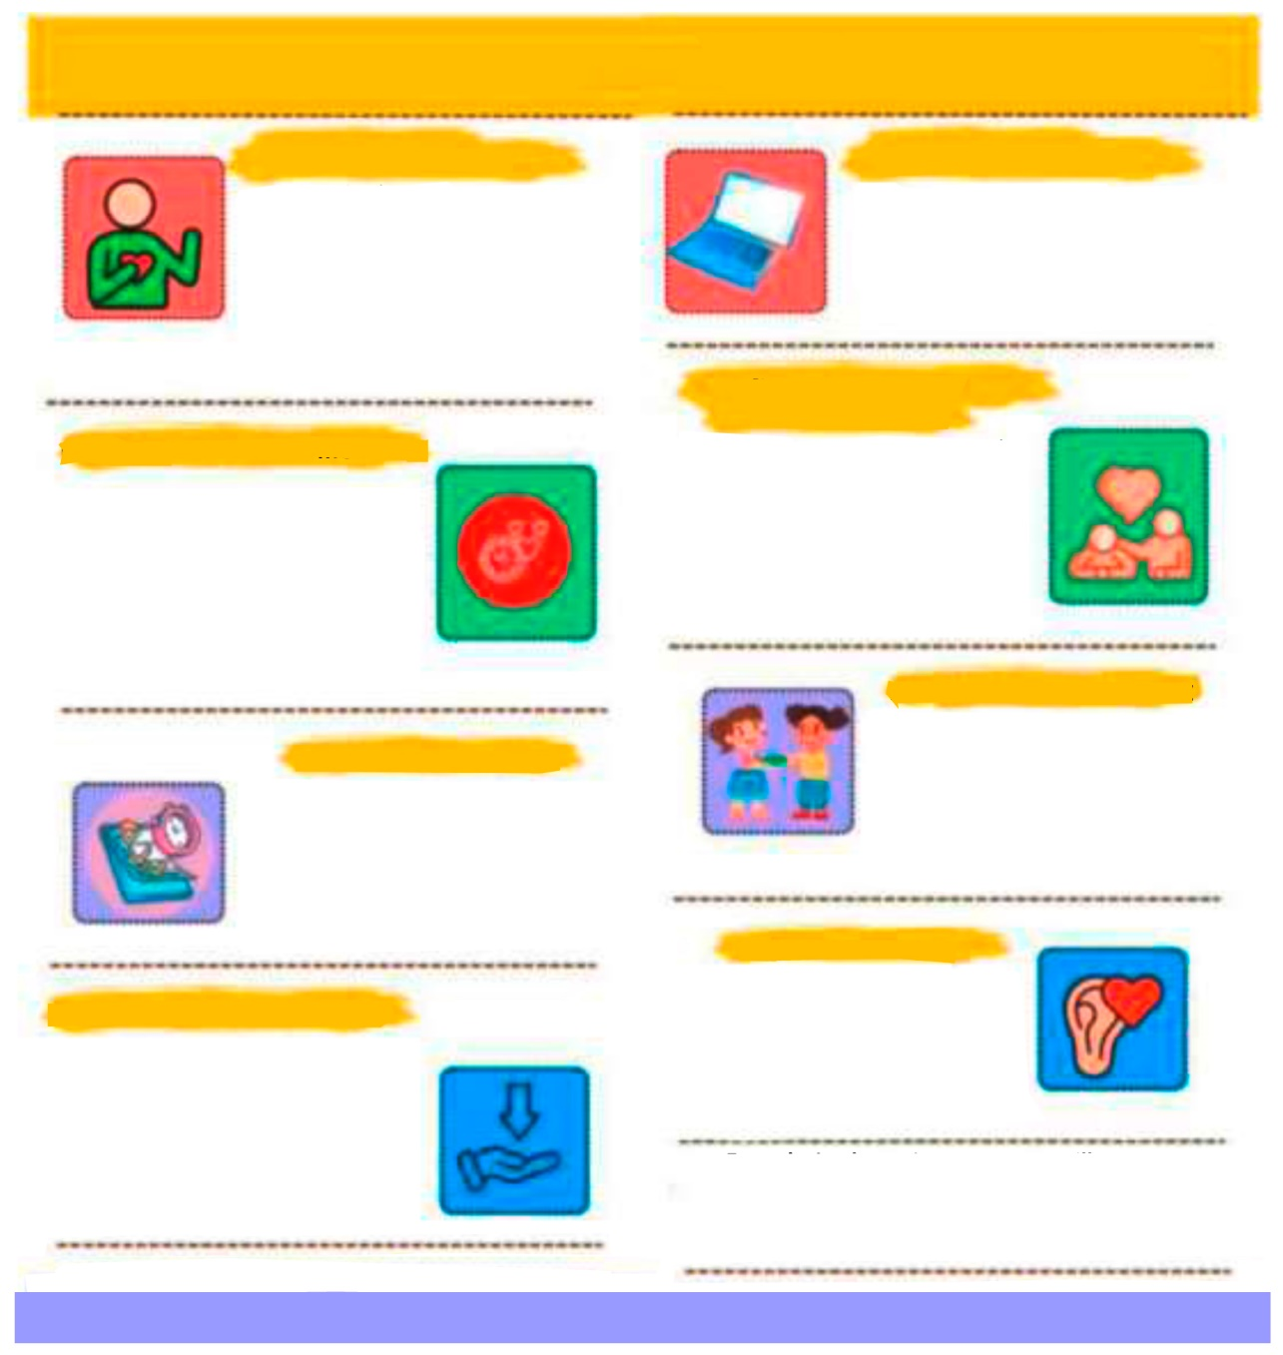
HOW TO BE A GOOD FRIEND HOW TO BE A GOOD FRIEND
BE OPEN AND HONEST
USE TECH TO STAY CLOSE
STAY FLEXABLE AND UNDERSTANDING
FOCUS ON MEANINGFUL MOMENTS
MAKE TIME ON PURPOSE
SHARE THE THINGS YOU LOVE
BE THERE WHEN THEY NEED YOU
LISTEN WITH HEART
Even during busy times, you can still nurture friendships. Reach out to someone today – say “hello”, make a plan or share this message:
“This made me think of you”.
You don’t need to fix everything. Sometimes the best thing you can do is listen, be kind and show you care. A true friend understands before they try to provide solutions.
If a friend is going through something tough, show your support however you can. Listen, send a sweet message, or remind them they’re not alone. Even small acts of kindness mean a lot.
Good friendships don’t just “happen” – they grow when you make time for them. Plan a call, set a date or send a message. Treat it like something important because it is.
Friendship grows when you share fun activities. Cook together, read the same book, watch a show, craft or go for a walk. Sharing hobbies creates memories and brings joy.
You don’t need long hangouts
to stay close. A quick text, a short call or a small update can make
a big difference. It’s the quality
of the time you share, not how long it is, that keeps friendships alive.
Life gets busy. Your friends might have work, family or responsibilities you don’t see. Try to be patient, understanding and kind when plans change. Good friends give each
other room to breathe.
Share what’s really going on in your life – your successes, your worries and everything in between. Let friends know when you’re free and when you’re busy. Being honest about your time and your feelings helps friendships stay strong and real.
When you can’t meet in person, use your phone to stay connected. Chat, call, send voice notes or video chat. You can show love and support from anywhere.

In this oral mediation, you need to paraphrase the tips on how to become a good friend and tell your friend about them in an informal way.  Mention the tips on the poster and make sure it is clear why you are talking about them. | 

