B2 - Written Mediation 1: Learning Sequence
Gender-inclusive language
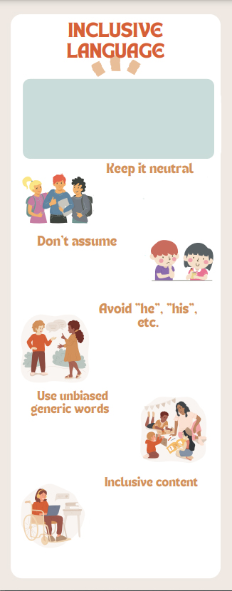
Your Australian friend, Aaron, has
been using language that may be
considered sexist by many people.
He is not conscious of the
(Gender-neutral language is a generic term covering the use of non-sexist language. The purpose of gender-neutral language is to avoid word choices which may be interpreted as biased, discriminatory or demeaning by implying that one sex or social gender is the norm. Using gender-fair and inclusive language also helps reduce gender stereotyping, promotes social change and contributes to archieving gender equality.
(European Parliament, 2018)
- Address people by their name instead of
“Mr.” or “Ms.”
- Say “Excuse me” instead of “Sir” or “Madam”.
- Avoid common masculine addressing
phrases such as “Hey guys”. Use “Hey everyone”.
Always ask. Don’t make assumptions based on appearances or how people sound when deciding the pronoun to use. A simple “What are your pronouns?” works perfectly.
Use “he” or “she” sparingly and only when strictly necessary. Instead
- Use plural forms.
- Use the imperative.
- Omit the pronoun altogether.
- Use passive.
Avoid the generic use of “man”. Use its derivates such as “humankind” instead
of “mankind”.
Use gender-neutral job titles such as firefighter” instead of “fireman”. Use
generic words such as “siblings”, “parents”, “partner”, etc.
Bear in mind that other realities apart from yours are possible. There are all sorts of families, people with disabilities, sexual orientations, gender identities and ethnicities, among other situations. Be careful when talking about certain topics and beware of the words you choose.
evolution of language use and
how gender-inclusive language
must be incorporated into our
ordinary speech.

Write a text message to your
friend (about 80 words) giving him
advice on how to use more
inclusive language.

In written
mediation, you
need to
interpret the
content of the
infographic, and be able to
explain and give your
opinion, if asked, in an
informal or colloquial way.

Make sure you include all the
aspects your friend needs to
know in your message.
A text message does not
have a clear structure, but it
normally has one paragraph.

Let’s get ready!
1. Analyse the task
Read the task carefully and say whether these statements are true (T) or False (F). They will help you choose the register of the mediation task.
- Your friend uses sexist language because he is a sexist. __________
- You are going to send him an informal e-mail. __________
- Your intention is to tell him off. __________
- You would like him to use more inclusive language. __________
2. Analyse the information
Read the information in the infographic carefully.
- Make a list of things you have to include in your text message in the first column. You can copy the words from the infographic.
- In the second column, paraphrase the list. Use your own words to refer to the same ideas. Do not write whole sentences. Just the idea behind each thing.
Things to include | Use your own words
Let’s prepare the language!
1. A text message
1. Read the message below where a student is explaining to their mother why he / she will not be home on time. Pay attention to the following aspects:
- What’s the style, tone and register? ______________________________
- Is there a greeting and a farewell? ______________________________
- How many paragraphs are there? ______________________________
- Which features of spoken language can you see in the message? ____________________________
- How does the writer express feelings or emotions? ______________________________



Hi mum!!!!! I’m not coming home for lunch today. The English teacher’s given us a lot of homework to do 3 people were doing maths in the English class, 2 people were playing truant and we were all speaking when she was trying to explain how to write a for and against essay. Need to do some group work with Chris & Julia and they’re free at 3 so we’ll stay in the canteen, eat something & do the work quickly. Wanna be home by 6. Love you

2. Persuading someone to do something
Are you good at persuading people to do things?
1. These are verbs that you can use to persuade. Match the verb and its definition.
urge | To give a very soft recommendation for something.
recommend | Strongly recommend someone to do something.
consider | Give a suggestion based on your opinion.
suggest | To think about something.
2. Decide which sentences are asking or persuading someone to do something. There are five answers.
- I really don’t know what to do.
- Why don’t you give it a go?
- I’d really appreciate your effort in doing it.
- You’d really be helping me out.
- I don’t usually do that kind of thing.
- I know you can do it.
- Come on! There’s nothing to lose!
- OK, I’ll think about it.
3. Another possible way of persuading people is to use modals verbs. Let’s revise when to use “should”, “ought to” and “had better”.
Subject + should + base form verb
Subject + shouldn’t + base form verb
They express advice.
e.g. You should go to see a dentist if you have toothache.
Subject + ought to + base form verb
It’s stronger than “should” as it implies that you are not doing it.
e.g. You ought to be studying right now. You have an exam tomorrow. (I’m telling you this because you are not studying right now).
Subject + had better + base form verb
Subject + had better not + base form verb
It is stronger than the previous ones as it implies a warning or even a threat.
e.g. You’d better be there on time. (If not, there will be consequences.)
4. Choose the correct answer.
a) We ………… call Mary. It’s been ages since we last saw her.
- should
- ought to
- both are correct.

b) You ………… park here. This is a parking for disabled people.
- shouldn’t to
- shouldn’t
- ought to

c) Mark, you ………… go on the school trip if you’re not feeling well.
- had better not
- ought to
- had better

d.) Medicine ………… be free for everyone.
- had better
- shouldn’t

- ought to
Do not use the same expressions all the time. It is important
to vary the language to show you have a good vocabulary.

Let’s mediate!
Your Australian friend, Aaron, has been using language that may be considered sexist by many
people. He is not conscious of the evolution of language use and how gender-inclusive
language must be incorporated into our ordinary speech.
Write a text message to your friend (about 80 words) giving him advice on how to use more
inclusive language
1. Content
Content
Look at the instructions and the infographics and read the information there carefully again. Select the information you are going to tell your friend. You can use the following questions:
- What is inclusive language?
- Why is it important to use inclusive language?
- Which tips can you give your friend? Be as specific as possible.
2. Language
Language
Use your own words. Simplify or paraphrase the information.
Remember to adapt your language (register, style) to the task and addressee.
Vary the language you use. Look at the useful language on pages 3 and 4.

