B2 - Written Mediation 1: Task
Gender-inclusive language
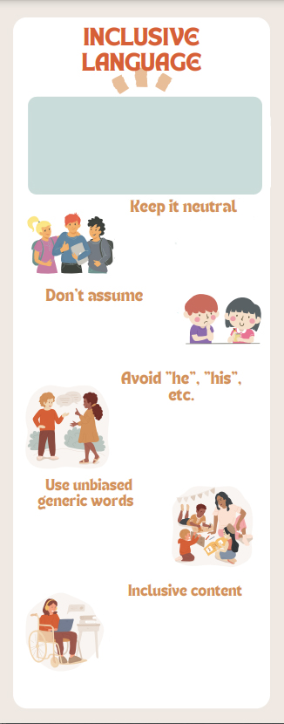
Your Australian friend, Aaron, has
been using language that may be
considered sexist by many people.
He is not conscious of the
(Gender-neutral language is a generic term covering the use of non-sexist language. The purpose of gender-neutral language is to avoid word choices which may be interpreted as biased, discriminatory or demeaning by implying that one sex or social gender is the norm. Using gender-fair and inclusive language also helps reduce gender stereotyping, promotes social change and contributes to archieving gender equality.
(European Parliament, 2018)
- Address people by their name instead of
“Mr.” or “Ms.”
- Say “Excuse me” instead of “Sir” or “Madam”.
- Avoid common masculine addressing
phrases such as “Hey guys”. Use “Hey everyone”.
Always ask. Don’t make assumptions based on appearances or how people sound when deciding the pronoun to use. A simple “What are your pronouns?” works perfectly.
Use “he” or “she” sparingly and only when strictly necessary. Instead
- Use plural forms.
- Use the imperative.
- Omit the pronoun altogether.
- Use passive.
Avoid the generic use of “man”. Use its derivates such as “humankind” instead
of “mankind”.
Use gender-neutral job titles such as firefighter” instead of “fireman”. Use
generic words such as “siblings”, “parents”, “partner”, etc.
Bear in mind that other realities apart from yours are possible. There are all sorts of families, people with disabilities, sexual orientations, gender identities and ethnicities, among other situations. Be careful when talking about certain topics and beware of the words you choose.
evolution of language use and
how gender-inclusive language
must be incorporated into our
ordinary speech.

Write a text message to your
friend (about 80 words) giving him
advice on how to use more
inclusive language.

In written
mediation, you
need to
interpret the content of the
infographic, and be able to
explain and give your
opinion, if asked, in an
informal or colloquial way.

Make sure you include all the
aspects your friend needs to
know in your message.
A text message does not
have a clear structure, but it
normally has one paragraph.

