B2 - Written Mediation 3: Teacher’s Notes
Schools Round the World
Before starting the mediation activity, ask students to read the task and the infographic carefully to make the aim of the activity clear.
One of your friends has been asked to write about education round the world. He does not understand English, but has found the infographic below that provides him with useful information. He needs to compare two countries, but he is pretty busy at the moment and he has asked you to write a paragraph for him.
Write a paragraph for your friend (about 100 words) comparing the education in two of the countries in the infographic.
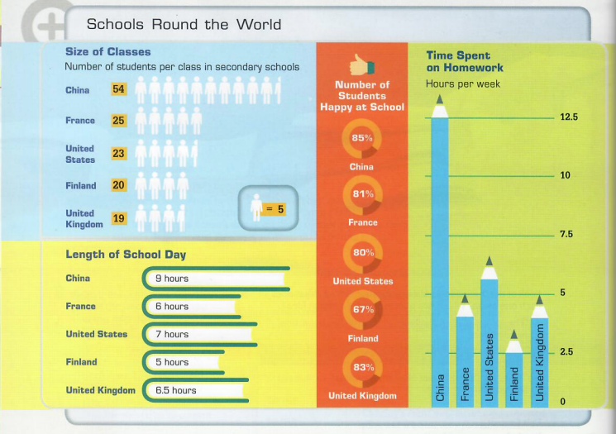

In written mediation, you need to interpret the content
of the infographic, and be able to explain and give your
opinion, if asked, in an informal or colloquial way.

Refer to the document you have been asked to read. But do not
copy it. Paraphrase the ideas there.

Let’s get ready!
In this section, you will help students to get ready for the task. First of all, they will learn what to do (Analyse the task) and later, they will work on the information (Analyse the information). You can give them the Learning Sequence worksheet to work on.
1. Analyse the task
Tell students they are going to think about the receiver of the message, the reason for the message and the information included. This will help them to use the proper register (formal or informal).
Read the task carefully and say whether these sentences are true or false. They will help you choose the register of the mediation task.
- Your teacher wants you to write a paragraph about education in the world. FALSE
- You have to compare two of the countries in the infographic. TRUE
- You have to write two paragraphs. FALSE
- Your paragraph has to have about 100 words. TRUE
2. Analyse the information
Tell students to think about the relevant information on the infographic they will have to use.
a) Read the information in the infographic carefully and answer the following questions.
Which country … | Country
Has the longest school day? | China
Has the largest classes? | China
Asks students to spend the longest time doing homework? | China
Has the biggest number of happy students? | China
Has the shortest school day? | Finland
Has the smallest classes? | United Kingdom
Asks students to spend the least time doing homework? | Finland
Has the lowest number of happy students? | Finland
b) Can you see any connection between the class size, length of school day and time spent on homework to students feeling happy or not so happy at school?
Encourage students to give their opinions. They may give different answers.
Possible answer: There doesn’t seem to be a connection between happiness and class size, but it seems that Chinese students are the happiest students despite the fact that they spend more time at school and have the most homework.
This exercise prepares students for the mediation task. Each student will have different answers.
c) Now, choose the two countries you will compare and fill in the table.
 | Country 1: ____________ | Country 2: ___________
Class size | Accept all factually-correct answers. | Accept all factually-correct answers.
Time spent on homework
Length of school day
Number of students happy at school
Let’s prepare the language!
In this section, students will learn structures and language suitable for the task. Ask students how they compare two things in English and then ask them to read this section and do the activity.
1. Comparing
Comparative adjectives are used to compare differences between the two objects
they modify.
Comparatives | Superlatives
More important than  fast + -er than  As important / fast as  Less important / fast than  Not nearly as  Not so much  Far more  Three times as much | The most important  The fast + -est  The least important / fast

2. Are these sentences correct or incorrect. Correct the incorrect ones.
a) There are less people here than at the concert.
There are fewer people here than at the concert.
b) Tennis is a far harder game than football.
Correct
c) This classroom is twice as big as that one.
Correct
d) Your dog is so friendlier than mine
Your dog is as friendly as mine. / Your dog is less friendly than mine.
e) This woman is considerably richest than that one.
This woman is considerably richer than that one.
Other Useful Language
In both …
They are similar because …
They are different because …
Another similarity / difference is that …
… in no way as … as …
In x, …, whereas in x, …
… nothing like as … as …
… not quite as … as …
Rather than …
So much … as …
Do not use the same expressions all the time. It is
important to vary the language to show you have a good
vocabulary.
2. A paragraph
The mediation task asks students to write a paragraph, so it is a good idea to revise how a paragraph is well organised. Read the information here and ask them to identify the two types of sentences in the paragraph below.
A paragraph consists of several sentences about a certain topic. It has three parts:
- A topic sentence: It gives the main idea of the paragraph.
- Some supporting sentences: They provide evidences, details and examples to support the topic sentence.
- A concluding sentence: It either summarises the paragraph or leads to the next paragraph.
Read this paragraph where France and the United Kingdom are compared. Underline the topic sentence and the concluding sentence.
France is a better place to live than the United Kingdom. The World Health Organization says France has one of the world's best life expectancy rates, as the average man can expect to live to 82, and the average woman to 85. In Britain, the figures are 81 for men and 83 for women. Living in France is less expensive than living in the United Kingdom. Even in Paris, it is cheaper to rent a house, to go out or to go shopping than in London. What is more, in the UK, recorded crimes of violence are 1,500/100,000 and property crime 5,287/100,000. The French equivalents are significantly lower, being 750/100,000 and 3,500/100,000. If you want to live a happy and safe life, you should live in France.
Tell students that this paragraph can be used as a model for their mediation task.
Let’s mediate!
Make sure students understand the task and you can summarise the tips below.
One of your friends has been asked to write about education round the world. He does not understand English, but has found the infographic below that provides him with useful information. He needs to compare two countries, but he is pretty busy at the moment and he has asked you to write a paragraph for him.
Write a paragraph for your friend (about 100 words) comparing the education in two of the countries in the infographic.
1. Content
Content
Look at the instructions and the infographic. Read the information there carefully again. Select the information you are going to include in your paragraph. You can use the following questions:
- Which country has the biggest class size, the longest school day, the longest time spent on homework and the happiest students?
- What connection, if any, can you find between the data?
- Are there more similarities or more differences between them?
2. Language
Language
Use your own words. Paraphrase the information.
Remember to adapt your language (register, style) to the task and addressee.
Vary the language you use to compare the two countries. Look at the Other Useful Language on page 3.
Refer students to the task again and pay special attention to the tip. Make students read the rubric, so that they know what is important.

Let’s evaluate!
Rubrics for assessment
 Written Mediation
 | Excellent | Good | Acceptable | Unsuitable
Clarity | The information is clear and easy to follow.The main points are emphasised. | The information is clear to follow but sometimes it is not easy to understand what the main points are. | The information selected is not relevant, lacks coherence and  may include contradictions. | The information selected is not relevant, not clear, not easy to follow and includes contradictions.
Relevancy and processing | The student has summarised and paraphrased the main ideas without copying literally. No information has been added. | The student has summarised the main ideas but has not paraphrased them. No information has been added. | The student conveys some appropriate information by summarising the main ideas, but not all. | The student doesn’t convey much appropriate information or has copied it from the text. Extra  information may have been added.
Genre and organisation | The text follows the conventions of the specific text type, addressing it appropriately to the specific audience. | The text follows the conventions of the specific text type, but it is not addressed appropriately to the specific audience. | The text follows the conventions of the specific text type to a certain extent but the degree of formality is not correct. | The text does not follow the conventions of the specific text type, or it is not addressed appropriately to the specific audience.
Cohesion and organisation | The written text is logically organised, connected and cohesive. The text is organised in paragraphs, which have a key sentence. A wide range of connectors and linkers is used. | The written text is logically organised, connected and cohesive. The text is organised in paragraphs, which mostly have a key sentence. Basic connectors and linkers are correctly used. | The written text is organised, connected and cohesive. The text is organised in paragraphs but they do not have key sentences. A few basic connectors and linkers are correctly used. | The written text is not logically organised. Some parts are not coherent. Paragraphs seem to have no connection. Some basic connectors and linkers are used but not all correctly.
Vocabulary | The student uses a wide rage of appropriate vocabulary. Spelling is correct. | The student mostly uses appropriate and varied vocabulary. Spelling is correct. | The student uses appropriate vocabulary but it is not varied. There are some spelling mistakes but they do not impede comprehension. | The student doesn’t use varied vocabulary or is not able to paraphrase. There are many spelling mistakes.
Grammar | The student uses a wide range of correct grammatical structures. | The student uses a wide range of grammatical structures but not always correctly. | The student uses basic but correct grammatical structures. | The student uses basic grammatical structures but not always correctly.

