B2 - Written Mediation 3: Learning Sequence
Schools Round the World
One of your friends has been asked to write about education round the world. He does not understand English, but has found the infographic below that provides him with useful information. He needs to compare two countries, but he is pretty busy at the moment and he has asked you to write a paragraph for him.
Write a paragraph for your friend (about 100 words) comparing the education in two of the countries in the infographic.
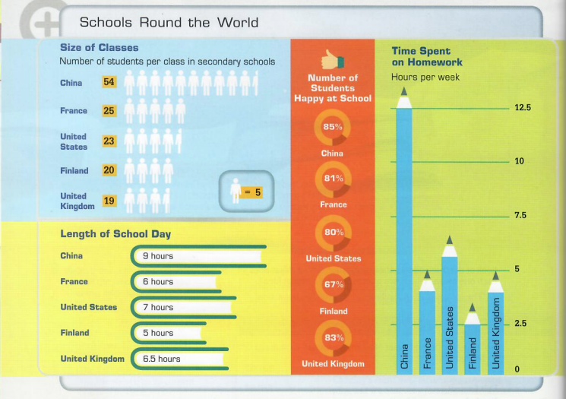

In written mediation, you need to interpret the content
of the infographic, and be able to explain and give your
opinion, if asked, in an informal or colloquial way.

Refer to the document you have been asked to read. But do not
copy it. Paraphrase the ideas there.

Let’s get ready!
1. Analyse the task
Read the task carefully and say whether the following sentences are true or false. They will help you choose the register of the mediation task.
- Your teacher wants you to write a paragraph about education in the world. ________
- You have to compare two of the countries in the infographic. ________
- You have to write two paragraphs. ________
- Your paragraph has to have about 100 words. ________
2. Analyse the information
a) Read the information in the infographic carefully and answer the following questions.
Which country … | Country
Has the longest school day?
Has the largest classes?
Asks students to spend the longest time doing homework?
Has the biggest number of happy students?
Has the shortest school day?
Has the smallest classes?
Asks students to spend the least time doing homework?
Has the lowest number of happy students?
b) Can you see any connection between the class size, length of school day and time spent
on homework to students feeling happy or not so happy at school?
c) Now, choose the two countries you will compare and fill in the table.
 | Country 1: ____________ | Country 2: ___________
Class size
Time spent on homework
Length of school day
Number of students happy at school

Let’s prepare the language!
1. Comparing
Comparative adjectives are used to compare differences between the two objects
they modify.
Comparatives | Superlatives
More important than  fast + -er than  As important / fast as  Less important / fast than  Not nearly as  Not so much  Far more  Three times as much | The most important  The fast + -est  The least important / fast
Are these sentences correct or incorrect. Correct the incorrect ones.
a) There are less people here than at the concert.
________________________________________________________
b) Tennis is a far harder game than football.
________________________________________________________
c) This classroom is twice as big as that one.
________________________________________________________
d) Your dog is so friendlier than mine
________________________________________________________
e) This woman is considerably richest than that one.
________________________________________________________
Other Useful Language
In both …
They are similar because …
They are different because …
Another similarity / difference is that …
… in no way as … as …
In x, …, whereas in x, …
… nothing like as … as …
… not quite as … as …
Rather than …
So much … as …
Do not use the same expressions all the time. It is
important to vary the language to show you have a good
vocabulary.
2. A paragraph
A paragraph consists of several sentences about a certain topic. It has three parts:
- A topic sentence: It gives the main idea of the paragraph.
- Some supporting sentences: They provide evidences, details and examples to support the topic sentence.
- A concluding sentence: It either summarises the paragraph or leads to the next paragraph.
Read this paragraph where France and the United Kingdom are compared. Underline the topic sentence and the concluding sentence.
France is a better place to live than the United Kingdom. The World Health Organization says France has one of the world's best life expectancy rates, as the average man can expect to live to 82, and the average woman to 85. In Britain, the figures are 81 for men and 83 for women. Living in France is less expensive than living in the United Kingdom. Even in Paris, it is cheaper to rent a house, to go out or to go shopping than in London. What is more, in the UK, recorded crimes of violence are 1,500/100,000 and property crime 5,287/100,000. The French equivalents are significantly lower, being 750/100,000 and 3,500/100,000. If you want to live a happy and safe life, you should live in France.

Let’s mediate!
One of your friends has been asked to write about education round the world. He does not understand English, but has found the infographic below that provides him with useful information. He needs to compare two countries, but he is pretty busy at the moment and he has asked you to write a paragraph for him.
Write a paragraph for your friend (about 100 words) comparing the education in two of the countries in the infographic.
1. Content
Content
Look at the instructions and the infographic. Read the information there carefully again. Select the information you are going to include in your paragraph. You can use the following questions:
- Which country has the biggest class size, the longest school day, the longest time spent on homework and the happiest students?
- What connection, if any, can you find between the data?
- Are there more similarities or more differences between them?
2. Language
Language
Use your own words. Paraphrase the information.
Remember to adapt your language (register, style) to the task and addressee.
Vary the language you use to compare the two countries. Look at the Other Useful Language on page 3.

