B2 - Written Mediation 3: Task
Schools Round the World
One of your friends has been asked to write about education round the world. He does not understand English, but has found the infographic below that provides him with useful information. He needs to compare two countries, but he is pretty busy at the moment and he has asked you to write a paragraph for him.
Write a paragraph for your friend (about 100 words) comparing the education in two of the countries in the infographic.
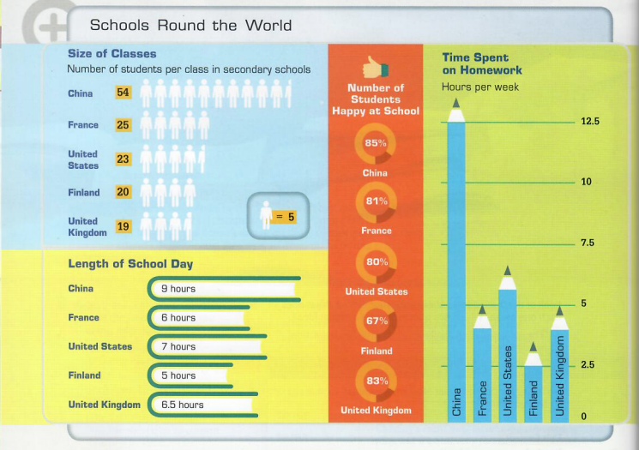

In written mediation, you need to interpret the content
of the infographic, and be able to explain and give your
opinion, if asked, in an informal or colloquial way.

Refer to the document you have been asked to read. But do not
copy it. Paraphrase the ideas there.

